Supplementary Information
(ESM_1 Comparisons of all plants in study areas.pdf)
Mery L. SUNI, Giovana P. VADILLO, Gerson E. PRADO, Liscely TUMI & Paul M. RAMSAY
“Size structure of Puya raimondii stands in Huascarán National Park, Perú”
Alpine Botany
Corresponding author: Paul M. RAMSAY, Universidad de las Américas Puebla, Departamento de Ciencias Químico-Biológicas, San Andrés Cholula, México; paul.ramsay@udlap.mx

Online Resource 1 UTM coordinates and elevations for the two extreme ends of 50 m x 6 m plots in Pumapampa, Pachapaqui and Queshque study areas.
UTM start | UTM end | Elevation (m)
Pumapampa
18 L 248065 8905831 | 18 L 248027 8905858 | 4209
18 L 248117 8905847 | 18 L 248165 8905836 | 4210
18 L 248168 8905721 | 18 L 248211 8905746 | 4232
18 L 248308 8905695 | 18 L 248358 8905681 | 4256
18 L 248420 8905730 | 18 L 248402 8905787 | 4255
18 L 248956 8906597 | 18 L 249002 8906616 | 4237
18 L 249521 8906828 | 18 L 249500 8906865 | 4287
18 L 249943 8907059 | 18 L 249994 8907063 | 4264
18 L 250027 8907121 | 18 L 250076 8907128 | 4255
18 L 250109 8907192 | 18 L 250159 8907202 | 4248
Pachapaqui
18 L 273714 8899303 | 18 L 273762 8899286 | 4095
18 L 272030 8898838 | 18 L 272080 8898847 | 4002
18 L 272389 8898991 | 18 L 272429 8899012 | 4021
18 L 272403 8899048 | 18 L 272432 8899059 | 4006
Queshque
18 L 246900 8912927 | 18 L 246940 8912894 | 4271
18 L 247324 8913386 | 18 L 247376 8913387 | 4282
18 L 243092 8912404 | 18 L 243065 8912447 | 4179
18 L 248241 8913464 | 18 L 248294 8913460 | 4290

Online Resource 2 Comparisons of the juvenile developmental stage of P. raimondii plants between the three study areas: Pachapaqui (n = 26), Pumapampa (n = 133), and Queshque (n = 189). a. Total plant height. b. Total rosette diameter. c. Live rosette diameter. The whiskers show 95% confidence ranges.
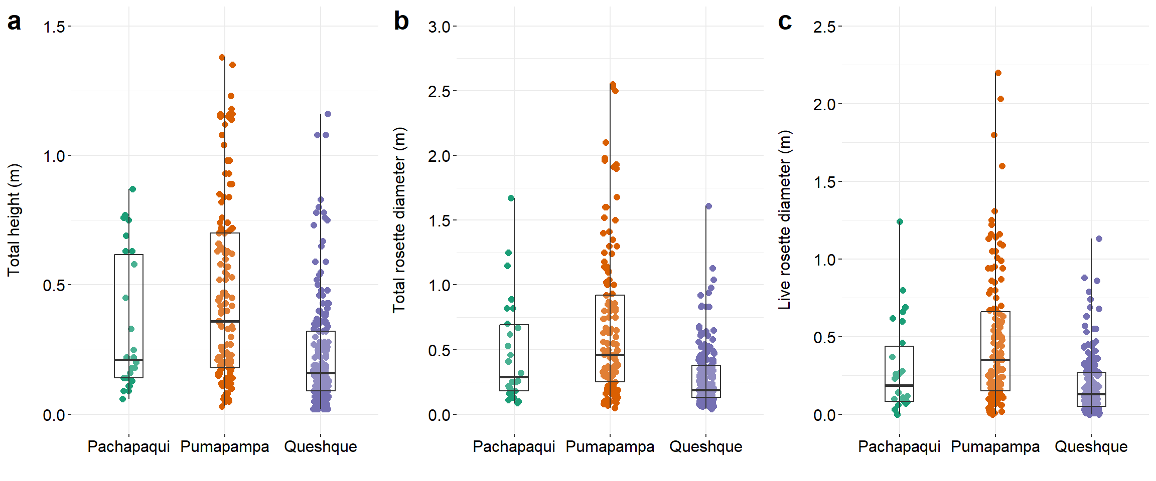
Online Resource 3 Comparisons of the subadult developmental stage of P. raimondii plants between the three study areas: Pachapaqui (n = 25), Pumapampa (n = 90), and Queshque (n = 55). a. Total plant height. b. Stem height. c. Total rosette diameter. d. Live rosette diameter. The whiskers show 95% confidence ranges.
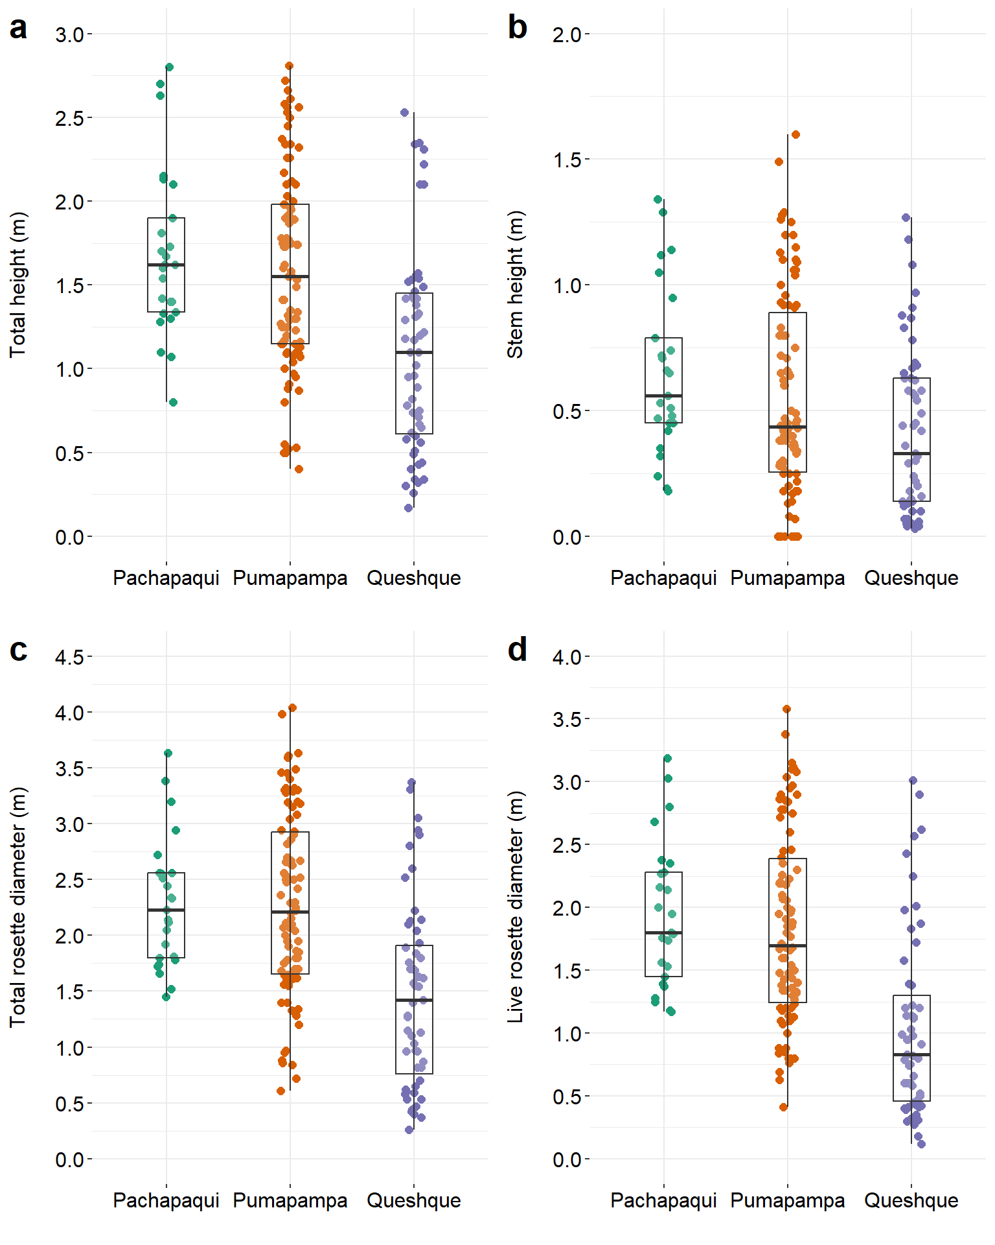
Online Resource 4 Comparisons of the adult developmental stage of P. raimondii plants between the three study areas: Pachapaqui (n = 16), Pumapampa (n = 10), and Queshque (n = 3). a. Total plant height. b. Stem height. c. Total rosette diameter. d. Live rosette diameter. e. Height to base of spherical rosette. The whiskers show 95% confidence ranges.
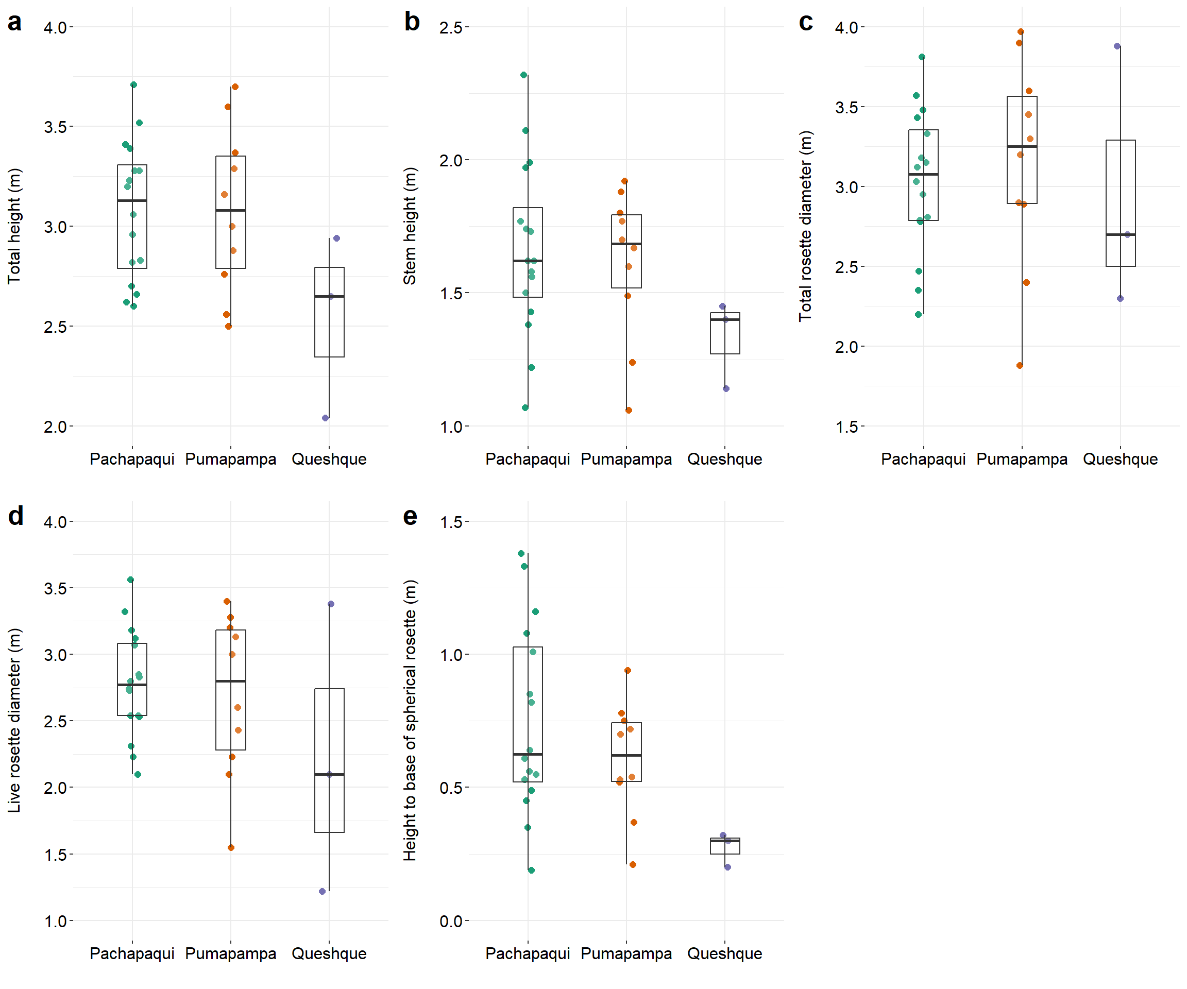
Online Resource 5 Comparisons of the reproductive adult developmental stage of P. raimondii plants between two study areas: Pumapampa (n = 12) and Queshque (n = 2). a. Total plant height. b. Stem height. c. Total rosette diameter. d. Live rosette diameter. e. Height to base of spherical rosette. The whiskers show 95% confidence ranges. There were no reproductive adults in the Pachapaqui plots.
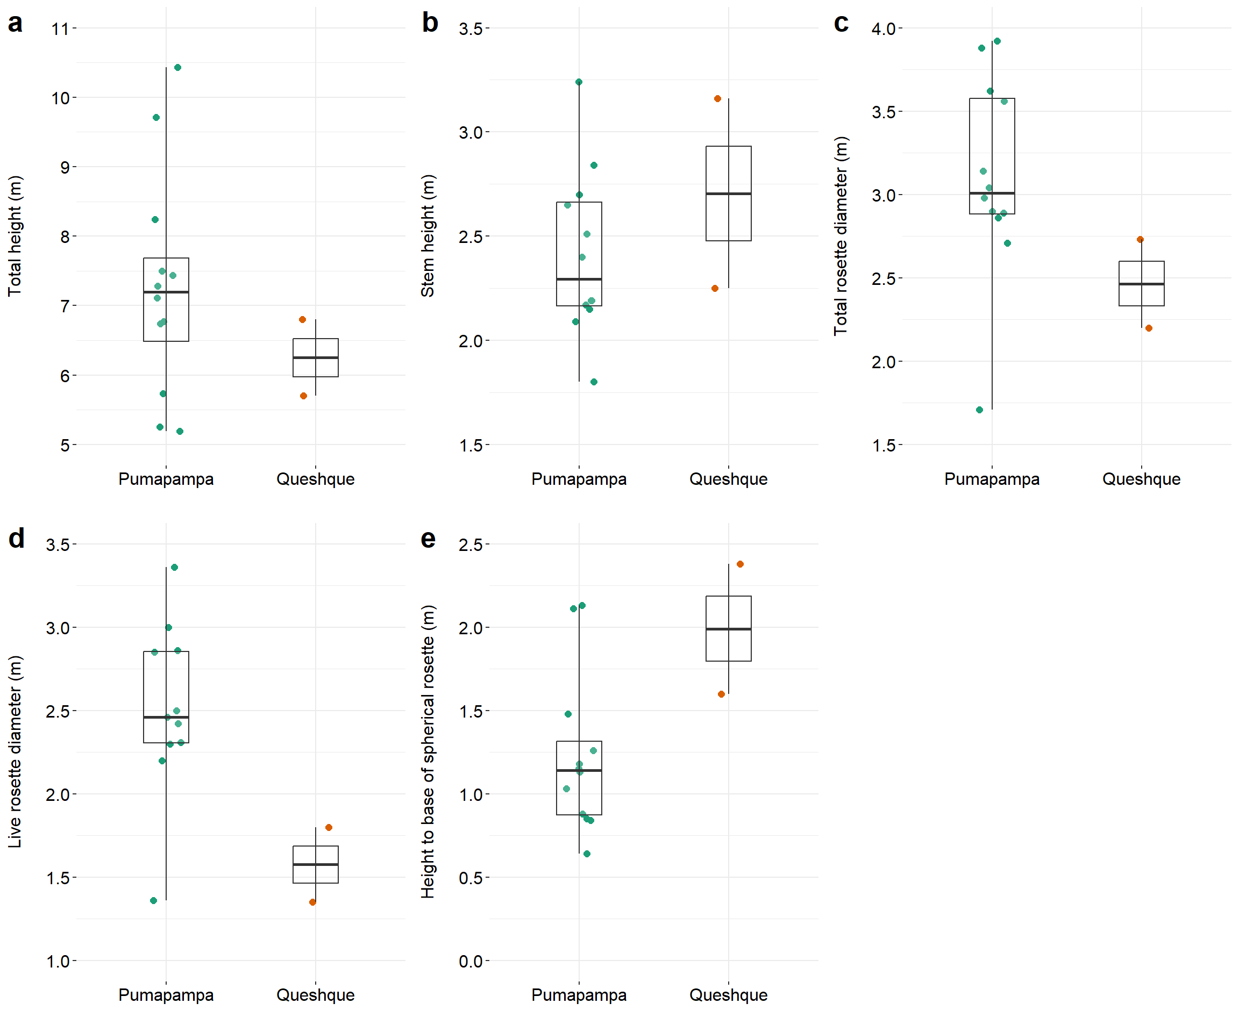
Online Resource 6 Comparisons of the senescent reproductive adult developmental stage of P. raimondii plants between the three study areas: Pachapaqui (n = 11), Pumapampa (n = 11), and Queshque (n = 3). a. Total plant height. b. Stem height. c. Height to base of spherical rosette. The whiskers show 95% confidence ranges.
