Table S1: Constant compositional expansion (CCE) analysis of used oil
Components | Reservoir oil (Mol %)
H₂S | 0.13
N₂ | 0.30
CO₂ | 3.33
C₁ | 26.50
C₂ | 7.37
C₃ | 4.51
iC₄ | 0.60
nC₄ | 2.03
iC₅ | 2.49
nC₅ | 2.96
C₆ | 7.56
C₇ | 4.44
C₈ | 3.77
C₉ | 2.82
C₁₀ | 3.35
C₁₁ | 3.29
C_{12*} | 24.53
Total | 100.00
GOR, SCF/STB | 323

Table S2: Used crude oil specification
Components | Weight Percent
Saturations | 49.5 %
Aromatics | 30 %
Asphaltene | 11.4 %
Resin | 9.1 %

Figure S1: TEM image (left), HR-TEM image (right), and lattice spacing of the E5_L CDs sample.

Figure S2: XRD spectra of CD samples (E5_L, U5_L, and T5_L)

E5_L CDs
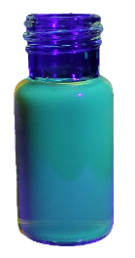U5_L CDs
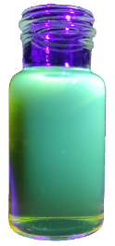
T5_L CDs
Figure S3: UV-Vis spectrum (first column), photoluminescence at 360 nm (second column) spectra, and solution under UV light (third column) for E5_L, U5_L, and T5_L CDs

Figure S4: FTIR spectra of E5_L, U5_L and T5_L CDs

C1s
Figure S5: XPS spectra of E5_L, U5_L, and T5_L CDs. The first row presents the full scan survey, and the second, third, and fourth rows display the high-resolution spectra for E5_L, U5_L, and T5_L CDs, respectively. The first, second, and third columns correspond to the high-resolution C1s, N1s, and O1s XPS spectra.

Figure S6: High-resolution XPS spectra of the S2p region for T5_L CDs.

Figure S7: IFT value of crude oil and different NaCl concentrations with 1000 ppm of T5_L and T10_L CDs

Figure S8: IFT value of crude oil and various NaCl concentrations in the presence of 1000 ppm T5_L and T5_M CDs

Figure S9: IFT value of crude oil and different MgCl₂ concentrations with 1000 ppm of U5_L, U5_M, and U5_H CDs

Figure S10: IFT value of crude oil and different CaCl₂ concentrations with 1000 ppm of T5_L and T5_M CDs

