Phytochemical Analysis, OHR-LCMS Assisted Metabolite Profiling, and Antifungal Activity of Natural Products from Medicinal Plant Tragia Plukentii A.R sm as Antitinea Agents
Santosh R. Butle^{1†*}, Sumer S. Sayyad^{1†}, Manish P. Deshmukh2†*
1 Department of Pharmaceutical Chemistry, School of Pharmacy,
Swami Ramanand Teerth Marathwada University Nanded, Dnyanteerth
Parisar, Vishnupuri, Nanded, 431606, Maharashtra, India.
2 Datta Meghe Institute of Higher Education and Research (Deemed to be University),
Sawangi (Meghe), Wardha – 442107, Maharashtra, India

*Corresponding author(s). E-mail(s): butlesr@gmail.com; manishpdeshmukh@gmail.com
Contributing authors: sumerpatel5082@gmail.com;
†These authors contributed equally to this work.

Supplementary Material:

Appendix A: Images of antifungal activity of T..plukentii extracts against Trichophyton rubrum.

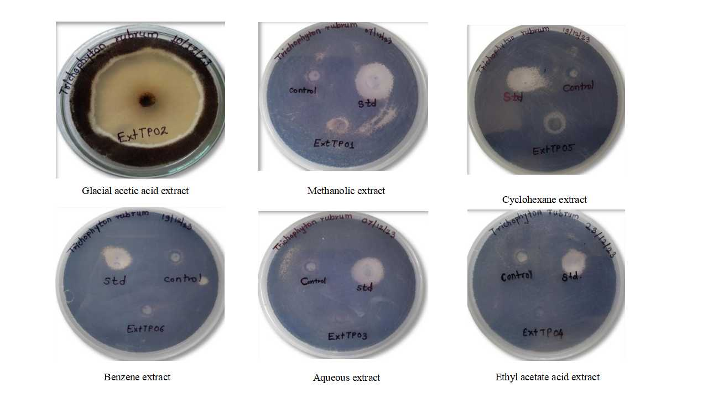

Figure 1: Depicting images of antifungal activity of T..plukentii extracts against Trichophyton rubrum.

Appendix B: Bioactive compounds identified in the Glacial acetic acid extract of Tragia plukentii by OHRLC-MS analysis (positive ionization mode)

Sr No | Name of Phytoconstituent | Structure | Retention Time (RT) | Molecular Formula | Molecular Weight
 | 2-(2,6 hydroxyphenyl) 3,5,7-trihydroxy-4H chrome-4-one | 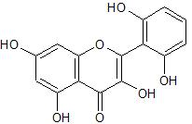 | 12.34 | C15 H10 O7 | 302.0427
2 | 10(15),11,13 hexane-21-yl 3,4,5 trihydroxybenzoate Norharman | 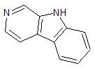 | 9.41 | C11 H8 N2 | 168.0687
 | NP-001787 | 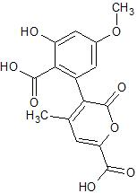 | 18.32 | C15 H12 O8 | 320.0532
 | L(-)-Pipecolinic acid | 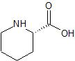 | 2.52 | C6 H11 N O2 | 129.0790
 | Maltol | 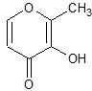 | 5.13 | C6 H6 O3 | 126.0317
 | NP-016582 | 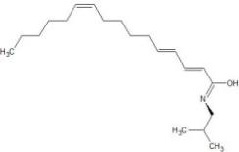 | 22.26 | C20 H35 N O | 305.2719
 | Corilagin | 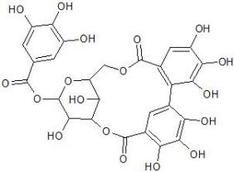 | 8.88 | C27 H22 O18 | 634.0806
 | Quercetin | 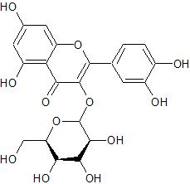 | 8.56 | C15 H10 O7 | 302.0427
 | Indole-3-acetic acid | 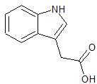 | 2.67 | C10 H9 N O2 | 175.0633
 | 3-(2 Hydroxyethyl)indole | 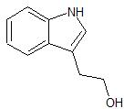 | 3.08 | C10 H11 N O | 161.0841
 | Salsolinol | 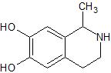 | 7.37 | C10 H13 N O2 | 179.0946
 | Caprolactam | 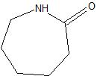 | 32.6 | C6 H11 N O | 113.0841
 | Sulfamethazine | 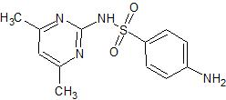 | 15.17 | C12 H14 N4 O2 | 278.0837
 | NP-019150 | 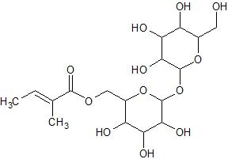 | 8.74 | C17 H28 O12 | 424.1581
 | Acetylcholine | 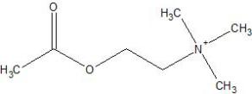 | 1.31 | C7 H15 N O2 | 145.1103
 | Robinetin | 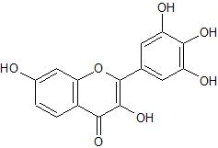 | 8.85 | C15 H10 O7 | 302.0427
 | NP-015145 | 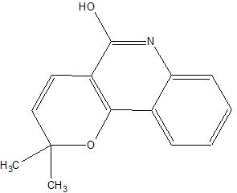 | 2.25 | C14 H13 N O2 | 227.0946
 | 4-Hydroxy-6 methyl-2-pyrone | 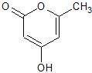 | 11.35 | C6 H6 O3 | 126.0317
 | 2 Hydroxyphenylalani ne | 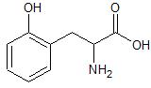 | 1.32 | C9 H11 N O3 | 181.0739
 | 5 Methoxyindoleaceti c acid | 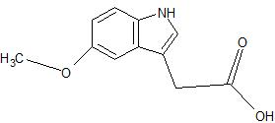 | 8.56 | C11 H11 N O3 | 205.0739
 | 9-Oxo-10(E),12(E) octadecadienoic acid | 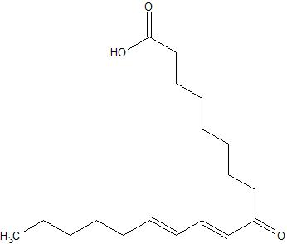 | 19.85 | C18 H30 O3 | 294.2195
 | Pyridoxal | 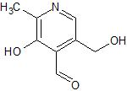 | 1.73 | C8 H9 N O3 | 167.0582
 | Trigonelline | 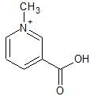 | 1.25 | C7 H7 N O2 | 137.0477
 | Arachidonoyl amide | 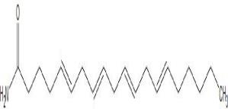 | 21.25 | C20 H33 N O | 303.2562
 | DL-Carnitine | 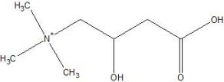 | 2.23 | C7 H15 N O3 | 161.1052
 | 4-Aminobenzoic acid | 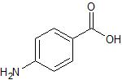 | 4.25 | C7 H7 N O2 | 137.0477
 | Methyl 2-furoate | 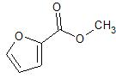 | 20.20 | C6 H6 O3 | 126.0317
 | Oleamide | 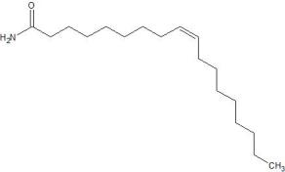 | 22.96 | C18 H35 N O | 281.2719
 | Hexadecanamide | 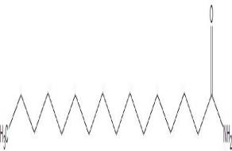 | 22.71 | C16 H33 N O | 255.2562
 | 14-(acetyloxy)-6 (furan-3-yl)-12 hydroxy 1,7,11,15,15 pentamethyl-5-oxo 3 oxapentacycl | 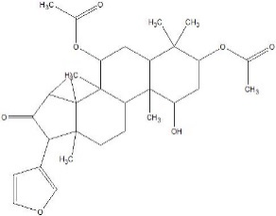 | 21.43 | C30 H40 O8 | 528.2723
 | NP-020273 | 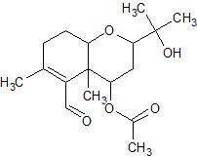 | 17.25 | C17 H26 O5 | 310.1780
 | NP-004713 | 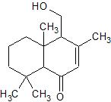 | 19.31 | C15 H24 O2 | 236.1776
 | NP-020521 | 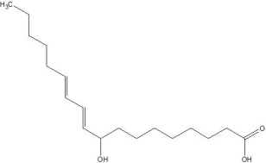 | 21.94 | C18 H32 O3 | 296.2351
 | Biotin | 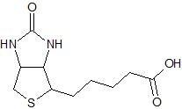 | 8.84 | C10 H16 N2 O3 S | 244.0882
 | DL-Tryptophan | 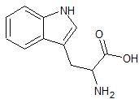 | 21.25 | C11 H12 N2 O2 | 204.0899
 | 9-Oxo-ODE | 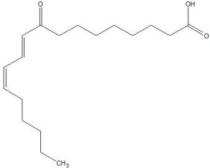 | 24.25 | C18 H30 O3 | 294.2195
 | Spectinomycin | 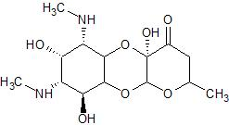 | 25.25 | C14 H24 N2 O7 | 332.1584
 | Nootkatone | 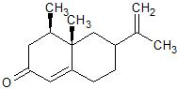 | 12.54 | C15 H22 O | 218.1671
 | Methylhippuric acid | 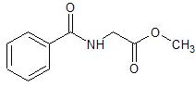 | 10.10 | C10 H11 N O3 | 193.0739
 | Octyl hydrogen phthalate | 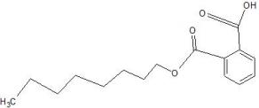 | 20.03 | C16 H22 O4 | 278.1518
 | (±)13-HpODE | 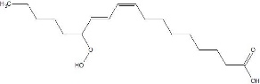 | 19.49 | C18 H32 O4 | 312.2301
 | Luotonin A | 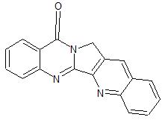 | 1.79 | C18 H11 N3 O | 285.0902
 | NP-008095 | 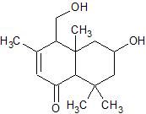 | 12.35 | C15 H24 O3 | 252.1725
 | L-Tyrosine | 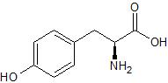 | 15.32 | C9 H11 N O3 | 181.0739
 | Perillartine | 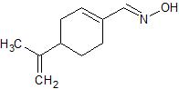 | 8.69 | C10 H15 N O | 165.1154
 | 12-oxo Phytodienoic Acid | 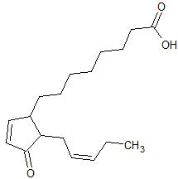 | 18.56 | C18 H28 O3 | 292.2038
 | N-(2,4 Dimethylphenyl) formamide | 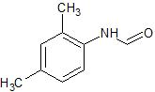 | 1.33 | C9 H11 N O | 149.0841
 | Laudanosine | 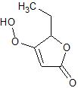 | 12.32 | C21 H27 N O4 | 357.1940
 | NP-005289 | 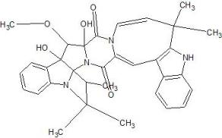 | 21.78 | C33 H34 N4 O5 | 566.2529
 | NP-014517 | 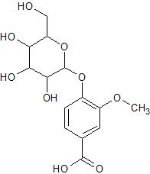 | 11.34 | C14 H18 O9 | 330.0951
 | Nicotinamide | 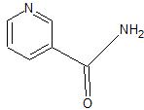 | 1.74 | C6 H6 N2 O | 122.0480
 | 3-Succinoylpyridine | 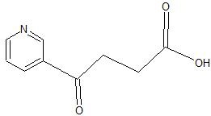 | 1.75 | C9 H9 N O3 | 179.0582
 | Mono(2-ethylhexyl) phthalate (MEHP) | 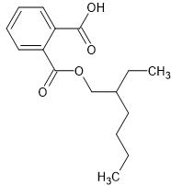 | 12.25 | C16 H22 O4 | 278.1518
 | 4-(beta-D Glucopyranosyloxy)-2 methylenebutanoic acid | 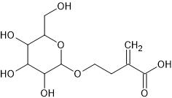 | 14.25 | C11 H18 O8 | 278.1002
 | 13(S)-HOTrE | 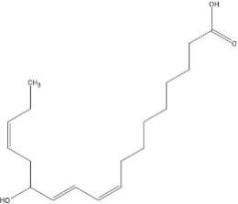 | 12.35 | C18 H30 O3 | 294.2195
 | N-(2 hydroxyphenyl) acetamide | 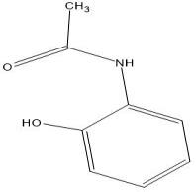 | 9.77 | C8 H9 N O2 | 151.0633
 | Palmitic Acid | 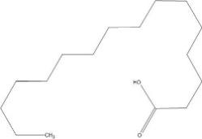 | 15.96 | C16 H32 O2 | 256.2402
 | 13(S)-HOTrE | 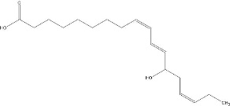 | 12.25 | C18 H30 O3 | 294.2195
 | 5-Aminovaleric acid | 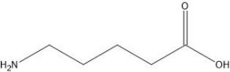 | 14.25 | C5 H11 N O2 | 117.0790
 | Valine | 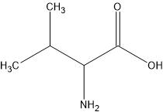 | 14.35 | C5 H11 N O2 | 117.0790
 | L-Pyroglutamic acid | 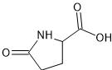 | 1.75 | C5 H7 N O3 | 129.0426
 | 3-Hydroxypicolinic acid | 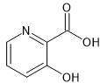 | 10.25 | C6 H5 N O3 | 139.0269
 | NP-013538 | 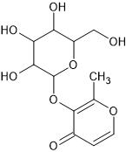 | 7.95 | C12 H16 O8 | 288.0845
 | Adenine | 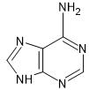 | 1.73 | C5 H5 N5 | 135.0545
 | 19-Nortestosterone | 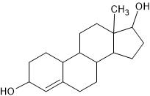 | 10.25 | C18 H26 O2 | 274.1933
 | NP-002322 | 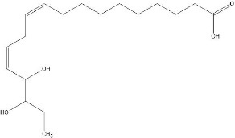 | 24.25 | C18 H32 O4 | 312.2301
 | KLK | 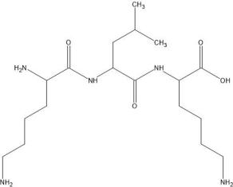 | 22.24 | C18 H37 N5 O4 | 387.2846
 | Nicotinic acid | 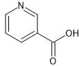 | 20.24 | C6 H5 N O2 | 123.0320
 | NP-010770 | 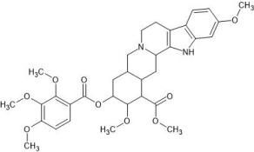 | 20.33 | C33 H40 N2 O9 | 608.2734
 | NP-021018 | 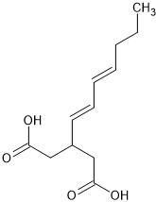 | 16.41 | C12 H18 O4 | 226.1205
 | Stearoyl Ethanolamide | 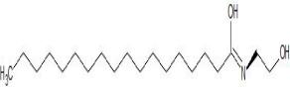 | 24.42 | C20 H41 N O2 | 327.3137
 | 2-(3,4 dihydroxyphenyl) acetamide | 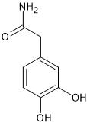 | 22.35 | C8 H9 N O3 | 167.0582
 | Guvacoline | 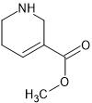 | 3.31 | C7 H11 N O2 | 141.0790
 | Xanthohumol | 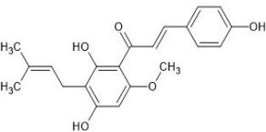 | 16.10 | C21 H22 O5 | 354.1467
 | tetranor-12(R)-HETE | 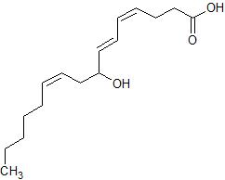 | 16.25 | C16 H26 O3 | 266.1882
 | 6-Hydroxynicotinic acid | 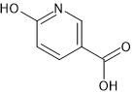 | 14.25 | C6 H5 N O3 | 139.0269
 | Tetranor-12(S) HETE | 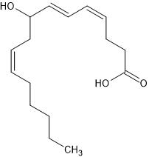 | 15.38 | C16 H26 O3 | 266.1882
 | NP-020403 | 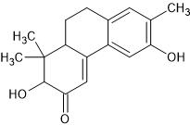 | 15.35 | C17 H20 O3 | 272.1412
 | NP-004036 | 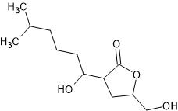 | 14.25 | C12 H22 O4 | 230.1518
 | NP-020020 | 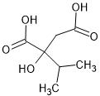 | 15.35 | C7 H12 O5 | 176.0685
 | Sphingosine (d18:1) | 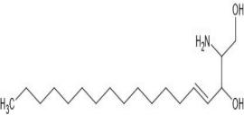 | 15.35 | C18 H37 N O2 | 299.2824
 | NP-022454 | 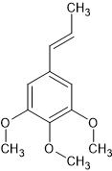 | 15.25 | C12 H16 O3 | 208.1099
 | Thromboxane B1 | 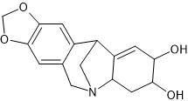 | 26.35 | C20 H36 O6 | 372.2512
 | Noroxymorphone | 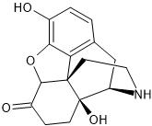 | 18.35 | C16 H17 N O4 | 287.1158
 | Coumarin | 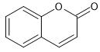 | 10.35 | C9 H6 O2 | 146.0368
 | 2-Hydroxycinnamic acid | 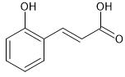 | 10.25 | C9 H8 O3 | 164.0473
 | Syringic acid | 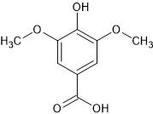 | 12.35 | C9 H10 O5 | 198.0528
 | 2-acetamido-3-(4 methoxyphenyl) propanoic acid | 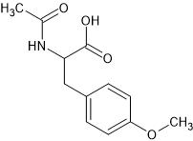 | 12.25 | C12 H15 N O4 | 237.1001
 | 2-Arachidonoyl glycerol | 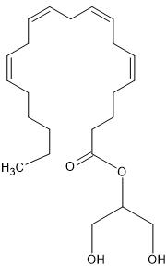 | 15.01 | C23 H38 O4 | 378.2770
 | Palmitoleic Acid | 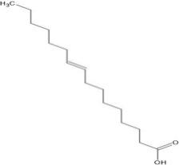 | 15.36 | C16 H30 O2 | 254.2246
 | Isovanillic acid | 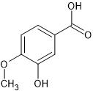 | 11.25 | C8 H8 O4 | 168.0423
 | 4 oxododecanedioic acid | 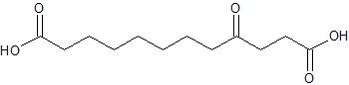 | 15.36 | C12 H20 O5 | 244.1311
 | 6-Gingerol | 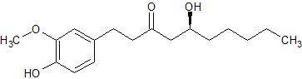 | 17.25 | C17 H26 O4 | 294.1831

Appendix C: Bioactive compounds identified in the Glacial acetic acid extract of Tragia plukentii by OHRLC-MS analysis ((negative ionization mode)

Sr No | Name of Phytoconstituent | Structure | Retention Time (RT) | Molecular Formula | Molecular Weight
1 | NP-009092 | 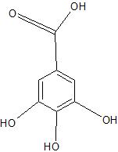  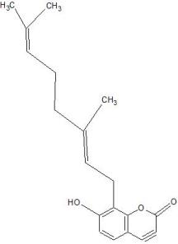 | 17.513 | C19 H22 O3 | 298.1569
2 | Gallic acid |  | 2.18 | C7 H6 O5 | 170.0215
3 | D-(-)-Quinic acid | 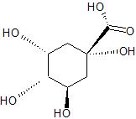 | 1.27 | C7 H12 O6 | 192.0634
4 | NP-012534 | 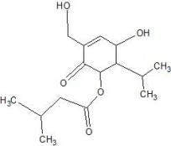 | 17.66 | C15 H24 O5 | 284.1624
5 | NP-006255 | 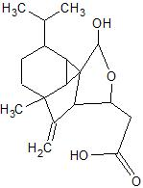 | 19.73 | C17 H26 O4 | 294.1831
6 | NP-021701 | 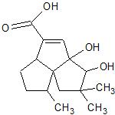 | 12.52 | C15 H22 O4 | 266.1518
7 | D-Mannitol 1 phosphate | 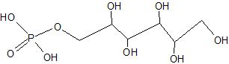 | 11.64 | C6 H15 O9P | 262.0454
8 | N-Acetylaspartic acid | 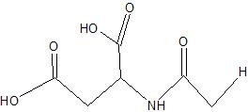 | 14.25 | C6 H9 N O5 | 175.0481
9 | NP-014334 | 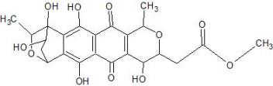 | 14.35 | C23 H24 O11 | 476.1319
10 | Aflatoxin G1 | 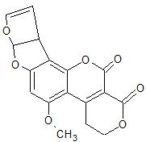 | 11.25 | C17 H12 O7 | 328.0583
11 | Carminic acid | 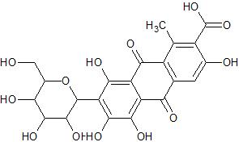 | 13.25 | C22 H20 O13 | 492.0904
12 | 13,14-dihydro 19(R)-hydroxy Prostaglandin E1 | 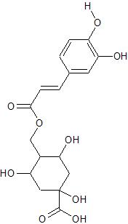 | 15.25 | C20 H36 O6 | 372.2512
13 | Rutin | 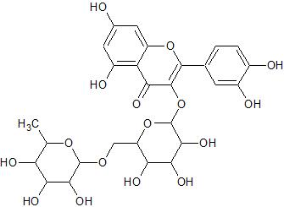 | 9.94 | C27 H30 O16 | 610.1534
14 | Phloroglucinol | 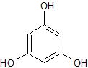 | 11.35 | C6 H6 O3 | 126.0317
15 | Quercetin-3β-D glucoside |  | 15.12 | C21 H20 O12 | 464.0955
16 | NP-004596 | 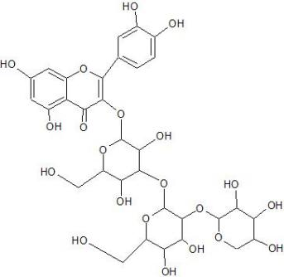 | 12.25 | C32 H38 O21 | 758.1906
17 | NP-021293 | 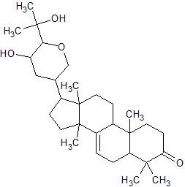 | 15.25 | C30 H48 O4 | 472.3553
18 | NP-015929 | 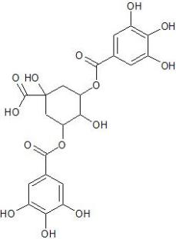 | 15.25 | C21 H20 O14 | 496.0853
19 | Epigallocatechin gallate | 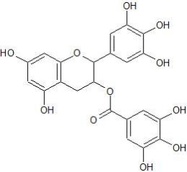 | 15.25 | C22 H18 O11 | 458.0849
20 | [phenyl]oxan-3-yl 3,4,5 trihydroxybenzoate Oleoyl Ethanolamide |  | 17.25 | C20 H39 N O2 | 325.2981
21 | NP-018609 | 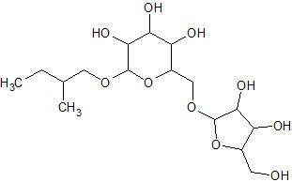 | 12.25 | C16 H30 O10 | 382.1839
22 | 13,14-dihydro Prostaglandin E1 | 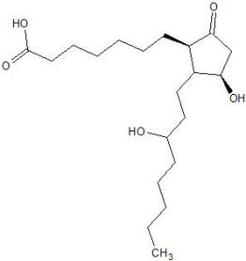 | 15.35 | C20 H36 O5 | 356.2563
23 | NP-004400 | 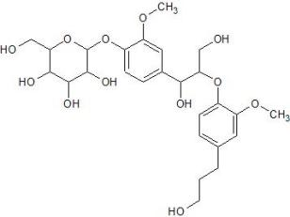 | 14.35 | C26 H36 O12 | 540.2207
24 | Esculin | 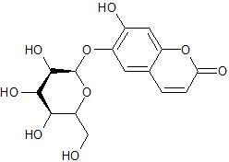 | 12.35 | C15 H16 O9 | 340.0794
25 | NP-020236 | 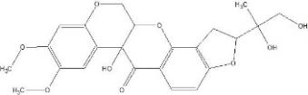 | 12.35 | C23 H24 O9 | 444.1420
26 | NP-004022 | 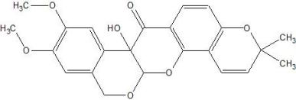 | 14.25 | C23 H22 O7 | 410.1366
27 | NP-005128 | 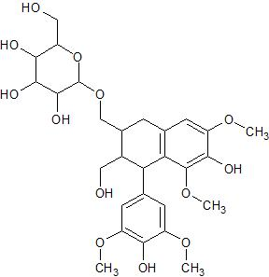 | 15.35 | C28 H38 O13 | 582.2312
28 | 8-iso Prostaglandin F2? Ethanolamide | 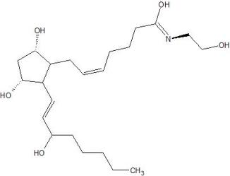 | 7.35 | C22 H39 N O5 | 397.2828
29 | NP-007735 | 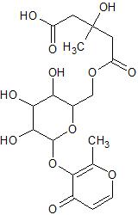 | 18.25 | C18 H24 O12 | 432.1268

Appendix D: Plant authentication certificate of Tragia plukentii

