THE EFFECT OF MICROPLASTICS ON MICROBIAL SUCCESSION AT IMPAIRED AND UNIMPAIRED SITES IN A RIVERINE SYSTEM

Anne L. Gilewski, MS, LVT^{1,2}, Saurav Shrestha, MS¹ Nikolas Stasulli, Ph.D¹, Sharon N. Kahara, Ph.D¹
¹Department of Biology and Environmental Science, University of New Haven, 300 Boston Post Road, West Haven, Connecticut 06516

Current Address: University of Connecticut, Department of Marine Sciences, 1080 Shennecossett Road, Groton, Connecticut 06340

Corresponding author: Anne L. Gilewski, anne.gilewski@uconn.edu

SUPPLEMENTAL MATERIALS
Table S1: Number of basecall pass and fail reads generated per pool on the MinION M1kc sequencing unit
 | Flow Cell ID | Reads Generated (M) | Basescall_Pass (Gb) | Basescall_Fail (Gb)
Pool1 | FAX22584 | 5.76 | 6.64 | 2.01
Pool2 | FAX22978 | 4.75 | 5.37 | 1.55
Pool3 | FAX22448 | 4.59 | 5.53 | 1.31
Pool4 | FAX22533 | 5.05 | 5.85 | 1.67
Pool5 | FAX22974 | 5.53 | 6.39 | 1.84
Pool6 | FAO62963 | 3.14 | 2.69 | 1.86
Pool7 | FAX78128 | 5.77 | 6.68 | 1.77

Table S2: MetONTIIME pipeline analysis parameters
Max Num Reads/Sample | 15000
Min Read Length (bp) | 1000
Max Read Length (bp) | 2000
Min Ave. PHRED Score | 10
Num Bases Trimmed (each end) | 20
Identify for de novo Clustering | 0.9
Max number candidate hits | 2
Min Consensus | 0.7
Min Alignment Identity | 0.8
Taxonomic Level | 6
Max Num Reads for Diversity Analysis | 15000

Table S3: Average water quality measurements for impaired (HP) and unimpaired (QR) sites at D30, D60, and D90 harvest points. *Probable phosphate spike from a poorly-mixed eddy
Date | Date | Site | DO (%) | DO (mg/L) | Sal (ppt) | Temp(C) | pH | NO₃(ppm) | PO₄(ppm)
6/22/23 | D30 | QR | 94.0 | 7.6 | 0.2 | 17.1 | 6.7 | 2.44 | 0.66
7/20/23 | D60 | QR | 85.8 | 6.3 | 0.1 | 21.4 | 7.2 | 1.76 | 0.66
8/17/23 | D90 | QR | 91.0 | 6.9 | 0.2 | 20.1 | 6.7 | 1.72 | 0.33
6/22/23 | D30 | HP | 102.7 | 8.3 | 0.2 | 16.8 | 6.6 | 1.65 | 0.54
7/20/23 | D60 | HP | 98.5 | 7.3 | 0.1 | 21.3 | 6.6 | 1.80 | >4.0*
8/17/23 | D90 | HP | 99.0 | 7.5 | 0.2 | 20.0 | 6.6 | 1.84 | 0.48

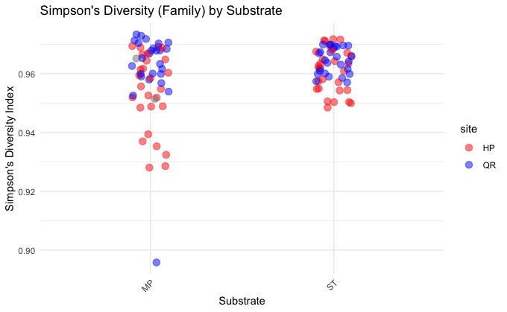
Figure S1: Standard Simpson’s Diversity Index for taxonomic level family for substrate compared to site. HP=unimpaired, QR=impaired, MP=microplastic, ST=stone

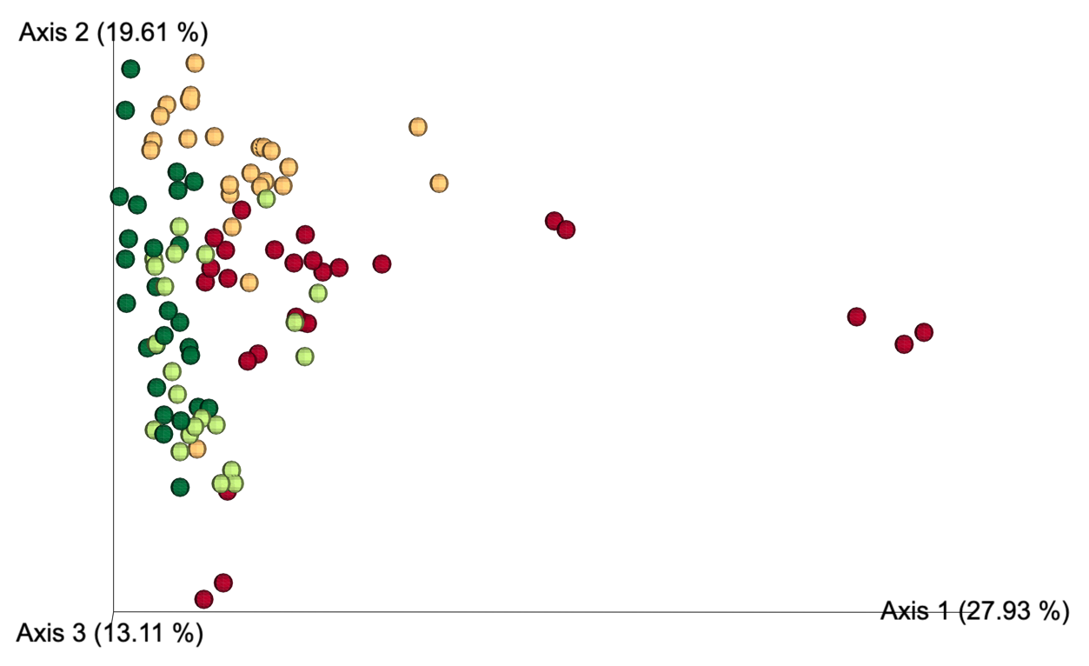
Figure S2: Bray-Curtis dissimilarity plot for family taxonomic level for site/substrate.
Green=impaired/stone, Lime=impaired/microplastic; Peach=unimpaired/stone, Red=unimpaired/microplastic

Table S4: Results of Generalized Linear Modelling and Likelihood Ratio Test with Site (QR/HP), Substrate (MP/ST), and Site/Substrate Combined against the Null. K=number of parameters, n=number of samples. *** = p<0.001, + = best fit
GLM Model | K | n | AIC | ΔAIC | ChiSq | p-value
Total-Site/Sub | 2 | 80 | 1868000⁺ | - | 347685⁺ | 2.2e-16***
Total-Site | 1 | 80 | 1953000 | 85000 | 262145 | 2.2e-16***
Total-Substrate | 1 | 80 | 2130000 | 262000 | 85540 | 2.2e-16***
E.coli-Substrate | 1 | 80 | 297700⁺ | - | 26192 | 2.2e-16***
E.coli-Site | 1 | 80 | 305300 | 7600 | 18617 | 2.2e-16***
E.coli-Site/Sub | 2 | 80 | 1500000 | 1202300 | 44809⁺ | 2.2e-16***
Non-E.coli Coliform-Site/Sub | 2 | 80 | 1500000⁺ | - | 826851⁺ | 2.2e-16***
Non-E.coli Coliform-Site | 1 | 80 | 1670000 | 170000 | 656866 | 2.2e-16***
Non-E.coli Coliform-Substrate | 1 | 80 | 2156000 | 656000 | 169985 | 2.2e-16***

Table S5: Confidence Intervals for the Site + Substrate GLM for total, non-E. coli
and coliform counts
GLM Model-Site + Substrate | 2.5% | 97.5%
Total-(Intercept) | 10.56 | 10.56
Total-Site QR | 0.54 | 0.55
Total-Substrate ST | -0.31 | -0.31
E.coli-(Intercept) | 9.84 | 9.85
E.coli-Site QR | 1.12 | 1.12
E.coli-Substrate ST | -0.54 | -0.54
Non-E.coli-(Intercept) | 5.62 | 5.66
Non-E.coli-Site QR | -1.42 | -1.37
Non-E.coli-Substrate ST | 1.73 | 1.78

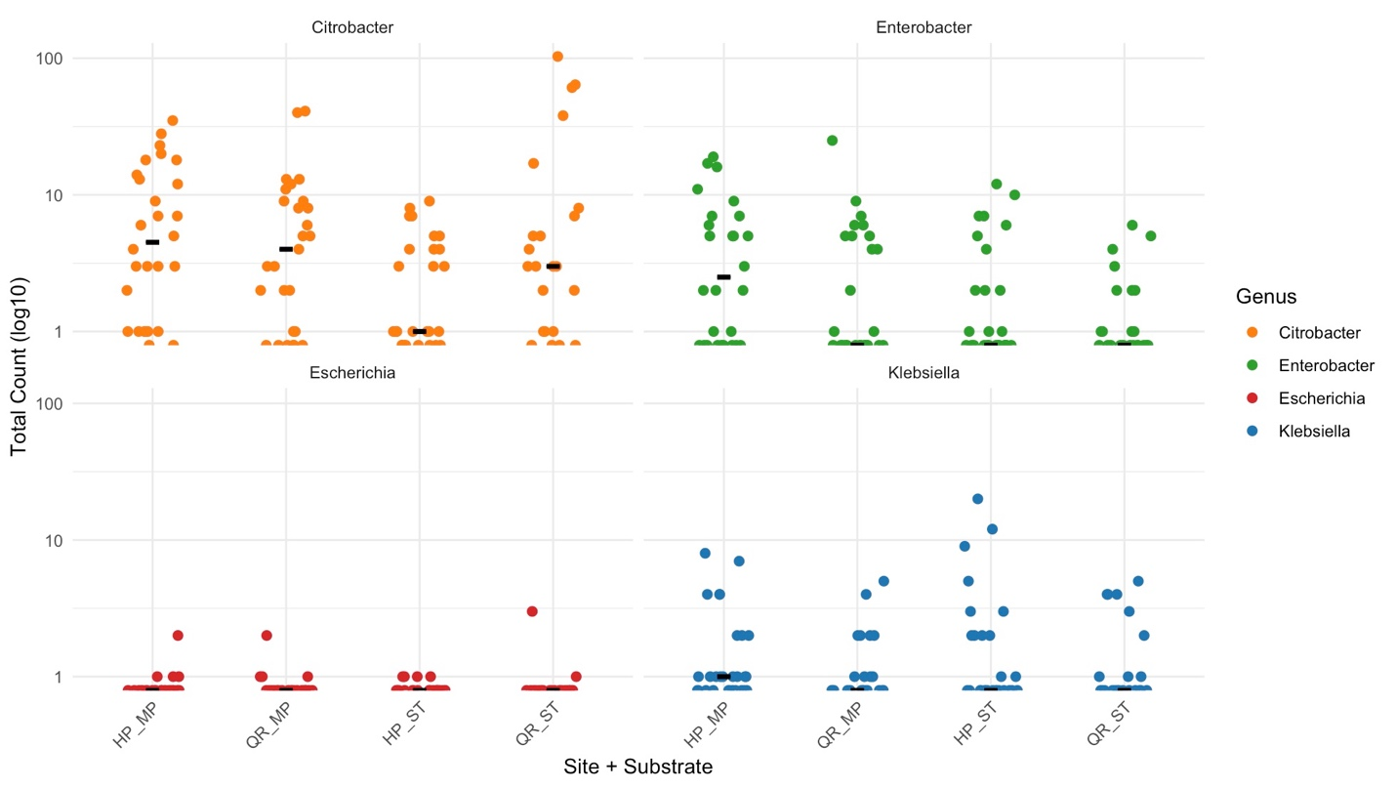

Figure S3: Representative abundances (log10) of the common human pathogenic organisms from genera Enterobacteriaceae on microplastic (MP) and stone (ST) substrate at D90. n=40

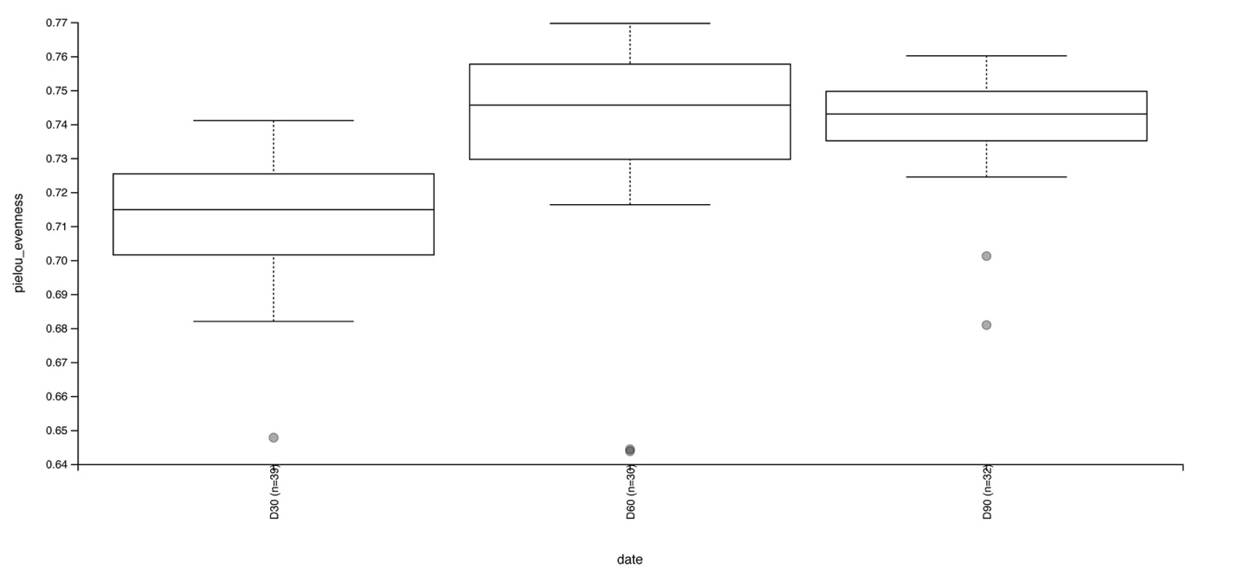
Figure S4: Pielou’s evenness index for family taxonomic level for sample collection date

