Supplementary File

Article: HOW TO COMBINE MULTIPLE TOOLS FOR THE GENETIC DIAGNOSIS WORK-UP OF B-CELL ACUTE LYMPHOBLASTIC LEUKAEMIA: A SINGLE CENTER EXPERIENCE

Gloria Hidalgo-Gómez¹⁻², Bárbara Tazón-Vega¹, Carlos Palacio¹, Silvia Saumell¹, Noemi Martínez-Morgado¹, Víctor Navarro³, Laura Murillo⁴, Pablo Velasco⁴, Thais Murciano⁴, Cristina Díaz de Heredia⁴, Gemma Armengol², Margarita Ortega¹

Author affiliations:
¹Hematology Service, Vall d’Hebron Hospital Universitari, Experimental Hematology, Vall d’Hebron Institute of Oncology (VHIO), Hospital Universitari Vall d'Hebron, Vall d’Hebron Barcelona Hospital Campus, Passeig Vall d'Hebron 119-129, 08035 Barcelona, Spain.
²Unit of Biological Anthropology, Department of Animal Biology, Plant Biology, and Ecology, Faculty of Biosciences, Universitat Autònoma de Barcelona, 08193 Barcelona, Catalonia, Spain.
³Oncology Data Science (ODysSey) Group, Vall d’Hebron Institute of Oncology (VHIO), Vall d’Hebron Barcelona Hospital Campus, Passeig Vall d'Hebron 119-129, 08035 Barcelona, Spain.
⁴Pediatric Oncology and Hematology Department, Hospital Universitari Vall d'Hebron, Vall d’Hebron Barcelona Hospital Campus, Passeig Vall d'Hebron 119-129, 08035 Barcelona, Spain.

Corresponding author:
Margarita Ortega
Vall d’Hebron Hospital Universitari
Hematology Service
Passeig Vall d'Hebron 119-129, 08035 Barcelona, Spain
Tel: +34 93 274 6205
Email: margarita.ortega@vallhebron.cat

Table of contents of supplementary patients and methods

Morphology and immunophenotype 3
Cytogenetic analysis 3
MLPA analysis 3
Targeted next generation sequencing (t-NGS) 4
Optical Genome Mapping 4
Stratification risk of SEHOP-PETHEMA 2013 treatment guidelines 4
Statistical methods 5
Data availability statement 5

List of supplementary tables
Table S1. Results of karyotype and FISH analyses of our paediatric B-ALL cohort. 6

List of supplementary figures
Figure S1. Bar chart and table showing the frequency and co-occurrence of copy number alterations (CNA) of the genes studied by P335 MLPA our paediatric B-ALL cohort 10

Figure S2. Outcomes according to SEHOP-PETHEMA 2013 Protocol risk classification for our paediatric B-ALL cohort. 11

Figure S3. Outcomes according to the genetic defining subtype for our paediatric B-ALL cohort 12

Figure S4. Outcomes according to the genetic risk classification plus the information of CNA profile for our paediatric B-ALL cohort 13

References for supplementary information

Morphology and immunophenotype
Bone marrow (BM) aspirate smears were stained with May–Grünwald–Giemsa according to standard laboratory protocols for cytochemical stains, including myeloperoxidase and Periodic Acid-Schiff (PAS). The diagnosis of ALL was based on the morphologic features of the cells, namely the presence of more than 20% cells showing lymphoblast morphology.
Immunophenotyping was performed by flow cytometry on BM samples according to standardized procedures. Antibodies used included anti-CD45, CD34, CD123, CD10, CD19, CD20, CD22, CD9, CD24, CD25, CD38, CD73, CD15, NG2, CD66c (KORSA), CD33, CD13, cit IgM, citMPO, nucTdT and citCD3 (from Beckman Coulter, CA, USA), CD304 (from Mitenyi Biotec, Germany).

Cytogenetic analysis
G-banded chromosomal analyses were performed on BM samples using standard techniques. Karyotypes were described according to the International System for Cytogenetic Nomenclature (ISCN 2020)[1].
Fluorescent in situ hybridization (FISH) assay was carried out on interphase nuclei using commercial probes for BCR::ABL1, KMT2A, ETV6::RUNX1, TCF3, CRLF2, ABL1, ABL2, PDGFRB, JAK2, IGH (MetaSystems Probes, Germany), EPOR, MEF2D, ZNF384 and PAX5 (Empire Genomics, NY, USA), according to the manufacturer’s protocol.

MLPA analysis
MLPA reactions were performed using the SALSA MLPA probemix P335 ALL-IKZF1 and P327 iAMP21-ERG (MRC-Holland, Amsterdam, Netherlands) according to the manufacturer’s instructions. DNA samples from three healthy donors served as controls. For MLPA studies, a minimum infiltration of ≥30% blasts in bone marrow and high-quality DNA was required. The P335 probemix contains probes for IKZF1, CDKN2A/B, PAX5, EBF1, ETV6, BTG1, RB1, as well as genes from the X/Y PAR1 region (CRLF2, CSF2RA, IL3RA and P2RY8). The P327 probemix contains probes for RUNX1 and ERG genes. MLPA amplification products were analysed on an ABI 3130XL Genetic Analyzer (Applied Biosystems), using the Genescan 500LIZ internal size standard (Applied Biosystems). MLPA analysis was performed on the Coffalyser.NET Software (MCR-Holland). CNA were deﬁned, following Schwab et al.[2], as: biallelic deletion (<0.25), monoallelic deletion (≥0.25 to <0.75), normal (≥0.75 to <1.3) and gain/ampliﬁcation (≥1.3).

Targeted next generation sequencing (t-NGS)
t-NGS was performed using Oncomine Childhood Cancer Research Assay (ThermoFisher Scientific, Life Technologies Corporation, CA, USA), which includes 203 genes involved in childhood cancer and allows the analysis of point mutations and fusions. Libraries were automatically prepared using the Ion Chef and sequenced on the S5 sequencer (ThermoFisher Scientific, Life Technologies Corporation, CA, USA), with an average coverage of 2500x. Variant alignment and detection were performed in Ion Reporter with the human reference genome (hg19). Variants with >1% allelic frequency were considered and manually reviewed with the Integrated Genome Viewer and classified according to the VARSOME23 software. Fusions were considered when transcript levels were >0.1%. Data from the literature and the Catalogue Of Somatic Mutations In Cancer (COSMIC) database were used for the interpretation of the somatic nature of the fusions and mutant calls. Single-nucleotide polymorphisms (SNPs) listed in the SNP database (dbSNP) and the Genome 10K Project were excluded.

Optical Genome Mapping
Optical Genome Mapping (OGM) requires ultra‐high molecular weight (UHMW) DNA. It was extracted from ~1.5x10⁶ cryopreserved cells (from bone marrow or peripheral blood) according to the manufacturer's instructions (Bionano Genomics, San Diego, USA). DNA was labeled using a sequence‐specific DLE‐1 (Direct Labeling Enzyme), that attaches a green fluorophore to a specific 6bp sequence, present around 15 times per 100 kb in the human genome. The labeled DNA was loaded onto a Saphyr chip and scanned on the Saphyr instrument (Bionano Genomics, San Diego, USA). Changes in the patterning or spacing of the labels were identified by software solutions to accurately detect all classes of SVs. For each sample, an effective genome coverage of about 300x is achieved, with a theoretical mean variant allele frequency sensitivity of 5%.

Stratification risk of SEHOP-PETHEMA 2013 treatment guidelines
This protocol incorporates risk-adapted treatment regimens based on factors such as age, white blood cell count (WBC), extramedullary infiltration (specifically CNS or testes involvement), immunophenotype, minimal residual disease (MRD), and cytogenetics.
For standard-risk group, patient must meet all of the following criteria: age >1 and <10 years, leukocytes <20x10⁹/L at diagnosis, non-T immunophenotype, absence of CNS and/or testicular infiltration, cytogenetics with high hyperdiploidy (51-67 chromosomes) and ETV6::RUNX1 positive, and not presenting t(1;19) or KMT2A rearrangement. Additionally, they must have <1,000 blasts/mm³ in peripheral blood on day +8 of induction, <5% blasts and <0.1% MRD in bone marrow on day +15 of induction and at the end of induction I’A.
The existence of any of the following criteria determines inclusion in the high-risk group: t(4;11)/KMT2A::AFF1, hypodiploidy (<44 chromosomes or DNA index <0.81), presence of >1,000 blasts/mm³ in peripheral blood on day +8 of Induction, > 25% blasts and > 10% MRD in bone marrow on day +15 of induction, MRD > 1% on day +33 of induction or MRD >0.1% before consolidation in bone marrow.
Those patients who do not meet the standard-risk or high-risk criteria will be included in the intermediate-risk group.

Statistical methods
Overall survival (OS) was defined as time to death, censoring at date of last contact. Event-free survival (EFS) was defined as time from randomization to relapse, second tumour or death, censoring at date of last contact. All survival rates are quoted at 5 years. Kaplan-Meier methods were used to estimate survival rates. Other comparisons were performed using chi-square, Fisher’s exact, and Mann–Whitney tests, as appropriate.

Data availability statement
Due to concerns regarding patient privacy, the datasets employed in this study are not accessible to the public; however, upon reasonable request to the corresponding, they may be made accessible. Please contact Gloria Hidalgo (gloria.hidalgo@vallhebron.cat) and Margarita Ortega (margarita.ortega@vallhebron.cat).

Table S1. Results of karyotype and FISH analyses of our paediatric B-ALL cohort.
ID | Genetic Subtype | Karyotype | FISH
ID_001 | Hypodiploid; Low-Hypodiplody | 39,XX,-3,-7,-13,-15,-16,-17,-20[18]/46,XX[2] | No alterations
ID_002 | B-other; B-rest | 47,XY,+Y[12]/49,idem,+X,t(7;19)(p15;q13),+21[4] | No alterations
ID_003 | ETV6::RUNX1 | 46,XX,add(12)(p13)[14]/48,XX,idem,+13,+14[2]/46,XX[6] | ETV6::RUNX1r
ID_005 | HeH | 56,XX,+X,+4,+6,+10,+16,+17,+18,+21,+21,+22[3]/46,XX[17] | SHeH
ID_007 | B-other; PAX5alt | 45,XY,-7,der(9)del(9)(p12pter)t(7;9)(q11;p12)[19]/46,XY[1] | No alterations
ID_009 | BCR::ABL1-Like; PDGFRBr | 48-49,XY,t(5;21)(q35;q21.2),+der(5)t(5;21)(q35;21.2),+mar1[2],+mar2[3][cp25]/46,XY[14] | PDGFRBr
ID_010 | HeH | 62,XX,+X,+4,+5,+6,+8,+8,+9,+10,add(14)(q32),+15,+17,+18,+18,+21,+21,+mar[16] | SHeH
ID_011 | ETV6::RUNX1 | 47,XY+21[13]/46,XY[7] | ETV6::RUNX1r
ID_012 | B-other; ZNF384r | 45,XX,del(12)(p12),-17[12] | ZNF384r
ID_013 | HeH | 60,XY,+X,dup(1)(q21q32),+4,+5,+6,+7,+8,+10,+12,+14,+17,+18, add(19)(p13),+21,+21,+22[17]/46,XY[3] | SHeH
ID_014 | iAMP21 | 46,X,der(Y),iamp(21)[12]/46,idem,del(3)(p11)[6]/46,XY[6] | RUNX1amp; CRLF2r
ID_016 | B-other; B-rest | 46,XX[20] | No alterations *
ID_017 | ETV6::RUNX1 | 46,XY[7] | ETV6::RUNX1r
ID_018 | B-other; B-rest | 46,XX[20] | NA
ID_019 | B-other; ZNF384r | 46,XX,del(6)(q13q25)[8]/46,XX,del(6)(q13q25),del(9) (q22q33)[3]/46,XX,del(6)(q13q25),del(16)(q22q24)[6]/46,XX[1] | No alterations
ID_020 | ETV6::RUNX1 | 56,XX,+X,+4,+5,+8,+9,+14,+15,+17,+21,+21[17]/46,XX[3] | ETV6::RUNX1r
ID_021 | B-other; B-rest | 46,XY,del(9)(p21p24)[19]/46,XY[4] | No alterations
ID_025 | HeH | 55,XX,+X,+4,+5,+8,+14,+17,+18,+21,+22[4]/46,XX[1] | SHeH
ID_026 | BCR::ABL1 | 46,XY,t(2;10)(p11;q24),t(9;22)(q34;q11.2)[15]/46,XY[5] | BCR::ABL1r
ID_027 | KMT2Ar; KMT2A::MLLT3 | 46,XY,t(9;11)(p21;q23)[5]/47,idem,+5[3]/48,idem,+5,+21[2]/46,XY,der(9)del(9)(q22q32)t(9;11)(p21;q23)[2]/47,XY,+5,der(9)del(9)(q22q32)t(9;11)(p21;q23)[2]/48,XY,+5,der(9)del(9)(q22q32)t(9;11)(p21;q23),+21[4]/46,XY[3] | KMT2Ar
ID_028 | KMT2Ar; KMT2A::AFF1 | 46,XY,t(4;11;12)(q21;q23;q22)[20] | KMT2Ar
ID_029 | ETV6::RUNX1 | 47,XY,+21[8]/48,XY,+10,+21[5]/47,XY,del(6)(q25),add(7)(q36),+10,-18,+21[3]/46,XY[9] | ETV6::RUNX1r
ID_030 | ETV6::RUNX1 | 89,XXYY,-1,iso(3)(p10),del(6)(q22),-8,del(12)(p12),-13,-17,+21[4]/46,XY[16] | ETV6::RUNX1r
ID_031 | HeH | 56,XY,+X,+4,+6,+8,+10,+14,+17,+18,+21,+21[20] | No alterations
ID_032 | ETV6::RUNX1 | 46,XX,t(3;12;21)?(q25;p13)[20] | ETV6::RUNX1r
ID_033 | iAMP21 | 46,XX,der(21)[3]/46,XX[7] | RUNX1amp
ID_034 | BCR::ABL1-Like; CRLF2r | 45,XY,-7,del(9)(p13pter),der(12)t(7;12)(q11.2;p11.2)[20] | CRLF2r
ID_035 | BCR::ABL1-Like; CRLF2r | 45,XX,-20[8]/46,XX[12] | CRLF2r
ID_036 | Hypodiploid; Near-Haploidy | 27,XX,-1,-2,-3,-4,-5,del(6)(q21q25),-7,-8,-9,-10,-11,-12,-13,-14,-15,-16,-17,-17,-19,-20,-22,+mar[5]/46,XX[15] | No alterations
ID_037 | B-other; B-rest | No mitosis | No alterations
ID_038 | HeH | 57,XX,+X,dup(1)(q21q25),+4,+6,+10,del(12)(p11),+14,+17,+18,+21,+21,+mar[9]/46,XX[11] | SHeH
ID_040 | ETV6::RUNX1 | 46,XY,del(11)(q22)[8]/46,XY[12] | ETV6::RUNX1r
ID_041 | ETV6::RUNX1 | 46,XX,del(12)(p12)[20] | ETV6::RUNX1r
ID_043 | HeH | 55,XX,+4,+6,+8,+10,+14,+17,+18,+18,+21[17]/46,XX[3] | SHeH
ID_044 | B-other; B-rest | 46,XY[20] | No alterations
ID_046 | iAMP21 | 45,XY,-12,der(13;15)(q10;q10),der(21)[5]/46,XY[15] | RUNX1amp
ID_047 | HeH | 64,XX,+X,+X,+3,+4,+5,+6,+8,+8,+10,+11,+12,+14,+14,+17,+18,+21,+21,+22[16]/46,XX[6] | SHeH
ID_050 | B-other; B-rest | 46,XX,i(5)(q10)[9]/46,XX[11] | No alterations
ID_052 | KMT2Ar; KMT2A::MLLT3 | 46,XX,t(9;11)(p22;q23)[20] | KMT2Ar
ID_053 | ETV6::RUNX1 | 46,XX,del(12)(p12)[7]/46,XX[13] | ETV6::RUNX1r
ID_054 | BCR::ABL1-Like; CRLF2r | 46-48XY, del(5)(p12),+8,-15,+1-2mar[20] | CRLF2r
ID_055 | B-other; ZNF384r | 46,XY,t(9;14)(p24;q12)[4]/46,XY[16] | No alterations
ID_056 | ETV6::RUNX1 | 46,XY,del(12)(p13)[8]/47,idem,+21[3]/46,XY[9] | ETV6::RUNX1r
ID_059 | ETV6::RUNX1 | 49,XY,+10,del(12)(p12),+21,+22[4]/46,XY[16] | ETV6::RUNX1r
ID_060 | B-other; B-rest | 46,XY,del(1)(p22p34),der(1)t(1;?)(p13;?),add(2)(p21),t(3;3)(p21;q29),dup(4)(q25q31),-8, add(18)(q23),add(22)(q13),+mar[18] | No alterations *
ID_061 | B-other; PAX5alt | 46,XY,dup(2)(q21q31),del(3)(q21),der(20)t(9;20)(p13;q13)[13]/46,XY[7] | PAX5r
ID_062 | B-other; ZNF384r | 46,XX,add(19)(p13)[4]/46,XX[26] | IGHr
ID_063 | HeH | 46,XY[20] | Hyperdiploid
ID_064 | HeH | No mitosis | Hyperdiploid
ID_065 | HeH | 46,XY[20] | Hyperdiploid
ID_067 | B-other; B-rest | 47,XX,add(3)(p25),-9,+10,der(16)t(9;16)(q13;q24),+22[13]/45,XX,idem,i(17)(q10)[3]/46,XX[4] | No alterations
ID_068 | B-other; B-rest | 46,XX,del(12)(p12)[6]/46,XX[6] | No alterations *
ID_069 | ETV6::RUNX1 | 46,XY,del(12)(p11),-20,+21[3]/46,idem,del(6)(q12)[9]/46,idem,+mar[5]/46,XY[3] | ETV6::RUNX1r
ID_071 | ETV6::RUNX1 | 46,XY[20] | ETV6::RUNX1r
ID_073 | B-other; B-rest | 46,XY,inv(2)(p11.2q13)[13]/46,XY[22] | No alterations *
ID_074 | BCR::ABL1-Like; CRLF2r | 48,XY,+X,+21c[7]/47,XY,+21c[13] | No alterations
ID_075 | ETV6::RUNX1 | 46,XX,del(3)(p21),del(6)(q21),del(11)(q23),add(12)(p13),add(16)(q22)[3]/46,idem,+10[1]/46,idem,+21,46,idem,add(9)(p24)[16]/46,idem,add(9),+21[1] | ETV6::RUNX1r
ID_076 | B-other; B-rest | 47,XY,del(9)(p21)x2,+21[cp4]/46,XY[cp6] | No alterations *
ID_078 | ETV6::RUNX1 | 50,X,-X,ins(1;1)(p36;q21-qter),+2,-4,add(6)(q25),+10,del(10)(q25),add(19)(q13.3),+21,+21,+mar1,+mar2[10]/46,XX[10] | ETV6::RUNX1r
ID_079 | HeH | 54,XX,+X,+4,+9,+10,+14,+17,+21,+21[15]/46,XX[5] | SHeH
ID_080 | ETV6::RUNX1 | No mitosis | ETV6::RUNX1r
ID_081 | BCR::ABL1-Like; CRLF2r | 46,XY[20] | No alterations
ID_082 | ETV6::RUNX1 | 47,XX,+21[3]/47,XX,del(12)(p12),+21[9]/46,XX[8] | ETV6::RUNX1r
ID_083 | HeH | 56,XY,+X,+4,+6,+8,+10,+14,+17,+18,+21,+21[7]/56,idem,dup(1)(q21qter)[12]/46,XY[2] | SHeH
ID_086 | ETV6::RUNX1 | 46,XY,del(12)(p11p12),der(21)[9]/46,XY[15] | ETV6::RUNX1r
ID_087 | BCR::ABL1-Like; CRLF2r | 50,XY,+X,+21,+21,i(21)(q10)x3,+mar[20] | CRLF2r
ID_088 | HeH | 52,XY,+X,+10,+17,+18,+21,+21[10]/46,XY[10] | SHeH
ID_089 | HeH | 62,XX,+2,+4,+5,+6,+9,+10,+10,+11,del(11)(q23),+14, +17,+19,+20,+21,+21,+mar1,+mar2[20] | SHeH
ID_091 | HeH | 55,XX,+X,+4,+6,+10,+17,+21,+21,+2mars[10] | SHeH
ID_093 | HeH | 54,XY,+X,dup(1)(q21q42),+4,+6,+10,+14,+17,+21,+21[13]/46,XY[7] | SHeH
ID_094 | TCF3::PBX1 | 46,XX,+1,der(1)t(1;12)(q10;p10),der(19)t(1;19)(q23; p13)[6]/46,XX[4] | TCF3::PBX1r
ID_095 | HeH | 57,XX,+X,dup(1)(q21q31),+3,+6,+8,+9,+10,+14,+17,+ 18,+21[13]/46,XX[7] | SHeH
ID_096 | iAMP21 | 47,XY,-13,+21+21,der(21),der(21)[11]/46,XY[9] | CRLF2r
ID_097 | HeH | 52,XY,+X,+4,+10,+14,+21,+21[3] | Hyperdiploid
ID_098 | B-other; PAX5 P80R | 45,XY,del(9)(p21),-20[15]/46,XY[5] | No alterations
ID_100 | TCF3::PBX1 | 49,XY,t(1;19)(q23;p13),add(1)(q42),dup(5)(q13q21),inv(6)(p21q26),+8,+8,+20[20] | TCF3::PBX1r
ID_101 | B-other; ZNF384r | 46,XY,del(6)(q21q25),del(12)(p11.2)[11]/46,XY[9] | ZNF384r
ID_102 | HeH | 54,X,+X,-Y,+6,+8,+10,+14,+17,+18,+21,+21[4]/46,XY[16] | SHeH
ID_103 | HeH | 56,XY,+X,+4,+6,+10,+14,+17,+18,+18,+21,+21[17]/46,XY[3] | SHeH
ID_104 | B-other; PAX5alt | 45,XY,t(2;4)(q33;q26),del(7)(q11.2),-8,der(8)t(8;9)(p21;q12),t(9;16)(q13;p11.2)[20] | PAX5r
ID_106 | B-other; B-rest | 53,XY,+X,+Y,+4,+6,-7,+10,+11,-13,+14,+21,+21[5]/53,XY,+Y,idem,add(16)(q24),+17[15] | No alterations
ID_107 | ETV6::RUNX1 | 46,XY[20] | ETV6::RUNX1r
ID_109 | HeH | NA | Hyperdiploid
ID_110 | BCR::ABL1-Like; CRLF2r | 47,XY,t(4;10)(q31;p11.2),+21c[7]/47,XY,+21c[13] | CRLF2r
ID_111 | ETV6::RUNX1 | 47,XY,+10,der(21)[8]/47,XY,+21,der(21)[8]/46,XY[4] | ETV6::RUNX1r
ID_112 | KMT2Ar; KMT2A::USP2 | 46,XX,der(16)t(1;16)(q23;q13)[9]/46,XX[11] | KMT2Ar
ID_114 | B-other; PAX5alt | No mitosis | No alterations
ID_115 | B-other; B-rest | 45,XX,-13,der(20)del(20)(q12)[20] | No alterations
ID_116 | HeH | 57,XY,+X,+4,+6,+7,+8,+10,+11,+14,+18,+21,+21[20] | SHeH
ID_117 | KMT2Ar; KMT2A::AFF1 | 46,XX,t(1;4)(p36;q12),t(4;11)(q21;q23)[14]/46,XX[6] | KMT2Ar
ID_118 | ETV6::RUNX1 | 45,X,-X,t(10;12)(q22;p13)[11]/45,idem,del(6)(q24)[5]/88,idem[6] | ETV6::RUNX1r
ID_119 | HeH | 55,XX,+X,+4,+8,+10,+14,+17,+18,+21,+21[1]/46,XX[19] | SHeH
ID_120 | B-other; B-rest | No mitosis | No alterations
ID_121 | ETV6::RUNX1 | No mitosis | ETV6::RUNX1r
ID_122 | ETV6::RUNX1 | 46,XY,del(1)(q32),t(2;11)(p12;p15),del(12)(p12)[7]/46,XY[93] | ETV6::RUNX1r
ID_123 | B-other; PAX5 P80R | 46,XY,+1,der(1;16)(q12;q11.2)[19]/46,XY,idem,dup(2)(q11.2q21)[6]/47,XY,+13[2] | No alterations
ID_126 | HeH | 64,XY,+X,+4,+5,+6,+7,+9,+10,+11,+12,+14,+15,+17,+18,+19,+21,+21,+22[8]/46,XY[9] | SHeH
ID_127 | ETV6::RUNX1 | 46,XY[20] | ETV6::RUNX1r
ID_128 | ETV6::RUNX1 | 46,X,-X,del(3)(p12),add(4)(q34),del(5)(q21q33),del(6)(q21q24),del(12)(p12),+mar[cp9]/90,idem[5]/46,XX[6] | ETV6::RUNX1r
ID_129 | B-other; B-rest | 46,XX[20] | No alterations *
ID_130 | B-other; B-rest | 46,XX[20] | No alterations
ID_131 | BCR::ABL1-Like; CRLF2r | 46,XY,del(9)(p21),t(11;12)(q22;q24)[19]/46,XY[1] | No alterations
ID_133 | KMT2Ar; KMT2A::MLLT3 | 46,XY[20] | KMT2Ar
ID_134 | TCF3::PBX1 | 54,XY,+X,+5,der(5)t(1;5)(q21;q31),+6,+6,+18,+19,der(19)t(1;19)(q21;p13),+20,+21[11]/46,XY[9] | TCF3r
ID_135 | B-other; PAX5 P80R | 46,XY[20] | No alterations
ID_136 | HeH | 56,XX,+X,+4,+6,+8,+10,+14,+17,+18,+21,+21[19]/46, XY[1] | SHeH
ID_138 | HeH | 54,XX,+X,+4,+6,+10,+14,+17,+18,+21[5]/54,idem,dup(1)(q23q42)[4]/46,XX[11] | SHeH
ID_139 | HeH | 56,XX,+X,+4,+5,+6,+8,+14,+17,+18,+21,+21[20] | SHeH
ID_140 | B-other; IGHr | No mitosis | IGHr
ID_141 | B-other; B-rest | 46,XX,t(2;16)(p12;p11)[17]/46,XX[3] | No alterations
ID_142 | TCF3::PBX1 | No mitosis | TCF3::PBX1r
ID_143 | ETV6::RUNX1 | 46,XX[20] | ETV6::RUNX1r
ID_144 | ETV6::RUNX1 | 46,XY,del(12)(p11.1p12)[6]/46,XY[14] | ETV6::RUNX1r
ID_145 | BCR::ABL1 | 65-66,XY,+X,+1,+2,+4,+4,+5,+6,+8,+9,del(9)(p21),t(9;22)(q34;q11.2)x2,+10,+11,del(12)(p12),+13 ,+14,+17,+18,+19,+21,+21,del(21)(q22)x2,+22,+22[18]/46,XY [2] | BCR::ABL1r
ID_146 | HeH | 54,XX,+X,+4,+10,+14,+17,+18,+21,+21[10]/46,XX[5] | SHeH
ID_147 | B-other; B-rest | 46,XY,der(10)t(1;10)(q21;p15),der(22)[5]/46,XY,idem,add(8)(p12)[7]/46,XY,del(9)(q13),t(10;?),der(10)t(1;10)(q21;p15)[8] | No alterations
ID_148 | ETV6::RUNX1 | 46,XY[20] | ETV6::RUNX1r
ID_149 | BCR::ABL1-Like; ABL1r | 45,XY,der(9)del(9)(p24)dic(9;12)(p13;p13),der(12)del(12)(p11p12)dic(9;12)[18]/46,XY[2] | ETV6r
ID_150 | HeH | 57,+X,+4,+6,+10,+11,i(12)(q10),+14,+17,+18,+21,+21,+22[20] | SHeH
ID_151 | B-other; IGHr | 45,XY,-7,der(12)t(7;12)(q11.2;p13),add(19)(p13)[15]/46,XY[5] | IGHr
ID_152 | HeH | 56,XY,+X,dup(1)(q22q42),+4,+6,+10,+14,+17,+18,+2 1,+21,+22[20] | SHeH
ID_153 | ETV6::RUNX1 | 47,XY,+21[4]/46,XY[6] | ETV6::RUNX1r
ID_155 | ETV6::RUNX1 | 46,XY,dup(1)(q25q32),der(3)add(3)(q27),der(9)del(9)(p13),del(12)(p12)[14]/46,XY[6] | ETV6::RUNX1r
ID_156 | BCR::ABL1-Like; CRLF2r | No mitosis | CRLF2 ::IGHr
ID_157 | HeH | 64,XY,+X,+1,der(1),+2,+4,+6,+8,+9,+10,+11,+12,+14, +15,+17,+18,+19,+21,+21,+21[20] | SHeH
ID_158 | B-other; B-rest | 46,XX[20] | No alterations
ID_159 | BCR::ABL1-Like; ABL1r | 46,XX[20] | No alterations
ID_160 | B-other; IGHr | 48,XY,+X,t(8;14)(q11.2;q32),+21c[20] | IGHr
ID_161 | B-other; ZNF384r | 46,XX[20] | TCF3r
ID_164 | HeH | 56,XX,+X,+4,+6,+8,+11,+14,+17,+18,+21,+21[24]/46,XX[3] | SHeH
ID_165 | HeH | 60,XY,+X,+4,+5,+6,+7,+8,+10,+12,+14,+14,+17,+21,+21,+22[15]/46,XX[5] | SHeH
ID_166 | HeH | 57,XX,+X,+4,+6,+8,+10+,14,+15,+17,+18,+21+21[1]/57,idem,dup(1)(q21q31)[16]/46,XX[3] | No alterations
ID_167 | B-other; B-rest | 46,XY,t(1;15)(q42;q14),der(3)?,t(13;20)(q14;q11.2)[12]/46,XY[8] | No alterations
ID_168 | B-other; DUX4-ERGdel | 46,XX,del(9)(p21pter)[13]/46,idem,del(7)(p15pter)[2]/47,XX,idem,+16[2]/46,XX[3] | No alterations
ID_169 | KMT2Ar; KMT2A::AFF1 | 46,XX,t(4;11)(q21;q23),t(10;10)(q22;q26)[20] | KMT2Ar
ID_170 | B-other; B-rest | 46,XY[20] | No alterations
ID_171 | ETV6::RUNX1 | 45,XY,-8,der(9)t(8;9)(q12;p13),del(10)(q22),add(12)(p13),der(13)t(11;13)(q23;q32)[19]/46,XY[1] | ETV6::RUNX1r
ID_172 | HeH | 60,XX,+X,+2,+3,+4,+6,+10,+11,+12,+12,+17,+18,+21,+22[8]/46,XX[12] | No alterations
ID_173 | Hypodiploid; Near-Haploidy | 26,XY,-1,-2,-3,-4,-5,-6,-7,-8,-9,-10,-11,-12,-13,-15,-16,-17,-18,-19,-20,-22[14]/52,idemx2[6] | No alterations
ID_174 | ETV6::RUNX1 | 46,XX,add(11)(q23)[14]/46,XX[6] | ETV6::RUNX1r
ID_175 | B-other; B-rest | 47,XY,+i(X)(p10),add(2)(q11.1),del(4)(q28qter),add(5)(p16),add(16)(q24),i(17)(q10),add(19)(p13)[20] | No alterations
ID_176 | BCR::ABL1-Like; CRLF2r | 47,XX,+21c[4] | CRLF2r
ID_179 | ETV6::RUNX1 | 46,XY[20] | ETV6::RUNX1r
ID_180 | B-other; B-rest | 47,XX,+mar[6]/46,XX[14] | No alterations
ID_181 | B-other; DUX4-ERGdel | No mitosis | IGHr
ID_183 | HeH | 56,XXYY,+4,+6,+10,add(11)(p13),+14,+17,+18,+der(19),-20,+21,+21[4]/46,XY[3] | SHeH
ID_184 | B-other; B-rest | 47,XX,+21[5] | No alterations *
ID_185 | HeH | No mitosis | Hyperdiploid
ID_186 | BCR::ABL1-Like; CRLF2r | 46,XY[17] | No valorable
ID_187 | TCF3::PBX1 | 46,XX,del(9)(p13pter),der(11),der(19)t(1;19)(q22;p13),der(22)t(1;22)?[4]/46,XX[5] | TCF3r
ID_188 | B-other; IKZF1 N159Y | 47,XY,+21,der(22)t(8;22)(q21;p11)[6]/46,XY[14] | No alterations
ID_189 | HeH | 61,XY,+X,+Y,+1,dic(1;14)(q10:q10),+4,+4,+5,+6,+8,+ 10,+14,+17,+18,+18,+19,+21,+21[9]/46,XY[11] | SHeH
ID_190 | B-other; DUX4-ERGdel | 45,XY,der(5)t(5;11)(q31;q13),dic(8;?)(q11.2;q11.2),-11,-12,+mar[17]/49,XY,+X,+4,+5[3] | No alterations
ID_191 | HeH | 57,XX,+X,+4,+6,+10,+11,+14,+17,+18,+19,+21,+21[7]/46,XX[13] | SHeH
ID_192 | KMT2Ar; KMT2A::AFF3 | 45,X,-Y,t(2;11)(q13;q23)[10]/44,XY,dic(2;14)(p10;q10),der(11)t(2;11),-18,i(21)(q10)[11]/44,XY,dic(2;14)(p10;q10),der(7)t(7;13)(q10;q10),i(8)(q10),der(11)t(2;11), -18,i(21)(q10)[2] | No alterations
ID_193 | B-other; B-rest | 50,XX,+X,+14,+17,+18,add(19)(p13),-20,+21[13]/46,XX[7] | No alterations *
ID_196 | HeH | 56,XX,+X,+4,+5,+10,+17,i(17)(q10),+18,+21,+21,+mar1,+mar2[4]/46,XX[20] | Hyperdiploid
ID_198 | HeH | No mitosis | Hyperdiploid
ID_199 | HeH | No mitosis | Hyperdiploid
ID_200 | B-other; B-rest | 46,X,t(X;10)(p11;p11.2),t(16;19)(p13;q13)[21]/46,XX[2] | PDGFRAr
ID_201 | HeH | 60,XY,+X,+4,+4,+5,der(7),+8,+9,+10,+11,del(12)(p12),+14,+14,+17,+18,+21,+21[7]/60,idem,dup(1)(q12q32)[11]/46,XY[2] | SHeH
ID_202 | BCR::ABL1-Like; JAK2r | 46,XY,inv(9)(p13p24)?[4]/46,idem,del(3)(p21pter)[5]/46,XY[11] | JAK2r
ID_204 | BCR::ABL1-Like; PDGFRBr | 46,XY,del(9)(p21)[4]/45,X,-Y,del(9)(p21)[14]/46,XY[2] | PDGFRBr
ID_205 | B-other; B-rest | 46,XX[20] | No alterations
ID_207 | HeH | 56,XX,+X,+X,dup(1)(q25qter),+4,+6,10,+14,+17,+18,+21,+21[20] | SHeH
ID_208 | BCR::ABL1 | 45,XY,add(9)(q33),der(10)add(10)(p11)t(10;22)(p11;q11),-13,add(21)(p10),der(22)t(9;22)(q34;q11.2)[6]/45,idem,del(4)(q22q28)[4]/47,idem,+2,del(4)(q22q28), +der(22)t(9;22)[7]/45,del(4)(q22q28),der(10)add(10)(p11)t(10;22)(p11;q11),add(9)(q33),-14,der(20)t(14;20)(q13;q13),der(22)t(9;22)(q34;q11.2)[3] | BCR::ABL1r
ID_209 | B-other; NUTM1r | 46,XY[20] | No alterations
ID_210 | TCF3::PBX1 | 48,XY,+5,+8,der(19)t(1;19)(q23;p13)[2]/46,XY[18] | TCF3::PBX1r
ID_211 | BCR::ABL1 | 52,XX,+X,+4,+4,add(4)(p12),+6,t(9;22)(q34;q11.2),+14,+21[9]/52,idem,i(17)(q10)[10]/46,XX[1] | BCR::ABL1r
ID_212 | BCR::ABL1-Like; PDGFRBr | 46,XY[20] | PDGFRBr
ID_213 | B-other; B-rest | 46,XX[20] | No alterations
ID_214 | ETV6::RUNX1 | 47,XY,+X,del(1)(p22p33),del(11)(q21qter),add(21)(p11)[2]/48,idem,+14[14]/46,XY[4] | ETV6::RUNX1r
ID_215 | B-other; B-rest | 46,XX,der(9)[9]/46,XX,idem,del(6)(q21)[3]/46,XX[8] | No alterations
ID_216 | ETV6::RUNX1 | 47,XY,dic(5;12)(p15;p13),+21[7]/46,XY[4] | ETV6::RUNX1r
ID_217 | HeH | 64,XY,+X,+4,+5,+6,+7,+8,+9,+10,+11,+12,+14,+14,+15,+16,+17,+18,+21,+21[6]/46,XY[14] | No alterations

The FISH study was performed sequentially: first KMT2A, ETV6::RUNX1, TCF3 probes were apply; if no alterations were detected, additional we continued with ABL-Class probes (ABL1, ABL2, PDGFRB, CSF1R), CRLF2, EPOR, JAK2, MEF2D, ZNF384, PAX5 and IGH probes. (*)Not all cases progress through the complete FISH panel, due to insufficient material or not valuable results. amp: amplification; NA: not available; r: rearranged; SHeH: suggestive of HeH (by 3-4 copies of RUNX1 or other genes studied).
Figure S1. Bar chart and table showing the frequency and co-occurrence of copy number alterations (CNA) of the genes studied by P335 MLPA our paediatric B-ALL cohort. Significant (p<0.05) concurrent deletions are marked in light blue.
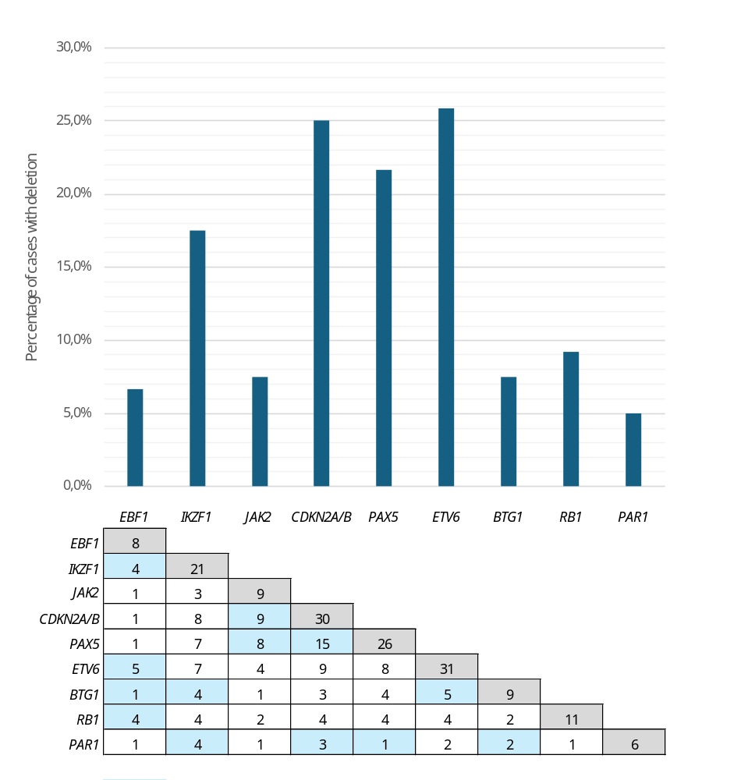

Figure S2. Outcomes according to SEHOP-PETHEMA 2013 Protocol risk classification for our paediatric B-ALL cohort. (A–C) Kaplan–Meier survival curves showing the overall survival, event-free survival and relapse incidence according to SEHOP-PETHEMA 2013 risk classification.
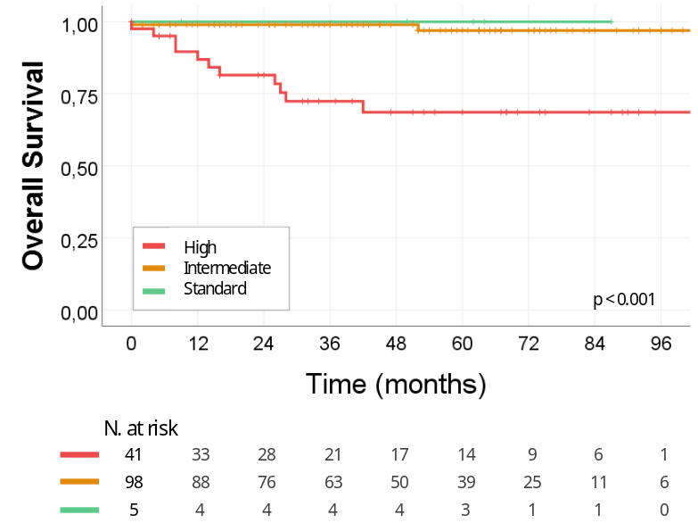
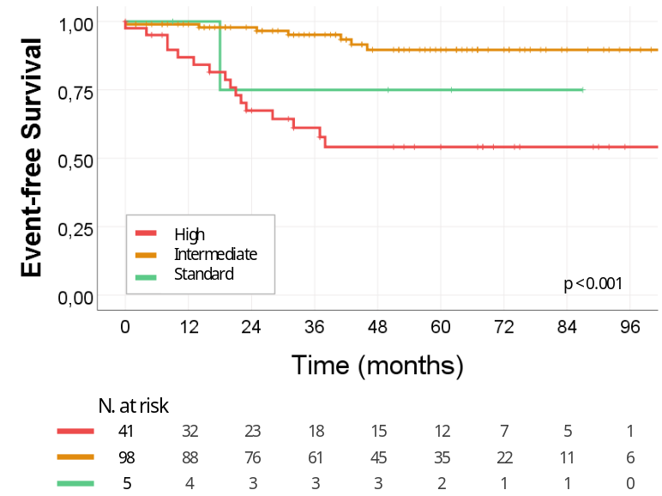
B
A

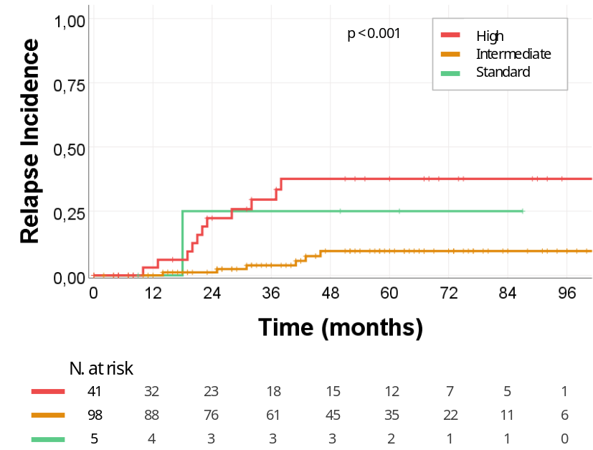
C

Figure S3. Outcomes according to the genetic defining subtype for our paediatric B-ALL cohort. (A–C) Kaplan–Meier survival curves showing the overall survival, event-free survival and relapse incidence according to genetic subtype.
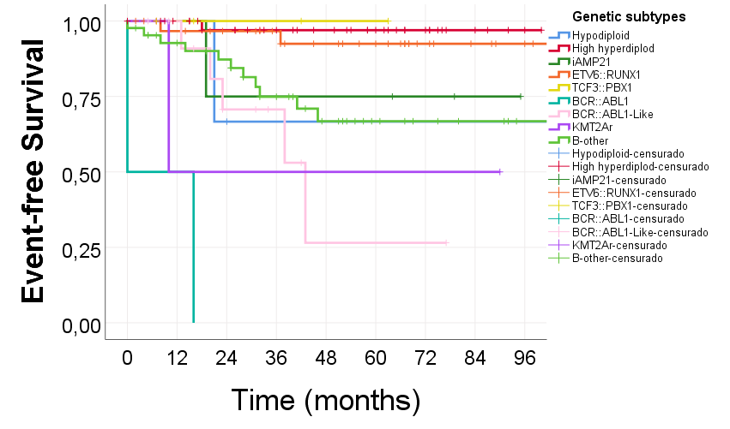
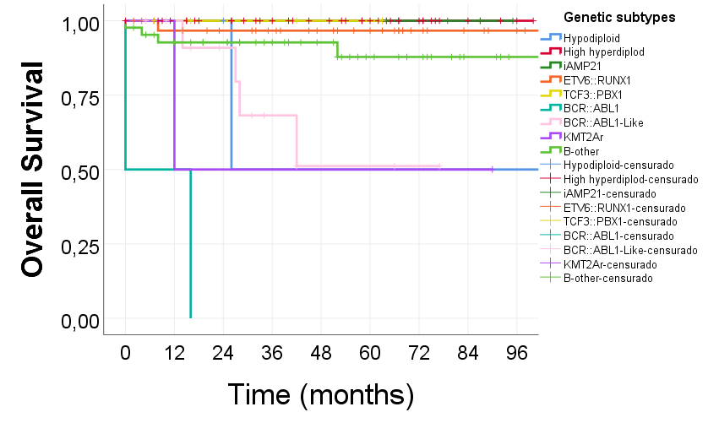

B

A

C
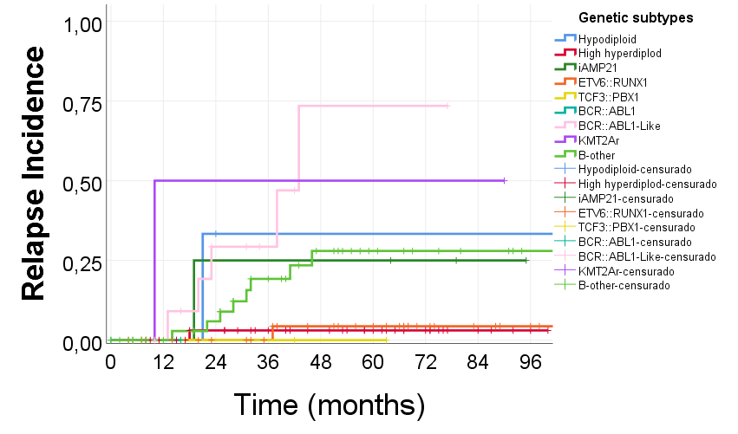

Figure S4. Outcomes according to the genetic risk classification plus the information of CNA profile for our paediatric B-ALL cohort. (A–C) Kaplan–Meier survival curves showing the overall survival, event-free survival and relapse incidence of the GEN-GR and GEN-IR by adding the CNA risk profile (CNA-GR: blue; CNA-PR: red). The results for the GEN-PR group are likely not shown due to a small sample size.
 | GEN-GR | GEN-IR
A | 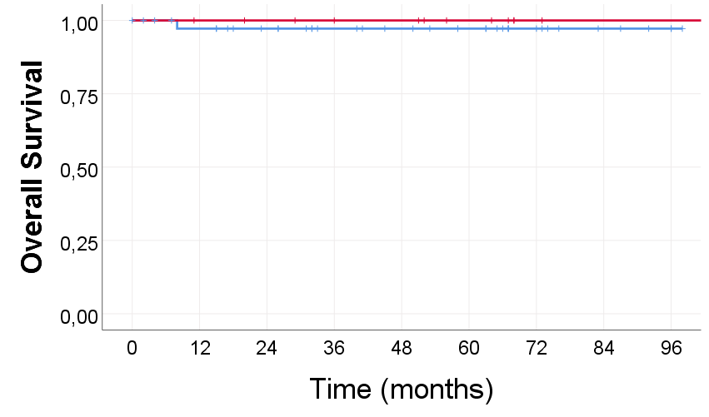 | 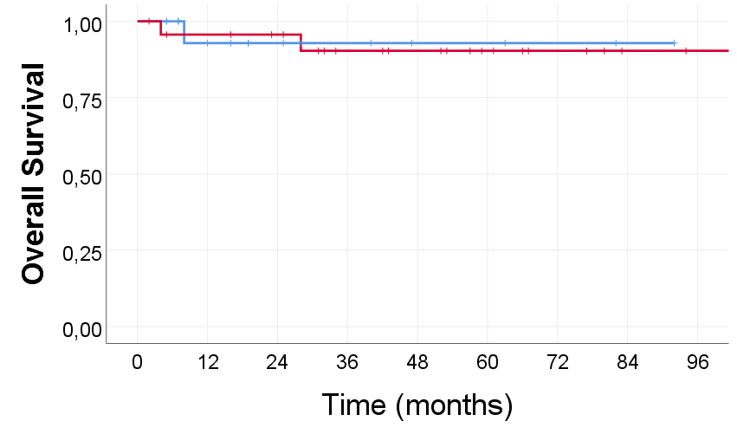
B | 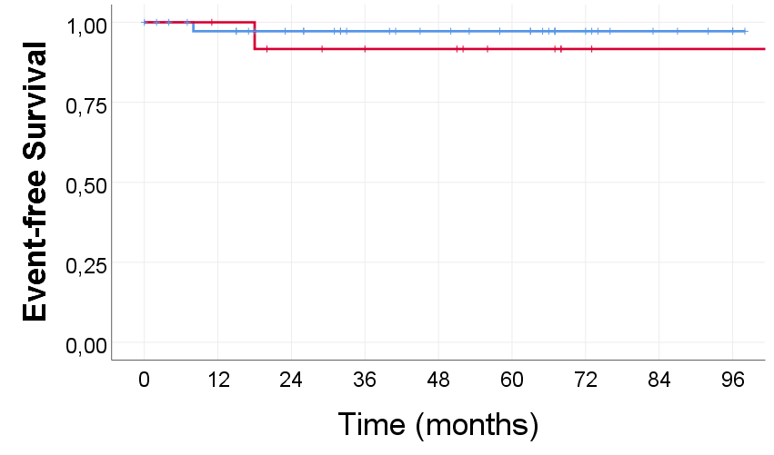 | 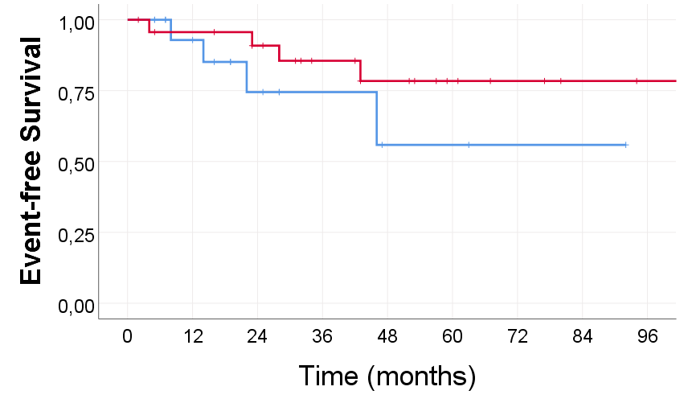
C | 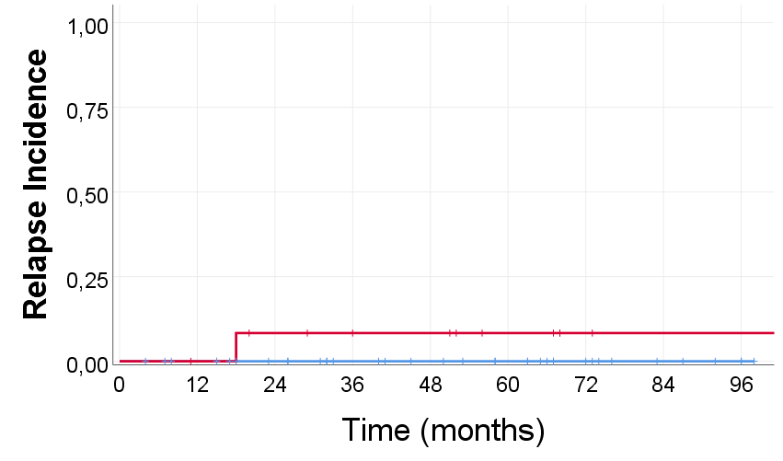 | 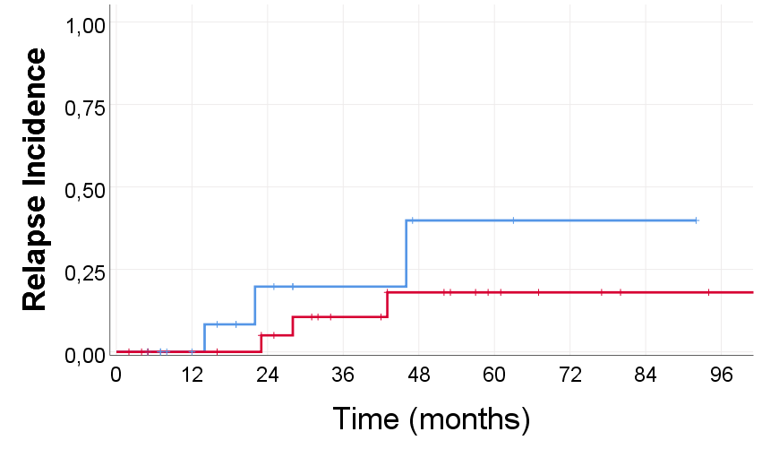

1. McGowan-Jordan J, Hastings RJ, Moore S (2020) ISCN 2020: An International System for Human Cytogenomic Nomenclature (2020). Kager
2. Schwab CJ, Jones LR, Morrison H, et al (2010) Evaluation of multiplex ligation-dependent probe amplification as a method for the detection of copy number abnormalities in B-cell precursor acute lymphoblastic leukemia. Genes Chromosomes Cancer 49:1104–1113. https://doi.org/10.1002/gcc.20818

