Attachment : visual supplementary pictures of various factors in RULSE model
1.Spatial distribution map of rainfall erosivity factors in Min-Tuo River
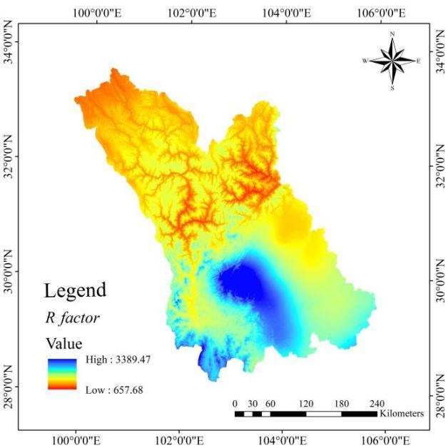
2.Spatial distribution map of soil erosion factors in Min-Tuo River
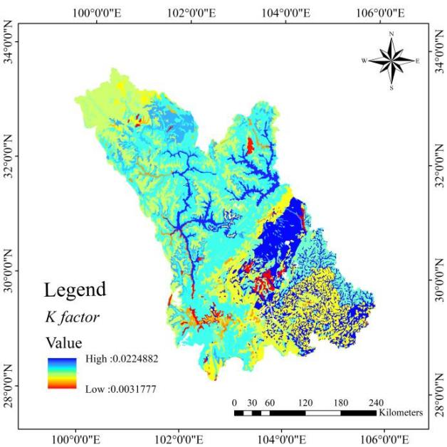

3.Min-Tuo River Spatial distribution map of topographic factors
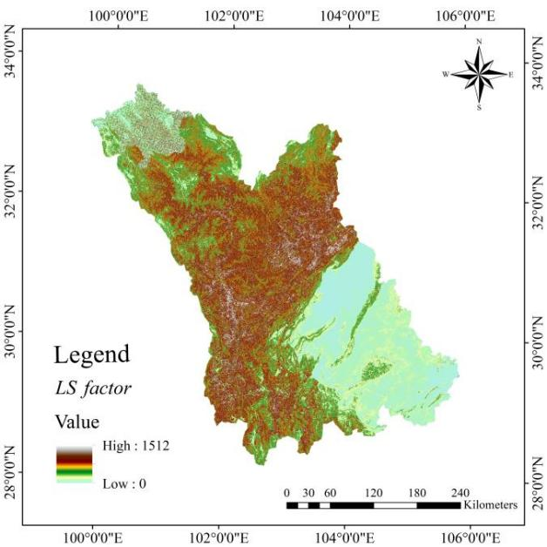
4.Spatial Distribution Map of Vegetation Cover Factors in Min-Tuo River
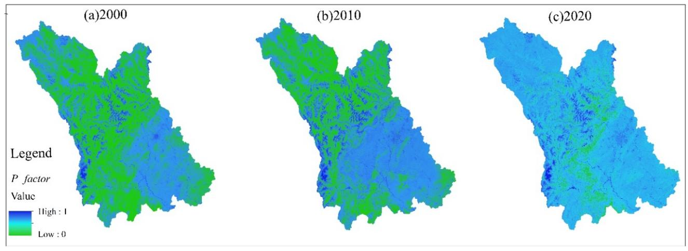
5.Spatial Distribution Map of Soil and Water Conservation Factors in Min-Tuo River
