Table S1. The comparison of clinical characteristics and outcomes of elderly patients with coinfections between the training cohort and internal validation cohort in the first stage.
Variables | Training cohort  (n=155) | Validation cohort  (n=465) | P
Demographic data
Male | 103 (66.5%) | 305 (65.6%) | 0.922
Age | 78.0 [72.0;85.0] | 77.0 [71.0;83.0] | 0.33
Underlying diseases
Diabetes | 48 (31.0%) | 164 (35.3%) | 0.379
Hypertension | 76 (49.0%) | 264 (56.8%) | 0.113
Heart disease | 58 (37.4%) | 173 (37.2%) | 1
Chronic respiratory disease | 40 (25.8%) | 131 (28.2%) | 0.641
Chronic renal disease | 14 (9.03%) | 36 (7.74%) | 0.733
Chronic liver disease | 4 (2.58%) | 27 (5.81%) | 0.208
Autoimmune disease | 8 (5.16%) | 19 (4.09%) | 0.762
Central nervous system disease | 21 (13.5%) | 79 (17.0%) | 0.377
Hematological disorder | 3 (1.94%) | 6 (1.29%) | 0.698
Tumor | 16 (10.3%) | 56 (12.0%) | 0.664
Invasive procedure | 27 (17.4%) | 100 (21.5%) | 0.329
Laboratory results
Lac | 1.24 [0.90;1.70] | 1.20 [0.90;1.70] | 0.408
OI | 307 [220;402] | 300 [208;410] | 0.581
WBC | 5.80 [4.30;7.70] | 6.00 [4.40;8.00] | 0.885
HGB | 122 [108;134] | 120 [110;131] | 0.791
PLT | 172 [127;232] | 178 [134;235] | 0.346
Percentage of NE | 76.2 [64.7;83.7] | 75.0 [64.9;84.8] | 0.974
Percentage of LY | 14.0 [8.38;21.4] | 14.6 [7.94;22.4] | 0.827
Percentage of MO | 9.59 [6.84;12.2] | 9.23 [5.79;12.0] | 0.566
NLR | 5.40 [3.04;10.3] | 5.17 [2.92;10.5] | 0.843
ALB | 33.2 [29.6;37.2] | 33.1 [29.8;36.0] | 0.598
GLB | 29.5 [26.0;32.0] | 28.9 [25.6;32.0] | 0.43
A/G | 1.19 [0.97;1.33] | 1.14 [0.99;1.33] | 0.964
TBIL | 10.5 [8.00;13.6] | 10.5 [7.90;14.2] | 0.807
DBIL | 3.90 [3.00;5.20] | 3.90 [3.00;5.40] | 0.737
ALT | 24.4 [15.5;35.2] | 24.8 [16.5;38.3] | 0.973
AST | 30.8 [23.8;42.5] | 31.7 [22.3;45.8] | 0.906
AST/ALT | 1.29 [1.00;1.64] | 1.31 [1.00;1.74] | 0.449
eGFR | 80.5 [58.9;90.8] | 78.7 [57.2;91.7] | 0.435
CK | 74.6 [47.2;128] | 71.5 [39.7;135] | 0.59
K⁺ | 3.93 [3.55;4.30] | 3.88 [3.58;4.22] | 0.611
Na⁺ | 139 [136;141] | 139 [136;142] | 0.522
PTA | 95.0 [81.5;102] | 93.5 [82.1;102] | 0.76
INR | 1.00 [0.95;1.09] | 1.01 [0.95;1.09] | 0.656
FIB | 4.47 [3.47;5.41] | 4.37 [3.47;5.44] | 0.904
D Dimer | 0.24 [0.13;0.57] | 0.24 [0.12;0.60] | 0.95
PCT | 0.08 [0.05;0.91] | 0.07 [0.05;0.28] | 0.907
CRP | 38.9 [12.0;90.0] | 42.2 [11.2;84.9] | 0.848
ESR | 58.0 [34.0;80.5] | 60.0 [40.0;82.0] | 0.408
IL10 | 5.00 [2.23;6.81] | 5.00 [2.94;5.66] | 0.939
IL6 | 12.2 [3.13;34.0] | 10.8 [3.31;29.6] | 0.559
Outcomes
Infection | 36 (23.2%) | 129 (27.7%) | 0.319
Types of infection |  |  | 0.514
Death | 15 (9.68%) | 63 (13.5%) | 0.263
Abbreviations: ALB: albumin; A/G: albumin/ globulin; ALT: alanine aminotransferase; AST: aspartate transaminase; AST/ALT: aspartate-to-alanine transaminase ratio; CK: creatine kinase; CRP: C-reactive protein; DBIL: direct bilirubin; eGFR: estimated glomerular filtration rate; ESR: erythrocyte sedimentation rate; FIB: fibrinogen; GLB: globulin; HGB: hemoglobin; INR: international normalized ratio; IL 10: interleukin 10; IL 6: interleukin 6; K⁺: blood potassium; Lac: lactic acid; LY: percentage of leukomonocyte; MO: percentage of monocyte; NE: percentage of neutrophil; NLR: neutrophil-to-lymphocyte ratio; Na⁺: blood sodium; OI: oxygenation index; PLT: platelet; PTA: prothrombin activity; PCT: procalcitonin; TBIL: total bilirubin; WBC: white blood cell.

Table S2: The screened variables that coefficient not equal to 0 using Lasso regression when λ was 0.0059
Characteristics | Active
Invasive procedure | 1.52
Diabetes | 1.41
WBC | 0.005
HGB | -0.003
MO | -0.024
ALB | -0.024
A/G | -0.217
eGFR | -0.005
K⁺ | 0.058
Na⁺ | 0.013
PCT | 0.927
CRP | -0.002
Abbreviations: ALB: albumin; A/G: albumin/ globulin; CRP: C-reactive protein; eGFR: estimated glomerular filtration rate; HGB: hemoglobin; K⁺: blood potassium; MO: percentage of monocyte; Na⁺: blood sodium; PCT: procalcitonin; WBC: white blood cell.

Table S3: The comparison of clinical characteristics and outcomes between elderly COVID-19 patients from the first and second stage
 | All  (n=926) | First stage  (n=620) | Second stage  (n=306) | P*
Demographic data
Male | 624 (67.4%) | 408 (65.8%) | 216 (70.6%) | 0.166
Age | 77.0 [71.0;83.0] | 77.0 [71.0;84.0] | 76.0 [70.0;82.0] | 0.046
Clinical symptoms
Fever |  |  |  | <0.001
<39℃ | 365 (39.4%) | 268 (43.2%) | 97 (31.7%)
≥39℃ | 231 (24.9%) | 130 (21.0%) | 101 (33.0%)
Chill | 17 (1.84%) | 14 (2.26%) | 3 (0.98%) | 0.27
Dry cough | 182 (19.7%) | 100 (16.1%) | 82 (26.8%) | <0.001
Expectoration | 563 (60.8%) | 454 (73.2%) | 109 (35.6%) | <0.001
Dyspnea | 438 (47.3%) | 313 (50.5%) | 125 (40.8%) | 0.007
Headache | 118 (12.7%) | 90 (14.5%) | 28 (9.15%) | 0.028
Muscular soreness | 97 (10.5%) | 78 (12.6%) | 19 (6.21%) | 0.004
Gastrointestinal symptom | 250 (27.0%) | 210 (33.9%) | 40 (13.1%) | <0.001
Underlying diseases
Diabetes | 309 (33.4%) | 212 (34.2%) | 97 (31.7%) | 0.495
Hypertension | 504 (54.4%) | 340 (54.8%) | 164 (53.6%) | 0.774
Chronic respiratory disease | 270 (29.2%) | 176 (28.4%) | 94 (30.7%) | 0.511
Chronic cardiovascular disease | 340 (36.7%) | 231 (37.3%) | 109 (35.6%) | 0.679
Chronic renal disease | 92 (9.94%) | 50 (8.06%) | 42 (13.7%) | 0.01
Chronic liver disease | 49 (5.29%) | 31 (5.00%) | 18 (5.88%) | 0.683
Autoimmune disease | 31 (3.35%) | 27 (4.35%) | 4 (1.31%) | 0.026
Cerebrovascular diseases | 156 (16.8%) | 100 (16.1%) | 56 (18.3%) | 0.461
Hematological disorder | 10 (1.08%) | 9 (1.45%) | 1 (0.33%) | 0.179
Tumor | 124 (13.4%) | 72 (11.6%) | 52 (17.0%) | 0.031
Invasive procedure | 263 (28.4%) | 127 (20.5%) | 136 (44.4%) | <0.001
Lac | 1.24 [0.90;1.72] | 1.20 [0.90;1.70] | 1.30 [0.90;1.85] | 0.15
OI | 283 [204;403] | 300 [210;410] | 257 [197;389] | 0.002
WBC | 6.00 [4.35;8.40] | 5.95 [4.40;8.00] | 6.40 [4.30;8.79] | 0.247
HGB | 120 [106;131] | 121 [109;132] | 118 [100;128] | <0.001
PLT | 170 [127;228] | 177 [131;234] | 159 [118;214] | 0.002
Percentage of NE | 76.1 [63.3;86.3] | 75.6 [64.8;84.5] | 77.7 [60.7;89.0] | 0.142
Percentage of LY | 13.5 [7.15;22.6] | 14.4 [8.00;21.9] | 12.2 [5.90;24.6] | 0.061
Percentage of MO | 8.57 [5.50;11.8] | 9.30 [5.88;12.1] | 7.50 [4.35;10.5] | <0.001
ALB | 32.8 [29.4;36.3] | 33.1 [29.7;36.3] | 32.1 [28.9;36.2] | 0.056
GLB | 28.8 [25.7;32.0] | 29.0 [25.8;32.0] | 28.4 [25.6;32.1] | 0.792
TBIL | 10.6 [7.90;13.6] | 10.5 [7.90;13.9] | 10.8 [7.90;12.2] | 0.106
DBIL | 3.90 [2.80;5.80] | 3.90 [3.00;5.40] | 3.75 [2.10;7.20] | 0.175
ALT | 23.2 [15.7;35.3] | 24.6 [16.2;38.0] | 20.1 [14.4;29.9] | <0.001
AST | 29.8 [21.6;43.2] | 31.3 [22.6;45.3] | 26.0 [19.7;38.0] | <0.001
eGFR | 77.4 [55.4;90.5] | 79.2 [57.5;91.7] | 73.9 [52.2;89.2] | 0.017
CK | 67.8 [37.5;128] | 72.6 [42.0;132] | 56.4 [31.2;111] | <0.001
K⁺ | 3.90 [3.56;4.22] | 3.89 [3.57;4.24] | 3.90 [3.54;4.20] | 0.653
Na⁺ | 139 [136;141] | 139 [136;141] | 138 [136;141] | 0.092
PTA | 94.8 [82.1;103] | 93.8 [82.1;102] | 95.6 [82.4;107] | 0.017
INR | 1.01 [0.95;1.09] | 1.01 [0.95;1.09] | 1.01 [0.95;1.10] | 0.946
FIB | 4.26 [3.36;5.19] | 4.37 [3.47;5.44] | 4.01 [3.12;5.14] | <0.001
D Dimer | 0.30 [0.14;0.77] | 0.24 [0.12;0.58] | 0.47 [0.23;1.23] | <0.001
PCT | 0.09 [0.05;0.49] | 0.07 [0.05;0.34] | 0.13 [0.06;0.64] | <0.001
CRP | 39.6 [11.1;91.2] | 41.5 [11.7;87.8] | 35.0 [10.2;98.7] | 0.817
ESR | 59.0 [37.0;85.8] | 60.0 [39.0;82.0] | 55.0 [29.0;90.0] | 0.688
IL 10 | 5.00 [2.50;7.49] | 5.00 [2.81;5.81] | 5.53 [2.11;12.1] | 0.001
IL 6 | 13.3 [4.00;43.0] | 10.9 [3.26;30.9] | 23.7 [5.40;80.5] | <0.001
Outcomes
Infection | 302 (32.6%) | 165 (26.6%) | 137 (44.8%) | <0.001
Death | 146 (15.8%) | 78 (12.6%) | 68 (22.2%) | <0.001
* Refers to comparing elderly COVID-19 patients from the first and second stages.
Abbreviations: ALB: albumin; A/G: albumin/ globulin; ALT: alanine aminotransferase; AST: aspartate transaminase; AST/ALT: aspartate-to-alanine transaminase ratio; CK: creatine kinase; CRP: C-reactive protein; DBIL: direct bilirubin; eGFR: estimated glomerular filtration rate; ESR: erythrocyte sedimentation rate; FIB: fibrinogen; GLB: globulin; HGB: hemoglobin; INR: international normalized ratio; IL 10: interleukin 10; IL 6: interleukin 6; K⁺: blood potassium; Lac: lactic acid; LY: percentage of leukomonocyte; MO: percentage of monocyte; NE: percentage of neutrophil; NLR: neutrophil-to-lymphocyte ratio; Na⁺: blood sodium; OI: oxygenation index; PLT: platelet; PTA: prothrombin activity; PCT: procalcitonin; TBIL: total bilirubin; WBC: white blood cell.

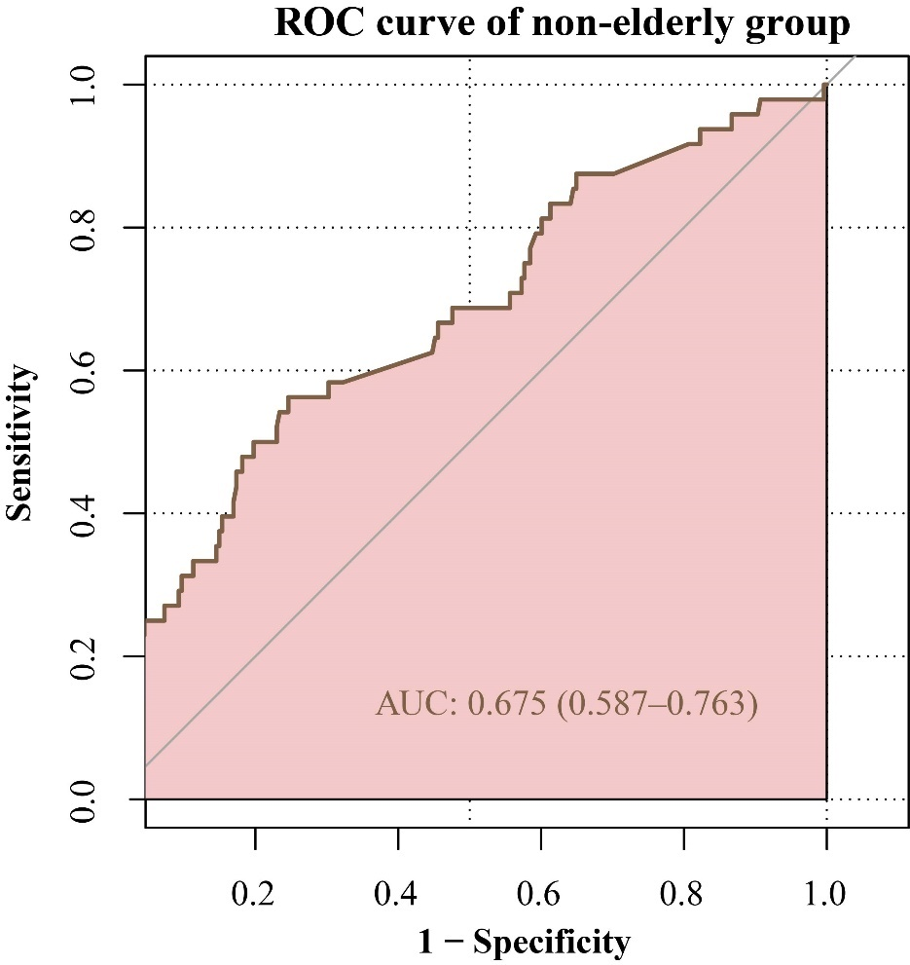
Figure S1: Receiver operating characteristic (ROC) curve in the non-elderly patients with COVID-19.

