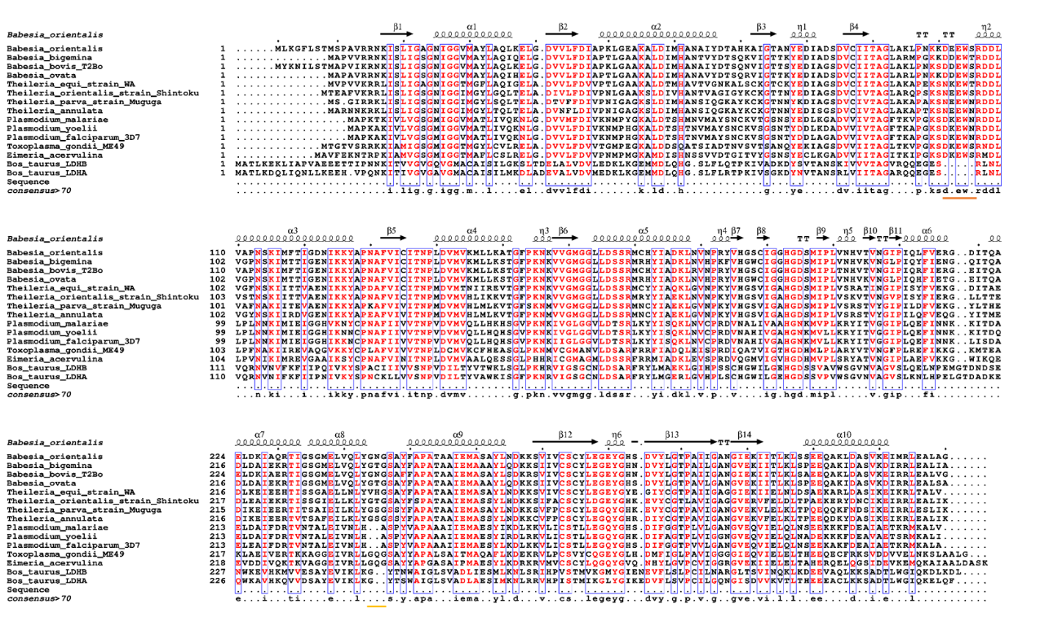
Supplementary Figure 1. ESPript 3 annotated total sequence alignment results. Red indicates complete conservation and partial conservation, and the orange line highlights a 5-amino acid insertion sequence (residues 93-97) before residue R98. Yellow line highlights opposing loop (residues 236-238).

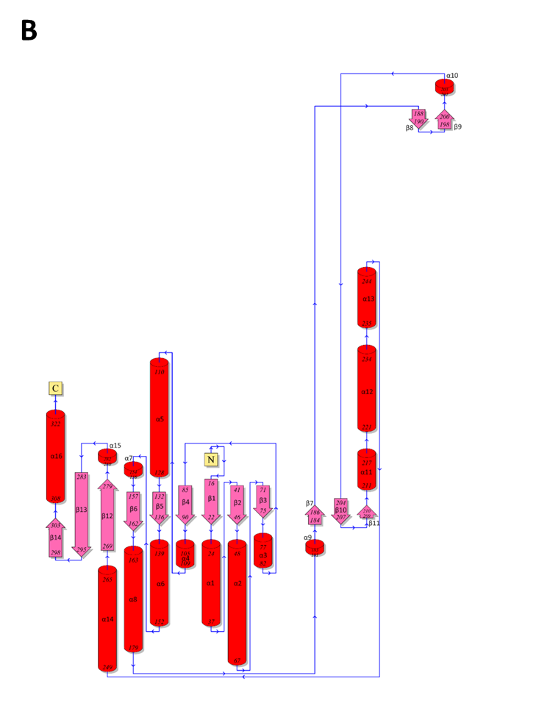
Supplementary Figure 2. PDBsum 2D topology model of BbigLDH based on the homology modelled structure.

Supplementary Figure 3. Phylogenetic tree representation using MEGA11. The phylogenetic tree is constructed using the Neighbor Joining method, which estimates the evolutionary relationships between sequences by joining neighboring branches based on their pairwise distances. The branch lengths in the tree are proportional to the genetic distances between sequences, where a distance of 0.20 indicates a relatively moderate level of genetic divergence.

 |  | BbigLDH  (Open state) | BbigLDH  (Closed state)
ERRAT | overall quality factor | 90.127 | 93.949
ProSA | z-skor | -10.19 | -10.02
ProCHECK | The preferred region of residues (A,B,L) | (% 88.1)  244 | (% 86.6)  240
 | The preferred residues in other regions  (a,b,l,p) | (% 10.8)  30 | (% 12.3)  34
 | Approximately acceptable residues in other regions  (~a, ~b, ~l, ~p) | (% 0.7)  2 | (% 0.7)  2
 | Residues outside the regions of interest | (% 0.4)  1 | (% 0.4)  1
Verify3D |  | 88.82% of the residues have a 3D-1D score >= 0.2: Passed | 93.79% of the residues have a 3D-1D score >= 0.2: Passed
QMEAN | Qmean4 | -2.47 | -2.19

Supplementary Table 1. Validation results of the homology modelled structures for BbigLDH protein. Ramachandran plot analysis (ProCHECK) showing the distribution of residues in the allowed regions. ERRAT score analysis indicating the overall quality of the models. Verify3D analysis depicting the compatibility of the models with the expected 3D-1D score. ProSA-web analysis displaying the Z-scores for the models, indicating their overall structural quality. Verify3D analysis providing an assessment of the model's geometry and potential clashes. The results demonstrate the validity and quality of the BbigLDH protein models.

Supplementary Figure 4. (A) Receiver Operating Characteristic (ROC) curve illustrating the classification performance of the computational model for virtual screening in drug discovery. (B) Percentage of screened compounds graph depicting the accumulation of active compounds in the ranked list during virtual screening.

Supplementary Table 2. Enrichment report results (1122 decoys + 34 actives set).
Count and percentage of actives in top N% of decoy results.
% Decoys | 1% | 2% | 5% | 10% | 20%
# Actives | 3 | 3 | 9 | 9 | 12
% actives | 8.8 | 8.8 | 26.5 | 26.5 | 35.3
Count and percentage of actives in top N% of results.
% Decoys | 1% | 2% | 5% | 10% | 20%
# Actives | 3 | 3 | 7 | 9 | 12
% actives | 8.8 | 8.8 | 26.5 | 26.5 | 35.3
Enrichment factors with respect to N% samle size.
% Sample | 1% | 2% | 5% | 10% | 20%
EF | 9 | 4.5 | 4.1 | 2.7 | 1.8
Validation parameters
ROC | RIE | AUAC | BEDROC (alpha)
 |  |  | 160.9 | 20.0 | 8.0
0.69 | 3.43 | 0.68 | 0.332 | 0.229 | 0.320

Supplementary Table 3. Inhibitor candidates for BbigLDH identified through Schrödinger QikProp ADME analysis, falling within the reference value range.
Compound no | ªCatalog ID | ^{b}mol MW | ^{c}donorHB | ^{d}accptHB | ^{e}QPlogPo/w | ^{f}QPlogHERG | ^{g}QPPCaco | ^{h}QPlogBB | ^{i}QPlogKhsa | ^{j}%İOA
^{C1} | ^{Z1478445725} | ^{351.45} | ² | ^{5.5} | ^{2.709} | ^{-3.559} | ^{489.216} | ^{-0.772} | ^{0.103} | ^{90.944}
^{C2} | ^{Z1246322905} | ^{372.426} | ¹ | ⁶ | ^{3.266} | ^{-4.103} | ^{630.873} | ^{-0.69} | ^{0.128} | ^{96.184}
^{C3} | ^{Z826473056} | ^{395.435} | ² | ^{6.5} | ^{3.212} | ^{-4.27} | ^{716.74} | ^{-0.814} | ^{0.158} | ^{96.859}
^{C4} | ^{Z509196536} | ^{343.308} | ³ | ⁴ | ^{2.783} | ^{-4.177} | ^{197.169} | ^{-1.073} | ^{-0.057} | ^{84.315}
^{C5} | ^{Z1424270493} | ^{360.455} | ² | ⁶ | ^{2.433} | ^{-2.837} | ^{168.922} | ^{-1.152} | ^{-0.07} | ^{81.06}
^{C6} | ^{Z278525320} | ^{378.35} | ² | ^{5.75} | ^{3.07} | ^{-4.577} | ^{409.892} | ^{-0.753} | ⁰ | ^{91.685}
^{C7} | ^{Z1640818270} | ^{382.434} | ² | ^{6.7} | ^{2.305} | ^{-4.471} | ^{153.139} | ^{-0.271} | ^{-0.134} | ^{79.55}
^{C8} | ^{Z604033838} | ^{326.397} | ³ | ^{5.5} | ^{2.751} | ^{-4.775} | ^{844.907} | ^{-0.878} | ^{-0.064} | ^{95.439}
^{C9} | ^{Z2373310039} | ^{396.491} | ¹ | ⁹ | ^{1.604} | ^{-2.504} | ^{387.899} | ^{-0.685} | ^{-0.587} | ^{82.669}
^{C10} | ^{Z973658262} | ^{378.181} | ³ | ^{7.5} | ^{1.339} | ^{-5.023} | ^{232.525} | ^{-1.102} | ^{-0.332} | ^{77.138}
^{C11} | ^{Z1616793138} | ^{298.344} | ² | ^{5.5} | ^{2.044} | ^{-4.171} | ^{416.076} | ^{-0.947} | ^{-0.233} | ^{85.792}
^{C12} | ^{Z2953881032} | ^{349.391} | ¹ | ^{7.5} | ^{2.088} | ^{-4.974} | ^{317.331} | ^{-0.995} | ^{0.073} | ^{83.941}
^{C13} | ^{Z1253206711} | ^{320.406} | ² | ^{6.7} | ^{1.893} | ^{-3.744} | ^{504.701} | ^{-0.99} | ^{-0.41} | ^{86.406}
^{C14} | ^{Z19650139} | ^{278.328} | ² | ⁴ | ^{1.881} | ^{-3.854} | ^{293.693} | ^{-0.848} | ^{-0.205} | ^{82.13}
^{C15} | ^{Z2400537901} | ^{343.425} | ³ | ^{7.2} | ^{1.288} | ^{-2.842} | ^{211.617} | ^{-1.158} | ^{-0.601} | ^{76.112}
^{C16} | ^{Z2201943136} | ^{342.192} | ² | ^{8.4} | ^{1.101} | ^{-3.999} | ^{658.174} | ^{-0.632} | ^{-0.505} | ^{83.833}
^{C17} | ^{Z2060912694} | ^{294.325} | ² | ^{7.2} | ^{0.976} | ^{-3.295} | ^{294.844} | ^{-0.917} | ^{-0.631} | ^{76.86}
^{C18} | ^{Z2063989764} | ^{356.421} | ¹ | ^{8.15} | ^{2.749} | ^{-5.073} | ^{1792.233} | ^{-0.524} | ^{-0.047} | ¹⁰⁰
^{C19} | ^{Z1531526443} | ^{340.378} | ² | ⁶ | ^{2.016} | ^{-4.734} | ^{74.968} | ^{-1.83} | ^{-0.173} | ^{72.307}
^{C20} | ^{Z2055833084} | ^{321.271} | ¹ | ^{6.4} | ^{2.662} | ^{-4.149} | ^{2104.635} | ^{0.087} | ^{-0.247} | ¹⁰⁰

^{a Enamine Store IDs.}
^{b Molecular weight (<500 Da)}
c Hydrogen bond donor count (<5)
d Hydrogen bond acceptor count (<10)
e Predicted octanol/water partition coefficient (-2.0 - 4)
f Predicted IC50 value for blocking HERG K+ channels (Accepted range: values greater than -5.0)
g Predicted apparent Caco-2 cell permeability in nm/s (<25 low, >500 high)
h Predicted blood-brain barrier permeability coefficient (-3.0 - 1.2)
i Predicted binding capacity to human serum albumin (-1.5 - 1.5)
j Predicted human oral absorption on a scale of 0 to 100 (>70%)
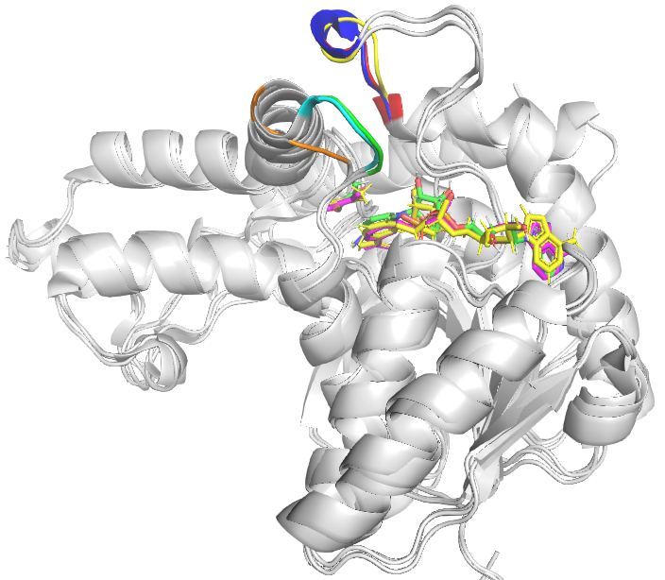
Supplementary Figure 5. Superimposition of the closed form of BbigLDH, ancestral LDH with lactate (PDB ID: 4PLF) and Plasmodium falciparum LDH complexed with NADH and Oxamate (PDB ID: 1LDG). Substrate specific loop shows as yellow, red and blue, respectively. Opposing loop shows as green, cyan and orange for BbigLDH, ancLDH and pfLDH respectively. Pyruvate and NADH colored as green, yellow and magenta for BbigLDH, ancLDH and pfLDH respectively.
Supplementary Figure 6. (A), (B) and (C) Binding interactions of 2-D structures of BbigLDH during the 1000 ns simulation time; C9, C16 and C18, respectively.

Supplementary Figure 7. Protein and ligand contacts for C9 (A), C16 (B), C18 (C) during 1 μs MD simulation.

Supplementary Figure 8. The superposition images of ligands with crystal structures (golden) and open BbigLDH (blue) are shown in the middle section. The ligands on the left of these images show the binding modes with crystal PfLDH, and the ligands on the right show the binding modes with open state of BbigLDH. PDB ID: Ligand (A) 1U4O:NDD, (B) 1U4S:BIH, (C) 1U5A:BIK.

Supplementary Figure 9. The superposition images of ligands with crystal structures (golden) and closed state of BbigLDH (blue) are shown. The ligands on the left of these images show the binding modes with the crystal structure (PfLDH), and the ligands on the right show the binding modes with closed state of BbigLDH. PDB ID: Ligand (A) 1LDG:OXM, (B) 1T24:OXQ, (C) 1T25:GAG, (D)1T26:GBD.

