Supplementary information:

Inner membrane components of the plasmid pKM101 type IV secretion system TraE and TraD are DNA-binding proteins

Zakaria Jemouai, Aleksandr Sverzhinsky, Jurgen Sygusch, John Pascal and Christian Baron*

Department of Biochemistry and Molecular Medicine, Faculty of Medicine,
Université de Montréal, Québec, Canada

*Contact address of corresponding author: christian.baron@umontreal.ca

Supplementary Figure 1

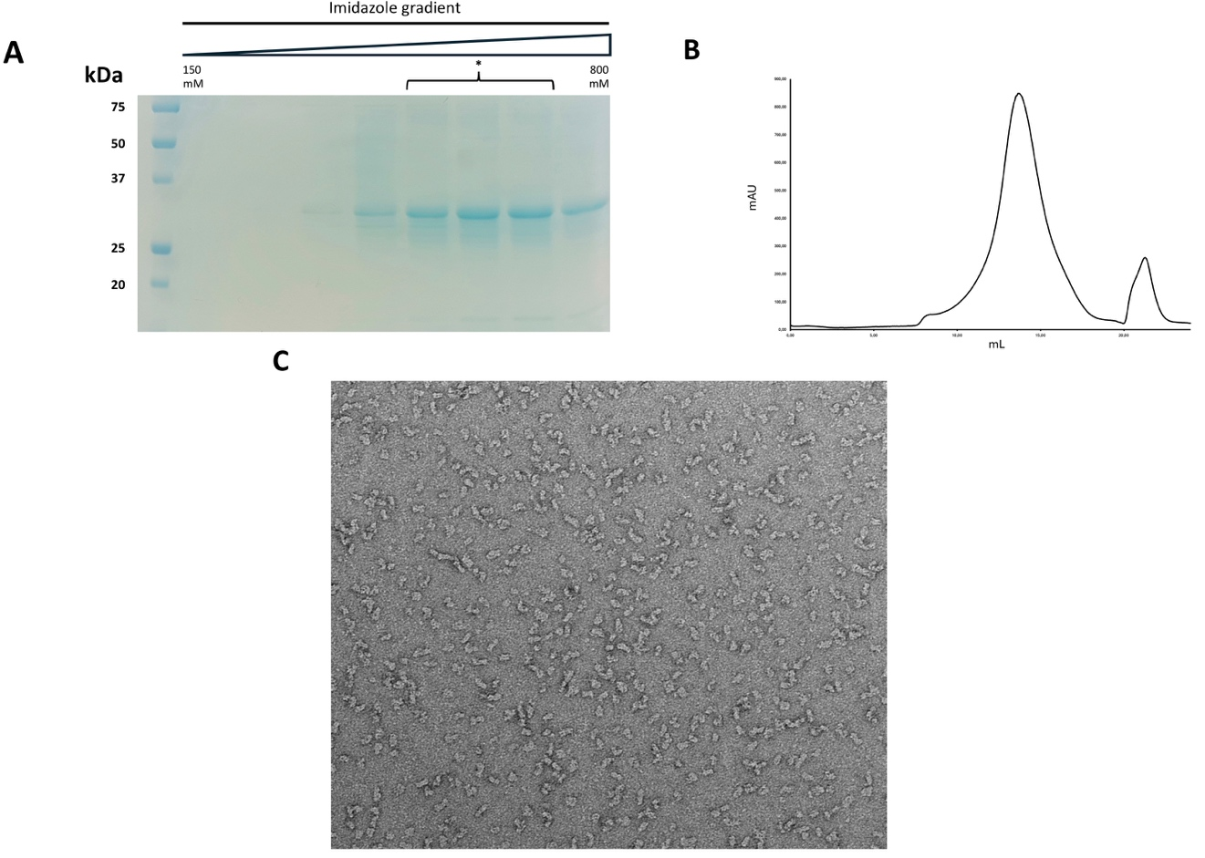

Legend to supplementary Figure 1: TraD purification and analysis. (A) IMAC elution fractions of TraD analysed on SDS-PAGE with Coomassie blue coloration. (B) Elution profile of TraD on a Superose 6 column. (C) Example of a negative stained micrograph of diluted sample from (B). The (*) labeling represents the fractions collected after elution and injected onto the Superose 6 column.

Supplementary Table 1: Oligonucletides used for site-directed mutagenesis.
