T cell phenotypes associated with insulin resistance: Results from the Berlin Aging Study II
Julia Sbierski-Kind¹, David Goldeck², Nikolaus Buchmann³, Joachim Spranger^{1,4,5}, Hans-Dieter Volk⁶, Elisabeth Steinhagen-Thiessen¹, Graham Pawelec^{7,8}, Ilja Demuth^{1,6}, Dominik Spira¹
¹Charité-Universitätsmedizin Berlin, Corporate Member of Freie Universität Berlin, Humboldt-Universität zu Berlin, and Department of Endocrinology and Metabolism, Berlin Institute of Health, Berlin, Germany.
²Fairfax Centre, Kidlington, United Kingdom.
³Clinic for Cardiology, Charité Universitätsmedizin Berlin, Berlin, Germany.
⁴Center for Cardiovascular Research (CCR), Department of Endocrinology and Metabolism, Charité-Universitätsmedizin Berlin, Berlin, Germany.
⁵German Center for Cardiovascular Research (DZHK), partner site Berlin, Berlin, Germany.
⁶Berlin Institute of Health (BIH) Center for Regenerative Therapies (BCRT), Charité - Universitätsmedizin Berlin, Berlin, Germany; Berlin Center for Advanced Therapies (BeCAT), Charité - Universitätsmedizin Berlin, Berlin, Germany; Institute of Medical Immunology, Charité - Universitätsmedizin Berlin, Berlin, Germany.
⁷Department of Immunology, University of Tübingen, Tübingen, Germany.
⁸Health Sciences North Research Institute, Sudbury, ON, Canada.

Address correspondence to Julia Sbierski-Kind, MD, Department of Endocrinology and Metabolism, Charité-Universitätsmedizin Berlin, Berlin, Germany. Chariteplatz 1, 10117 Berlin, Deutschland.

Present address
University of California, San Francisco
Dept. of Laboratory Medicine
HSW1201U, Box 0451
513 Parnassus Ave
San Francisco, CA 94143-0451
Julia.Sbierski-Kind@ucsf.edu

Supplementary Table 1
Association between BMI, HOMA-IR, ISI_{OGTT} and immune cell frequencies in elderly participants.
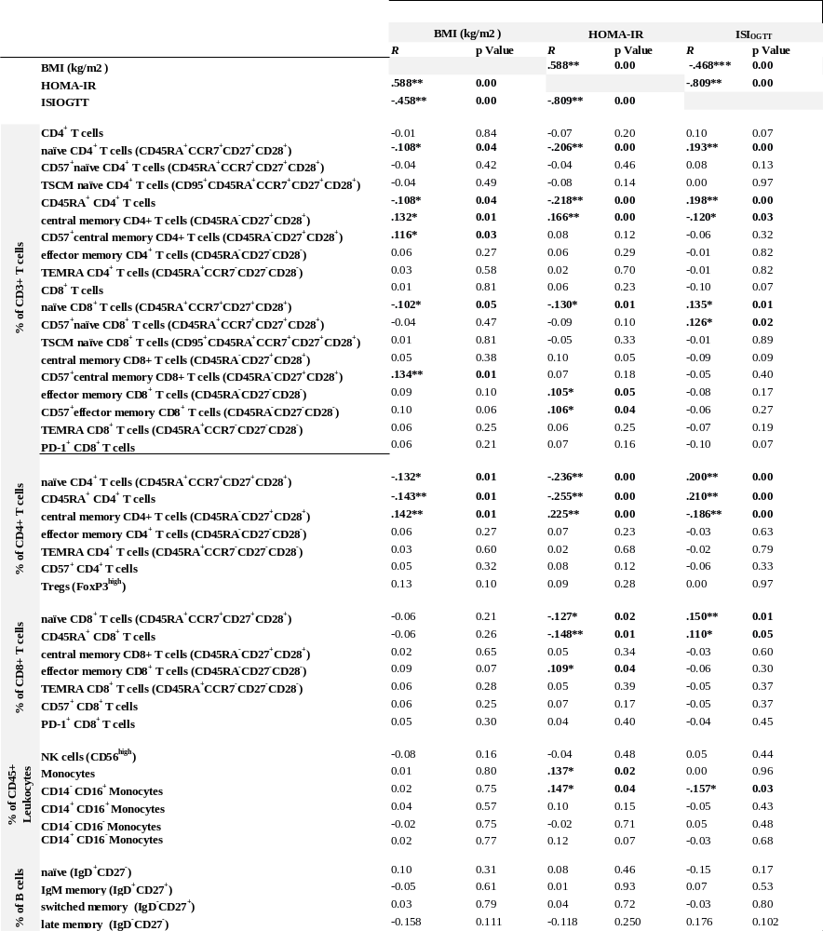

Spearman correlation analysis was conducted. * p < 0.05. ** p < 0.01. Body mass index (BMI). Homeostatic model assessment of insulin resistance (HOMA-IR) Insulin sensitivity index (ISI_{OGTT}).

Supplementary Table 2
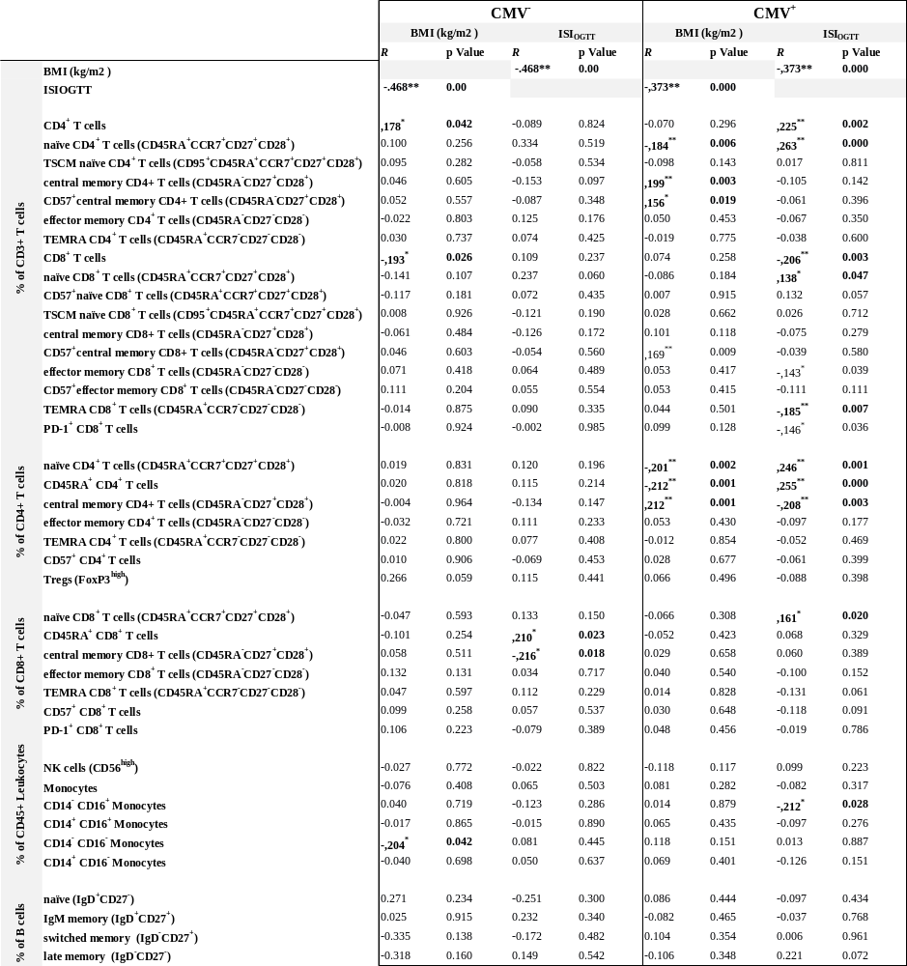

Spearman correlation analysis was conducted for CMV⁻ and CMV⁺ participants. * p < 0.05. ** p < 0.01. Body mass index (BMI). Homeostatic model assessment of insulin resistance (HOMA-IR) Insulin sensitivity index (ISI_{OGTT}).

Supplementary Table 3
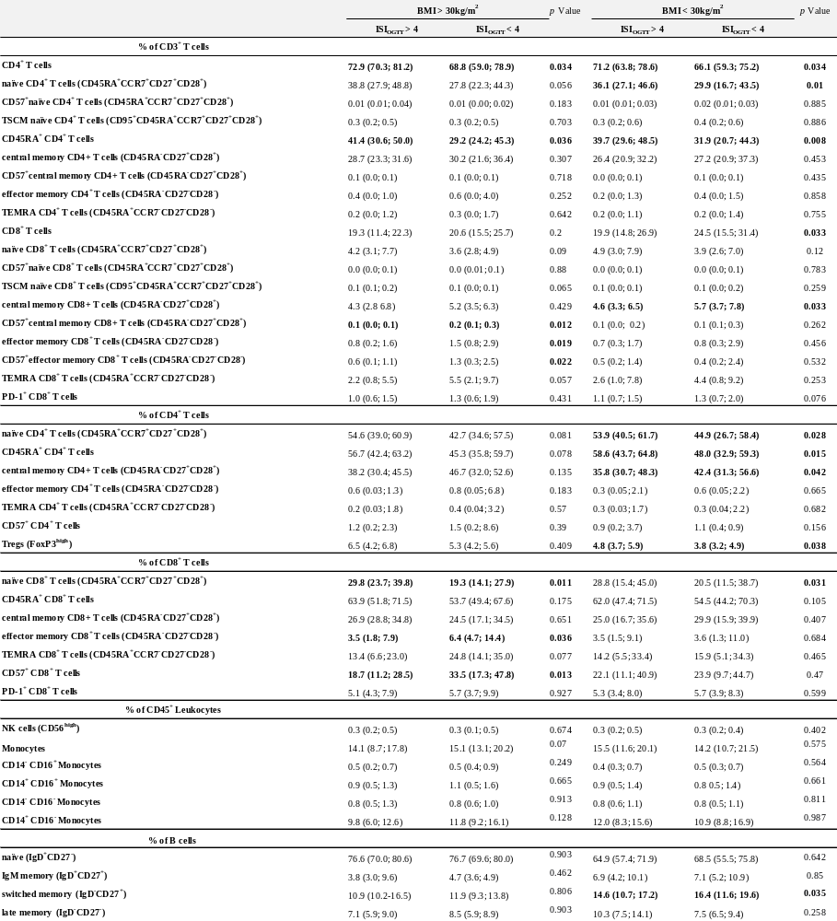
Comparison of the distributions of immune cell subpopulation proportions in obese and non-obese insulin resistant and non-insulin resistant participants.

Mann-Whitney U test was conducted to estimate differences between obese (BMI > 30 kg/m²) non-insulin resistant and insulin resistant, and non-obese (BMI < 30 kg/m²) non-insulin resistant and insulin resistant participants. Data are given as median and interquartile range. Body mass index (BMI). Insulin sensitivity index (ISI_{OGTT}).

Supplementary Table 4
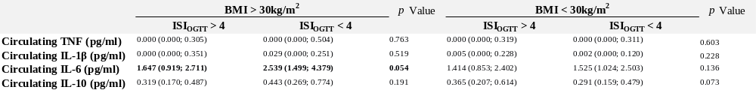
Comparison of cytokine levels in obese and non-obese insulin resistant and non-insulin resistant participants.
Mann-Whitney U test was conducted to estimate differences between obese (BMI>30 kg/m²) non-insulin resistant and insulin resistant, and non-obese (BMI < 30 kg/m²) non-insulin resistant and insulin resistant participants. Data are given as median and interquartile range. Body mass index (BMI). Insulin sensitivity index (ISI_{OGTT}).

Supplementary Table 5
Association of immune cell subsets with ISI_{OGTT.}
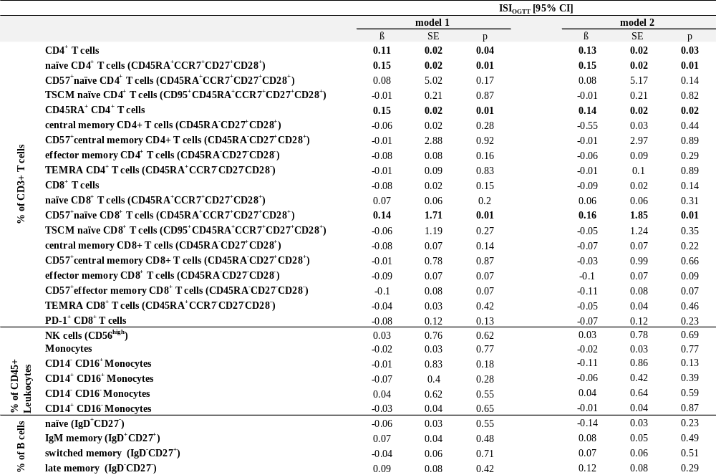

Linear regression adjusted for sex, BMI (model 1), and linear regression adjusted for sex, BMI, morbidity index and CMV status (model 2). SE (standard error). Significant associations are highlighted in bold.

Supplementary Table 6
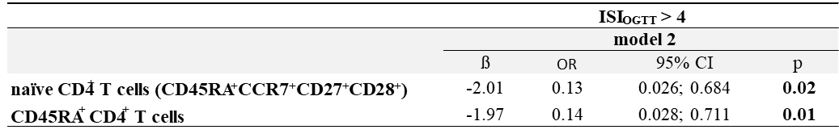
Logistic regression analysis displaying the association of immune cell subsets with ISI_{OGTT.}
Logistic regression adjusted for sex, BMI, morbidity index and CMV status (model 2). OR (odds ratio). CI (confidence interval). Significant associations are highlighted in bold.

Supplementary Table 7
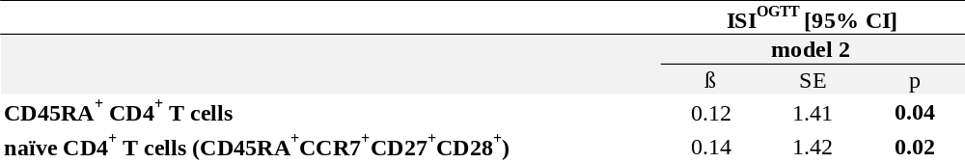
Linear regression analysis displaying the association of immune cell subsets with ISI_{OGTT.}
Linear regression adjusted for sex, BMI, morbidity index and CMV status (model 2) and analyzed after ruling out subjects aged 80 years or older (8 subjects, age 80-84 years). CI (confidence interval). Significant associations are highlighted in bold.

Supplementary Table 8
Antibody Table
REAGENT or RESOURCE
SOURCE
IDENTIFIER
Anti-human CD45RA BUV 421 (clone HI100)
BioLegend
Cat#304130; AB_10965547
Anti-human CD3 Pacific Orange
Life Technologies
Cat#CD0330; AB_2536469
Anti-human CD25 PE (clone M-A251)
BD Biosciences
Cat#555432; AB_395826
Anti-human CD4 PercP (clone SK3)
BD Biosciences
Cat#345770;
Anti-human FoxP3 AF 647 (clone 259D/C7)
BD Biosciences
Cat#560045; AB_1645411
Anti-Human CD8 APC-H7 (clone SK1)
BD Biosciences
Cat#560179; AB_1645481
Anti-human CCR7(clone CD197)
BD Biosciences
Cat#557648
Anti-human CD45 V500 (clone HI30)
BD Horizon
Cat#560777; AB_1937324
Anti-human CD3 APC (clone UCHT1)
BioLegend
Cat#300412; AB_314066
Anti-Human CD14 APC-H7 (clone M5E2)
BD Biosciences
Cat#561384;
Anti-Human CD56 BUV 605 (clone NCAM16.2)
BD Horizon
Cat#562780; AB_2728700
Anti-Human CD16 BUV 711 (clone 3G8)
BioLegend
Cat#302043; AB_11219184
Anti-Human CD279 (clone EH12.2H7)
BioLegend
Cat#329937
Anti-Human CD95 PE-Cy7 (clone DX2)
BD Biosciences
Cat#561636
Anti-Human CD57 FITC (clone HNK-1)
BD Biosciences
Cat#347393
Anti-Human CD19 V500 (clone HIB19)
BD Biosciences
Cat#561121
Anti-Human CD27 APC (clone O323)
BioLegend
Cat#302809
Anti-Human CD28 PE (clone CD28.2)
BD Biosciences
Cat#561793
Anti-Human IgD PE (clone IA6-2)
BioLegend
Cat#348203; AB_10550096

