Screening and validation of optimal real-time PCR reference genes for Abelmoschus manihot
Qixuan Wu¹, Meixin Deng¹, Xiaolan Zhao¹, Jianmei Long¹, Jianxia Zhang^{1*}
¹Guangdong Key Laboratory for Innovative Development and Utilization of Forest Plant Germplasm, College of Forestry and Landscape Architecture, South China Agricultural University, Guangzhou 510642, China
*Email. zhangjianxia@scau.edu.cn
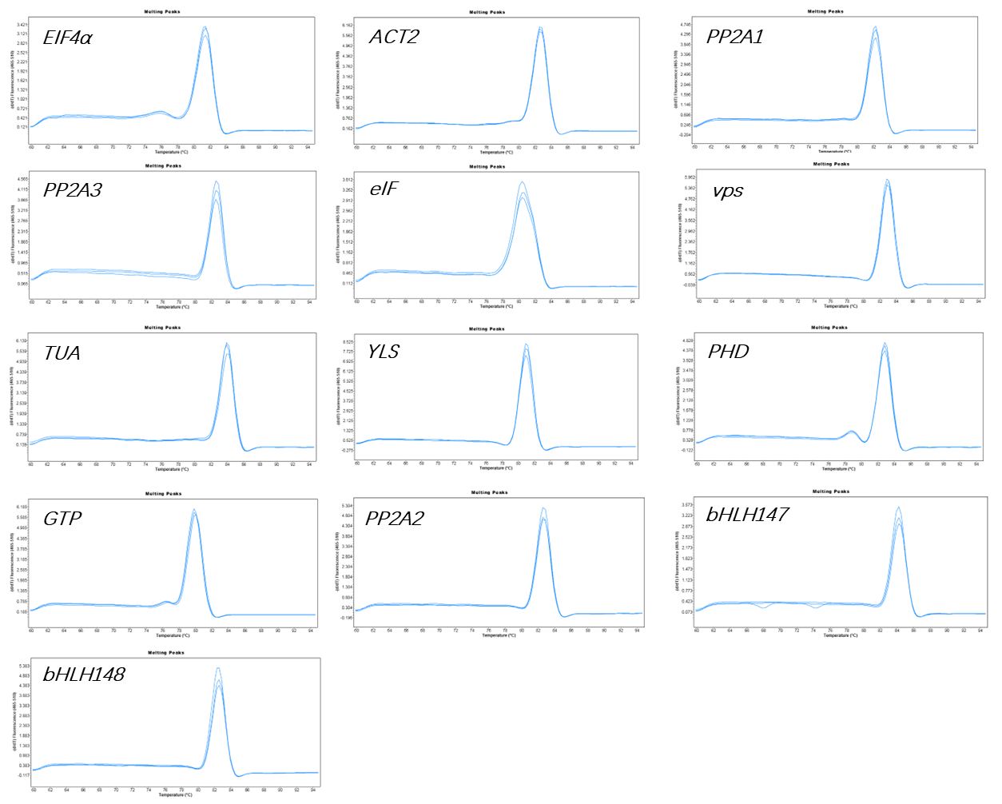
Figure S1. Melting curves of 11 candidate reference genes and two target genes in Abelmoschus manihot

Table S1. Stability ranking of reference genes assessed by geNorm, NormFinder, BestKeeper, and RefFinder in different tissues (roots, stems, and leaves).
Note: SD, standard deviation; CV, coefficient of variation.
Group | Rank | geNorm |  | NormFinder |  | BestKeeper |  |  | RefFinder
Group | Rank | Gene | Stability | Gene | Stability | Gene | SD | CV | Gene | Stability
Roots | 1 | PP2A1 | 0.07 | vps | 0.04 | YLS | 0.07 | 0.31 | vps | 1.41
Roots | 2 | vps | 0.07 | PP2A1 | 0.04 | vps | 0.13 | 0.53 | PP2A1 | 1.78
Roots | 3 | PP2A2 | 0.14 | ACT2 | 0.14 | PP2A3 | 0.13 | 0.50 | ACT2 | 4.12
Roots | 4 | ACT2 | 0.17 | GTP | 0.18 | TUA | 0.17 | 0.74 | YLS | 4.14
Roots | 5 | GTP | 0.23 | PP2A3 | 0.23 | PP2A1 | 0.18 | 0.70 | PP2A3 | 4.61
Roots | 6 | PP2A3 | 0.26 | PP2A2 | 0.24 | GTP | 0.18 | 0.76 | GTP | 4.68
Roots | 7 | YLS | 0.28 | YLS | 0.27 | PP2A2 | 0.25 | 1.02 | PP2A2 | 5.45
Roots | 8 | TUA | 0.31 | TUA | 0.42 | ACT2 | 0.26 | 1.24 | TUA | 6.73
Roots | 9 | PHD | 0.37 | PHD | 0.54 | eIF | 0.41 | 1.84 | PHD | 9.24
Roots | 10 | EIF4α | 0.42 | EIF4α | 0.62 | PHD | 0.47 | 1.87 | EIF4α | 10.24
Roots | 11 | eIF | 0.48 | eIF | 0.71 | EIF4α | 0.52 | 2.37 | eIF | 10.46
Stems | 1 | ACT2 | 0.08 | PP2A1 | 0.07 | PHD | 0.05 | 0.20 | PP2A1 | 1.73
Stems | 2 | YLS | 0.08 | eIF | 0.07 | eIF | 0.14 | 0.62 | eIF | 2.38
Stems | 3 | PP2A1 | 0.18 | PHD | 0.22 | PP2A1 | 0.19 | 0.77 | PHD | 2.78
Stems | 4 | eIF | 0.23 | YLS | 0.37 | PP2A2 | 0.21 | 0.86 | YLS | 2.78
Stems | 5 | PHD | 0.27 | ACT2 | 0.42 | YLS | 0.22 | 0.98 | ACT2 | 3.50
Stems | 6 | PP2A2 | 0.31 | EIF4α | 0.52 | ACT2 | 0.27 | 1.36 | PP2A2 | 5.86
Stems | 7 | EIF4α | 0.37 | PP2A2 | 0.56 | vps | 0.45 | 1.89 | EIF4α | 6.70
Stems | 8 | GTP | 0.41 | vps | 0.56 | EIF4α | 0.50 | 2.21 | vps | 8.43
Stems | 9 | TUA | 0.50 | TUA | 0.59 | GTP | 0.53 | 2.18 | GTP | 8.71
Stems | 10 | vps | 0.57 | GTP | 0.64 | TUA | 0.63 | 3.08 | TUA | 9.49
Stems | 11 | PP2A3 | 0.75 | PP2A3 | 1.53 | PP2A3 | 1.08 | 4.07 | PP2A3 | 11.00
Leaves | 1 | ACT2 | 0.03 | eIF | 0.06 | ACT2 | 0.10 | 0.46 | eIF | 2.34
Leaves | 2 | TUA | 0.03 | GTP | 0.09 | TUA | 0.10 | 0.40 | ACT2 | 2.45
Leaves | 3 | vps | 0.06 | PP2A1 | 0.17 | vps | 0.14 | 0.58 | TUA | 2.66
Leaves | 4 | EIF4α | 0.20 | vps | 0.19 | GTP | 0.34 | 1.34 | GTP | 3.13
Leaves | 5 | eIF | 0.27 | TUA | 0.25 | EIF4α | 0.36 | 1.54 | vps | 3.22
Leaves | 6 | GTP | 0.30 | ACT2 | 0.29 | eIF | 0.39 | 1.69 | PP2A1 | 4.92
Leaves | 7 | PP2A1 | 0.32 | EIF4α | 0.38 | PP2A1 | 0.47 | 1.82 | EIF4α | 5.60
Leaves | 8 | PHD | 0.37 | PHD | 0.44 | PP2A2 | 0.57 | 2.33 | PHD | 8.24
Leaves | 9 | PP2A2 | 0.43 | PP2A2 | 0.49 | PHD | 0.62 | 2.36 | PP2A2 | 8.74
Leaves | 10 | PP2A3 | 0.54 | PP2A3 | 1.10 | PP2A3 | 0.67 | 2.58 | PP2A3 | 10.00
Leaves | 11 | YLS | 0.79 | YLS | 1.91 | YLS | 1.26 | 5.37 | YLS | 11.00

Table S2. Stability ranking of reference genes assessed by geNorm, NormFinder, BestKeeper, and RefFinder in different tissues (flowers, fruits, and buds).
Note: SD, standard deviation; CV, coefficient of variation.
Group | Rank | geNorm |  | NormFinder |  | BestKeeper |  |  | RefFinder
Group | Rank | Gene | Stability | Gene | Stability | Gene | SD | CV | Gene | Stability
Flowers | 1 | eIF | 0.11 | eIF | 0.05 | PHD | 0.08 | 0.34 | PHD | 1.19
Flowers | 2 | PHD | 0.11 | PHD | 0.05 | PP2A3 | 0.11 | 0.40 | eIF | 1.73
Flowers | 3 | PP2A3 | 0.20 | GTP | 0.06 | eIF | 0.12 | 0.52 | GTP | 3.13
Flowers | 4 | GTP | 0.28 | PP2A2 | 0.11 | GTP | 0.18 | 0.70 | PP2A3 | 3.98
Flowers | 5 | PP2A2 | 0.30 | EIF4α | 0.12 | PP2A2 | 0.24 | 1.02 | PP2A2 | 4.47
Flowers | 6 | EIF4α | 0.34 | PP2A1 | 0.12 | EIF4α | 0.34 | 1.48 | EIF4α | 5.48
Flowers | 7 | PP2A1 | 0.37 | PP2A3 | 0.36 | PP2A1 | 0.37 | 1.48 | PP2A1 | 6.74
Flowers | 8 | vps | 0.44 | vps | 0.55 | vps | 0.44 | 1.81 | vps | 8.00
Flowers | 9 | TUA | 0.53 | TUA | 0.88 | TUA | 0.46 | 1.61 | TUA | 9.00
Flowers | 10 | ACT2 | 0.66 | ACT2 | 1.31 | ACT2 | 0.85 | 4.03 | ACT2 | 10.00
Flowers | 11 | YLS | 1.01 | YLS | 2.58 | YLS | 2.00 | 8.40 | YLS | 11.00
Fruit | 1 | PP2A2 | 0.10 | vps | 0.05 | ACT2 | 0.13 | 0.62 | vps | 1.19
Fruit | 2 | vps | 0.10 | PP2A2 | 0.05 | vps | 0.14 | 0.51 | PP2A2 | 2.06
Fruit | 3 | eIF | 0.20 | eIF | 0.11 | PP2A2 | 0.15 | 0.62 | ACT2 | 2.83
Fruit | 4 | ACT2 | 0.29 | ACT2 | 0.44 | eIF | 0.29 | 1.22 | eIF | 2.91
Fruit | 5 | PHD | 0.43 | PHD | 0.47 | PP2A1 | 0.47 | 1.87 | PHD | 5.44
Fruit | 6 | PP2A1 | 0.55 | GTP | 0.66 | EIF4α | 0.50 | 2.17 | PP2A1 | 6.19
Fruit | 7 | EIF4α | 0.65 | PP2A1 | 0.98 | PHD | 0.61 | 2.37 | GTP | 6.93
Fruit | 8 | GTP | 0.74 | EIF4α | 1.04 | GTP | 0.75 | 2.95 | EIF4α | 7.20
Fruit | 9 | PP2A3 | 0.87 | PP2A3 | 1.17 | PP2A3 | 1.01 | 3.79 | PP2A3 | 9.00
Fruit | 10 | YLS | 0.98 | YLS | 1.48 | TUA | 1.20 | 5.60 | YLS | 10.24
Fruit | 11 | TUA | 1.16 | TUA | 1.81 | YLS | 1.30 | 5.39 | TUA | 10.74
Buds | 1 | ACT2 | 0.09 | ACT2 | 0.04 | EIF4α | 0.17 | 0.81 | EIF4α | 1.19
Buds | 2 | EIF4α | 0.09 | EIF4α | 0.04 | ACT2 | 0.23 | 1.17 | ACT2 | 1.57
Buds | 3 | PP2A2 | 0.20 | YLS | 0.07 | YLS | 0.23 | 0.91 | YLS | 3.13
Buds | 4 | YLS | 0.26 | PP2A2 | 0.07 | GTP | 0.28 | 1.15 | PP2A2 | 3.98
Buds | 5 | eIF | 0.28 | eIF | 0.18 | eIF | 0.31 | 1.42 | eIF | 5.00
Buds | 6 | PP2A1 | 0.37 | GTP | 0.49 | PHD | 0.32 | 1.30 | GTP | 5.83
Buds | 7 | vps | 0.43 | PP2A1 | 0.60 | PP2A2 | 0.33 | 1.41 | PP2A1 | 6.96
Buds | 8 | GTP | 0.47 | PHD | 0.63 | PP2A1 | 0.50 | 2.03 | PHD | 7.90
Buds | 9 | PHD | 0.55 | vps | 0.71 | TUA | 0.56 | 2.59 | vps | 8.43
Buds | 10 | TUA | 0.63 | TUA | 0.99 | vps | 0.56 | 2.38 | TUA | 9.74
Buds | 11 | PP2A3 | 0.87 | PP2A3 | 1.90 | PP2A3 | 1.43 | 5.62 | PP2A3 | 11.00

