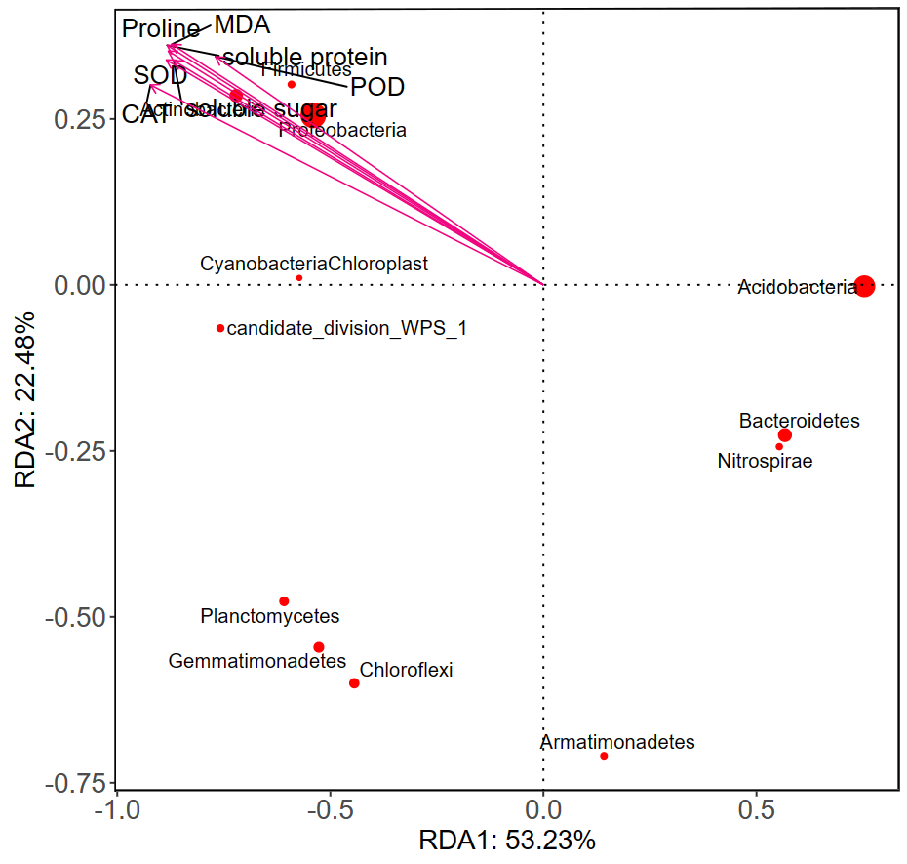
Figure S1. Redundant analysis of relationships between abundant phylum and drought resistance indicators in ‘Baiye No.1’.
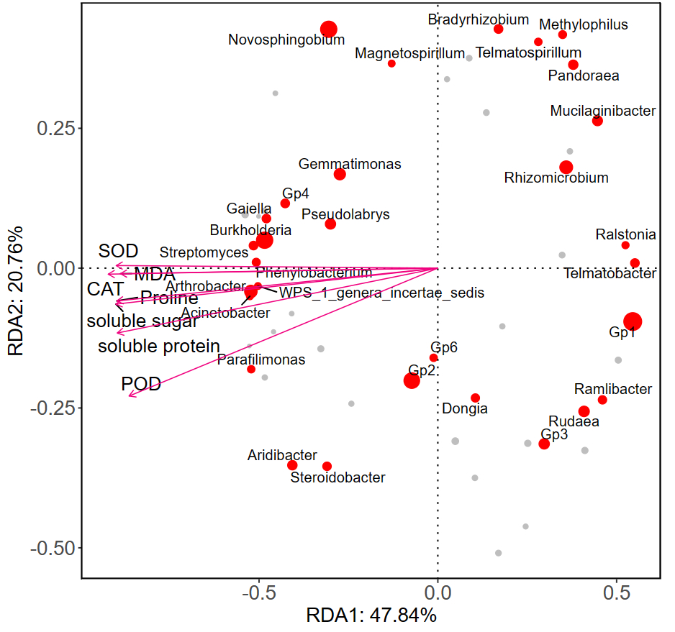
Figure S2. Redundant analysis of relationships between abundant genus and drought resistance indicators in ‘Baiye No.1’.
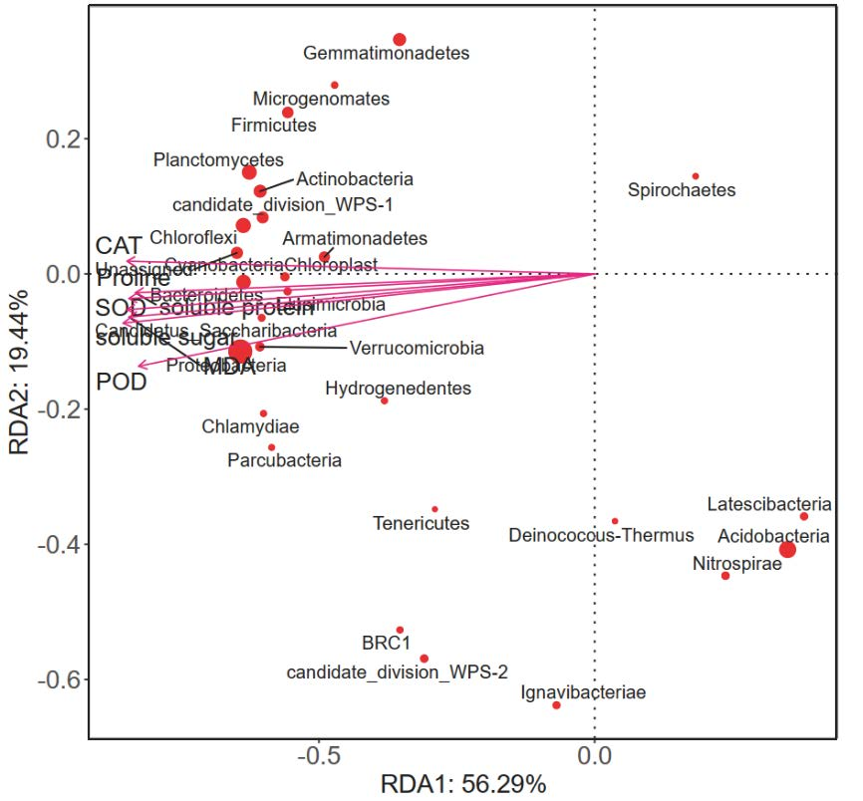
Figure S3. Redundant analysis of relationships between rare phylum and drought resistance indicators in ‘Baiye No.1’.
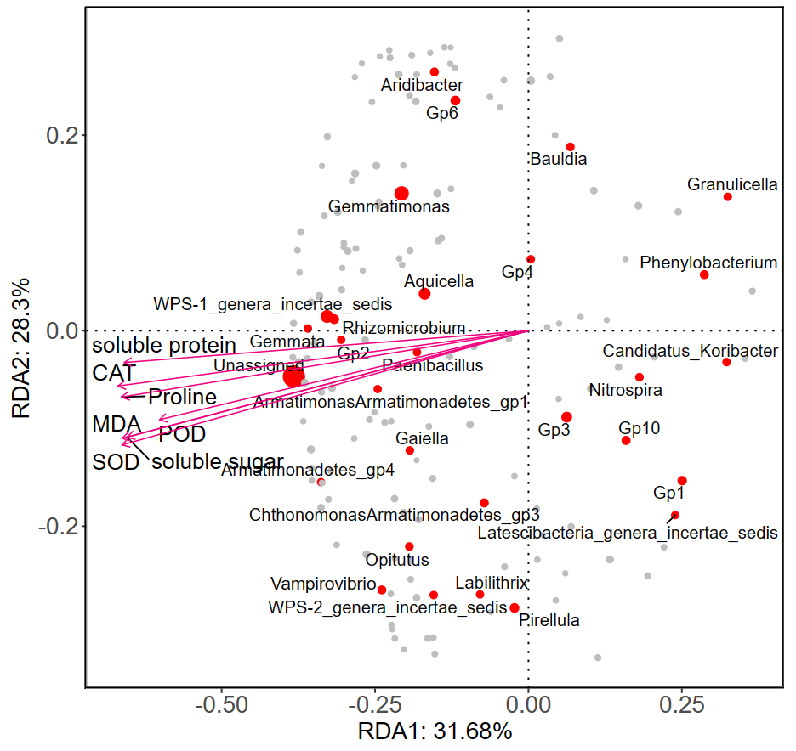
Figure S4. Redundant analysis of relationships between rare genus and drought resistance indicators in ‘Baiye No.1’.
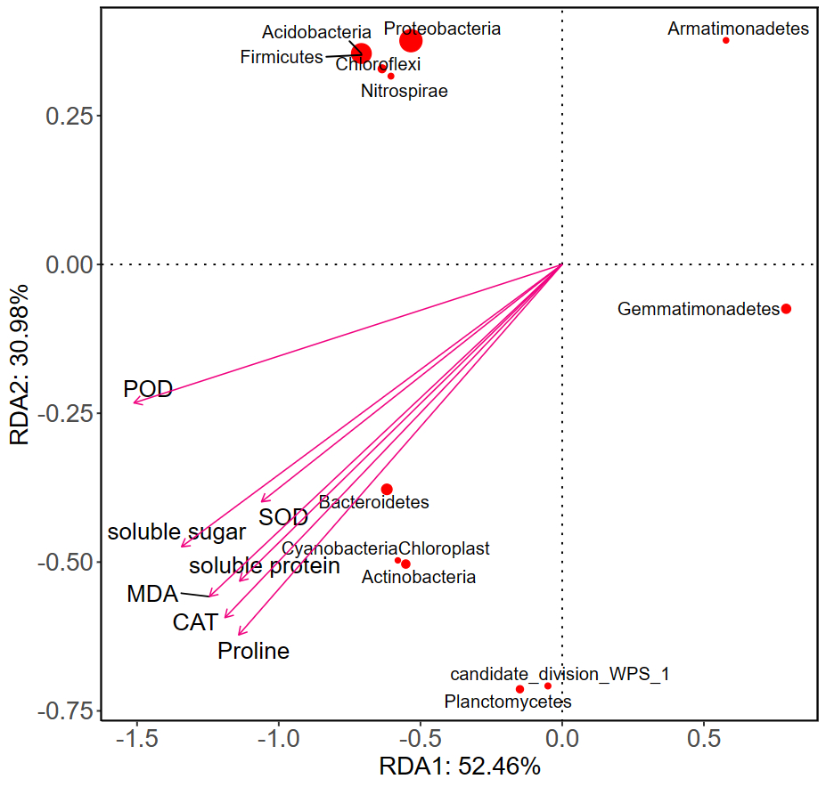

Figure S5. Redundant analysis of relationships between abundant phylum and drought resistance indicators in ‘FudingDabaicha’.
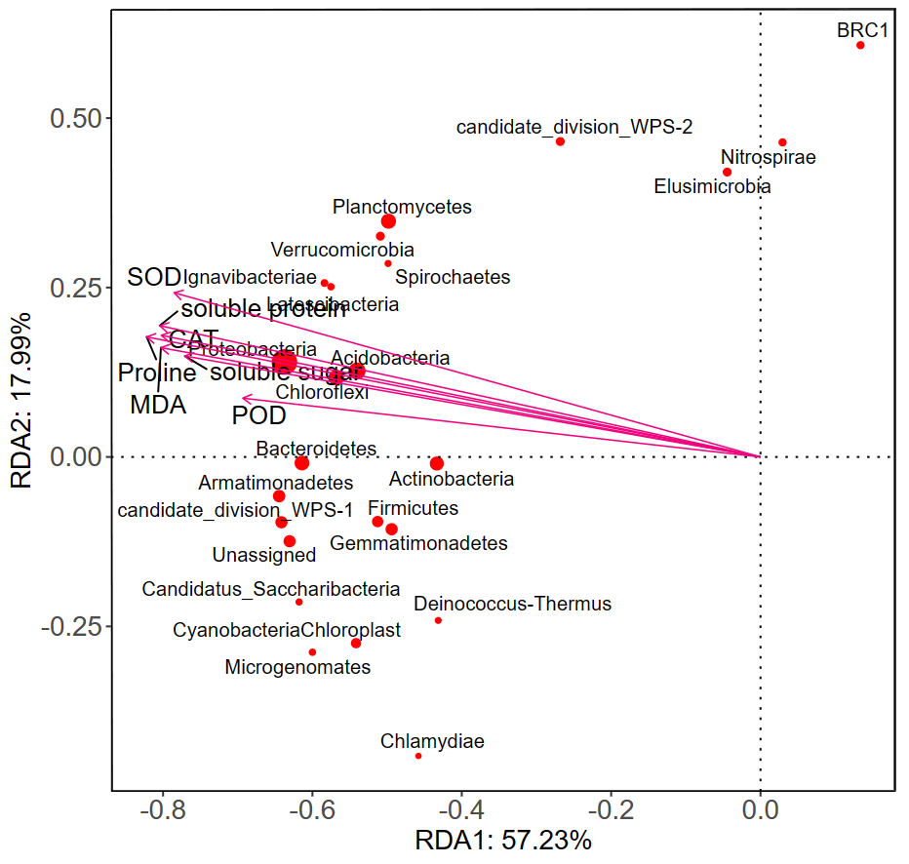
Figure S6. Redundant analysis of relationships between abundant genus and drought resistance indicators in ‘FudingDabaicha’.
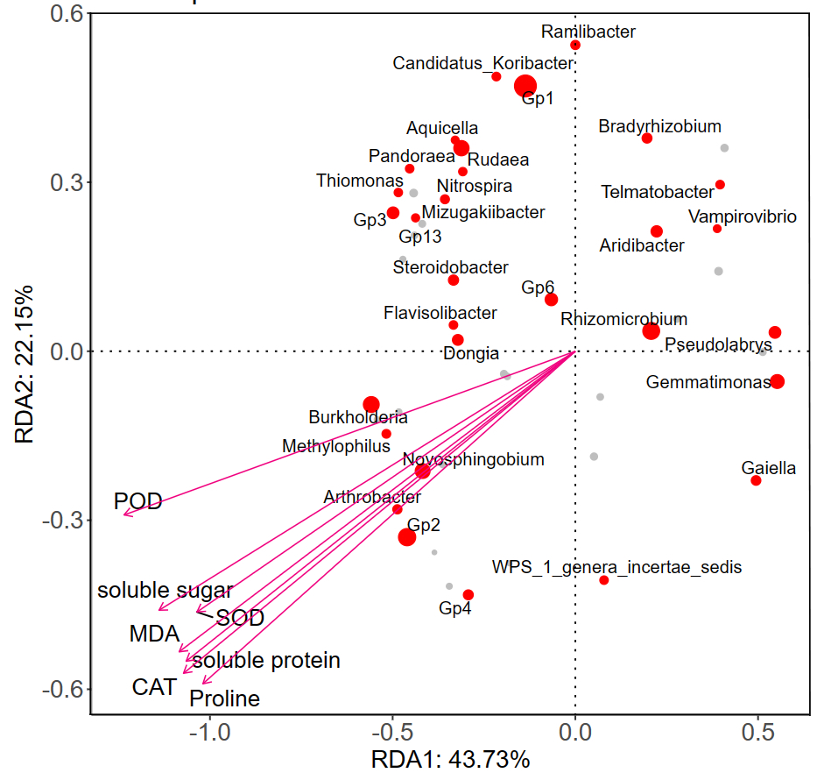
Figure S7. Redundant analysis of relationships between rare phylum and drought resistance indicators in ‘FudingDabaicha’.
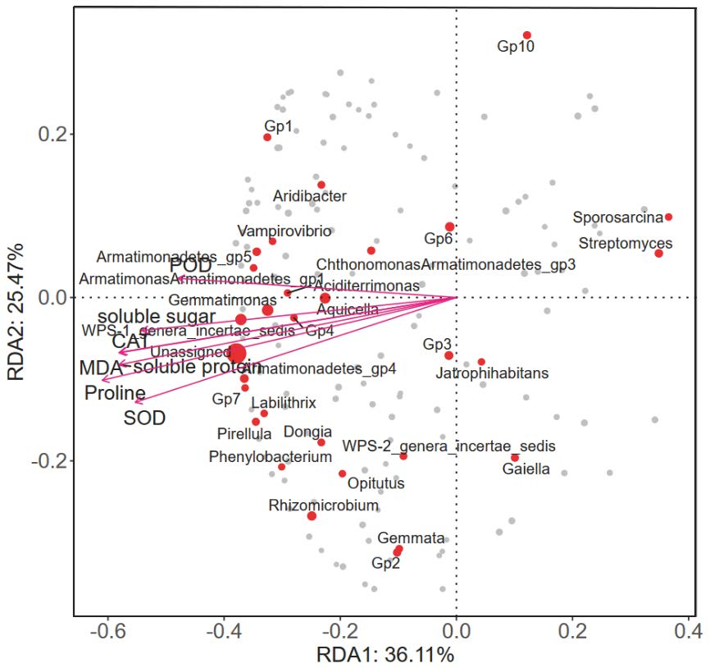
Figure S8. Redundant analysis of relationships between rare genus and drought resistance indicators in ‘FudingDabaicha’.

