Additional Information
Novel immunogenic cell death inducer combined with autophagy inhibitor to amplify photodynamic synergistic immunotherapy for triple-negative breast cancer
Gankun Yuanª, Ruyue Yang^{b}, Wenjing Wen^{b}, Zhaoyi Wei^{b}, Meiru Songª, Lingyang Zhangª, Kun Houª, Gaofeng Liang^{a,b*}
- Institute of Biomedical Research, Henan Academy of Sciences, 450000, Zhengzhou, Henan, People's Republic of China
- School of Basic Medicine and Forensic Medicine, Henan University of Science & Technology, 471023, Luoyang, Henan, People's Republic of China
*Corresponding Author: Gaofeng Liang
E-mail: lgfeng990448@163.com
Synthesis of poly-β-CD: Synthesis of poly-β-CD based on previous literature reports^{[1,2]}. First, the accurately weighed compound β-CD (10 g) was dissolved in NaOH (15 WT%, 15 mL) solution, stirred at 35℃ for 2 h, and then toluene (2 mL) was added to stir for 2 h. Subsequently, 3.8 mL epichlorohydrin as a crosslinking agent was added to the reaction system for slow reaction for 3 h, the crude product was pretreated with isopropyl alcohol (200 mL), the precipitates were dissolved in water and neutralized with dilute hydrochloric acid. Finally, the reaction solution was dialysed in deionized water (MW = 8000) for 2 days, changing the water every 3 h to remove the monomers and oligomers. White solid products were prepared by vacuum freeze-drying.
Synthesis of Da-COOH: Synthesis of poly-β-CD based on previous literature reports^{[3,4]}. First, accurately weighed dasatinib (1.60 g, 3.27 mmol) and succinic anhydride (0.37 g, 3.70 mmol) were placed in a double-necked bottle. Then, anhydrous DMF (15 mL) was added to the two-necked flask and accurately weighed triethylamine (0.70 g, 6.93 mmol) was slowly added to the mixing reaction drop by drop. The reaction was stirred at room temperature for 48 h. After the reaction, the reaction system was evaporated by vacuum rotation, and the mixture was purified by column chromatography (CH₂Cl₂/CH₃OH 20:1 v/v). Finally, the white solid compound Da-COOH (1.73 g) was obtained, and the yield was 90%.
Synthesis of Da-Ad: First, Da-COOH (0.9 g, 2.0 mmol) was accurately weighed and placed in a round-bottled flask, and 30 mL anhydrous DMF solution was added. Then NHS (0.3 g, 2.4 mmol) and EDCI (0.5 g, 2.4 mmol) were accurately weighed and added into the mixed reaction solution. Reaction in ice bath for 1 h. Then, accurately weighed amantadine (0.3 g, 2.1 mmol) was added to the mixture and stirred at room temperature for 12 h. After the reaction, the mixture was purified by column chromatography (CH₂Cl₂/CH₃OH 30:1 v/v) to obtain the white solid compound Da-Ad (0.72 g) with a yield of 65%. ¹H NMR (400 MHz, DMSO-d₆) δ 9.90 (s, 1H), 8.24 (s, 1H), 7.40 (d, J = 7.6 Hz, 1H), 7.33 (s, 1H), 7.28 (d, J = 4.3 Hz, 1H), 6.07 (s, 1H), 4.14 (t, J = 5.6 Hz, 2H), 3.51 (s, 4H), 2.59 (s, 2H), 2.48-2.38 (m, 6H), 2.32 (t, J = 6.6 Hz, 2H), 2.24 (s, 3H), 1.98 (s, 3H), 1.90 (s, 3H), 1.59 (s, 6H), 1.35 (s, 2H), 1.25 (d, J = 9.9 Hz, 4H), 0.88 (d, J = 19.4 Hz, 1H). ¹³C NMR (151 MHz, DMSO-d₆) δ 162.68, 154.31, 154.19, 143.03, 137.33, 130.17, 127.82, 126.97, 124.67, 123.54, 118.86, 111.08, 67.38, 57.40, 55.18, 54.59, 52.73, 45.97, 44.26, 42.09, 41.31, 36.46, 36.10, 34.35, 32.83, 31.30, 29.19, 25.50, 21.30, 15.95, 14.55, 7.66. HRMS (ESI): m/z calculated for C₃₆H₄₅ClN₈O₄S [M + H]⁺: 721.3052, found: 721.3009.
Synthesis of ET: First, the accurately weighed ethylenediamine (1.5 g, 25 mmol) was dissolved in anhydrous dichloromethane solution (50 mL), and then the ice bath was mixed. Then, the weighed p-methylbenzene sulfonyl chloride (0.95 g, 5 mmol) was dissolved in anhydrous dichloromethane solution (5 mL), and then slowly added to the reaction system and continued to react at room temperature for 24 h. After the reaction, the mixture was purified by column chromatography (CH₂Cl₂/CH₃OH 30:1 v/v) to obtain the light yellow solid compound ET (0.75 g) with a yield of 72%.¹H NMR (400 MHz, CDCl₃-d₆) δ 7.76 (s, 2H), 7.29 (d, J = 8.0 Hz, 2H), 2.97 (d, J = 11.2 Hz, 2H), 2.83 (s, 2H), 2.41 (s, 3H). ¹³C NMR (101 MHz, CDCl₃-d₆) δ 143.17, 136.44, 129.74, 127.09, 44.92, 40.79, 21.13. HRMS (ESI): m/z calculated for C₉H₁₄N₂O₂S [M + H]⁺: 215.0855, found: 215.0824.
Synthesis of CET: First, Ce6 (48.0 mg, 0.08 mmol), HOBT (16.0 mg, 0.12 mmol) and EDCI (23.0 mg, 0.12 mmol) were dissolved in anhydrous DMF solution (3 mL) and reacted at room temperature without light for 30 min. ET (21.4 mg, 0.10 mmol) was added to the system and the reaction continued for 24 h. After the reaction, the mixture was purified by column chromatography (CH₂Cl₂/CH₃OH 30:1 v/v) to obtain brown-black solid compound CET (12.3 mg) with a yield of 19%. ¹H NMR (400 MHz, DMSO-d₆) δ 9.87 (s, 1H), 8.23 (s, 1H), 7.32-7.22 (m, 3H), 6.06 (s, 1H), 4.13 (t, J = 5.6 Hz, 2H), 3.50 (s, 4H), 2.58 (d, J = 11.4 Hz, 2H), 2.43 (d, J = 6.9 Hz, 2H), 2.40 (s, 3H), 2.31 (t, J = 6.6 Hz, 2H), 2.23 (s, 3H), 1.97 (s, 4H), 1.88 (s, 6H), 1.58 (s, 6H), 1.29 (d, J = 47.2 Hz, 6H), 0.86 (d, J = 23.2 Hz, 2H). ¹³C NMR (151 MHz, DMSO-d₆) δ 175.31, 174.90, 172.89, 170.75, 169.87, 168.44, 157.65, 152.29, 149.18, 144.14, 143.23, 142.23, 141.86, 137.58, 137.02, 136.48, 135.28, 133.60, 133.23, 132.96, 131.26, 130.13, 129.77, 129.22, 128.55, 126.98, 126.09, 121.71, 60.23, 52.40, 48.24, 42.90, 42.43, 32.34, 30.78, 23.88, 21.36, 19.36, 18.24, 14.56, 12.60, 11.55. HRMS (ESI): m/z calculated for C₄₃H₄₈N₆O₇S [M + H]⁺: 793.3384, found: 793.3346.

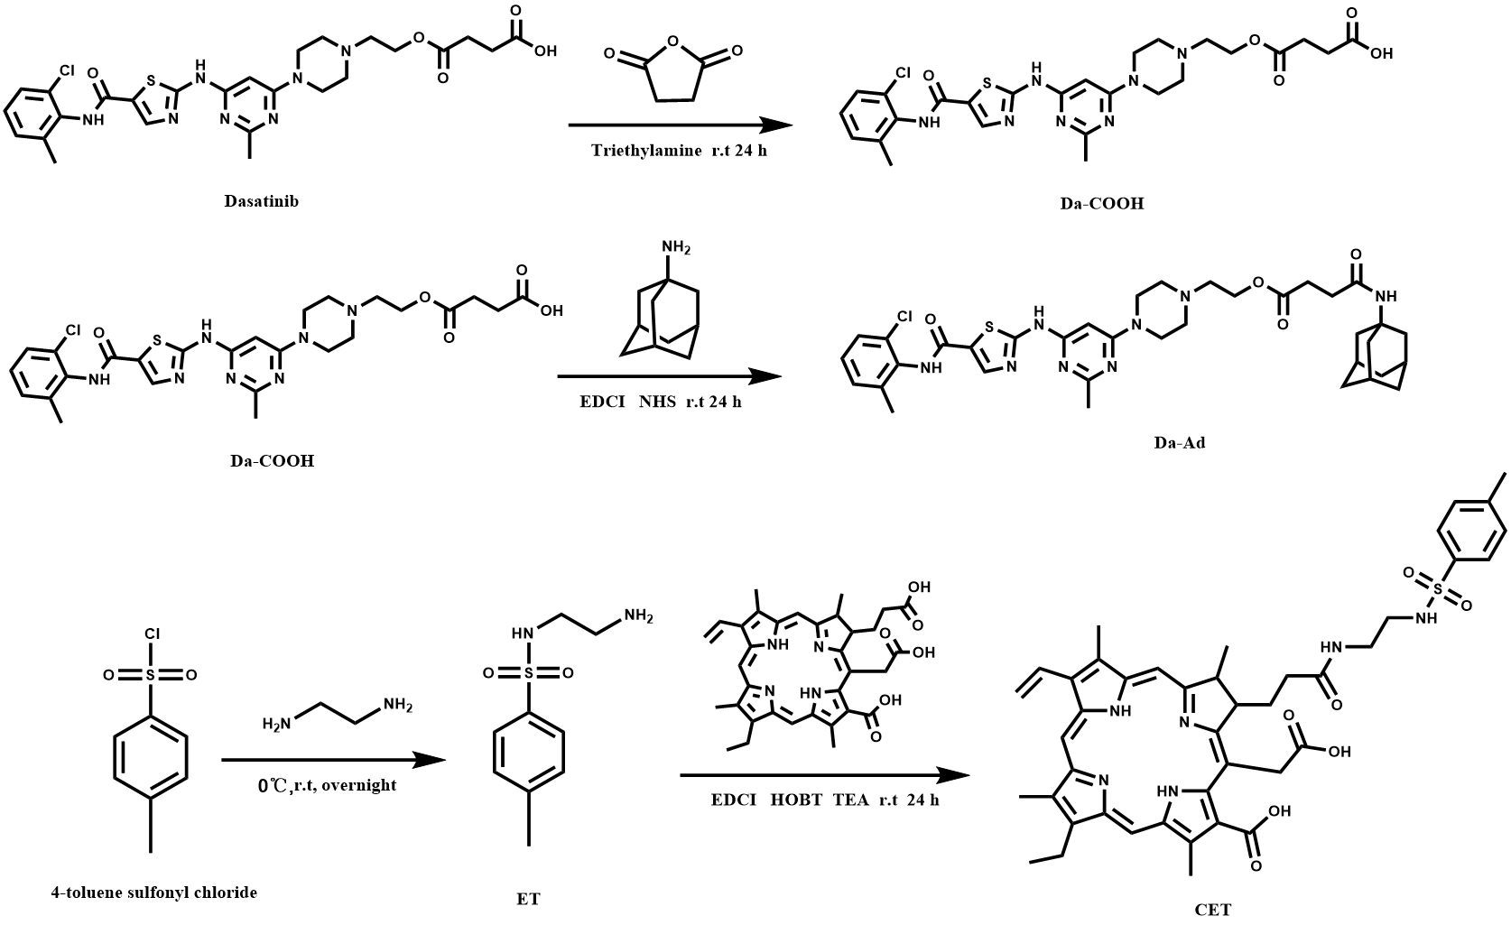
Fig. S1. The synthetic route of targeting compound Da-Ad and ER targeting photosensitizer CET.

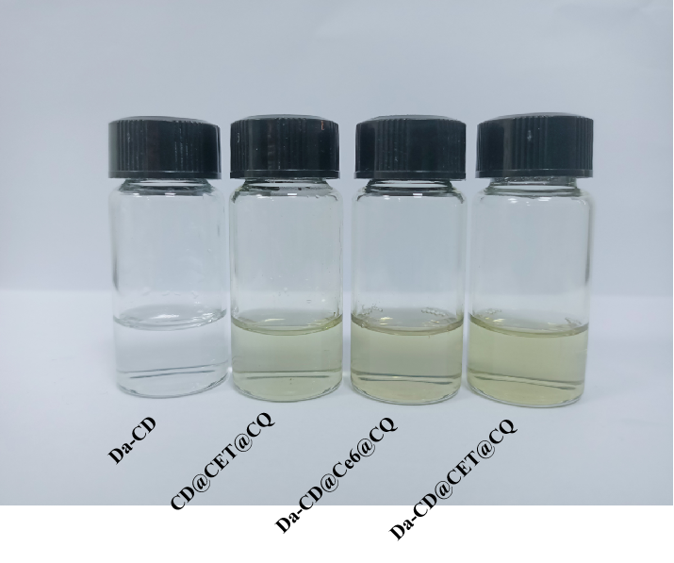
Fig. S2. The status of Da-CD NPs, CD@CET@CQ NPs, Da-CD@Ce6@CQ NPs and Da-CD@CET@CQ NPs in DI water for 1 day.

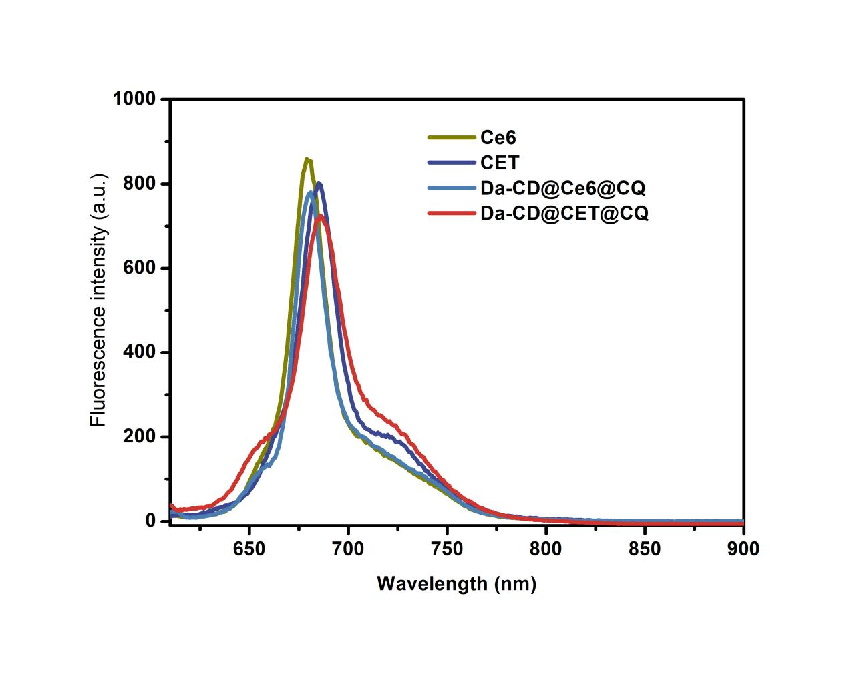
Fig. S3. Fuorescence emission spectra of Ce6, CET, Da-CD@Ce6@CQ NPs and Da-CD@CET@CQ NPs in DMF with the excitation wavelength at 610 nm.

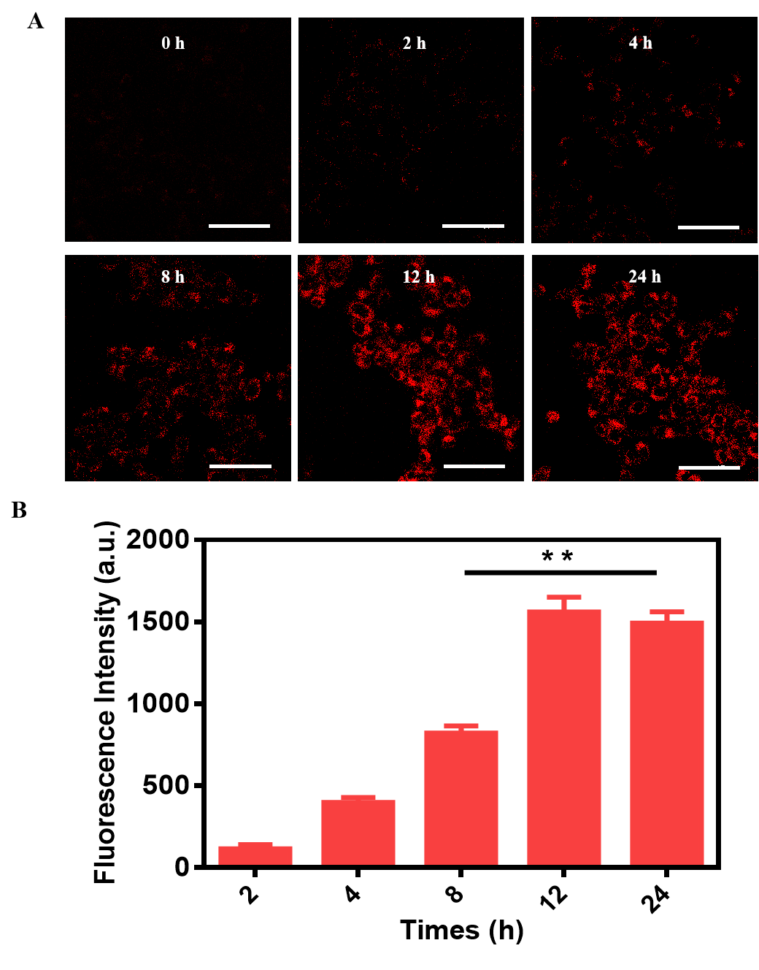
Fig. S4. A) The uptake of Da-CD@CET@CQ NPs in 4T1 cells at different time points was observed by CLSM. B) The average fluorescence intensity in 4T1 cells at different time points. The scale is 50 μm.

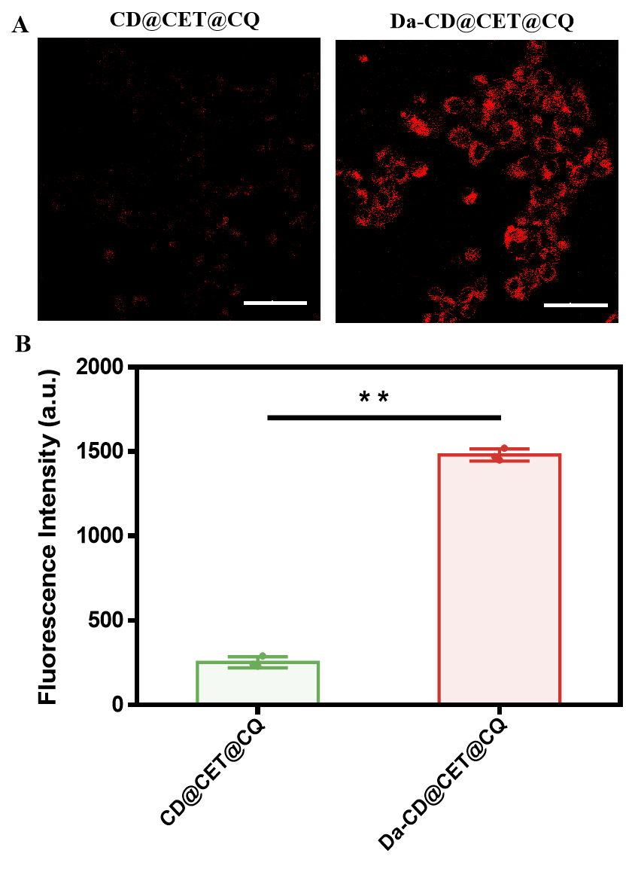
Fig. S5. A) The uptake of CD@CET@CQ NPs and Da-CD@CET@CQ NPs in 4T1 cells incubate for 12 h was observed by CLSM. B) The average fluorescence intensity in 4T1 cells incubate for 12 h. The scale is 50 μm.

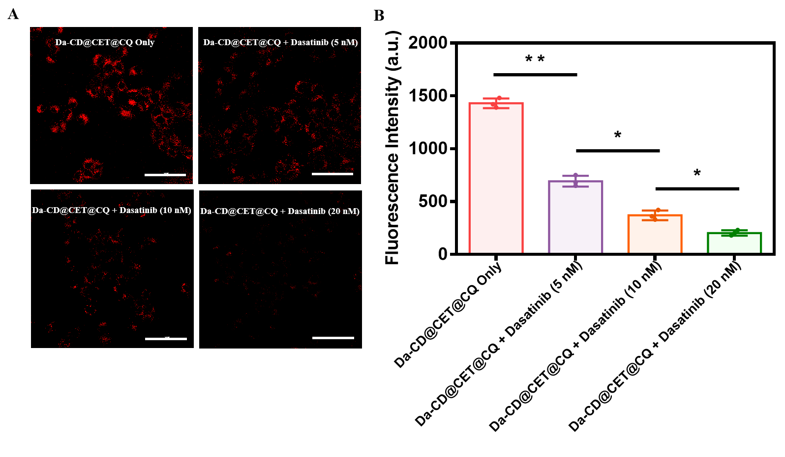
Fig. S6. A) The uptake of Da-CD@CET@CQ NPs by 4T1 cells and B) average intracellular fluorescence intensity after incubation with different concentrations of Da (0, 5, 10 and 20 nM) were detected by CLSM. The scale is 50 μm.

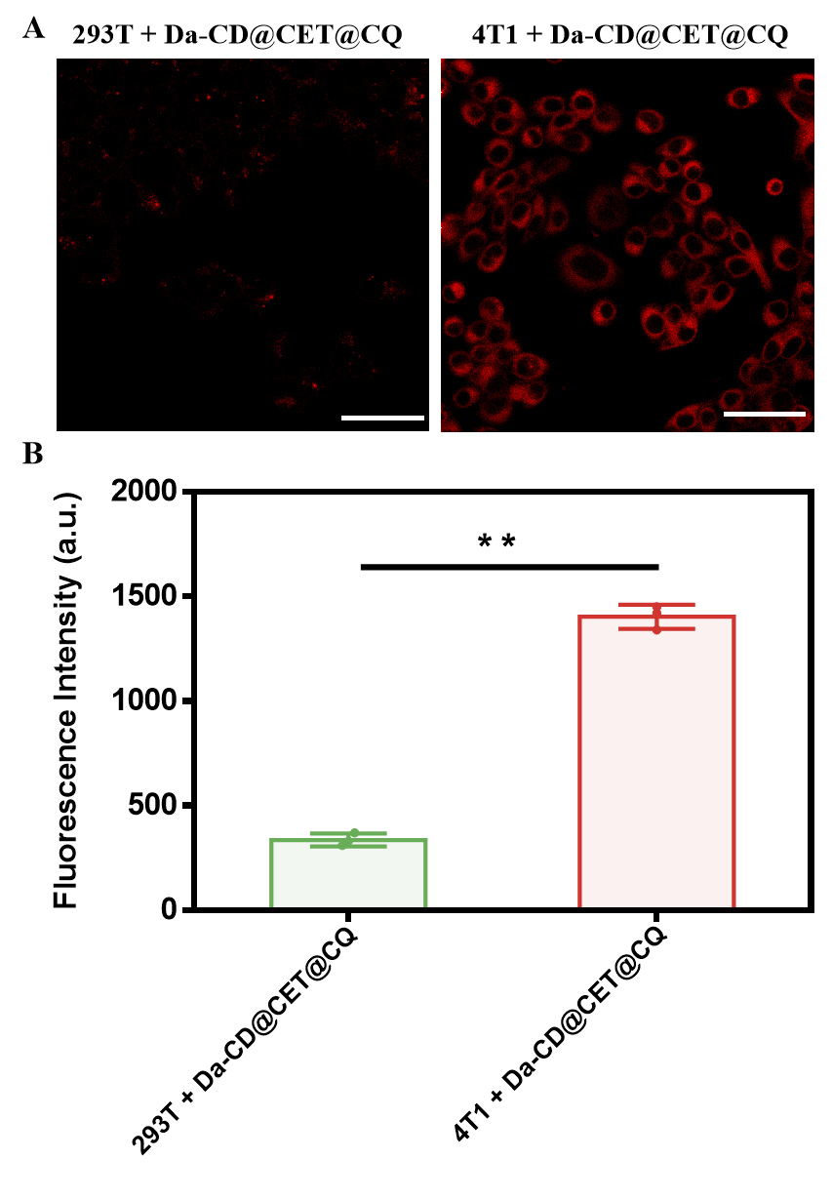
Fig. S7. A) The uptake of Da-CD@CET@CQ NPs by 293T cells or 4T1 cells and B) average intracellular fluorescence intensity were detected by CLSM. The scale is 50 μm.

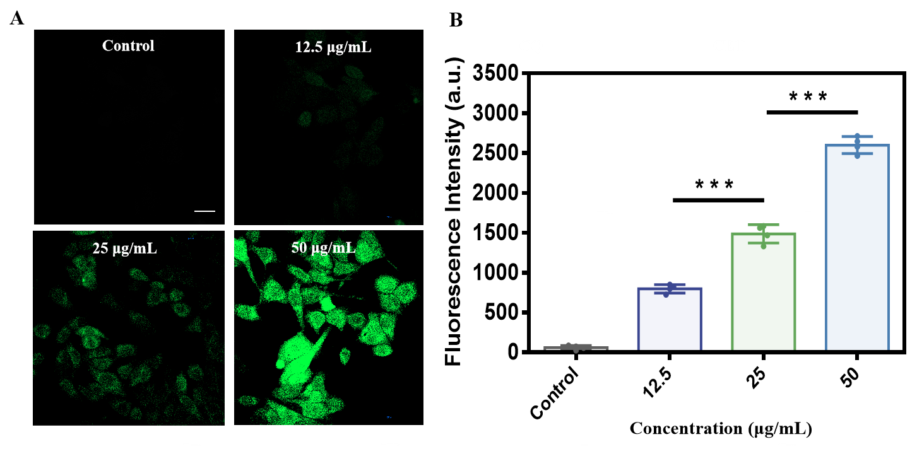
Fig. S8. A) Under the illumination condition (λ = 670 nm, 4 mW/cm²), the different concentrations of Da-CD@CET@CQ NPs (0, 12.5, 25 and 50 μg/mL) produced fluorescent images of ROS in 4T1 cells were observed by CLSM and B) the mean intracellular ROS fluorescence intensity. The scale is 20 μm.

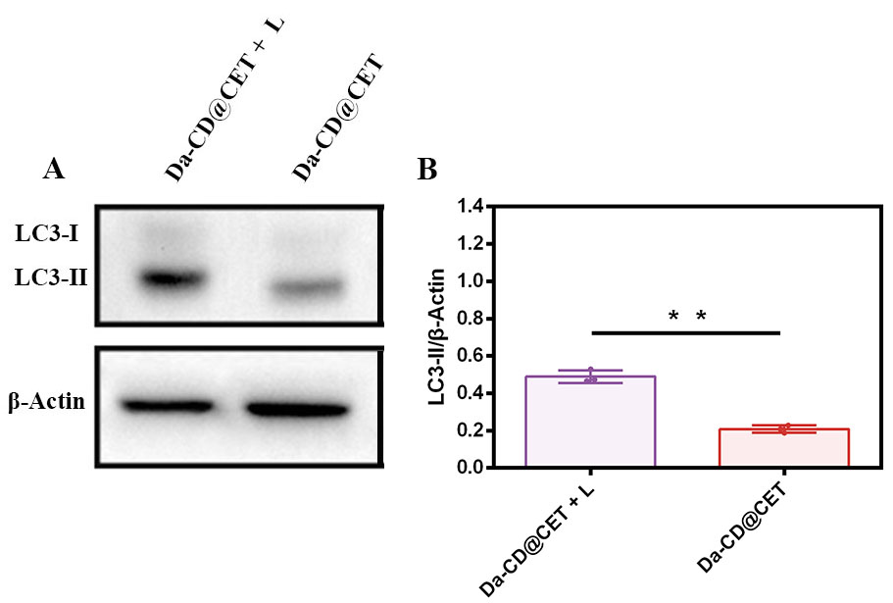

Fig. S9. A) Immunoblot detection of LC3-I and LC3-II. B) The gray scale analysis of LC3-II. β-actin was used as a loading control. 4T1 cells were administered Da-CD@CET NPs with or without a laser (λ = 670 nm, 4 mW/cm²).

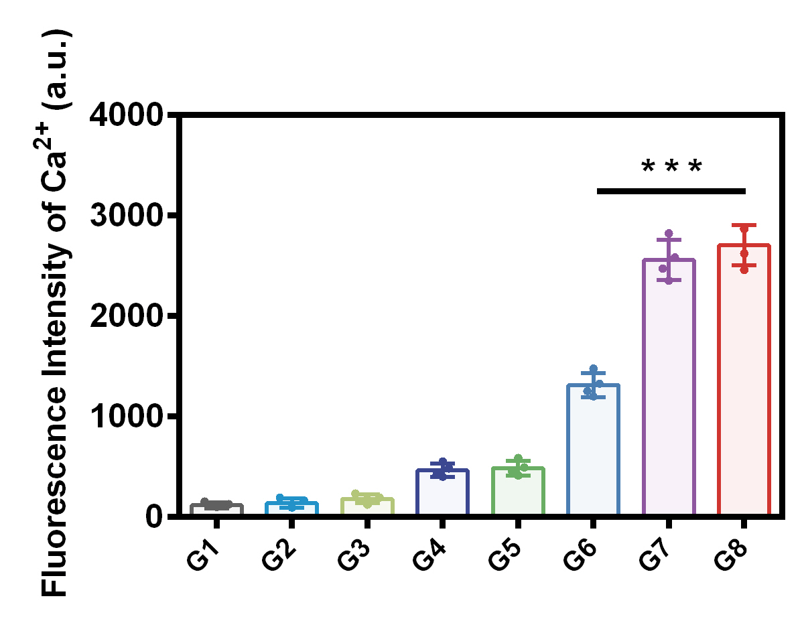
Fig. S10. CLSM images showed the distribution of intracellular Ca²⁺ of different groups. The scale is 20 μm.

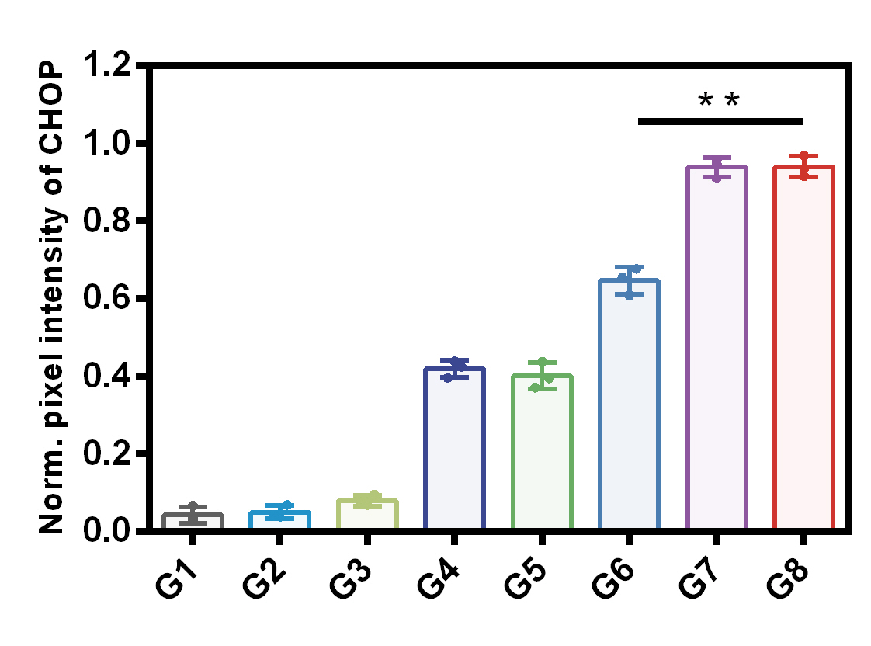
Fig. S11. A) Quantification of the CHOP by pixel intensity.

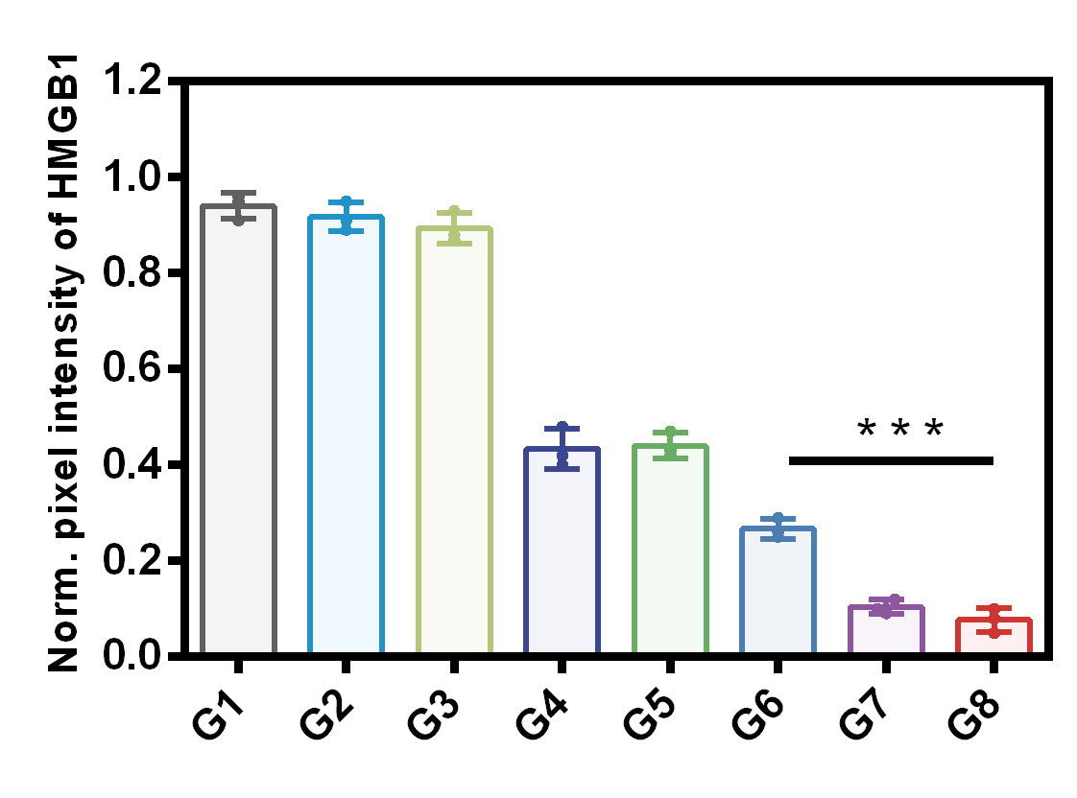
Fig. S12. A) Quantification of the HMGB1 by pixel intensity.

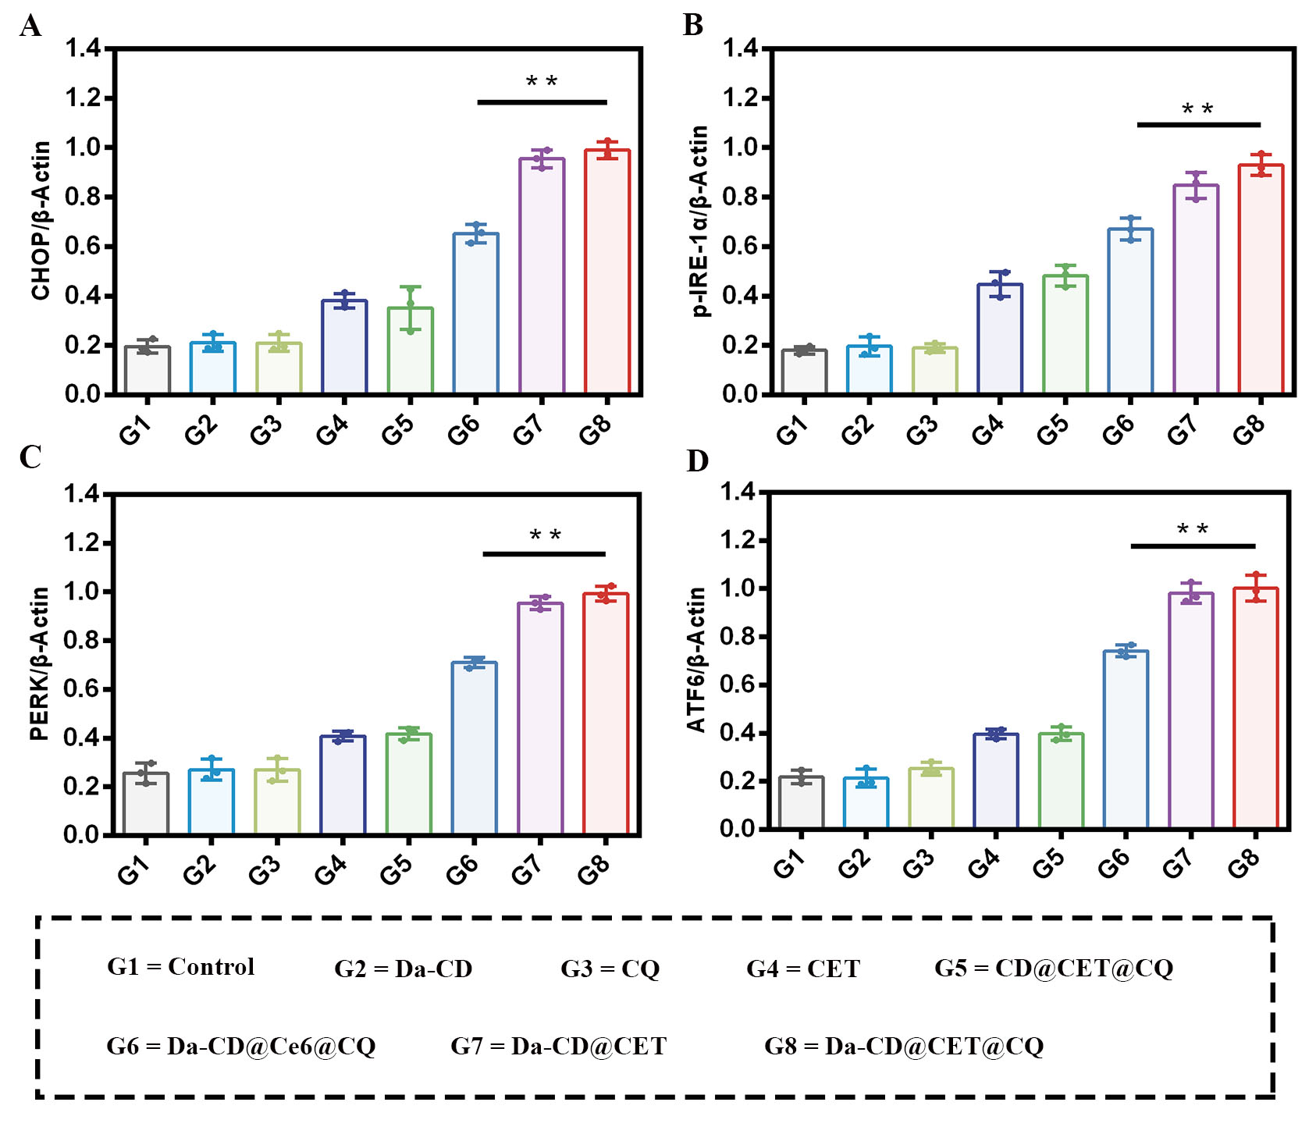
Fig. S13. The gray scale analysis of A) CHOP, B) p-IRE-1α, C) PERK and D) ATF6 bands. β-actin was used as a loading control.

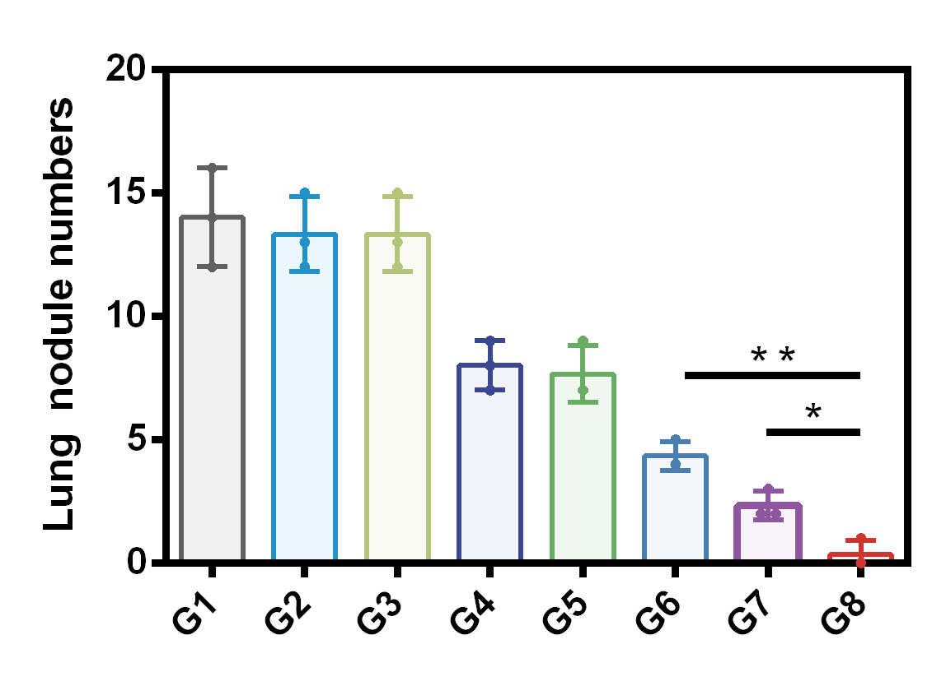
Fig. S14. Lung metastatic nodule numbers after day 15 of tumor inoculation of different group (n = 5). All results were presented as mean ± SD (n = 3). *p < 0.05, **p < 0.01.

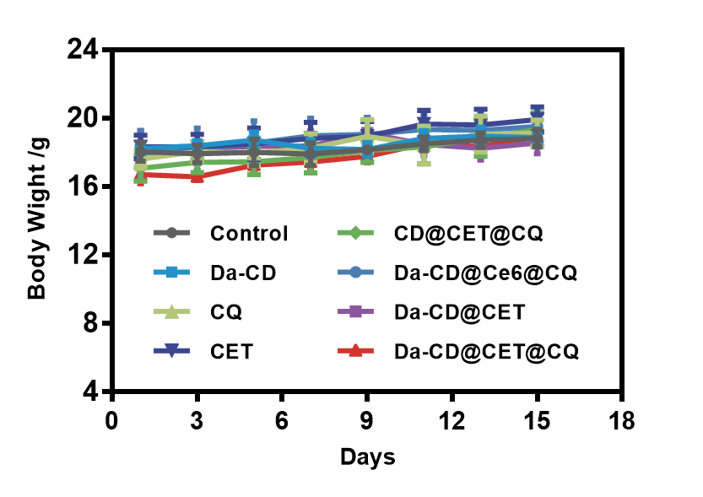
Fig. S15. Weight change curves of different groups of mice within 15 days of treatment.

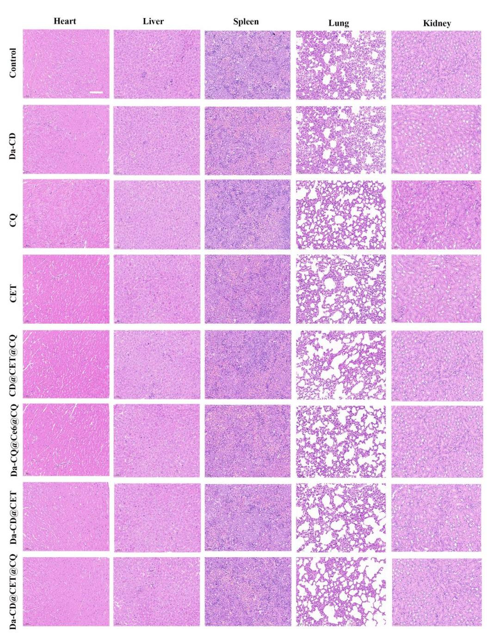
Fig. S16. H&E staining of major organs (Heart, Liver, Spleen, Lung, Kidney) in different groups of mice.

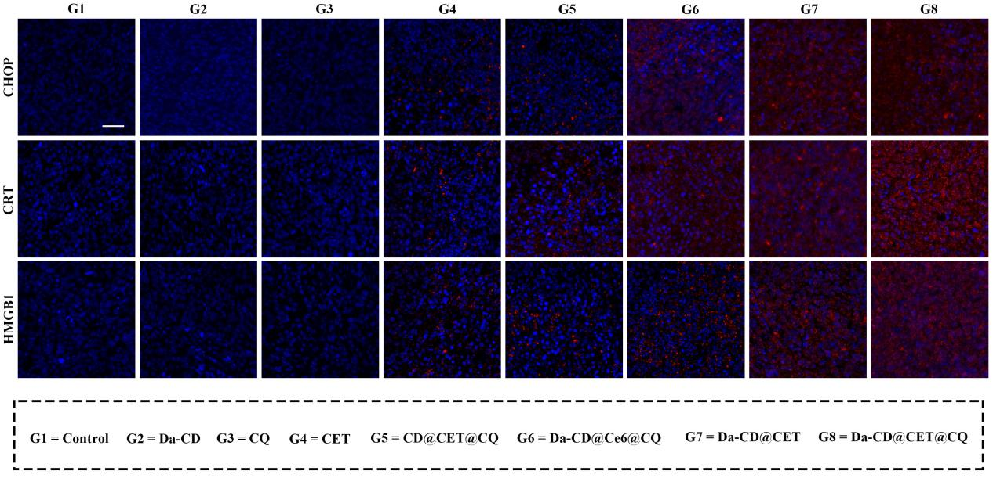
Fig. S17. Da-CD@CET@CQ NPs induced ER stress and DAMPs release under light irradiation in vivo. Immunofluorescence staining of of CHOP (upper), CRT exposure (middle) and HMGB1 release (lower) in 4T1 model mice after various treatments. The scale is 100 μm.

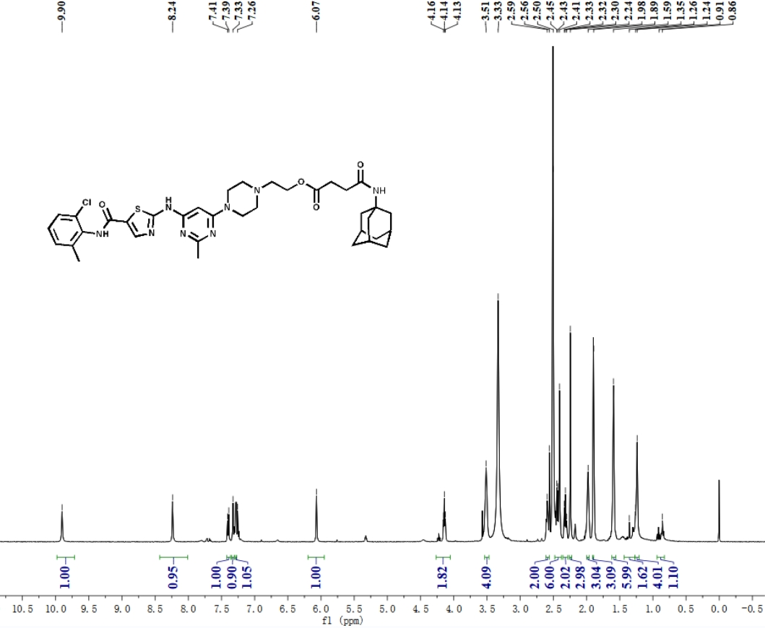
Fig. S18. ¹H NMR spectrum of Da-Ad (400 MHz, DMSO-d₆).

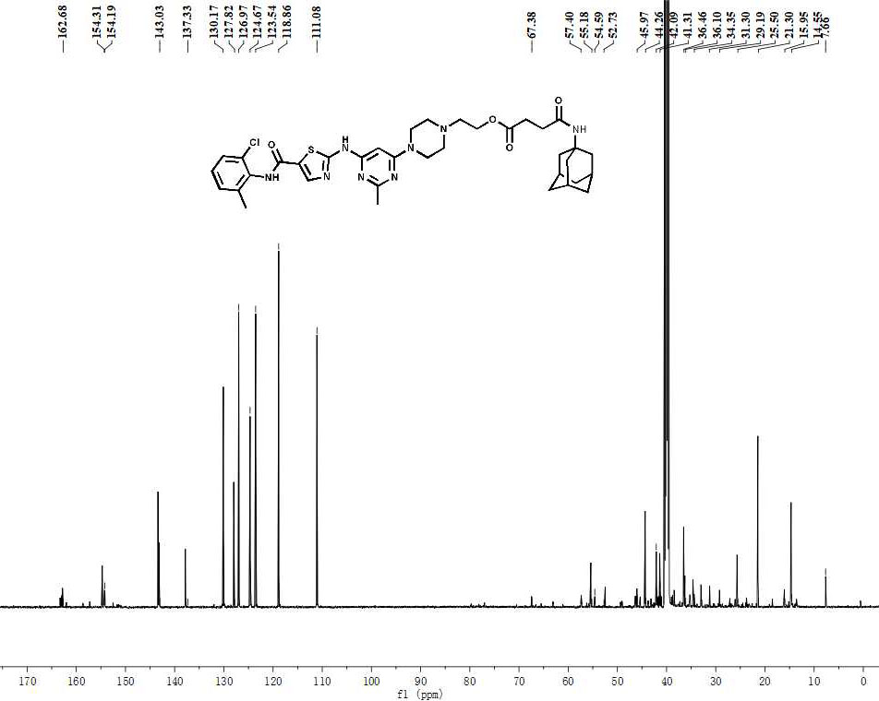
Fig. S19. ¹³C NMR spectrum of Da-Ad (151 MHz, DMSO-d₆).

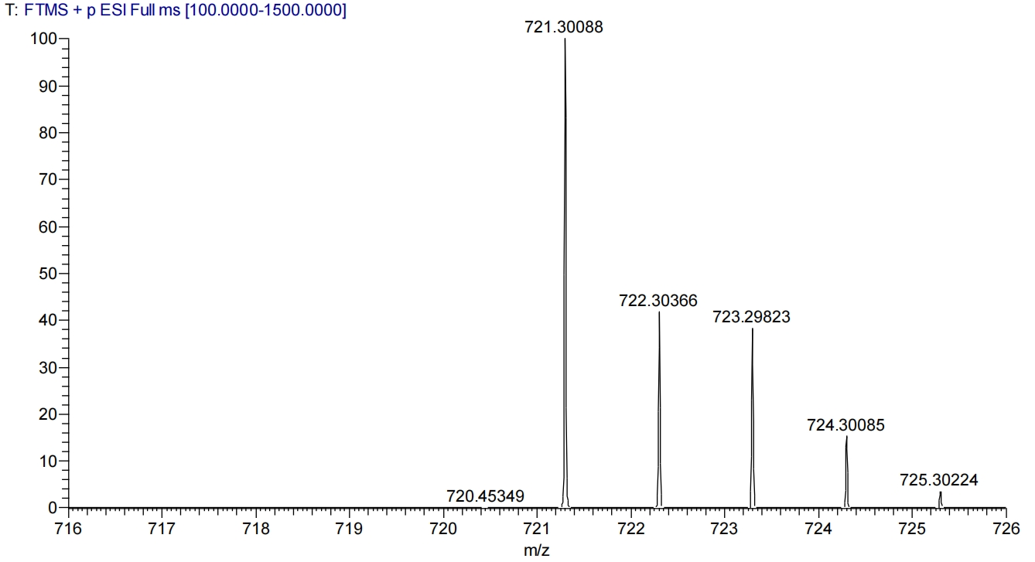
Fig. S20. HRMS spectrum of Da-Ad.

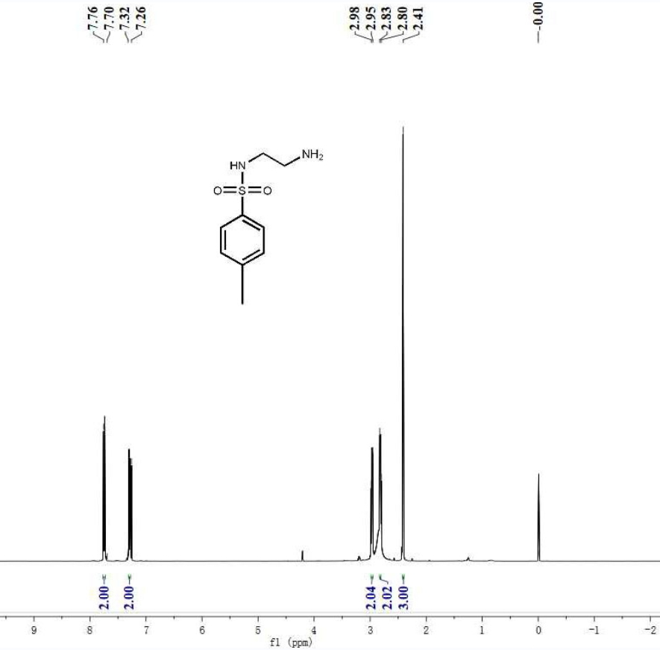
Fig. S21. ¹H NMR spectrum of ET (400 MHz, CDCl₃-d₆).

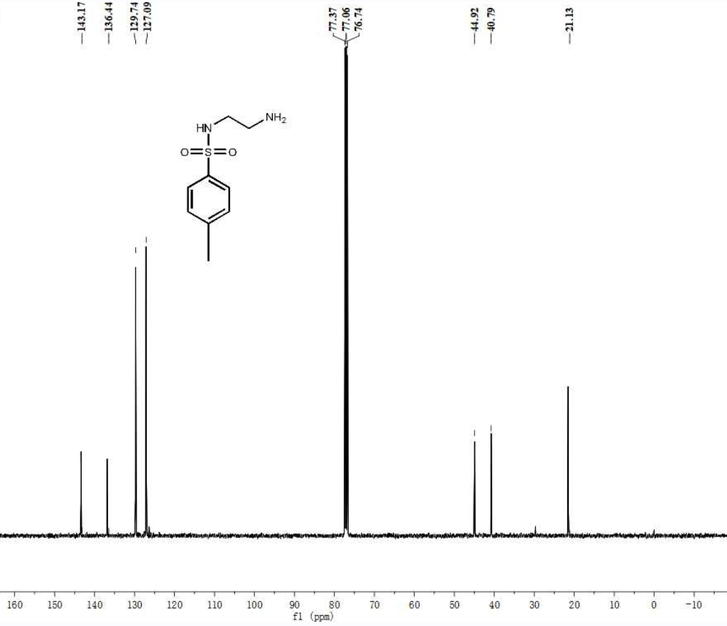
Fig. S22. ¹³C NMR spectrum of ET (101 MHz, CDCl₃-d₆).

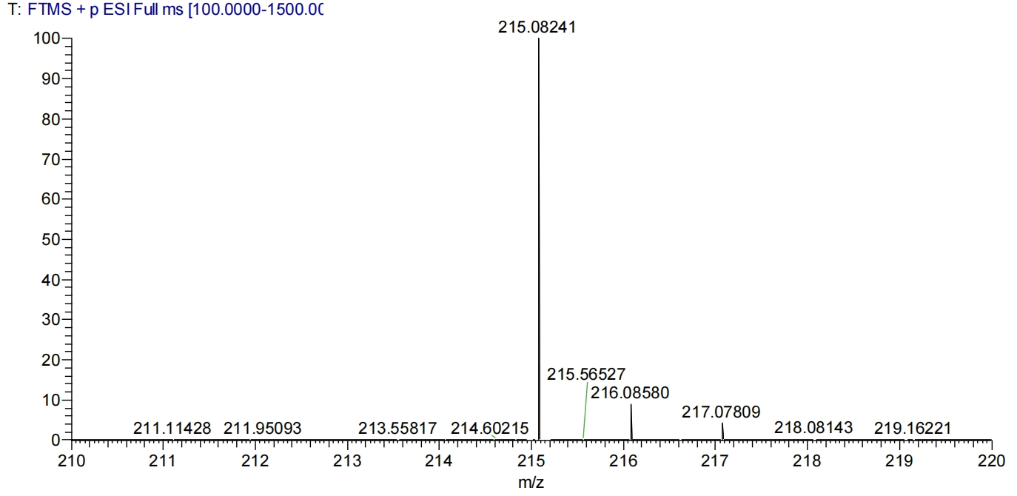
Fig. S23. HRMS spectrum of ET.

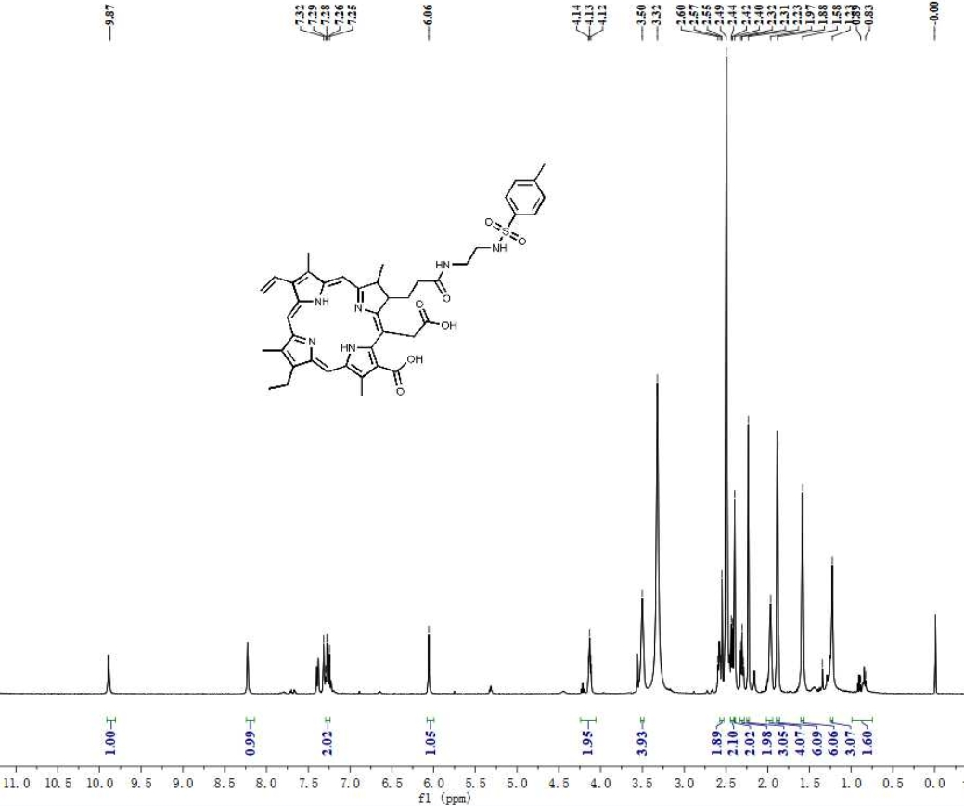
Fig. S24. ¹H NMR spectrum of CET (400 MHz, DMSO-d₆).

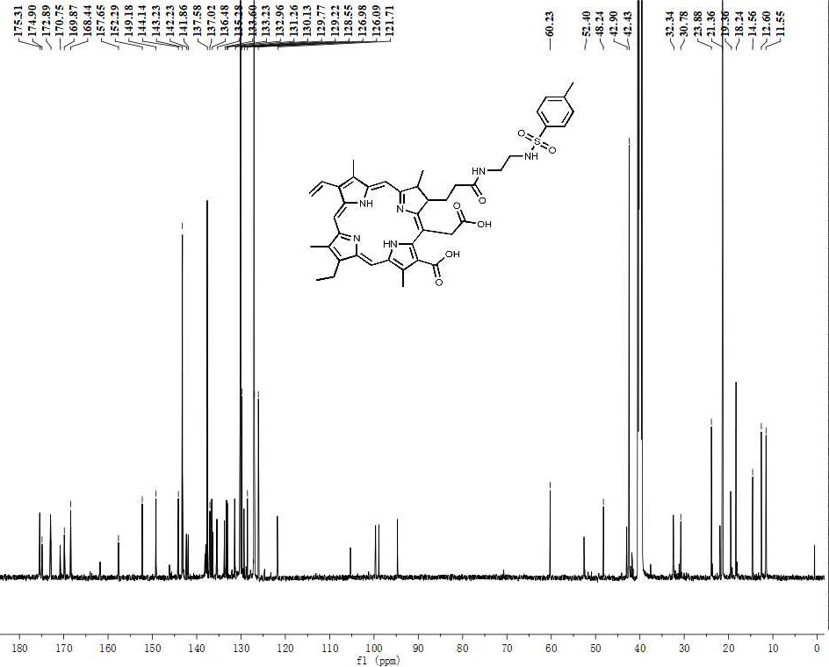
Fig. S25. ¹³C NMR spectrum of CET (151 MHz, DMSO-d₆).

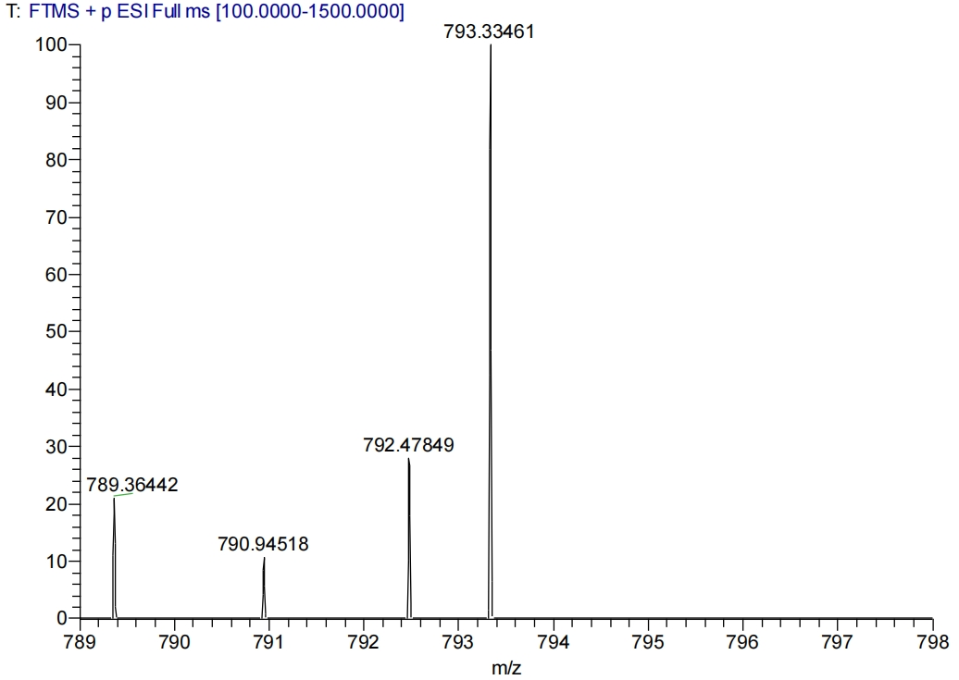
Fig. S26. HRMS spectrum of CET.

References
[1] C. Koopmans, H. Ritter, Macromolecules 2008, 41, 7418-7422.
[2] G. Yuan, Q. Wang, Z. You, X. Chen, J. Xue, X. Jia, J. Chen, Nano Res. 2022, 15, 4212-4223.
[3] E. Păunescu, C. Clavel, P.Nowak-Sliwinska, A. Griffioen, P. Dyson, Acs Med Chem Lett. 2015, 6, 313- 317.
[4] G. Yuan, M. Yao, H. Lv, X. J, J. Chen, J. Xue, J Med. Chem. 2020, 63, 15655−15667.

