Supplementary Informations
Obervation of relativistic collisionless shocks generation and breakout dynamics Authors: Yafeng Bai^{1, 3}, Dongdong Zhang¹, Yushan Zeng^{1, 3}, Jiakang Mao^{1, 3}, Liwei Song^{1, 3}, Ye Tian^{1, 3*}, Ruxin Li^{1,2,3*}
Affiliations:
1 State Key Laboratory of High Field Laser Physics, Shanghai Institute of Optics and Fine Mechanics, Chinese Academy of Sciences, Shanghai 201800, China.
2 Zhangjiang Laboratory, Shanghai 201210, China
3 Center of Materials Science and Optoelectronics Engineering, University of Chinese Academy of Sciences, Beijing 100049, China
*Corresponding author. Email: tianye@siom.ac.cn, ruxinli@siom.ac.cn
- Plasma density retrieved from the complex interference shadowgraph
Supplementary Fig.1 The plasma density measured at different time delays when preplasma density is ~ 0.1n_{c}: Up, spatiotemporal evolution of the density of the plasma in front of the target extracted from the interferometry; Down, the mean density distribution of plasmas along the x axis.
- Anisotropic parameter theory for expanding hot electrons
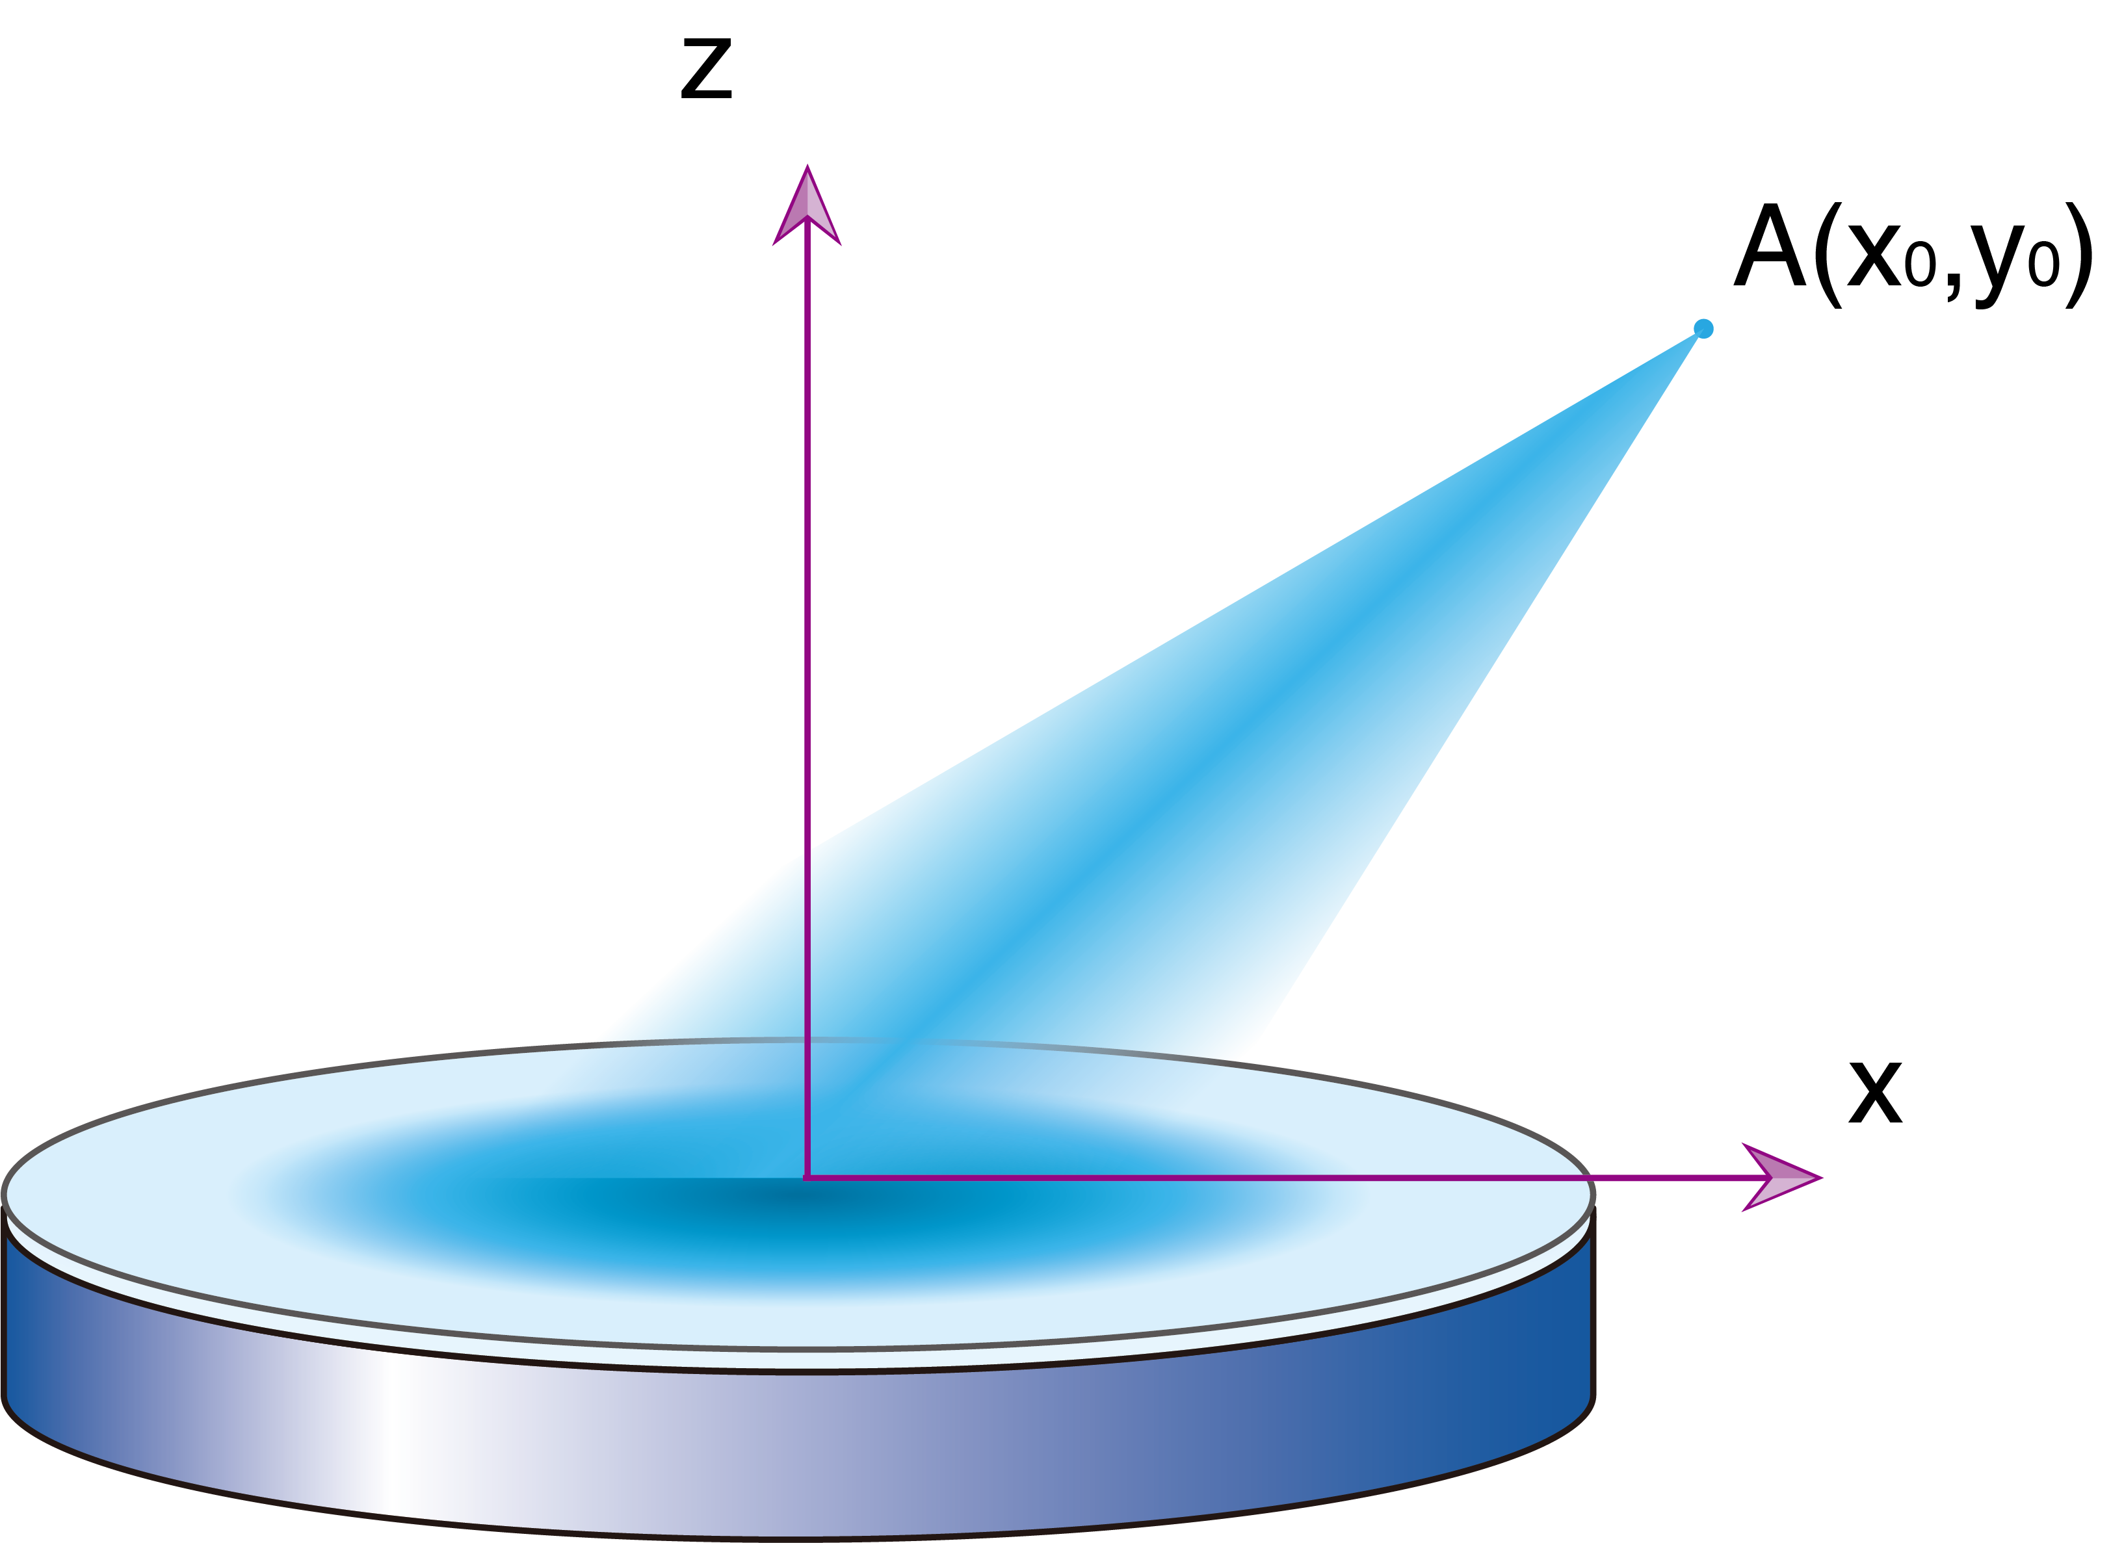
Supplementary Fig.2 A Sketch Map for the 2D electron expansion model
In laser solid density plasma interaction, laser energy is absorbed at the critical surface of the preplasma and then expands out of the target. For high preplasma densities (such n_{e} ~ 0.4n_{c}) in front of the target, since return currents can be stimulated easily, electrons can expand freely and thus a free-expanding model is suitable. Because the prepulse of the laser beam is illuminated onto the target ~ 2.8ns before the main pulse, plasmas have expanded for a sufficiently long time. The critical surface is on the target surface. In the following calculations, we assume electrons are expanding out from the surface of the target.
At first, if we assume electrons are expanding out from a point source, then the anisotropic parameter along the y direction A_{y} can be calculated as,
$$A_{y}=\frac{<v_{y}^{2}>}{<v_{x}^{2}>}-1=\cot^{2}{θ}-1$$
where θ is the angle between the y direction and the line that connects the reference point and the origin. This equation indicates that A_{y} peaks in the preferred y direction. Since a zero-dimension geometric point electron source is used in the calculation, A_{y} is divergent when θ = 0. Electrons can be seen as very unstable to the Weibel instability along the x-axis, while are relatively stable along other directions. Most importantly, when θ = π/4，A_{x} →0, which indicates that electrons are unstable only in the middle of the expanding plasma.
To show this more clearly, a more realistic 2D electron expansion model is established. In this model, electrons expand out from a line on the x-axis with a distribution function ρ(y). At each point on the line, electrons expand isotropically. If we only consider the electrons with constant velocity |v| = const, electron density at each point on the line decreases as ~ ρ/r while expanding along the line. As it is shown in Supplementary Fig.2, the anisotropic parameter along the y direction A_{y} can then be written as,
$A_{y}\left(x_{0},y_{0}\right)=\frac{T_{y}}{T_{x}}-1=\frac{<v_{y}^{2}>}{<v_{x}^{2}>}-1=\frac{\int_{-∞}^{∞}{dy}\frac{ρ\left(y\right)}{r}\frac{x_{0}^{2}}{r^{2}}}{\int_{-∞}^{∞}{dy}\frac{ρ\left(y\right)}{r}\frac{{\left(y-y_{0}\right)}^{2}}{r^{2}}}-1$ (S1)
If we take
$ρ\left(x\right)=\left\{\begin{aligned}1 \left|y\right|<r_{s}μm \\ 0 \left|y\right|≥r_{s}μm\end{aligned}\right.$ (S2)
Where r_{s} determines the size of the electron source. The integration in equation(S3) can be integrated out explicitly and gives
$$A_{x}=\frac{u}{\sinh^{-1}{\frac{r_{s}-y}{x}}+\sinh^{-1}{\frac{r_{s}+y}{x}}-u}-1$$
where $u=\frac{r_{s}-y}{r_{r}}-\frac{-r_{s}-y}{r_{l}}$, and r_{r} is distance between the point A and the right endpoint at (r_{s},0), r_{l} is the distance between the point A and the left endpoint (-r_{s},0). It is easy to check that when y >> r_{s}, Ax → -1. Most important of all, when |y| > r_{s}, A_{x} decreases to 0 quickly. This indicates that the expansion of the electrons is only unstable in the middle of the expanding plasma. This result is in good agreement with our point expansion model developed at first. For a more practical case, we can take $ρ\left(x\right)=ρ_{0}\exp\left(-\frac{x^{2}}{2σ^{2}}\right)$, the integration in equation(S3) cannot be integrated out explicitly. The integration in equation (S3) is calculated numerically, as it is shown in Supplementary Fig.3.
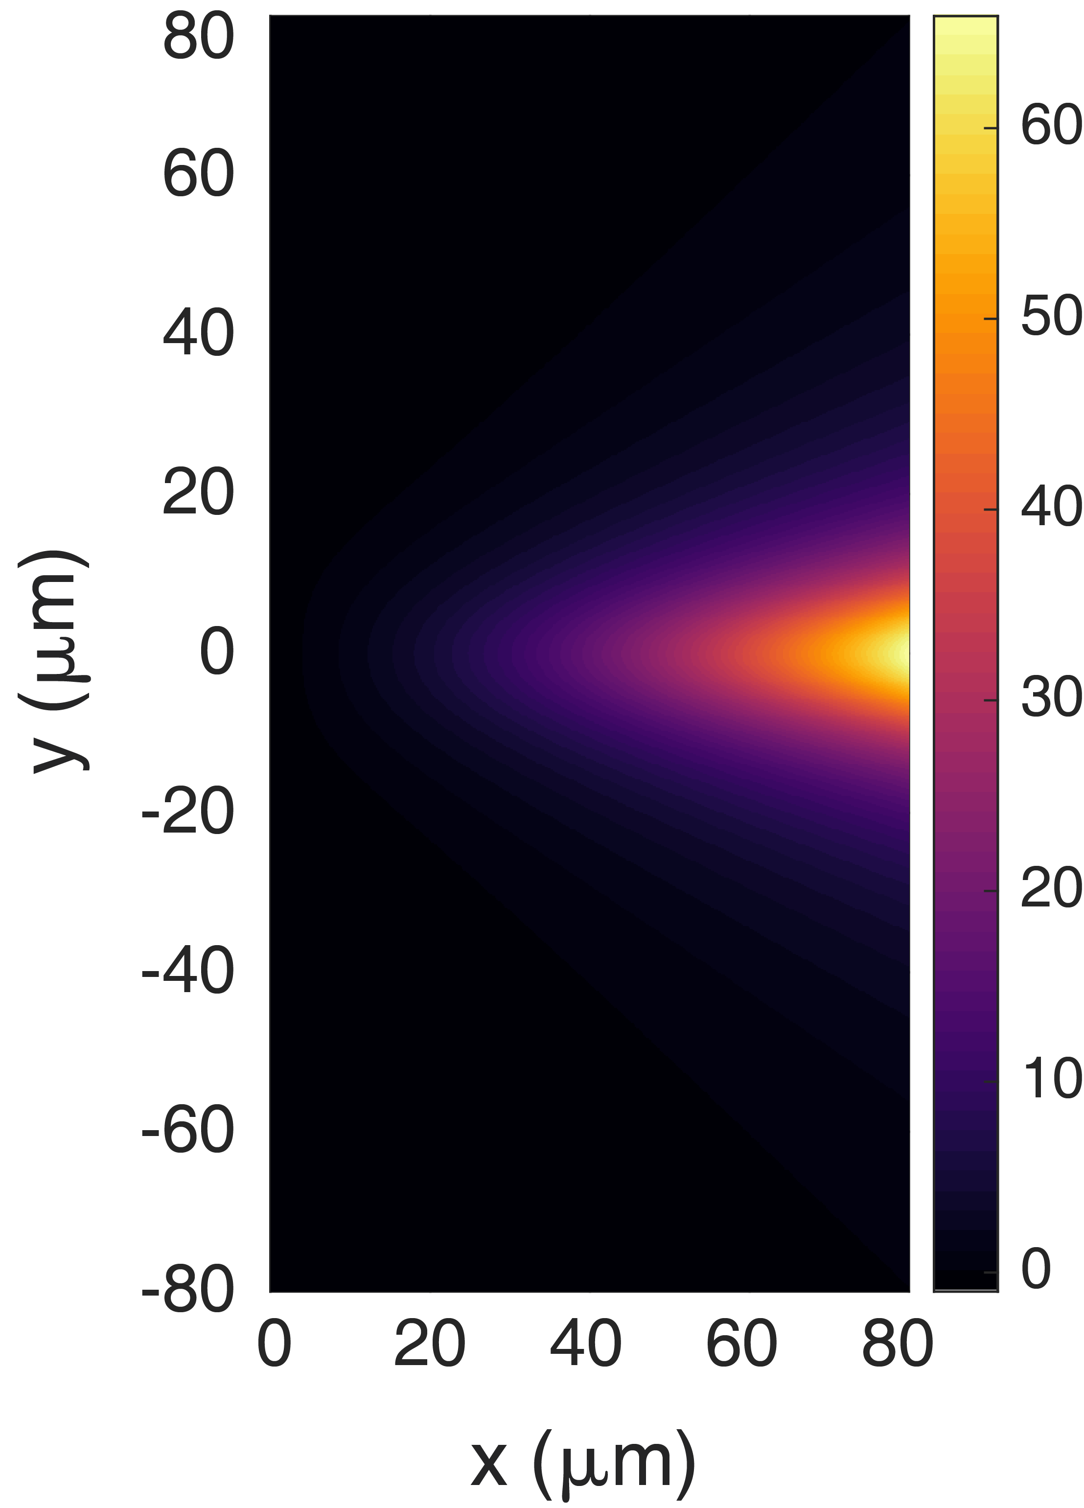
Supplementary Fig.3 A_{x}(x, y) calculated based on the numerical integration of equation (S1).
This indicates that electrons are unstable in the middle of the expanding plasma at the boundary of the plasma region, and the radius of the unstable region is approximately equal to several times the laser radius. This is just in good agreement with our experimental result, and due to small unstable regions, only 2-3 filaments can be observed.
- Simulations
Simulations are conducted and compared with the experimental results. The experimental results indicate that the acceleration of the aluminum ions is driven by the expanding electrons, this can result in highly directed ion beams which can be much different from an expanding plasma. Particle-in-cell simulations are conducted with EPOCH. In the simulation, electrons are assumed to expand out of the target isotropically from a region r < r₀ with a temperature T_{e}. The density distribution of the electrons is given below,
$n_{e}=\left\{\begin{aligned} n_{0}+n_{b} r<r_{0} \\ n_{0}\exp\left[-\frac{r-r_{0}}{r_{s}}\right]+n_{b} r_{0}<r<r_{1} \\ \left\{n_{0}\exp\left[-\frac{r_{1}-r_{0}}{r_{s}}\right]+n_{b}\right\}\exp\left[-\frac{r-r_{1}}{r_{k}}\right] r>r_{1}\end{aligned}\right.$ (S4)
The Al⁺⁸ ions are simulated with an identity density profile but 8 times smaller to make sure that all the charges are neutralized. We take r₀ = 8 μm,r₁ = 60μm and r_{s} = 3μm, r_{k} = 2μm, which is consistent with the experimentally measured plasma density. To reproduce the collisionless shocks observed in the experiment, the preplasma density is set to 0.1n_{c}. For electrons in the region r < r₀, a temperature of ~ 100keV is set to simulate the laser-heated electrons which should have a solid density. The temperature of the background electrons and the ions is set to be ~ 10keV to simulate the preheated preplasma. We have conducted simulations in which background electron and ion temperatures are set to zero, due to the heating of the electrons and the ions by the hot electrons, the interaction can still be seen as collisionless.
To prove that the shocks formed are collisionless, Particle-in-cell simulations with collisions taken into consideration are also conducted. Since high energy charged particles (~ 5MeV Al⁺⁸ ions) only need to diffuse within a range of 100μm, the simulations with collisions taken into consideration get almost the same result as the collisionless case, this proof that the shocks are formed due to collisionless interactions.

