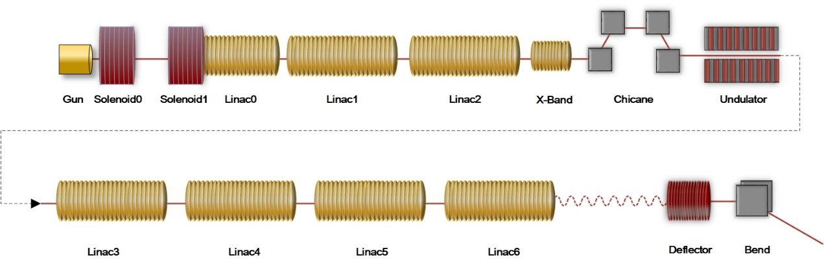

Extended Data Fig. 1 DCLS beamline.

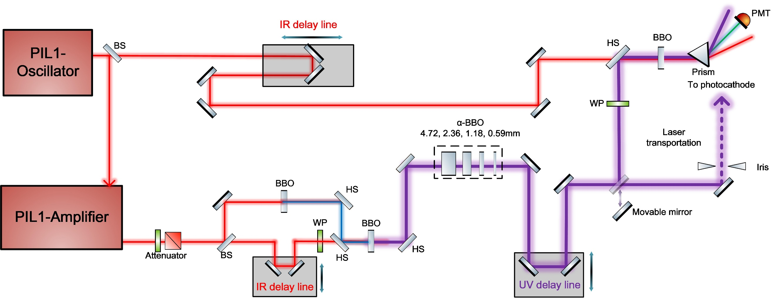
Extended Data Fig. 2 Photoinjector drive laser generation and measurements.

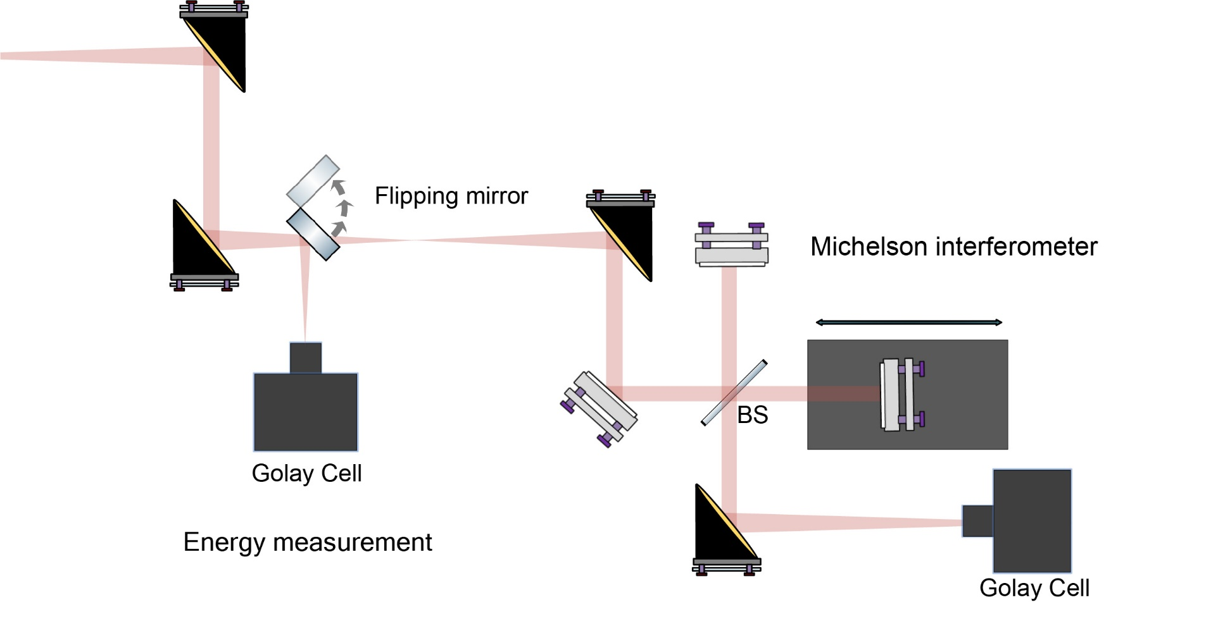
Extended Data Fig. 3 THz measurement set-up

