SUPPLEMENTAL FIGURES
Supplemental Figure S1. MSCs collection and cell culture.
Representative images showing double-fluorescent ICC staining of MSCs in cBMT culture a. GFP (green) and SDF1 (red), b. GFP (green) and CD105 (red), c. GFP (green) and CD45 (red), d. GFP (green) and CD31 (red).
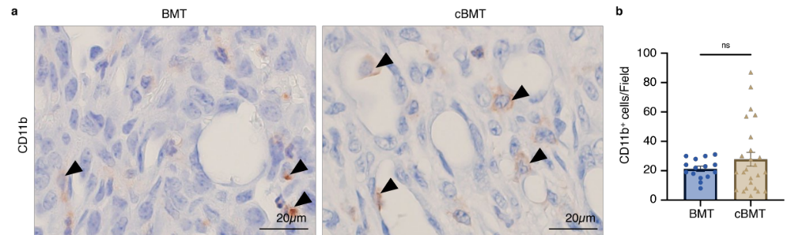
Supplemental Figure S2. CD11b⁺ immune cells in TME.
Representative IHC images showing a. CD11b⁺ cells in BMT mice and cBMT mice. ▲represent the positive cells. The number of b. CD11b⁺ cells in BMT mice and cBMT mice. BMT: n=3, cBMT: n=5. All data are presented as mean ± SEM. Statistical analysis was done using Student’s T test. ns: not significant.
SUPPLEMENTAL TABLE
Primary antibody | Immunized animal | Antigen retrieval | Dilution | Supplier | Uses
GFP | Goat | Microwave heating in 0.01 mol/L citrate buffer (pH 6.0) at 100°C for 1 min | 1:1000 | Abcam | ICC/IHC
 |  |  |  | (ab6673) | ICC/IHC
GFP | Rabbit | no activation | 1:500 | MBL | ICC
 |  |  |  | (MBL598) | ICC
SDF1 | Rabbit | no activation | 1:200 | Abcam | ICC
 |  |  |  | (ab9797) | ICC
CD105/Endoglin | Goat | no activation | 1:100 | R&D system | ICC
 |  |  |  | (AF1320) | ICC
CD45 | Rabbit | Microwave heating in 0.01 mol/L citrate buffer (pH 6.0) at 100°C for 1 min | 1:200 | Cell signaling technology | ICC/IHC
 |  |  |  | (D3F8Q) | ICC/IHC
CD31 | Rat | no activation | 1:50 | Abcam | ICC
 |  |  |  | (ab56299) | ICC
CD3 | Rabbit | Microwave heating in 0.01 mol/L citrate buffer (pH 6.0) at 100°C for 1 min | 1:100 | Abcam | IHC
 |  |  |  | (ab16669) | IHC
CD4 | Rabbit | Microwave heating in 0.01 mol/L citrate buffer (pH 6.0) at 100°C for 1 min | 1:150 | Cell signaling technology | IHC
 |  |  |  | (D7D2Z) | IHC
CD8 | Rabbit | Microwave heating in 0.01 mol/L citrate buffer (pH 6.0) at 100°C for 1 min | 1:500 | Cell signaling technology | IHC
 |  |  |  | (D4W2Z) | IHC
FOXP3 | Rabbit | Pressure cooker heating in 0.01 mol/L Tris EDTA buffer (pH 9.0) at 121°C for 8 min | 1:300 | Abcam | IHC
 |  |  |  | (ab215106) | IHC
F4/80 | Rabbit | Microwave heating in 0.01 mol/L citrate buffer (pH 6.0) at 100°C for 1 min | 1:200 | Cell signaling technology | IHC
 |  |  |  | (D2S9R) | IHC
CD11b | Rabbit | Microwave heating in 0.01 mol/L citrate buffer (pH 6.0) at 100°C for 1 min | 1:4000 | Abcam | IHC/IF
 |  |  |  | (ab133357) | IHC/IF
CD11c | Rabbit | Pressure cooker heating in 0.01 mol/L Tris EDTA buffer (pH 9.0) at 121°C for 5 min | 1:350 | Cell signaling technology | IHC
 |  |  |  | (D1V9Y) | IHC
Gr-1 | Rat | 0.1% trypsin/CaCl₂ at 37°C for 5 min | 1:200 | Biolegend | IHC/IF
 |  |  |  | (108401) | IHC/IF
CD20 | Rabbit | Microwave heating in 0.01 mol/L citrate buffer (pH 6.0) at 100°C for 1 min | 1:100 | Abcam | IHC
 |  |  |  | (ab64088) | IHC
CD79a | Mouse | Microwave heating in 0.01 mol/L citrate buffer (pH 6.0) at 100°C for 1 min | 1:100 | Novus Biological | IHC
 |  |  |  | (NBP2-32834) | IHC
CD138 | Rabbit | Microwave heating in 0.01 mol/L citrate buffer (pH 6.0) at 100°C for 1 min | 1:500 | Abcam | IHC
 |  |  |  | (ab128936) | IHC
Supplemental Table S1: Primary antibodies used in IHC, double fluorescent IHC and ICC.
Secondary antibody | Immunized animal | Fluorescent dye | Supplier
Anti-rat IgG | Donkey | Alexa Fluor 594 | Thermo
Anti-rat IgG | Donkey | Alexa Fluor 594 | (A21209)
Anti-goat IgG | Donkey | Alexa Fluor 488 | Thermo
Anti-goat IgG | Donkey | Alexa Fluor 488 | (A11055)
Anti-rabbit IgG | Chicken | Alexa Fluor 488 | Thermo
Anti-rabbit IgG | Chicken | Alexa Fluor 488 | (A21441)
Anti-rabbit IgG | Donkey | Alexa Fluor 568 | Thermo
Anti-rabbit IgG | Donkey | Alexa Fluor 568 | (A10042)
Supplemental Table S2: Secondary antibodies used in double fluorescent IHC and ICC.

