Supplementary Material
High-throughput screening-based design of multifunctional natural polyphenol nano-vesicles to accelerate diabetic wound healing

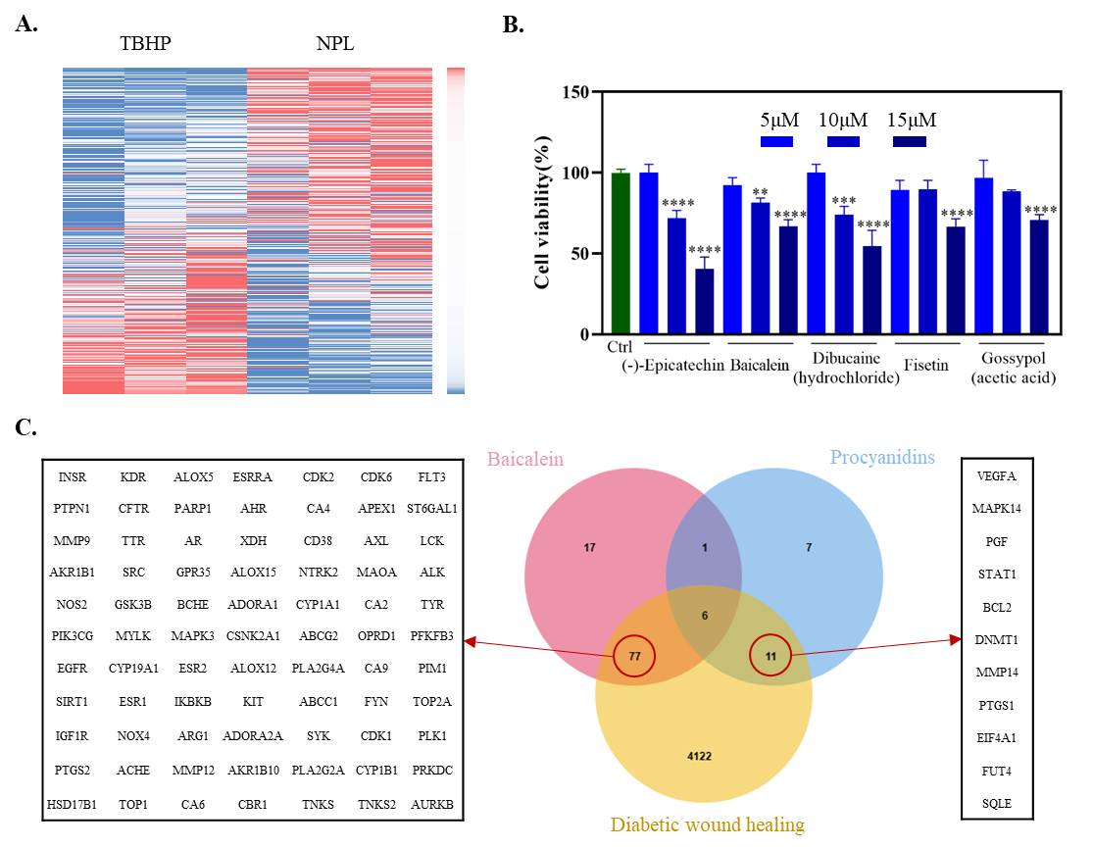
Supplement 1. A. Heat map of NPL high-throughput screening results. B. Drug toxicity test (n=3). *P < 0.05, **P < 0.01, ***P < 0.005, ****P < 0.001. C. Venn diagram and corresponding potential target of procyanidin and baicalein and the disease targets of diabetic wound healing.

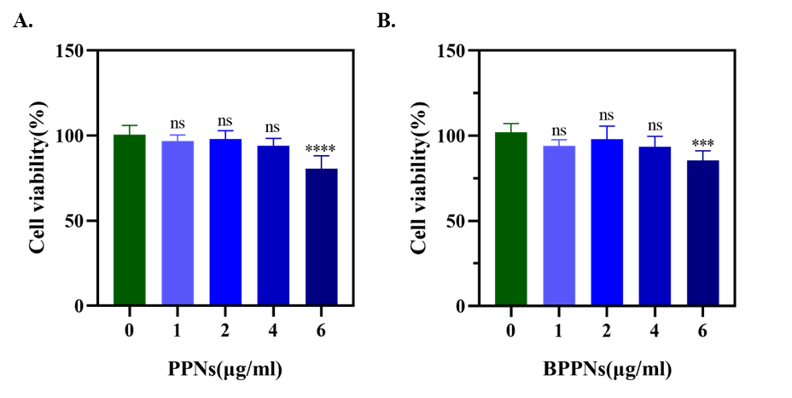

Supplement 2. A. Toxicity test of PPNs. B. Toxicity test of BPPNs. n=3, *P < 0.05, **P < 0.01, ***P < 0.005, ****P < 0.001.
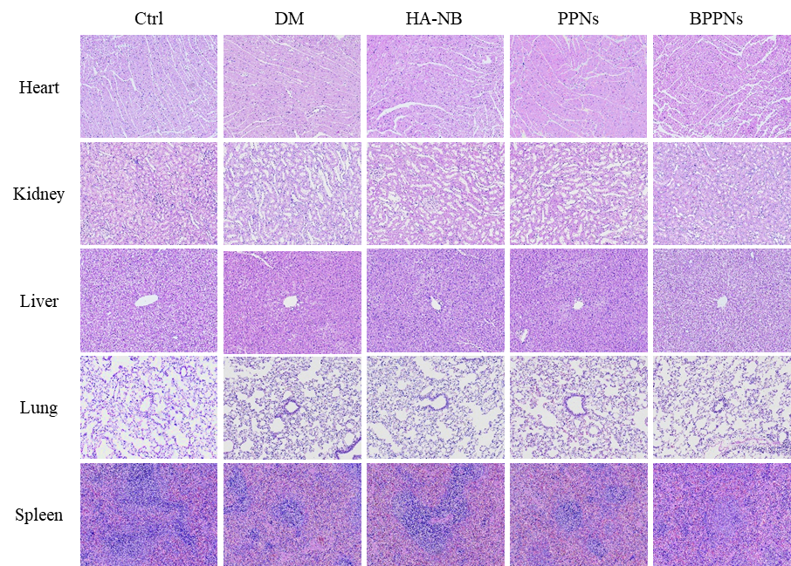

Supplement 3. Organ toxicity testing.

