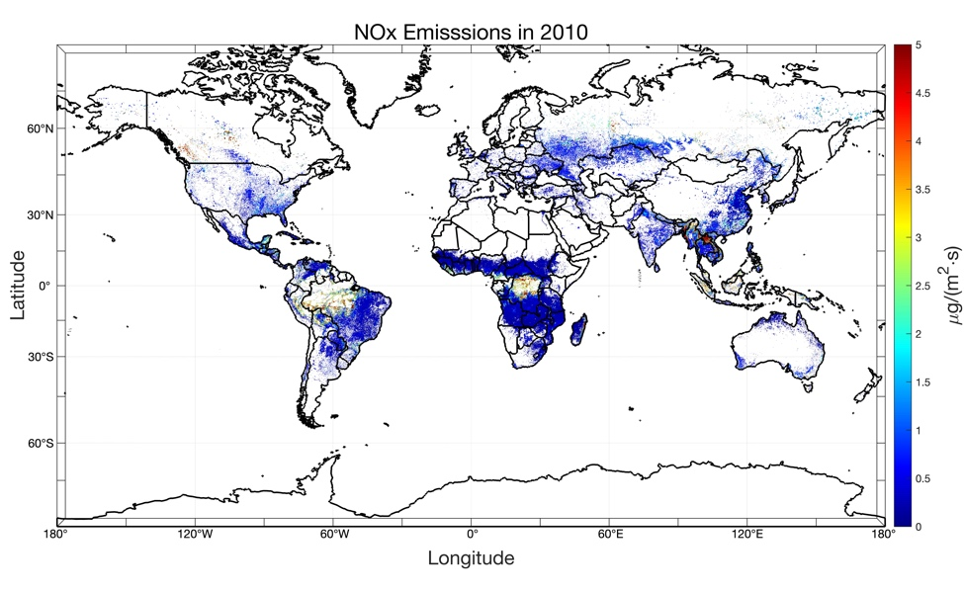(a) 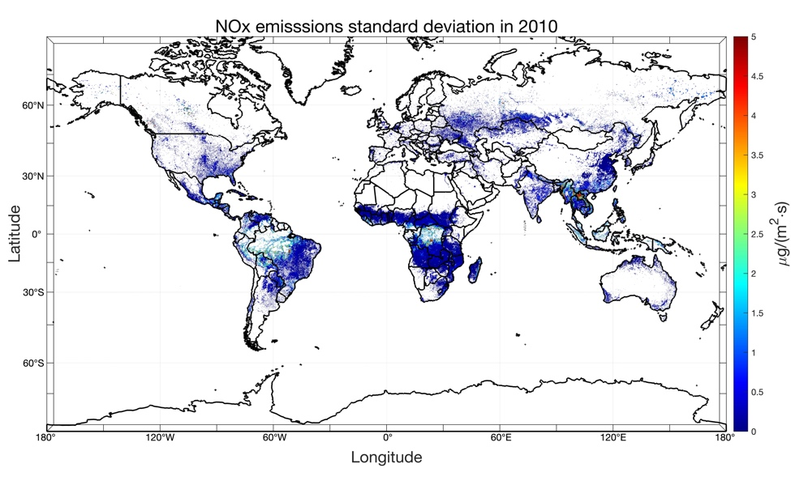 (b)
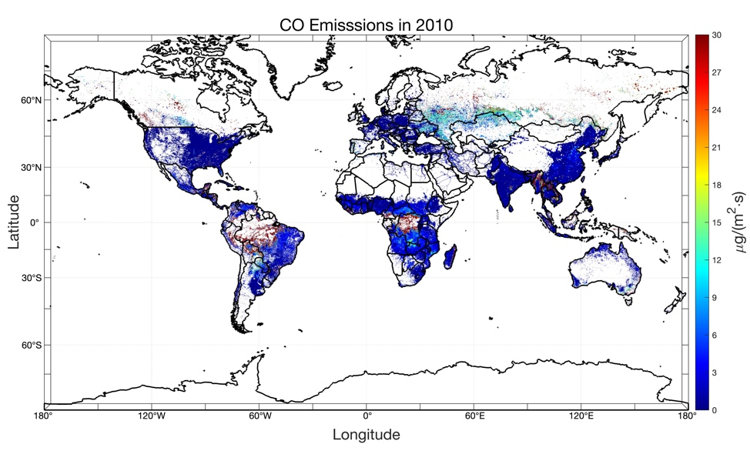 (c)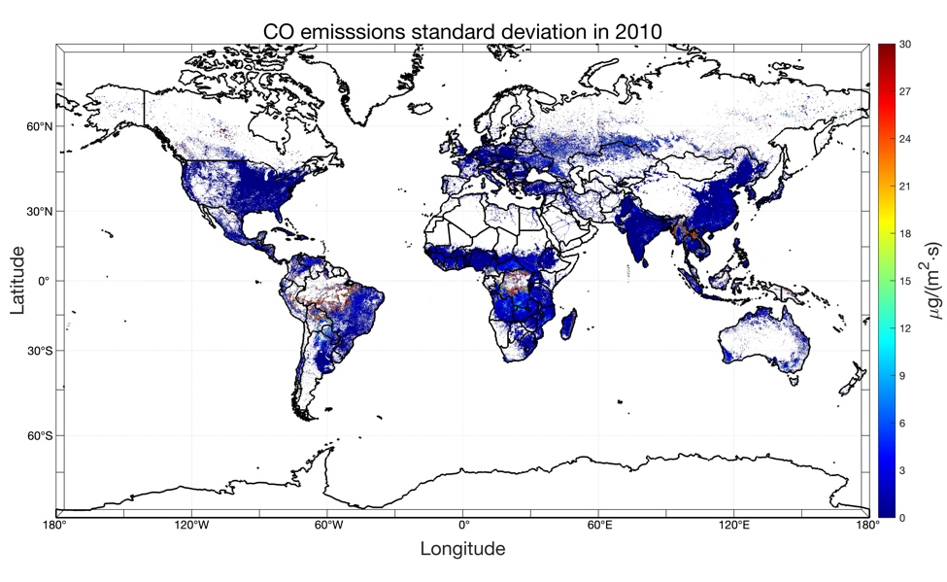(d)
Figure S1 Mean and standard deviation of merged emission priori datasets in 2010. (a) mean value of NO_{x} emissions in 2010 [ug•(m⁻²•s⁻¹)]; (b) standard deviation of NO_{x} emissions in 2010 [ug•(m⁻²•s⁻¹)]; (c) mean value of CO emissions in 2010 [ug•(m⁻²•s⁻¹)]; (d) standard deviation of CO emissions in 2010 [ug•(m⁻²•s⁻¹)]
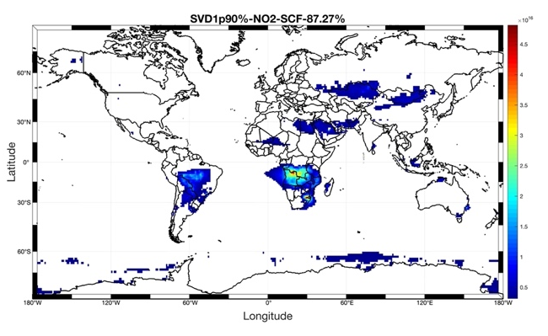(a)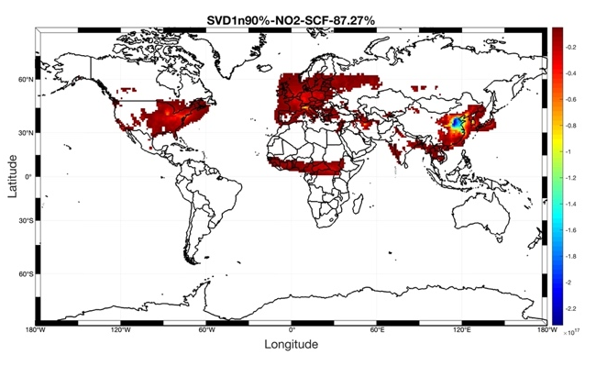(b)
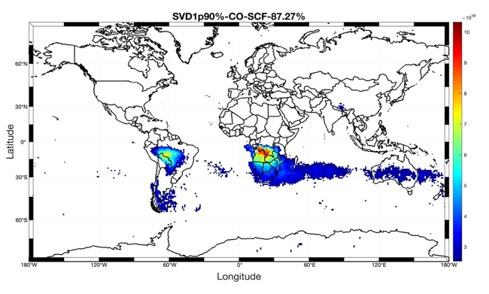(c)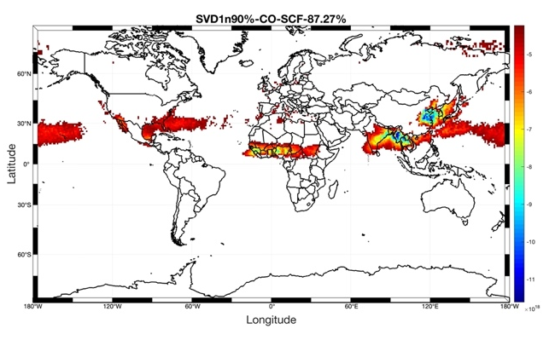(d)
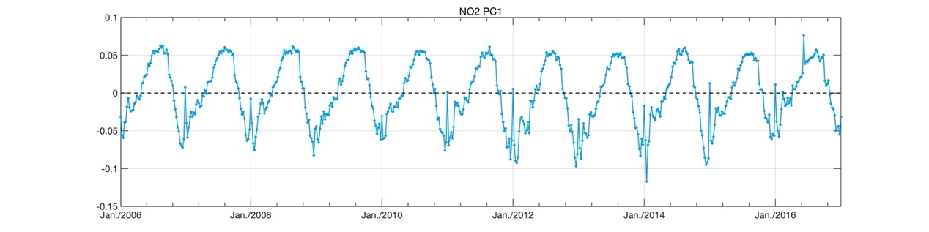(e)
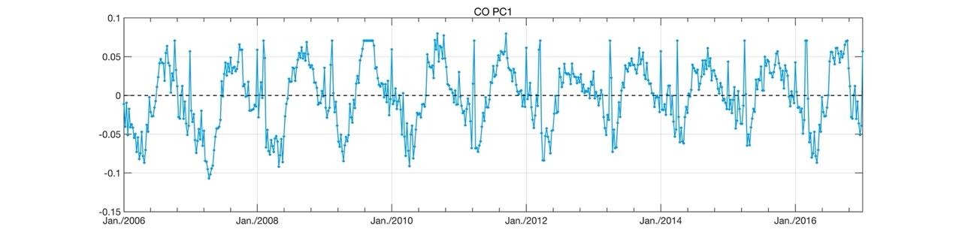(f)
Figure S2 Geographic distribution of CO and NO₂ from SVD₁, (a)NO₂ positive; (b)NO₂ negative; (c) CO positive; (d) CO negative; (e) Time series of NO₂ PCA₁; (f) Time series of CO PCA₁.
(a)(b)
(c)(d)
Figure S3 Mean and standard deviation of filtered CO and NO₂ satellite measurements in 2010. (a) mean value of NO₂ total column loading [molecules/cm²]; (b) standard deviation of NO₂ total column loading [molecules/cm²]; (c) mean value of CO total column loading [molecules/cm²]; (d) standard deviation of CO total column loading [molecules/cm²].
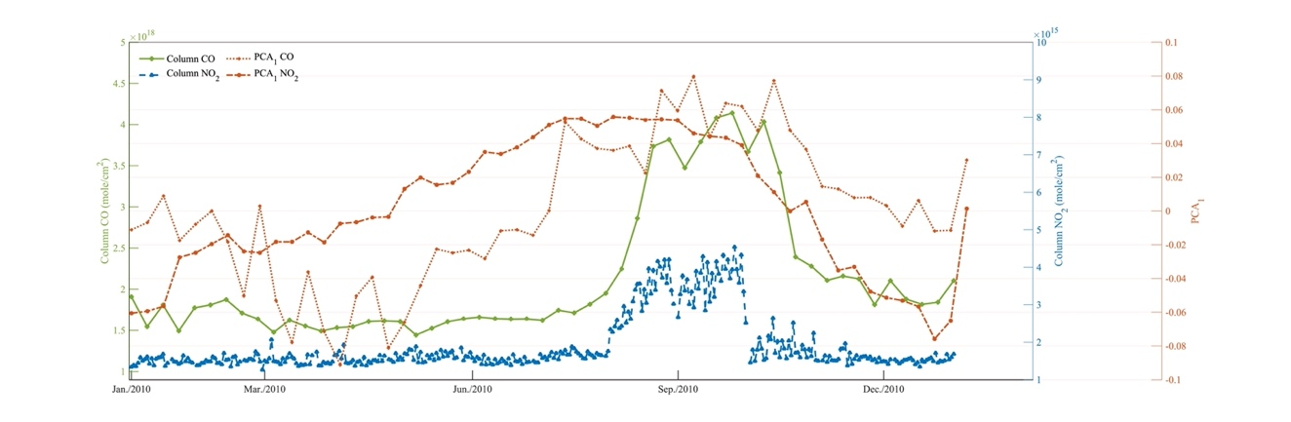(a)
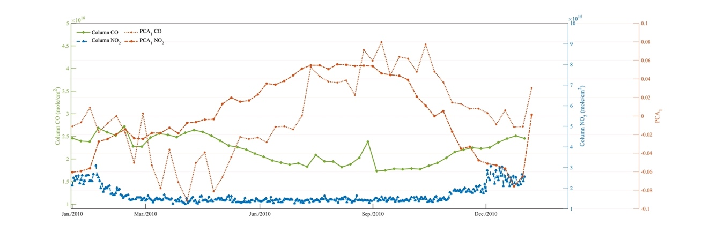(b)
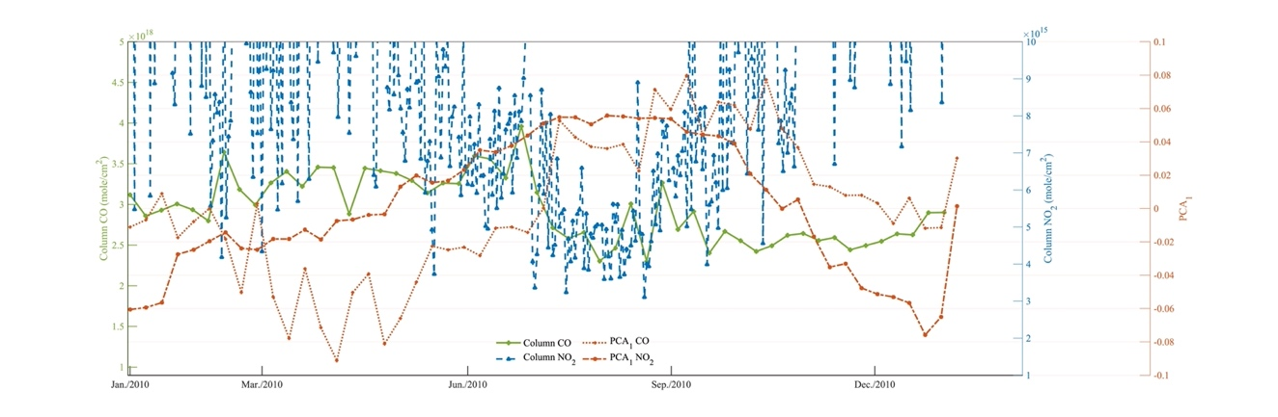(c)
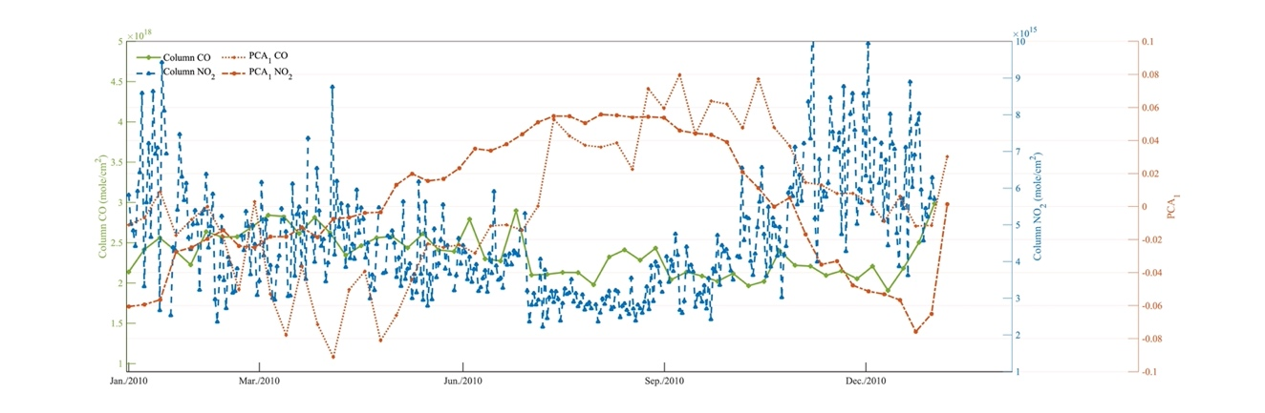(d)

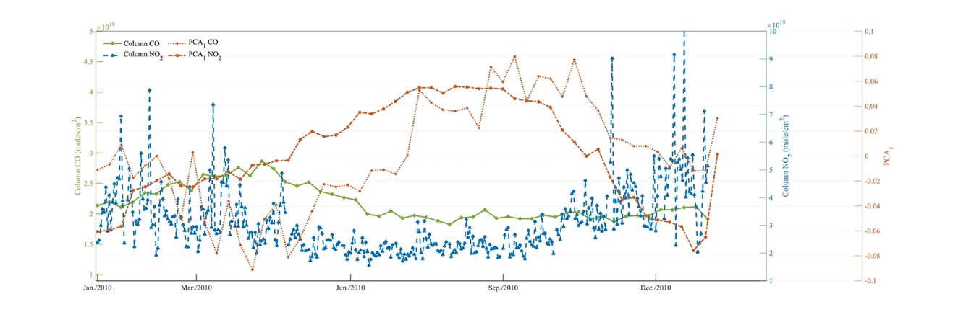(e)
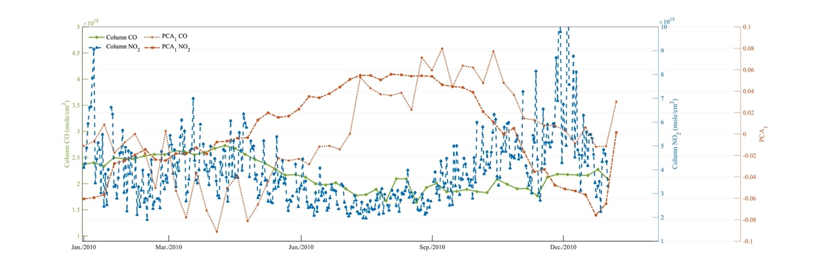(f)
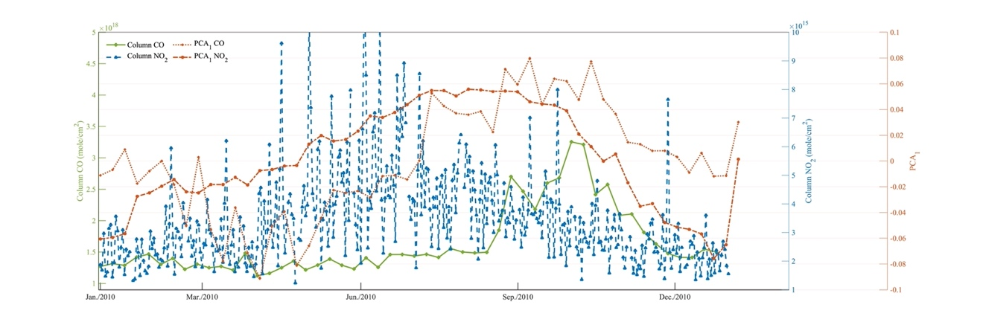(g)
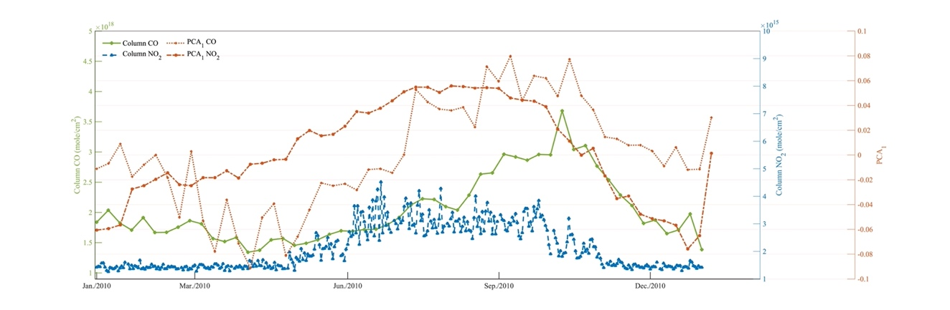(h)

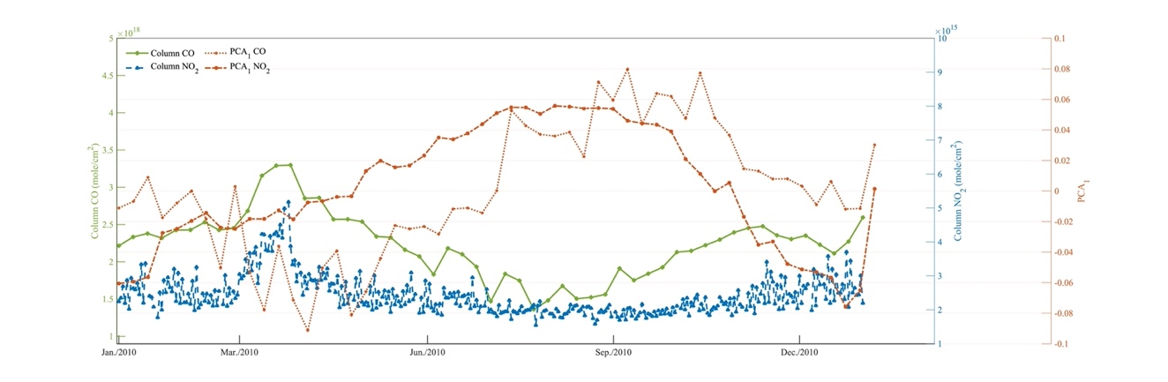(i)
Figure S4 Spatially averaged time series of CO and NO₂ respectively over the regions and PCA₁(87.27%) of NO₂ and CO. (a) Amazon; (b) Central Africa; (c) China (NO₂/CO); (d) China (NO₂); (e) Eastern US; (f) Europe; (g) South Africa; (h) South Central Africa; (i) Southeast Asia.
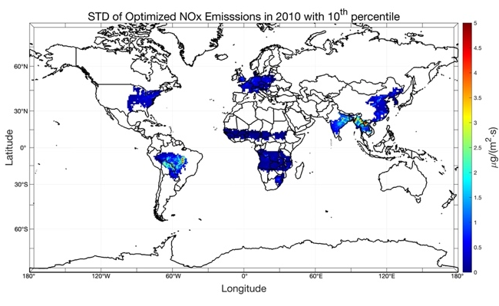(a)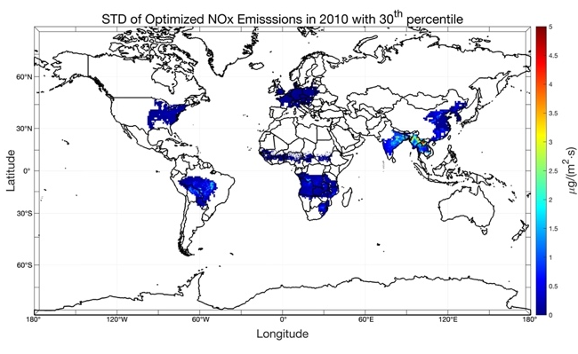(b)
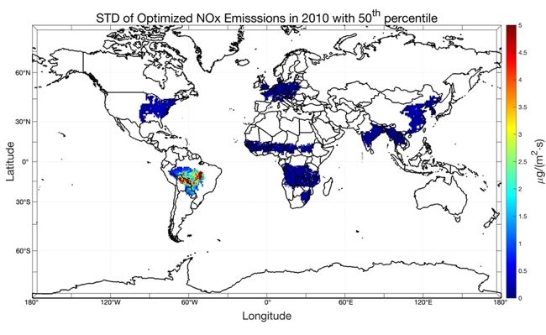(c)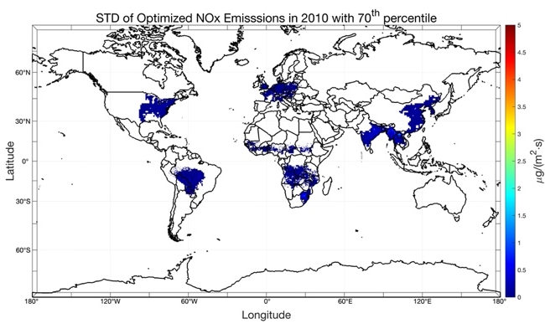(d)
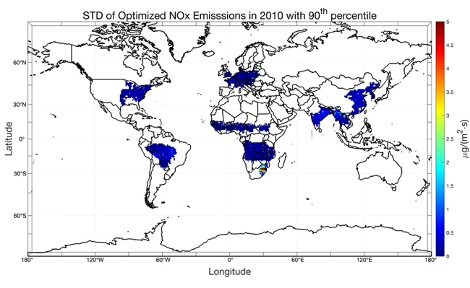(e)
Figure S5 Standard deviations of optimized NO_{x} emissions with (a) the 10th percentile, (b) the 30th percentile, (c) the 50th percentile, (d) the 70th percentile, (e) the 90th percentile.
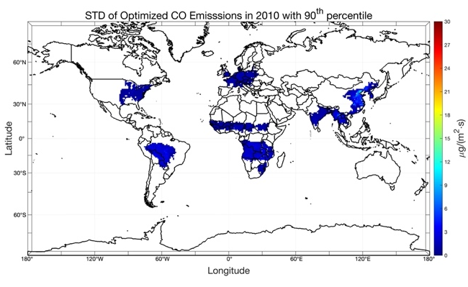(a)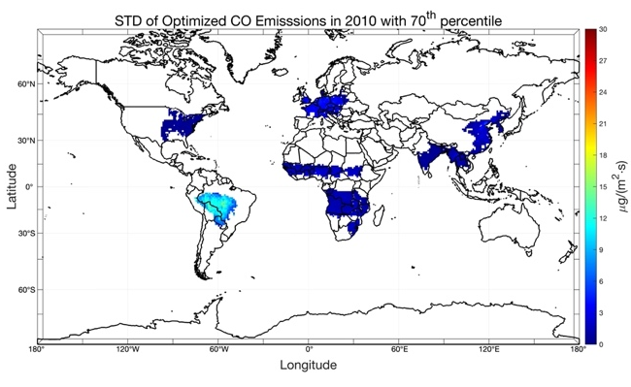(b)
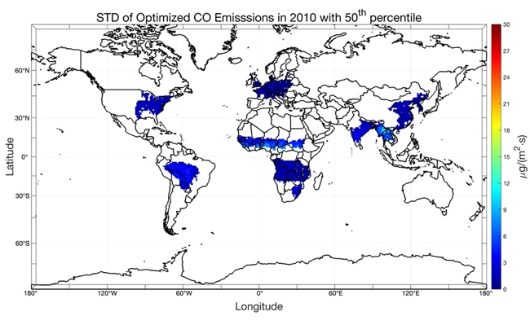(c)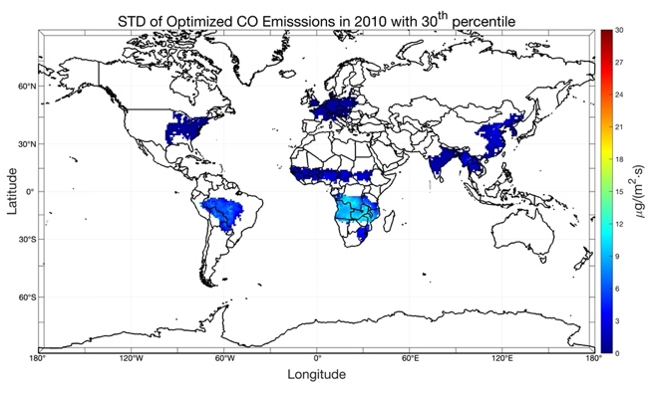(d)
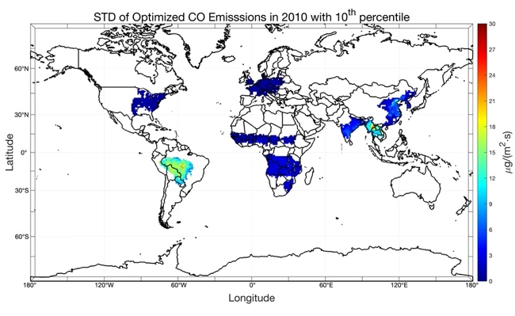(e)
Figure S6 Standard deviations of optimized CO emissions with (a) the 10th percentile, (b) the 30th percentile, (c) the 50th percentile, (d) the 70th percentile, (e) the 90th percentile.

