Appendix A1
Raman Spectra: Transcutaneous, Non-invasive (Finger)

Same patient tested using different fingers:
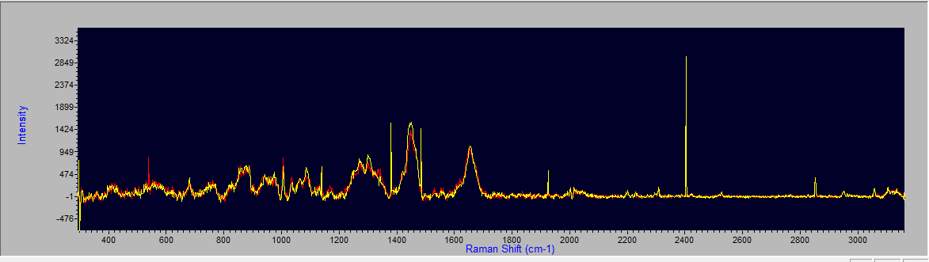

COVID-19 Negative Spectrum: Processed (Raman)
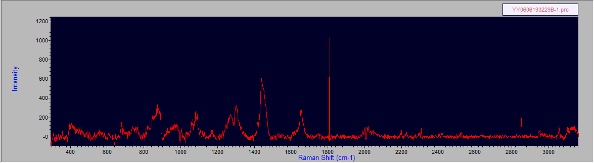

COVID-19 Negative Spectrum: Raw (includes fluorescence and background signals)
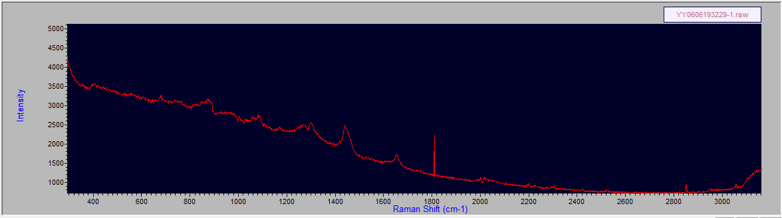

COVID-19 Negative Spectrum: Processed
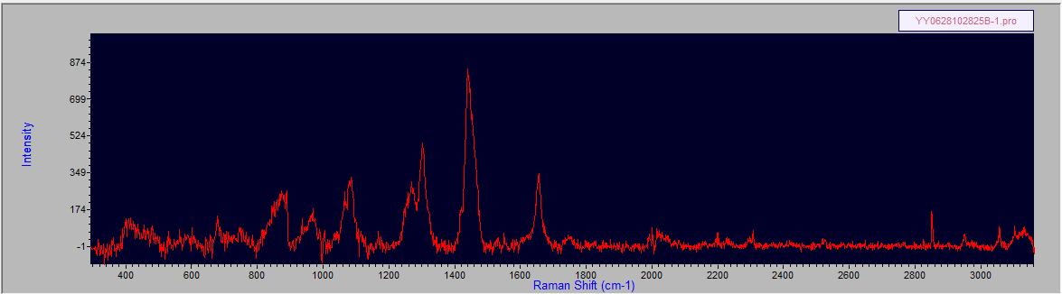

COVID-19 Negative Spectrum: Raw
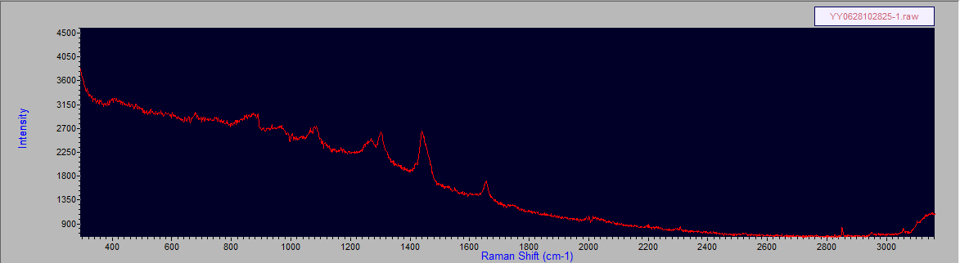

COVID-19 Positive Spectrum: Processed
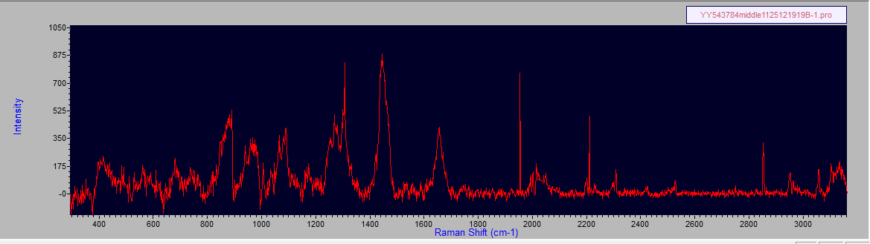

COVID-19 Positive Spectrum: Raw

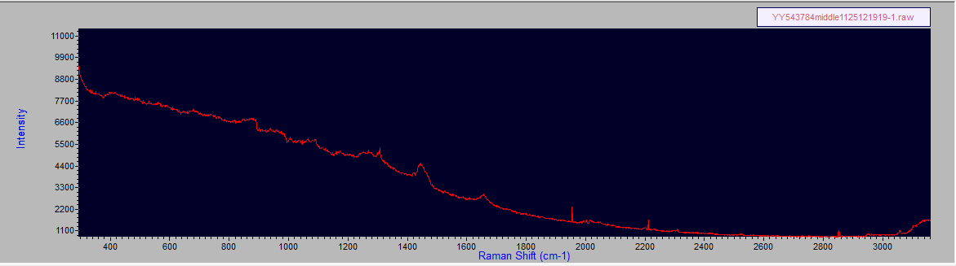

COVID-19 Positive Spectrum: Processed
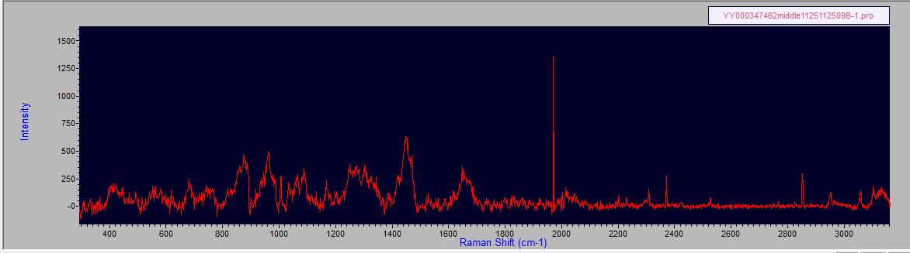

COVID-19 Positive Spectrum: Raw
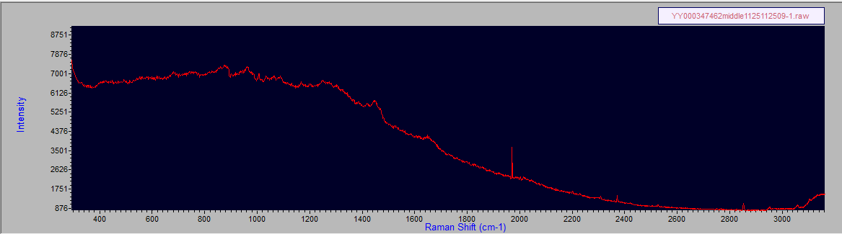

COVID-19 Negative Spectra from 4 patients:
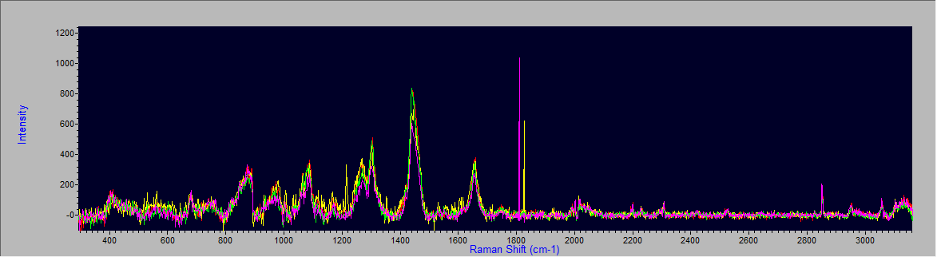

COVID-19 Positive Spectra from 3 patients:
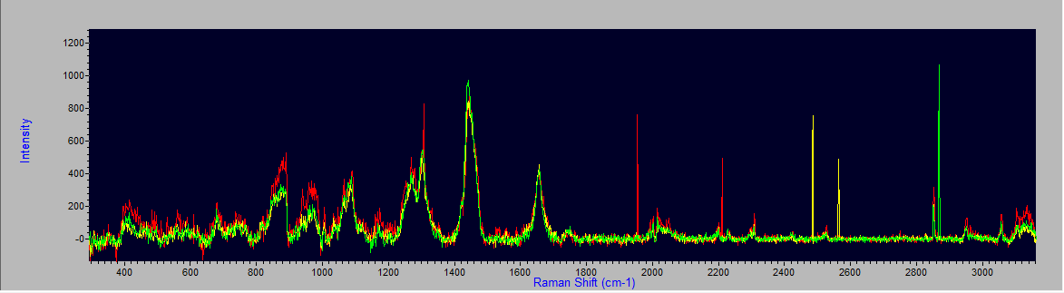

COVID-19 Spectra Positive and Negative Overlap: Pos(yellow and red) and Neg(green and purple)
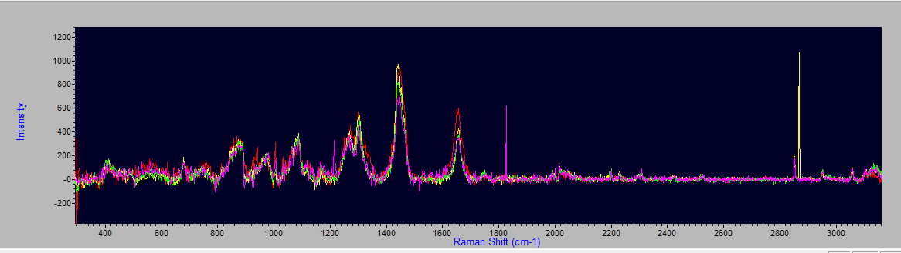

Appendix A2
Blood Glucose Raman Signal with No Specimen at 800 cm-1 and 1100 cm-1
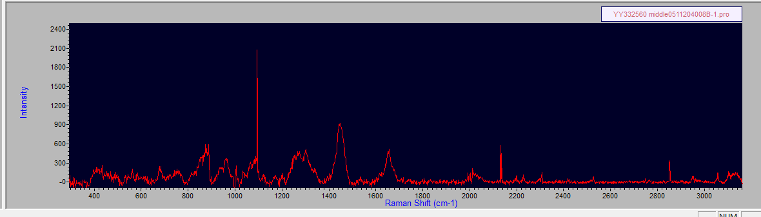
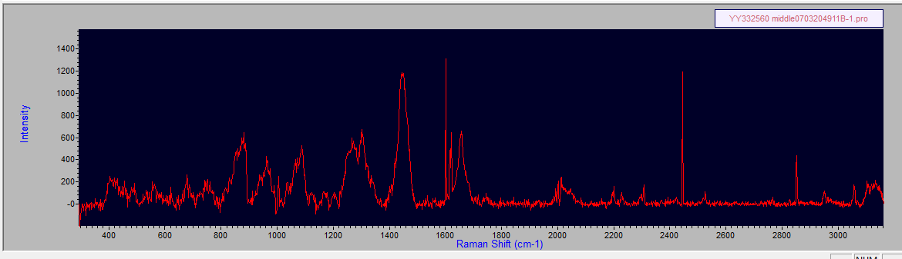

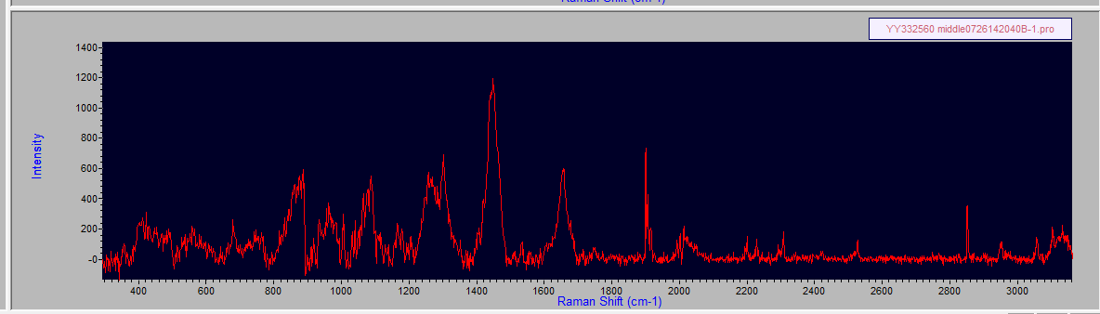
AccuChek 52 Dexcom 67

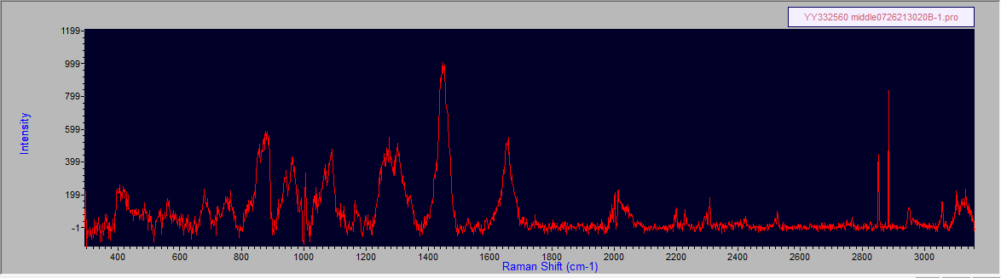
AccuChek 260 Dexcom 287

Appendix B

For IL-10, the peaks are found at 852, 1064, 1298 and 1470 cm-1. The peaks at 852 cm-1 might be from proline, hydroxyproline and tyrosine, and 1298 cm-1 is suspected from CH2 deformation modes. The peak at 1470 cm-1 can be assigned to a C=N stretching bond within the IL-10 protein structure. For IL-10, the SNR of the highest peak at 1064 cm-1 is 5.02. A single peak at 990 cm-1 is found in IL-21 with a SNR of 6.10 (1).
The Raman spectrum of IL-6 showing bands at 938, 1261 and 1655 cm-1 due to the C–C stretching of the backbone structure, amide III and amide I, respectively, correspond to the typical a-helix secondary structure conformation of IL-6. In addition, conventional residues of amino acids, such as the band at 708 cm-1, indicate the C–S stretching of cysteine residues in the IL-6 structure. The conformational structure of IL-6 was corroborated using Raman spectroscopy (2,3).
The Raman spectra for monocyte and lymphocyte subgroups, as well as IL-4, have been described (4). C-Reactive protein , creatinine and cystatin C as markers of renal function and C-reactive protein (CRP) and interleukin 6 as biomarkers of inflammation have unique Raman signatures (5,6).

References: Appendix B (6)

1. Zhang S, A.M. van der Mee F, Erckens R, et al. Raman spectroscopic detection of interleukin-10 and angiotensin converting enzyme. Journal of the European Optical Society-Rapid Publications volume 17, Article number: 7 (2021)

2. O-Cuevas E, Badillo-Ramirez I, Islas S, et al. Sensitive Raman detection of human recombinant interleukin-6 mediated by DCDR/GERS hybrid platforms.RSC Adv., 2019, 9, 12269

3. De La O E, Badillo-Ramirez I. Sensitive Raman detection of human recombinant interleukin-6 mediated by DCDR/GERS hybrid platforms. RSC Advances 9(22):12269-12275;April 2019

4. Chaudhary N, Nguyet T, Nguyen Q, et al. Discrimination of immune cell activation using Raman micro-spectroscopy in an in-vitr0 and ex-vivo model. Spectrochimica Acta Part A: Molecular and Biomolecular Spectroscopy
Volume 248, 5 March 2021, 11911

5. Bergholt M, Hassing S. Quantification of C-Reactive protein in human blood plasma using near-infrared Raman spectroscopy. The Analyst 134(10):2123- 7,October
2009

6. Staritzbichler R, Hunold P, Estrela-Lopis I, et al. Raman spectroscopy on blood samples of patients with end-stage liver disease. September 7,
2021,https://doi.org/10.1371/journal.pone.0256045

