APPENDIX I
Table 3: Correlation matrix for Antioxidant activity and Phytochemical constituents in Carica papaya fruit (pear-shaped variety: Local pawpaw) at the Unripe stage
Correlation matrix for Antioxidant activity and Phytochemical constituents (Pear-shaped variety) Local Pawpaw |  | Antioxidant (Pear-shaped variety) Local Pawpaw | Tannins (Pear-shaped variety) Local Pawpaw | Flavonoids (Pear-shaped variety) Local Pawpaw | Phenol (Pear-shaped variety) Local Pawpaw | Saponins (Pear-shaped variety) Local Pawpaw | Alkaloids (Pear-shaped variety) Local Pawpaw
Antioxidant (Pear-shaped variety) Local Pawpaw | Pearson Correlation | 1 | -.738 | .350 | -.240 | -.856 | -1.000**
Antioxidant (Pear-shaped variety) Local Pawpaw | Sig. (2-tailed) |  | .472 | .772 | .846 | .346 | .000
Antioxidant (Pear-shaped variety) Local Pawpaw | N | 4 | 3 | 3 | 3 | 3 | 3
Tannins (Pear-shaped variety) Local Pawpaw | Pearson Correlation | -.738 | 1 | .374 | -.478 | .282 | .738
Tannins (Pear-shaped variety) Local Pawpaw | Sig. (2-tailed) | .472 |  | .756 | .683 | .818 | .472
Tannins (Pear-shaped variety) Local Pawpaw | N | 3 | 3 | 3 | 3 | 3 | 3
Flavonoids (Pear-shaped variety) Local Pawpaw | Pearson Correlation | .350 | .374 | 1 | -.993 | -.784 | -.350
Flavonoids (Pear-shaped variety) Local Pawpaw | Sig. (2-tailed) | .772 | .756 |  | .073 | .426 | .772
Flavonoids (Pear-shaped variety) Local Pawpaw | N | 3 | 3 | 3 | 3 | 3 | 3
Phenol (Pear-shaped variety) Local Pawpaw | Pearson Correlation | -.240 | -.478 | -.993 | 1 | .708 | .240
Phenol (Pear-shaped variety) Local Pawpaw | Sig. (2-tailed) | .846 | .683 | .073 |  | .499 | .846
Phenol (Pear-shaped variety) Local Pawpaw | N | 3 | 3 | 3 | 3 | 3 | 3
Saponins (Pear-shaped variety) Local Pawpaw | Pearson Correlation | -.856 | .282 | -.784 | .708 | 1 | .856
Saponins (Pear-shaped variety) Local Pawpaw | Sig. (2-tailed) | .346 | .818 | .426 | .499 |  | .346
Saponins (Pear-shaped variety) Local Pawpaw | N | 3 | 3 | 3 | 3 | 3 | 3
Alkaloids (Pear-shaped variety) Local Pawpaw | Pearson Correlation | -1.000** | .738 | -.350 | .240 | .856 | 1
Alkaloids (Pear-shaped variety) Local Pawpaw | Sig. (2-tailed) | .000 | .472 | .772 | .846 | .346
Alkaloids (Pear-shaped variety) Local Pawpaw | N | 3 | 3 | 3 | 3 | 3 | 3
**. Correlation is significant at the 0.01 level (2-tailed).

Table 4: Correlation matrix for Antioxidant activity and Phytochemical constituents in Carica papaya fruit (pear-shaped variety: Local pawpaw) at the Ripe stage
Correlation matrix for Antioxidant activity and Phytochemical constituents (Pear-shaped variety) Local Pawpaw |  | Antioxidant (Pear-shaped variety) Local Pawpaw | Tannins (Pear-shaped variety) Local Pawpaw | Flavonoids (Pear-shaped variety) Local Pawpaw | Phenol (Pear-shaped variety) Local Pawpaw | Saponins (Pear-shaped variety) Local Pawpaw | Alkaloids (Pear-shaped variety) Local Pawpaw
Antioxidant (Pear-shaped variety) Local Pawpaw | Pearson Correlation | 1 | -.500 | .977 | .721 | -.159 | .824
Antioxidant (Pear-shaped variety) Local Pawpaw | Sig. (2-tailed) |  | .667 | .138 | .488 | .898 | .383
Antioxidant (Pear-shaped variety) Local Pawpaw | N | 4 | 3 | 3 | 3 | 3 | 3
Tannins (Pear-shaped variety) Local Pawpaw | Pearson Correlation | -.500 | 1 | -.302 | .240 | .935 | .078
Tannins (Pear-shaped variety) Local Pawpaw | Sig. (2-tailed) | .667 |  | .805 | .846 | .232 | .950
Tannins (Pear-shaped variety) Local Pawpaw | N | 3 | 3 | 3 | 3 | 3 | 3
Flavonoids (Pear-shaped variety) Local Pawpaw | Pearson Correlation | .977 | -.302 | 1 | .853 | .057 | .927
Flavonoids (Pear-shaped variety) Local Pawpaw | Sig. (2-tailed) | .138 | .805 |  | .350 | .964 | .245
Flavonoids (Pear-shaped variety) Local Pawpaw | N | 3 | 3 | 3 | 3 | 3 | 3
Phenol (Pear-shaped variety) Local Pawpaw | Pearson Correlation | .721 | .240 | .853 | 1 | .570 | .987
Phenol (Pear-shaped variety) Local Pawpaw | Sig. (2-tailed) | .488 | .846 | .350 |  | .614 | .104
Phenol (Pear-shaped variety) Local Pawpaw | N | 3 | 3 | 3 | 3 | 3 | 3
Saponins (Pear-shaped variety) Local Pawpaw | Pearson Correlation | -.159 | .935 | .057 | .570 | 1 | .428
Saponins (Pear-shaped variety) Local Pawpaw | Sig. (2-tailed) | .898 | .232 | .964 | .614 |  | .718
Saponins (Pear-shaped variety) Local Pawpaw | N | 3 | 3 | 3 | 3 | 3 | 3
Alkaloids (Pear-shaped variety) Local Pawpaw | Pearson Correlation | .824 | .078 | .927 | .987 | .428 | 1
Alkaloids (Pear-shaped variety) Local Pawpaw | Sig. (2-tailed) | .383 | .950 | .245 | .104 | .718
Alkaloids (Pear-shaped variety) Local Pawpaw | N | 3 | 3 | 3 | 3 | 3 | 3

Table 5: Correlation matrix for Antioxidant activity and Phytochemical constituents in Carica papaya fruit (pear-shaped variety: Local pawpaw) at the Overripe stage
Correlation matrix for Antioxidant activity and Phytochemical constituents (Pear-shaped variety) Local Pawpaw |  | Antioxidant (Pear-shaped variety) Local Pawpaw | Tannins (Pear-shaped variety) Local Pawpaw | Flavonoids (Pear-shaped variety) Local Pawpaw | Phenol (Pear-shaped variety) Local Pawpaw | Saponins (Pear-shaped variety) Local Pawpaw | Alkaloids (Pear-shaped variety) Local Pawpaw
Antioxidant (Pear-shaped variety) Local Pawpaw | Pearson Correlation | 1 | .801 | -.847 | .452 | .642 | .636
Antioxidant (Pear-shaped variety) Local Pawpaw | Sig. (2-tailed) |  | .408 | .357 | .702 | .556 | .562
Antioxidant (Pear-shaped variety) Local Pawpaw | N | 4 | 3 | 3 | 3 | 3 | 3
Tannins (Pear-shaped variety) Local Pawpaw | Pearson Correlation | .801 | 1 | -.360 | -.172 | .056 | .971
Tannins (Pear-shaped variety) Local Pawpaw | Sig. (2-tailed) | .408 |  | .765 | .890 | .965 | .153
Tannins (Pear-shaped variety) Local Pawpaw | N | 3 | 3 | 3 | 3 | 3 | 3
Flavonoids (Pear-shaped variety) Local Pawpaw | Pearson Correlation | -.847 | -.360 | 1 | -.857 | -.951 | -.127
Flavonoids (Pear-shaped variety) Local Pawpaw | Sig. (2-tailed) | .357 | .765 |  | .344 | .199 | .919
Flavonoids (Pear-shaped variety) Local Pawpaw | N | 3 | 3 | 3 | 3 | 3 | 3
Phenol (Pear-shaped variety) Local Pawpaw | Pearson Correlation | .452 | -.172 | -.857 | 1 | .974 | -.402
Phenol (Pear-shaped variety) Local Pawpaw | Sig. (2-tailed) | .702 | .890 | .344 |  | .145 | .737
Phenol (Pear-shaped variety) Local Pawpaw | N | 3 | 3 | 3 | 3 | 3 | 3
Saponins (Pear-shaped variety) Local Pawpaw | Pearson Correlation | .642 | .056 | -.951 | .974 | 1 | -.184
Saponins (Pear-shaped variety) Local Pawpaw | Sig. (2-tailed) | .556 | .965 | .199 | .145 |  | .882
Saponins (Pear-shaped variety) Local Pawpaw | N | 3 | 3 | 3 | 3 | 3 | 3
Alkaloids (Pear-shaped variety) Local Pawpaw | Pearson Correlation | .636 | .971 | -.127 | -.402 | -.184 | 1
Alkaloids (Pear-shaped variety) Local Pawpaw | Sig. (2-tailed) | .562 | .153 | .919 | .737 | .882
Alkaloids (Pear-shaped variety) Local Pawpaw | N | 3 | 3 | 3 | 3 | 3 | 3

Table 6: Correlation matrix for Antioxidant activity and Phytochemical constituents in Carica papaya fruit (pear-shaped variety: Local pawpaw) at various ripening stages (unripe, ripe and overripe)
Correlation matrix for Antioxidant activity and Phytochemical constituents (Pear-shaped variety) Local Pawpaw |  | Antioxidant (Pear-shaped variety) Local Pawpaw | Tannins (Pear-shaped variety) Local Pawpaw | Flavonoids (Pear-shaped variety) Local Pawpaw | Phenols (Pear-shaped variety) Local Pawpaw | Saponins (Pear-shaped variety) Local Pawpaw | Alkaloids (Pear-shaped variety) Local Pawpaw
Antioxidant (Pear-shaped variety) Local Pawpaw | Pearson Correlation | 1 | -.950** | .916** | .661 | .974** | .911**
Antioxidant (Pear-shaped variety) Local Pawpaw | Sig. (2-tailed) |  | .000 | .001 | .053 | .000 | .001
Antioxidant (Pear-shaped variety) Local Pawpaw | N | 12 | 9 | 9 | 9 | 9 | 9
Tannins (Pear-shaped variety) Local Pawpaw | Pearson Correlation | -.950** | 1 | -.907** | -.602 | -.976** | -.749*
Tannins (Pear-shaped variety) Local Pawpaw | Sig. (2-tailed) | .000 |  | .001 | .086 | .000 | .020
Tannins (Pear-shaped variety) Local Pawpaw | N | 9 | 9 | 9 | 9 | 9 | 9
Flavonoids (Pear-shaped variety) Local Pawpaw | Pearson Correlation | .916** | -.907** | 1 | .426 | .894** | .819**
Flavonoids (Pear-shaped variety) Local Pawpaw | Sig. (2-tailed) | .001 | .001 |  | .253 | .001 | .007
Flavonoids (Pear-shaped variety) Local Pawpaw | N | 9 | 9 | 9 | 9 | 9 | 9
Phenols (Pear-shaped variety) Local Pawpaw | Pearson Correlation | .661 | -.602 | .426 | 1 | .665 | .673*
Phenols (Pear-shaped variety) Local Pawpaw | Sig. (2-tailed) | .053 | .086 | .253 |  | .050 | .047
Phenols (Pear-shaped variety) Local Pawpaw | N | 9 | 9 | 9 | 9 | 9 | 9
Saponins (Pear-shaped variety) Local Pawpaw | Pearson Correlation | .974** | -.976** | .894** | .665 | 1 | .813**
Saponins (Pear-shaped variety) Local Pawpaw | Sig. (2-tailed) | .000 | .000 | .001 | .050 |  | .008
Saponins (Pear-shaped variety) Local Pawpaw | N | 9 | 9 | 9 | 9 | 9 | 9
Alkaloids (Pear-shaped variety) Local Pawpaw | Pearson Correlation | .911** | -.749* | .819** | .673* | .813** | 1
Alkaloids (Pear-shaped variety) Local Pawpaw | Sig. (2-tailed) | .001 | .020 | .007 | .047 | .008
Alkaloids (Pear-shaped variety) Local Pawpaw | N | 9 | 9 | 9 | 9 | 9 | 9
**. Correlation is significant at the 0.01 level (2-tailed).
Table 7: Correlation matrix for Antioxidant activity and Phytochemical constituents in Carica papaya fruit (oblong variety: Agric Pawpaw ) at the Unripe stage
Correlation matrix for Antioxidant activity and Phytochemical constituents (Oblong variety)  Agric Pawpaw |  | Antioxidant (Oblong variety) Agric Pawpaw | Tannins (Oblong variety) Agric Pawpaw | Flavonoids (Oblong variety) Agric Pawpaw | Phenol (Oblong variety) Agric Pawpaw | Saponins (Oblong variety) Agric Pawpaw | Alkaloids (Oblong variety) Agric Pawpaw
Antioxidant (Oblong variety) Agric Pawpaw | Pearson Correlation | 1 | .707 | -.062 | .442 | .635 | .988
Antioxidant (Oblong variety) Agric Pawpaw | Sig. (2-tailed) |  | .500 | .960 | .708 | .562 | .099
Antioxidant (Oblong variety) Agric Pawpaw | N | 4 | 3 | 3 | 3 | 3 | 3
Tannins (Oblong variety) Agric Pawpaw | Pearson Correlation | .707 | 1 | -.750 | .947 | .995 | .808
Tannins (Oblong variety) Agric Pawpaw | Sig. (2-tailed) | .500 |  | .460 | .208 | .062 | .401
Tannins (Oblong variety) Agric Pawpaw | N | 3 | 3 | 3 | 3 | 3 | 3
Flavonoids (Oblong variety) Agric Pawpaw | Pearson Correlation | -.062 | -.750 | 1 | -.923 | -.810 | -.217
Flavonoids (Oblong variety) Agric Pawpaw | Sig. (2-tailed) | .960 | .460 |  | .252 | .398 | .861
Flavonoids (Oblong variety) Agric Pawpaw | N | 3 | 3 | 3 | 3 | 3 | 3
Phenol (Oblong variety) Agric Pawpaw | Pearson Correlation | .442 | .947 | -.923 | 1 | .974 | .577
Phenol (Oblong variety) Agric Pawpaw | Sig. (2-tailed) | .708 | .208 | .252 |  | .146 | .609
Phenol (Oblong variety) Agric Pawpaw | N | 3 | 3 | 3 | 3 | 3 | 3
Saponins (Oblong variety) Agric Pawpaw | Pearson Correlation | .635 | .995 | -.810 | .974 | 1 | .748
Saponins (Oblong variety) Agric Pawpaw | Sig. (2-tailed) | .562 | .062 | .398 | .146 |  | .462
Saponins (Oblong variety) Agric Pawpaw | N | 3 | 3 | 3 | 3 | 3 | 3
Alkaloids (Oblong variety) Agric Pawpaw | Pearson Correlation | .988 | .808 | -.217 | .577 | .748 | 1
Alkaloids (Oblong variety) Agric Pawpaw | Sig. (2-tailed) | .099 | .401 | .861 | .609 | .462
Alkaloids (Oblong variety) Agric Pawpaw | N | 3 | 3 | 3 | 3 | 3 | 3
*. Correlation is significant at the 0.05 level (2-tailed).

Table 8: Correlation matrix for Antioxidant activity and Phytochemical constituents in Carica papaya fruit (oblong variety: Agric Pawpaw) at the Ripe stage
Correlation matrix for Antioxidant activity and Phytochemical constituents (Oblong variety)  Agric Pawpaw |  | Antioxidant (Oblong variety) Agric Pawpaw | Tannins (Oblong variety) Agric Pawpaw | Flavonoids (Oblong variety) Agric Pawpaw | Phenol (Oblong variety) Agric Pawpaw | Saponins (Oblong variety) Agric Pawpaw | Alkaloids (Oblong variety) Agric Pawpaw
Antioxidant (Oblong variety) Agric Pawpaw | Pearson Correlation | 1 | .919 | -.097 | .735 | -.955 | .754
Antioxidant (Oblong variety) Agric Pawpaw | Sig. (2-tailed) |  | .258 | .938 | .475 | .192 | .456
Antioxidant (Oblong variety) Agric Pawpaw | N | 4 | 3 | 3 | 3 | 3 | 3
Tannins (Oblong variety) Agric Pawpaw | Pearson Correlation | .919 | 1 | -.481 | .408 | -.995 | .434
Tannins (Oblong variety) Agric Pawpaw | Sig. (2-tailed) | .258 |  | .680 | .733 | .066 | .714
Tannins (Oblong variety) Agric Pawpaw | N | 3 | 3 | 3 | 3 | 3 | 3
Flavonoids (Oblong variety) Agric Pawpaw | Pearson Correlation | -.097 | -.481 | 1 | .604 | .388 | .581
Flavonoids (Oblong variety) Agric Pawpaw | Sig. (2-tailed) | .938 | .680 |  | .587 | .746 | .606
Flavonoids (Oblong variety) Agric Pawpaw | N | 3 | 3 | 3 | 3 | 3 | 3
Phenol (Oblong variety) Agric Pawpaw | Pearson Correlation | .735 | .408 | .604 | 1 | -.500 | 1.000*
Phenol (Oblong variety) Agric Pawpaw | Sig. (2-tailed) | .475 | .733 | .587 |  | .667 | .018
Phenol (Oblong variety) Agric Pawpaw | N | 3 | 3 | 3 | 3 | 3 | 3
Saponins (Oblong variety) Agric Pawpaw | Pearson Correlation | -.955 | -.995 | .388 | -.500 | 1 | -.525
Saponins (Oblong variety) Agric Pawpaw | Sig. (2-tailed) | .192 | .066 | .746 | .667 |  | .648
Saponins (Oblong variety) Agric Pawpaw | N | 3 | 3 | 3 | 3 | 3 | 3
Alkaloids (Oblong variety) Agric Pawpaw | Pearson Correlation | .754 | .434 | .581 | 1.000* | -.525 | 1
Alkaloids (Oblong variety) Agric Pawpaw | Sig. (2-tailed) | .456 | .714 | .606 | .018 | .648
Alkaloids (Oblong variety) Agric Pawpaw | N | 3 | 3 | 3 | 3 | 3 | 3
*. Correlation is significant at the 0.05 level (2-tailed).

Table 9: Correlation matrix for Antioxidant activity and Phytochemical constituents in Carica papaya fruit (oblong variety: Agric Pawpaw) at the Overripe stage
Correlation matrix for Antioxidant activity and Phytochemical constituents (Oblong variety)  Agric Pawpaw |  | Antioxidant (Oblong variety) Agric Pawpaw | Tannins (Oblong variety) Agric Pawpaw | Flavonoids (Oblong variety) Agric Pawpaw | Phenol (Oblong variety) Agric Pawpaw | Saponins (Oblong variety) Agric Pawpaw | Alkaloids (Oblong variety) Agric Pawpaw
Antioxidant (Oblong variety) Agric Pawpaw | Pearson Correlation | 1 | -.866 | .815 | .350 | -.594 | -.941
Antioxidant (Oblong variety) Agric Pawpaw | Sig. (2-tailed) |  | .333 | .394 | .772 | .595 | .219
Antioxidant (Oblong variety) Agric Pawpaw | N | 4 | 3 | 3 | 3 | 3 | 3
Tannins (Oblong variety) Agric Pawpaw | Pearson Correlation | -.866 | 1 | -.995 | .165 | .917 | .984
Tannins (Oblong variety) Agric Pawpaw | Sig. (2-tailed) | .333 |  | .061 | .894 | .262 | .114
Tannins (Oblong variety) Agric Pawpaw | N | 3 | 3 | 3 | 3 | 3 | 3
Flavonoids (Oblong variety) Agric Pawpaw | Pearson Correlation | .815 | -.995 | 1 | -.258 | -.951 | -.963
Flavonoids (Oblong variety) Agric Pawpaw | Sig. (2-tailed) | .394 | .061 |  | .834 | .201 | .175
Flavonoids (Oblong variety) Agric Pawpaw | N | 3 | 3 | 3 | 3 | 3 | 3
Phenol (Oblong variety) Agric Pawpaw | Pearson Correlation | .350 | .165 | -.258 | 1 | .545 | -.013
Phenol (Oblong variety) Agric Pawpaw | Sig. (2-tailed) | .772 | .894 | .834 |  | .633 | .991
Phenol (Oblong variety) Agric Pawpaw | N | 3 | 3 | 3 | 3 | 3 | 3
Saponins (Oblong variety) Agric Pawpaw | Pearson Correlation | -.594 | .917 | -.951 | .545 | 1 | .831
Saponins (Oblong variety) Agric Pawpaw | Sig. (2-tailed) | .595 | .262 | .201 | .633 |  | .376
Saponins (Oblong variety) Agric Pawpaw | N | 3 | 3 | 3 | 3 | 3 | 3
Alkaloids (Oblong variety) Agric Pawpaw | Pearson Correlation | -.941 | .984 | -.963 | -.013 | .831 | 1
Alkaloids (Oblong variety) Agric Pawpaw | Sig. (2-tailed) | .219 | .114 | .175 | .991 | .376
Alkaloids (Oblong variety) Agric Pawpaw | N | 3 | 3 | 3 | 3 | 3 | 3

Table 10: Correlation matrix for Antioxidant activity and Phytochemical constituents in Carica papaya fruit (oblong variety: Agric Pawpaw) at various ripening stages (unripe, ripe and overripe)
Correlation matrix for Antioxidant activity and Phytochemical constituents (Oblong variety)  Agric Pawpaw |  | Antioxidant (Oblong variety) Agric Pawpaw | Tannins (Oblong variety) Agric Pawpaw | Flavonoids (Oblong variety) Agric Pawpaw | Phenol (Oblong variety) Agric Pawpaw | Saponins (Oblong variety) Agric Pawpaw | Alkaloids (Oblong variety) Agric Pawpaw
Antioxidant (Oblong variety) Agric Pawpaw | Pearson Correlation | 1 | -.831** | .852** | -.981** | .972** | .955**
Antioxidant (Oblong variety) Agric Pawpaw | Sig. (2-tailed) |  | .005 | .004 | .000 | .000 | .000
Antioxidant (Oblong variety) Agric Pawpaw | N | 12 | 9 | 9 | 9 | 9 | 9
Tannins (Oblong variety) Agric Pawpaw | Pearson Correlation | -.831** | 1 | -.909** | .900** | -.764* | -.697*
Tannins (Oblong variety) Agric Pawpaw | Sig. (2-tailed) | .005 |  | .001 | .001 | .016 | .037
Tannins (Oblong variety) Agric Pawpaw | N | 9 | 9 | 9 | 9 | 9 | 9
Flavonoids (Oblong variety) Agric Pawpaw | Pearson Correlation | .852** | -.909** | 1 | -.914** | .721* | .661
Flavonoids (Oblong variety) Agric Pawpaw | Sig. (2-tailed) | .004 | .001 |  | .001 | .028 | .053
Flavonoids (Oblong variety) Agric Pawpaw | N | 9 | 9 | 9 | 9 | 9 | 9
Phenol (Oblong variety) Agric Pawpaw | Pearson Correlation | -.981** | .900** | -.914** | 1 | -.924** | -.896**
Phenol (Oblong variety) Agric Pawpaw | Sig. (2-tailed) | .000 | .001 | .001 |  | .000 | .001
Phenol (Oblong variety) Agric Pawpaw | N | 9 | 9 | 9 | 9 | 9 | 9
Saponins (Oblong variety) Agric Pawpaw | Pearson Correlation | .972** | -.764* | .721* | -.924** | 1 | .992**
Saponins (Oblong variety) Agric Pawpaw | Sig. (2-tailed) | .000 | .016 | .028 | .000 |  | .000
Saponins (Oblong variety) Agric Pawpaw | N | 9 | 9 | 9 | 9 | 9 | 9
Alkaloids (Oblong variety) Agric Pawpaw | Pearson Correlation | .955** | -.697* | .661 | -.896** | .992** | 1
Alkaloids (Oblong variety) Agric Pawpaw | Sig. (2-tailed) | .000 | .037 | .053 | .001 | .000
Alkaloids (Oblong variety) Agric Pawpaw | N | 9 | 9 | 9 | 9 | 9 | 9
**. Correlation is significant at the 0.01 level (2-tailed).
*. Correlation is significant at the 0.05 level (2-tailed).
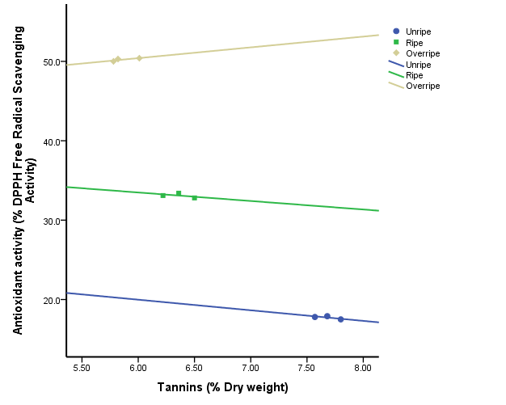
Figure 5: Correlation between Tannins and Antioxidant activity (DPPH free radical scavenging activity) of Carica papaya fruit (pear-shaped variety: ‘Local pawpaw’) at various ripening stages. Correlation coefficient, r = –0.738, –0.500 and 0.801; 99% confidence interval = –79.098 to 76.428, –119.204 to 117.061 and –63.141 to 65.857; Coefficient of determination, r2 = 0.544, 0.250 and 0.642 for the unripe, ripe and overripe respectively.

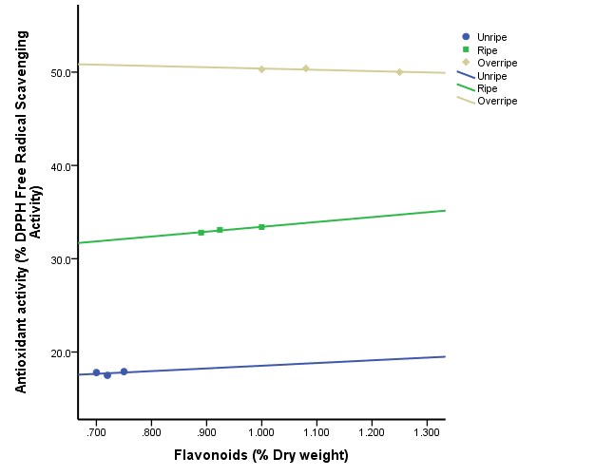
Figure 6: Correlation between Flavonoids and Antioxidant activity (DPPH free radical scavenging activity) of Carica papaya fruit (pear-shaped variety: ‘Local pawpaw’) at various ripening stages. Correlation coefficient, r = 0.350, 0.977 and –0.847; 99% confidence interval = –490.359 to 496.148, –67.793 to 78.196 and –56.621 to 53.861; Coefficient of determination, r² = 0.122, 0.954 and 0.717 for the unripe, ripe and overripe respectively.

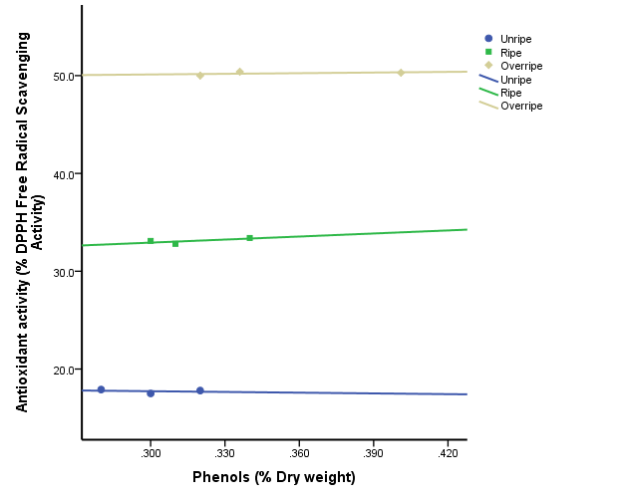
Figure 7: Correlation between Phenols and Antioxidant activity (DPPH free radical scavenging activity) of Carica papaya fruit (pear-shaped variety: ‘Local pawpaw’) at various ripening stages. Correlation coefficient, r = –0.240, 0.721 and 0.452; 99% confidence interval = –645.664 to 640.664, –625.712 to 646.481 and –273.400 to 277.783; Coefficient of determination, r2 = 0.058, 0.519 and 0.204 for the unripe, ripe and overripe respectively.

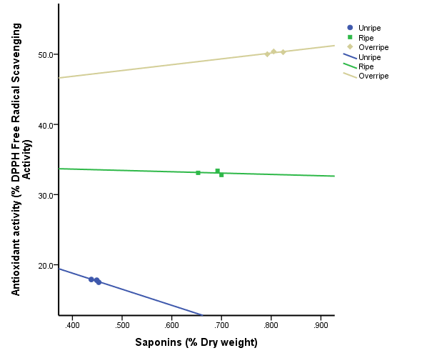
Figure 8: Correlation between Saponins and Antioxidant activity (DPPH free radical scavenging activity) of Carica papaya fruit (pear-shaped variety: ‘Local pawpaw’) at various ripening stages. Correlation coefficient, r = –0.856, –0.159 and 0.642; 99% confidence interval = –906.200 to 860.344, –751.667 to 747.871 and –623.156 to 639.759; Coefficient of determination, r2 = 0.732, 0.025 and 0.412 for the unripe, ripe and overripe respectively.

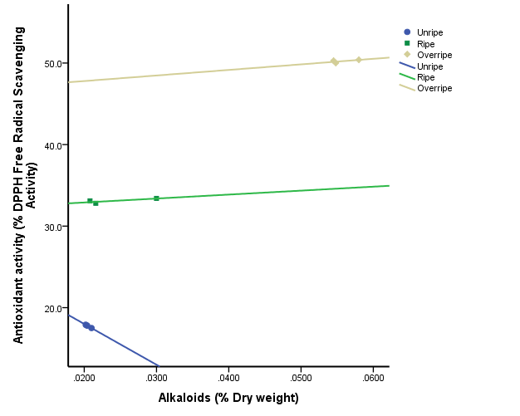
Figure 9: Correlation between Alkaloids and Antioxidant activity (DPPH free radical scavenging activity) of Carica papaya fruit (pear-shaped variety: ‘Local pawpaw’) at various ripening stages. Correlation coefficient, r = –1, 0.824 and 0.636; 99% confidence interval = –500.000 to –500.000, –2073.987 to 2171.010 and –5205.370 to 5341.774; Coefficient of determination, r2 = 1.000, 0.679 and 0.404 for the unripe, ripe and overripe respectively.

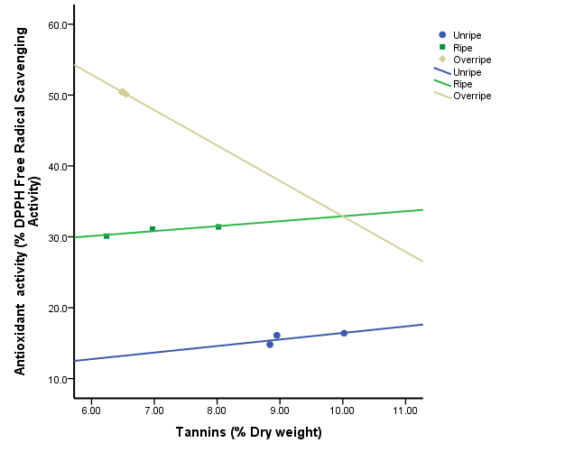
Figure 10: Correlation between Tannins and Antioxidant activity (DPPH free radical scavenging activity) of Carica papaya fruit (oblong variety: ‘Agric pawpaw’) at various ripening stages. Correlation coefficient, r = 0.707, 0.919 and –0.866; 99% confidence interval = –57.808 to 59.653, –18.374 to 19.772 and –188.761 to 178.761; Coefficient of determination, r2 = 0.500, 0.845 and 0.750 for the unripe, ripe and overripe respectively.

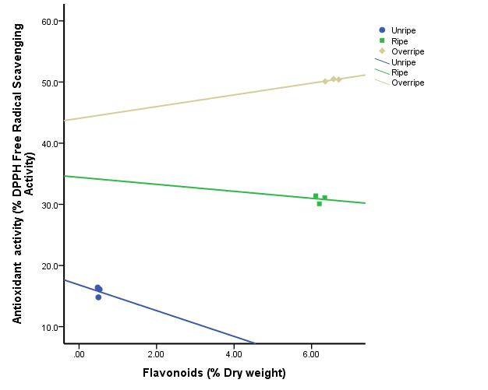
Figure 11: Correlation between Flavonoids and Antioxidant activity (DPPH free radical scavenging activity) of Carica papaya fruit (oblong variety: ‘Agric pawpaw’) at various ripening stages. Correlation coefficient, r = –0.062, –0.097 and 0.815; 99% confidence interval = –2149.210 to 2144.999, –372.653 to 371.511 and –42.487 to 44.404; Coefficient of determination, r² = 0.004, 0.009 and 0.664 for the unripe, ripe and overripe respectively.

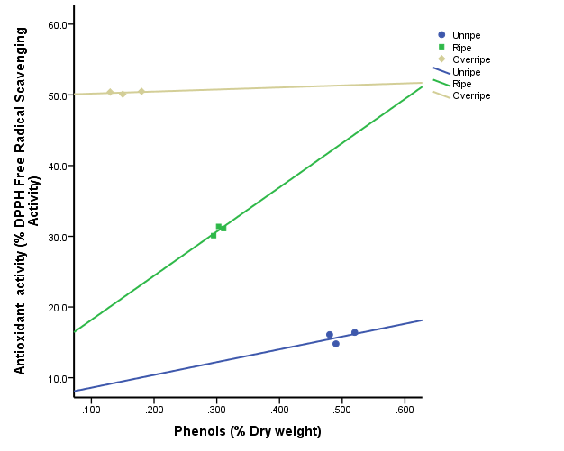
Figure 12: Correlation between Phenols and Antioxidant activity (DPPH free radical scavenging activity) of Carica papaya fruit (oblong variety: ‘Agric pawpaw’) at various ripening stages. Correlation coefficient, r = 0.442, 0.735 and 0.350; 99% confidence interval = –2314.277 to 2350.430, –3612.724 to 3737.724 and –490.359 to 496.148; Coefficient of determination, r² = 0.196, 0.540 and 0.122 for the unripe, ripe and overripe respectively.

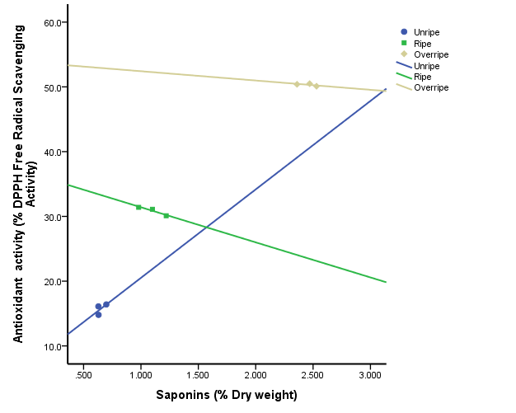
Figure 13: Correlation between Saponins and Antioxidant activity (DPPH free radical scavenging activity) of Carica papaya fruit (oblong variety: ‘Agric pawpaw’) at various ripening stages. Correlation coefficient, r = 0.635, –0.955 and –0.594; 99% confidence interval = –1043.565 to 1070.883, –112.611 to 101.777 and –125.041 to 122.171; Coefficient of determination, r2 = 0.403, 0.912 and 0.353 for the unripe, ripe and overripe respectively.
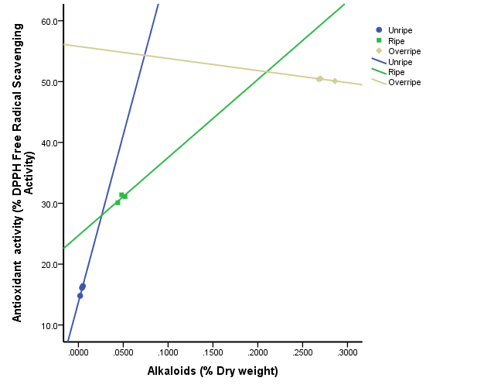
Figure 14: Correlation between Alkaloids and Antioxidant activity (DPPH free radical scavenging activity) of Carica papaya fruit (oblong variety: ‘Agric pawpaw’) at various ripening stages. Correlation coefficient, r = 0.988, 0.754 and –0.941; 99% confidence interval = –4962.835 to 6062.835, –6986.590 to 7243.043 and –472.973 to 433.247; Coefficient of determination, r2 = 0.976, 0.568 and 0.886 for the unripe, ripe and overripe respectively.

APPENDIX II
FORMULAR FOR CALCULATING CONCENTRATION OF VARIOUS PARAMETER
DPPH scavenging activity (%) = (A_{blank} –A_{sample}) × 100.
A_{blank}
Where A is the absorbance.
Phenols
Weight of Sample used = 2g
Extract used = 5ml
Final volume of Extract = 100ml
Percentage = 100%
A_{Sample} – A_{Blank} × Extract × 100%
Final Volume Weight of Sample used
Alkaloids
Weight of Sample used = 5g
Extract used = 5ml
Final volume of Extract = 200ml
Percentage = 100%
Extract × 100% × Reading (Final Weight – Initial Weight)
Final Volume Weight of Sample used
Tannins
Weight of Sample used = 5g
Extract used = 5ml
Final volume of Extract = 50ml
Percentage = 100%
A_{Sample} – A_{Blank} × Extract × 100%
Final Volume Weight of Sample
Saponins
Weight of Sample used = 20g
Extract used = 40ml
Final volume of Extract = 300ml
Percentage = 100%
Extract × 100% × Reading (Final Weight – Initial Weight)
Final Volume Weight of Sample used
Flavonoids
Weight of Sample used = 10g
Extract used = 100ml
Final volume of Extract = 100ml
Percentage = 100%
Reading = Final Weight – Initial Weight
Extract × 100% × Reading (Final Weight – Initial Weight)
Final Volume Weight of Sample used

