Supplemental Figures

Supplemental Figure 1.
A graphical representation of exclusionary criteria and the quality control process for the study.
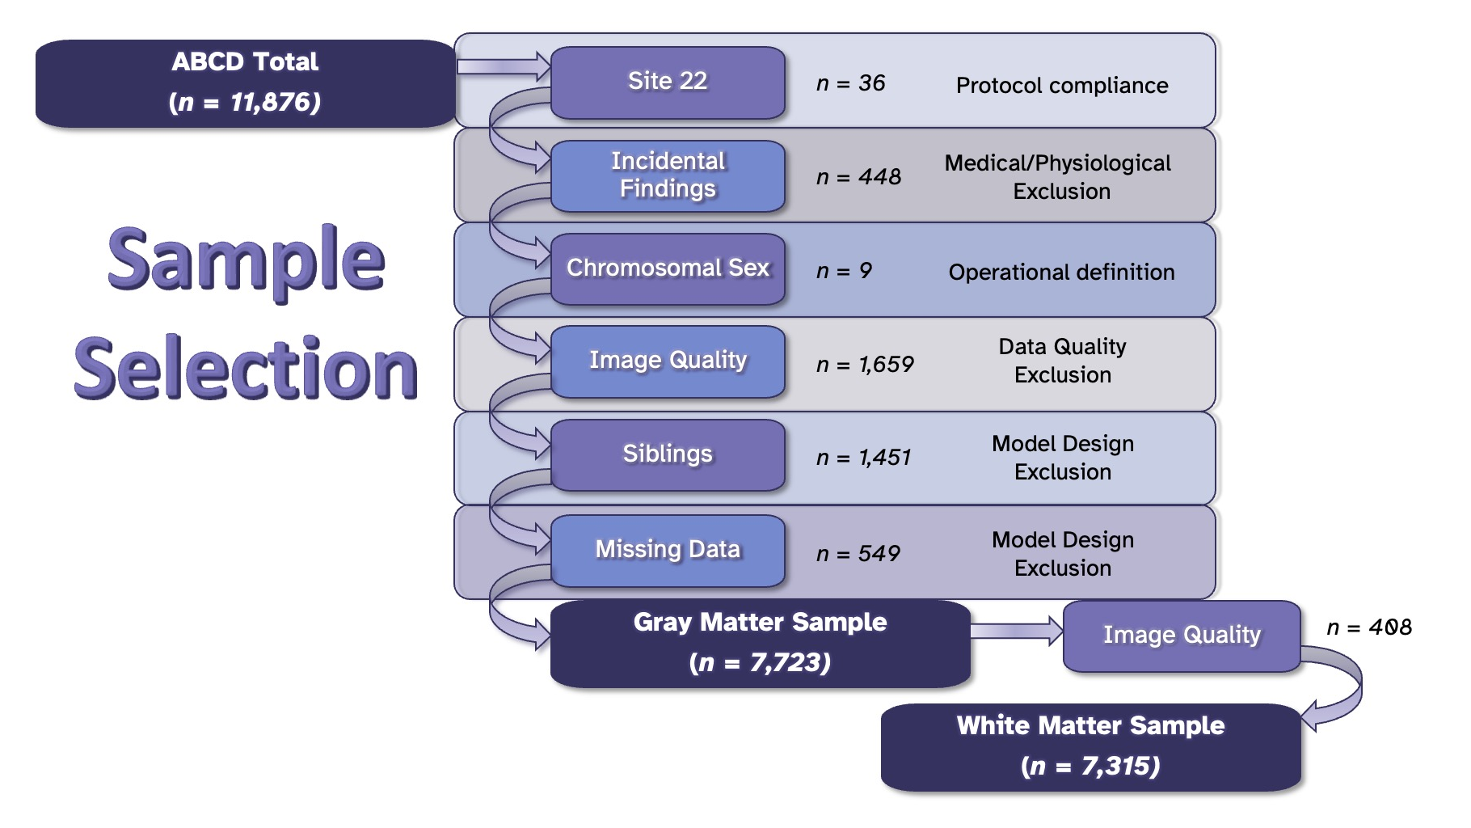

Supplemental Figure 2. Unadjusted coefficient of variance for males (blue) and females (pink) in regional cortical gray matter volume ROIs. Abbreviations: L = left hemisphere, R = right hemisphere. * denotes Fligner-Killeen χ2 test for inhomogeneity of variance FDR p-value < 0.05. 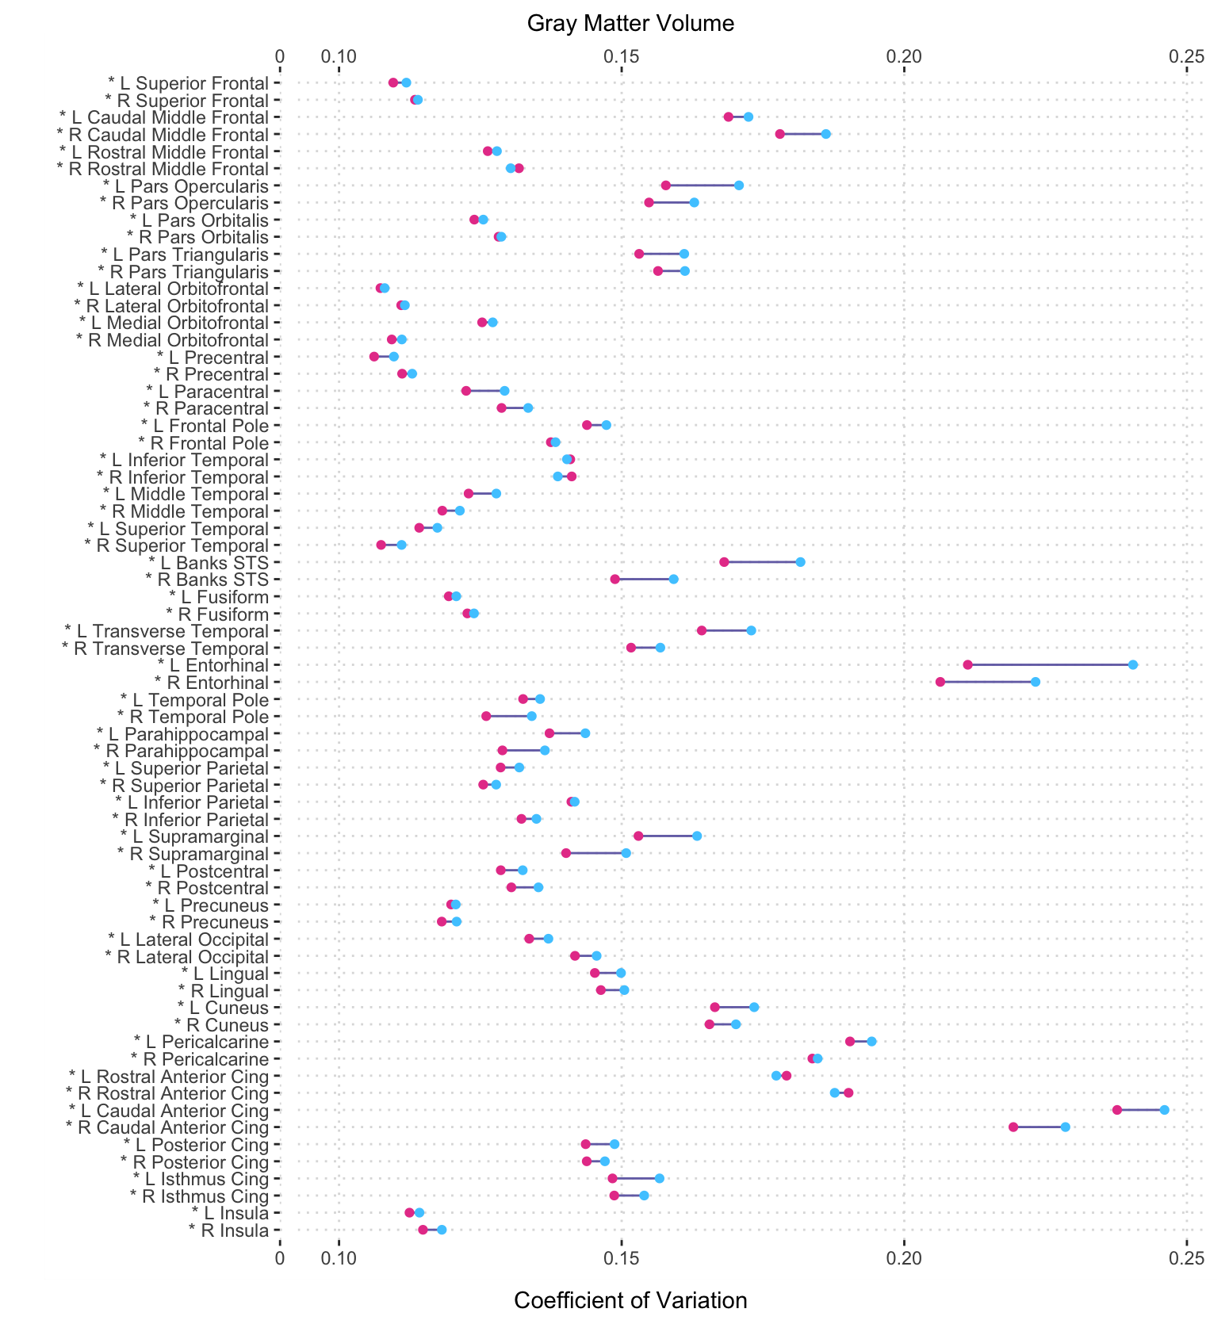

Supplemental Figure 3. Unadjusted coefficient of variance for males (blue) and females (pink) in regional volumes for subcortical ROIs . Abbreviations: CC = corpus callosum; L = left hemisphere, R = right hemisphere. * denotes= Fligner-Killeen χ2 test for inhomogeneity of variance FDR p-value < 0.05.

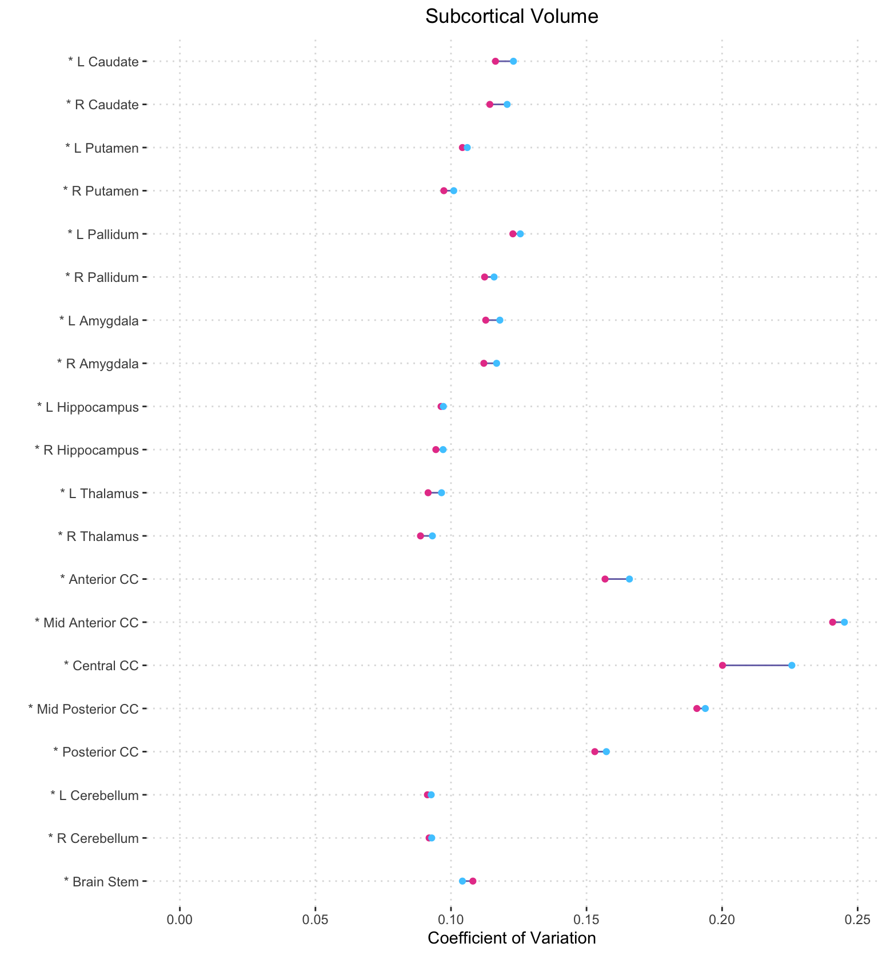

Supplemental Figure 4. Unadjusted coefficient of variance for males (blue) and females (pink) in regional cortical thickness ROIs. Abbreviations: L = left hemisphere, R = right hemisphere. * denotes= Fligner-Killeen χ2 test for inhomogeneity of variance FDR p-value < 0.05.

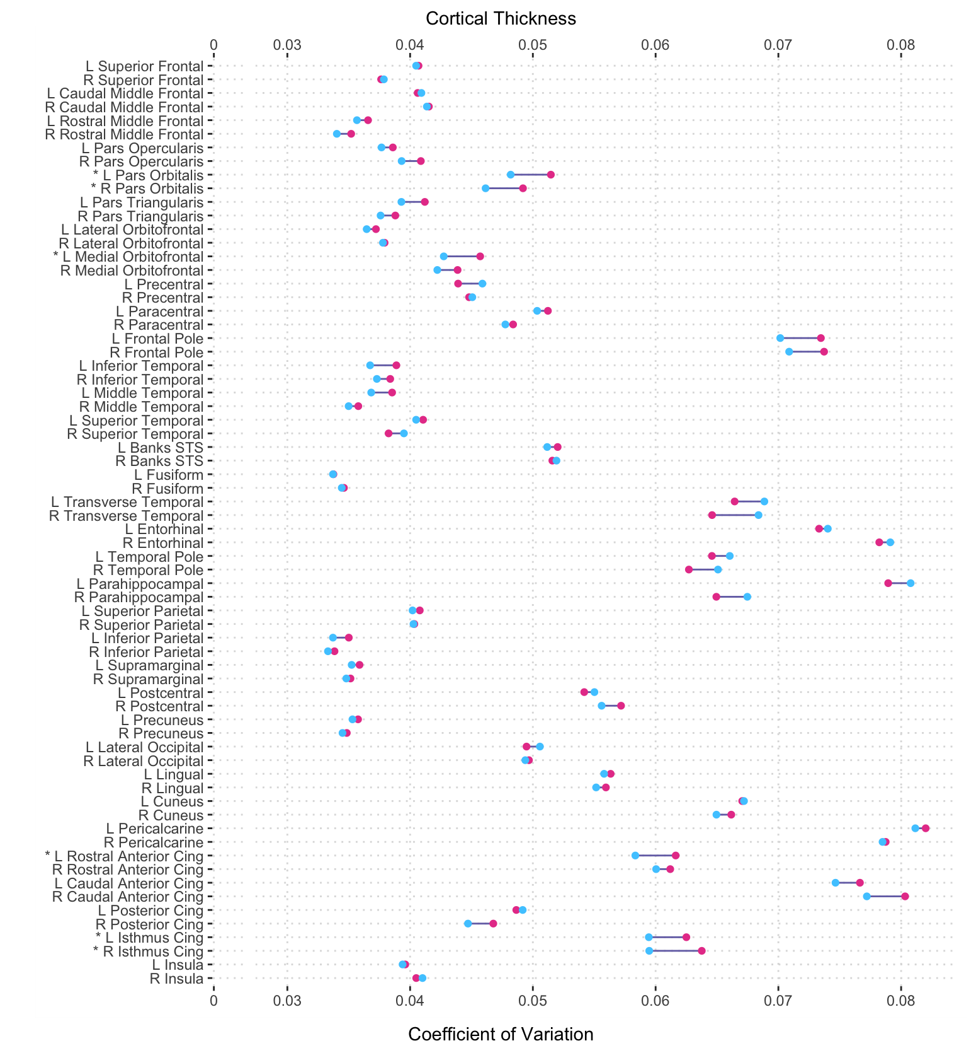

Supplemental Figure 5. Unadjusted coefficient of variance for males (blue) and females (pink) in regional white matter volume ROIs. Abbreviations: L = left hemisphere, R = right hemisphere. * denotes Fligner-Killeen χ² test for inhomogeneity of variance FDR p-value < 0.05.
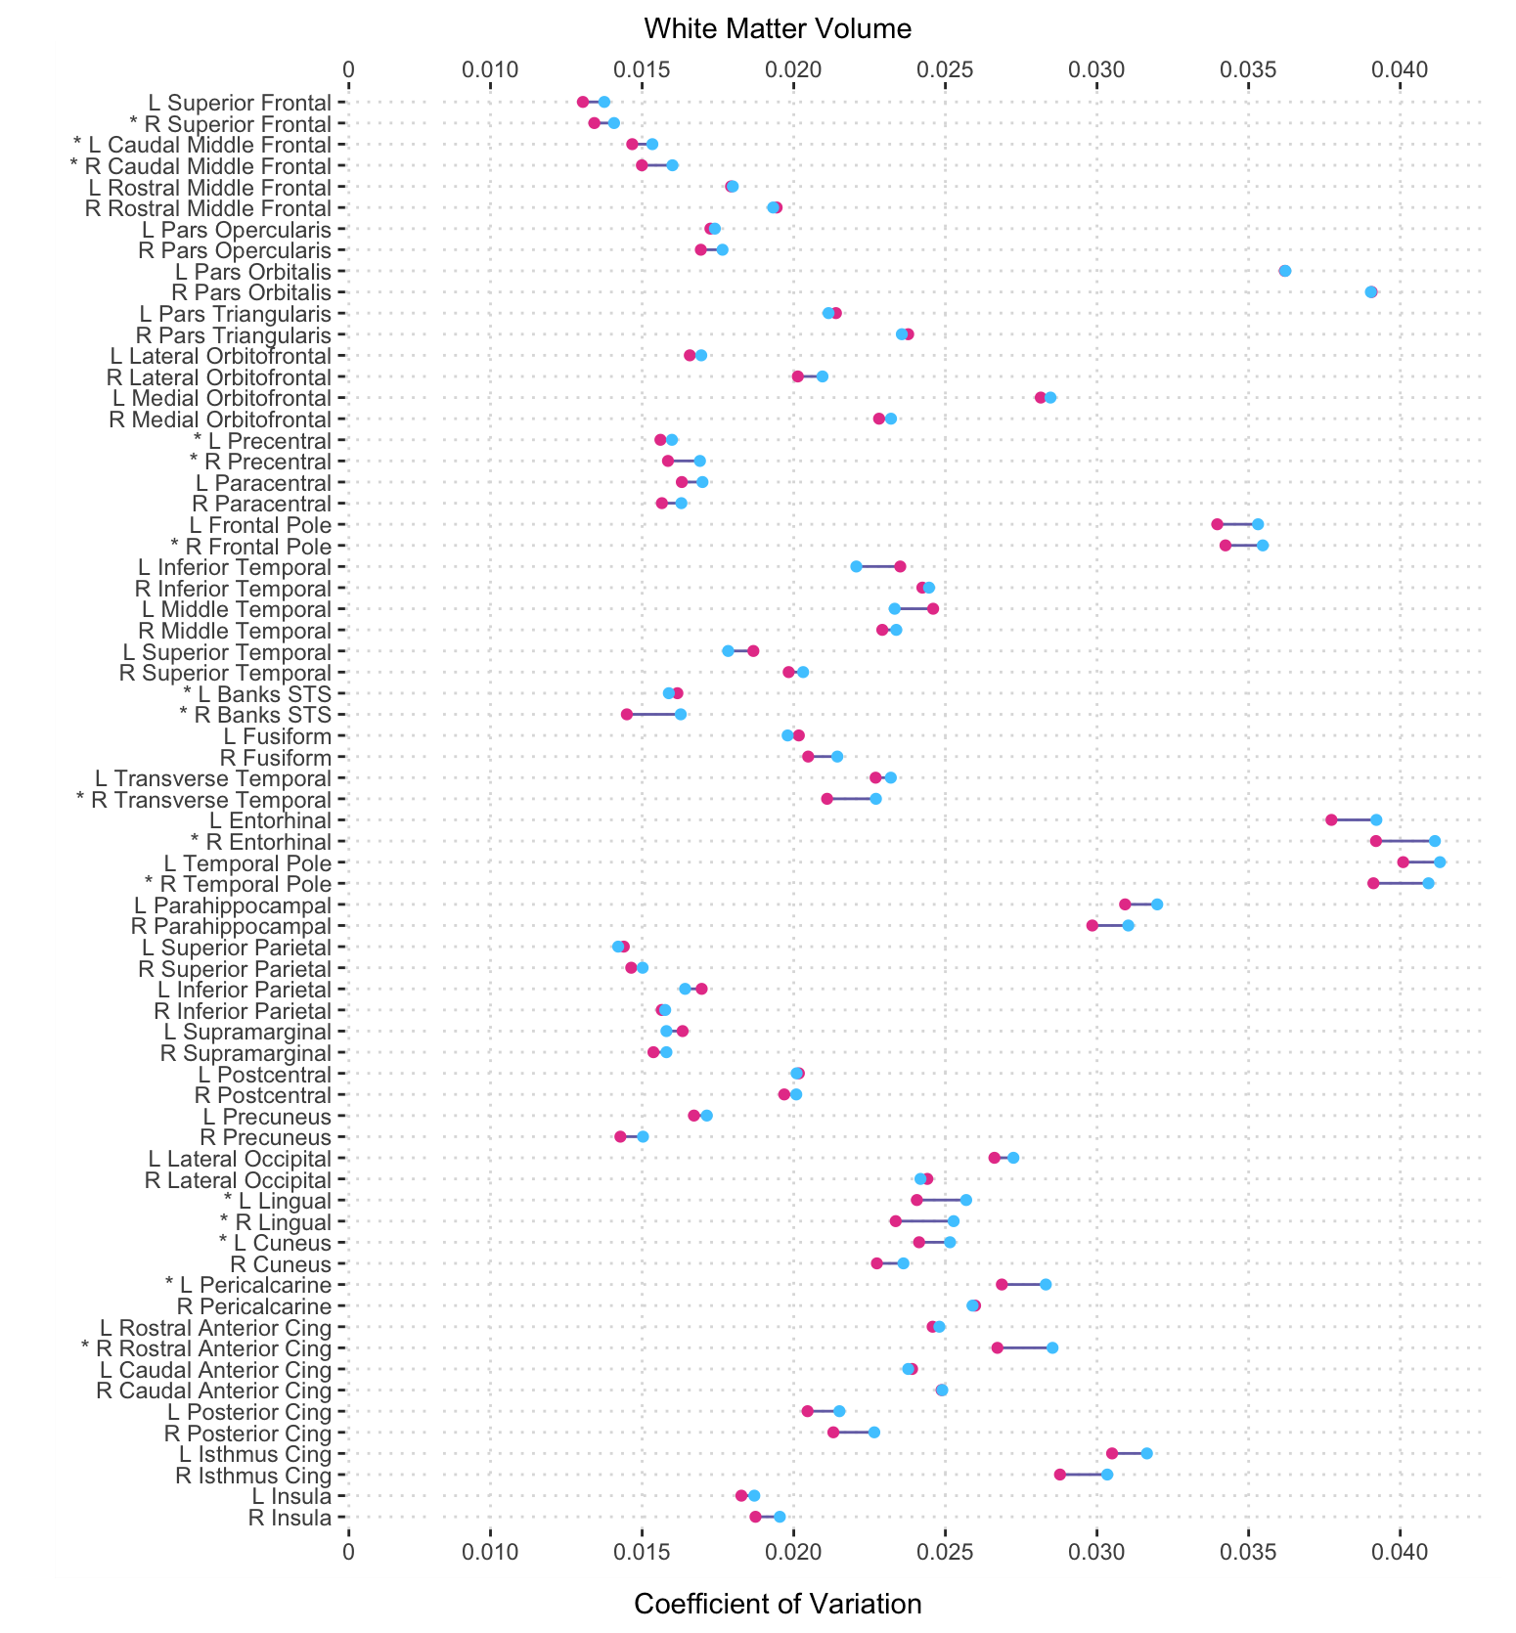

Supplemental Figure 6. Unadjusted coefficient of variance for males (blue) and females (pink) in regional FA. Abbreviations: L = left hemisphere, R = right hemisphere, CST = corticospinal tract, ILF = inferior longitudinal fasciculus, IFOF = inferior fronto-occipital fasciculus. * denotes Fligner-Killeen χ² test for inhomogeneity of variance FDR p-value < 0.05.
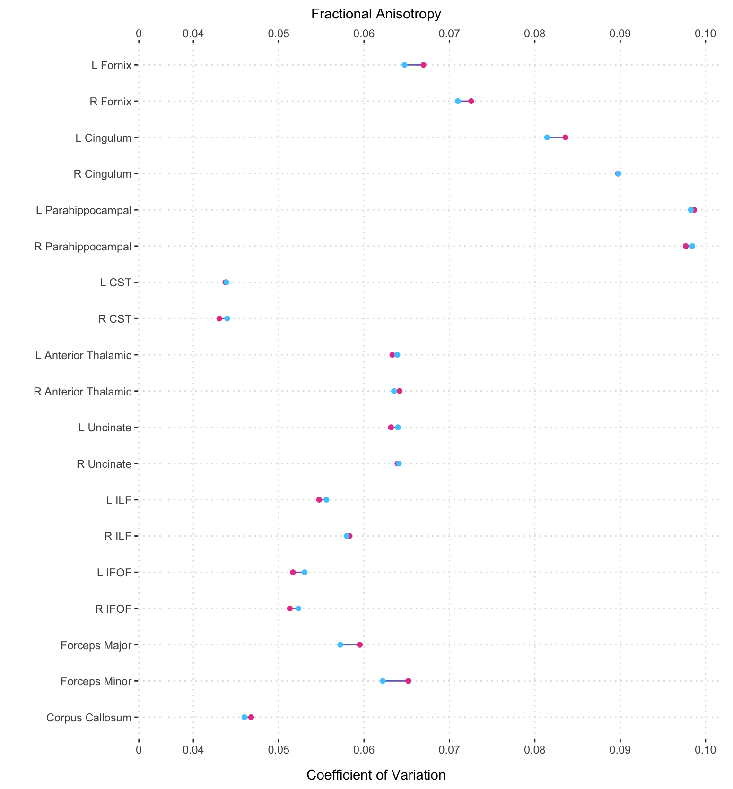

Supplemental Figure 7. Unadjusted coefficient of variance for males (blue) and females (pink) in regional MD. Abbreviations: L = left hemisphere, R = right hemisphere. * denotes Fligner-Killeen χ² test for inhomogeneity of variance FDR p-value < 0.05.
