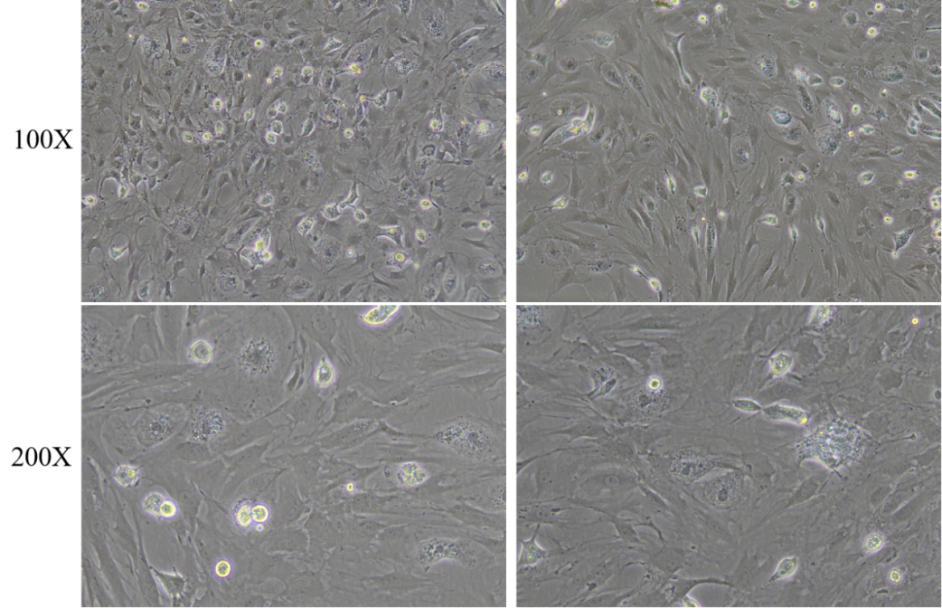
Supplementary information of “BMSCs Combined with Grafted igament Promote ACL Healing by Regulating NF-kB Signaling Pathway The mechanism of action of the combination”

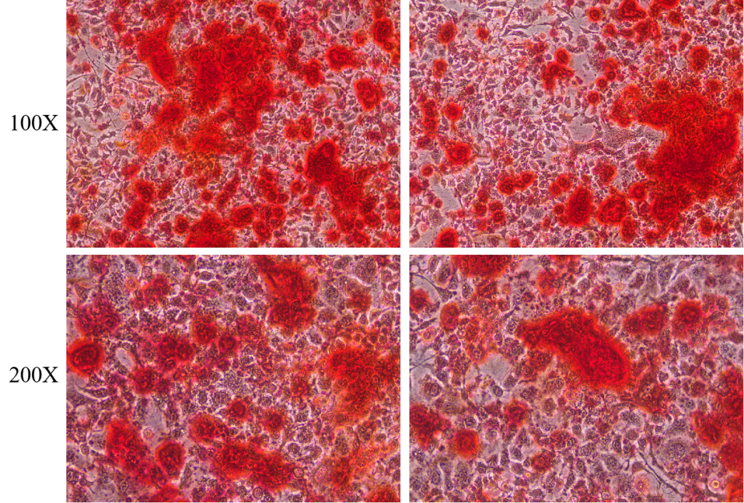
Fig.2 Alizarin red staining was used to identify whether the osteogenic induction of rat BMSCs was successful.
Fig.1 Isolation, purification and culture of rat BMSCs.

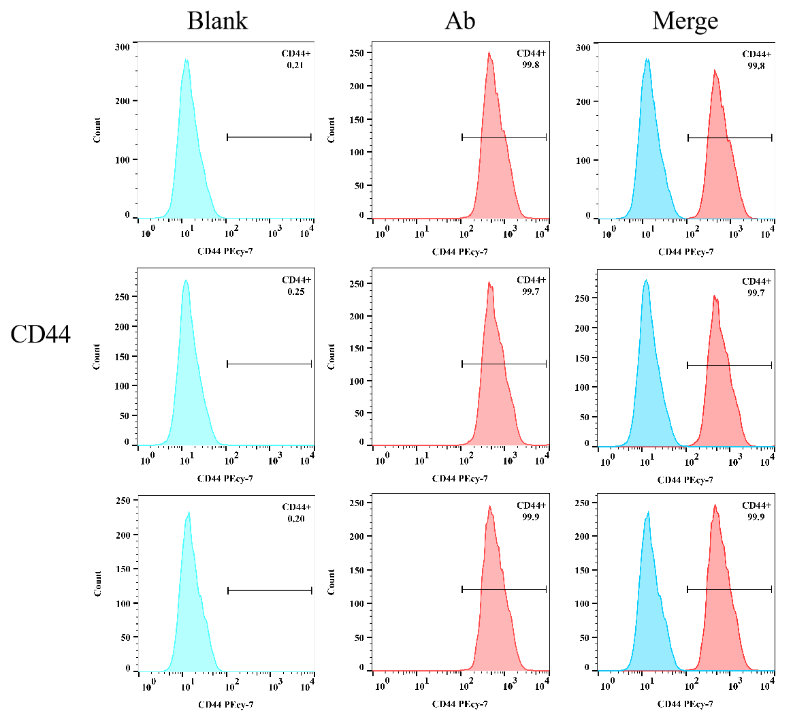
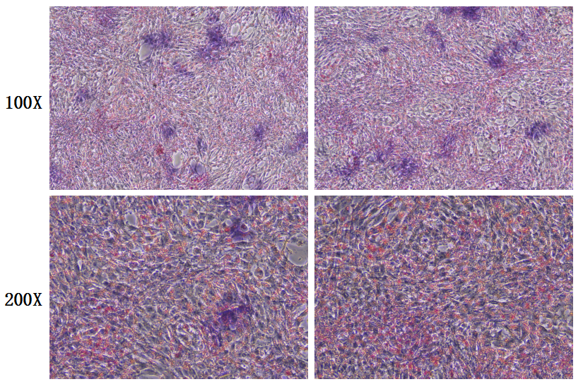
Fig.4 Identification of surface markers CD44 on rat bone marrow mesenchymal stem cells by flow cytometry
Fig.3 Oil red O staining was used to identify the success of adipogenic induction of rat BMSCs
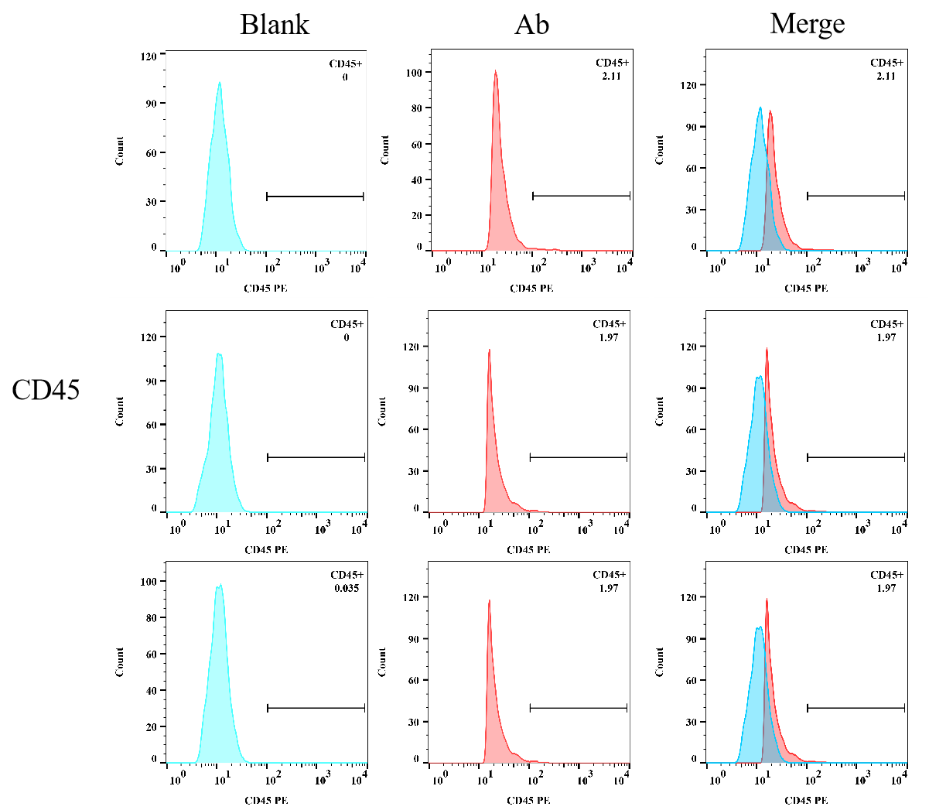
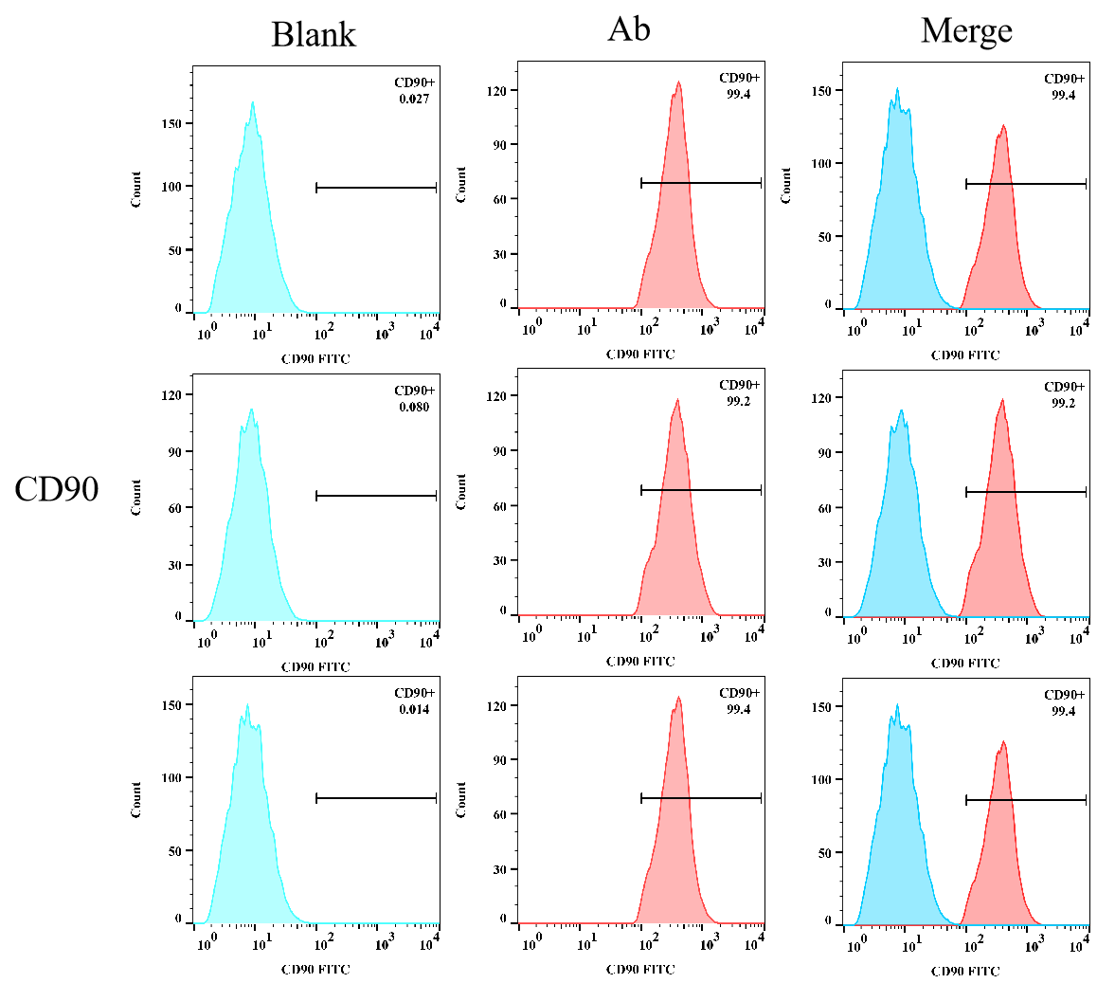
Fig.6 Identification of surface markers CD45 on rat bone marrow mesenchymal stem cells by flow cytometry
Fig.5 Identification of surface markers CD90 on rat bone marrow mesenchymal stem cells by flow cytometry
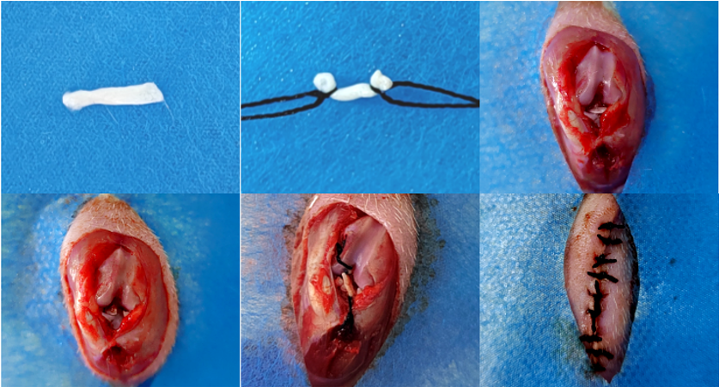
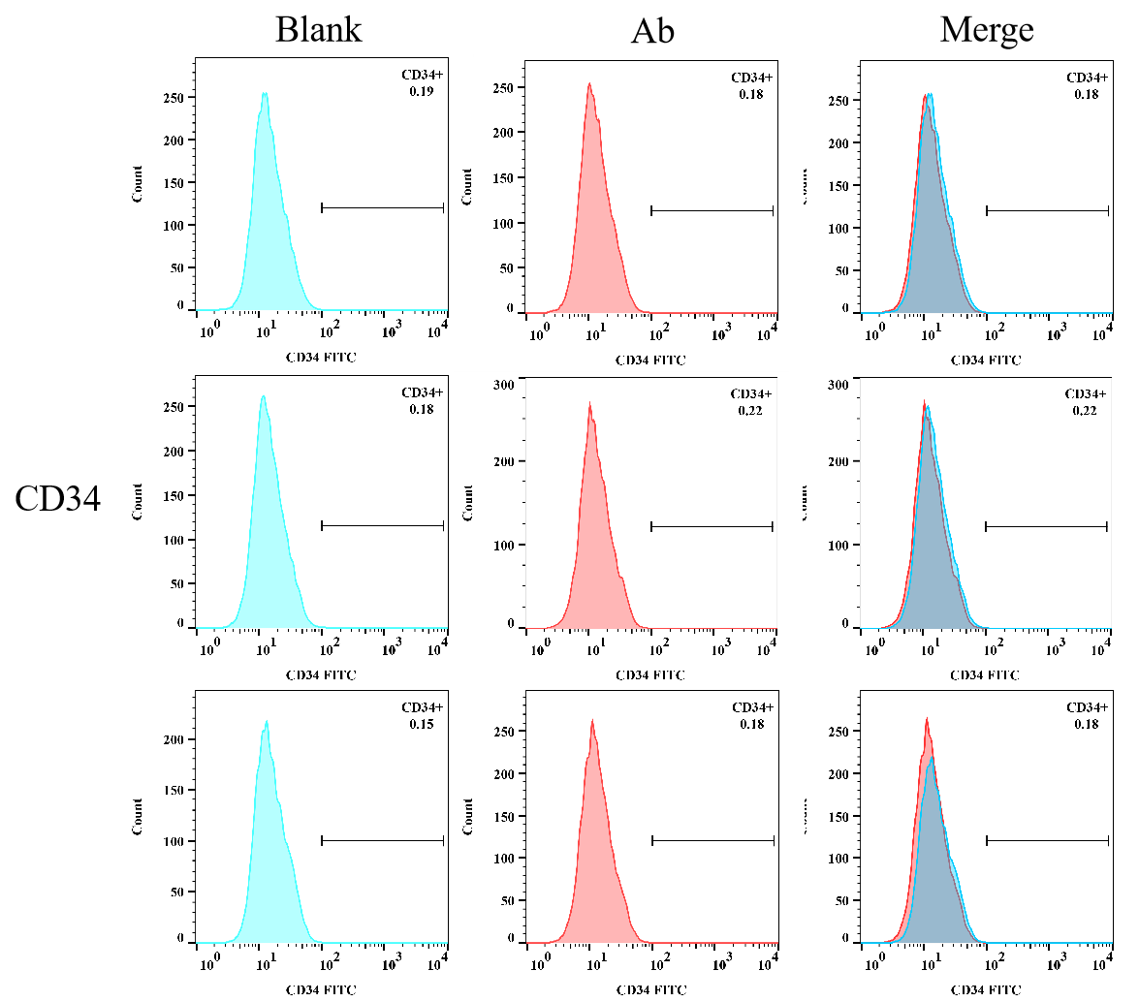
Fig.8 Establishment of Rat Model of Bilateral Anterior Cruciate Ligament Injury
A
B
C
D
E
F
Fig.7 Identification of surface markers CD34 on rat bone marrow mesenchymal stem cells by flow cytometry
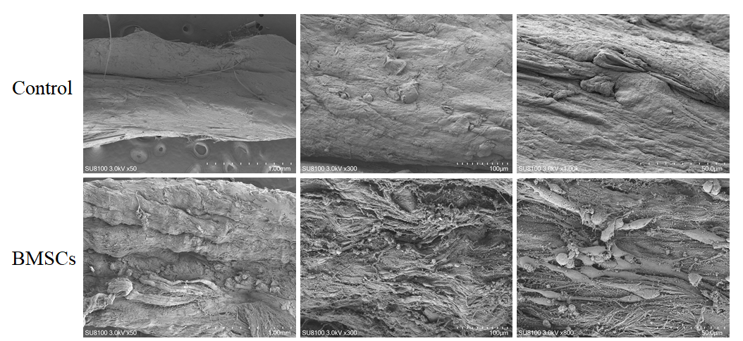
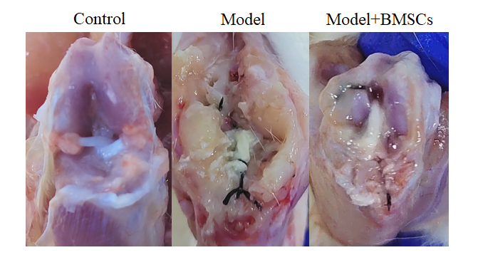
Fig.10 The microstructural changes of the ligaments co-cultured with BMSCs were observed by electron microscopy
Fig.9 Reconstruction of bilateral anterior cruciate ligament injury in rats
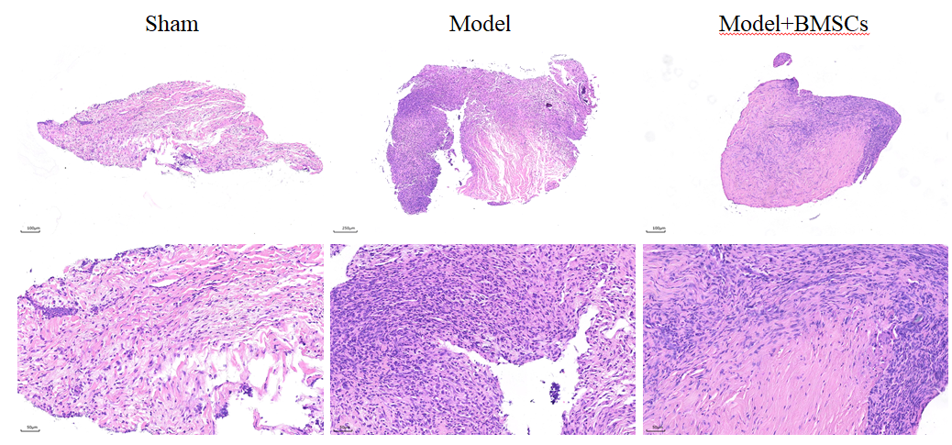
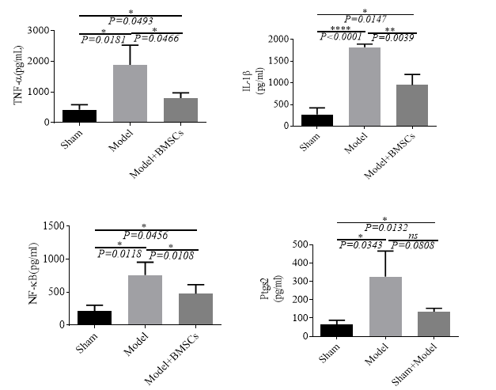
Fig.12 Anterior cruciate ligament (ACL) was stained with hematoxylin and eosin (he) to observe the adhesion of ACL.
Fig.11 The levels of TNF-α, IL-1β, NF-B and Ptgs2 in serum were detected by ELISA.
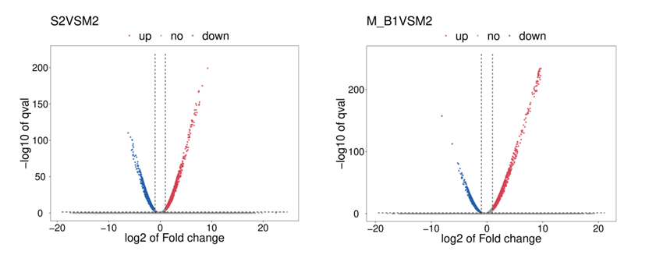
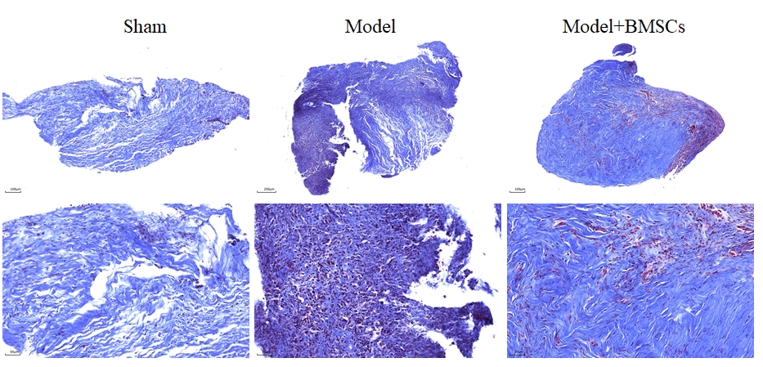
Fig.14 Analysis of differentially expressed genes
Fig.13 Masson stain of anterior cruciate ligament
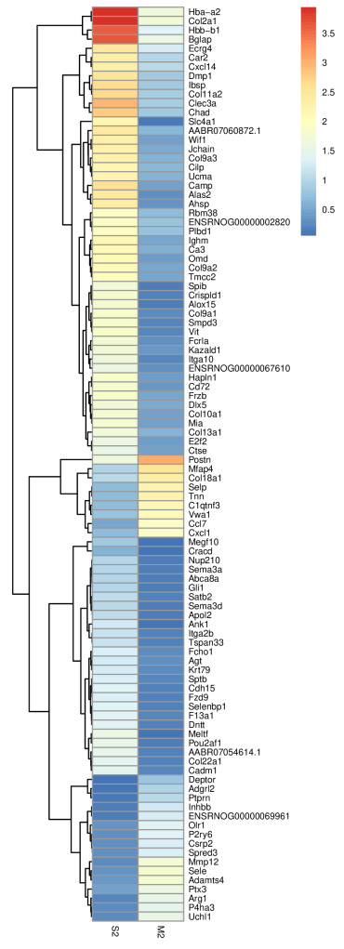
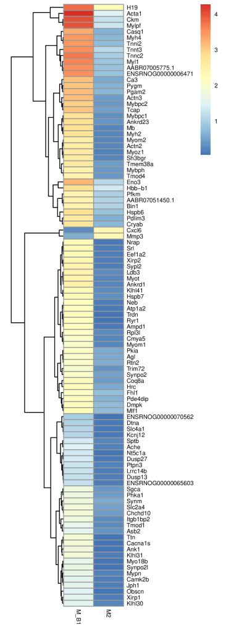
Fig.15 Cluster analysis of differentially expressed genes

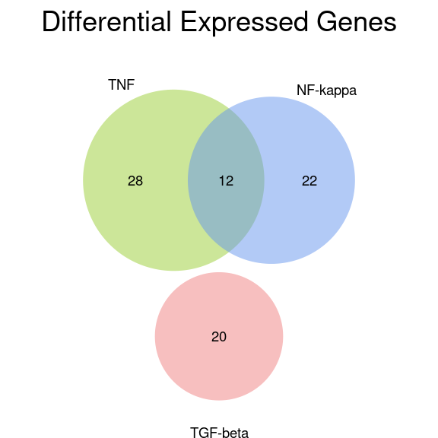
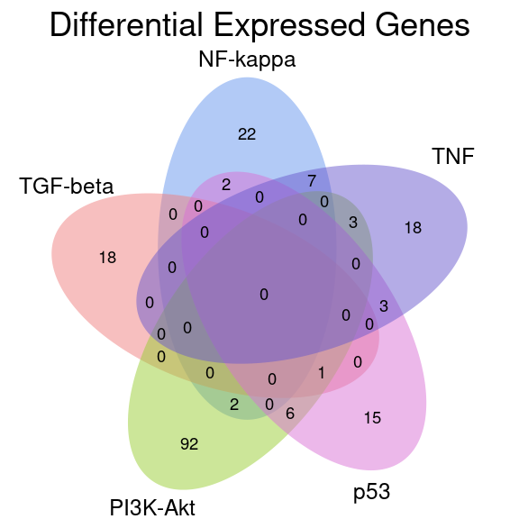
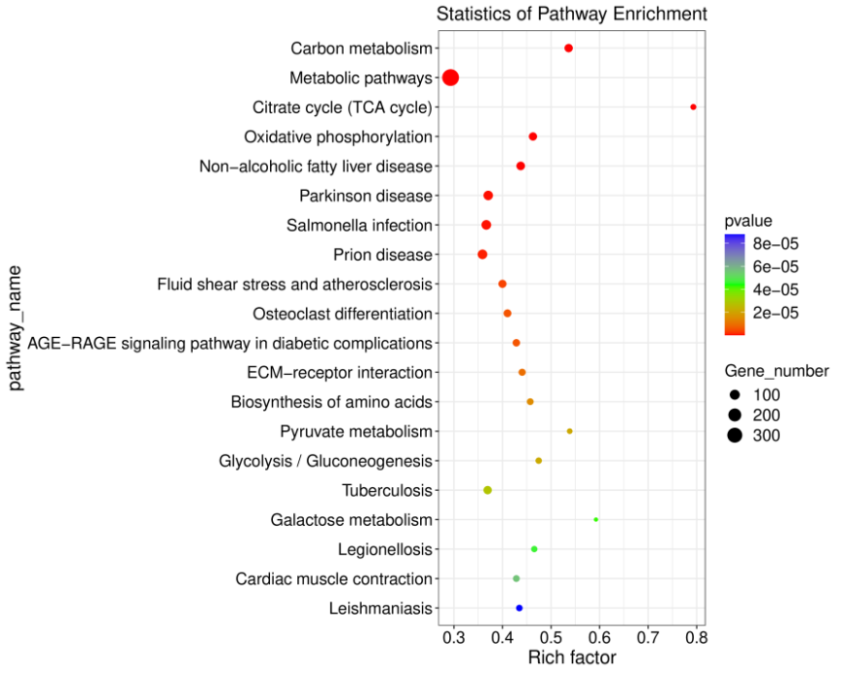
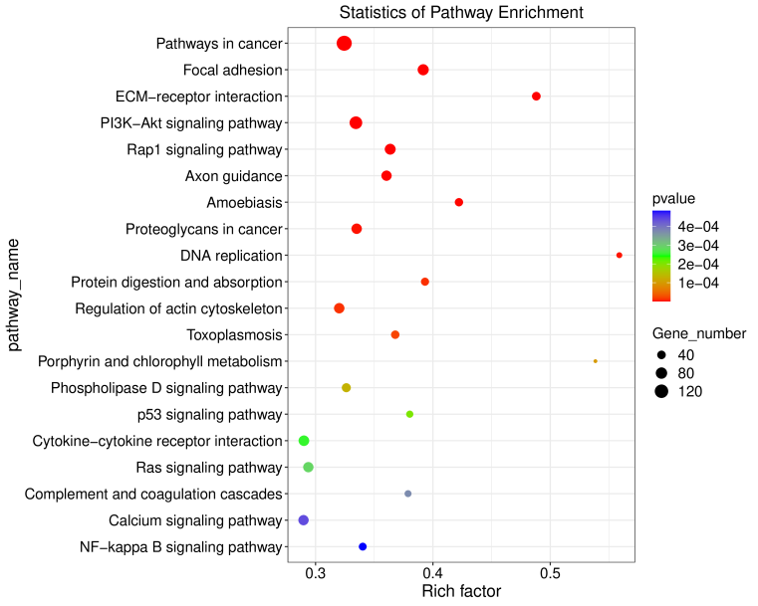
Fig.16 Transcriptomic sequencing screening for differentially expressed genes

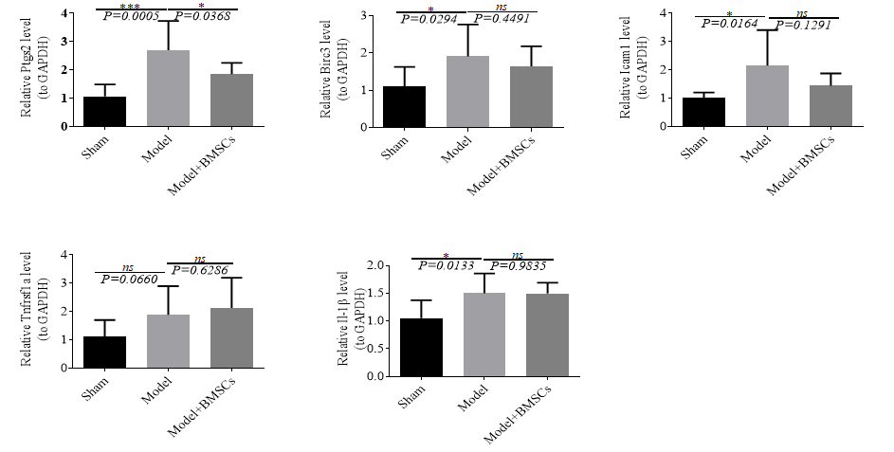
Fig.17 The expression levels of Ptgs2, Birc3, Icam1, Tnfrsf1a and IL-1β in the left anterior cruciate ligament (ACL) were detected by RT-qPCR

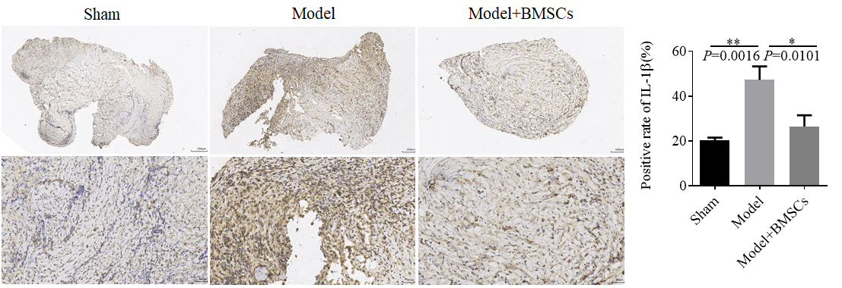
Fig.18 The expression levels of IL-1β in the left anterior cruciate ligament were detected by immunohistochemistry.

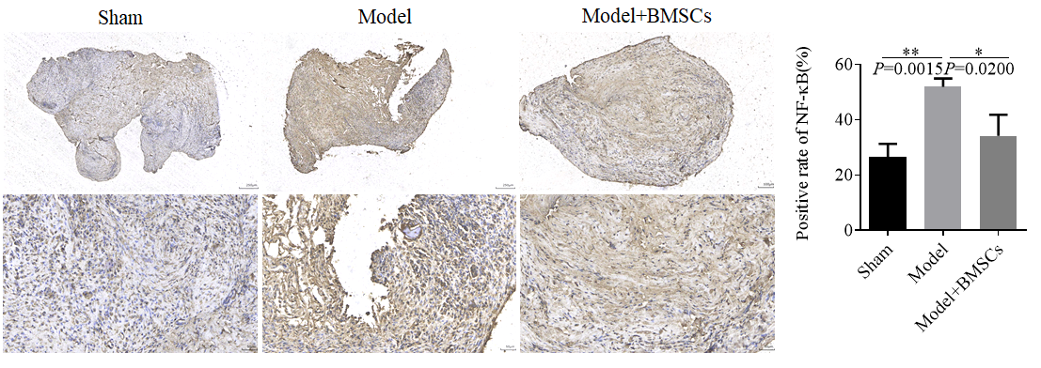
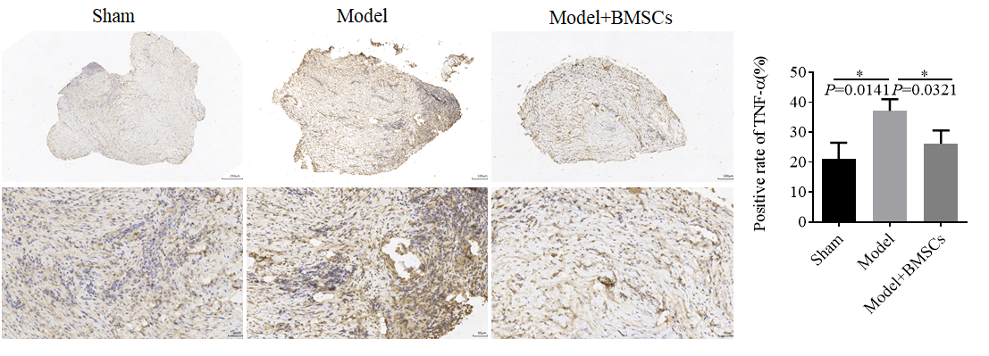
Fig.20 The expression levels of NF-kB in the left anterior cruciate ligament were detected by immunohistochemistry.

Fig.19 The expression levels of TNF-α in the left anterior cruciate ligament were detected by immunohistochemistry.

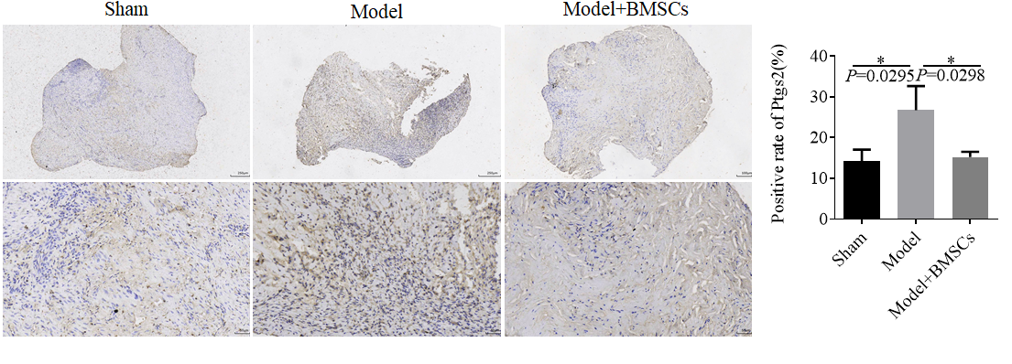
Fig.21 The expression levels of Ptgs2 in the left anterior cruciate ligament were detected by immunohistochemistry.

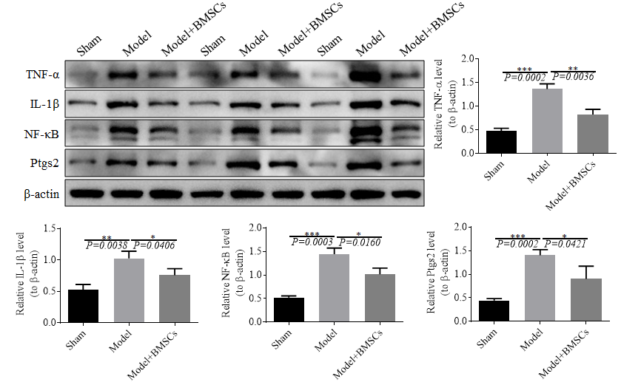
Fig.22 The expression levels of TNF-α, IL-1β, NF-B and Ptgs2 in the right anterior cruciate ligament tissue were detected by Western blot.

