Article title: Application of Box-Behnken design for optimization of betulinic acid, ursolic acid and phenolics extraction from endemic Rosa psiformis subsp. pisiformis in relation to its cytotoxic activities
Hatice DEMİRAY¹, Mesut Emir DİBEK¹, Onur ÖZEL¹
¹ Ege University Science Faculty Department of Biology Section of Botany, Bornova/İzmir-Turkey
Corresponding author: Hatice DEMİRAY
e-mail address: haticedemus@yahoo.com
Supplementary Figure of Contents
Supplementary Figure S1. Total content of R. pisiformis stem dichloromethane, ethanol and hexane extract (65%)
Supplementary Figure S2. Total content of R. pisiformis stem dichloromethane, ethanol and hexane extract (80%)
Supplementary Figure S3. Total content of R. pisiformis stem dichloromethane, ethanol and hexane extract (95%)
Supplementary Figure S4. Total content of R. pisiformis root dichloromethane, ethanol and hexane extract (65%)
Supplementary Figure S5. Total content of R. pisiformis root dichloromethane, ethanol and hexane extract (80%)
Supplementary Figure S6. Total content of R. pisiformis root dichloromethane, ethanol and hexane extract (95%)
Supplementary Figure S7. Total content of R. pisiformis leaf dichloromethane, ethanol and hexane extract (65%)
Supplementary Figure S8. Total content of R. pisiformis leaf dichloromethane, ethanol and hexane extract (80%)
Supplementary Figure S9. Total content of R. pisiformis leaf dichloromethane, ethanol and hexane extract (95%)
Supplementary Figure S10. Total content of R. pisiformis fruit dichloromethane, ethanol and hexane extract (65%)
Supplementary Figure S11. Total content of R. pisiformis fruit dichloromethane, ethanol and hexane extract (80%)
Supplementary Figure S12. Total content of R. pisiformis fruit dichloromethane, ethanol and hexane extract (95%)
Supplementary Figure S13. 3D diagrams for phenolic (catechin, rutin, quercetin), of R. pisiformis subsp. pisiformis stem extracts
Supplementary Figure S14. 3D diagrams for phenolic (catechin, rutin, quercetin), of R. pisiformis subsp. pisiformis root extracts
Supplementary Figure S15. 3D diagrams for phenolic (catechin, rutin, quercetin), of R. pisiformis subsp. pisiformis fruit extracts
Supplementary Figure S16. 3D diagrams for phenolic (catechin, rutin, quercetin), of R. pisiformis subsp. pisiformis leaf extracts
Supplementary Figure S17. 3D diagrams for Betulinic acid and Ursolic acid of R. pisiformis subsp. pisiformis stem extracts
Supplementary Figure S18. Chromatograms of HPLC standards: a. Betulinic acid, b. Catechin, c. Quercetin, d. Rutin
Supplementary Figure S19. HPLC chromatograms: DCM extracts: a. stem, b. root, c. fruit, d. leaf
Supplementary Figure S20. HPLC chromatograms: Ethanol extracts: a. stem, b. root, c. fruit, d. leaf
Supplementary Figure S21. HPLC chromatograms of terpenes and phenols: a. stem PH, b. stem BA, c. root BA, d. root PH, e. leaf PH, f. leaf BA, g. fruit BA, h. fruit PH (PH: phenol, BA: betulinic acid)

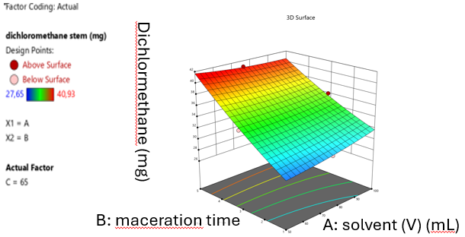
DCM stem 65%
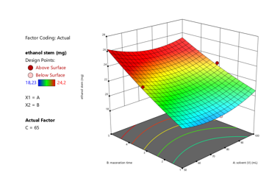
Ethanol stem 65%
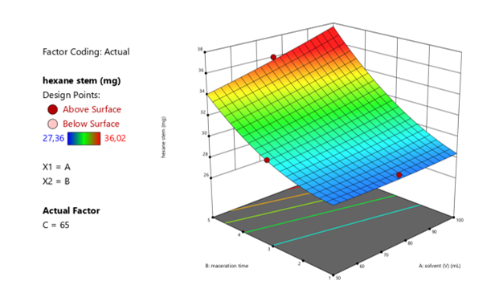
Hexane stem 65%
Figure S1 Total content of R.pisiformis stem dichloromethane, ethanol and hexane extract (65%)

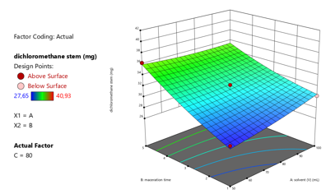
DMC stem 80%
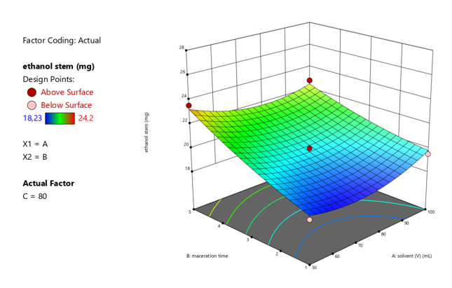
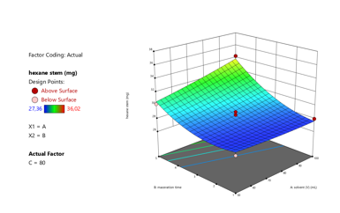
Ethanol stem 80%
Hexane stem 80%
Figure S2 Total content of R.pisiformis stem dichloromethane, ethanol and hexane extract (80%)

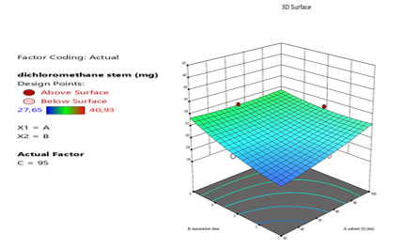
DCM stem 95%
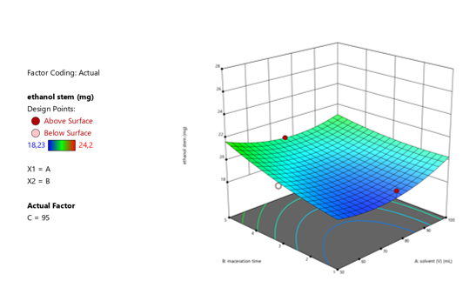
Ethanol stem 95%
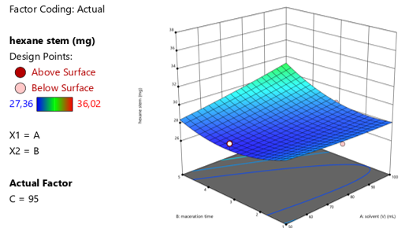
Hexane stem 95%
Figure S3 Total content of R.pisiformis stem dichloromethane, ethanol and hexane extract (95%)

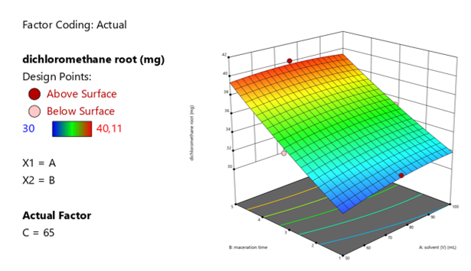
DCM root 65%
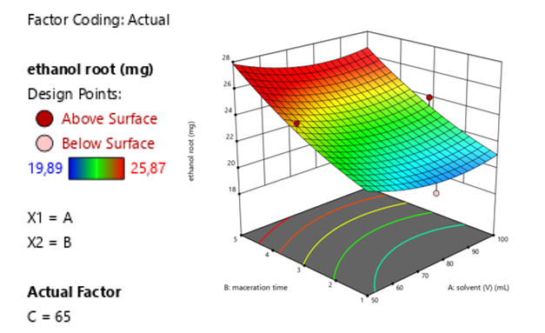
Ethanol root 65%
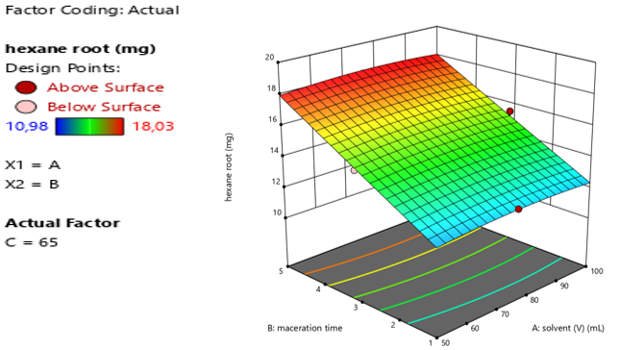
Hexane root 65%
Figure S4 Total content of R.pisiformis root dichloromethane, ethanol and hexane extract (65%)

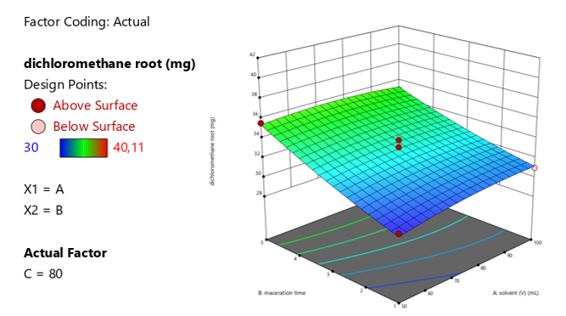
DCM root 80%
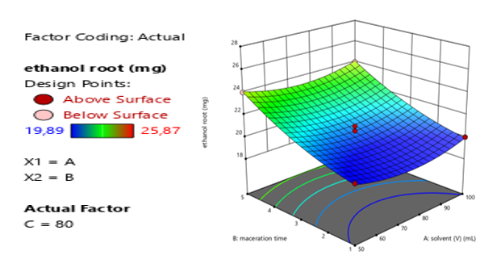
Ethanol root 80%

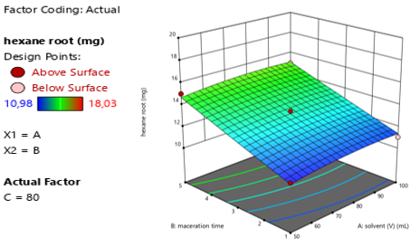
Hexane root 80%
Figure S5 Total content of R.pisiformis root dichloromethane, ethanol and hexane extract (80%)

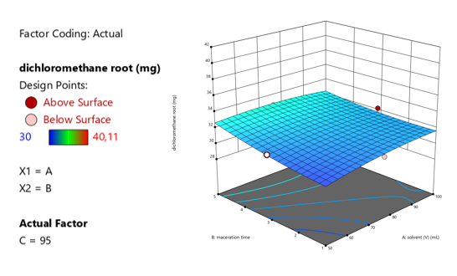
DCM root 95%

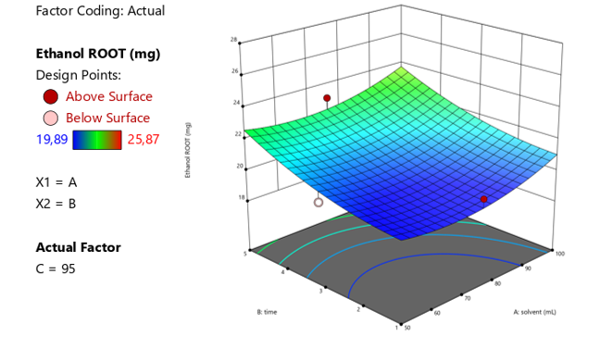
Ethanol root 95%
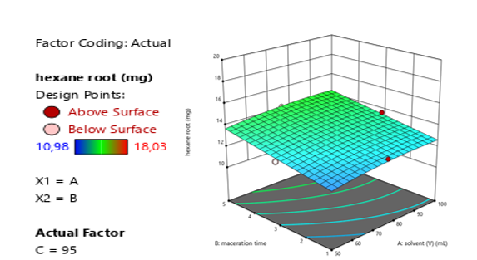
Hexane root 95%

Figure S6 Total content of R.pisiformis root dichloromethane, ethanol and hexane extract (95%)

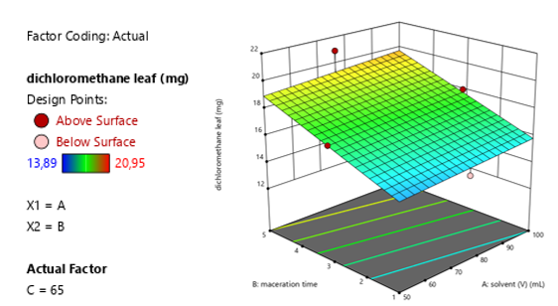
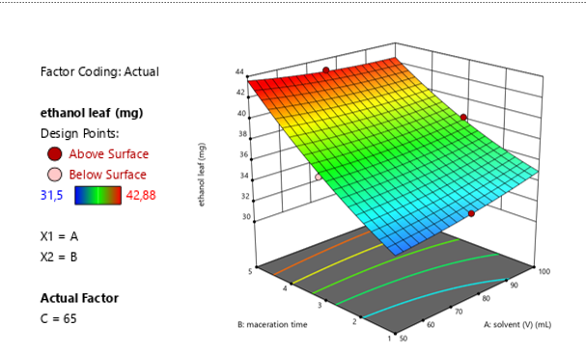
DCM leaf 65%
Ethanol leaf 65%

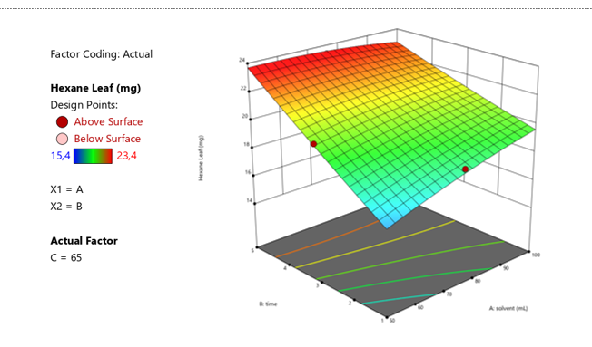
Hexane leaf 65%
Figure S7 Total content of R.pisiformis leaf dichloromethane, ethanol and hexane extract (65%)

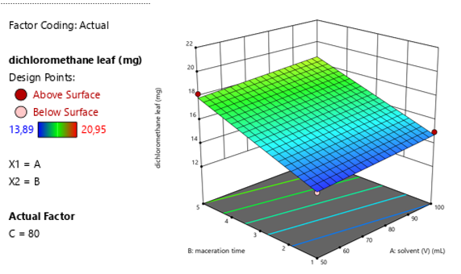
DCM leaf 80%
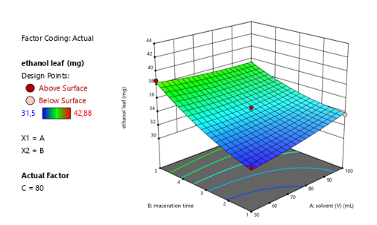
Ethanol leaf 80%
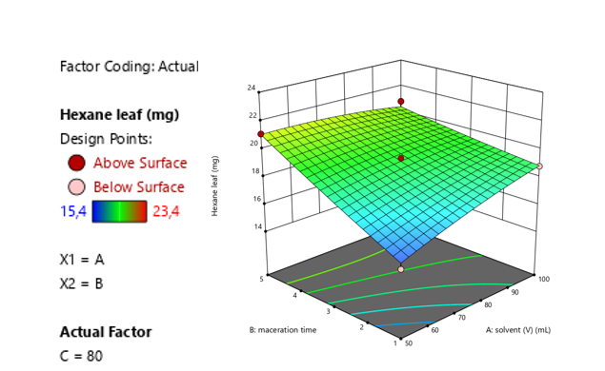
Hexane leaf 80%
Figure S8 Total content of R.pisiformis leaf dichloromethane, ethanol and hexane extract (80%)

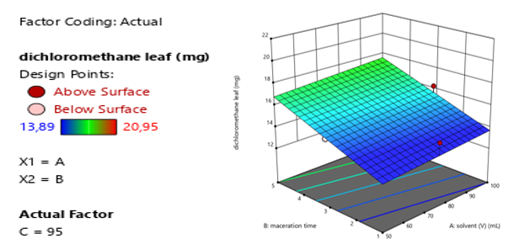

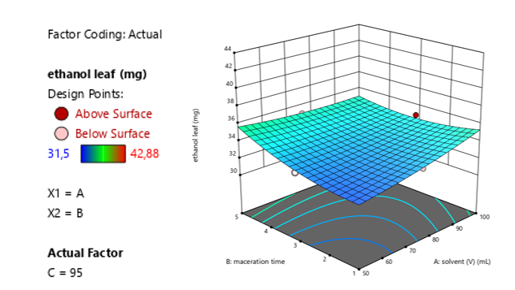
DCM leaf 95%
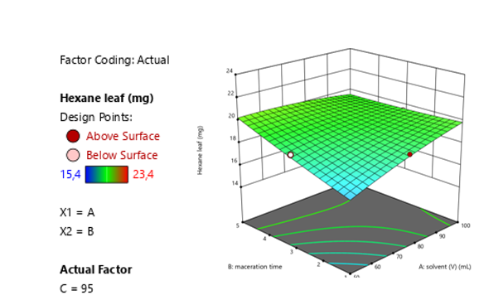
Ethanol leaf 95%
Hexane leaf 95%
Figure S9 Total content of R.pisiformis leaf dichloromethane, ethanol and hexane extract (95%)

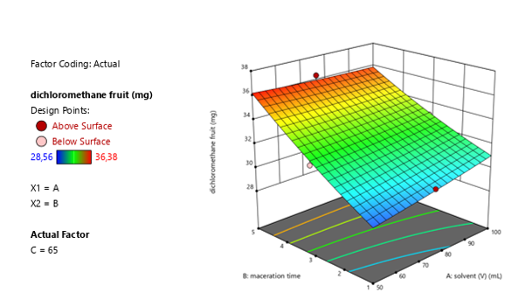
DCM fruit 65%
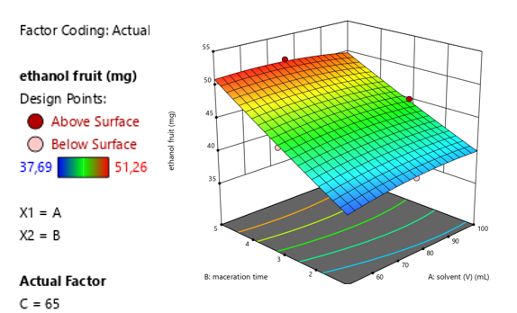
Ethanol fruit 65%
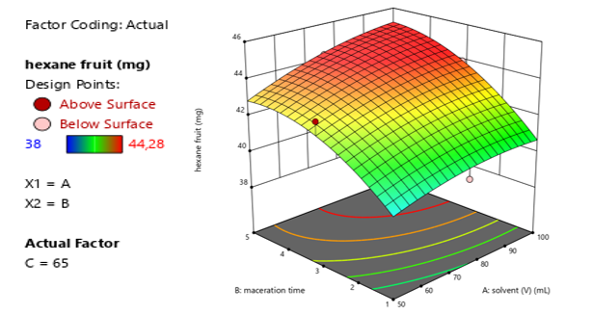
Hexane fruit 65%
Figure S10 Total content of R.pisiformis fruit dichloromethane, ethanol and hexane extract (65%)

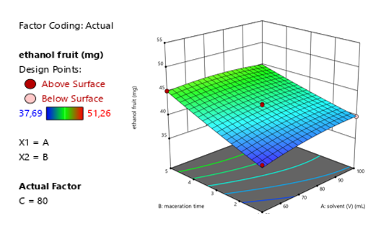
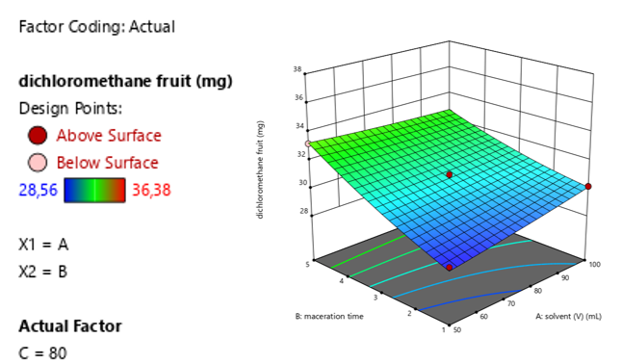
DCM fruit 80%
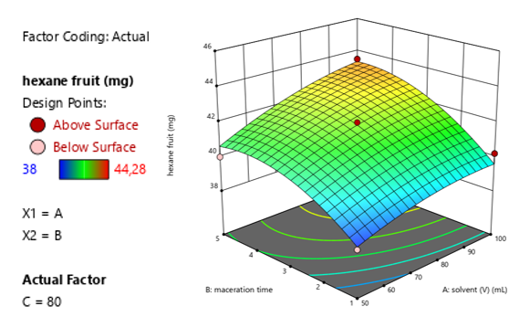
Ethanol fruit 80%
Hexane fruit 80%
Figure S11 Total content of R.pisiformis fruit dichloromethane, ethanol and hexane extract (80%)

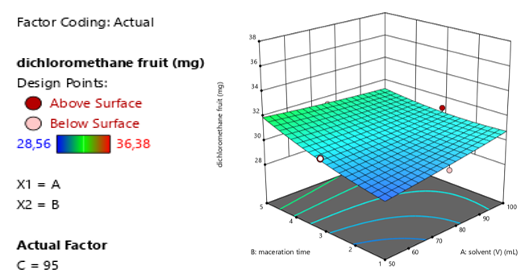
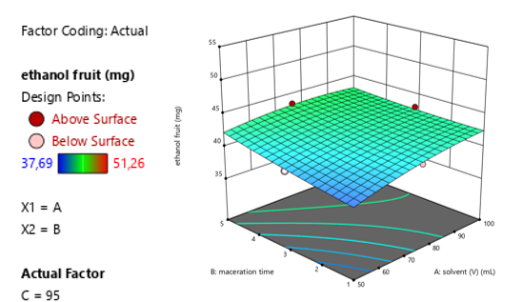
DCM fruit 95%
Ethanol fruit 95%
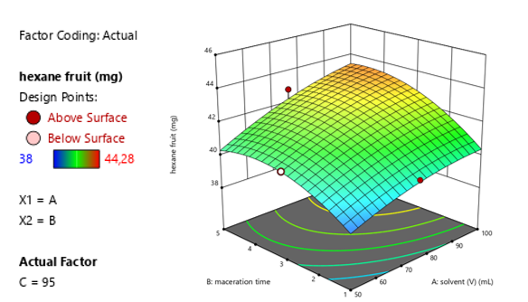
Hexane fruit 95%
Figure S12 Total content of R.pisiformis fruit dichloromethane, ethanol and hexane extract (95%)
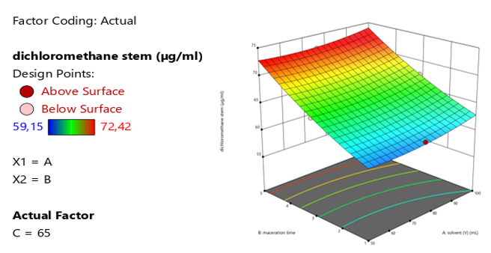
DCM stem (µg/mg)
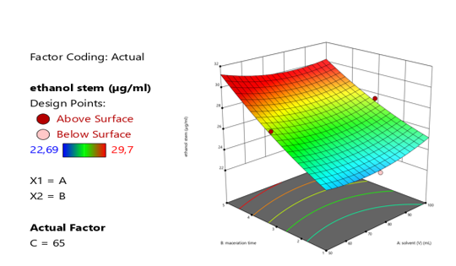
Ethanol stem (µg/mg)
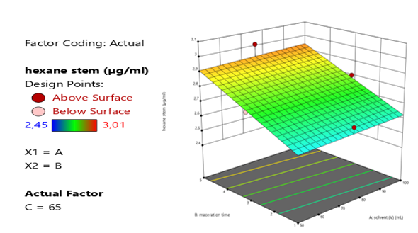
Hexane stem (µg/mg)
Figure S13. 3D diagrams for phenolic (catechin, rutin, quercetin), of R. pisiformis subsp. pisiformis stem extracts

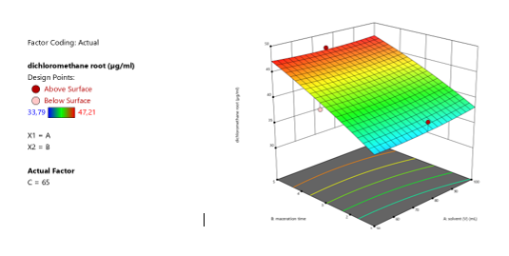

DCM root µg/mL

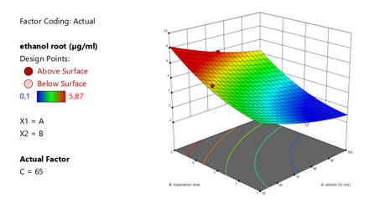
Ethanol root µg/mL

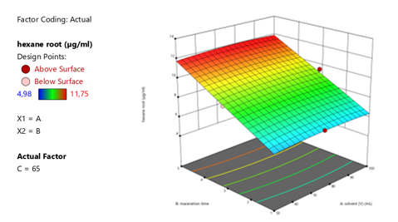
Hexane root µg/mL

Figure S14. 3D diagrams for phenolic (catechin, rutin, quercetin), of R. pisiformis subsp. pisiformis root extracts

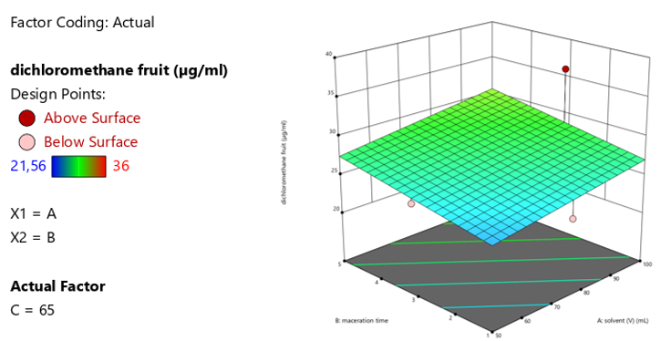
DCM fruit µg/mL
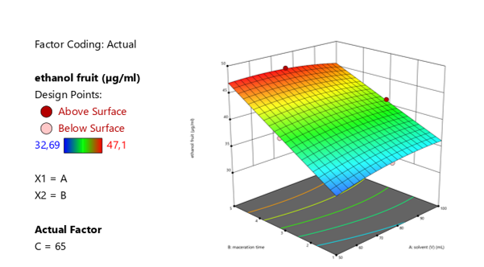
Ethanol fruit µg/mL

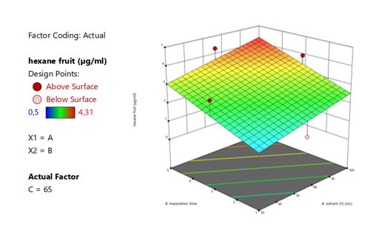
Hexane fruit µg/mL
Figure S15. 3D diagrams for phenolic (catechin, rutin, quercetin), of R. pisiformis subsp. pisiformis fruit extracts

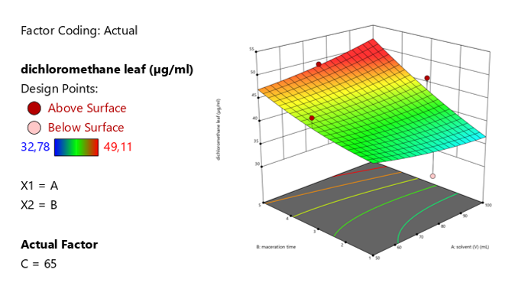
DCM leaf µg/mL
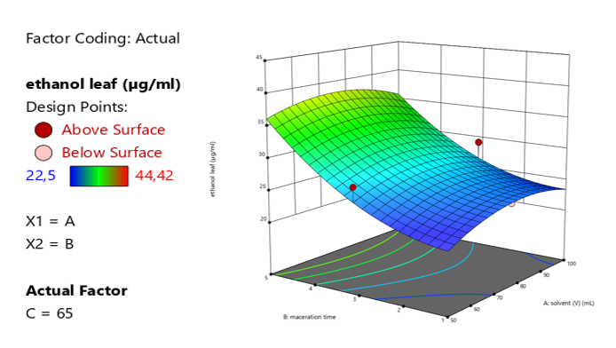
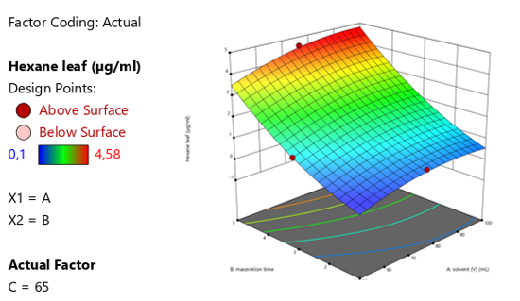
Ethanol leaf µg/mL

Hexane leaf µg/mL
Figure S16. 3D diagrams for phenolic (catechin, rutin, quercetin), of R. pisiformis subsp. pisiformis leaf extracts

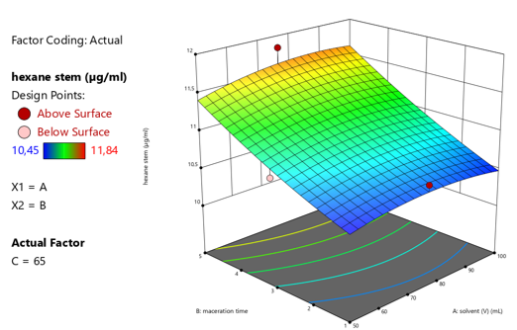

Hexane stem (µg/mL)

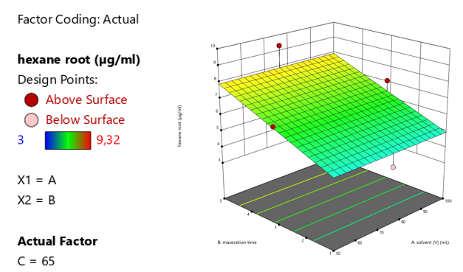
Hexane root (µg/mL)
Figure S17. 3D diagrams for Betulinic acid and Ursolic acid of R. pisiformis subsp. pisiformis stem extracts

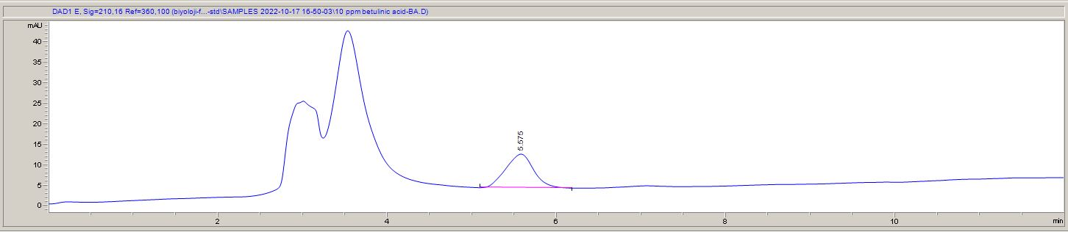
a
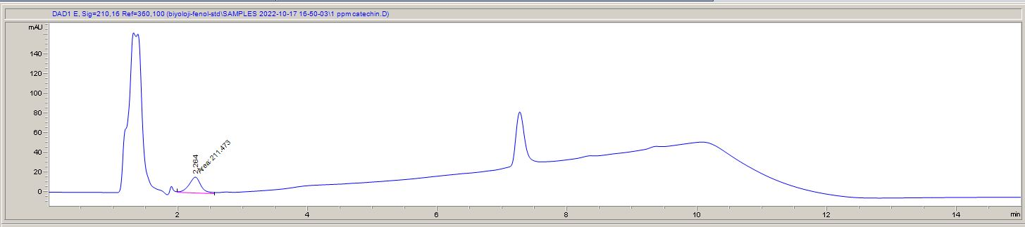
b
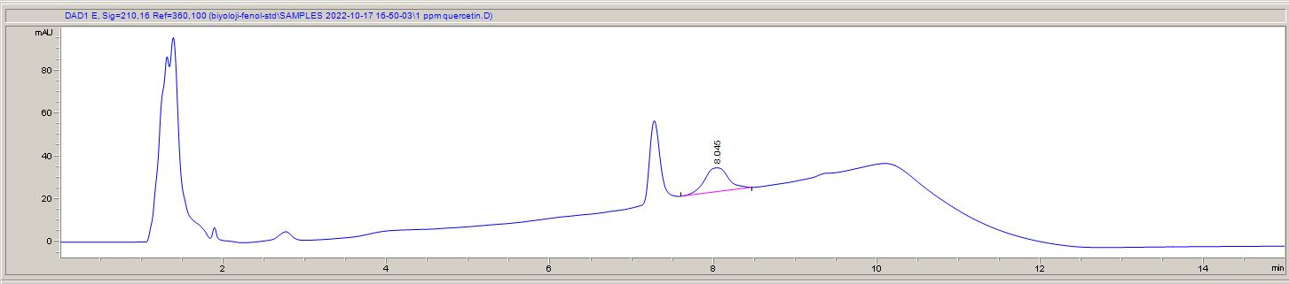
c
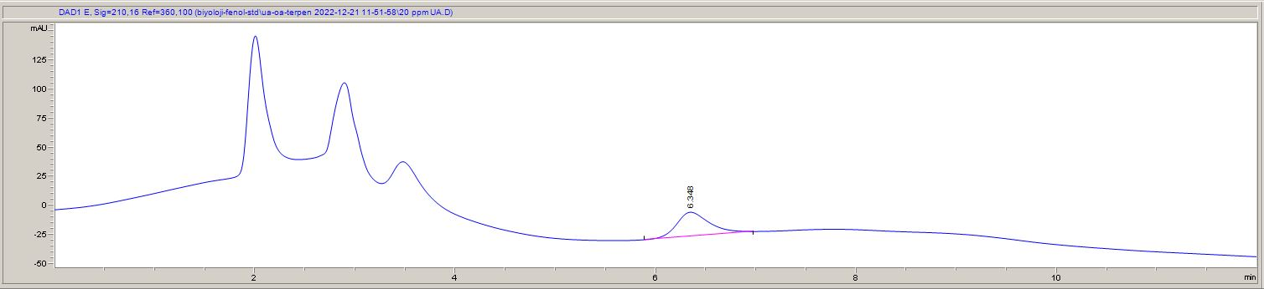
d
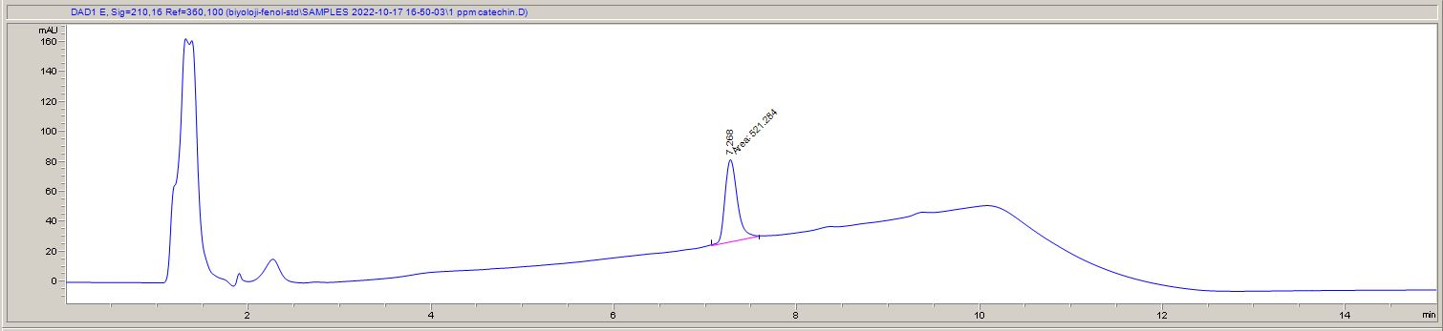
e
Figure S18. Chromatograms of HPLC standards: a. Betulinic acid, b. Catechin, c. Quercetin, d. Rutin, e. Ursolic acid

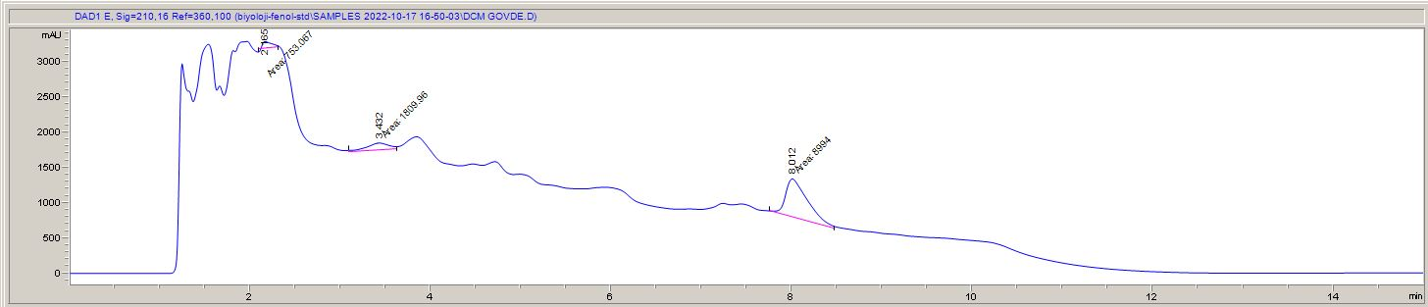
a
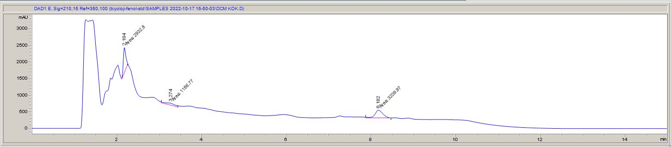
b
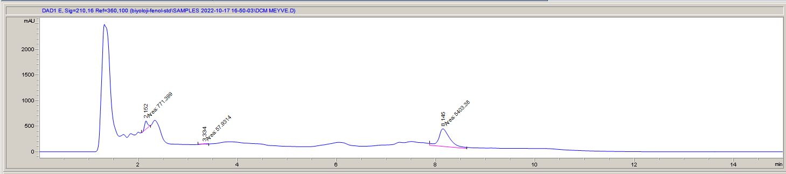
c
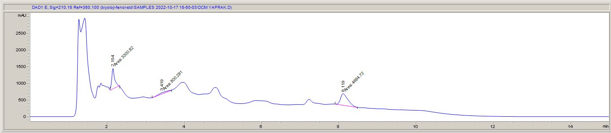
d
Figure S19. HPLC chromatograms: DCM extracts: a.stem, b.root, c.fruit, d.leaf

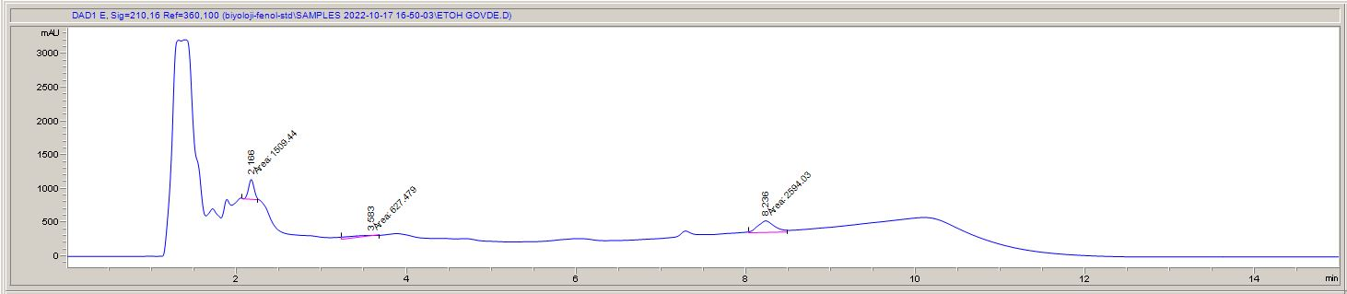
a
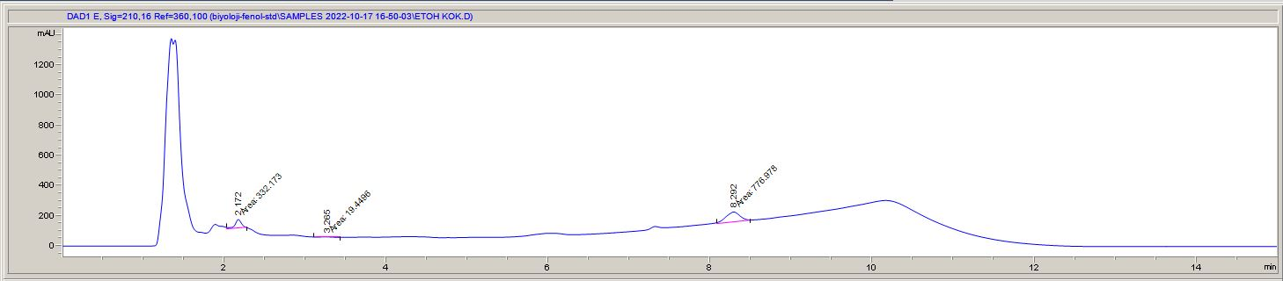
b
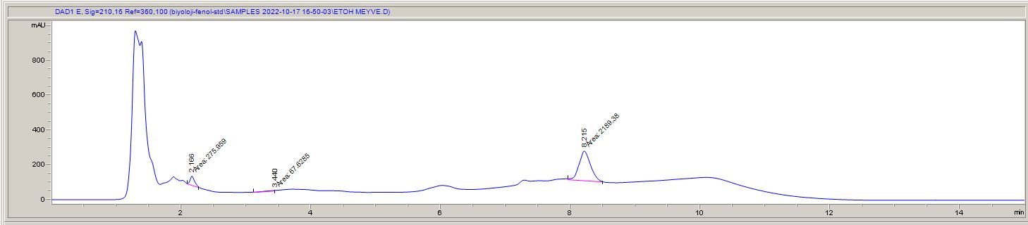
c
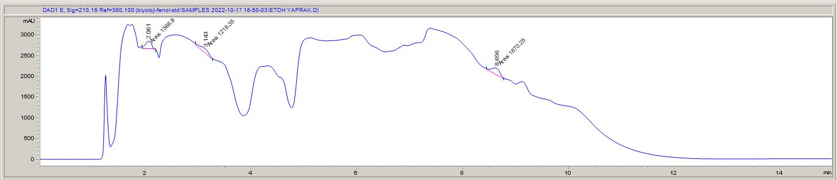
d
Figure S20. HPLC chromatograms: Ethanol extracts: a.stem, b.root, c.fruit, d.leaf

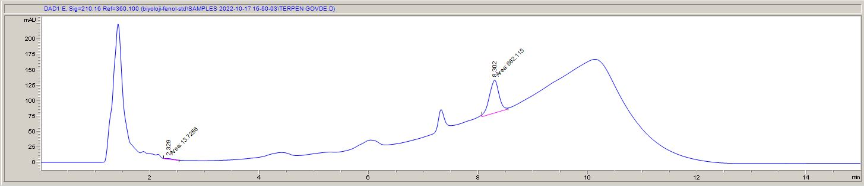
a
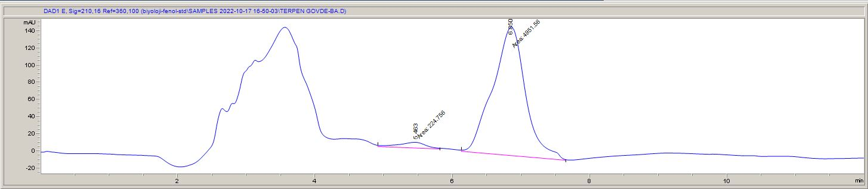
b
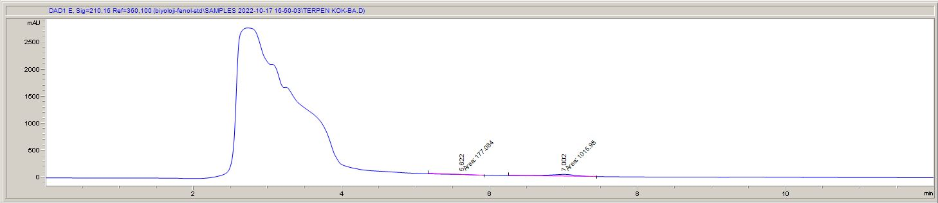
c
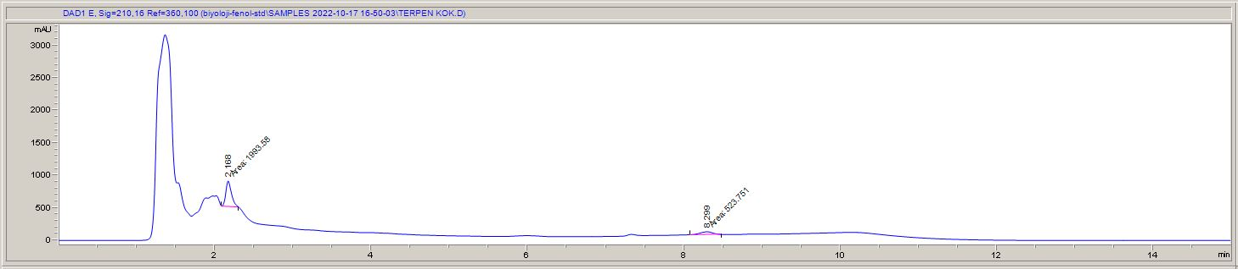
d
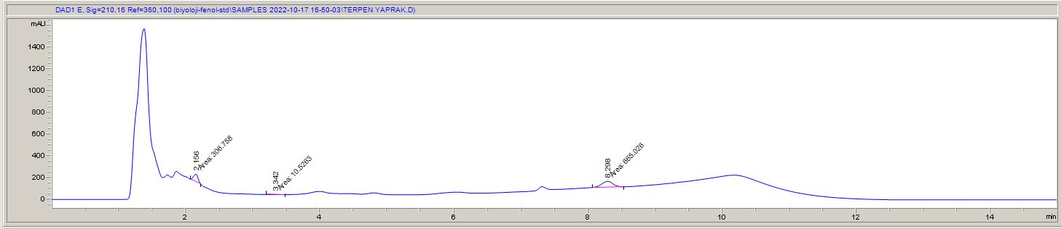
e
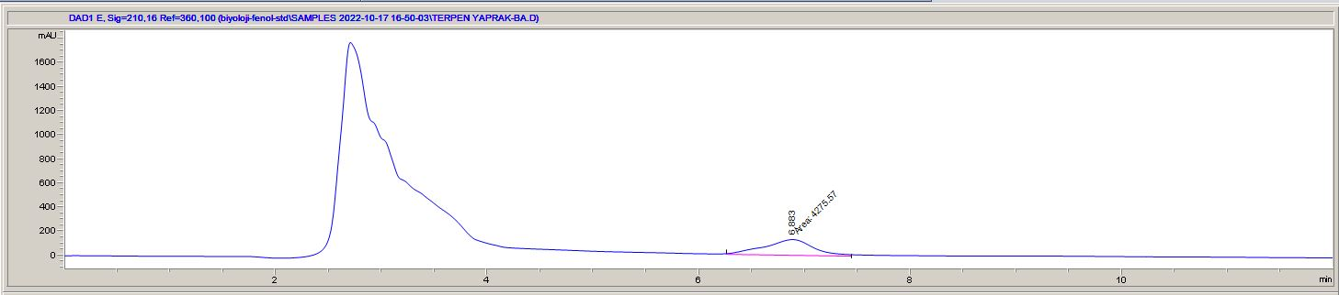
f
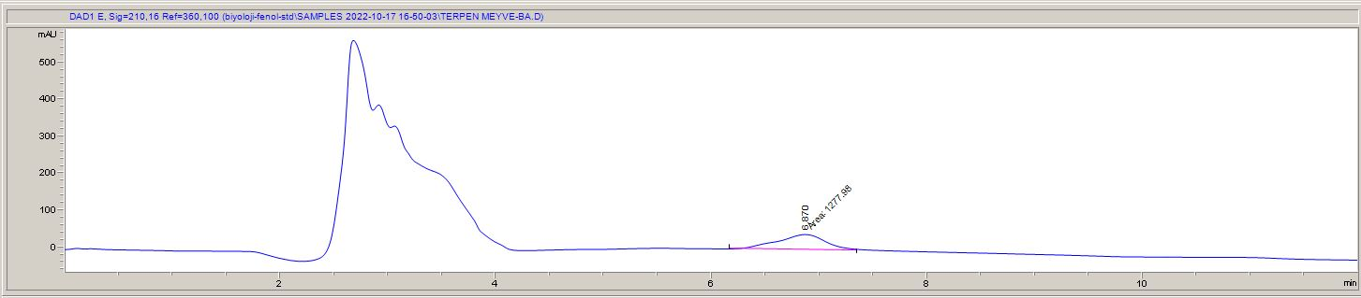
g
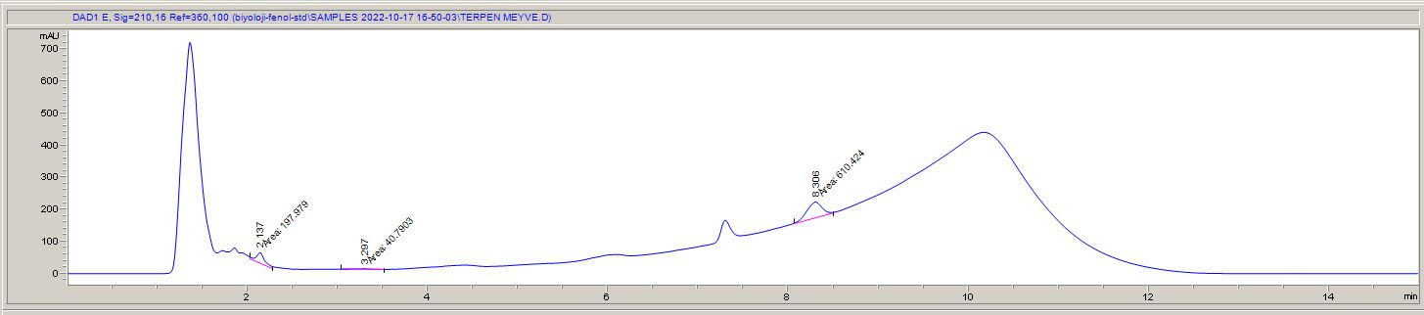
h
Figure S21. HPLC chromatograms of terpenes and phenols: a. stem PH, b. stem BA, c. root BA, d. root PH, e. leaf PH, f. leaf BA, g. fruit BA, h. fruit PH (PH: phenol, BA: betulinic acid)

