SUPPLEMENTAL FIGURES
Supplemental Figure 1. Immune cell killing efficiencies.
Supplemental Figure 2. Deconvolving phagocytic evasion genes in CT2A.
Supplemental Figure 3. Pathview maps of CTL evasion mechanisms in CT2A.
Supplemental Figure 4. Immunoblot of DAtg12 CT2A cells.
Supplemental Figure 5. Comparison of murine and human genetic dependencies.
Supplemental Figure 6. snRNA-seq recovery statistics.
Supplemental Figure 7. Cell type markers.
Supplemental Figure 8. Spatial annotation of snRNA-seq data.
Supplemental Figure 9. Reference atlas-based annotation of snRNA-seq profile.
Supplemental Figure 10. Further characterization of in vitro and in vivo glioma cells.
Supplemental Figure 11. Immune-intrinsic gene programs in murine and human GBM.
Supplemental Figure 12. Similarity between murine and human gliomas.
Supplemental Figure 13. Differential transcriptomic profiles in CT2A and GL261 cells.
Supplemental Figure 14. Prognostic value of murine glioma gene programs.
Supplemental Figure 15. Defining glioma-associated transcriptional regulators.

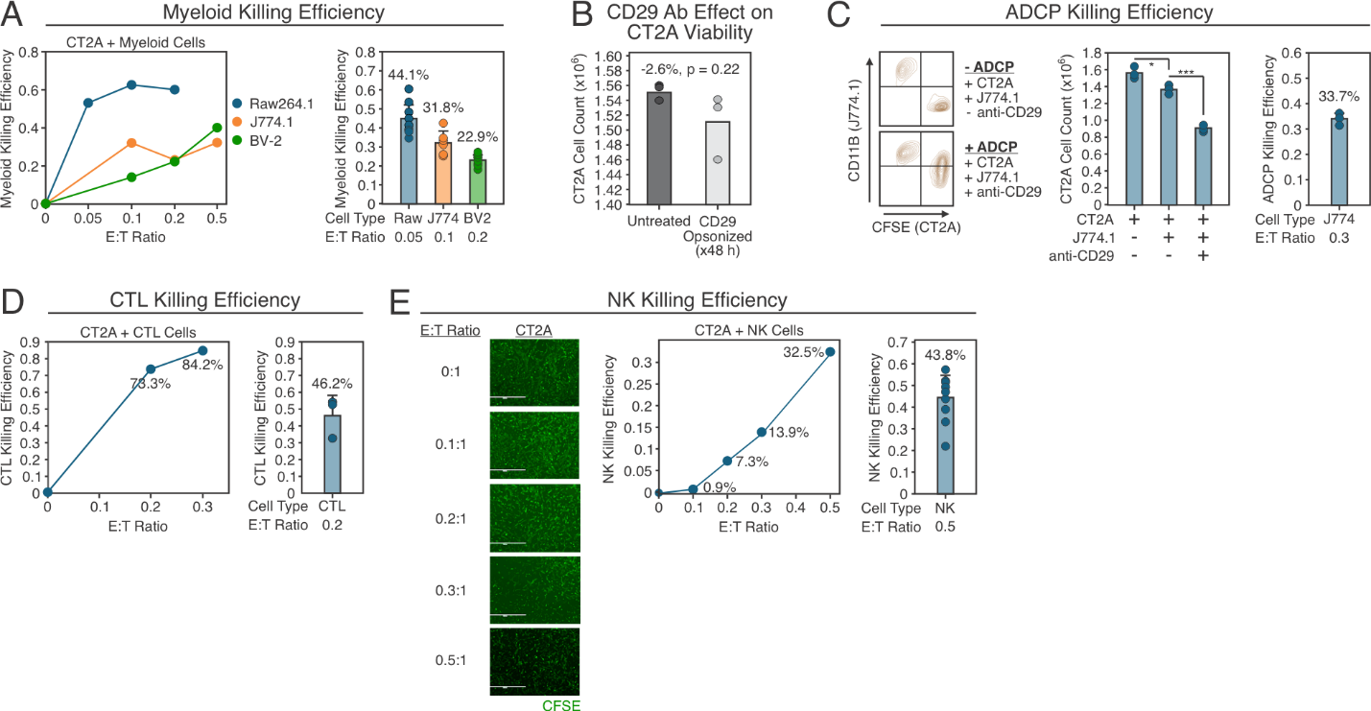
Supplemental Figure 1. Immune cell killing efficiencies. (A) Myeloid killing efficiencies. CT2A and myeloid cell lines (Raw264.1, J774.1, or BV-2) were co-cultured at various effector-to-tumor (E:T) to select optimal E:T for genome-wide CRISPR screens (left panel), and killing efficiencies achieved during the screen are shown (right panel). (B) Effect of anti-CD29 antibody on CT2A viability after 48 h of co-culture. Statistical significance determined by T-test. (C) ADCP killing efficiency. CT2A were opsonized with anti-CD29 antibody and cocultured with J774.1 cells. Flow cytometry (left panel) was used to quantify killing efficiency (middle panel), and killing efficiency achieved during screen is shown (right panel). (D) CTL killing efficiency. CT2A and CTL cells were co-cultured at different E:T ratios to select optimal screening condition (left panel) and killing efficiency achieved during CTL screen is shown (right panel). (D) NK killing efficiency. NK cells and CT2A cells (CFSE-stained) were co-cultured at various E:T ratios (left and middle panels), and killing efficiency achieved during the screen is shown (right panel). Abbreviations: ADCP; antibody-dependent cellular phagocytosis, CFSE; carboxyfluorescein succinimidyl, CTL; cytotoxic T-lymphocytes, E:T; effector-to-tumor cell ratio, NK; natural killer cells.
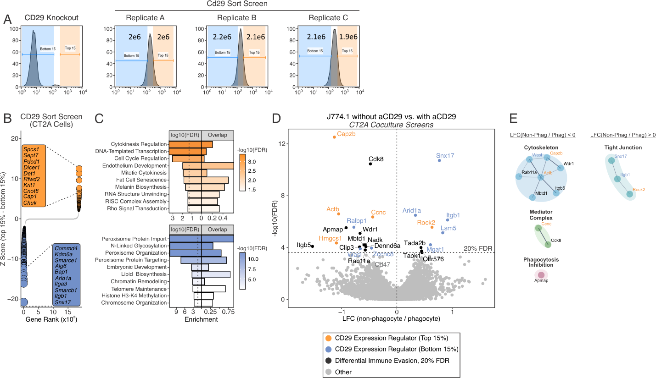
Supplemental Figure 2. Deconvolving phagocytic evasion genes in CT2A cells. (A-C) CD29 sort screen in CT2A cells. Cas9-expressing CT2A were transduced with mTKO sgRNA library and FACS-sorted into CD29-high (top 15%) and CD29-low (bottom 15%) populations (A). Differential sgRNA-enrichment was quantified using limma. Scatter plot shows sgRNA rank-ordered by z-scores and reveals regulators of CD29 expression (B) and bar plots show functional annotation of genes involved in regulating CD29 expression (C). Functional annotation was performed using hypergeometric gene set enrichment. (D) Differential sgRNA enrichment among CT2A-J774.1 coculture screens, treated with (phagocytic condition) vs. without (non-phagocytic condition) anti-CD29. Significance indicated at 20% FDR. Regulators of CD29 expression are indicated. (E) STRING network analysis of phagocyte and non-phagocyte-specific evasion genes. Clusters were determined by Markov clustering, and unclustered genes were omitted. Nodes represents genes, and solid edges represent protein-level interactions. Abbreviations: STRING; Search Tool for the Retrieval of Interacting Genes/Proteins.
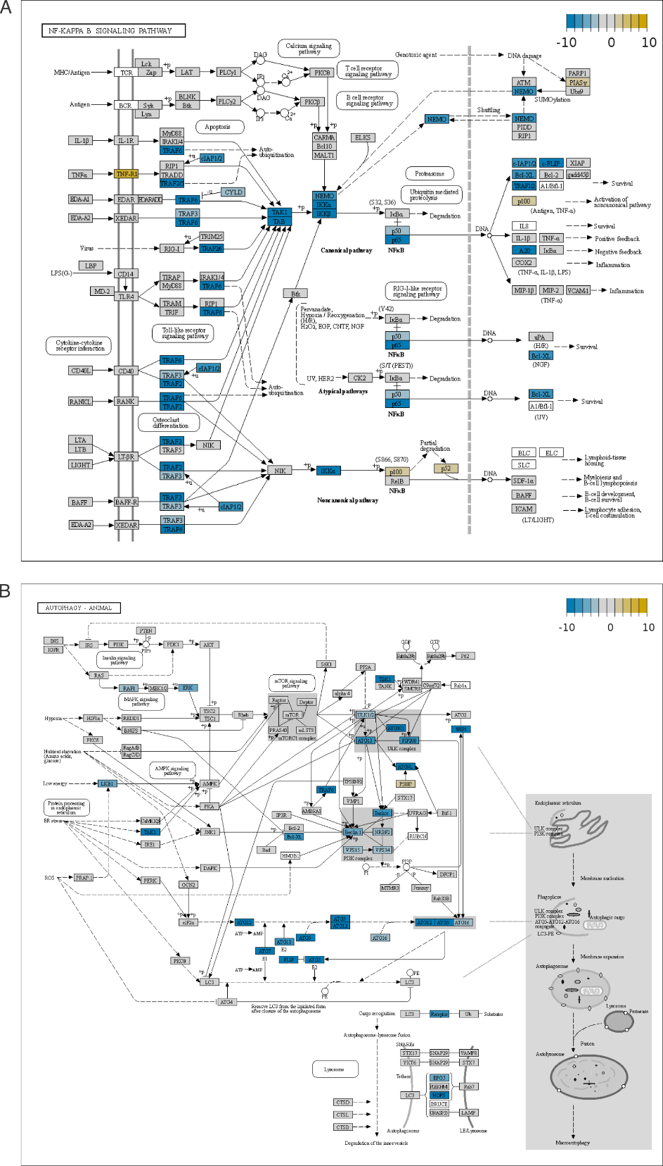
Supplemental Figure 3. Pathview maps of CTL evasion mechanisms (A-B) Pathview map visualizing CTL evasion gene profiles in NFkB and autophagy pathways. Genes conferring sensitivity or resistance to CTL-mediated cytotoxicity are indicated in blue and yellow, respectively.

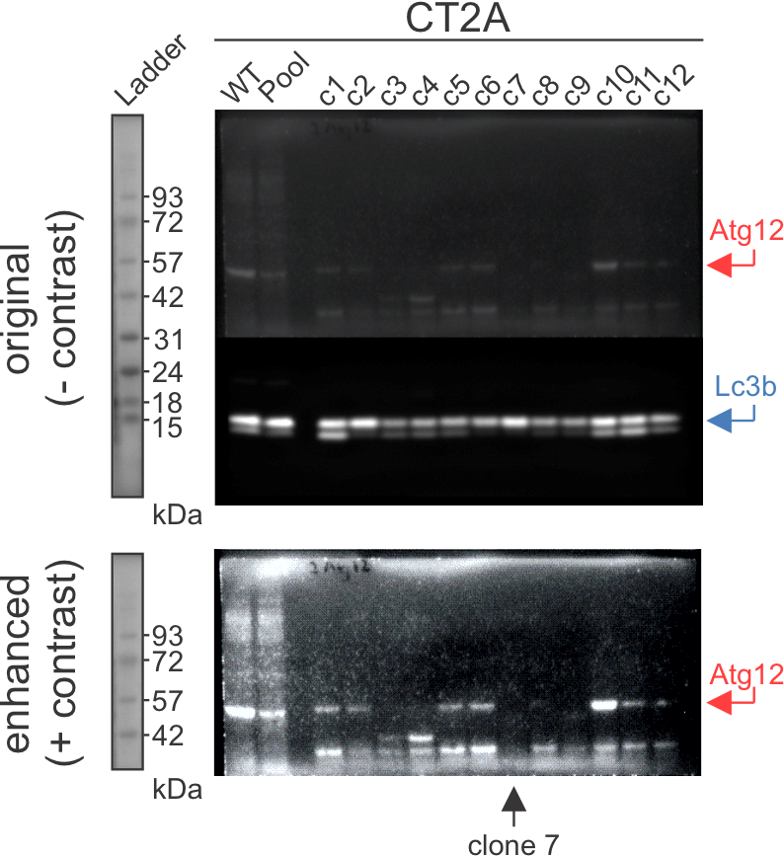
Supplemental Figure 4. Immunoblot of CRISPR-Cas9-edited CT2A cells, with sgRNA targeting Atg12. Top blot represent original blot, and bottom blot represents contrast-enhanced blot. Wild-type (WT; parental) and pooled lysates were included as positive and negative controls, respectively. Lc3b was included as an autophagy marker. Arrow represents clone (c7) used for subsequent experiments.

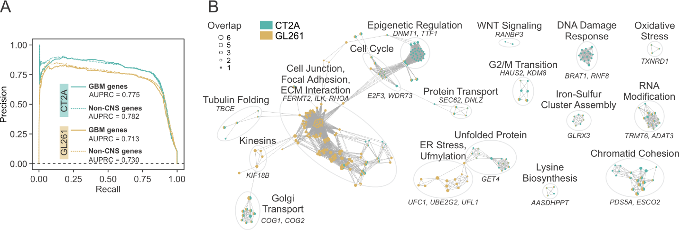
Supplemental Figure 5. Comparison of murine and human genetic dependencies. (A) Precision-Recall analysis of essential genes recovered in CT2A (green) and GL261 (brown) CRISPR screens. Human GBM and non-CNS essential genes were used as ground-truths. (B) Enrichment map illustrating shared human-murine genetic dependencies. Nodes are gene sets, edges are Jaccard similarities between gene sets. Abbreviations: AUPRC; area under precision-recall curve.

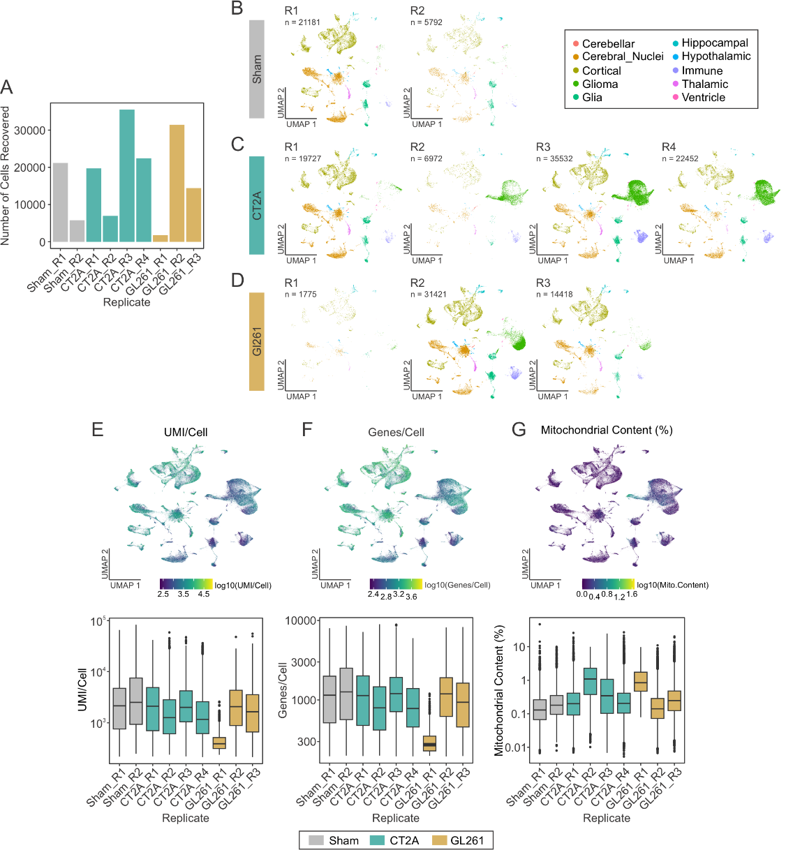
Supplemental Figure 6. snRNA-seq recovery statistics. (A) Number of cells recovered per snRNA-seq replicate experiment. For each condition, replicates are denoted R1 to Rn, where n = number of total replicates per condition. (B-D) UMAPs showing cells recovered for each replicate, grouped by sham (B), CT2A (C) and GL261 (D) conditions. (E-F) Summary of recovery statistics, including UMI/cell (E), genes/cell (F), and mitochondrial content (G). Results are overlaid on UMAP (top row) and summarized in boxplots grouped by replicate (bottom row). Abbreviations: Mito; mitochondrial, R; replicate, UMI; unique molecular identifier.
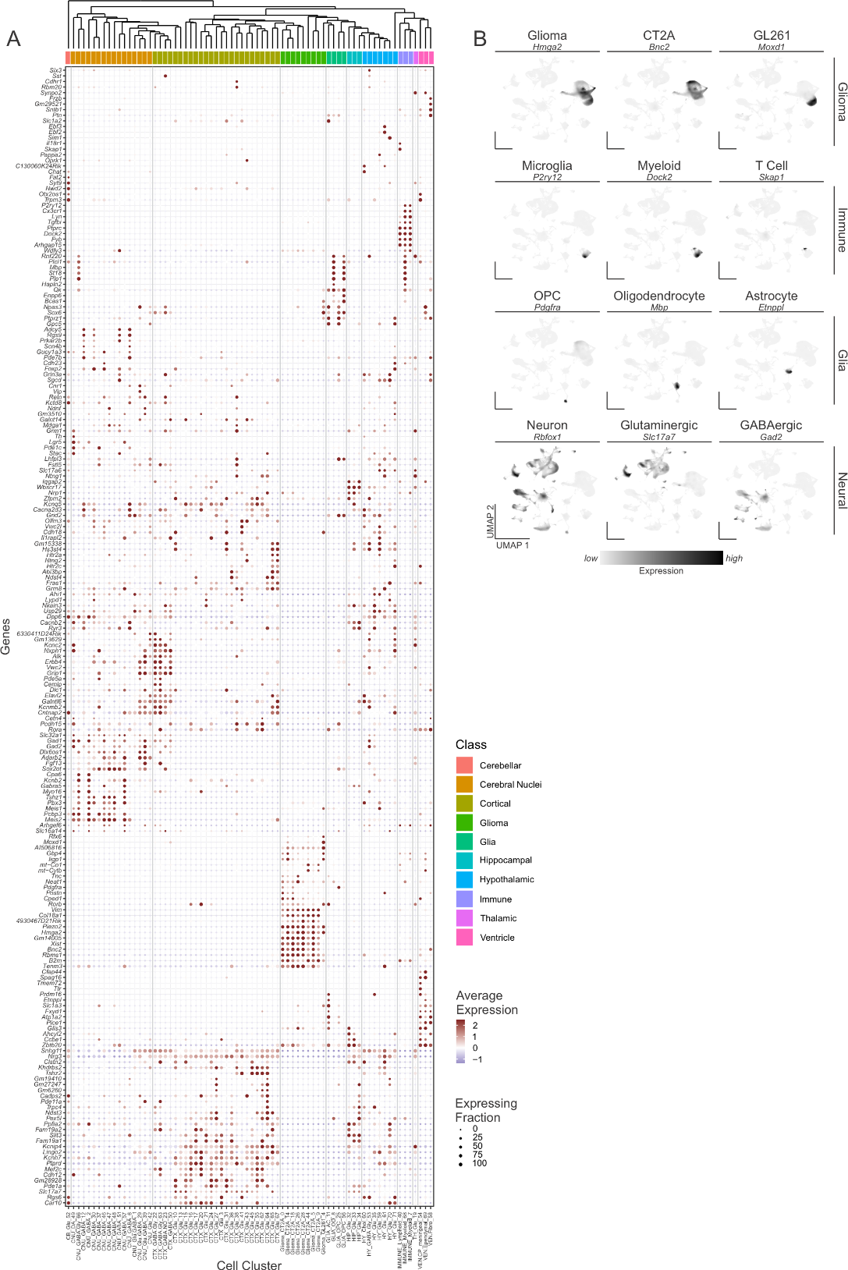
Supplemental Figure 7. Cell type markers. (A) Top markers for each cell cluster identified by Wilcoxon and CDI method (see methods). (B) Representative expression profiles of cell markers are shown as UMAPs. Abbreviations: CDI; codependency index, DEG; differentially-expressed genes.

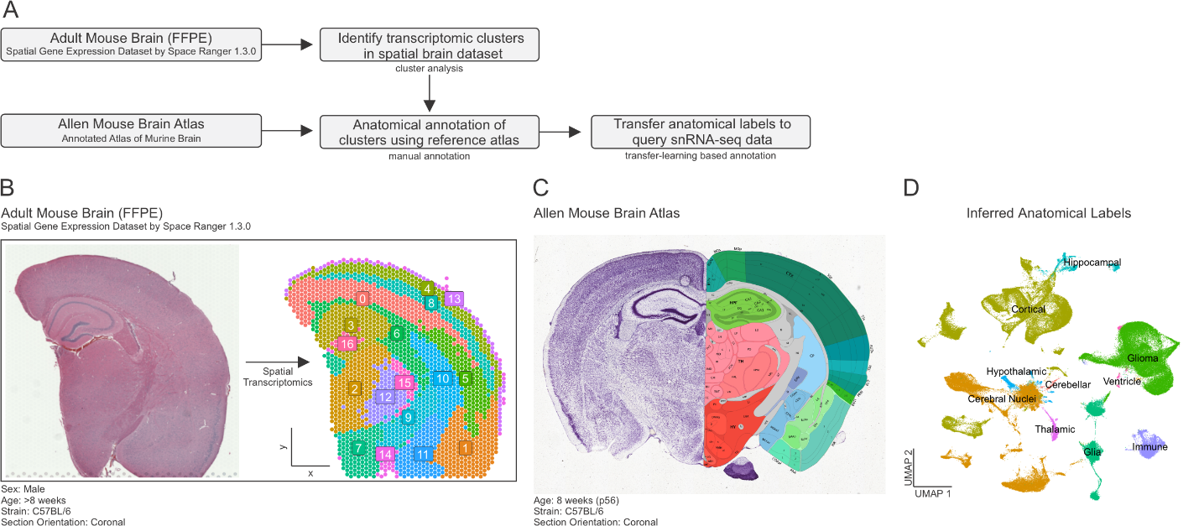
Supplemental Figure 8. Spatial annotation of snRNA-seq data. (A) Schematic of workflow used to assign anatomical labels to snRNA-seq dataset. (B) Public spatial transcriptomics data of coronal section from 8-week male C57Bl/6 mice (10x Genomics, Adult Mouse Brain FFPE dataset). Hematoxylin and eosin-stained section shown on left, and corresponding transcriptomic clusters on right. (C) Annotated coronal section from age- and section-matched C57Bl/6 mouse brain, obtained from Allen Mouse Brain Atlas (image 70 of 132 image atlas series). (D) Anatomical labels in query snRNA-seq data were inferred by label transfer of transcriptomic clusters identified in panel B, and anatomical annotations were assigned based on annotations from atlas in panel C. Note that anatomical annotations were only assigned to neuronal populations.

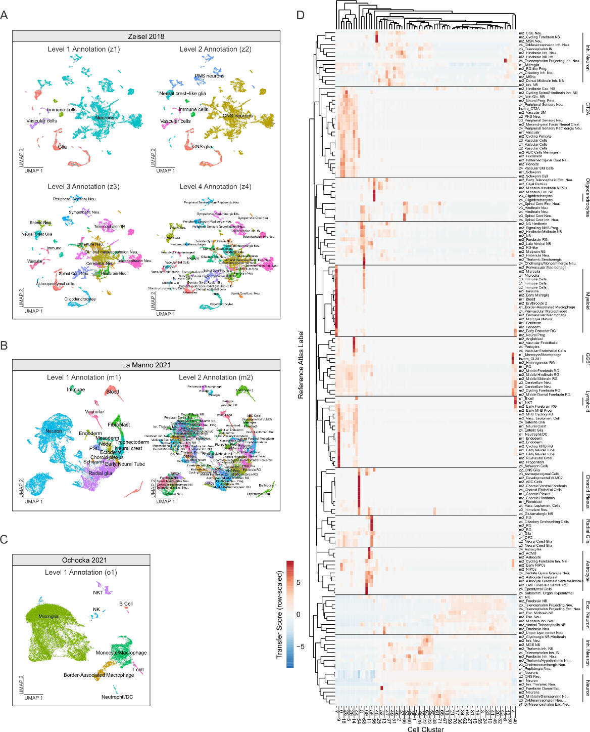
Supplemental Figure 9. Reference atlas-based annotation of snRNA-seq profile. (A-C) Reference atlases used to annotate snRNA-seq profiles, including adolescent mouse brain (A, Zeisel et al.)³⁰, fetal mouse brain (B, La Manno et al.)³¹, and immune cells from mice engrafted with GL261 cells (C, Ochocka et al.)³². Different levels of annotations for each reference atlas are indicated. (D) Heatmap showing transfer scores (i.e., similarity between query and reference) between each query cell cluster (columns) and reference label (rows). Values are row scaled. Cell clusters are the same as those shown in Fig 1B. Each reference label contains a prefix (m1-2, z1-4, and o1) that relates the reference label to its source reference atlas in A-C (e.g., ‘z2’ labels represent labels from Zeisel annotation level 2). Abbreviations: DC; dendritic cell, Exc.; excitatory, Glu; glutaminergic, IN; interneuron, Inh.; inhibitory, NB; neuroblast, Neu.; neuron, Prog.; progenitor, RG; radial glia, SM; smooth muscle.

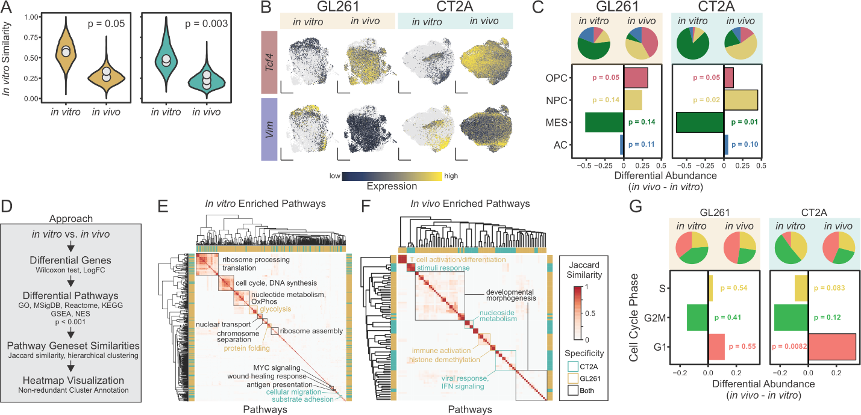Supplemental Figure 10. Further characterization of in vitro and in vivo glioma cells. (A) Similarity of in vitro and in vivo single cell transcriptomic profiles to pseudobulk in vitro references quantified by correlation coefficient (R²). In vitro vs. in vivo similarities compared by Wilcoxon test. (B) (B) Differential gene expression of Tcf4 and Vim in in vitro and in vivo GL261 and CT2A glioma cells shown as UMAPs. (C) Abundance analysis of Neftel GBM subtypes in vitro vs. in vivo. Top panel shows relative abundances in pie charts, and bottom panel shows differential abundances (in vitro vs. in vivo) in bar chart³⁹. (D) Schematic of workflow used to identified differentially-expressed pathways between in vitro and in vivo glioma cells. (E-F) Heatmap of Jaccard similarities between pathways that were significantly enriched among differentially expressed genes in vitro (E) and in vivo (F). Gene enrichments was performed using GSEA, and p<0.001 was deemed significant. Non-redundant cluster annotations are shown. Black labels indicated commonly perturbed pathways, turquoise labels are CT2A-specific, and brown labels are GL261-specific. (G) Comparison of cell cycle phases in glioma cells between in vitro and in vivo conditions. Cell cycles were inferred by scoring individual cells using S-, G1-, and G2/M-phase signatures, and phase was assigned based on the top score. Top panel shows relative distribution of cell cycle phase, and bottom panel shows differential abundance of each phase between in vitro and in vivo condition. Abbreviations: GSEA; gene set enrichment analysis, NES; normalized enrichment score.

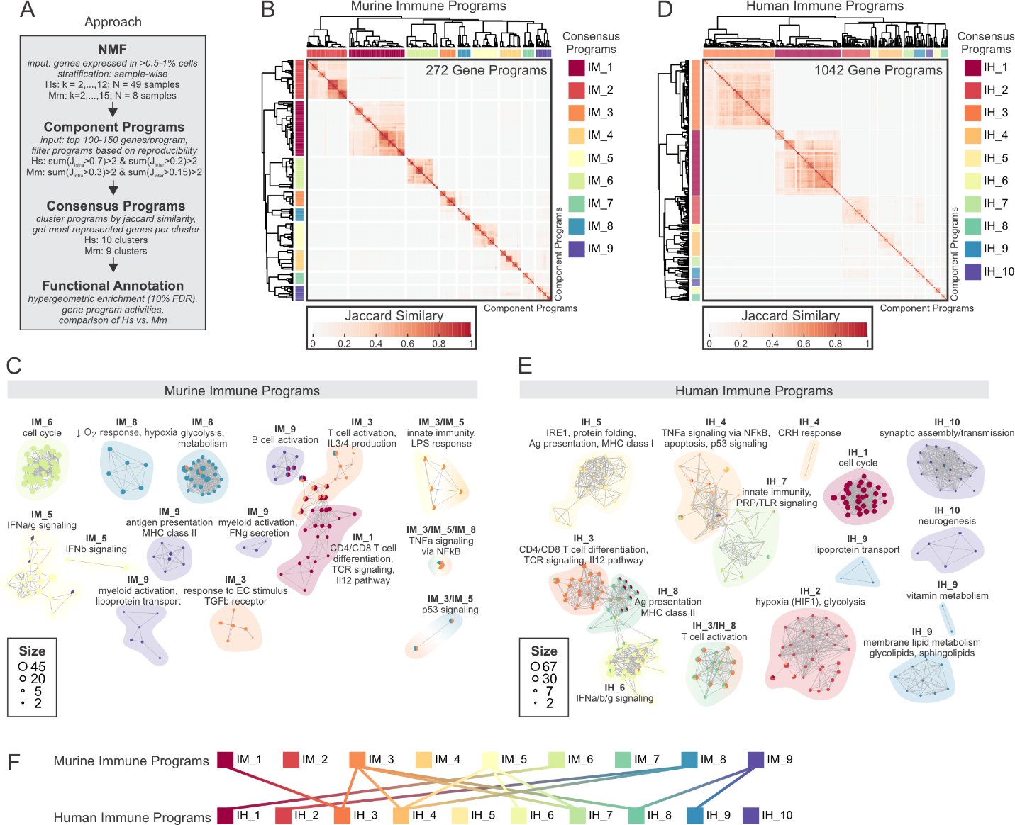

Supplemental Figure 11. Immune-intrinsic gene programs in murine and human GBM. (A) Flowchart for NMF-based gene program discovery and annotation. (B) Heatmap showing Jaccard similarity between 272 NMF component programs identified in murine glioma-associated immune populations. Component programs were hierarchically clustering into consensus immune murine gene programs (IM). (C) Enrichment maps of functionally annotated IM programs. Significant enrichments were determined by hypergeometric gene set enrichment (10% FDR). IM_2, IM_4 and IM_7 gene programs had no significant enrichments. (D) Jaccard similarity of 1042 NMF component programs and corresponding consensus clusters identified in human GBM-associated immune populations. (E) Enrichment maps showing functional annotations of IH gene programs. (F) Mapping of murine to human immune programs, based on common term enrichment. Abbreviations: IH; human immune gene programs, IM; murine immune gene programs, NMF; non-negative matrix factorization.

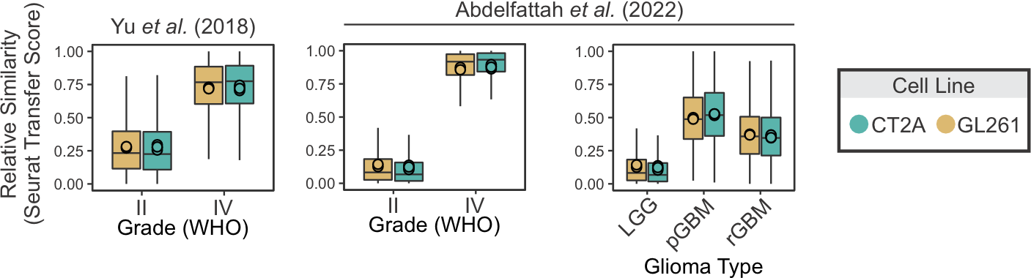
Supplemental Figure 12. Similarity of GL261 and CT2A glioma cells to human WHO Grade II and IV glioma cells, and primary vs. recurrent GBM. Relative similarities estimated using Seurat Transfer Score algorithm. Abbreviations: LGG; low grade glioma, pGBM; primary GBM, rGBM; recurrent GBM.

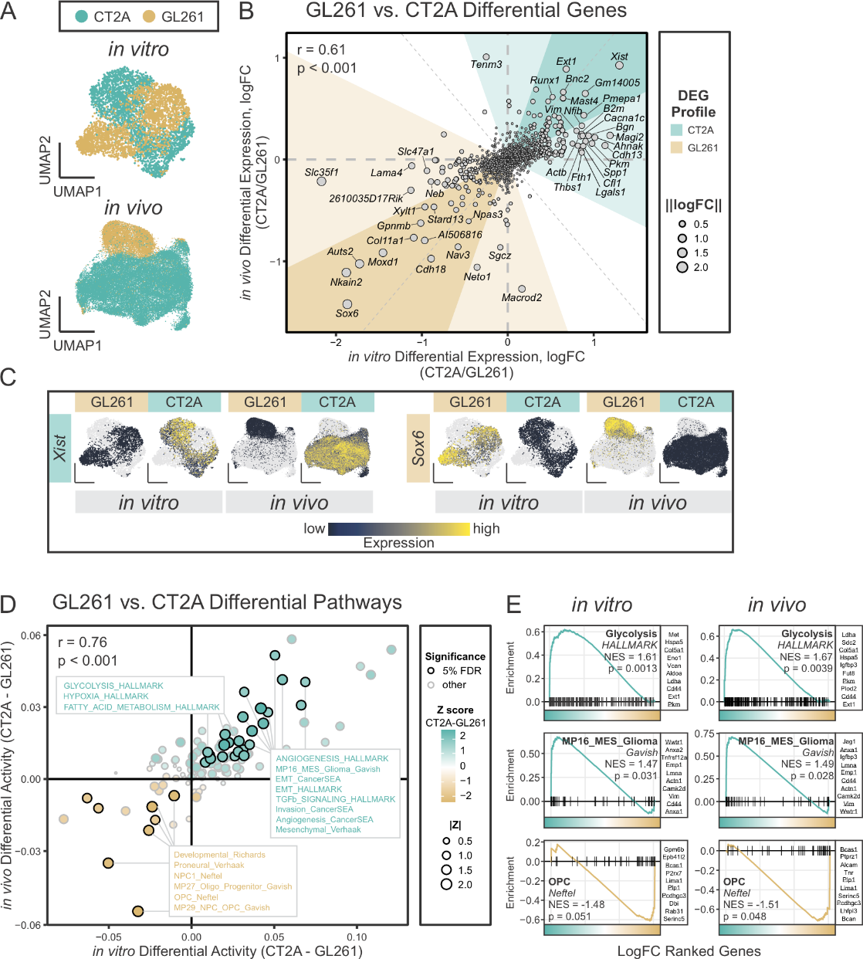
Supplemental Figure 13. Differential transcriptomic profiles in CT2A and GL261 cells. (A) UMAPs of CT2A and GL261 cells across in vitro (top) and in vivo (bottom) conditions. (B) Sectored scatter plot comparing differential gene expression (logFC) between CT2A and GL261 glioma cells across in vitro (x-axis) and in vivo (y-axis) conditions. (C) UMAPs comparing gene expression of Xist and Sox6 in GL261 and CT2A, across in vitro and in vivo conditions. (D-E) Comparison of differential pathway activities between GL261 and CT2A gliomas across in vitro and in vivo. Differential pathways were determined by GSEA analysis using logFC-ranked genes. Differential activities are shown in scatter plot [D; in vitro (x-axis) and in vivo (y-axis)] and representative GSEA plots (E). Abbreviations: GSEA; gene set enrichment scores, logFC; log fold changes, MES; mesenchymal, NES; normalized enrichment score, OPC; oligodendrocyte progenitor.
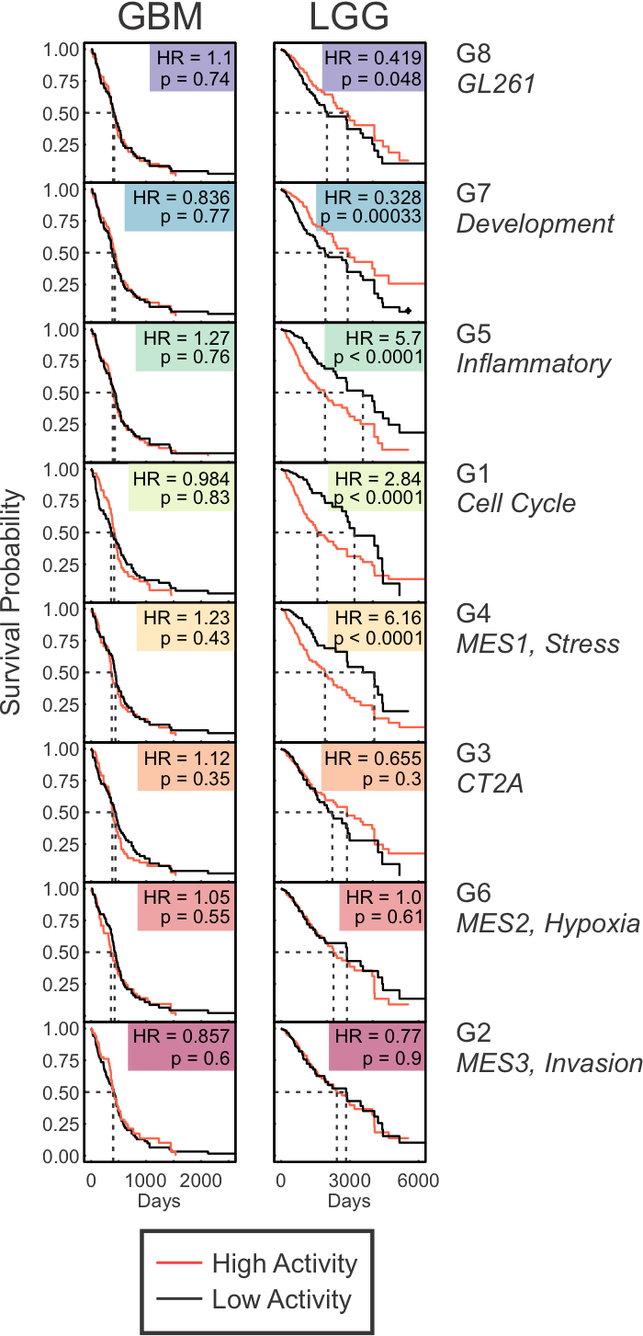
Supplemental Figure 14. Survival analyses evaluating prognostic value of murine glioma gene programs across GBM and LGG patients from TCGA cohort. For Kaplan Meier analyses, high- and low-activity groups were split according to median scores. Hazard ratio (HR) was calculated using univariate cox proportional hazards regression. Dashed lines represent median survival times. Abbreviations: HR; hazard ratio, GBM; glioblastoma multiforme, LGG; low grade glioma, MES; mesenchymal, TCGA; The Cancer Genome Atlas.
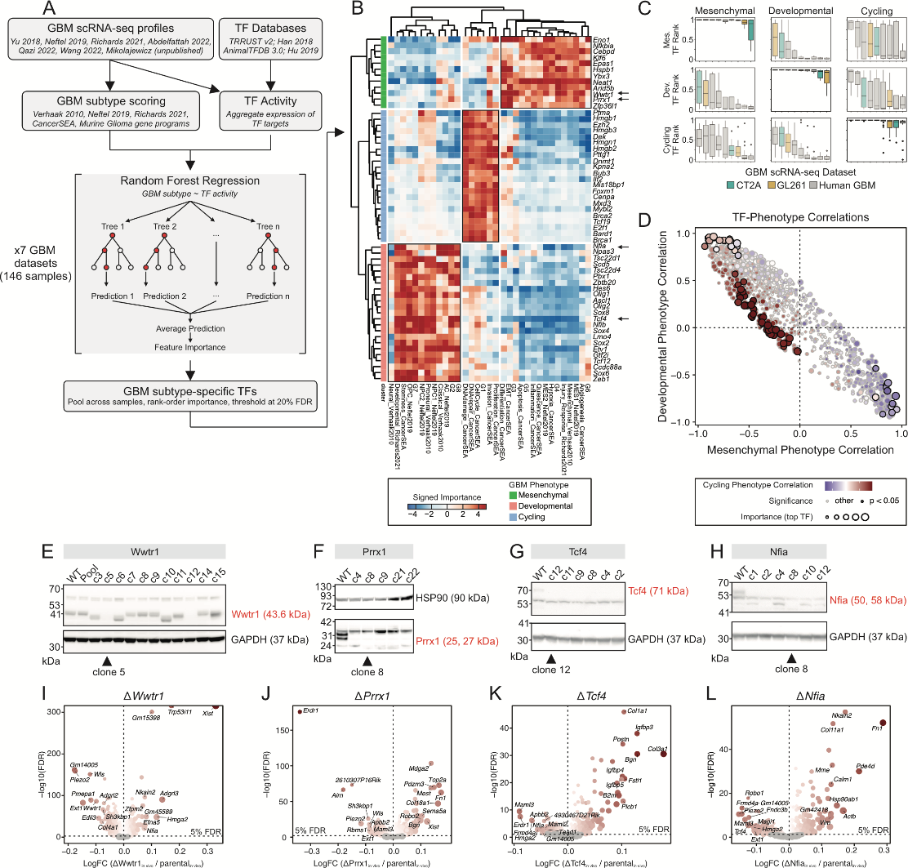
Supplemental Figure 15. Defining glioma-associated transcriptional regulators. (A) Workflow used to define glioma-associated transcriptional regulators (GTRs) using scRNA-seq data from 7 independent GBM cohorts. (B) Heatmap illustrating relationship between each GTR and glioma-associated pathways. Values are signed importance (SI) scores, derived from random forest regression models. GTRs and pathways were hierarchically clustered into mesenchymal (green), developmental (red), and cycling (blue) phenotypes. (C) Phenotype-specific GTRs (rows) were rank-ordered by SI within each phenotype (columns), and rank distributions visualized across each GBM cohort. Intra-phenotypic ranks were higher than inter-phenotypic ranks across all independent GBM cohorts. Rank distributions among GL261 and CT2A tumors are included. (D) Relationship between each TF and phenotype. Scatter plot shows correlations between TF-level SI and intra-phenotypic SI profiles (calculated as column-wise averages of pathway SIs across intra-phenotypic GTRs, as seen in Fig S9B). Each point is a different TF, and borders indicate GTR membership. (E-H) Immunoblots for CRISPR-Cas9-edited CT2A cells. Wwtr1 (E), Prrx1 (F), Tcf4 (G), and Nfia (H). Wild-type (WT; parental) lysates are included as positive controls. Arrowheads represent clones used for subsequent experiments. (I-L) Volcano plots of differentially expressed genes in in vivo DWwtr1 (I), DPrrx1 (J), DTcf4 (K), and DNfia (L) CT2A tumors, compared to parental tumors. Data are scRNA-seq profiles of in vivo tumors. Abbreviations: GBM; glioblastoma multiforme, GTR; glioma-associated transcriptional regulator, SI; signed importance, TF; transcription factor.
SUPPLEMENTAL TABLES
Table S1. Immune coculture screens. Separate .xlsx file.
Table S2. BAGEL scores for GL261/CT2A genome-wide CRISPR screens. Separate .xlsx file.
Table S3. Differentially-expressed cell-type markers. Separate .xlsx file.
Table S4. Differentially-expression between in vitro and in vivo glioma cells. Separate .xlsx file.
Table S5. CT2A and GL261 tumor-associated gene programs. Separate .xlsx file.
Table S6. Glioma transcriptional regulators. Separate .xlsx file.
Table S7 Differential expression in GTR-perturbed cell lines. Separate .xlsx file.
Table S8. Immune cell-associated gene programs. Separate .xlsx file.
Table S9. Immune evasion phenotype genes. Separate .xlsx file.
Table S10. Public scRNA-seq datasets used in current study.
Table S11. List of sgRNA.
Table S12. List of primers.
Table S13. List of antibodies.
Table S14. NMF gene program discovery parameters.

Table S10. Public scRNA-seq datasets used in current study.
Study | N patients | n cells | Description
Yu (2018) | 7 | 2,542 | Primary GBM
Neftel (2019) | 9 | 11,820 | Primary GBM
Richards (2019) | 29 | 69,391 | GBM stem cells
Qazi (2022) | 4 | 1,873 | GBM, Minimal-residual disease, PDX
Abdelfattah (2022) | 16 | 81,459 | Primary-recurrent GBM
Wang (2022) | 57 | 72,701 | Primary-recurrent GBM
Mikolajewicz (unpublished) | 18 | 104,371 | Primary-recurrent GBM
Abbreviations: GBM; glioblastoma multiforme, PDX; patient-derived xenograft.

Table S11. List of sgRNA.
Gene | Guide 1 | Guide 2 | Guide 3
Atg12 | CGAGGACGGGGGCUCUGGGG | UCGGCUCCUGUAGGAGCCGG | UUUUUCUUGGUGUCUCCGGG
Nfia | GCUUAGCAGUUCAUCCUUCA | AUUUCCGCUUUCGGGCCUGC | GGCAGAAGUGCUUCAAUGAA
Prrx1 | UGCUAGACCUGGAGGAGGCC | GGGCAACCUCGACACCCUGC | CUCCAGAACGUGCCCGUAGC
Tcf4 | AACAAACACUCAAUGGCCUG | CCUAGCUCCUUCUUCAUGCA | UGGCGAGUCCCUGUUGUAGU
Wwtr1 | AUGACUUGCUGCCCUGGCGG | CCUUAAAGAAGGACUCCGGG | GGUUCAUGACAGAGUUGAAG

Table S12. List of primers.
Gene | Forward | Reverse
Atg12 | GGTAGAACTTGGAGAGCCGC | AAACCCCGATTTAGGGCCAG
 | AGGGGTACGTGGTCAGATGG | TTGGGTTCATCAGACAGCCG
Nfia | GGCAATGGTGCCGATAGTAGATTC | GCATCTTGCCTTTCTGATCAGG
Prrx1 | CCACAGCGTTTGGTGTTGATTCG | CCTCACTCACTGTCCTGCTG
Tcf4 | CAGGTTTAGAATCTTACAGCATCCG | AAAGTCTTCAGGTCAGTTCTGC
Wwtr1 | CTCTGTTGCGGGAAAGTTGC | CTCGTCGGTCACGTCATAGG

Table S13. List of antibodies.
Target | Predicted size (kDa) | Supplier | Catalog | Dilution
Atg12 | 55 | Cell Signaling | 2011 | 1:1,000
b-Tubulin | 55 | CST | 2128 | 1:1,000
Gapdh | 37 | CST | 2118 | 1:10,000
Hsp90 | 90 | Santa Cruz | 13119 | 1:1,000
Lc3b | 15 | Abcam | Ab51520 | 1:1,000
Nfia | 58 | Invitrogen | PA5-52252 | 1:1,000
Prrx1 | 25 | Abclonal | A10237 | 1:3,000
Tcf4 | 70 | Abcam | 217668 | 1:1,000
Wwtr1 | 50, 44 | Cell Signaling | 8418 | 1:1,000

Table S14. NMF gene program discovery parameters
Parameter | Murine tumors | Murine immune | Human immune | Immune Evasion
Minimum gene expression (% of cells) | 5% | 0.5% | 1% | *
N Samples | 8 | 8 | 49 | 6
Rank parameter, k | 2, …,9 | 2, …,15 | 2, …,12 | 2, …, 15
Number of genes per component program | 100 | 100 | 150 | 70
Intrasample Jaccard similarity, J_{intra} | 0.5 | 0.3 | 0.7 | 0.2
Intersample Jaccard similarity, J_{inter} | 0.3 | 0.15 | 0.2 | 0.5
Minimum samples satisfying criteria | >2 | >2 | >2 | >1
Final program genes represented in % of component programs | 50% | 25% | 50% | 50%
Number of gene programs | 8 | 9 | 10 | 2
*Input included evasion genes identified in immune coculture CRISPR screens.

