Supplementary material

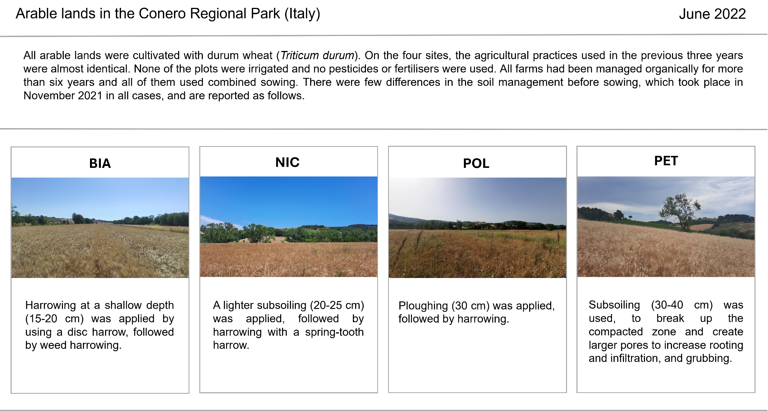

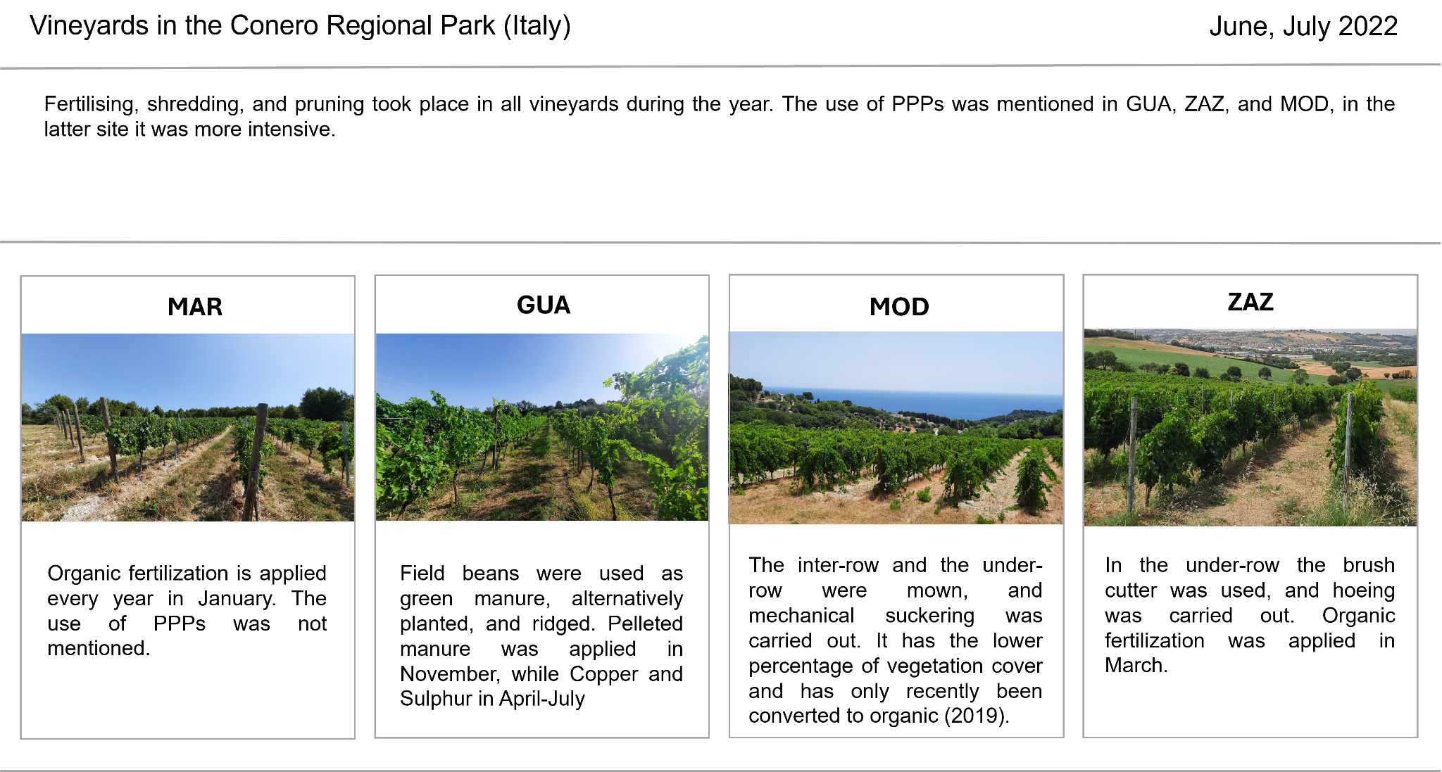
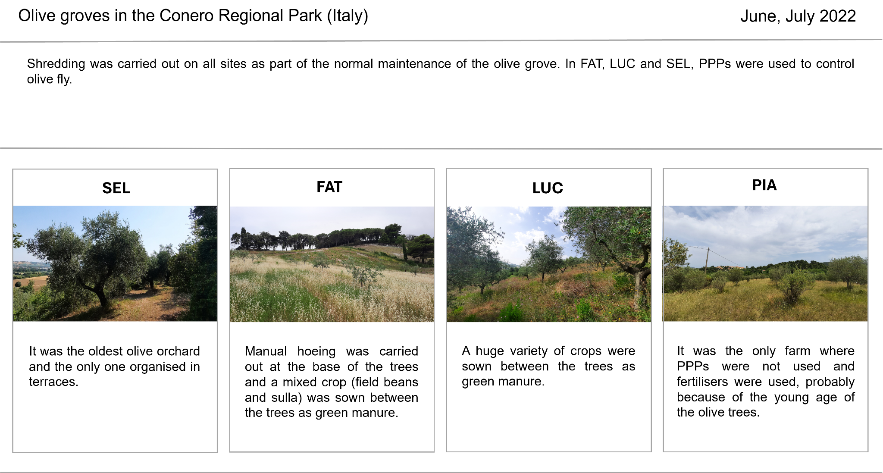
Tab. S1. The table shows the photos and the field management information for each site and agroecosystem. In-depth interviews with field owners were conducted, the following information were recorded: use of herbicides, pesticides, and fertilisers, crop rotation, irrigation, ploughing/harrowing/subsoiling depth (measured in cm), grubbing, shredding, pruning, hoeing, and sowing.

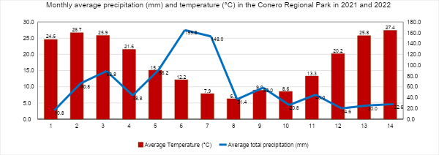

Fig. S1. The table shows the monthly average precipitation (mm) and temperature (°C) in the Conero Regional Park in 2021 and 2022. The red columns show the average temperature (°C), while the blue line shows the trend of the average total precipitation (mm). Both parameters were registered by the Camerano weather station.

Agroecosystem | Average Acari density (ind/m²) | Average Acari density (ind/m³) | Average Oribatid mites density (ind/m²) | Average Oribatid mites density (ind/m³) | % of Oribatid mites out of total mites
Arable lands | 49847 | 433667 | 19636 | 170833 | 39.4 %
Olie groves | 37404 | 325417 | 6006 | 52250 | 16.1 %
Vineyards | 33305 | 289750 | 7816 | 68000 | 23.5 %

Tab. S2. The table shows the overall Acari and Oribatid mites density data (ind/m² and ind/m³), and the percentage of oribatid mites out of total mites for each agroecosystem.

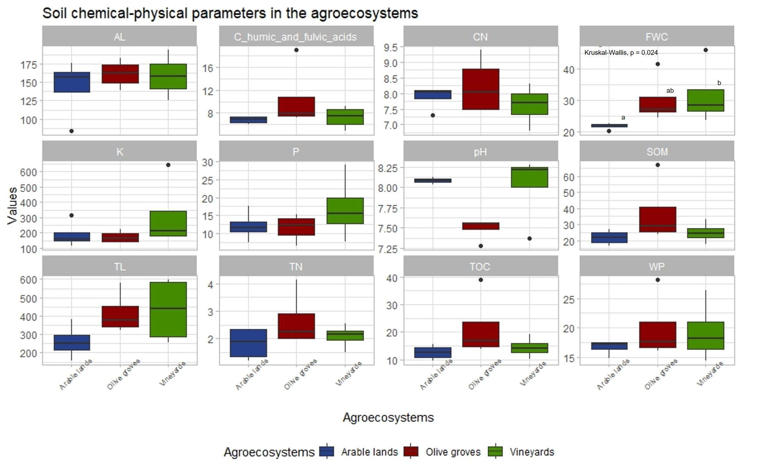
Fig. S2. Boxplots show the distribution of the values of the soil chemical-physical parameters in the three different agroecosystems. The median (horizontal line), and outliers (isolated black dots) are reported. The field water capacity (FWC) was the only parameter that showed a significant difference. For this parameter, lowercase letters represent significant differences between the average values (across management systems) by Post-hoc Dunn tests at p-value < 0.05. No indication is given for the other parameters because no significant differences were found. Total organic carbon, TOC; soil organic matter, SOM; total nitrogen, TN; assimilable phosphorus, P; exchangeable potassium, K; wilting point WP; total limestone, TL; active limestone, AL; carbon/nitrogen ratio, C/N ratio; carbon of humic and fulvic acids; pH.

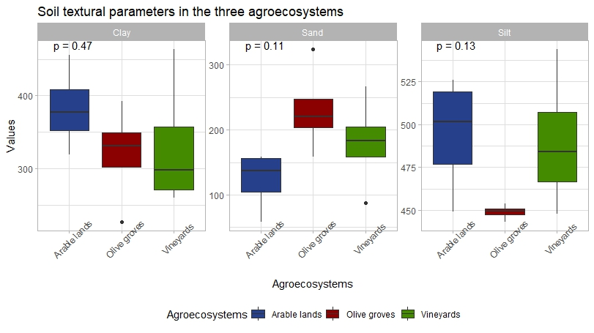

Fig. S3. Boxplots show the distribution of the soil textural parameters in the three different agroecosystems. The median (horizontal line), and outliers (isolated black dots) are reported. The content of sand, silt, and clay particles (g/kg) are reported. Arable lands and vineyards have a silty clay loam texture, while olive groves have a clay loam texture. ANOVA test at p-value < 0.05 was used.

