Supplementary Information

Development of Intervertebral Disc Organoids through Directed Differentiation of Mesenchymal Stem Cells and Hierarchical Bioprinting

Di Wu^{1#}, Dingchao Zhu^{1#}, Xingyu Zhou^{1#}, Gaocai Li^{1#}, Xiaoguang Zhang¹, Liang Ma¹, Huaizhen Liang¹, Bide Tong¹, Jie Lei¹, Hongchuan Wang¹, Xiaobo Feng¹, Kun Wang¹, Lei Tan¹*, Yunsong Shi²*, Cao Yang¹*, Bingjin Wang¹*

Affiliations
¹ Department of Orthopaedics, Union Hospital, Tongji Medical College, Huazhong University of Science and Technology, Wuhan 430022, China.
² Department of Stomatology, Union Hospital, Tongji Medical College, Huazhong University of Science and Technology, Wuhan 430022, China.

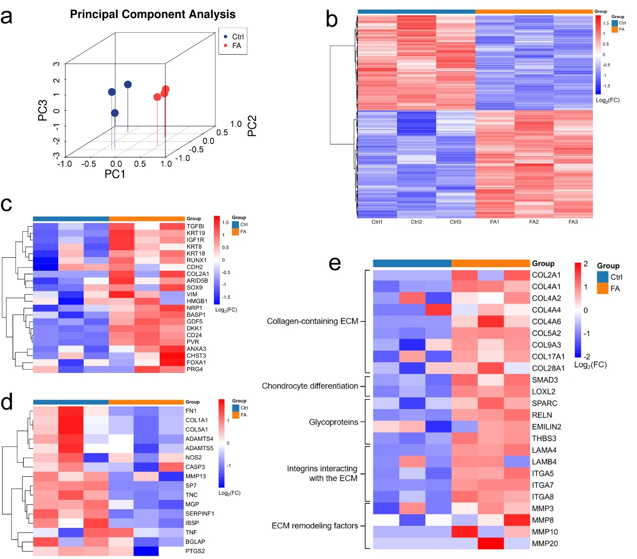
Figure S1. a) Principal component analysis between different groups. b) Heatmap showing DEGs between each group. c) DEGs associated with secondary NP differentiation genes. d) DEGs associated with AF-specific genes and inflammatory markers. e) DEGs associated with the secretion of ECM. n=3 independent experiments per group.

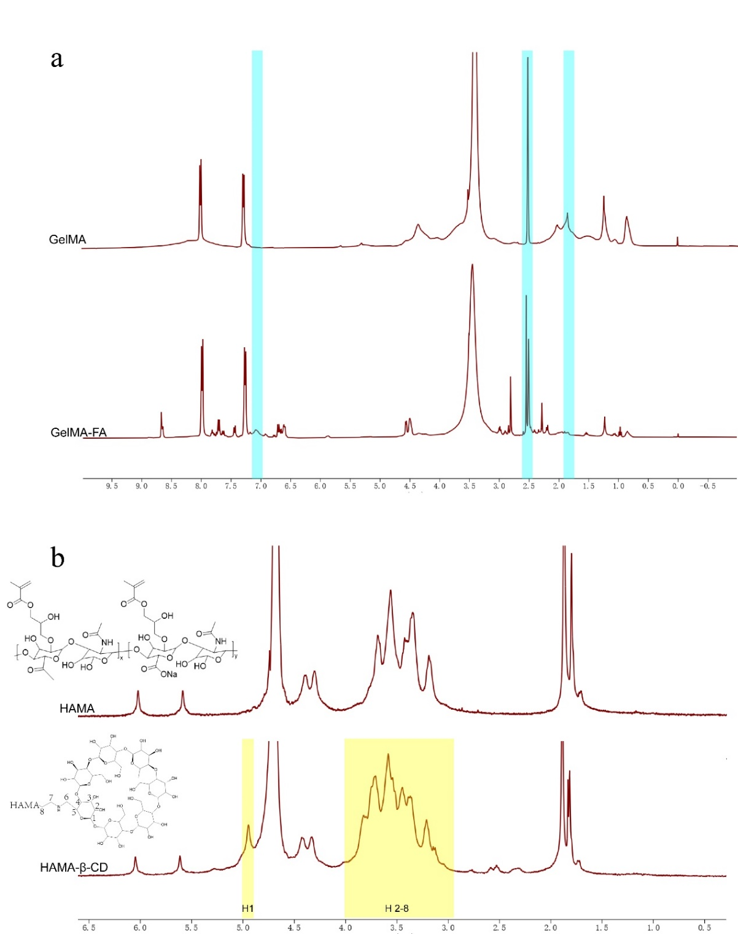
Figure S2. Preparation of GelMA with modification by Folic acid and HAMA with modification by β-CD. a) 1H NMR (400MHz, DMSO-d₆,) spectra of GelMA and GelMA-FA. The new resonance peaks in the folate region (blue) of the GelMA-FA spectrum indicated successful conjugation of the folic acid motifs. b) 1H NMR (400MHz, D₂O) spectra of HAMA and HAMA-βCD. The new resonance peaks in the βCD region (yellow) of HAMA-βCD. The spectrum indicated successful conjugation of the β-CD motif.
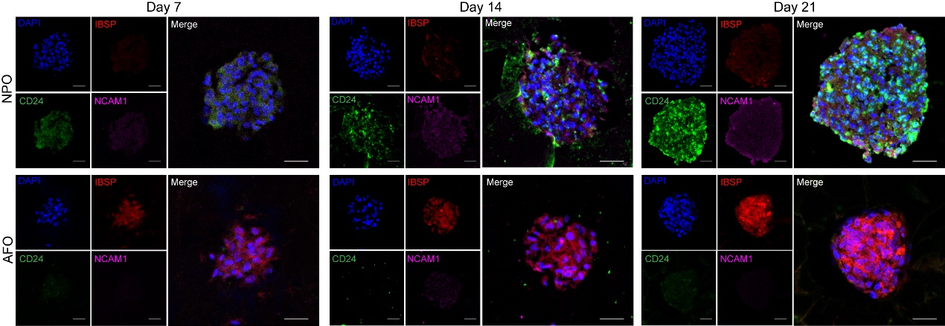
Figure S3. Immunofluorescence staining for CD24, IBSP, and NCAM1 indicated that the HG and SilMA hydrogels and the NP and AF differentiation media had synergistic effects on the ECM secretion of NPOs and AFOs at 7,14,21 days. Scale bar: 50 μm.

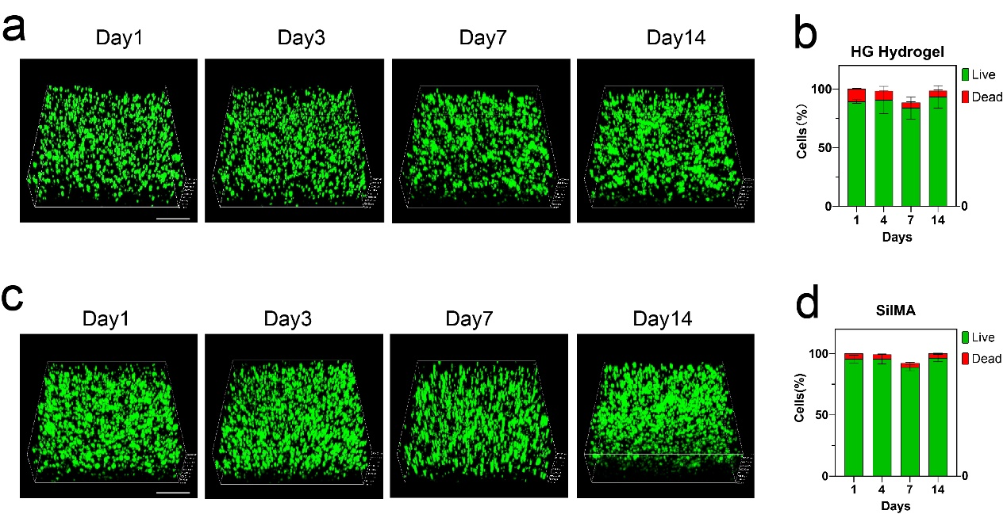
Figure S4. Cell viability test of a) HG and c) SilMA hydrogels for 3D bioprinted organoids. Live-dead assay of hMSCs in b) the HG hydrogel and d) SilMA after culturing for 1, 4, 7, or 14 days (live cells: green fluorescence; dead cells: red fluorescence). Scale bar: 400 μm. n=3 independent experiments per group.

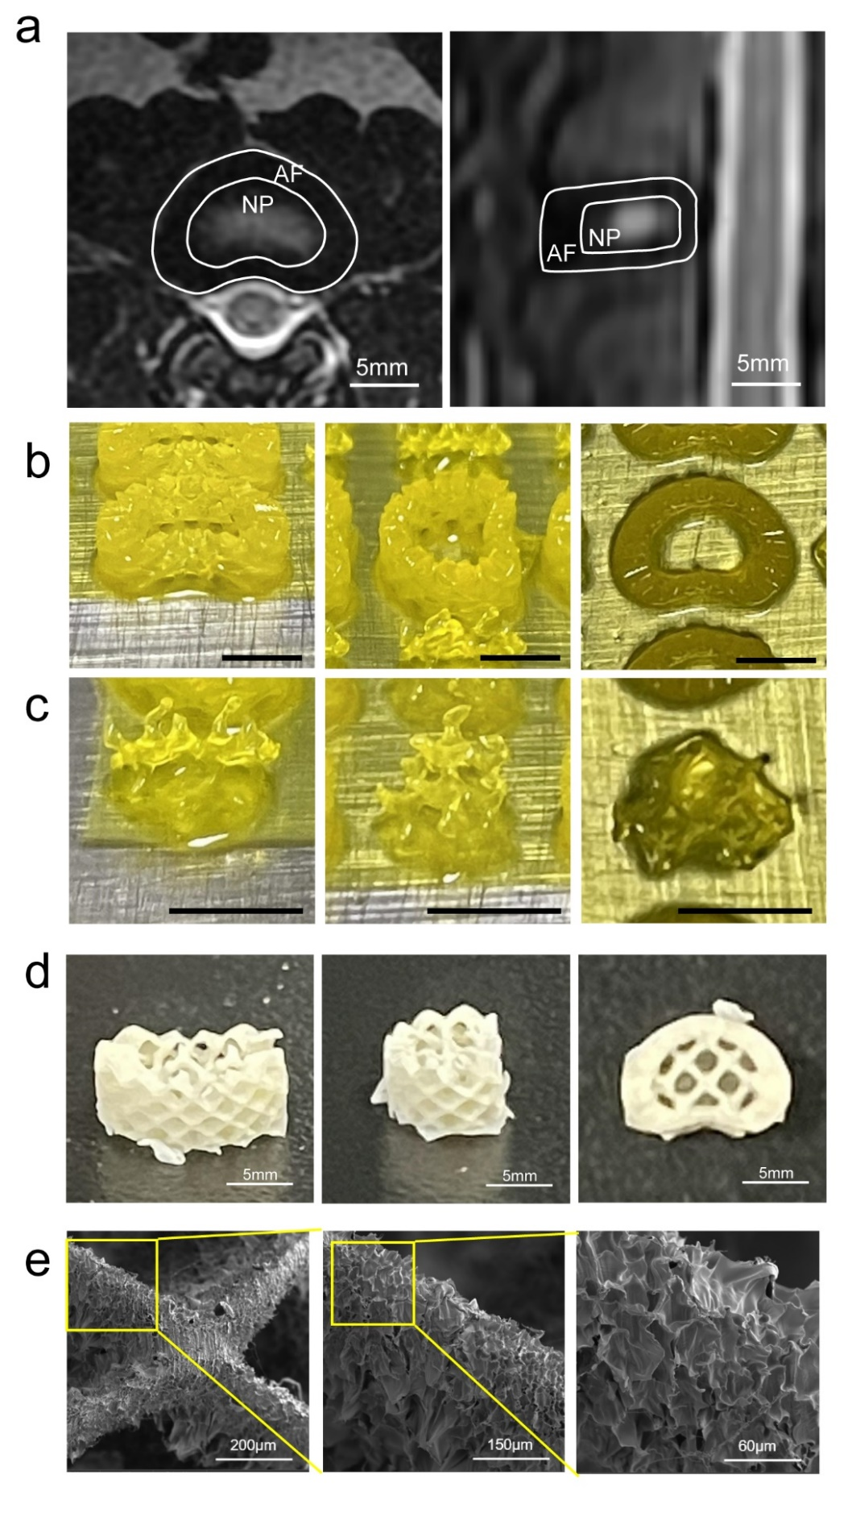
Figure S5. a) Morphology and shape parameters of IVDs obtained from MR images. Photographs of 3D-printed b) AF scaffolds and c) NP scaffolds taken from different views. Scale bars: 5mm. d) Photographs of freeze-dried IVD scaffolds. Scale bars: 5mm. e) Scanning electron microscopy of freeze-dried IVD scaffolds revealed a porous structure. Scale bars: 60μm.
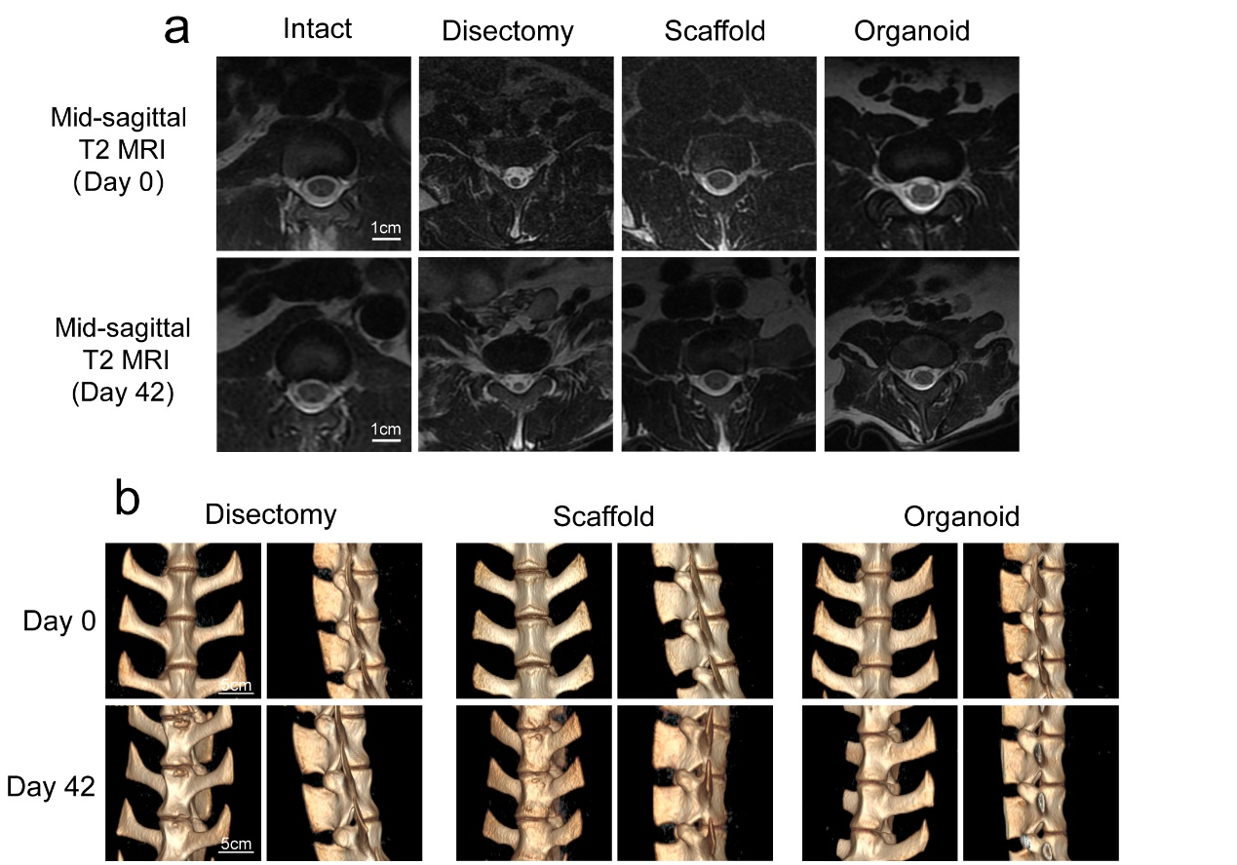
Figure S6. a) Representative mid-sagittal T2 MR images showing differences in the IVD across treatment groups. b) Reconstruction results of CT images showing the formation of vertebral osteophytes.

Table S1. PCR primer sequences
Genes | Forward primer | Reverse primer
GAPDH | AATCCCATCACCATCTTCCAG | GAGCCCCAGCCTTCTCCAT
COL2A1 | TGTCCATTCATCCCACCCT | CACCAGTTAGTTTCCTGCCTCT
CD24 | AATTTCCCCATCTTCTAAACCC | TTGGCATCCATCATCTAGTCAA
ACAN | ACCACTTTACTCTGGGTTTTCG | ACACGGCTCCACTTGATTCTT
NCAM1 | GTGGATAAGAACGACGAGG | CGGAGGCTTCACAGGTAA
COL1A1 | GATTGACCCCAACCAAGGC | GAATCCATCGGTCATGCTCT
COL5A1 | CCGATTGGCTACCCAGGTC | CACCCTTGATGCCCATGTCT
IBSP | AGGGCAGTAGTGACTCATCCG | AGCCCAGTGTTGTAGCAGAAAG
TNMD | TTGGTATCCTGGCCCTAA | CAGTGCCATTTCCGCTTC
BGLAP | GACAAGTCCCACACAGCAACT | GGACATGAAGGCTTTGTCAGA

Table S2. Antibody list
Antibody | Cat No. | Manufacturer
Col2A1 | 28459-1-AP | Proteintech
KRT19 | 10712-1-AP | Proteintech
GAPDH | 60004-1-Ig | Proteintech
β-actin | 66009-1-Ig | Proteintech
α-tubulin | 66031-1-Ig | Proteintech
Col1A1 | 14695-1-AP | Proteintech
CD24 | 10600-1-AP | Proteintech
Col5A1 | DF3551 | Affinty
TNMD | DF13715 | Affinty
IBSP | DF7738 | Affinty
FBLN1 | DF9516 | Affinty

