Supplementary information
SVLearn: a dual-reference machine learning approach enables accurate cross-species genotyping of structural variants
Qimeng Yang^{1#}, Jianfeng Sun^{2#}, Xinyu Wang¹, Jiong Wang¹, Quanzhong Liu³, Jinlong Ru⁴, Xin Zhang³, Sizhe Wang³, Ran Hao³, Peipei Bian¹, Xuelei Dai^{1,5}, Mian Gong^{1,6}, Zhuangbiao Zhang¹, Ao Wang¹, Fengting Bai¹, Ran Li¹, Yudong Cai^{1*}& Yu Jiang^{1*}

¹Key Laboratory of Animal Genetics, Breeding and Reproduction of Shaanxi Province, College of Animal Science and Technology, Northwest A&F University, Yangling, Shaanxi, China
²Botnar Research Centre, Nuffield Department of Orthopaedics, Rheumatology and Musculoskeletal Sciences, National Institute of Health Research Oxford Biomedical Research Unit (BRU), University of Oxford, Oxford, UK
³College of Information Engineering, Northwest A&F University, Yangling, Shaanxi, China
⁴Institute of Virology, Helmholtz Centre Munich - German Research Centre for Environmental Health, Neuherberg, Germany
⁵Yazhouwan National Laboratory, Sanya, Hainan, China
⁶State Key Laboratory of Animal Biotech Breeding, Institute of Animal Science, Chinese Academy of Agricultural Sciences (CAAS), Beijing, China

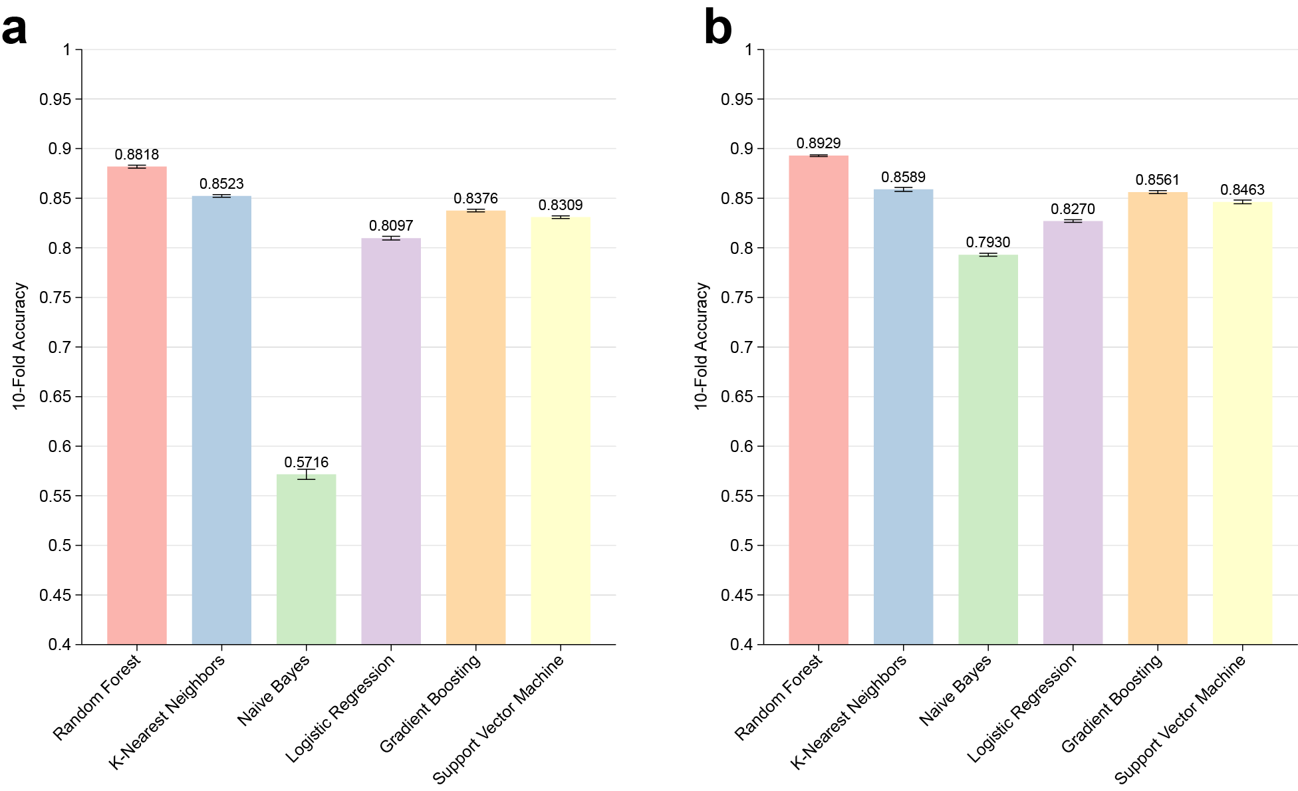
Supplementary Figure 1. Model selection.
a-b: represents the accuracy of ten-fold cross-validation for the Human 18 Feature Train Set and the Human 24 Feature Train Set, respectively, under the default parameters of six classic classification models.

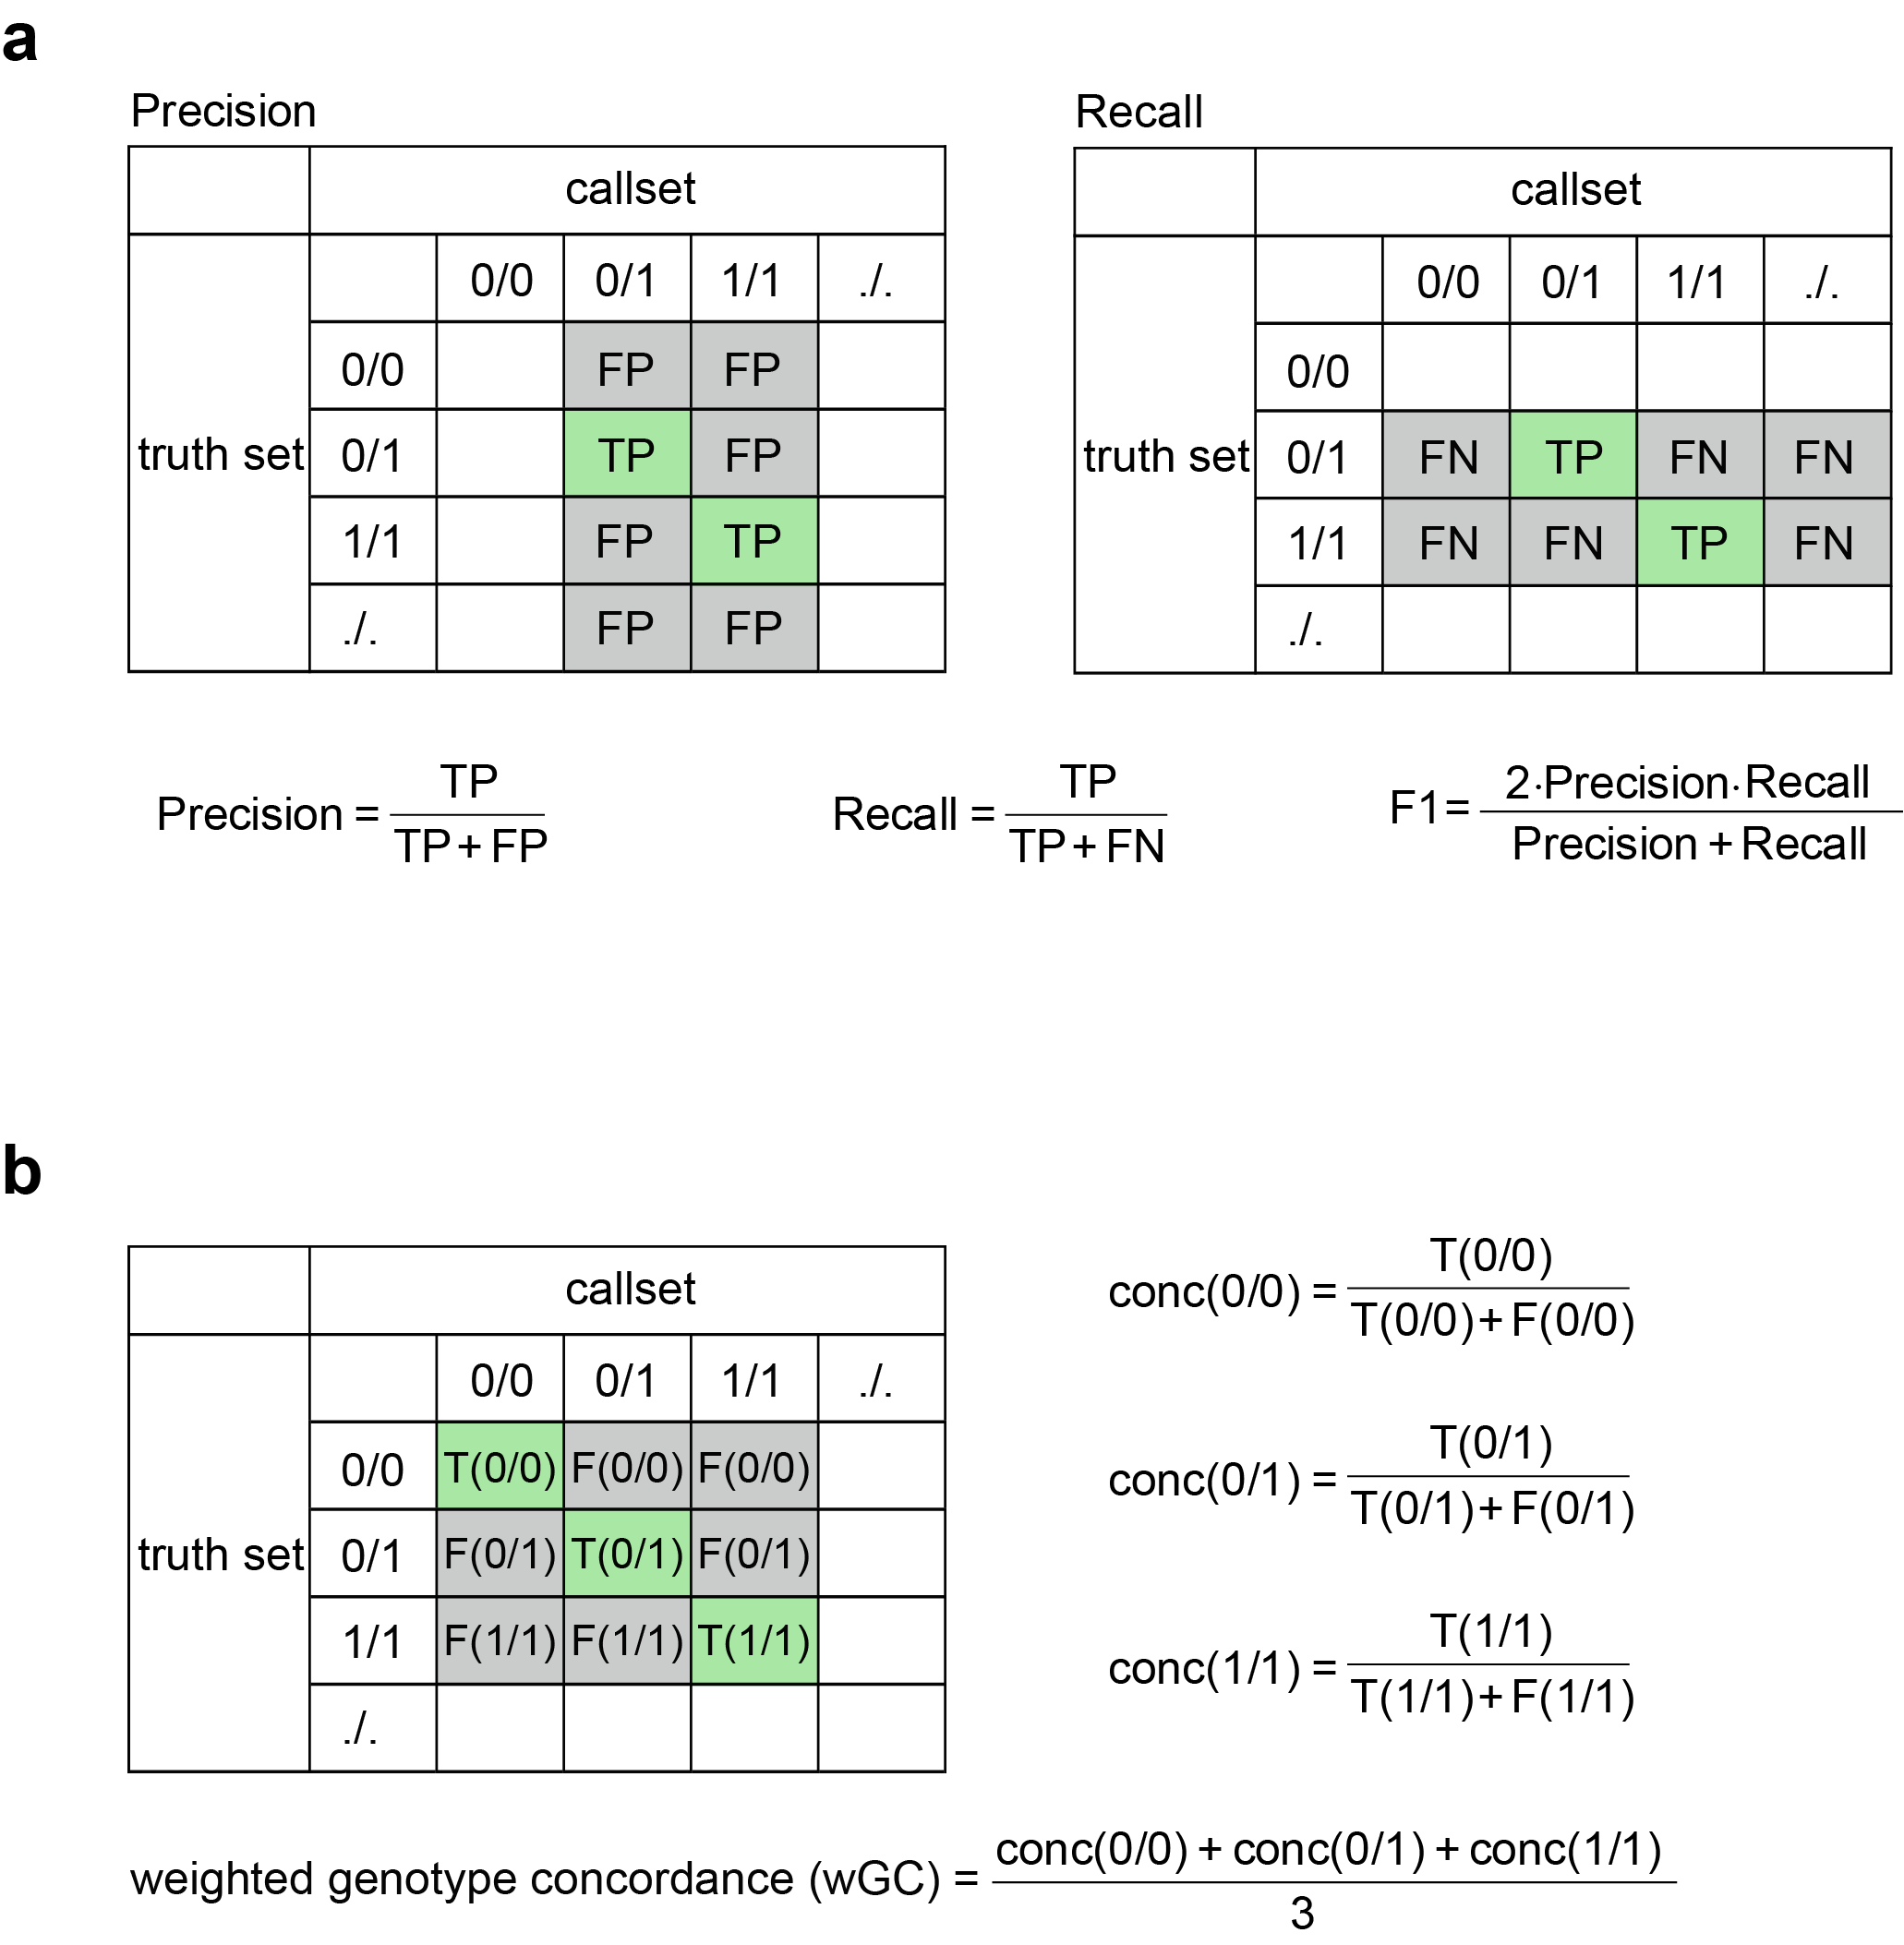
Supplementary Figure 2. Genotyping performance evaluation metrics.
a: The calculation methods for precision, recall, and F1. b: The calculation method for weighted genotype concordance (wGC).

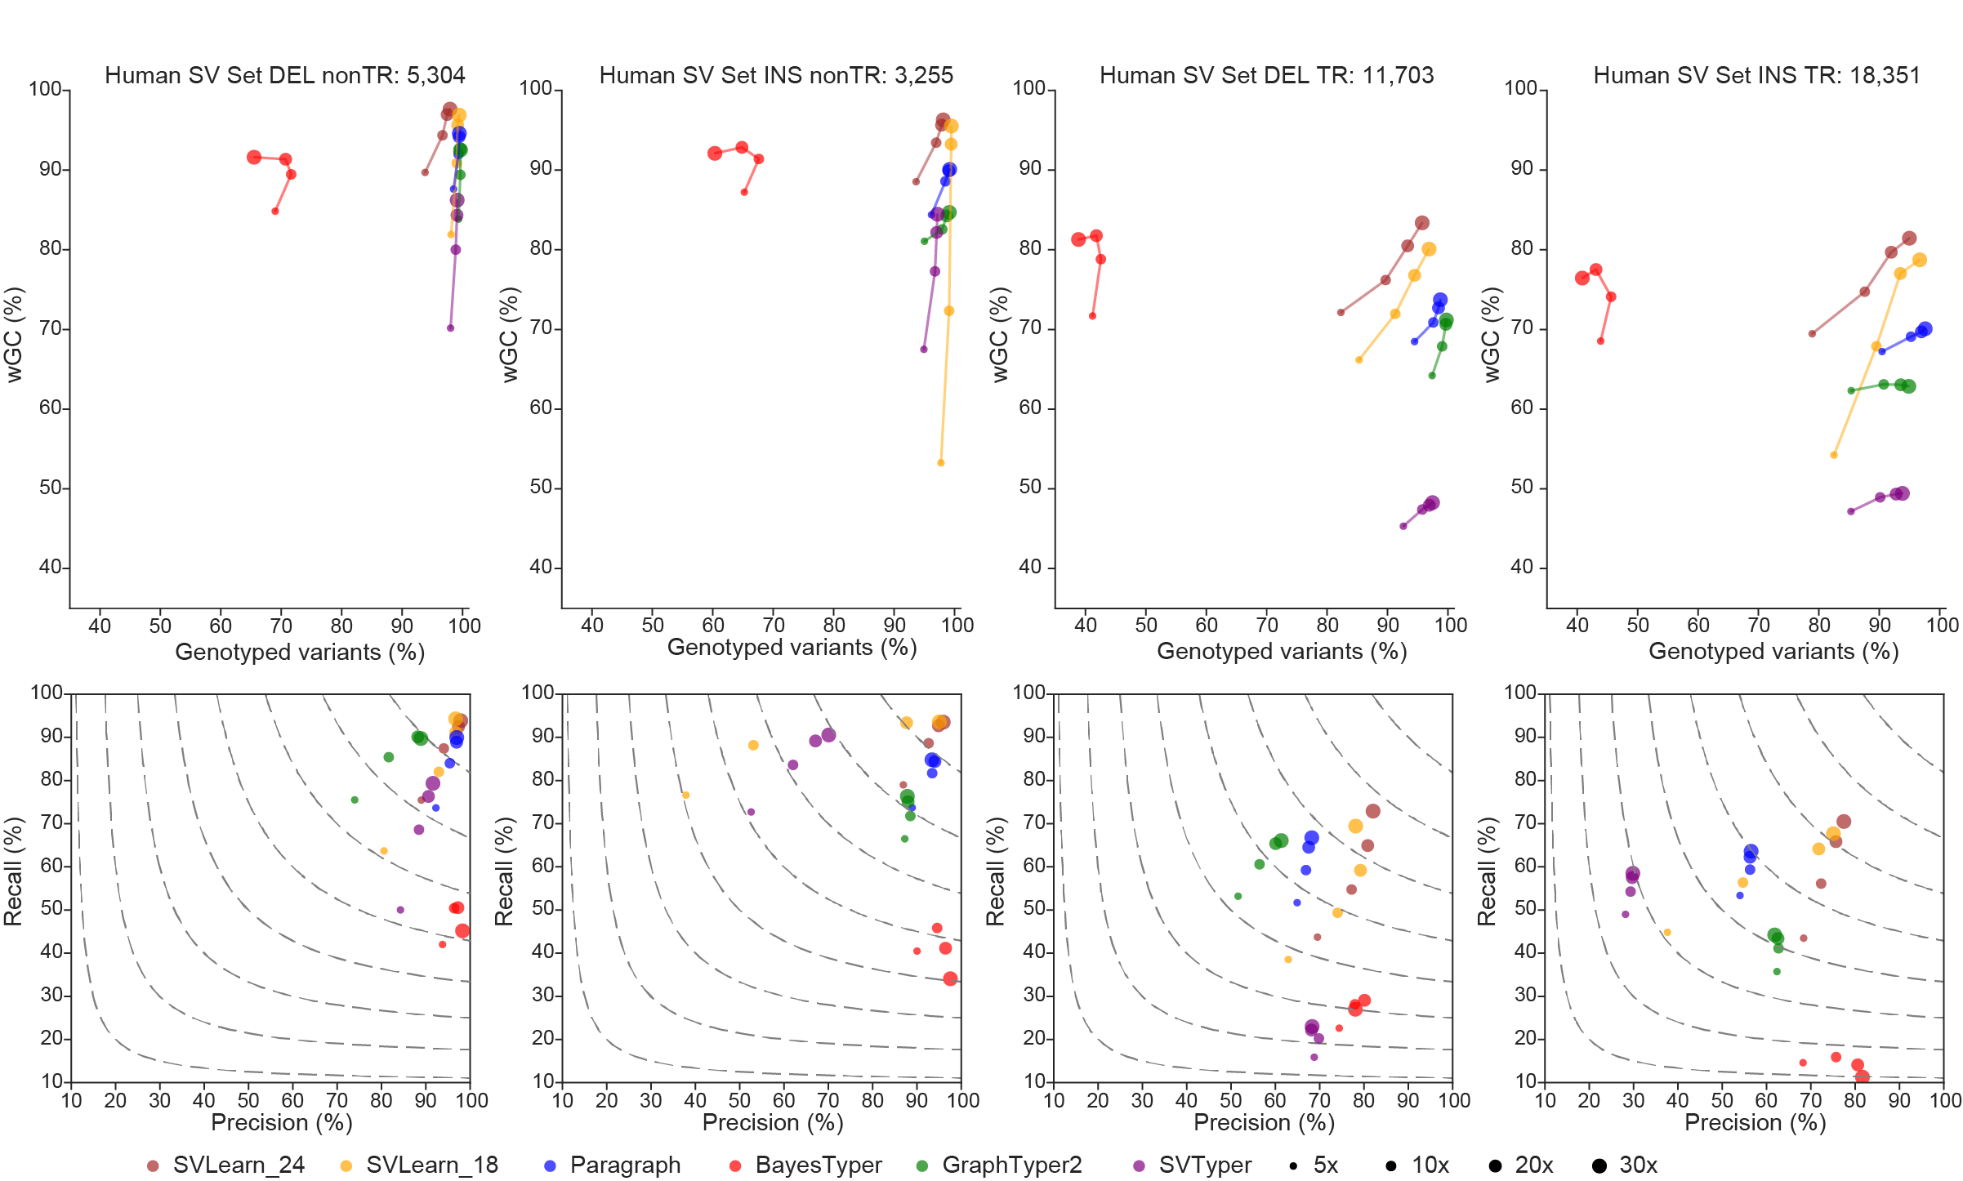
Supplementary Figure 3. Comparison of genotyping tools.
The performance of Paragraph, BayesTyper, GraphTyper2, SVTyper, and the Human 18 feature model and Human 24 feature model of SVLearn was evaluated on the HG002 under four different coverage. The evaluation was performed separately for deletions and insertions associated with non-tandem repeat (nonTR) and tandem repeat (TR) regions of the Human SV Set. The upper panel presents the genotype rate and weighted genotype concordance (wGC), while the lower panel displays the precision and recall of the genotyping results for each tool. The contour lines in the figure represent F1 scores ranging from 0.2 to 0.9.
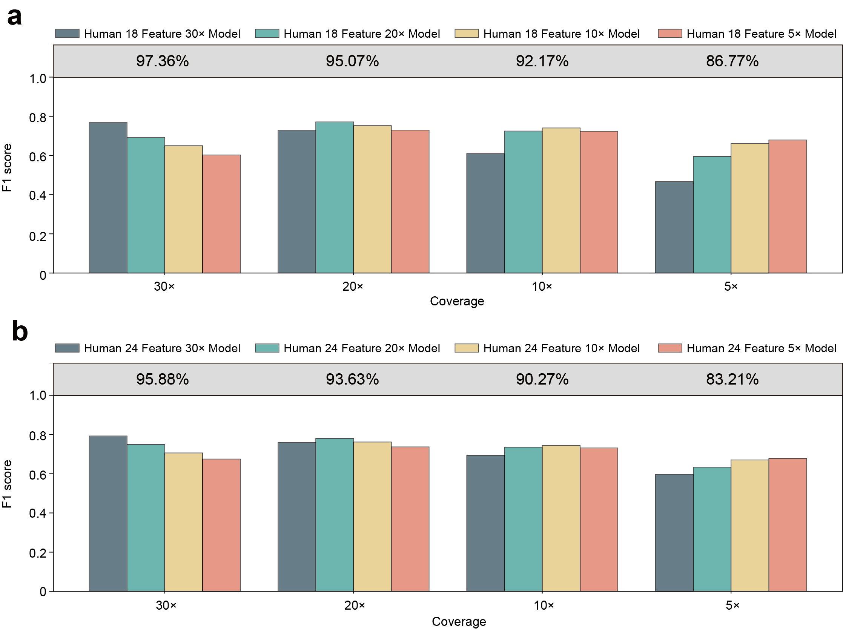
Supplementary Figure 4. Comparison of models trained at multiple coverage levels.
a: F1 score of genotyping SVs using 18 features. b: F1 score of genotyping SVs using 24 features. Human 18 Feature 30× Model and Human 24 Feature 30× Model refer to the Human 18 Feature Model and Human 24 Feature Model, respectively. The percentages in the shaded area at the top of the figure represent the genotyping rate corresponding to the coverage sequencing data, indicating that the genotyping rate is consistent across models with the same number of features.

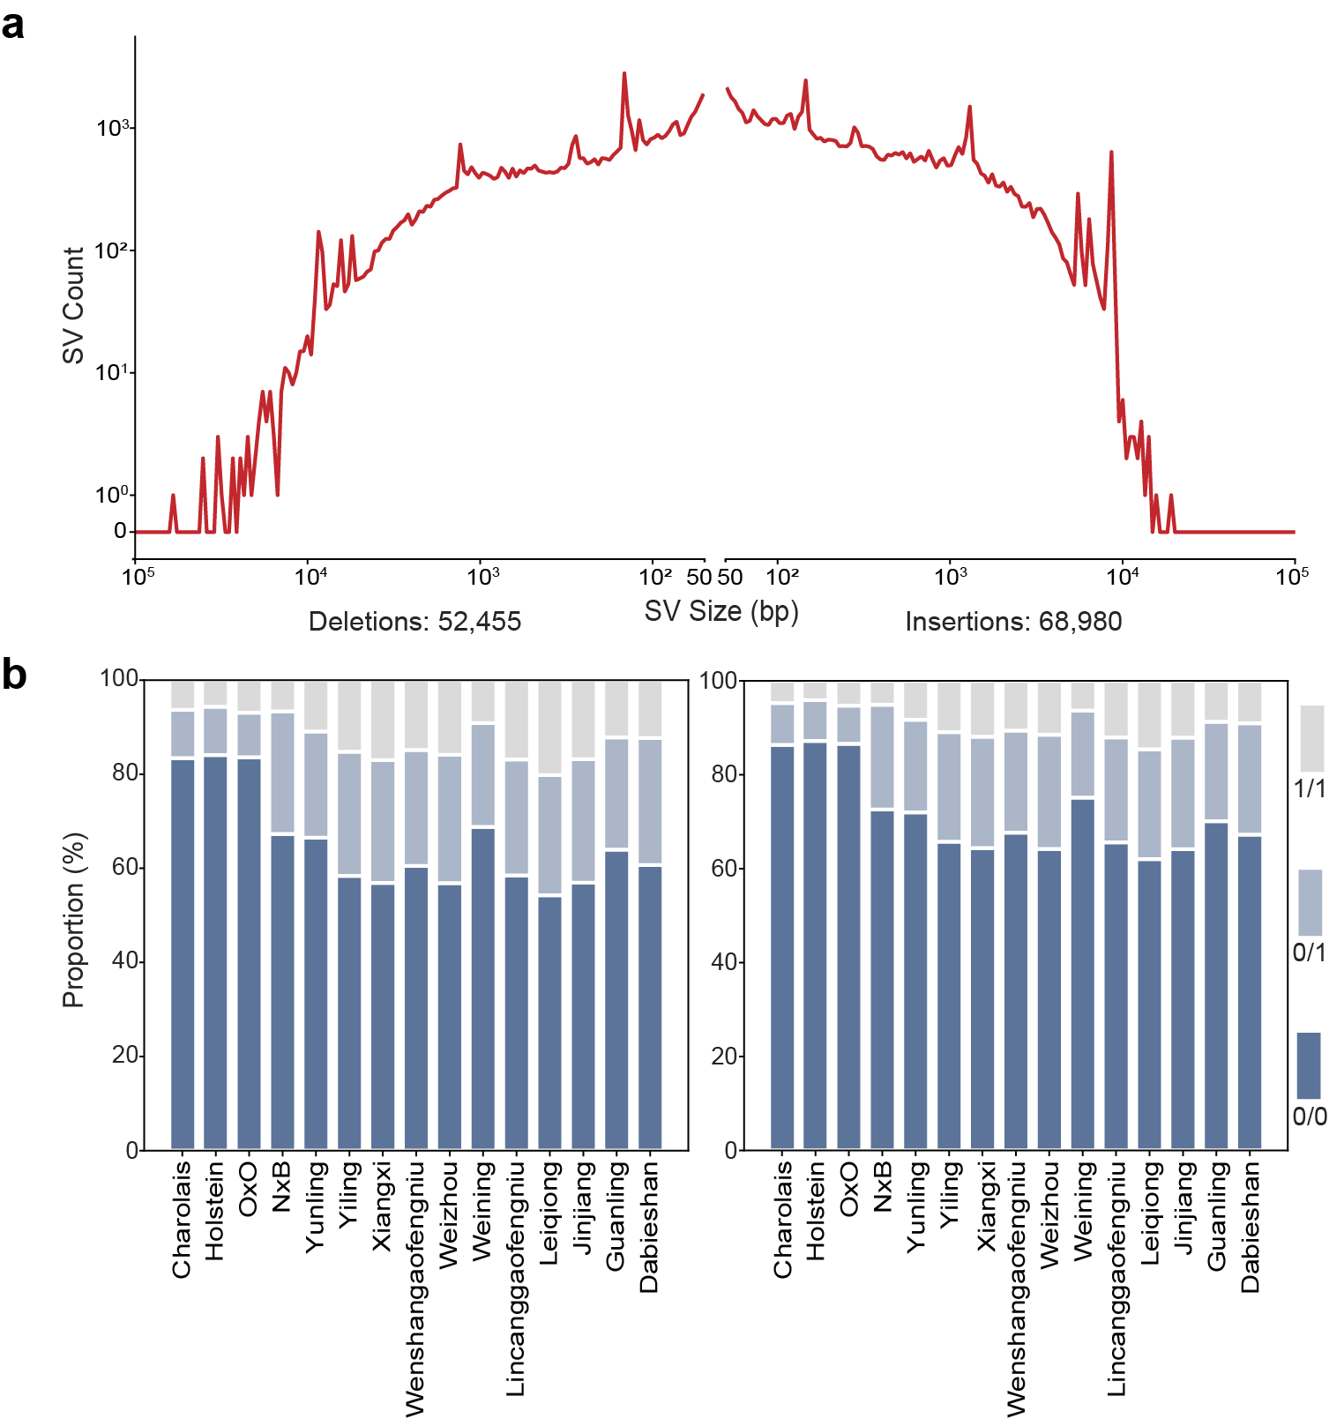
Supplementary Figure 5. Description of Cattle SV Set.
a: Length distribution of deletions and insertions in the Cattle SV Set. b: Proportion of three genotypes for deletions and insertions across 15 cattle individuals; among them, Charolais was the validation individual.

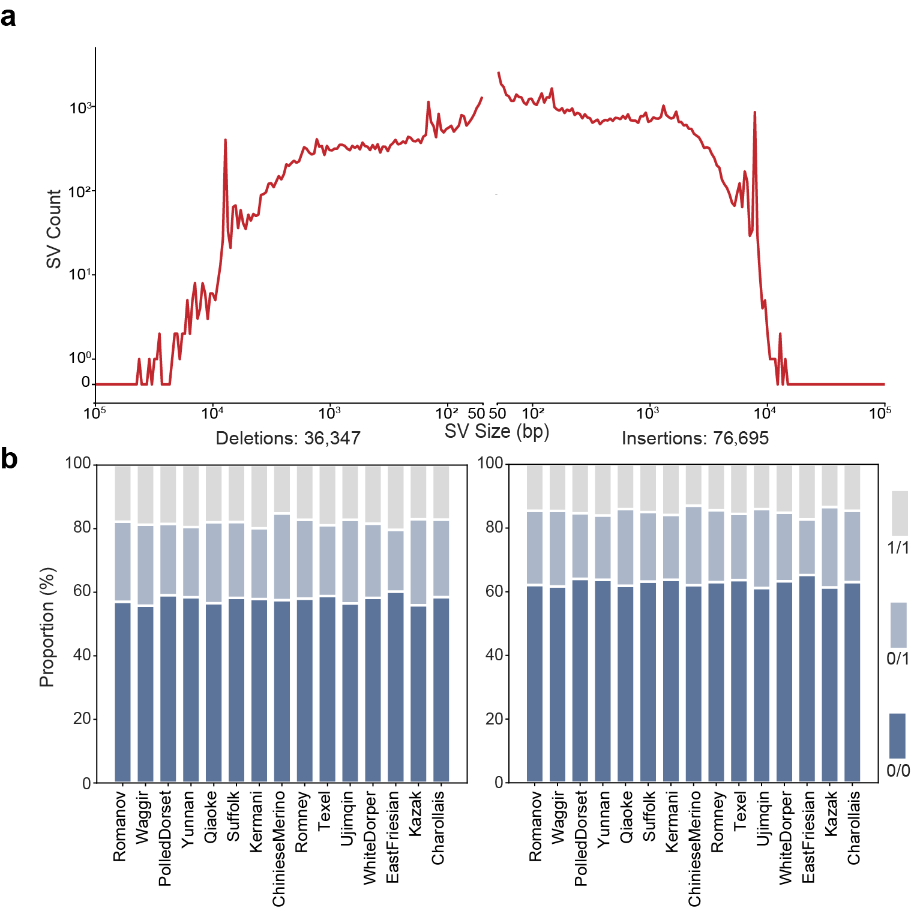
Supplementary Figure 6. Description of Sheep SV Set.
a: Length distribution of deletions and insertions in the Sheep SV Set. b: Proportion of three genotypes for deletions and insertions across 15 sheep individuals; among them, Romanov was the validation individual.

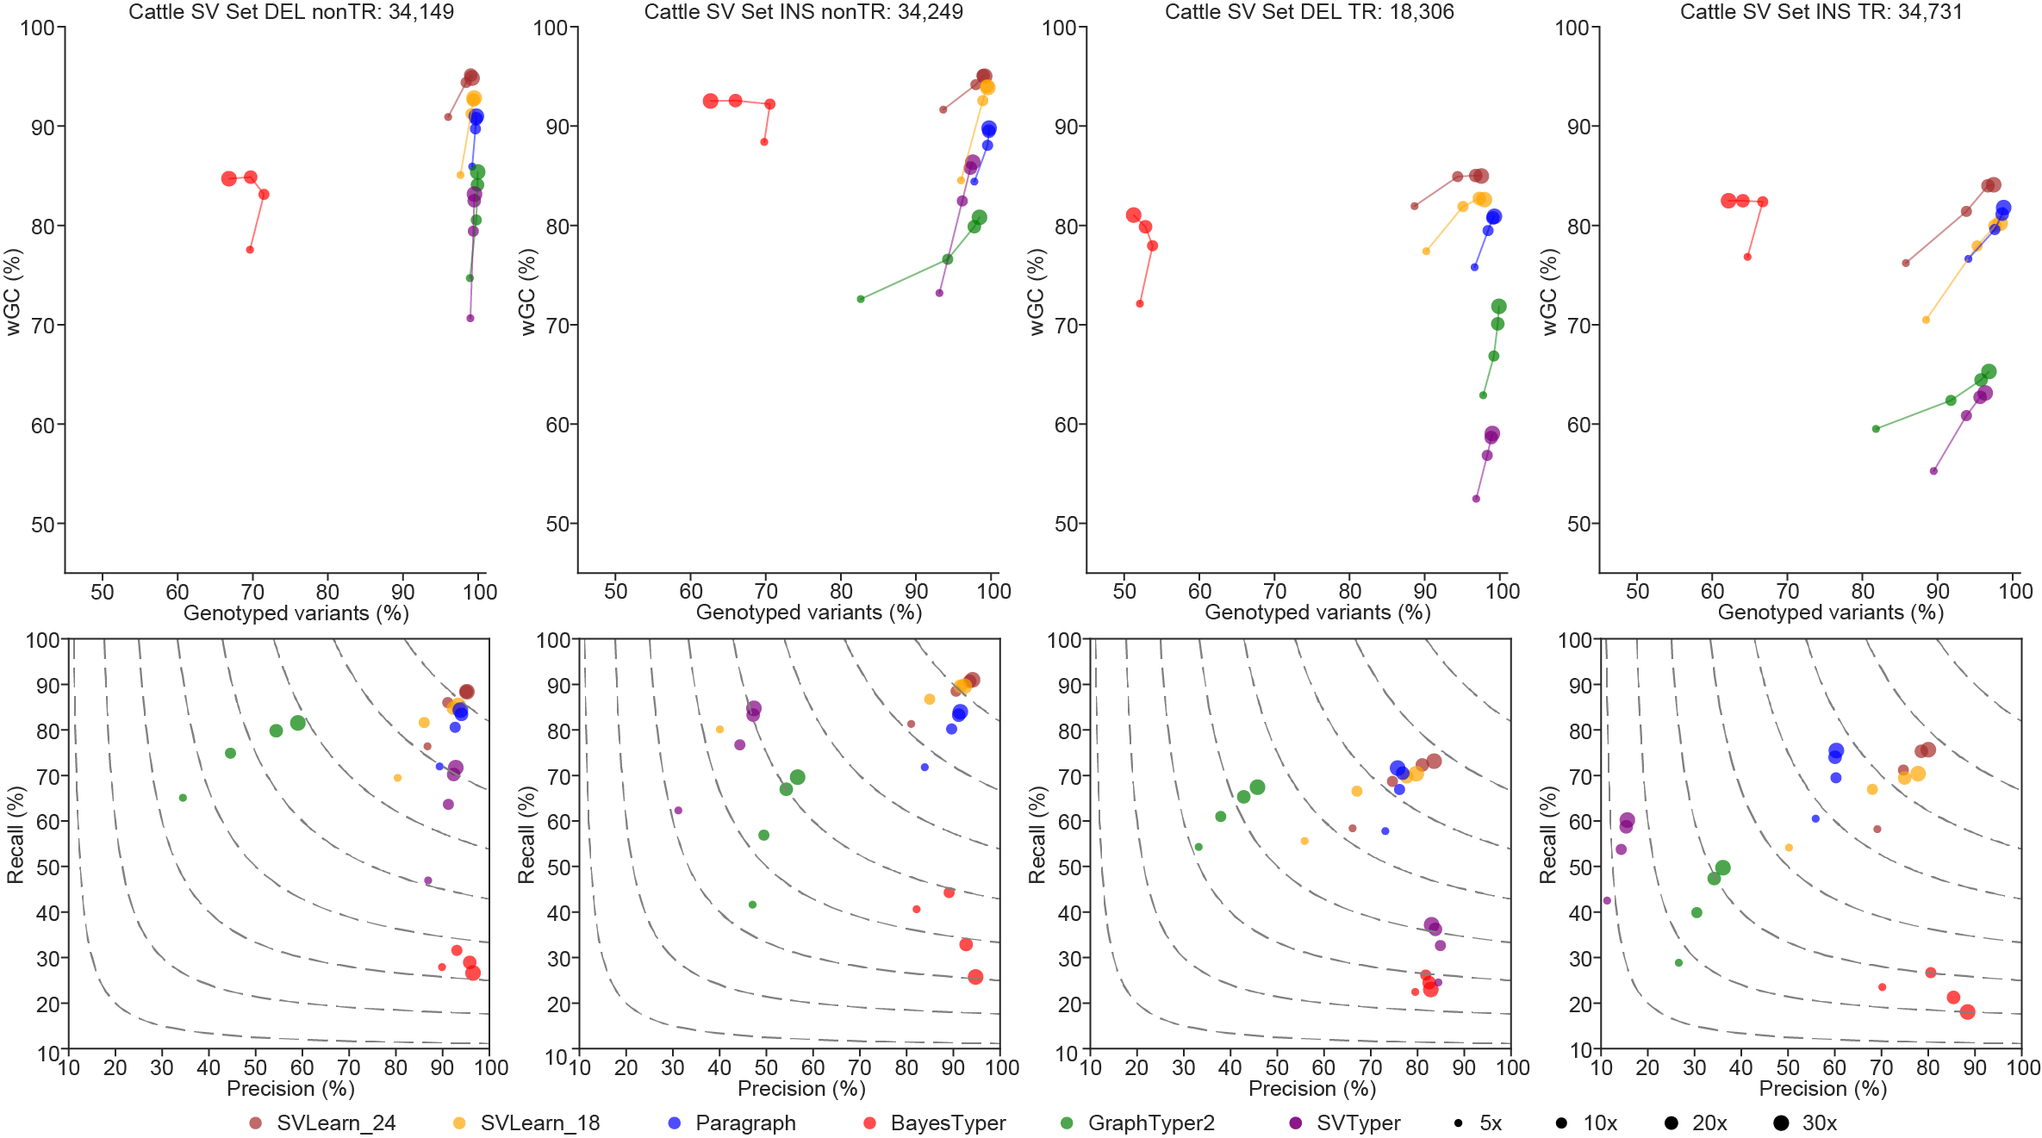
Supplementary Figure 7. The genotyping evaluation of Cattle SV Set.
The upper panel shows the genotype rate and weighted genotype concordance (wGC), while the lower panel indicates the precision and recall of the genotyping results for each tool. The contour lines in the figure represent F1 scores ranging from 0.2 to 0.9.

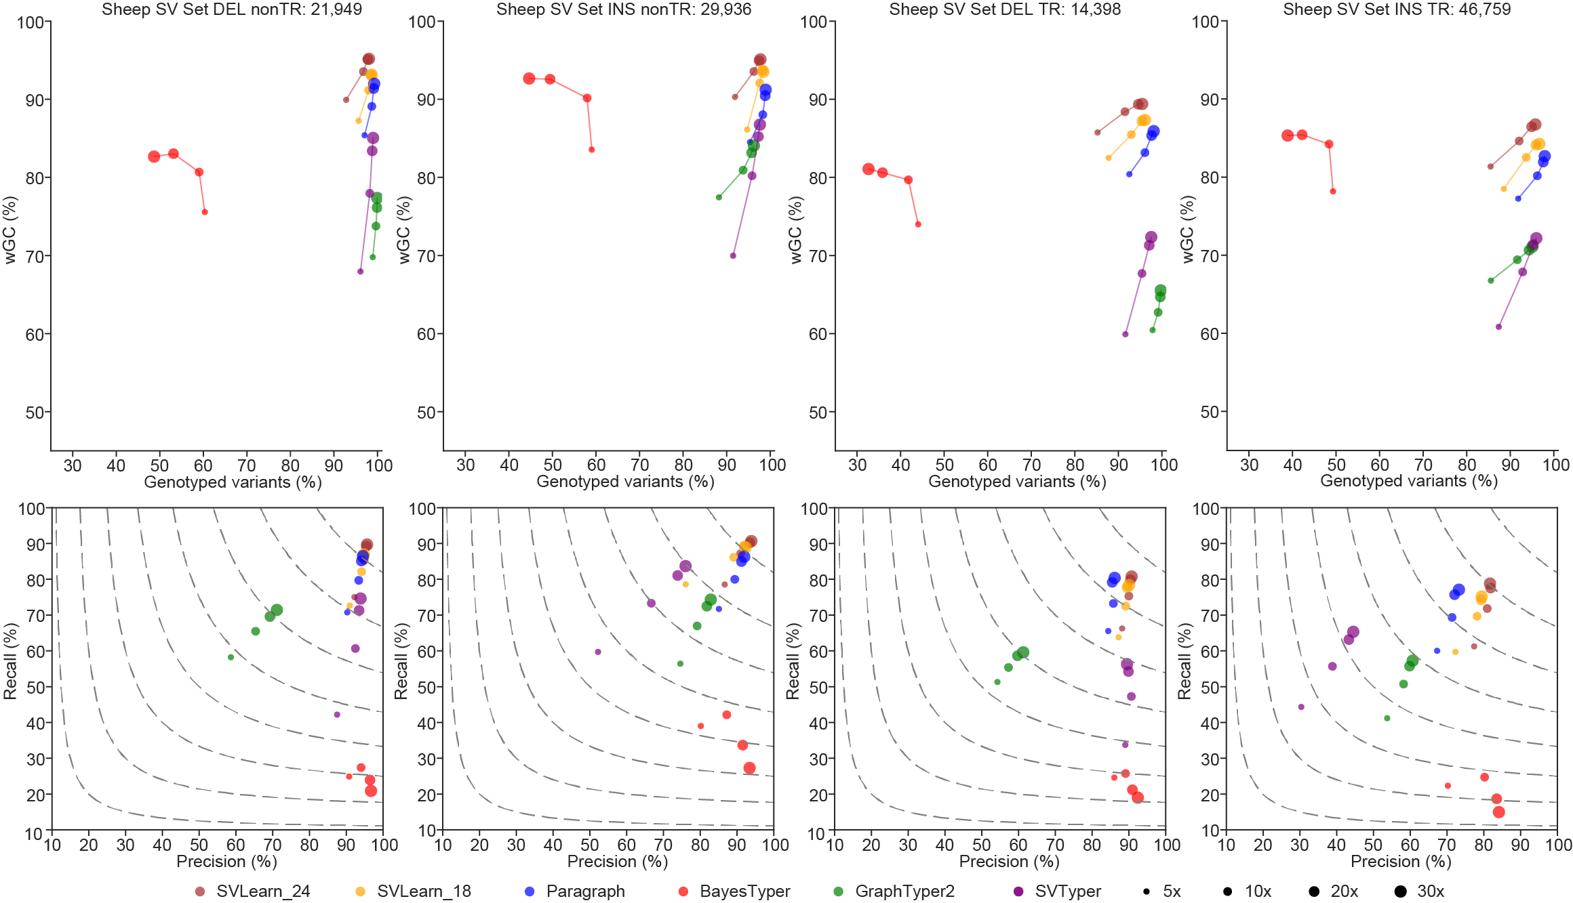
Supplementary Figure 8. The genotyping evaluation of Sheep SV Set.
The upper panel shows the genotype rate and weighted genotype concordance (wGC), while the lower panel indicates the precision and recall of the genotyping results for each tool. The contour lines in the figure represent F1 scores ranging from 0.2 to 0.9.

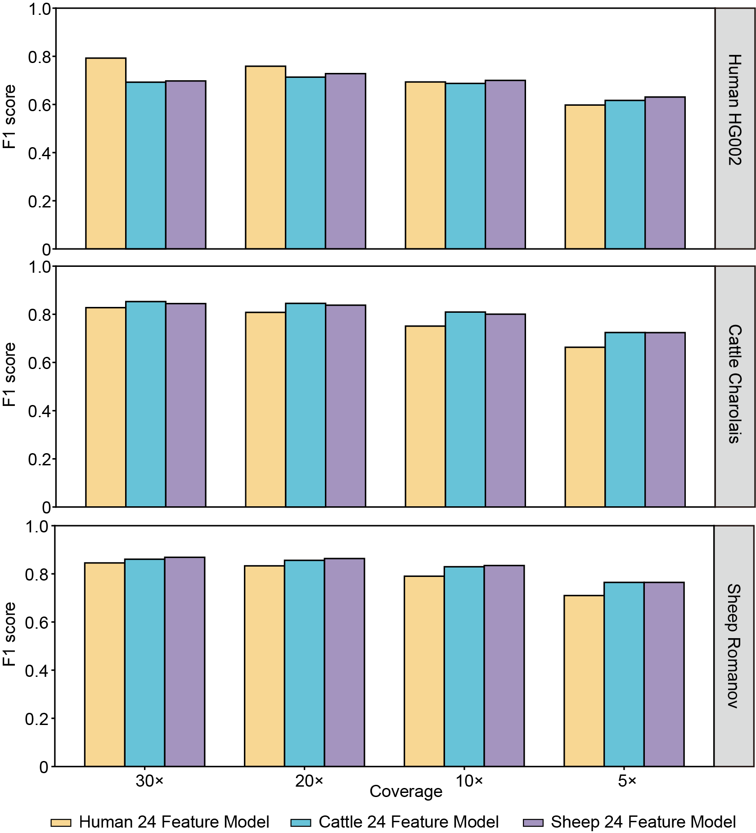
Supplementary Figure 9. Cross-species genotyping of F1 score.
Cross-species of genotyping performance (F1 score) using human, cattle, and sheep models across three validation individuals.

Supplementary Table 1. Sequencing reads Statistics. The short reads of the Charolais, Holstein, and Yunling samples of cattle, had original sequencing depths exceeding 30×. They were downsampled to approximately 30× for the purpose of this study.
Individuals | Species | PacBio HiFi reads coverage (×) | 2x150bp reads coverage (×) | Validation individual
HG002 | Homo sapiens | 35.90 | 30.60 | P
HG00438 | Homo sapiens | 39.87 | 31.69
HG00621 | Homo sapiens | 38.32 | 30.81
HG00735 | Homo sapiens | 41.70 | 31.37
HG01071 | Homo sapiens | 34.05 | 32.38
HG01175 | Homo sapiens | 35.02 | 30.49
HG01361 | Homo sapiens | 40.69 | 34.09
HG01978 | Homo sapiens | 36.80 | 35.06
HG02257 | Homo sapiens | 34.68 | 33.36
HG03516 | Homo sapiens | 34.54 | 29.97
HG01109 | Homo sapiens | 31.19 | 32.05
HG01243 | Homo sapiens | 34.17 | 31.15
HG02080 | Homo sapiens | 33.15 | 33.35
HG03492 | Homo sapiens | 32.66 | 30.60
HG01928 | Homo sapiens | 34.12 | 34.26
Charolais | Bos taurus | 38.71 | 30.00 | P
Holstein | Bos taurus | 15.48 | 30.00
OxO | Bos taurus | 32.22 | 29.42
Dabieshan | Bos indicus | 23.48 | 13.12
Guanling | Bos indicus | 24.40 | 13.15
Jinjiang | Bos indicus | 23.08 | 12.54
Leiqiong | Bos indicus | 21.50 | 12.82
Yiling | Bos indicus | 21.59 | 13.35
Weizhou | Bos indicus | 18.38 | 12.69
Wenshangaofeng | Bos indicus | 15.85 | 13.07
Lincanggaofeng | Bos indicus | 21.72 | 12.85
Xiangxi | Bos indicus | 18.76 | 12.95
Weining | Bos indicus | 18.85 | 13.62
Yunling | Bos indicus | 21.59 | 30.00
NxB | Bos indicus ✖ Bos taurus | 51.13 | 17.35
Romanov | Ovis aries | 21.49 | 28.40 | P
EastFriesian | Ovis aries | 30.75 | 28.04
PolledDorset | Ovis aries | 27.41 | 17.82
Charollais | Ovis aries | 21.09 | 19.26
Romney | Ovis aries | 21.13 | 18.35
Suffolk | Ovis aries | 20.62 | 17.97
Texel | Ovis aries | 19.64 | 17.84
WhiteDorper | Ovis aries | 16.91 | 18.66
ChinieseMerino | Ovis aries | 20.54 | 18.91
Kermani | Ovis aries | 23.74 | 9.19
Waggir | Ovis aries | 23.67 | 27.54
Kazak | Ovis aries | 24.51 | 18.00
Ujimqin | Ovis aries | 23.41 | 18.68
Qiaoke | Ovis aries | 23.54 | 17.05
Yunnan | Ovis aries | 24.20 | 16.97

Supplementary Table 2. Statistical analysis of PacBio HiFi reads for calling SV Sets.
Species | Number of individuals | Mean HiFi reads coverage (×) | Max HiFi reads coverage (×) | Min HiFi reads coverage (×)
Human | 15 | 35.79 | 41.70 | 31.19
Cattle | 15 | 24.45 | 51.13 | 15.48
Sheep | 15 | 22.84 | 30.75 | 16.91

Supplementary Table 3. Statistical analysis of short reads for training model.
Species | Number of Individuals | Mean 2×150bp reads coverage (×) | Max 2×150bp reads coverage (×) | Min 2×150bp reads coverage (×)
Human | 14 | 32.19 | 35.06 | 29.97
Cattle | 14 | 16.92 | 30.00 | 12.54
Sheep | 14 | 18.88 | 28.04 | 9.19

Supplementary Table 4. Extracted features Information.
Feature | Type | Classification feature | Information
Type | SV feature | P | Insertion or deletion
Length | SV feature |  | The length of the longest allelic sequence
GC content | SV feature |  | The GC content of the longest allelic sequence
SD class | SV feature | P | SD region or non-SD region
SD content | SV feature |  | The proportion of sequences overlapping with SDs regions in SV sequences
Repeat class | SV feature | P | SINE, LNE, LTR, DNA, Mixed_TEs, Satellite, VNTR, STR, Mixed_repeat, Low_Repeat
Repeat content | SV feature |  | The proportion of Repeat sequences belonging to the Repeat class of SV sequences within SV sequences
TR length | SV feature |  | The length of tandem repeats intersecting with SV regions
TR content | SV feature |  | The proportion of tandem repeat sequences within SV sequences
Mappability | SV feature |  | The mappability of SV sequences
BP HomRef | Alignment feature |  | Binomial probability of finding the number of alternate reads given a probability of 0.001
BP HomAlt | Alignment feature |  | Binomial probability of finding the number of alternate reads given a probability of 0.5
BP Het | Alignment feature |  | Binomial probability of finding the number of alternate reads given a probability of 0.9
RD HomRef | Alignment feature |  | Binomial probability of finding the number of alternate reads given a probability of 0.0625
RD HomAlt | Alignment feature |  | Binomial probability of finding the number of alternate reads given a probability of 0.5
RD Het | Alignment feature |  | Binomial probability of finding the number of alternate reads given a probability of 0.99
RD upstream | Alignment feature |  | RD upstream = ref_up1kb_RD / (ref_up1kb_RD + alt_up1kb_RD)
RD downstream | Alignment feature |  | RD downstream = ref_down1kb_RD / (ref_down1kb_RD + alt_down1kb_RD)
Ref GT | Paragraph feature (Optional) | P | Paragraph SV genotype obtained in ref bam
Alt GT | Paragraph feature (Optional) | P | Paragraph SV genotype obtained in alt bam
Ref FT | Paragraph feature (Optional) | P | Filter tag obtained from ref bam
Alt FT | Paragraph feature (Optional) | P | Filter tag obtained from alt bam
DP | Paragraph feature (Optional) |  | DP = DP_ref - DP_alt
PL | Paragraph feature (Optional) |  | PL = PL_ref - PL_alt

Supplementary Table 5. Classification of SVs.
SV sets | SV Class | Deletions | Deletions (%) | Insertions | Insertions (%)
Human SV Set | Low_Repeat | 3,868 | 22.74% | 2,196 | 10.16%
Human SV Set | SINE | 2,771 | 16.29% | 5,620 | 26.01%
Human SV Set | LINE | 1,299 | 7.64% | 1,335 | 6.18%
Human SV Set | LTR | 750 | 4.41% | 437 | 2.02%
Human SV Set | DNA | 121 | 0.71% | 67 | 0.31%
Human SV Set | Mixed_TEs | 636 | 3.74% | 284 | 1.31%
Human SV Set | Satellite | 909 | 5.34% | 553 | 2.56%
Human SV Set | VNTR | 5,661 | 33.29% | 8,938 | 41.37%
Human SV Set | STR | 962 | 5.66% | 2,089 | 9.67%
Human SV Set | Mixed_Repeat | 30 | 0.18% | 87 | 0.40%
Cattle SV Set | Low_Repeat | 18,351 | 34.98% | 17,405 | 25.23%
Cattle SV Set | SINE | 7,360 | 14.03% | 5,763 | 8.35%
Cattle SV Set | LINE | 14,392 | 27.44% | 26,566 | 38.51%
Cattle SV Set | LTR | 1,794 | 3.42% | 3,182 | 4.61%
Cattle SV Set | DNA | 230 | 0.44% | 192 | 0.28%
Cattle SV Set | Mixed_TEs | 2,788 | 5.32% | 2,087 | 3.03%
Cattle SV Set | Satellite | 86 | 0.16% | 87 | 0.13%
Cattle SV Set | VNTR | 6,912 | 13.18% | 12,139 | 17.60%
Cattle SV Set | STR | 415 | 0.79% | 1,089 | 1.58%
Cattle SV Set | Mixed_Repeat | 127 | 0.24% | 470 | 0.68%
Sheep SV Set | Low_Repeat | 14,437 | 39.72% | 24,382 | 31.79%
Sheep SV Set | SINE | 3,206 | 8.82% | 3,433 | 4.48%
Sheep SV Set | LINE | 11,391 | 31.34% | 32,159 | 41.93%
Sheep SV Set | LTR | 726 | 2.00% | 1,114 | 1.45%
Sheep SV Set | DNA | 150 | 0.41% | 145 | 0.19%
Sheep SV Set | Mixed_TEs | 1,593 | 4.38% | 1,295 | 1.69%
Sheep SV Set | Satellite | 91 | 0.25% | 69 | 0.09%
Sheep SV Set | VNTR | 4,041 | 11.12% | 9,703 | 12.65%
Sheep SV Set | STR | 502 | 1.38% | 3,134 | 4.09%
Sheep SV Set | Mixed_Repeat | 210 | 0.58% | 1,261 | 1.64%

Supplementary Table 6. Number of SVs inside and outside tandem repeat regions. We differentiated whether SVs are located in repetitive regions based on the extracted tandem repeat (TR) content. SVs with a TR content greater than zero are classified as being in repetitive regions, whereas those with a TR content of zero are classified as being in non-repetitive regions.
SV sets | Repetitive regions |  | Non-repetitive regions |  | Repeat regions (%)
SV sets | Deletions | Insertions | Deletions | Insertions | Repeat regions (%)
Human SV Set | 11,703 | 18,351 | 5,304 | 3,255 | 77.83%
Cattle SV Set | 18,306 | 34,731 | 34,149 | 34,249 | 43.68%
Sheep SV Set | 14,398 | 46,759 | 21,949 | 29,936 | 54.10%

Supplementary Table 7. Hyperparameter combinations for grid search optimization.
Hyperparameters | Value
n_estimators | 100, 200, 300, 400, 500, 750, 1000
max_depth | None, 10, 20, 30, 50, 100, 200, 300
min_samples_split | 2, 5, 10
min_samples_leaf | 1, 2, 4
bootstrap | True, False
class_weight | None, balanced

Supplementary Table 8. Best hyperparameter combinations.
Species | Model | Best hyperparameter combinations | Validation*accuracy
Human | Human 18 Feature Model | {'bootstrap': False, 'class_weight': None, 'max_depth': 50, 'min_samples_leaf': 1, 'min_samples_split': 2, 'n_estimators': 750} | 0.8726
Human | Human 24 Feature Model | {'bootstrap': False, 'class_weight': None, 'max_depth': 30, 'min_samples_leaf': 1, 'min_samples_split': 2, 'n_estimators': 1000} | 0.8902
Human | Human 18 Feature 20× Model | {'bootstrap': False, 'class_weight': None, 'max_depth': 200, 'min_samples_leaf': 1, 'min_samples_split': 10, 'n_estimators': 1000} | 0.8811
Human | Human 24 Feature 20× Model | {'bootstrap': False, 'class_weight': None, 'max_depth': 200, 'min_samples_leaf': 1, 'min_samples_split': 5, 'n_estimators': 1000} | 0.8894
Human | Human 18 Feature 10× Model | {'bootstrap': False, 'class_weight': None, 'max_depth': 300, 'min_samples_leaf': 1, 'min_samples_split': 10, 'n_estimators': 1000} | 0.8718
Human | Human 24 Feature 10× Model | {'bootstrap': False, 'class_weight': None, 'max_depth': 30, 'min_samples_leaf': 1, 'min_samples_split': 5, 'n_estimators': 400} | 0.8791
Human | Human 18 Feature 5× Model | {'bootstrap': False, 'class_weight': None, 'max_depth': 100, 'min_samples_leaf': 4, 'min_samples_split': 5, 'n_estimators': 500} | 0.8547
Human | Human 24 Feature 5× Model | {'bootstrap': False, 'class_weight': None, 'max_depth': 50, 'min_samples_leaf': 2, 'min_samples_split': 2, 'n_estimators': 750} | 0.8656
Cattle | Cattle 18 Feature Model | {'bootstrap': False, 'class_weight': None, 'max_depth': 30, 'min_samples_leaf': 1, 'min_samples_split': 10, 'n_estimators': 750} | 0.9601
Cattle | Cattle 24 Feature Model | {'bootstrap': False, 'class_weight': None, 'max_depth': 50, 'min_samples_leaf': 1, 'min_samples_split': 5, 'n_estimators': 750} | 0.9682
Sheep | Sheep 18 Feature model | {'bootstrap': False, 'class_weight': None, 'max_depth': None, 'min_samples_leaf': 1, 'min_samples_split': 10, 'n_estimators': 1000} | 0.9194
Sheep | Sheep 24 Feature model | {'bootstrap': False, 'class_weight': None, 'max_depth': 300, 'min_samples_leaf': 1, 'min_samples_split': 5, 'n_estimators': 1000} | 0.9345
* The validation accuracy is calculated as the ratio of the number of correctly genotyped structural variants (SVs) to the total number of SVs that have been genotyped.
Supplementary Table 9. Resource Consumption.
Coverage | Method | Mapping CPU time | Mapping Max memory (MB) | Genotyping CPU time | Mapping Max memory (MB)
30× | SVLearn_18_Feature | 97:04:52 | 45,142 | 0:34:16 | 15,690
30× | SVLearn_24_Feature | 97:04:52 | 45,142 | 23:22:41 | 23,105
30× | Paragraph | 51:36:52 | 45,142 | 15:44:09 | 5,022
30× | BayesTyper | 51:36:52 | 45,142 | 8:49:08 | 26,015
30× | GraphTyper2 | 51:36:52 | 45,142 | 20:22:28 | 12,737
30× | SVTyper | 51:36:52 | 45,142 | 0:10:50 | 786
20× | SVLearn_18_Feature | 58:03:41 | 44,282 | 0:24:13 | 19,668
20× | SVLearn_24_Feature | 58:03:41 | 44,282 | 14:58:21 | 23,178
20× | Paragraph | 29:21:10 | 44,04 | 9:50:50 | 4,996
20× | BayesTyper | 29:21:10 | 44,042 | 7:11:12 | 23,195
20× | GraphTyper2 | 29:21:10 | 44,042 | 13:54:49 | 12,771
20× | SVTyper | 29:21:10 | 44,042 | 0:06:20 | 614
10× | SVLearn_18_Feature | 29:19:30 | 43,940 | 0:15:21 | 19,364
10× | SVLearn_24_Feature | 29:19:30 | 43,940 | 7:49:00 | 22,967
10× | Paragraph | 14:46:07 | 43,833 | 4:57:05 | 4,949
10× | BayesTyper | 14:46:07 | 43,833 | 5:44:59 | 20,786
10× | GraphTyper2 | 14:46:07 | 43,833 | 7:36:14 | 12,777
10× | SVTyper | 14:46:07 | 43,833 | 0:03:17 | 377
5× | SVLearn_18_Feature | 14:33:16 | 43,869 | 0:11:40 | 19,055
5× | SVLearn_24_Feature | 14:33:16 | 43,869 | 4:21:09 | 22,660
5× | Paragraph | 7:14:22 | 43,869 | 2:37:11 | 4,639
5× | BayesTyper | 7:14:22 | 43,869 | 4:38:59 | 19,220
5× | GraphTyper2 | 7:14:22 | 43,869 | 4:12:08 | 12,738
5× | SVTyper | 7:14:22 | 43,869 | 0:02:53 | 234

