SUPPLEMENTARY MATERIALS
Target genes | TaqMan probes ID
Gusb | Mm01197698_m1
Abcb1a | Mm00440761_m1
Abcb1b | Mm00440736_m1
Abcg2 | Mm00496364_m1
Cyp1a1 | Mm00487218_m1
Cyp1a2 | Mm00487224_m1
Cyp1b1 | Mm00487229_m1
Cyp2e1 | Mm00491127_m1
Cyp3a11 | Mm00731567_m1
Sult1a1 | Mm00467072_m1
Slc22a6 | Mm00456258_m1
Slc22a8 | Mm00459534_m1
Table 1 Supplementary Materials. List of TaqMan probes references used in qPCR experiments

SUPPLEMENTARY DATA

Figure 1 Supplementary Data. Graphic representation of the transporters and metabolic enzymes studied. Every organ studied on the mice trial is represented, as well as clarification on the transportation flow of the different transporters.
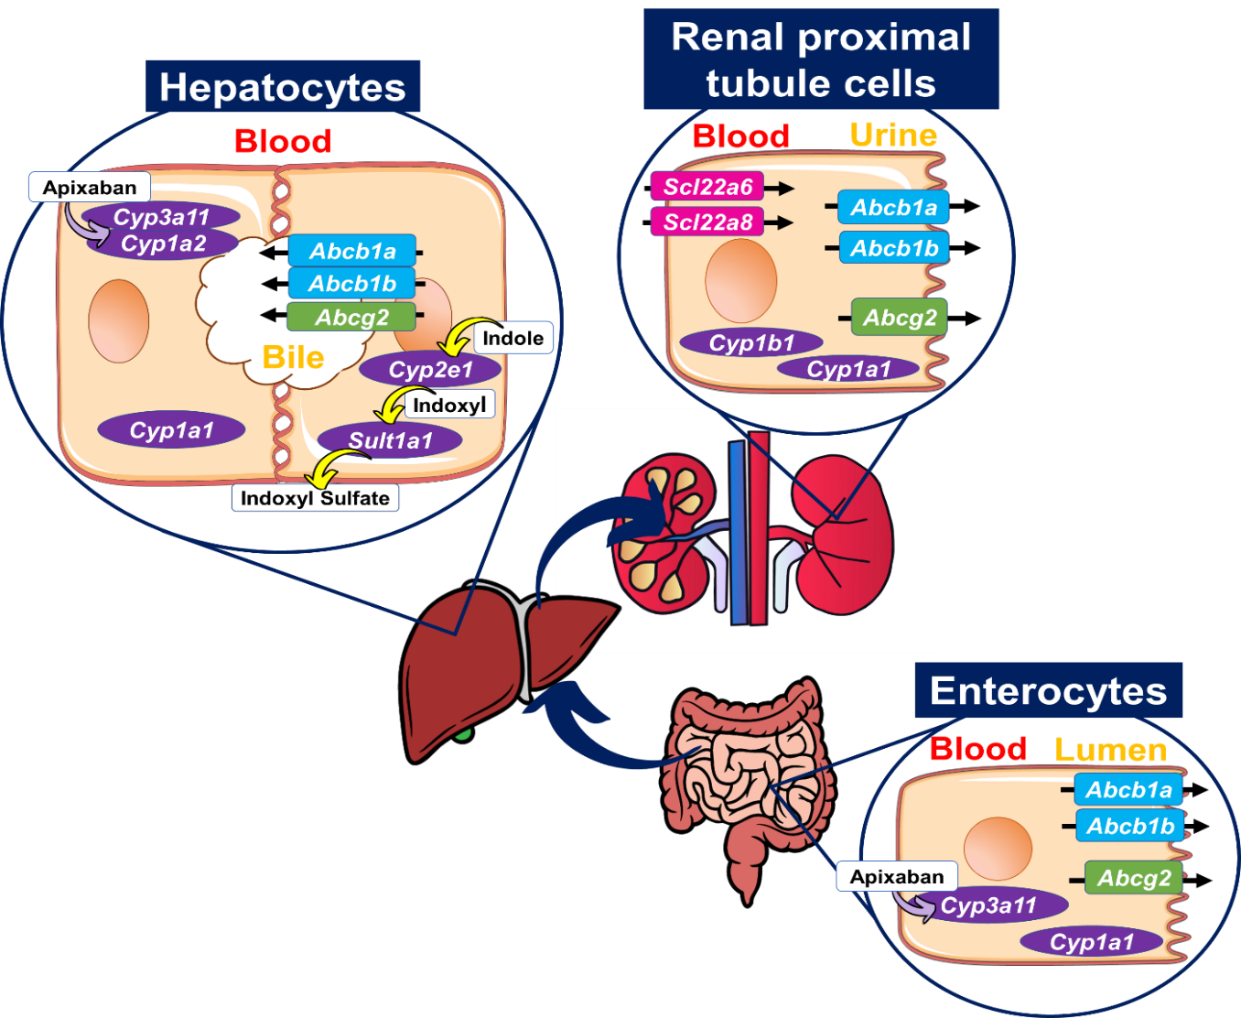
Every organ studied on the mice trial is represented, as well as clarification on the transportation flow of the different transporters. Abcb1a and Abcb1b encode for P-glycoprotein and they belong to the multidrug resistance phosphoglycoprotein ATP-binding cassette subfamily B (ABCB1) which actively excretes structurally and functionally distinct xenobiotics[64]. Abcg2 belongs to the ATP binding cassette (ABC) transporters, in the small intestine;it limits the amount of xenobiotics that are absorbed into the body, and promotes liver and kidney excretion of such compounds, playing an essential role in xenobiotic elimination[65]. Cyp1a1, Cyp1a2 and Cyp1b1 are phase I enzymes (mixed function oxidase activity) that belong to the cytochrome P 450 family; these metabolic enzymes are AhR targets, meaning that their expression is controlled by AhR and can be increased/inhibited in presence/absence of AhR ligands [66]. Cyp3a11 who also belongs to the cytochrome P450 family is the main responsible for Apixaban metabolization [67]. Cyp2e1 and Sult1a1 are liver metabolic enzymes that transform Indole to Indoxyl Sulfate [68]. Scl22a6 (OAT1) and Scl22a8 (OAT3) belong to the organic anion transporter (OAT) family. OAT1 and OAT3 are expressed at the basolateral membrane of proximal tubular cells, mediating in the renal excretion of potentially toxic compounds by promoting its absorption into the proximal tubular cells. Both OAT1 and OAT3 expression range seems to depend on gender and species [69].

Figure 2 Supplementary Data. mRNA Expression of efflux transporters and metabolic enzymes in mice ileum, kidney and liver treated with KCl/IS and KCl/IS+Apixaban. Kruskal Wallis statistical test followed by Dunn’s test to correct for multiple comparisons was performed. Pairwise comparisons - Males vs. Females - were performed using Mann-Whitney U test. Data shown as median with interquartile range *p ≤ 0.05, **p ≤ 0.01, ***p ≤ 0.001, ****p ≤ 0.0001 (n=3-12)
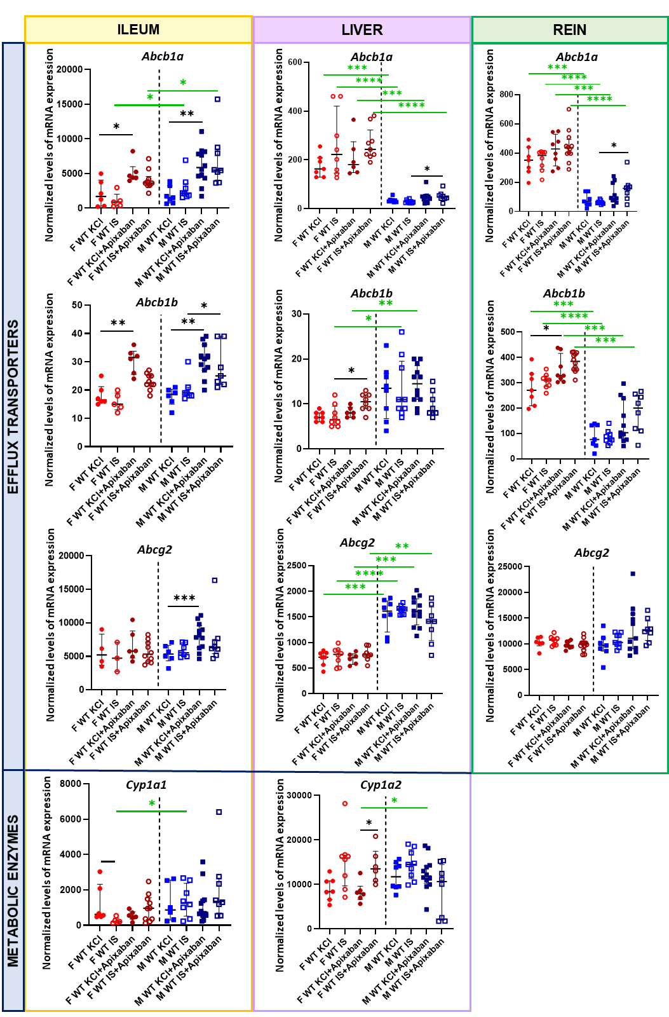
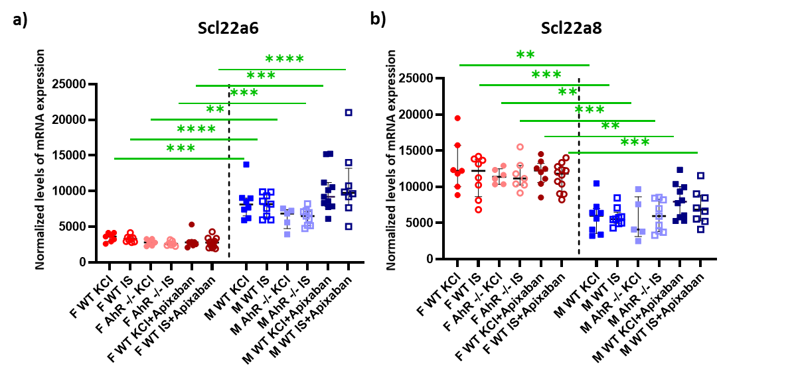
Figure 3 Supplementary Data. mRNA Expression of Scl22a6 (A) and Scl22a8 (B) in mice kidney. Pairwise comparisons - Males vs. Females - were performed using Mann-Whitney U test. Data shown as median with interquartile range *p ≤ 0.05, **p ≤ 0.01, ***p ≤ 0.001, ****p ≤ 0.0001 (n=5-12).

Figure 4 Supplementary Data. mRNA Expression of metabolic enzymes in ileum and kidney in mice treated with KCl (control) or IS. Kruskal Wallis statistical test followed by Dunn’s test to correct for multiple comparisons was performed. Pairwise comparisons - Males vs. Females - were performed using Mann-Whitney U test. Data shown as median with interquartile range *p ≤ 0.05, **p ≤ 0.01, ***p ≤ 0.001 (n = 5-9).
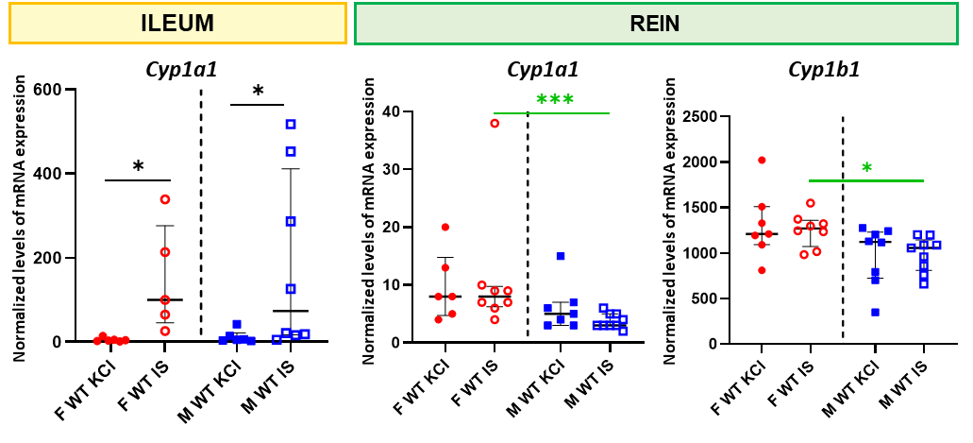

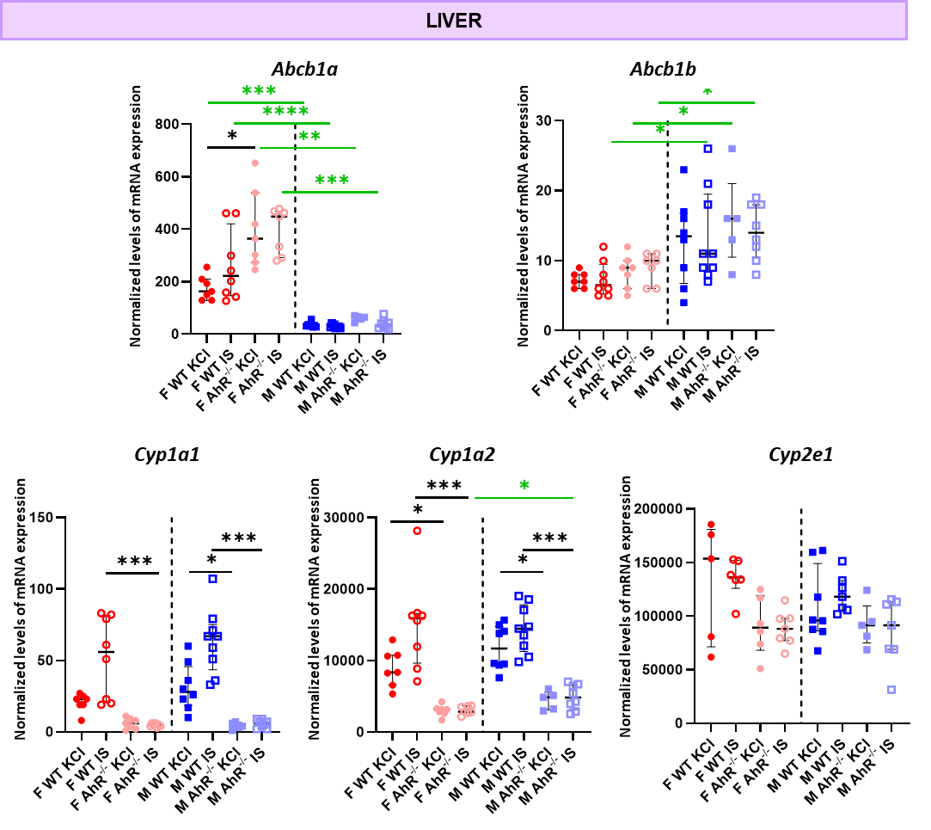
Figure 5 Supplementary Data. mRNA Expression of metabolic enzymes in liver of WT or AhR^{-/-}mice treated with KCl (control) or IS. Kruskal Wallis statistical test followed by Dunn’s test to correct for multiple comparisons was performed. Pairwise comparisons - Males vs. Females - were performed using Mann-Whitney U test. Data shown as median with interquartile range *p ≤ 0.05, **p ≤ 0.01, ***p ≤ 0.001 (n=5-9).

Table 1 Supplementary Data. Proteins contributing to the dysregulated pathways (Excel attached)

