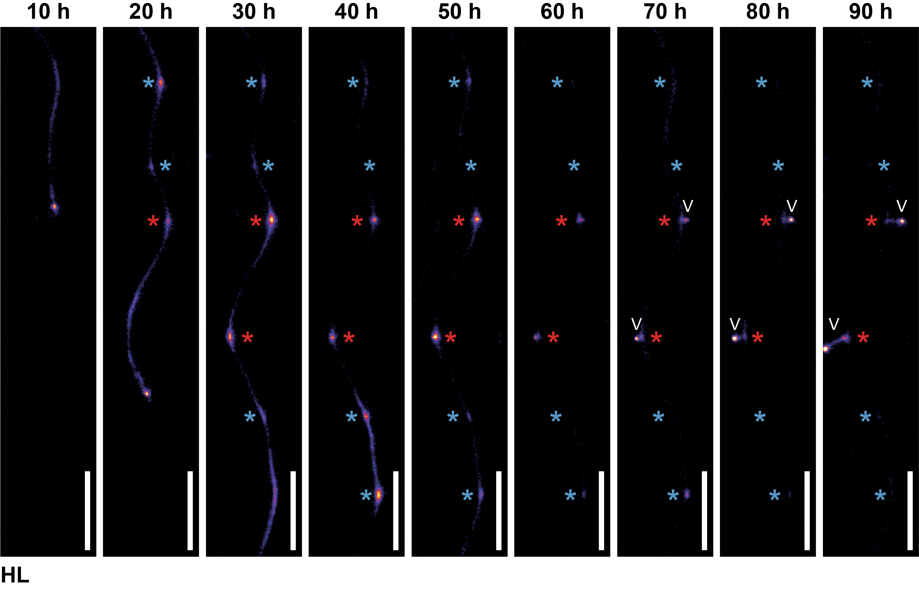
Supplementary Figure 1. Original images showing the distinct progression of persistent and transient PBS at HL condition.
Time series images of the primary root were taken every 10 hours under 21°C and high light (HL) conditions. Persistent PBS is marked by a red asterisk and transient PBS is marked by a blue asterisk. The white arrowhead denotes the emerged lateral root (Scale bar = 1 mm).
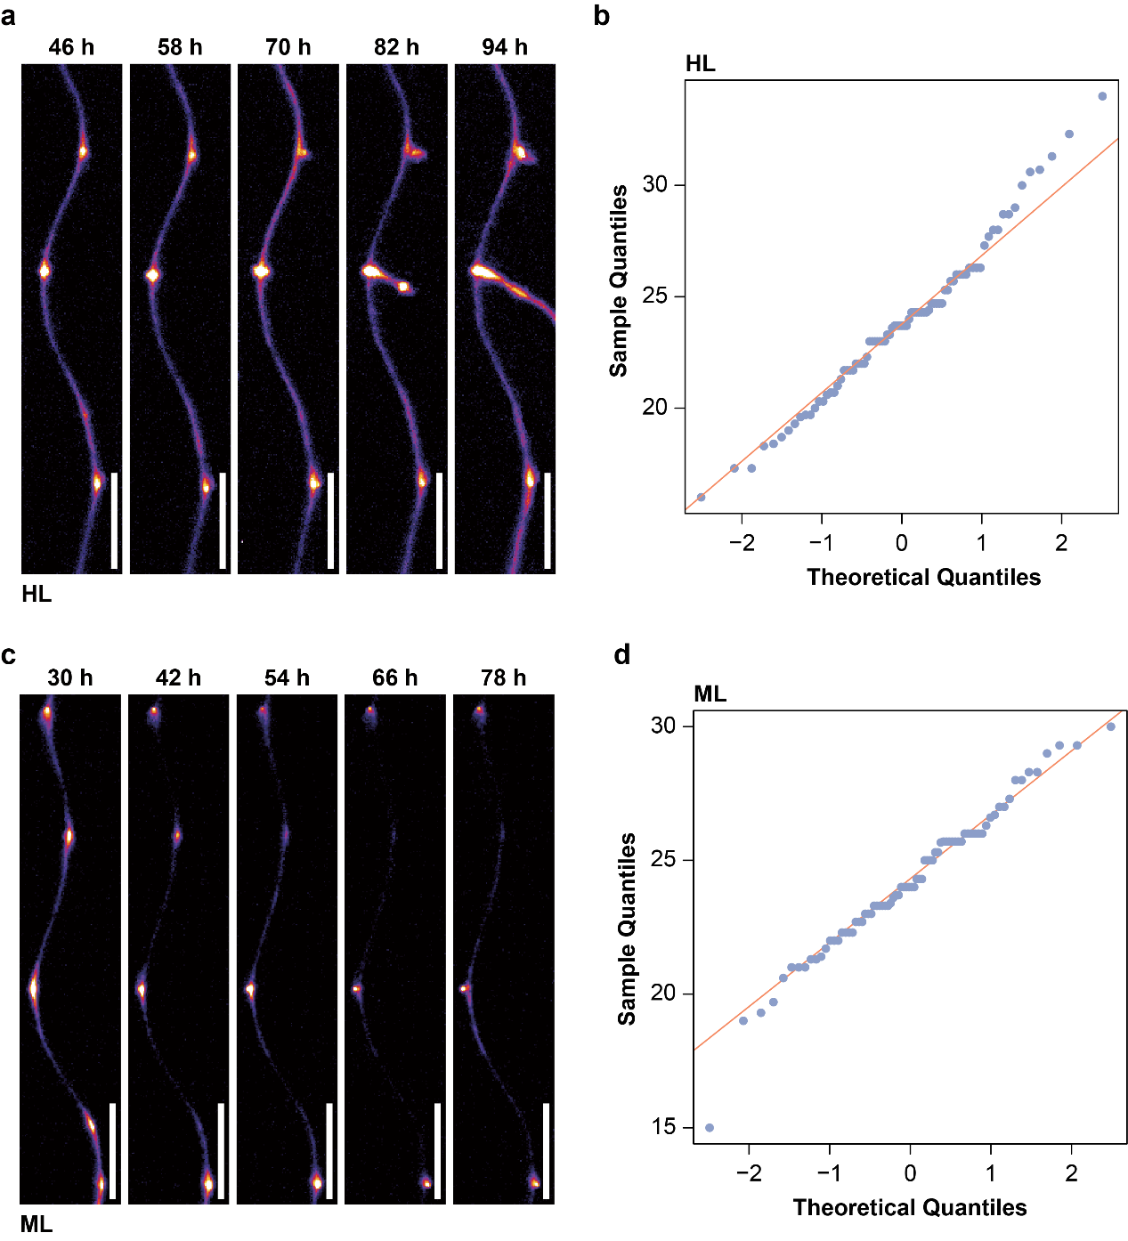
Supplementary Figure 2. The time intervals between oscillatory peaks of systemic auxin follow a normal distribution.
a, c, Time series images of the primary root were taken every 12 hours under high light (HL) (a) and medium light (ML) (c) at 21°C conditions (Scale bar = 1 mm). b, d, The quantile-quantile (Q-Q) plot compares the sample quantiles of the time intervals between peaks of systemic auxin oscillations with the corresponding theoretical quantiles of normal distribution at 21°C and light intensities of HL (b) and ML (d) conditions (n = 23 to 29). The pattern closely following the orange line indicates that the frequency of the systemic oscillation is likely to follow a normal distribution.
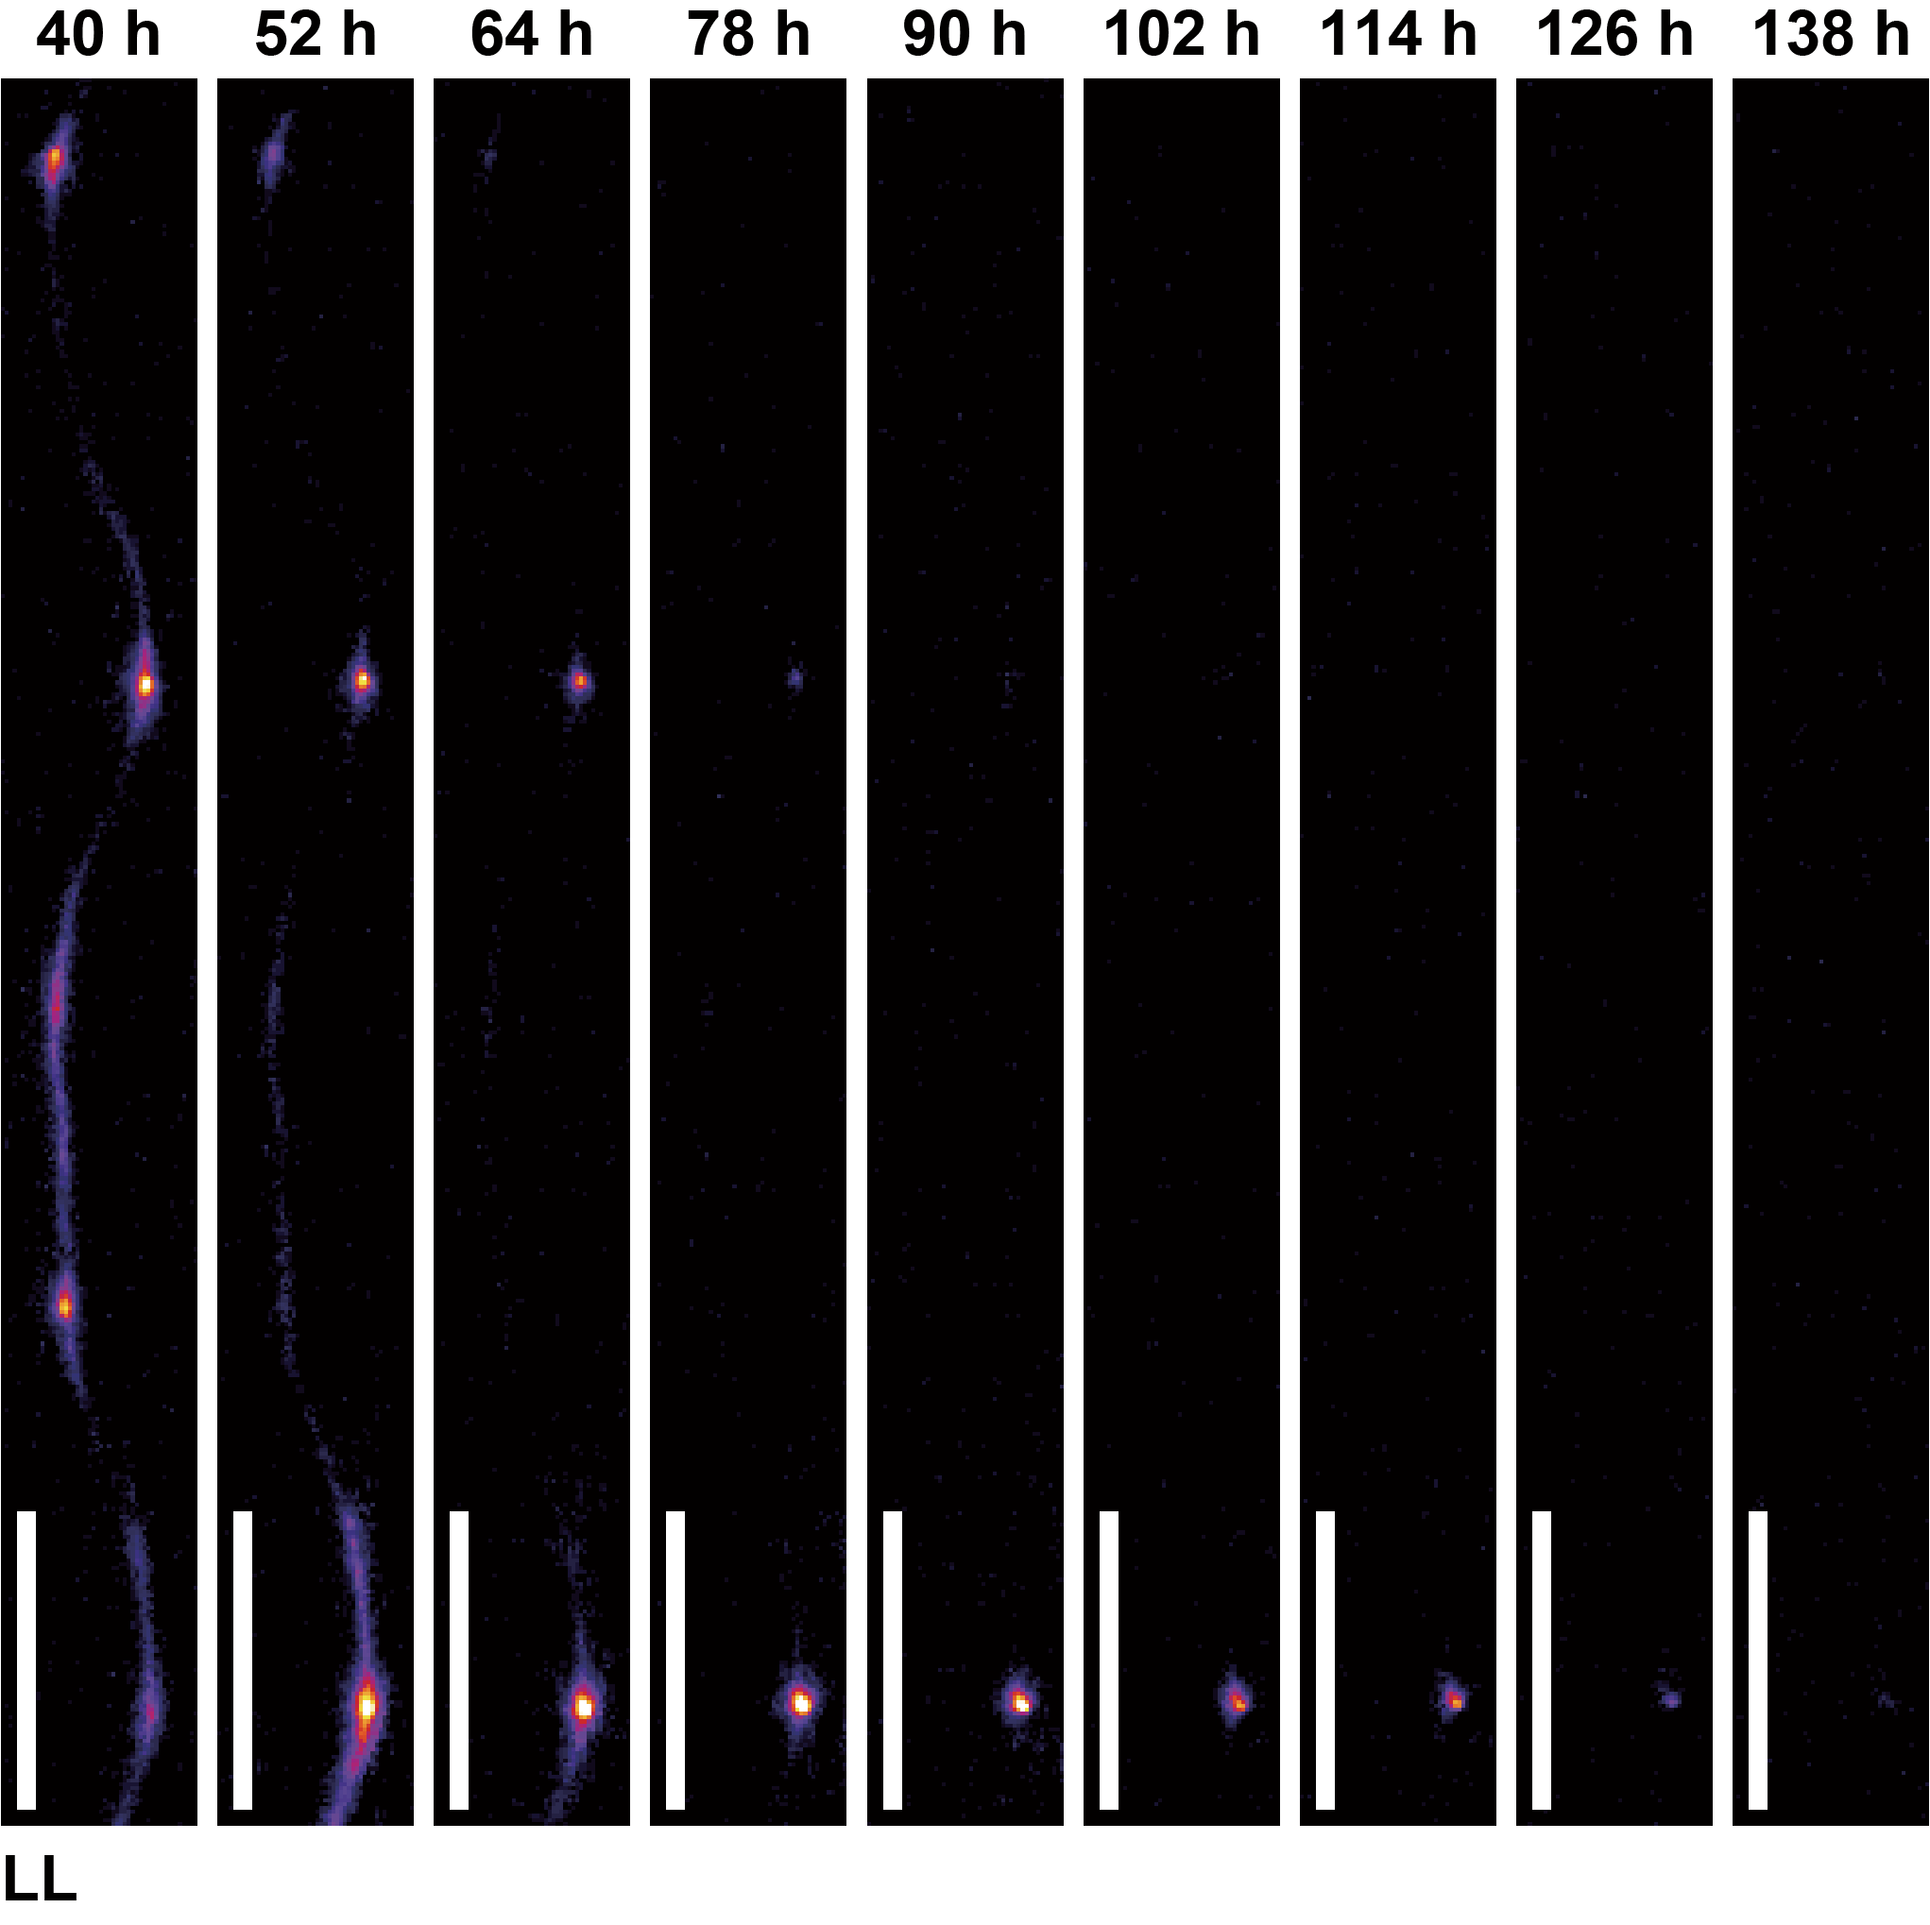
Supplementary Figure 3. Original images showing the dynamic of systemic auxin signal and progression of PBS at low light conditions.
Time series images of the primary root were taken every 12 hours under 21°C and low light (LL) conditions (Scale bar = 1 mm).
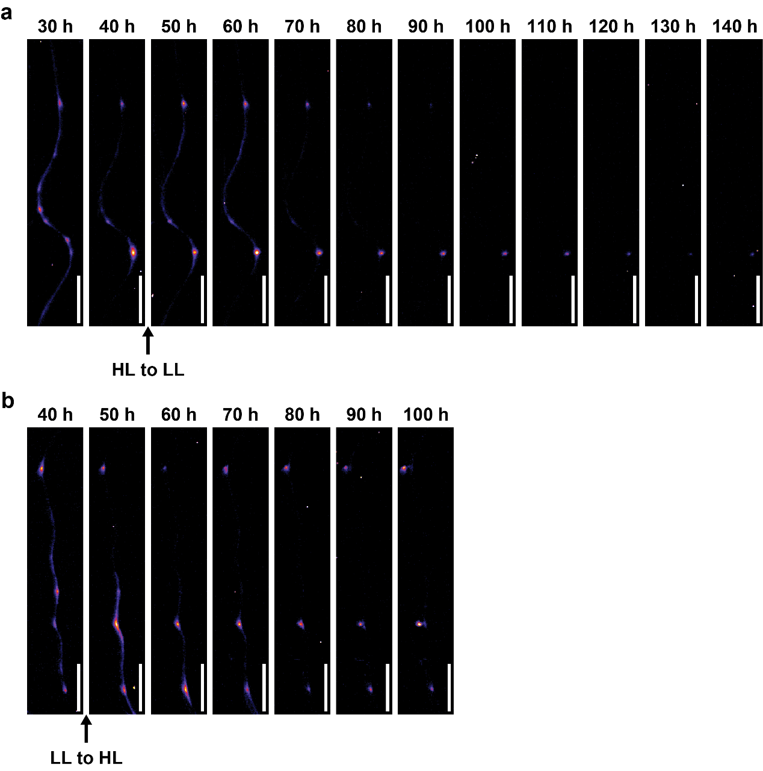
Supplementary Figure 4. Original images showing the dynamic of systemic auxin signal and progression of PBS during light transitions.
a, b, Time series images of the primary root were taken every 12 hours under light transitional conditions from high light (HL) to low light (LL) (a), and from LL-to-HL (b) (Scale bar = 1 mm).
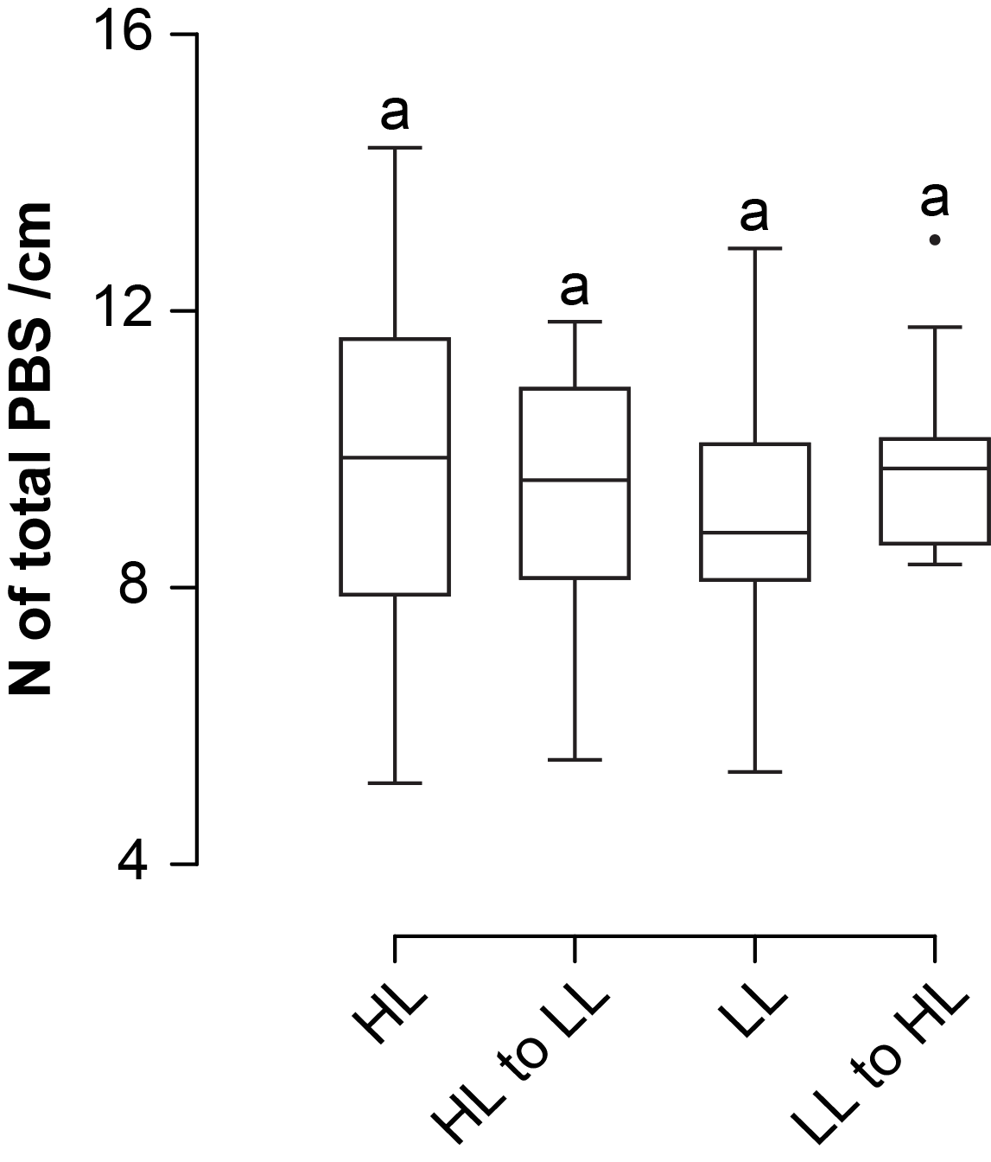
Supplementary Figure 5. The density of total PBS is quantitatively comparable at maintained and fluctuating light conditions.
Quantification of total PBS density under high light (HL), low light (LL) and transfer from HL-to-LL and LL-to-HL conditions (n = 16 to 38). Letters indicate values with statistically significant differences from one-way ANOVA performed (P > 0.05).
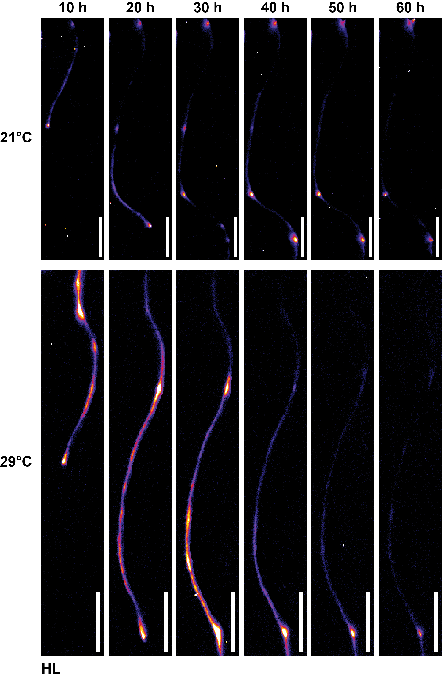
Supplementary Figure 6. Original images showing the dynamic of systemic auxin signal and progression of PBS under 21°C and 29°C at high light conditions.
Time series images of the primary root were captured every 10 hours under high light (HL) conditions at 21°C (top row) and 29°C (bottom row) (Scale bar = 1 mm).
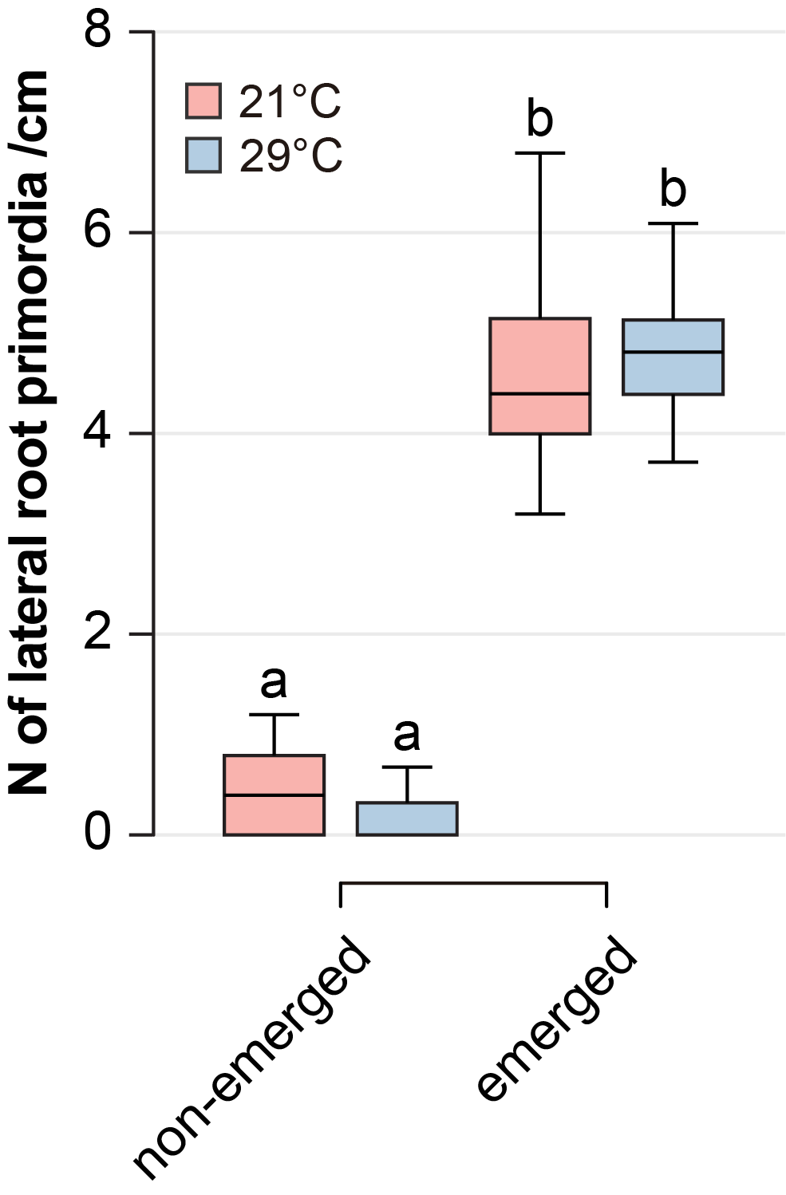
Supplementary Figure 7. Density of lateral root primordia is quantitively comparable between 21°C and 29°C at high light conditions.
Quantification of lateral root primordia density at 21°C and 29°C under high light (HL) conditions (n = 34 to 38). Letters indicate values with statistically significant differences from one-way ANOVA performed (P < 0.0001).
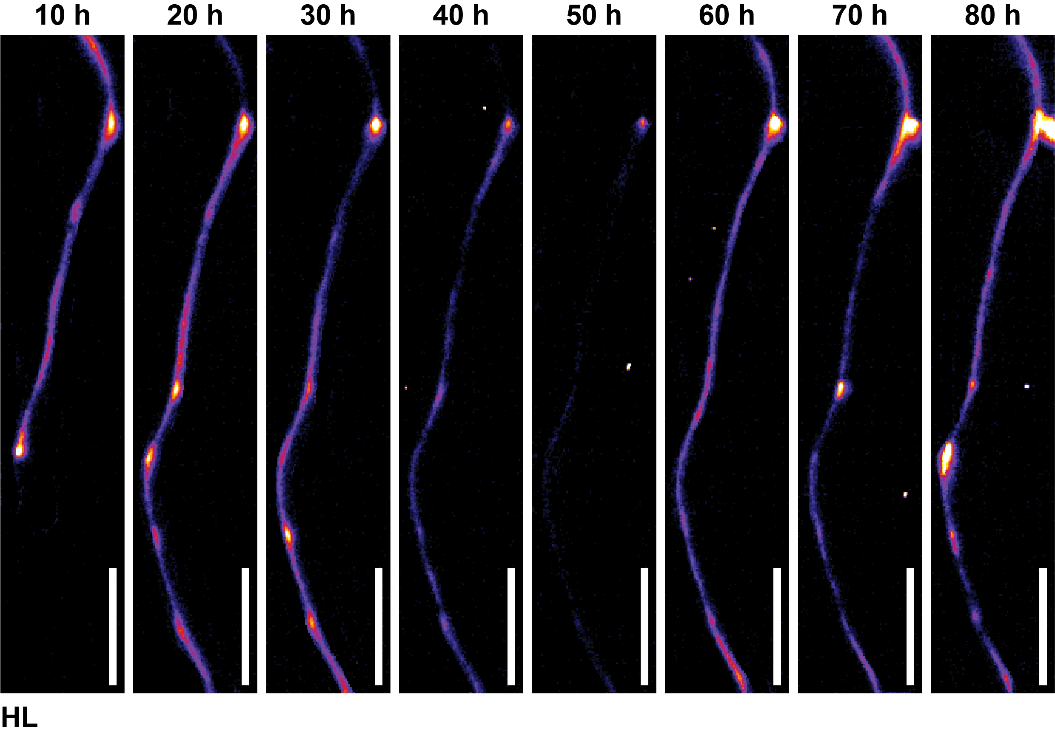
Supplementary Figure 8. Original images showing the recovery of systemic auxin signal and PBS under high temperature at high light conditions.
Time series images of the primary root were captured every 10 hours under high light (HL) conditions at 29°C. Scale bar = 1 mm.
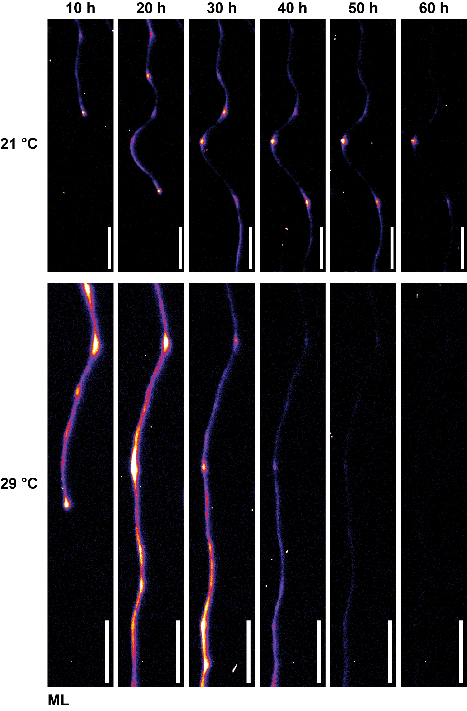
Supplementary Figure 9. Original images showing the dynamic of systemic auxin signal and progression of PBS under 21°C and 29°C at medium light conditions.
Time series images of the primary root were captured every 10 hours at 21°C (top row) and 29°C (bottom row) under medium light (ML) conditions (Scale bar = 1 mm).
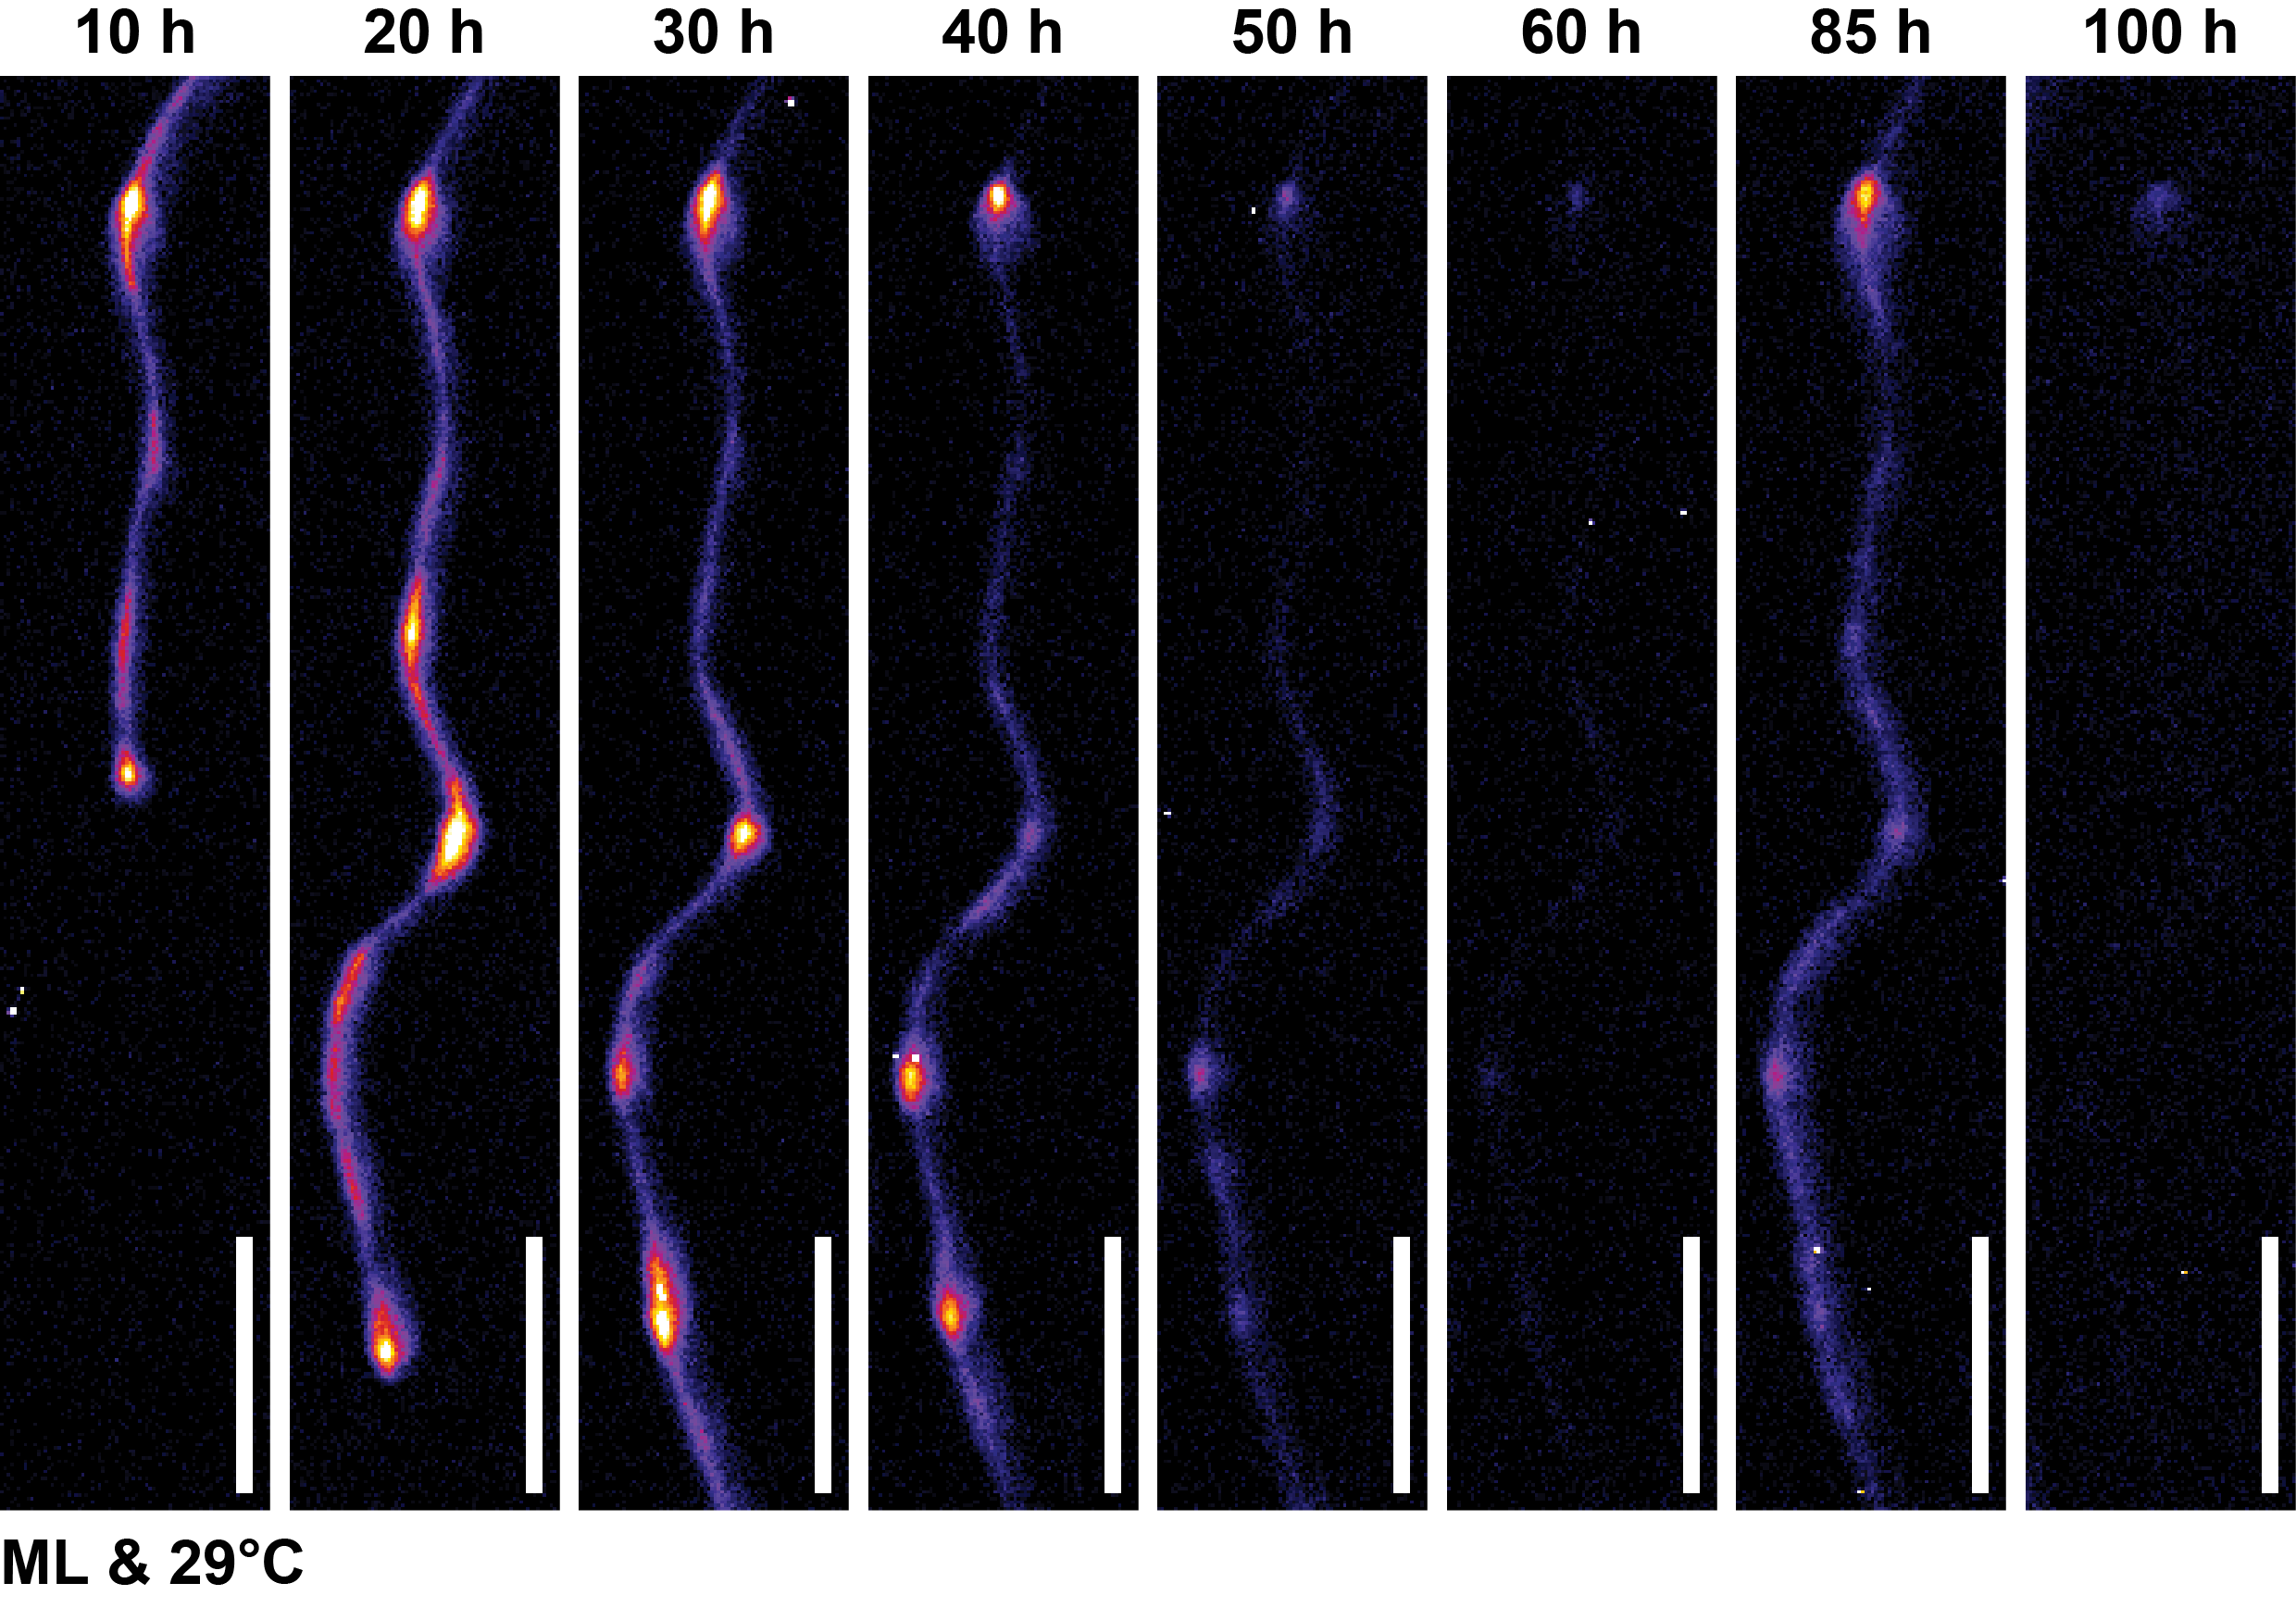
Supplementary Figure 10. Original images showing the recovery of systemic auxin signal and PBS under HT and ML conditions.
Time series images of the primary root were captured every 10 hours under 29°C and ML conditions (Scale bar = 1 mm).
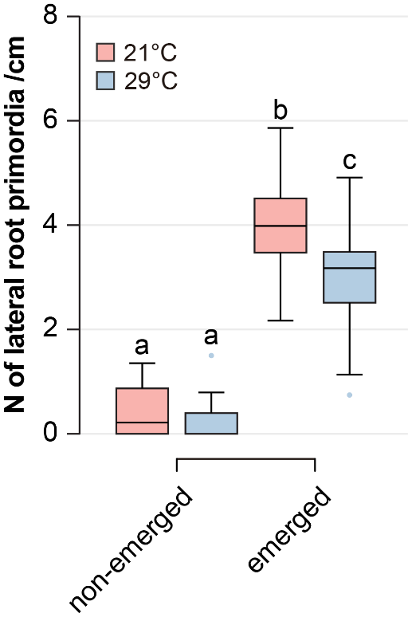
Supplementary Figure 11. Density of lateral root primordia under 21°C and 29°C at medium light (ML) conditions.
Quantification of lateral root primordia density at 21°C and 29°C under medium light (ML) conditions (n = 32 to 34). Letters indicate values with statistically significant differences from one-way ANOVA performed (P < 0.0001).
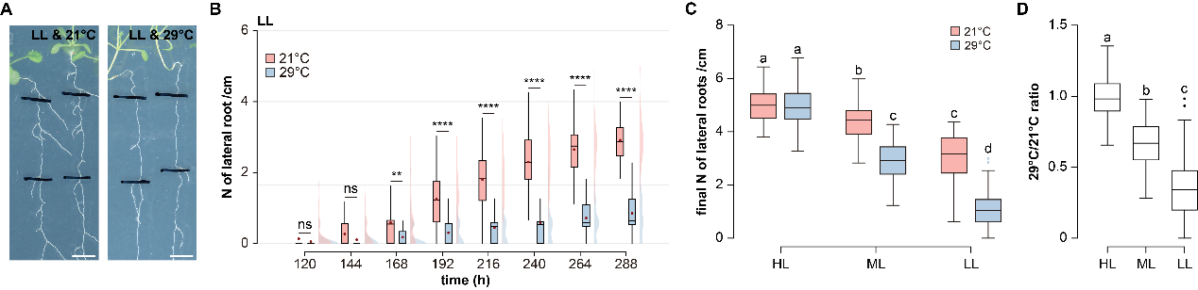
Supplementary Figure 12. Light quantity gates the high temperature-dependent inhibition of lateral root density.
a, b, Representative images of root systems (a) and time series quantification of LR density (b) at 21°C and 29°C under low light (LL) conditions (n = 53 to 55; Scale bar = 5 mm). c, d, Quantification (c) and calculated ratio (d) of final LR density at 21°C and 29°C under high light (HL), medium light (ML) and LL conditions (n = 53 to 55). Letters indicate values with statistically significant differences from one-way ANOVA performed for (c) and (d) (P < 0.0001 for both).
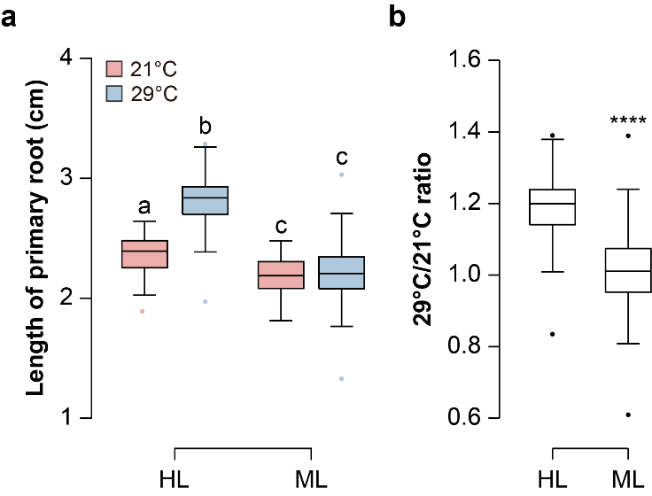
Supplementary Figure 13. HT-dependent elongation of the primary root relies on light.
a, b, Quantification (a) and Calculated ratio (b) of primary root length of Col-0 at 21°C and 29°C under high light (HL) and medium light (ML) (n = 54 to 55). Letters indicate values with statistically significant differences from one-way ANOVA performed for (a) (P < 0.0001). Paired and two-tailed student's t-test performed for (b) (P < 0.0001****).
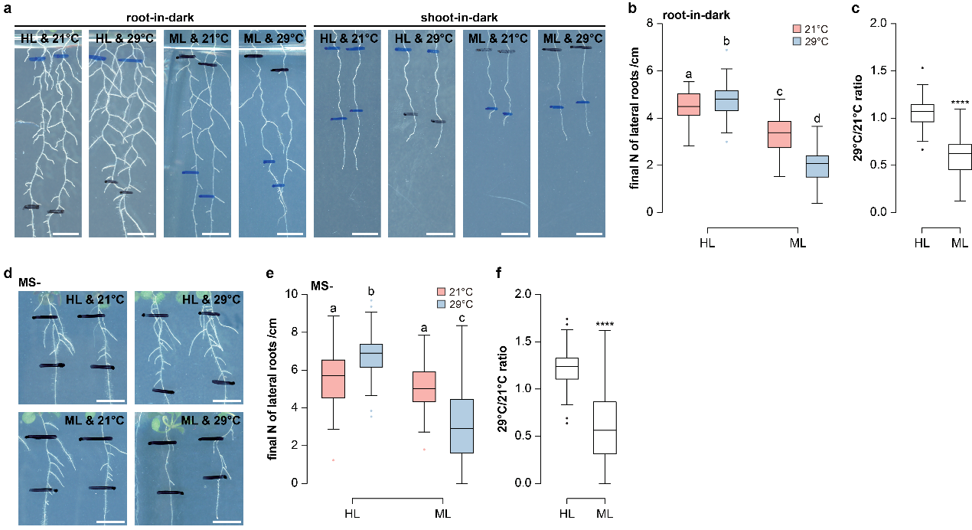
Supplementary Figure 14. Shoot-received light gates the high temperature-dependent inhibition of lateral root density.
a, Representative images of root systems at 21°C and 29°C under root-in-dark and shoot-in-dark conditions(Scale bar = 5 mm). b, c, Quantification (b) and calculated ratio (c) of LR density at 21°C and 29°C under root-in-dark conditions (n = 50 to 61). d, Representative images of root systems at 21°C and 29°C under high light (HL) and medium light (ML) conditions on solid medium without sucrose (MS-) plates (Scale bar = 5 mm). e, f, Quantification (e) and calculated ratio (f) of LR density of seedlings grown at 21°C and 29°C under HL and ML conditions on MS- plates (n = 47-51). Paired and two-tailed student's t-test performed for (c) and (f) (P < 0.0001**** for both). Letters indicate values with statistically significant differences from one-way ANOVA performed for (b) and (e) (P < 0.0001 for both).
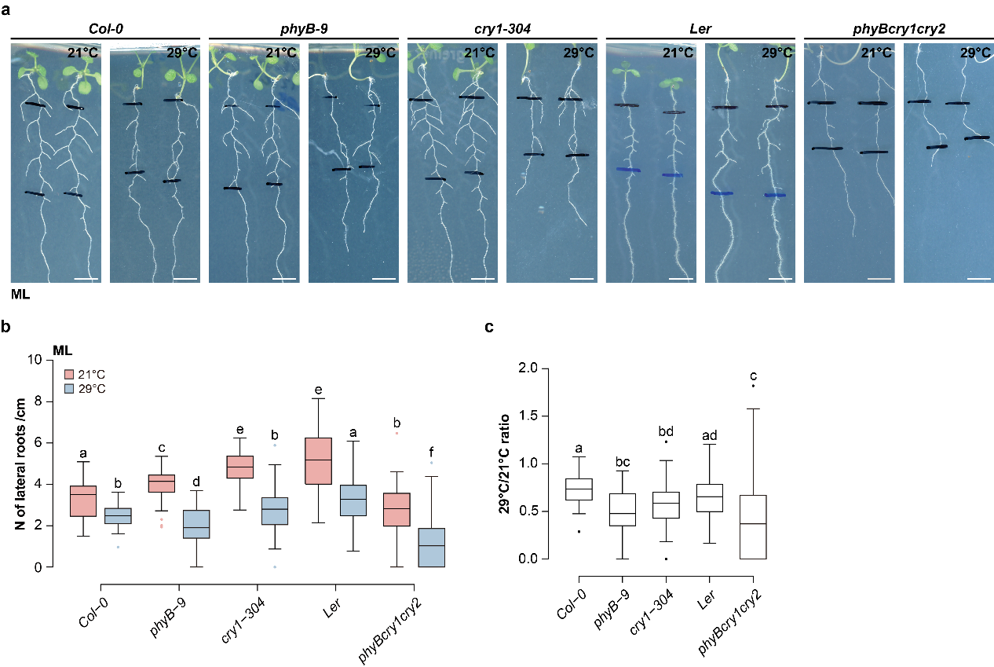
Supplementary Figure 15. The loss of PHYB and CRY1 enhances the HT-dependent inhibition of LR under ML conditions.
a-c, Representative root system images (a) and quantification (b) as well as the calculated ratio (c) of LR density in Col-0, phyB-9, cry1-304, Ler and phyBcry1cry2 at 21°C and 29°C under medium light (ML) conditions (n = 51 to 90; Scale bar = 5 mm). Letters indicate values with statistically significant differences from one-way ANOVA performed for (b) and (c) (P < 0.0001 for both).
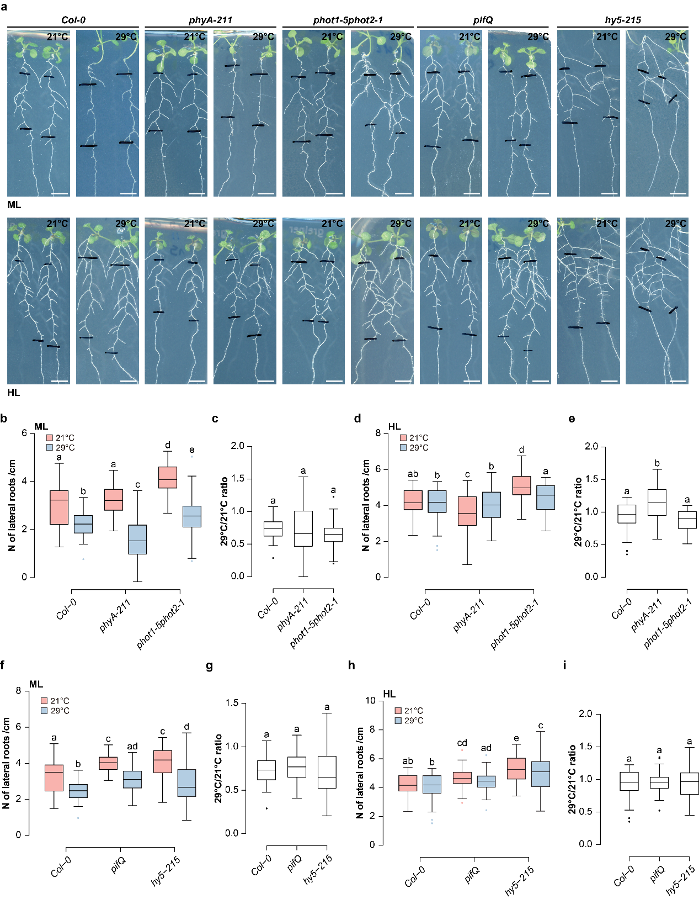
Supplementary Figure 16. The inhibition of lateral rooting under high-temperature conditions in light signalling mutants.
a, Representative root system images of wild-type Col-0 and light signalling mutants at 21°C and 29°C under medium light (ML) (top row) and high light (HL) (bottom row) conditions (Scale bar = 5 mm). b, c, Quantification (b) and calculated ratio (c) of LR density in Col-0, phyA-211 and phot1-5phot2-1 at 21°C and 29°C under ML conditions (n = 45 to 54). d, e, Quantification (d) and calculated ratio (e) of LR density in Col-0, phyA-211 and phot1-5phot2-1 at 21°C and 29°C under HL conditions (n = 52 to 54). f, g, Quantification (f) and calculated ratio (g) of LR density in Col-0, pifQ and hy5-215 at 21°C and 29°C under ML conditions (n = 52 to 54). h, i, Quantification (h) and calculated ratio (i) of LR density in Col-0, pifQ and hy5-215 at 21°C and 29°C under HL conditions (n = 53 to 54). Letters indicate values with statistically significant differences from one-way ANOVA performed for (b), (d), (e), (f) and (h) (P < 0.0001 for all) and for (c), (g) and (i) (P > 0.05 for all).

Supplementary References
22. Reed J. W., et al., Phytochrome A and Phytochrome B Have Overlapping but Distinct Functions in Arabidopsis Development. Plant Physiol. 104, 1139-1149 (1994).
23. Reed J. W., et al., Mutations in the gene for the red/far-red light receptor phytochrome B alter cell elongation and physiological responses throughout Arabidopsis development. Plant Cell 5, 147-157 (1993).
24. Guo H., et al., Regulation of Flowering Time by Arabidopsis Photoreceptors. Science 279, 1360-1363 (1998).
25. Leivar P., et al., Multiple phytochrome-interacting bHLH transcription factors repress premature seedling photomorphogenesis in darkness. Curr. Biol. 18, 1815-1823 (2008).
26. Oyama T., Shimura Y., Okada K., The Arabidopsis HY5 gene encodes a bZIP protein that regulates stimulus-induced development of root and hypocotyl. Genes Dev. 11, 2983-2995 (1997).
27. Mazzella M. A., Casal J. J., Interactive signalling by phytochromes and cryptochromes generates de-etiolation homeostasis in Arabidopsis thaliana. Plant Cell Environ. 24, 155-161 (2001).
28. Malamy J. E., Benfey P. N., Organization and cell differentiation in lateral roots of Arabidopsis thaliana. Development 124, 33-44 (1997).

