Supplementary material to the manuscript entitled

“Agroforestry's potential to buffer climate change impacts on maize yields in Dodoma, Tanzania”

Authors: Johanna Siebenlist (0009-0007-2901-0105)^{1,2*}, Anna Hampf (0000-0002-2405-7250)², Christoph Gornott (0000-0003-3933-3358)^{1,2}
¹ Agroecosystem Analysis and Modelling, Faculty of Organic Agricultural Sciences, University of Kassel, Kassel, Germany
² Potsdam Institute for Climate Impact Research (PIK), a Member of the Leibniz Association, Potsdam, Germany
*Corresponding author: Anna Hampf, anna.hampf@pik-potsdam.de

Study sites and agro-ecological zones in Dodoma, Tanzania
SI-Table 1: Study sites with summary of baseline climate and resulting average across Dodoma 1990-2019. The soil type is taken from Poggio et al. (2021), the agro-ecological zone from FAO (GAEZ). Precipitation records stem from CHIRPS (Funk et al. 2015) and temperature from W5E5v2.0 (Lange et al. 2021).
Site | Location  (lat., lon.) | Height (m) | District | AEZ* | Soil | Precipitation  (mm) | min. T**  (°C) | max. T**  (°C)
1 | -5.9618, 35.6682 | 1,091 | Bahi | Semi-arid | Luvisol | 619.5 | 16.50 | 28.52
2 | -5.5517, 36.2916 | 1,231 | Kongwa | semi-arid | Luvisol | 617.6 | 16.39 | 28.17
3 | -6.7914, 35.2609 | 998 | Chamwino | semi-arid | Cambisol | 540.8 | 18.29 | 30.20
4 | -4.8115, 36.0874 | 1,212 | Kondoa | sub-humid | Cambisol | 640.5 | 14.81 | 26.55
5 | -5.1156, 35.4679 | 1,196 | Chemba | semi-arid | Lixisol | 664.4 | 16.65 | 28.72
6 | -6.3449, 36.535 | 1,150 | Mpwapwa | semi-arid | Lixisol | 652.7 | 16.26 | 27.69
Ø | - |  |  | - |  | 630.0 | 16.46 | 28.27
* agroecological zone
** temperature
SI-Figure 1: a) Location of Dodoma within Tanzania and b) Agro-ecological zones of Dodoma with selected study sites. Data source of map b): https://gaez.fao.org

Soil parametrization in APSIM
SI-Table 2: Soil physical properties (based on Poggio et al. 2021 and computed based on Saxton and Rawls 2006).
Site | Depth  (cm) | Clay  (%) | Silt  (%) | BD¹  (g/cm³) | LL15²  (cm³/cm³) | DUL³  (cm³/cm³) | SAT⁴  (cm³/cm³) | KS⁵  (mm) | SWCON⁶
1 | 0-5 cm | 36.40 | 13.60 | 1.40 | 0.22 | 0.33 | 0.42 | 175.64 | 0.25
1 | 5-15 cm | 36.10 | 13.70 | 1.41 | 0.22 | 0.32 | 0.41 | 183.18 | 0.25
1 | 15-30 cm | 37.00 | 13.20 | 1.41 | 0.22 | 0.33 | 0.42 | 160.87 | 0.25
1 | 30-60 | 39.20 | 12.90 | 1.44 | 0.23 | 0.35 | 0.42 | 116.43 | 0.25
1 | 60-100 | 40.80 | 13.20 | 1.44 | 0.24 | 0.36 | 0.43 | 92.44 | 0.25
1 | 100-200 | 40.60 | 12.90 | 1.45 | 0.24 | 0.36 | 0.43 | 94.74 | 0.25
2 | 0-5 | 36.00 | 7.30 | 1.31 | 0.22 | 0.32 | 0.41 | 188.01 | 0.3
2 | 5-15 | 34.90 | 8.20 | 1.33 | 0.21 | 0.31 | 0.41 | 222.96 | 0.3
2 | 15-30 | 35.20 | 7.90 | 1.34 | 0.21 | 0.31 | 0.41 | 212.93 | 0.3
2 | 30-60 | 40.40 | 7.60 | 1.31 | 0.24 | 0.35 | 0.42 | 90.88 | 0.3
2 | 60-100 | 41.10 | 7.90 | 1.31 | 0.25 | 0.36 | 0.42 | 81.04 | 0.3
2 | 100-200 | 41.10 | 8.10 | 1.32 | 0.25 | 0.36 | 0.42 | 81.31 | 0.3
3 | 0-5 | 19.70 | 9.40 | 1.45 | 0.12 | 0.19 | 0.38 | 1755.87 | 0.5
3 | 5-15 | 19.40 | 9.10 | 1.47 | 0.11 | 0.19 | 0.38 | 1831.67 | 0.5
3 | 15-30 | 23.60 | 9.00 | 1.48 | 0.14 | 0.22 | 0.38 | 1087.89 | 0.5
3 | 30-60 | 28.00 | 8.50 | 1.49 | 0.17 | 0.25 | 0.39 | 610.66 | 0.5
3 | 60-100 | 28.20 | 9.00 | 1.50 | 0.17 | 0.26 | 0.39 | 589.22 | 0.5
3 | 100-200 | 28.00 | 9.10 | 1.50 | 0.17 | 0.25 | 0.39 | 604.70 | 0.5
4 | 0-5 | 32.70 | 11.70 | 1.24 | 0.20 | 0.30 | 0.40 | 302.29 | 0.25
4 | 5-15 | 31.60 | 12.00 | 1.25 | 0.19 | 0.29 | 0.40 | 352.16 | 0.25
4 | 15-30 | 33.30 | 12.20 | 1.25 | 0.20 | 0.30 | 0.41 | 275.78 | 0.25
4 | 30-60 | 40.20 | 11.90 | 1.26 | 0.24 | 0.35 | 0.43 | 99.28 | 0.25
4 | 60-100 | 39.40 | 14.30 | 1.27 | 0.24 | 0.35 | 0.43 | 114.56 | 0.25
4 | 100-200 | 41.60 | 12.30 | 1.28 | 0.25 | 0.36 | 0.43 | 80.94 | 0.25
5 | 0-5 | 30.80 | 16.10 | 1.31 | 0.18 | 0.29 | 0.40 | 374.23 | 0.40
5 | 5-15 | 30.70 | 16.30 | 1.33 | 0.18 | 0.29 | 0.40 | 378.24 | 0.40
5 | 15-30 | 29.70 | 15.90 | 1.34 | 0.18 | 0.28 | 0.40 | 433.52 | 0.40
5 | 30-60 | 31.10 | 16.90 | 1.40 | 0.19 | 0.29 | 0.40 | 355.87 | 0.40
5 | 60-100 | 31.90 | 17.10 | 1.40 | 0.19 | 0.30 | 0.41 | 319.41 | 0.40
5 | 100-200 | 33.40 | 17.10 | 1.40 | 0.20 | 0.31 | 0.41 | 261.56 | 0.40
6 | 0-5 | 27.70 | 9.70 | 1.23 | 0.17 | 0.25 | 0.39 | 626.27 | 0.50
6 | 5-15 | 28.20 | 9.60 | 1.26 | 0.17 | 0.26 | 0.39 | 585.08 | 0.50
6 | 15-30 | 29.10 | 8.20 | 1.28 | 0.17 | 0.26 | 0.39 | 526.52 | 0.50
6 | 30-60 | 35.80 | 8.90 | 1.27 | 0.21 | 0.32 | 0.41 | 193.39 | 0.50
6 | 60-100 | 37.70 | 9.00 | 1.29 | 0.23 | 0.33 | 0.41 | 143.32 | 0.50
6 | 100-200 | 37.80 | 9.10 | 1.29 | 0.23 | 0.33 | 0.41 | 141.05 | 0.50
¹ Bulk density
² Water content at drained lower limit
³ Water content at drained upper limit
⁴ Water content at saturation
⁵ Water drainage at saturation
⁶ Proportion of water draining per day when above DUL

SI-Table 3: Soil chemical properties (based on Poggio et al. 2021)ª
Site | Depth  (cm) | C_{org}  (%) | FOM¹ (kg/ha) | Biom² | Inert³ | pH | CEC  (mmol/kg) | NO₃ (ppm) | N  (cg/kg)
1 | 0-5 cm | 1.10 | 150.00 | 0.04 | 0.80 | 6.40 | 251 | 0.50 | 97
1 | 5-15 cm | 0.81 | 122.81 | 0.03 | 0.81 | 6.40 | 230 | 0.50 | 75
1 | 15-30 cm | 0.68 | 100.55 | 0.03 | 0.82 | 6.30 | 231 | 0.49 | 67
1 | 30-60 | 0.53 | 82.32 | 0.02 | 0.82 | 6.40 | 235 | 0.49 | 57
1 | 60-100 | 0.44 | 67.40 | 0.02 | 0.83 | 6.40 | 236 | 0.48 | 47
1 | 100-200 | 0.37 | 55.18 | 0.01 | 0.84 | 6.40 | 238 | 0.48 | 37
2 | 0-5 | 1.28 | 150.00 | 0.04 | 0.80 | 6.50 | 277 | 0.50 | 133
2 | 5-15 | 1.06 | 122.81 | 0.03 | 0.81 | 6.50 | 284 | 0.50 | 113
2 | 15-30 | 0.79 | 100.55 | 0.03 | 0.82 | 6.50 | 274 | 0.49 | 103
2 | 30-60 | 0.88 | 82.32 | 0.02 | 0.82 | 6.60 | 268 | 0.49 | 70
2 | 60-100 | 0.76 | 67.40 | 0.02 | 0.83 | 6.60 | 268 | 0.48 | 57
2 | 100-200 | 0.69 | 55.18 | 0.01 | 0.84 | 6.70 | 265 | 0.48 | 44
3 | 0-5 | 0.94 | 150.00 | 0.04 | 0.80 | 6.30 | 172 | 0.50 | 83
3 | 5-15 | 0.71 | 122.81 | 0.03 | 0.81 | 6.30 | 120 | 0.50 | 59
3 | 15-30 | 0.57 | 100.55 | 0.03 | 0.82 | 6.30 | 124 | 0.49 | 56
3 | 30-60 | 0.41 | 82.32 | 0.02 | 0.82 | 6.30 | 126 | 0.49 | 50
3 | 60-100 | 0.28 | 67.40 | 0.02 | 0.83 | 6.30 | 132 | 0.48 | 40
3 | 100-200 | 0.24 | 55.18 | 0.01 | 0.84 | 6.40 | 132 | 0.48 | 36
4 | 0-5 | 1.42 | 150.00 | 0.04 | 0.80 | 6.60 | 203 | 0.50 | 127
4 | 5-15 | 1.17 | 122.81 | 0.03 | 0.81 | 6.60 | 186 | 0.50 | 127
4 | 15-30 | 0.79 | 100.55 | 0.03 | 0.82 | 6.60 | 186 | 0.49 | 97
4 | 30-60 | 0.63 | 82.32 | 0.02 | 0.82 | 6.60 | 184 | 0.49 | 70
4 | 60-100 | 0.56 | 67.40 | 0.02 | 0.83 | 6.70 | 185 | 0.48 | 65
4 | 100-200 | 0.52 | 55.18 | 0.01 | 0.84 | 6.80 | 186 | 0.48 | 50
5 | 0-5 | 1.37 | 150.00 | 0.04 | 0.80 | 6.30 | 199 | 0.50 | 199
5 | 5-15 | 1.36 | 122.81 | 0.03 | 0.81 | 6.30 | 188 | 0.50 | 188
5 | 15-30 | 0.79 | 100.55 | 0.03 | 0.82 | 6.30 | 189 | 0.49 | 189
5 | 30-60 | 1.22 | 82.32 | 0.02 | 0.82 | 6.40 | 186 | 0.49 | 186
5 | 60-100 | 1.24 | 67.40 | 0.02 | 0.83 | 6.30 | 187 | 0.48 | 187
5 | 100-200 | 1.04 | 55.18 | 0.01 | 0.84 | 6.40 | 184 | 0.48 | 184
6 | 0-5 | 2.34 | 150.00 | 0.04 | 0.80 | 6.30 | 181 | 0.50 | 146
6 | 5-15 | 1.66 | 122.81 | 0.03 | 0.81 | 6.20 | 176 | 0.50 | 139
6 | 15-30 | 0.95 | 100.55 | 0.03 | 0.82 | 6.10 | 174 | 0.49 | 101
6 | 30-60 | 1.06 | 82.32 | 0.02 | 0.82 | 6.10 | 169 | 0.49 | 66
6 | 60-100 | 0.82 | 67.40 | 0.02 | 0.83 | 6.20 | 164 | 0.48 | 49
6 | 100-200 | 0.60 | 55.18 | 0.01 | 0.84 | 6.20 | 166 | 0.48 | 43
ª Constant values across all layers and sites: Soil C:N = 12, FOM C:N = 40, NH₄ = 0.05 ppm
¹ Fresh organic matter
² Proportion of microbial biomass
³ Proportion of inert carbon

Evaluation of random forest regression
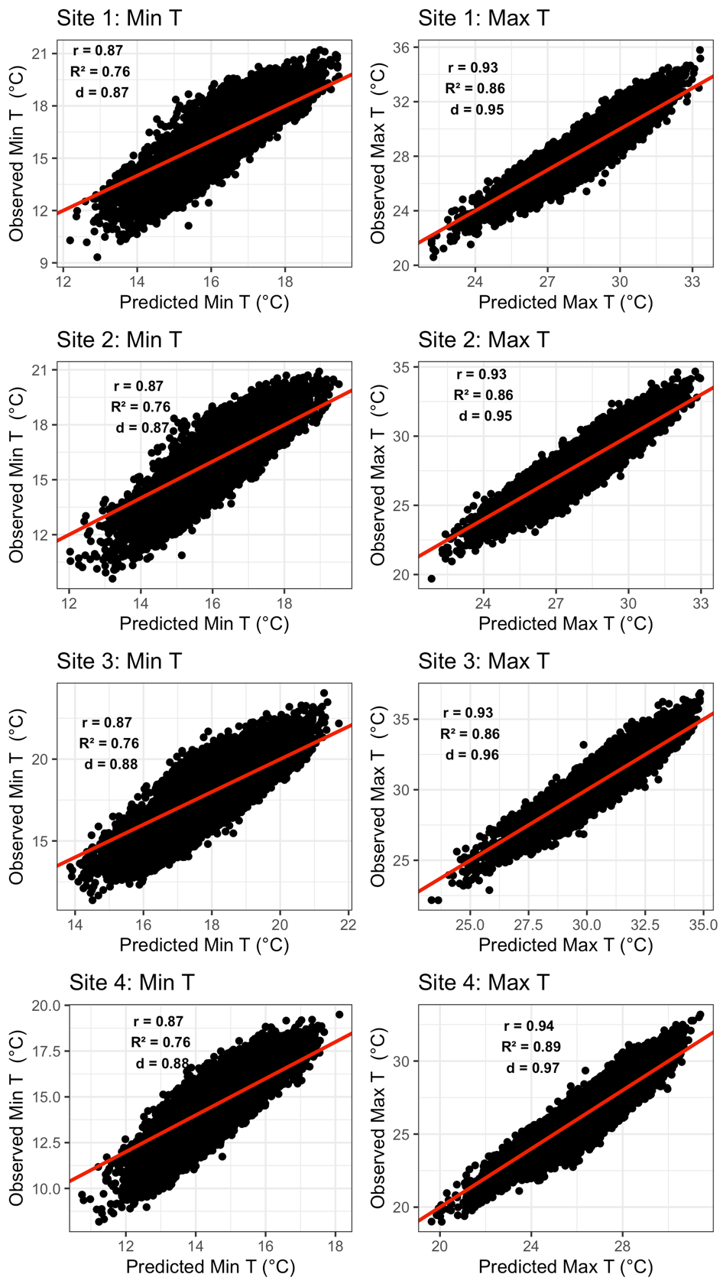
SI-Figure 2: Evaluation of random forest regressions for prediction of minimum and maximum temperatures from solar radiation for sites 1-4.
Plots show predicted against observed values. Values for r, R² and d, are annotated.

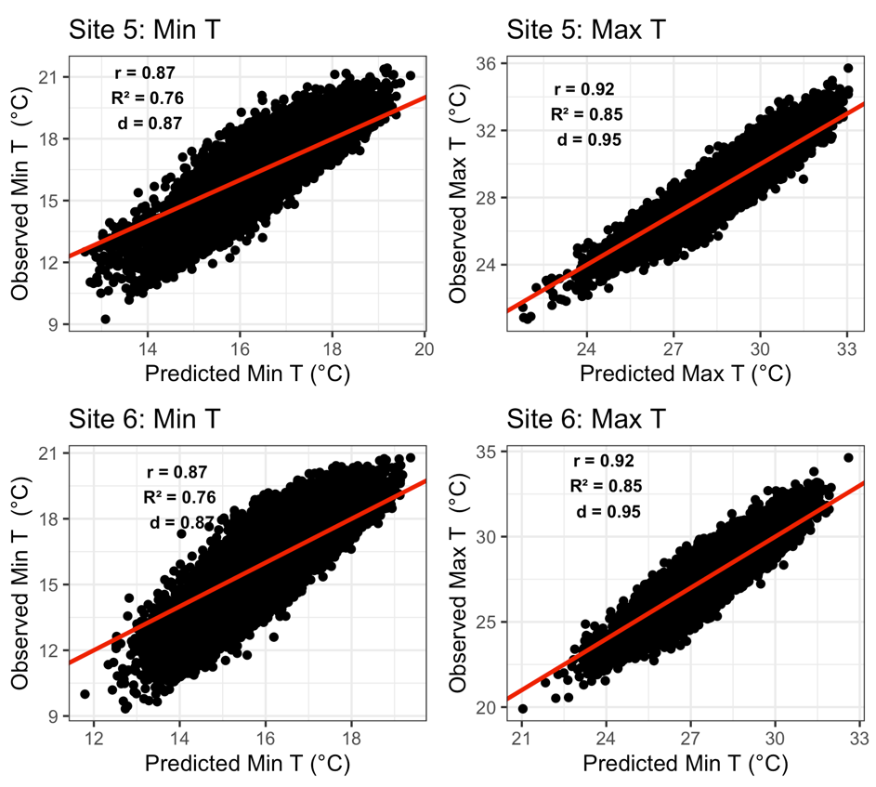

SI-Figure 3: Evaluation of random forest regressions for prediction of minimum and maximum temperatures from solar radiation for sites 5 and 6.
Plots show predicted against observed values. Values for r, R² and d, are annotated.

