SUPPLEMENTARY MATERIAL

Antibiotic amoxicillin degradation by electrochemical oxidation process: Effects of process parameters and degradation pathway at environmentally relevant concentrations
Bhavana Kanwar¹, Mitil Koli¹ and Swatantra P. Singh^{1,2,3,4}*

¹ Environmental Science and Engineering Department (ESED), Indian Institute of Technology Bombay, Mumbai 400076, India
² Centre for Research in Nanotechnology & Science (CRNTS), Indian Institute of Technology Bombay, Mumbai 400076, India
³ Interdisciplinary Program in Climate Studies, Indian Institute of Technology Bombay, Mumbai 400076, India
⁴ Centre of Excellence on Membrane Technologies for Desalination, Brine Management, and Water Recycling, Indian Institute of Technology Bombay, Mumbai 400076, India

*Corresponding author’s e-mail: swatantra@iitb.ac.in

Table S1: Chemical properties of amoxicillin
Table S2: Main characteristics of the synthetic wastewater.
Figure S3: Row (a) Images of the initial condition, (b) after 30 minutes of electrolysis, and columns representing the variable Na₂SO₄ molarities.
Figure S4: The efficiency of different radical scavengers in AMX degradation for (a) 0.005 M Na₂SO₄ electrolyte solution, (b) 0.01 M Na₂SO₄ electrolyte solution, (c) 0.05 M Na₂SO₄ electrolyte solution, and (b) The efficiency of low AMX concentration in synthetic wastewater (initial AMX concentration 5 mg L⁻¹, 7.5 V, and initial pH 5.5).
Figure S5: The reaction kinetics of different radical scavengers of AMX degradation for (a) 0.005 M Na₂SO₄ electrolyte solution, (b) 0.01 M Na₂SO₄ electrolyte solution, (c) 0.05 M Na₂SO₄ electrolyte solution and (b) The efficiency of low AMX concentration in synthetic wastewater (initial AMX concentration 5 mg L⁻¹, 7.5 V, and initial pH 5.5).
Figure S6: Chromatographs of (a) The initial sample, and (b) after 30 minutes of the EO process.
Figure S7: m/z values of the 30-minute EO process sample.

Table S1: Chemical properties of amoxicillin.
Structure | 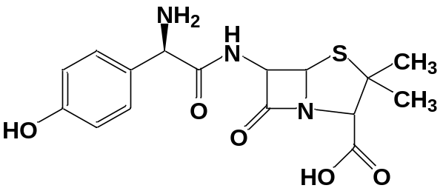
Chemical Name | (2S,5R,6R)-6-{[(2R)-2-Amino-2-(4-hydroxyphenyl) acetyl] amino}-3,3-dimethyl-7-oxo-4-thia-1-azabicyclo [3.2.0] heptane-2-carboxylic acid
Molecular Formula | C₁₆H₁₉N₃O₅S
Usage | Antibiotic
Molecular Weight (g/mol) | 365.4
pKa | 2.4, 7.4, 9.6
Log P | 0.87

Table S2: Main characteristics of the synthetic wastewater.
Parameter | COD | TOC | TN | DO | pH
Unit | mg/L | mg/L | mg/L | mg/L
Value | 48 + 3 | 15 + 2 | 2.7 + 0.5 | 7 + 0.3 | 6.5 + 0.1

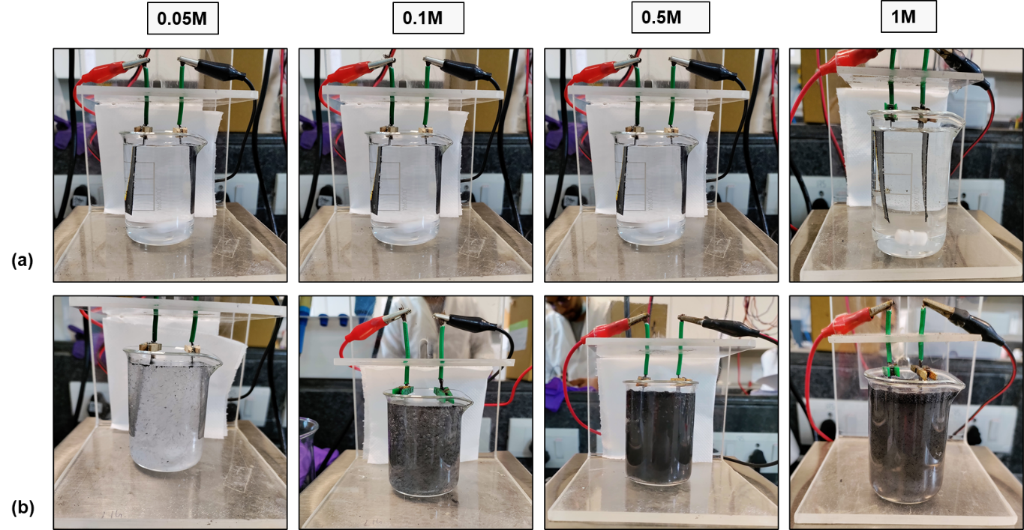
Figure S3: Row (a) Images of the initial condition, (b) after 30 minutes of electrolysis, and columns representing the variable Na₂SO₄ molarities.
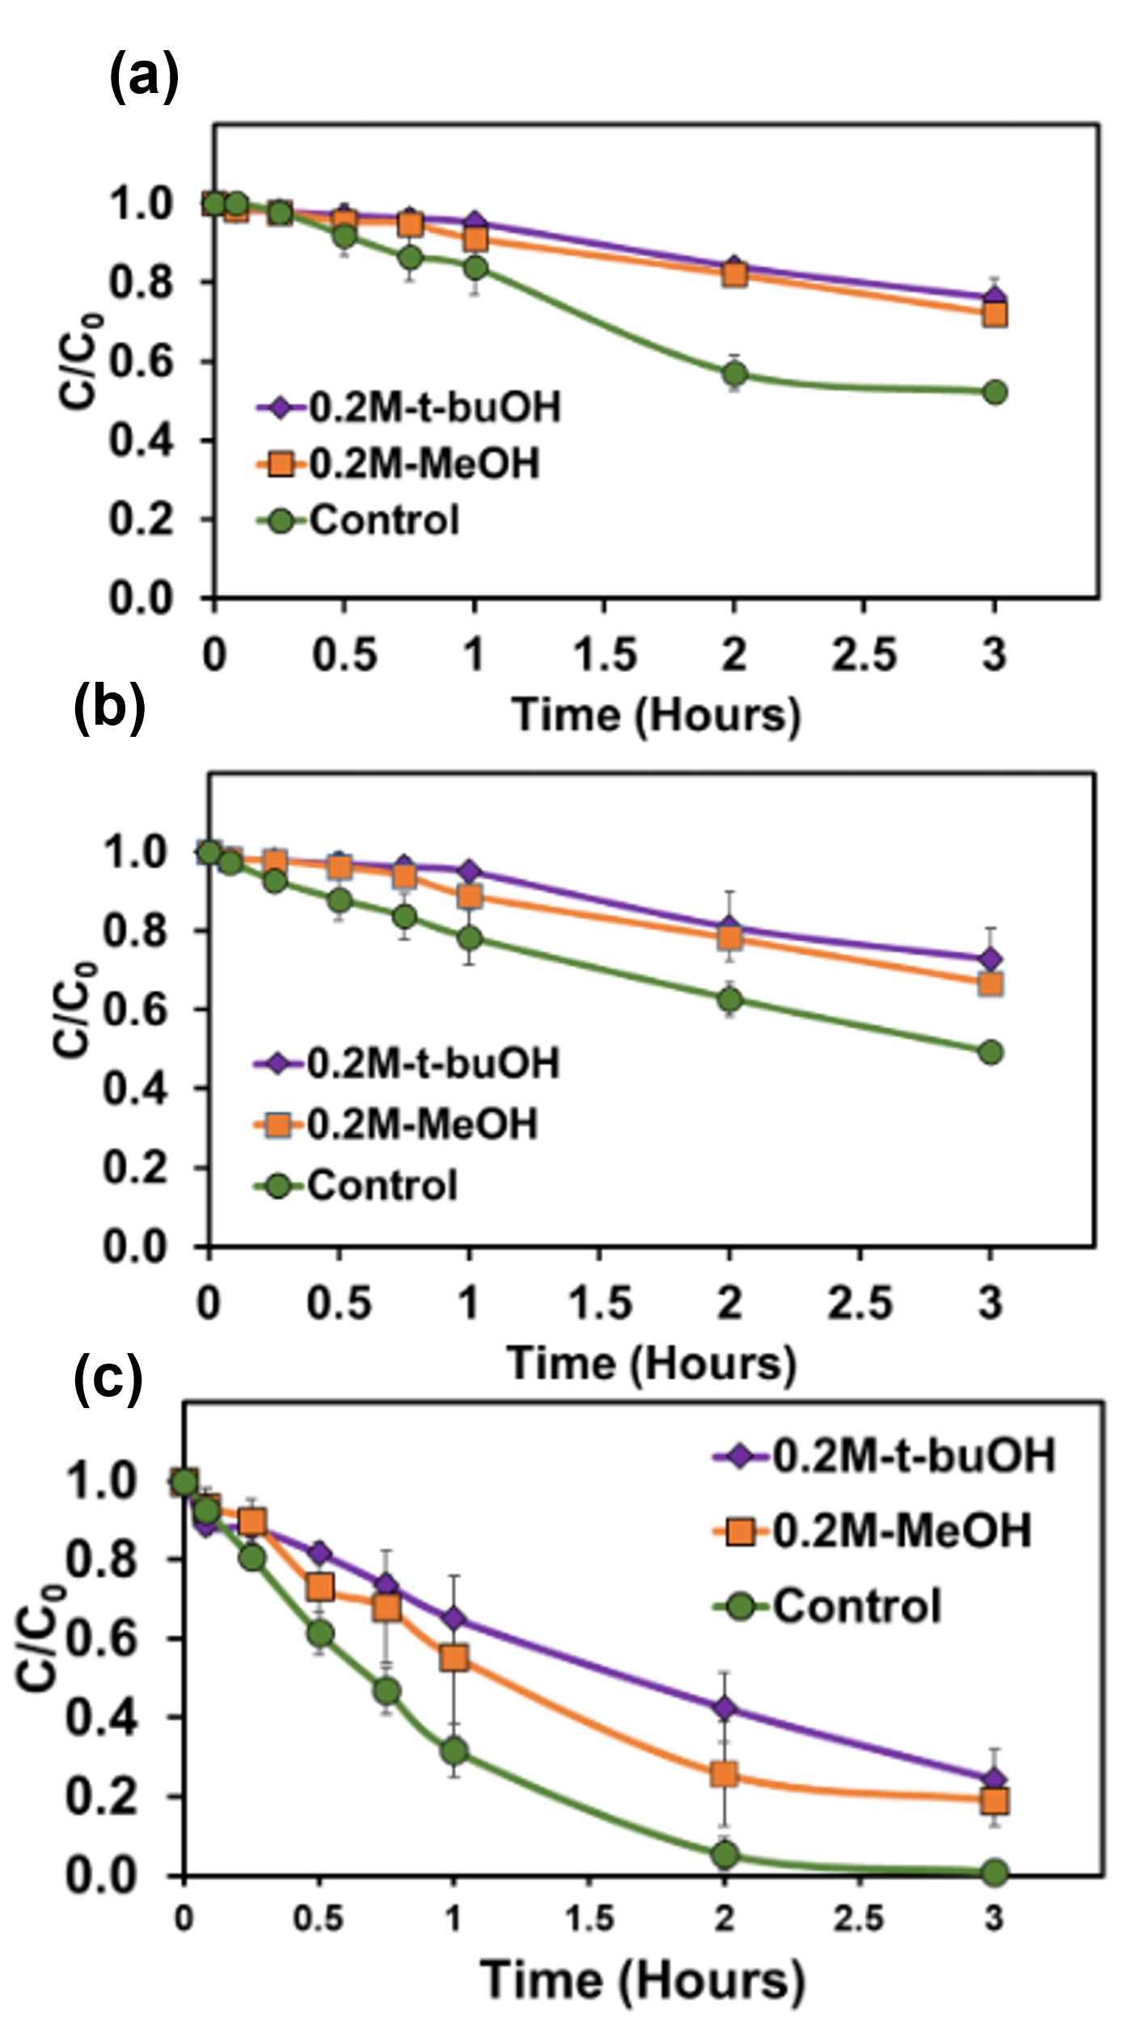
Figure S4: The efficiency of different radical scavengers in AMX degradation for (a) 0.005 M Na₂SO₄ electrolyte solution, (b) 0.01 M Na₂SO₄ electrolyte solution, (c) 0.05 M Na₂SO₄ electrolyte solution and (b) The efficiency of low AMX concentration in synthetic wastewater (initial AMX concentration 5 mg L⁻¹, 7.5 V, and initial pH 5.5).

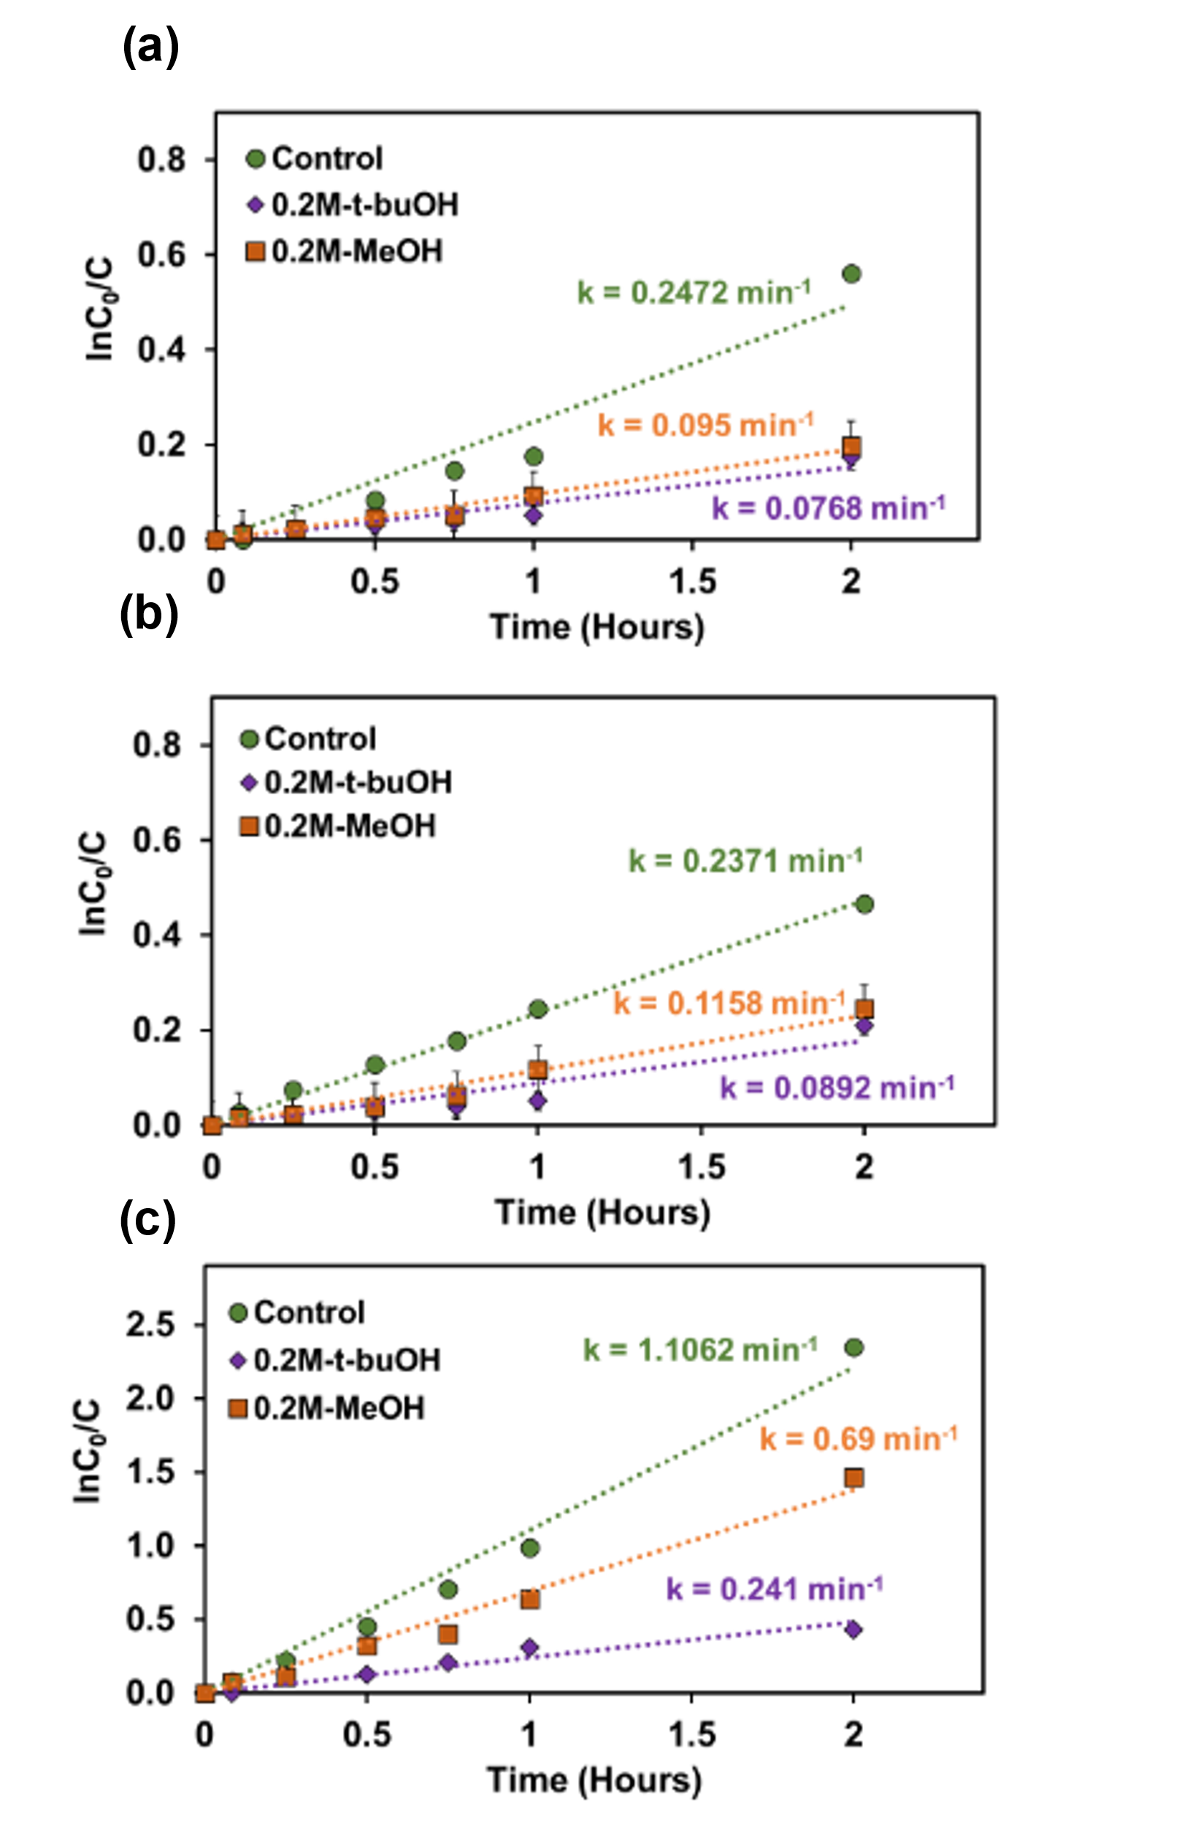

Figure S5: The reaction kinetics of different radical scavengers of AMX degradation for (a) 0.005 M Na₂SO₄ electrolyte solution, (b) 0.01 M Na₂SO₄ electrolyte solution, (c) 0.05 M Na₂SO₄ electrolyte solution and (b) The efficiency of low AMX concentration in synthetic wastewater (initial AMX concentration 5 mg L⁻¹, 7.5 V, and initial pH 5.5).

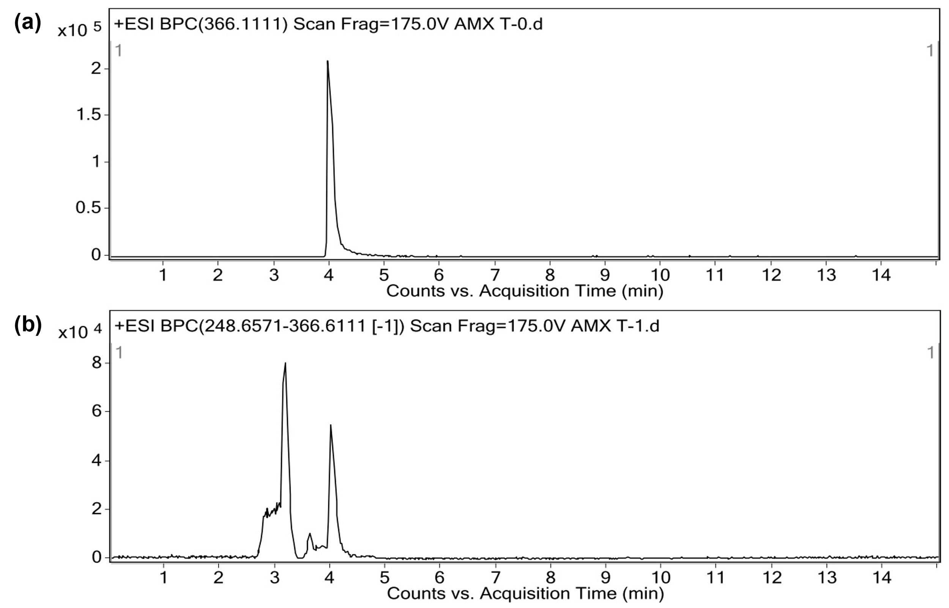
Figure S6: Chromatographs of (a) The initial sample, and (b) after 30 minutes of the EO process.
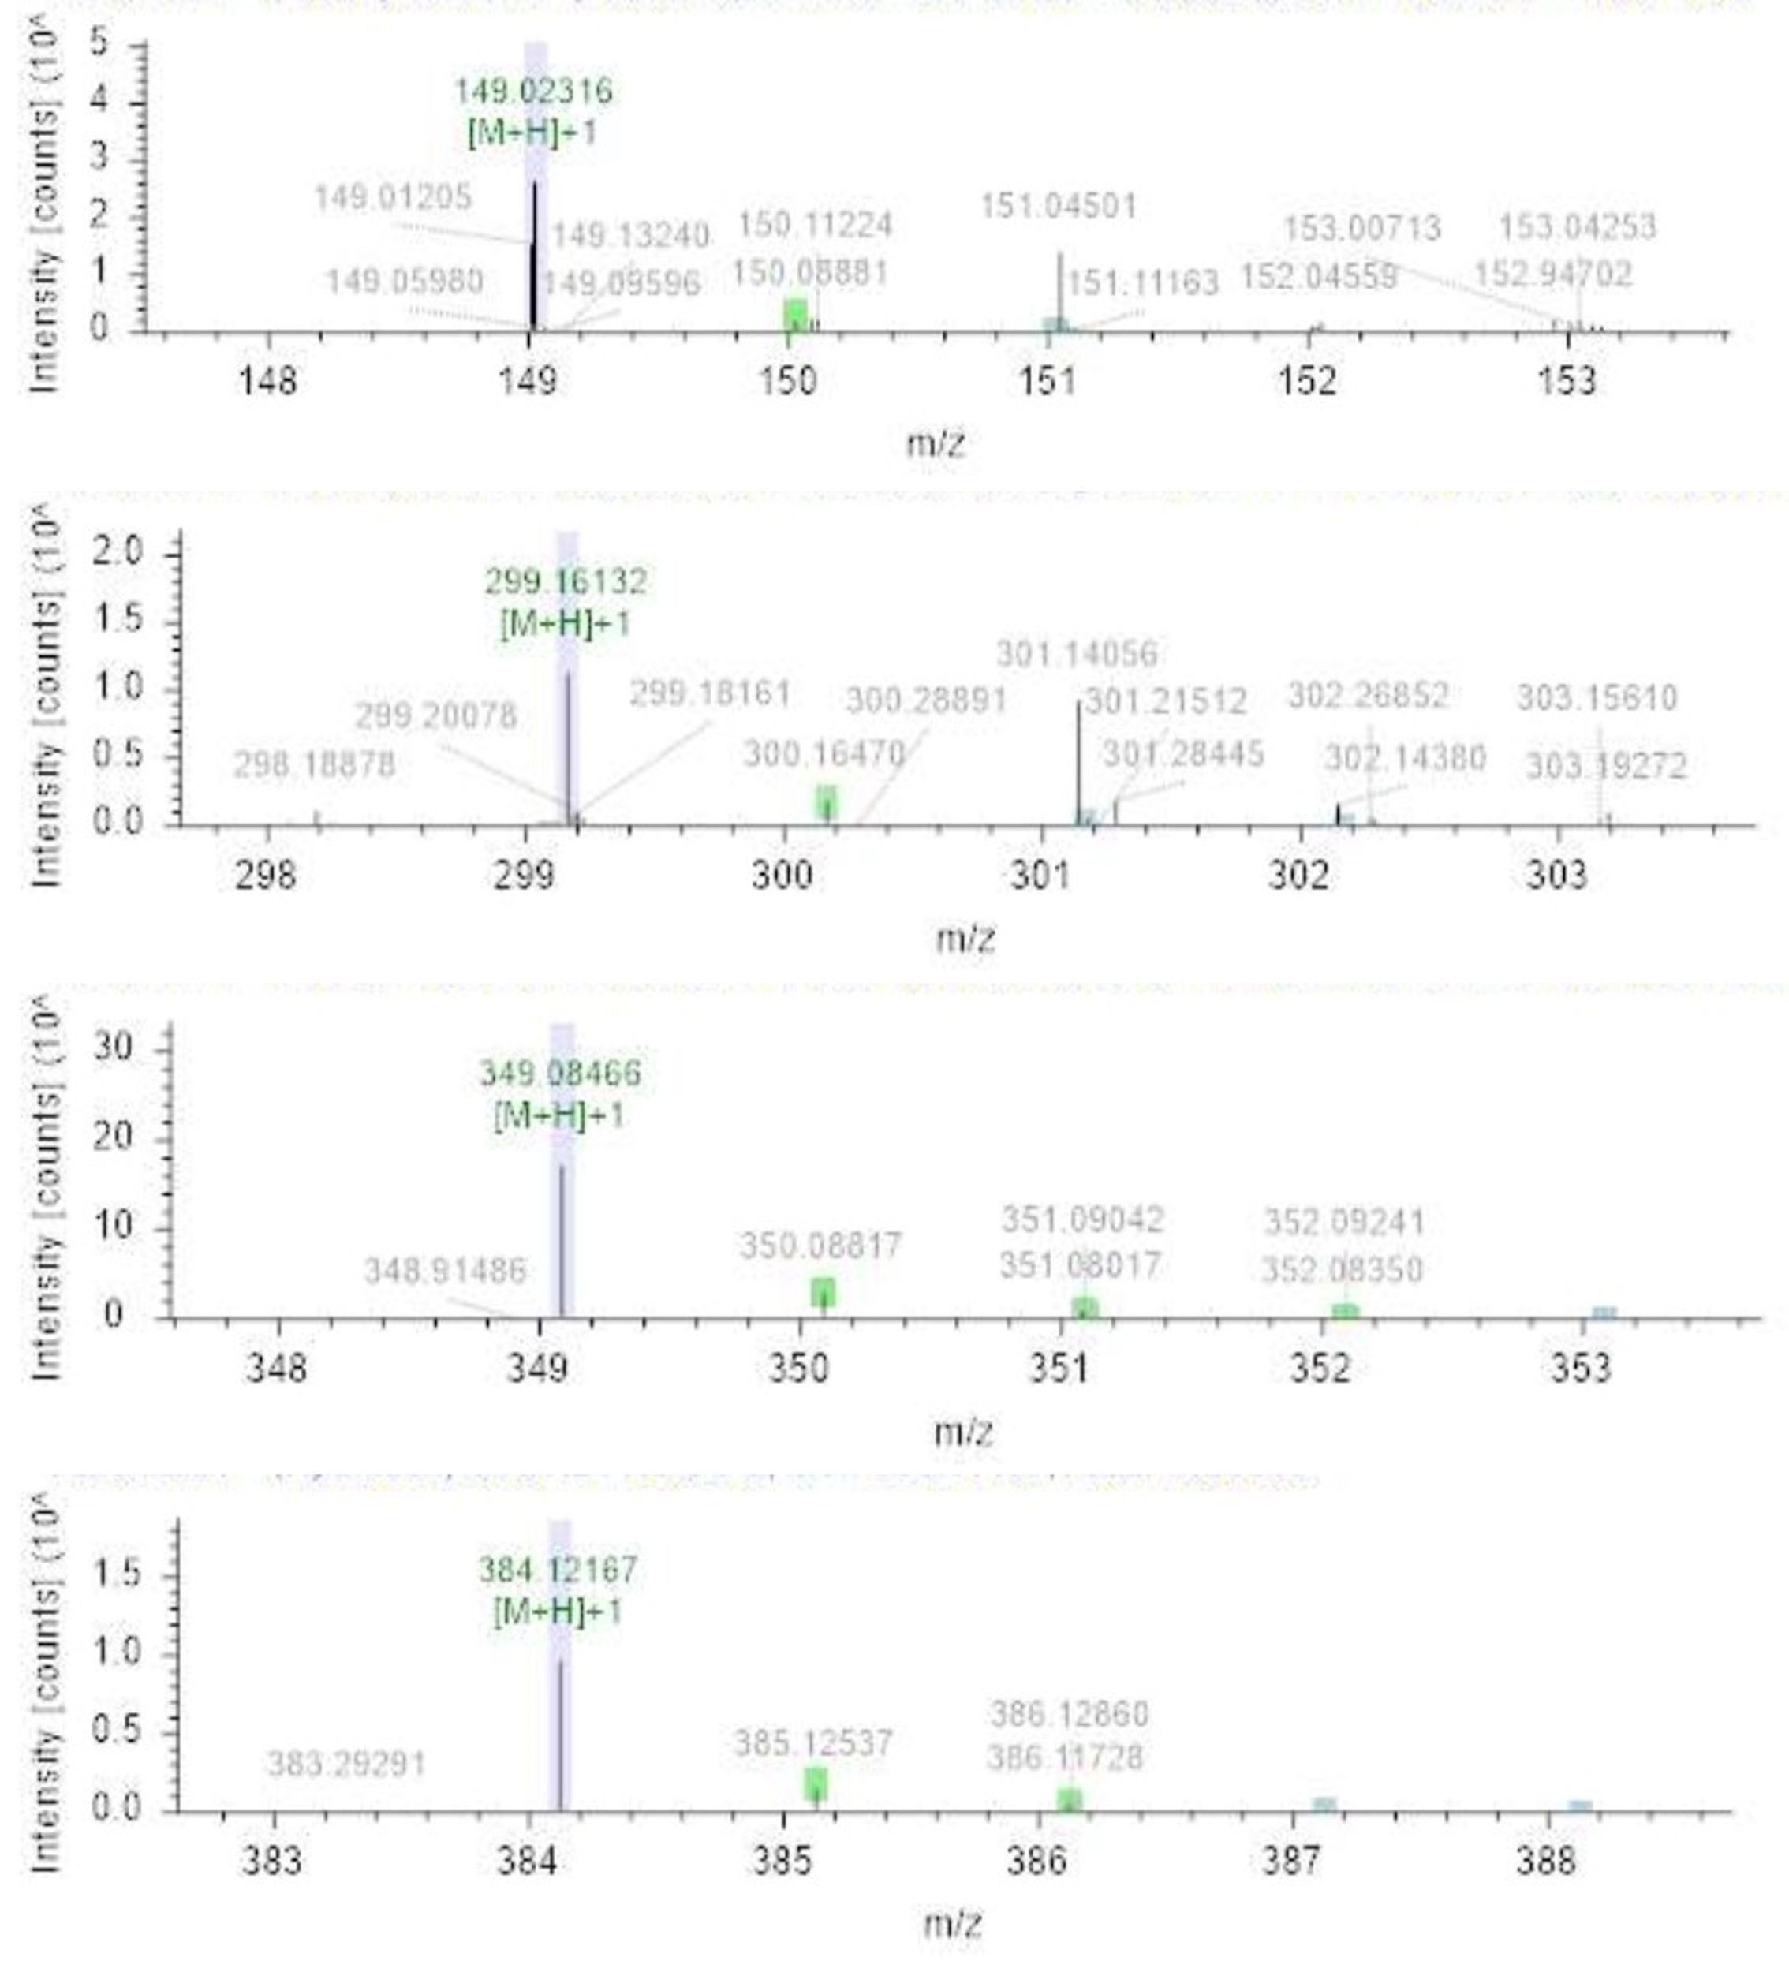
Figure S7: m/z values of the 30-minute EO process sample.

References:
Hakizimana, I., Zhao, X., Wang, C., Zhang, C., Pan, S., Li, Y., & Liu, N. (2022). Effective degradation of amoxicillin by multi-stage flow-through electrochemical system using porous electrodes. Separation and Purification Technology, 300, 121832. https://doi.org/10.1016/J.SEPPUR.2022.121832
Parvez, K., Wu, Z. S., Li, R., Liu, X., Graf, R., Feng, X., & Müllen, K. (2014). Exfoliation of graphite into graphene in aqueous solutions of inorganic salts. Journal of the American Chemical Society, 136(16), 6083–6091. https://doi.org/10.1021/ja5017156

