Predicting Progression-free Survival in Primary Liver Cancer Patients via Radiomics from DSA during TACE
supplementary materials
Image Acquisition 2
Feature Selection Method 3
Table S1 4
Table S2 6
Table S3 9
Figure S1 12
Figure S2 13
Figure S3 14

Image Acquisition
A Philips Digital FD20 flat-panel angiographic system from the Netherlands was used for DSA imaging and video capture. Digital subtraction angiography images of liver cancer lesions before TACE treatment were captured while the patients held their breath, with a frame rate of 3-8 frames per second and an injection speed of 4-6 ml per second. Angiograms of the proper hepatic artery or hepatic artery branches before TACE were obtained in Digital Imaging and Communications in Medicine (DICOM) format from the Philips IntelliSpace Cardiovascular system. Each patient's DSA angiogram contains 28-71 frames, with an image size of 1024×1024 pixels and a resolution of 72 dpi.

Feature Selection Method
Then, high-dimensional imaging feature data were reduced through a combination of multiple algorithms: (1) the intra- and inter-group consistency correlation coefficient (ICC) was used to quantify the stability and reliability of the features extracted by the two physicians, and stable feature parameters (ICC ≥ 0.9) were selected for analysis; (2) the selected stable features underwent an initial T-test or Mann-Whitney U test, and features with P < 0.05 were selected for further dimensionality reduction; (3) The Maximum Relevance Minimum Redundancy (MRMR) method was used, applying Pearson correlation analysis for normally distributed features and Spearman correlation analysis for non-normally distributed features to screen radiomics features, and features with a correlation coefficient > 0.9 were excluded; (4) to avoid overfitting or underfitting of the model, the LASSO-Cox algorithm was applied to further reduce the dimensionality of the selected features. Using 10-fold cross-validation and following the "minimum lambda value" criterion, features with a final regression coefficient of 0 were excluded, and those with non-zero coefficients were included in the study.

Table S1: Clinical Baseline Data of All Patients and the Two Groups After Stratification
Characteristics | Overall | Training cohort(n=79) | Validation cohort(n=54) | p-value
Age≥60years | 45 (33.8) | 27 (34.2) | 18 (33.3) | 1
Male sex | 108 (81.2) | 68 (86.1) | 40 (74.1) | 0.13
Diabetes | 17 (12.8) | 11 (13.9) | 6 (11.1) | 0.832
Hypertension | 31 (23.3) | 19 (24.1) | 12 (22.2) | 0.971
Smoke | 53 (39.8) | 35 (44.3) | 18 (33.3) | 0.276
Alcohol | 52 (39.1) | 34 (43.0) | 18 (33.3) | 0.344
Viral hepatitis |  |  |  | 0.331
HBV | 99 (74.4) | 58 (73.4) | 41 (75.9)
HCV | 5 (3.8) | 1 (1.3) | 4 (7.4)
Prior TACE | 49 (36.8) | 28 (35.4) | 21 (38.9) | 0.825
Number of TACE≥2 | 81 (60.9) | 48 (60.8) | 33 (61.1) | 1
WBC≥4×109/L | 106 (79.7) | 64 (81.0) | 42 (77.8) | 0.813
HGB≥120 g/L | 90 (67.7) | 53 (67.1) | 37 (68.5) | 1
PLT≥100×109/L | 106 (79.7) | 63 (79.7) | 43 (79.6) | 1
ALT≥40 U/L | 66 (49.6) | 40 (50.6) | 26 (48.1) | 0.916
AST≥40 U/L | 84 (63.2) | 50 (63.3) | 34 (63.0) | 1
ALB≥35 g/L | 96 (72.2) | 59 (74.7) | 37 (68.5) | 0.56
ALP≥125 U/L | 72 (54.1) | 41 (51.9) | 31 (57.4) | 0.653
Serum AFP, ng/ml |  |  |  | 0.852
<200 | 80 (60.2) | 49 (62.0) | 31 (57.4)
≥200, <400 | 33 (24.8) | 19 (24.1) | 14 (25.9)
≥400 | 20 (15.0) | 11 (13.9) | 9 (16.7)
Total bilirubin≥34.2 mol/L | 16 (12.0) | 8 (10.1) | 8 (14.8)
NLR, median (IQR) | 2.9 (2.0, 4.4) | 2.8 (2.1, 4.4) | 3.2 (2.0, 4.5) | 0.611
PLR, median (IQR) | 135.0 (96.8, 187.3) | 132.7 (98.9, 178.9) | 138.5 (100.1, 194.1) | 0.632
PT, median (IQR, s) | 13.4 (12.6, 14.0) | 13.4 (12.6, 14.1) | 13.4 (12.5, 13.9) | 0.472
Child-Pugh class |  |  |  | 0.222
A | 111 (83.5) | 69 (87.3) | 42 (77.8)
B | 22 (16.5) | 10 (12.7) | 12 (22.2)
ALBI grade |  |  |  | 0.527
≤-2.6 | 58 (43.6) | 33 (41.8) | 25 (46.3)
>-2.6, ≤-1.39 | 72 (54.1) | 45 (57.0) | 27 (50.0)
>-1.39 | 3 (2.3) | 1 (1.3) | 2 (3.7)
BCLC stage |  |  |  | 0.359
A | 35 (26.3) | 21 (26.6) | 14 (25.9)
B | 43 (32.3) | 22 (27.8) | 21 (38.9)
Table S1 (Continued)
Characteristics | Overall | Training cohort(n=79) | Validation cohort(n=54) | p-value
C | 55 (41.4) | 36 (45.6) | 19 (35.2)
Number of tumors≥2 | 80 (60.2) | 46 (58.2) | 34 (63.0) | 0.713
Tumor diameter, cm |  |  |  | 0.393
<3 | 8 (6.0) | 5 (6.3) | 3 (5.6)
≥3, <5 | 21 (15.8) | 11 (13.9) | 10 (18.5)
≥5, <10 | 56 (42.1) | 30 (38.0) | 26 (48.1)
≥10 | 48 (36.1) | 33 (41.8) | 15 (27.8)
Lymph node metastasis | 9 (6.8) | 7 (8.9) | 2 (3.7) | 0.417
Extrahepatic metastases | 20 (15.0) | 11 (13.9) | 9 (16.7) | 0.851
PVTT | 17 (12.8) | 10 (12.7) | 7 (13.0) | 1
Vascular invasion | 41 (30.8) | 29 (36.7) | 12 (22.2) | 0.113
Liver cirrhosis | 52 (39.1) | 29 (36.7) | 23 (42.6) | 0.616
Portal hypertension | 33 (24.8) | 15 (19.0) | 18 (33.3) | 0.094
Ascites | 13 (9.8) | 6 (7.6) | 7 (13.0) | 0.468
Splenauxe | 33 (24.8) | 19 (24.1) | 14 (25.9) | 0.967
DEB-TACE | 56 (42.1) | 32 (40.5) | 24 (44.4) | 0.785
TT with/without IT |  |  |  | 0.883
TT without IT | 13 (9.8) | 7 (8.9) | 6 (11.1)
TT with IT | 31 (23.3) | 18 (22.8) | 13 (24.1)
Follow-up treatment | 27 (20.3) | 17 (21.5) | 10 (18.5) | 0.839
HAIC | 11 (8.3) | 6(7.6) | 5(9.3)
Liver resection | 11 (8.3) | 8(10.1) | 3(5.6)
Chemotherapy | 5 (3.8) | 4(5.1) | 1(1.9)
Radiothreapy | 4 (3.0) | 3(3.8) | 1(1.9)
RFA | 1 (0.8) | 1(1.3) | 0(0)
Note: WBC: White Blood Cell; HGB: Hemoglobin; PLT: Platelet; ALT: Alanine Aminotransferase; AST: Aspartate Aminotransferase; ALB: Albumin; ALP: Alkaline Phosphatase; AFP: Alpha-Fetoprotein; prior TACE: Previous Transarterial Chemoembolization; NLR: Neutrophil-to-Lymphocyte Ratio; PLR: Platelet-to-Lymphocyte Ratio; PT: Prothrombin Time; ALBI: Albumin-Bilirubin Grade; BCLC: Barcelona Clinic Liver Cancer Staging System; PVTT: Portal Vein Tumor Thrombus; DEB-TACE: Drug-Eluting Bead Transarterial Chemoembolization; TT: Targeted Therapy; IT: Immunotherapy; HAIC: Hepatic Arterial Infusion Chemotherapy; RFA: Radiofrequency Ablation.

Table S2: Comparison of Baseline Data between High-Risk and Low-Risk Patients in the Training Cohort
Characteristics | High risk(n=18) | Low risk(n=61) | p-value
PFS (median (IQR)) | 5.5 (2.4, 8.3) | 15.70 (13.4, 18.1) | <0.001
Age≥60years | 4 (22.2) | 23 (37.7) | 0.35
Male sex | 16 (88.9) | 52 (85.2) | 0.996
Diabetes | 2 (11.1) | 9 (14.8) | 0.996
Hypertension | 4 (22.2) | 15 (24.6) | 1
Smoke | 7 (38.9) | 28 (45.9) | 0.798
Alcohol | 6 (33.3) | 28 (45.9) | 0.499
Viral hepatitis |  |  | 0.231
HBV | 11 (61.1) | 47 (77.0)
HCV | 0 (0.0) | 1 (1.6)
Prior TACE | 7 (38.9) | 21 (34.4) | 0.946
Number of TACE≥2 | 11 (61.1) | 37 (60.7) | 1
WBC≥4×109/L | 15 (83.3) | 49 (80.3) | 1
HGB≥120 g/L | 9 (50.0) | 44 (72.1) | 0.141
PLT≥100×109/L | 12 (66.7) | 51 (83.6) | 0.216
ALT≥40 U/L | 9 (50.0) | 31 (50.8) | 1
AST≥40 U/L | 15 (83.3) | 35 (57.4) | 0.084
ALB≥35 g/L | 12 (66.7) | 47 (77.0) | 0.561
ALP≥125 U/L | 11 (61.1) | 30 (49.2) | 0.534
Serum AFP, ng/ml |  |  | 0.177
<200 | 10 (55.6) | 39 (63.9)
≥200, <400 | 7 (38.9) | 12 (19.7)
≥400 | 1 (5.6) | 10 (16.4)
Total bilirubin≥34.2 mol/L | 4 (22.2) | 4 (6.6) | 0.136
NLR, median (IQR) | 3.9 (2.9, 4.8) | 2.7 (2.0, 3.4) | 0.009
PLR, median (IQR) | 138.2 (108.2, 208.1) | 132.7 (96.3, 173.5) | 0.615
PT, median (IQR, s) | 13.7 (13.0, 14.4) | 13.4 (12.6, 14.0) | 0.43
Child-Pugh class |  |  | 0.001
A | 11 (61.1) | 58 (95.1)
B | 7 (38.9) | 3 (4.9)
ALBI grade |  |  | 0.31
≤-2.6 | 5 (27.8) | 28 (45.9)
>-2.6, ≤-1.39 | 13 (72.2) | 32 (52.5)
>-1.39 | 0 (0.0) | 1 (1.6)
BCLC stage |  |  | 0.098
A | 2 (11.1) | 19 (31.1)
B | 4 (22.2) | 18 (29.5)
Table S2 (Continued)
Characteristics | High risk(n=18) | Low risk(n=61) | p-value
C | 12 (66.7) | 24 (39.3)
Number of tumors≥2 | 10 (55.6) | 36 (59.0) | 1
Tumor diameter, cm |  |  | 0.423
<3 | 0 (0.0) | 5 (8.2)
≥3, <5 | 2 (11.1) | 9 (14.8)
≥5, <10 | 6 (33.3) | 24 (39.3)
≥10 | 10 (55.6) | 23 (37.7)
Lymph node metastasis | 2 (11.1) | 5 (8.2) | 1
Extrahepatic metastases | 2 (11.1) | 9 (14.8) | 0.996
PVTT | 4 (22.2) | 6 (9.8) | 0.324
Vascular invasion | 11 (61.1) | 18 (29.5) | 0.03
Liver cirrhosis | 9 (50.0) | 20 (32.8) | 0.292
Portal hypertension | 4 (22.2) | 11 (18.0) | 0.955
Ascites | 3 (16.7) | 3 (4.9) | 0.251
Splenauxe | 4 (22.2) | 15 (24.6) | 1
DEB-TACE | 8 (44.4) | 24 (39.3) | 0.909
TT with/without IT |  |  | 0.615
TT without IT | 1 (1.3) | 6 (9.8)
TT with IT | 3 (16.7) | 15 (24.6)
Follow-up treatment | 2 (11.1) | 15 (24.6) | 0.37
HAIC | 1 (5.6) | 5 (8.2)
Liver resection | 1 (5.6) | 7 (11.5)
Chemotherapy | 0 (0.0) | 4 (6.6)
Radiothreapy | 0 (0.0) | 3 (4.9)
RFA | 0 (0.0) | 1 (1.6)
Response (%) |  |  | <0.001
CR | 1 (5.6) | 8 (13.1)
PR | 1 (5.6) | 15 (24.6)
SD | 4 (22.2) | 31 (50.8)
PD | 12 (66.7) | 7 (11.5)
ORR (%) | 2(11.1) | 23(37.7) | 0.065
DCR (%) | 6(33.3) | 54(88.5) | <0.001
Note: WBC: White Blood Cell; HGB: Hemoglobin; PLT: Platelet; ALT: Alanine Aminotransferase; AST: Aspartate Aminotransferase; ALB: Albumin; ALP: Alkaline Phosphatase; AFP: Alpha-Fetoprotein; prior TACE: Previous Transarterial Chemoembolization; NLR: Neutrophil-to-Lymphocyte Ratio; PLR: Platelet-to-Lymphocyte Ratio; PT: Prothrombin Time; ALBI: Albumin-Bilirubin Grade; BCLC: Barcelona Clinic Liver Cancer Staging System; PVTT: Portal Vein Tumor Thrombus; DEB-TACE: Drug-Eluting Bead Transarterial Chemoembolization; TT: Targeted Therapy; IT: Immunotherapy; HAIC: Hepatic Arterial Infusion Chemotherapy; RFA: Radiofrequency Ablation; CR: Complete Response; PR: Partial Response; SD: Stable Disease; PD: Progressive Disease; ORR: Overall Response Rate; DCR: Disease Control Rate.

Table S3: Comparison of Baseline Data between High-Risk and Low-Risk Patients in the Validation Cohort
Characteristics | High risk(n=13) | Low risk(n=41) | p-value
PFS (median (IQR)) | 2.4 (1.7, 6.9) | 9.3 (3.7, 14.9) | 0.005
Age≥60years | 4 (30.8) | 14 (34.1) | 1
Male sex | 9 (69.2) | 31 (75.6) | 0.925
Diabetes | 0 (0.0) | 6 (14.6) | 0.339
Hypertension | 2 (15.4) | 10 (24.4) | 0.766
Smoke | 6 (46.2) | 12 (29.3) | 0.431
Alcohol | 6 (46.2) | 12 (29.3) | 0.431
Viral hepatitis |  |  | 0.255
HBV | 8 (61.5) | 33 (80.5)
HCV | 1 (7.7) | 3 (7.3)
Prior TACE | 6 (46.2) | 15 (36.6) | 0.772
Number of TACE≥2 | 9 (69.2) | 24 (58.5) | 0.717
WBC≥4×109/L | 10 (76.9) | 32 (78.0) | 1
HGB≥120 g/L | 11 (84.6) | 26 (63.4) | 0.275
PLT≥100×109/L | 9 (69.2) | 34 (82.9) | 0.501
ALT≥40 U/L | 9 (69.2) | 17 (41.5) | 0.153
AST≥40 U/L | 11 (84.6) | 23 (56.1) | 0.127
ALB≥35 g/L | 8 (61.5) | 29 (70.7) | 0.78
ALP≥125 U/L | 11 (84.6) | 20 (48.8) | 0.051
Serum AFP, ng/ml |  |  | 0.29
< 200 | 6 (46.2) | 25 (61.0)
≥200, < 400 | 3 (23.1) | 11 (26.8)
≥400 | 4 (30.8) | 5 (12.2)
Total bilirubin≥34.2 mol/L | 3 (23.1) | 5 (12.2)
NLR, median (IQR) | 2.8 (2.0, 4.6) | 3.3 (2.1, 4.4) | 0.919
PLR, median (IQR) | 114.1 (88.1, 177.4) | 140.3 (120.9, 196.4) | 0.326
PT, median (IQR, s) | 12.6 (12.4, 13.8) | 13.5 (12.6, 13.9) | 0.62
Child-Pugh class |  |  | 0.64
A | 9 (69.2) | 33 (80.5)
B | 4 (30.8) | 8 (19.5)
ALBI grade |  |  | 0.027
≤-2.6 | 4 (30.8) | 21 (51.2)
>-2.6, ≤-1.39 | 7 (53.8) | 20 (48.8)
>-1.39 | 2 (15.4) | 0 (0.0)
BCLC stage |  |  | 0.132
A | 5 (38.5) | 9 (22.0)
B | 2 (15.4) | 19 (46.3)
Table S3 (Continued)
Characteristics | High risk(n=13) | Low risk(n=41) | p-value
C | 6 (46.2) | 13 (31.7)
Number of tumors≥2 | 7 (53.8) | 27 (65.9)
Tumor diameter, cm |  |  | 0.447
<3 | 1 (7.7) | 2 (4.9) | 0.447
≥3, <5 | 4 (30.8) | 6 (14.6)
≥5, <10 | 4 (30.8) | 22 (53.7)
≥10 | 4 (30.8) | 11 (26.8)
Lymph node metastasis | 0 (0.0) | 2 (4.9) | 1
Extrahepatic metastases | 3 (23.1) | 6 (14.6) | 0.776
PVTT | 3 (23.1) | 4 (9.8) | 0.44
Vascular invasion | 4 (30.8) | 8 (19.5) | 0.64
Liver cirrhosis | 7 (53.8) | 16 (39.0) | 0.535
Portal hypertension | 4 (30.8) | 14 (34.1) | 1
Ascites | 2 (15.4) | 5 (12.2) | 1
Splenauxe | 5 (38.5) | 9 (22.0) | 0.412
DEB-TACE | 5 (38.5) | 19 (46.3) | 0.859
TT with/without IT |  |  | 0.647
TT without IT | 2 (15.4) | 4 (9.8)
TT with IT | 2 (15.4) | 11 (26.8)
Follow-up treatment | 0 (0.0) | 10 (24.4) | 0.118
HAIC | 0 (0.0) | 5 (12.2)
Liver resection | 0 (0.0) | 3 (7.3)
Chemotherapy | 0 (0.0) | 1 (2.4)
Radiothreapy | 0 (0.0) | 1 (2.4)
RFCA | 0 (0.0) | 0 (0.0)
Response (%) |  |  | 0.273
CR | 0 (0.0) | 2 (4.9)
PR | 1 (7.7) | 6 (14.6)
SD | 2 (15.4) | 14 (34.1)
PD | 10 (76.9) | 19 (46.3)
ORR (%) | 1(7.7) | 8(19.5) | 0.569
DCR (%) | 3(23.1) | 22(53.7) | 0.108
Note: WBC: White Blood Cell; HGB: Hemoglobin; PLT: Platelet; ALT: Alanine Aminotransferase; AST: Aspartate Aminotransferase; ALB: Albumin; ALP: Alkaline Phosphatase; AFP: Alpha-Fetoprotein; prior TACE: Previous Transarterial Chemoembolization; NLR: Neutrophil-to-Lymphocyte Ratio; PLR: Platelet-to-Lymphocyte Ratio; PT: Prothrombin Time; ALBI: Albumin-Bilirubin Grade; BCLC: Barcelona Clinic Liver Cancer Staging System; PVTT: Portal Vein Tumor Thrombus; DEB-TACE: Drug-Eluting Bead Transarterial Chemoembolization; TT: Targeted Therapy; IT: Immunotherapy; HAIC: Hepatic Arterial Infusion Chemotherapy; RFA: Radiofrequency Ablation; CR: Complete Response; PR: Partial Response; SD: Stable Disease; PD: Progressive Disease; ORR: Overall Response Rate; DCR: Disease Control Rate.

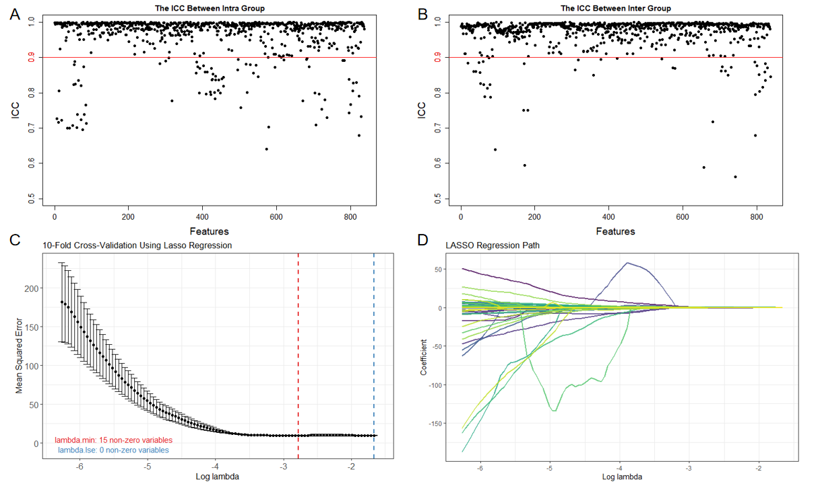
Figure S1. Analysis and selection of radiomics features. (A) and (B) show the results of intra-class and inter-class correlation coefficient, where the x-axis represents features and the y-axis represents the correlation coefficient between intra-class and inter-class features. (C) and (D) depict the screening of radiomics features using LASSO-Cox regression model, where the x-axis represents the tuning parameter Lambda, and the y-axis in (C) represents mean squared error, while the y-axis in (D) represents the coefficients corresponding to the radiomics features.
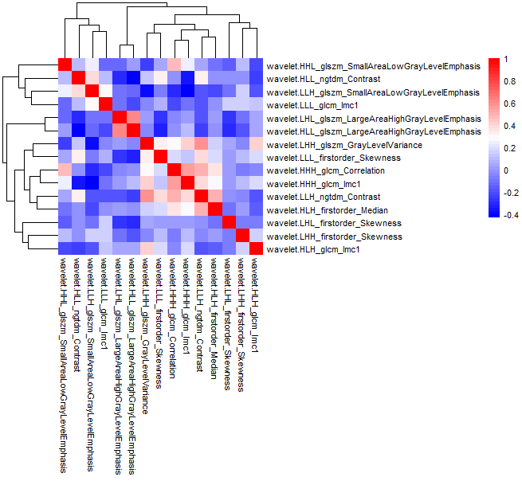
Figure S2. Heatmap of correlation matrix for radiomic features (red indicates positive correlation, blue indicates negative correlation)

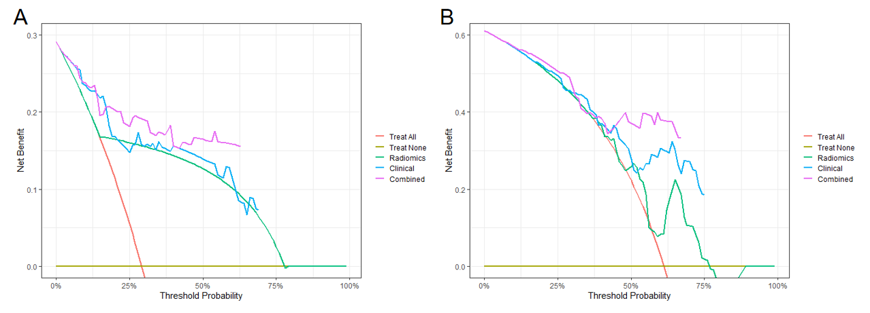
Figure S3. Decision curves of three models. The Y-axis represents the net benefit, and the X-axis represents the threshold probability. (A) represents the decision curves of three prediction models in the training cohort; while (B) depicts the decision curves of three prediction models in the validation cohort.

