Spatiotemporal analysis of sea ice in the Weddell Sea of Antarctic based on GTWR
Y.R. Ding¹, X. Liu^{1,}*, X.F. Dai¹, Y. Yang¹, G.Y. Yin¹, H.P. Sun² & J.Y. Guo¹
Table A1. The list of years having a standard deviation greater than 1 is regarded as high sea-ice years, and the years with less than 1 standard deviation are considered as low sea-ice years.
Seasons | High sea-ice years | Low sea-ice years
Summer | 2014,2015 | 2023
Autumn | 2012,2014 | 2018,2023
Winter | 2015 | 2018,2022,2023
Spring | 2011,2013,2014,2015 | 2016,2021
Table A2. Annual Correlation Matrix (2011-2023)
Parameters | SIE | SIC | SST | NHF | SAM | ENSO | AMM | IOD
SIE | 1.00
SIC | 1.00 | 1.00
SST | -0.81 | -0.80 | 1.00
NHF | -0.42 | -0.42 | 0.30 | 1.00
SAM | 0.04 | 0.04 | -0.05 | -0.41 | 1.00
ENSO | 0.33 | 0.33 | -0.20 | 0.09 | -0.14 | 1.00
AMM | -0.14 | -0.13 | 0.25 | 0.09 | -0.12 | -0.26 | 1.00
IOD | -0.18 | -0.18 | 0.03 | 0.52 | -0.46 | 0.30 | -0.22 | 1.00
Note: Significance levels are shown in italics at 90%, in bold at 95%, and in bold italics at 99%
Table A3. Summer Correlation Matrix (2011-2023)
Parameters | SIE | SIC | SST | NHF | SAM | ENSO | AMM | IOD
SIE | 1.00
SIC | 1.00 | 1.00
SST | -0.89 | -0.89 | 1.00
NHF | 0.30 | 0.30 | -0.32 | 1.00
SAM | 0.29 | 0.30 | -0.31 | -0.57 | 1.00
ENSO | 0.22 | 0.22 | -0.32 | -0.01 | 0.38 | 1.00
AMM | -0.19 | -0.19 | 0.11 | -0.19 | -0.03 | -0.54 | 1.00
IOD | -0.62 | -0.62 | 0.53 | -0.11 | -0.32 | 0.13 | 0.25 | 1.00
Note: Significance levels are shown in italics at 90%, in bold at 95%, and in bold italics at 99%
Table A4. Autumn Correlation Matrix (2011-2023)
Parameters | SIE | SIC | SST | NHF | SAM | ENSO | AMM | IOD
SIE | 1.00
SIC | 1.00 | 1.00
SST | -0.71 | -0.71 | 1.00
NHF | -0.65 | -0.65 | 0.62 | 1.00
SAM | 0.15 | 0.16 | -0.80 | -0.64 | 1.00
ENSO | 0.18 | 0.17 | -0.31 | 0.26 | 0.48 | 1.00
AMM | -0.19 | -0.20 | 0.13 | 0.39 | 0.15 | -0.10 | 1.00
IOD | -0.33 | -0.34 | -0.09 | 0.48 | 0.28 | 0.31 | -0.19 | 1.00
Note: Significance levels are shown in italics at 90%, in bold at 95%, and in bold italics at 99%
Table A5. Winter Correlation Matrix (2011-2023)
Parameters | SIE | SIC | SST | NHF | SAM | ENSO | AMM | IOD
SIE | 1.00
SIC | 1.00 | 1.00
SST | -0.72 | -0.71 | 1.00
NHF | -0.52 | -0.51 | 0.29 | 1.00
SAM | -0.28 | -0.28 | -0.15 | -0.06 | 1.00
ENSO | 0.13 | 0.15 | -0.12 | 0.26 | 0.28 | 1.00
AMM | -0.07 | -0.05 | 0.21 | 0.18 | -0.17 | 0.16 | 1.00
IOD | 0.22 | 0.23 | -0.42 | 0.29 | 0.01 | 0.42 | 0.17 | 1.00
Note: Significance levels are shown in italics at 90%, in bold at 95%, and in bold italics at 99%
Table A6. Spring Correlation Matrix (2011-2023)
Parameters | SIE | SIC | SST | NHF | SAM | ENSO | AMM | IOD
SIE | 1.00
SIC | 1.00 | 1.00
SST | -0.70 | -0.70 | 1.00
NHF | 0.72 | 0.71 | -0.90 | 1.00
SAM | -0.12 | -0.12 | -0.30 | 0.36 | 1.00
ENSO | 0.30 | 0.30 | 0.14 | -0.17 | -0.30 | 1.00
AMM | 0.11 | 0.12 | 0.05 | -0.15 | 0.05 | -0.33 | 1.00
IOD | 0.31 | 0.31 | 0.01 | 0.18 | -0.25 | 0.56 | -0.52 | 1.00
Note: Significance levels are shown in italics at 90%, in bold at 95%, and in bold italics at 99%

Table A7. Environmental factors correlation statistics table.
variable | 10m u-component of wind | 10m v-component of wind | Mean sea level pressure | Sea surface temperature | 10m wind speed | Latent heat flux | Net thermal radiation | Sensible heat flux
10m u-component of wind | 1.00 | -0.63 | 0.62 | 0.52 | 0.90 | -0.58 | 0.09 | -0.11
10m v-component of wind | -0.63 | 1.00 | -0.47 | -0.48 | -0.68 | 0.48 | 0.11 | -0.10
Mean sea level pressure | 0.62 | -0.47 | 1.00 | 0.90 | 0.57 | -0.74 | -0.31 | 0.06
Sea surface temperature | 0.52 | -0.48 | 0.90 | 1.00 | 0.50 | -0.89 | -0.57 | -0.12
10m wind speed | 0.90 | -0.68 | 0.57 | 0.50 | 1.00 | -0.62 | 0.06 | -0.20
Latent heat flux | -0.58 | 0.48 | -0.74 | -0.89 | -0.62 | 1.00 | 0.55 | 0.47
Net thermal radiation | 0.09 | 0.11 | -0.31 | -0.57 | 0.06 | 0.55 | 1.00 | 0.24
Sensible heat flux | -0.11 | -0.10 | 0.06 | -0.12 | -0.20 | 0.47 | 0.24 | 1.00

Table A8. Trends in sea ice area in the Weddell Sea from 2011 to 2023.
2011-2023 | Trend (10⁴km²yr⁻¹) | p
Annual | -6.6±1.3 | 0.007
Summer | -8.9±2.1 | 0.001
Autumn | -10.7±2.3 | 0.001
Winter | -1.3±0.5 | 0.03
Spring | -6.2±1.9 | 0.007
Table A9. Seasonal sea ice correlation with SST, U and Si.
season | region | SST | U | Si
Summer |  | -0.62 | -0.42 | -0.62
Autumn | E | -0.62 | -0.70 | -0.77
Autumn | W | -0.68 | -0.39 | -0.40
Winter | E | -0.71 | -0.29 | -0.27
Winter | W | -0.57 | -0.35 | -0.53
Spring |  | -0.65 | -0.71 | -0.74
Note: E represents the eastern Weddell Sea; W represents the western Weddell Sea; U represents the zonal wind; Si represents the wind speed; Significant correlations are shown in bold.

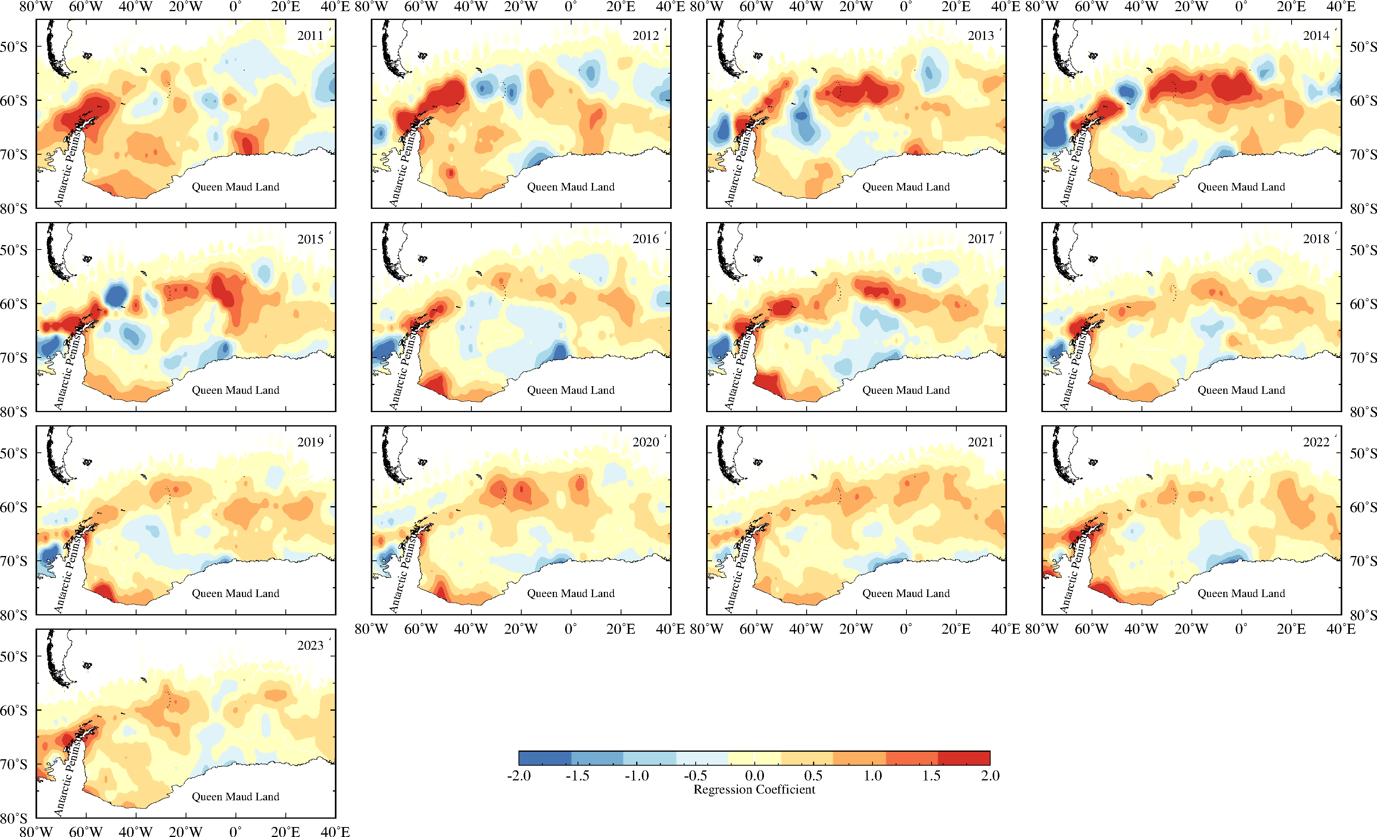
Figure A1. Spatial and temporal distribution of the influence coefficient of 10m meridional wind on schistosomiasis
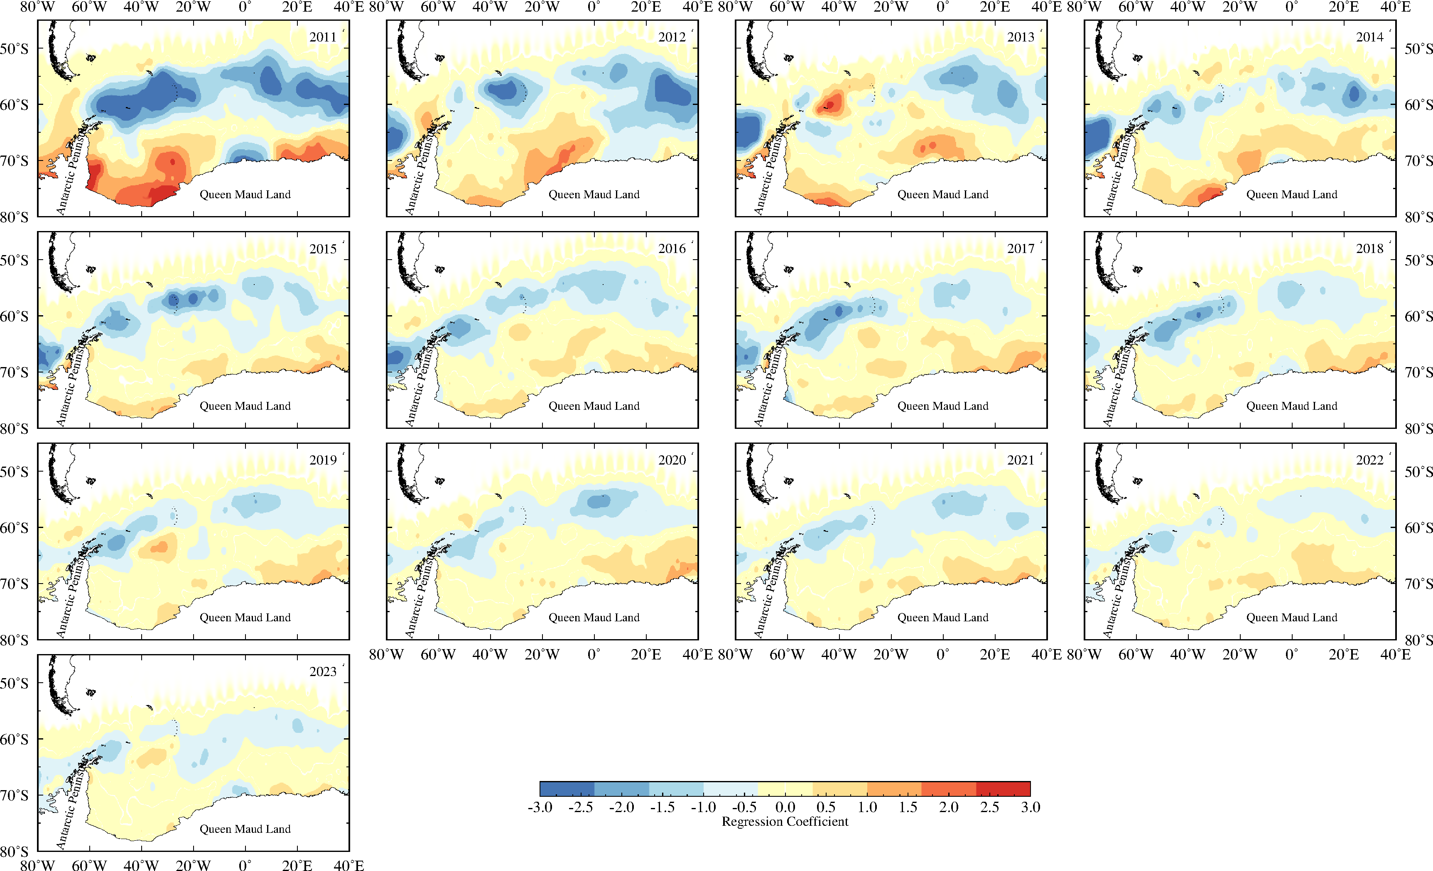
Figure A2. Spatial and temporal distribution of the influence coefficient of MSL on schistosomiasis

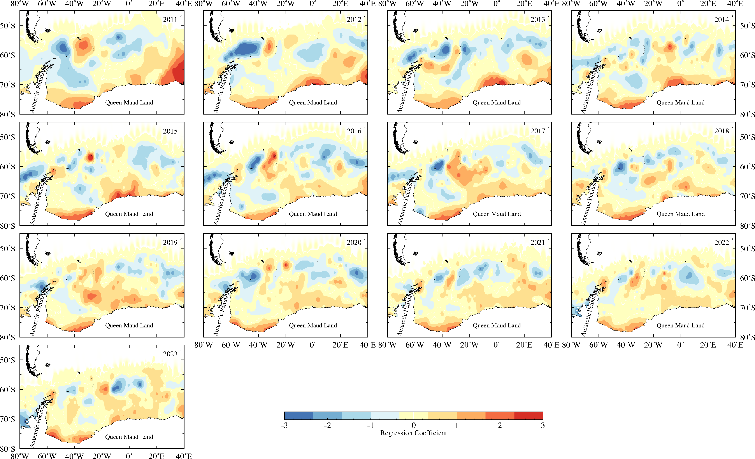
Figure A3. Spatial and temporal distribution of the influence coefficient of wind speed on schistosomiasis
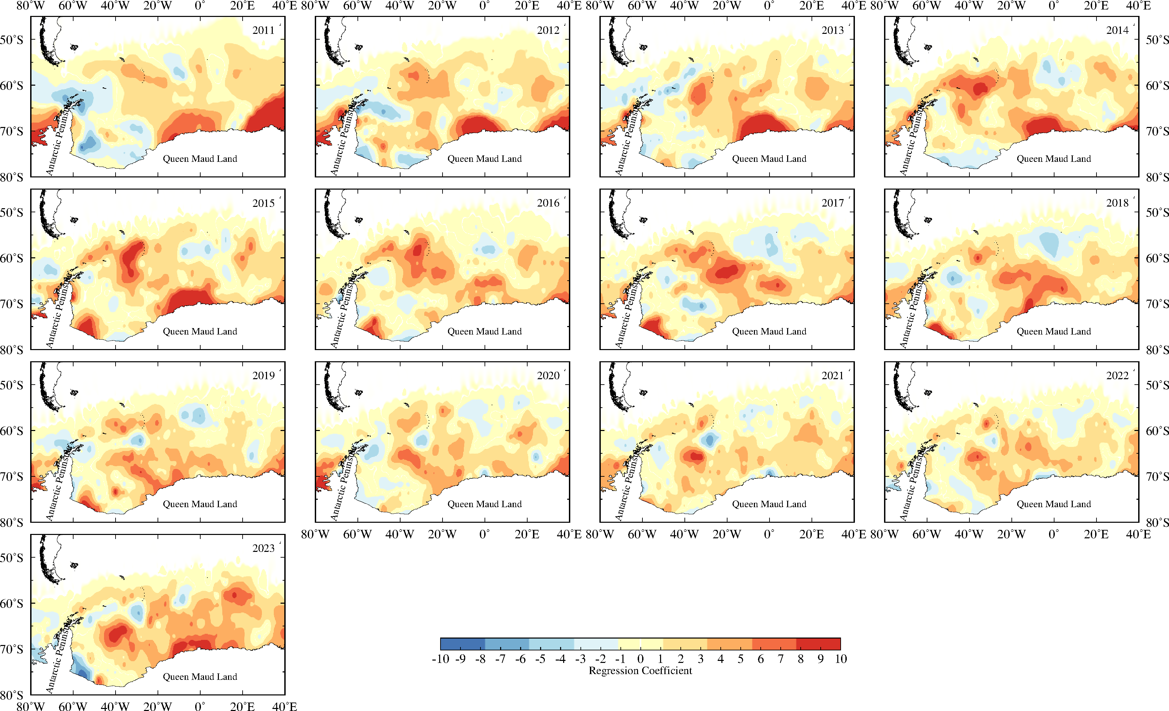
Figure A4. Spatial and temporal distribution of the influence coefficient of LH on schistosomiasis

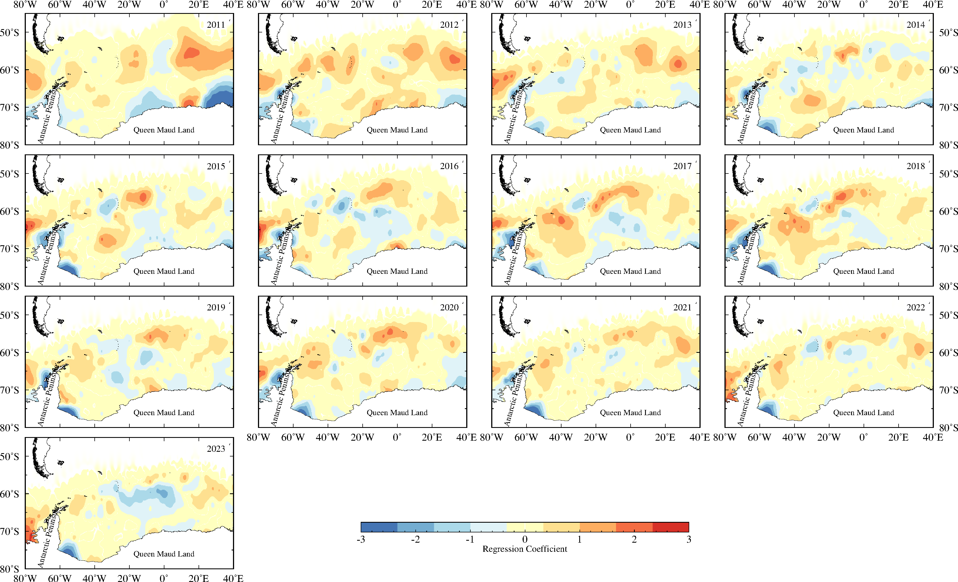
Figure A5. Spatial and temporal distribution of the influence coefficient of NR on schistosomiasis
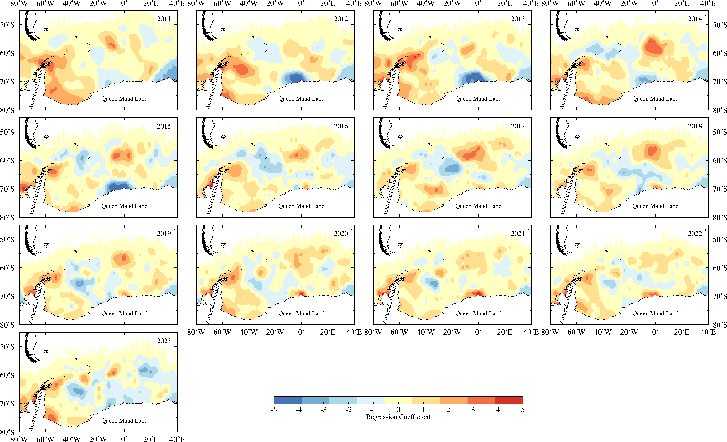
Figure A6. Spatial and temporal distribution of the influence coefficient of SH on schistosomiasis

