Supplementary information

Elucidating the potential role of cerium-based nanomaterial in triggering activation of xylose-utilizing genes in Saccharomyces cerevisiae to convert lignocellulosic biomass into bioethanol

Mamata S. Singhvi¹*, Beom Soo Kim²

¹Department of Biotechnology (with Jointly Merged Institute of Bioinformatics and Biotechnology), Savitribai Phule Pune University, Pune 411007, India
²Department of Chemical Engineering, Chungbuk National University, Cheongju,
Chungbuk 28644, Republic of Korea

Corresponding Author*:
Dr. Mamata S. Singhvi
Department of Biotechnology (with Jointly Merged Institute of Bioinformatics and Biotechnology),
Savitribai Phule Pune University,
Pune 411007, India
E-mail: mamatasinghvi@gmail.com

S1. Materials and Methods
S1.1. Production of laccase enzyme for delignification of corn cob biomass waste (CCBW)
Laccase was produced by Pleurotus ostreatus ATCC 56761 using CCBW as reported earlier (1). To delignify the CC biomass, laccase with an activity level of 100 IU/mL was employed. The enzymatic delignification process involved the addition of laccase enzyme to the powdered substrate within a 100 mL Erlenmeyer conical flask, utilizing a 20% w/v substrate concentration. Following a specific incubation period, the solid residue was isolated and subsequently subjected to oven drying in order to determine the residual lignin content.

S2. Results and Discussion
S2.1. Characterization of synthesized CeFe₃O₄NPs
To comprehend the physical modifications, the size and morphology of CeFe₃O₄NPs were examined through TEM and SEM analysis which demonstrated agglomerated sphere-shaped particles with a size ranging from 11-16 nm (2) (Fig. S1A and S1B). Fig.1C represents the elemental analysis of CeFe₃O₄NPs using EDS technique. The presence of peak at 4.75 and 6.5 keV corroborates the occurrence of cerium (39.30%) and iron (30.95%) elements substantiating the higher content of cerium than iron. Also, FTIR analysis (as shown in Fig.1D) was carried out to identify the functional groups present in NPs displaying individual peaks at 515 cm⁻¹ and 585 cm⁻¹ wavelength corresponding to Ce-O and Fe-O groups. The presence of absorption peaks at 1510, 1645 and 3470 cm⁻¹ ascribing to vibration of –NH, C=O and –OH group, correspondingly, validate the conjugation of synthesized CeFe₃O₄NPs (2) (3) (Fig.1D). DLS analysis was conducted to investigate zeta potential (ZP) and hydrodynamic size of CeFe₃O₄NPs. The zeta potential (ZP) studies of the synthesized NPs is significant factor for understanding the stability and surface chemistry of NPs in the colloidal phase. As shown in Fig. S1E, the measured ZP value was -15.0 ± 3.92 mV, which demonstrates that NPs has a net negative charge on its surface and are stable. Further, XRD and TGA analysis was performed to check crystallinity and thermal stability of synthesized NPs. The magnetic properties of CeFe₃O₄NPs were tested by applying a magnetic field. Even after the doping of cerium, Fe₃O₄ still possessed its ferromagnetic properties, which is beneficial for degradation of LB materials.
S2.2. Oxidase and CHE mimicking activities of CeFe₃O₄NPs
Oxidase enzymes serve to promote the oxidation of specific substrates by acting as electron donors, leading to the production of oxidized products utilizing O₂ as the electron acceptor under standard environmental conditions, thus producing water or H₂O₂. This capability can be advantageous for the pretreatment of LB materials.(4). Similar to oxidases, CeFe₃O₄NPs also oxidized substrates through electron transfer (5). Recently, numerous nanomaterials have been reported to act as catalysts for the oxidation of substrates in the presence of O₂, demonstrating oxidase mimicking activities (6, 7). Cerium-based nanomaterials containing the Ce^{3+/}Ce⁴⁺ redox pair have demonstrated the capability to catalyze the oxidation of TMB compounds under ambient conditions. This oxidation process associated with cerium-based NPs aligns with the kinetics observed in natural oxidase enzymes.(8).
The color change from colourless to bluish-green, accompanied by an absorbance peak at 420 nm, indicated the oxidation of ABTS and TMB substrates upon the addition of CeFe3O4NPs to the reaction mixture. A subtle color alteration observed with TMB as the substrate, as opposed to ABTS, suggests that CeFe₃O₄NPs exhibit a superior affinity for ABTS due to their oxidase properties (3) . As displayed in Table S2, the oxidase activity of CeFe₃O₄NPs using ABTS and TMB substrates was quantified at 0.4507±0.051 and as 0.3407±0.051IU/mg NPs, respectively. Furthermore, EDX analysis illustrated a higher mass percentage of cerium (39.30) than iron (30.95%) in CeFe₃O₄NPs, potentially attributing to their noteworthy laccase activity by oxidizing the ABTS substrate. CeFe₃O₄NPs represent novel insights in the field and have not been previously documented. The oxidase activity of CeFe₃O₄NPs in this study surpassed that of previously synthesized NPs (3) due to a higher percentage of cerium. Additionally, prior studies have reported that the presence of Ce⁴⁺ correlates with heightened oxidase activity compared to Ce³⁺ (9).
The flawed sites of nanomaterials exhibit a distinct influence in promoting the special adsorption of O₂ . Consequently, the adsorbed O₂ undergoes conversion into O₂^{•-} resulting in the concurrent oxidation of TMB. Simultaneously, the Ce⁴⁺ and Fe³⁺ species present on the surface of CeFe₃O₄NPs are reduced to Fe³⁺ and Fe^{2+,} subsequently recommencing their oxidation to Ce⁴⁺ and Fe³⁺ through the action of the generated O₂^{•-}. The oxidase-mimicking property of CeFe₃O₄NPs can be attributed to both the redox transformation of Ce³⁺/Ce⁴⁺ and Fe²⁺/Fe³⁺ as well as the production of O₂^{•-} radicals (as expressed in equations 1 and 2) (9).
$${Ce}^{4+}+HO_{2}^{•}= {Ce}^{3+}+H^{+}+ O_{2} \left(1\right)$$
$${Fe}^{3+}+HO_{2}^{•}= {Fe}^{2+}+H^{+}+ O_{2} \left(2\right)$$
EDS spectra analysis of CeFe₃O₄NPs (shown in Fig.S1C) revealed that the concentration of iron was lower than that of cerium. This resulted in a higher oxidase activity when the NPs were mixed with ABTS and TMB. This improved oxidase activity was employed for lignin degradation.
Cellulases encompass exoglucanase (FPase), endoglucanase (CMCase), and β-glucosidase (Cellobiase) enzymes, which may act sequentially or synergistically during cellulose depolymerization. The endoglucanase cleaves the β-1,4 linkages of the cellulose chains to release free ends, further fragmented into 2-4 units by exoglucanase to yield oligosaccharides. Subsequently, β-glucosidase degrades these oligosaccharides into glucose molecules.(10) Moreover, hemicellulase enzymes can degrade the hemicellulose biomass component, leading to increased accessibility of cellulose for hydrolysis (11). In the present study, the cellulase and hemicellulase mimicking activities of CeFe3O4-NPs were evaluated, and the results are presented in Table S2. Table S2 outlines the cellulase and hemicellulase mimicking activities of CeFe₃O₄NPs. Among the cellulases, β-glucosidase (0.211±0.009 IU/mg) exhibited higher activity compared to exoglucanase (0.059±0.0023 IU/mg) and endoglucanase (0.029±0.0011 IU/mg). Additionally, CeFe₃O₄NPs exhibited hemicellulase activities (0.073± 0.0035 IU/mg) when xylan was used as a substrate. The utilization of CeFe₃O₄NPs to reveal cellulase and hemicellulase activities could offer a sustainable and cost-effective alternative to the expensive pretreatment and enzymatic hydrolysis processes typically required for biomass conversion.
S2.3. Lignin degradation profile of CCBW samples by GC-MS analysis
The lignin-based materials consist of lignin, a key structural component, containing various functional groups including phenolic, hydroxyl, and carboxyl groups. The presence of these functional groups enhances the reactivity of lignin and facilitates its release in an intact form, rendering it suitable for diverse applications (12) . In the context of this study, the Folin-Ciocalteau method was employed to evaluate the phenolic content of samples collected at different intervals during SPH. The findings revealed that the highest concentration of phenolic compounds, measuring 0.431 ± 0.0052 mg/mL, was observed after 9h (data not shown). The released compounds after the delignification of CCBW substrate during SPH process were examined using GC-MS analysis to investigate the oxidase-mimicking activity of CeFe₃O₄NPs. Oxidase enzymes play a vital role in the delignification of biomass substrates in the presence of O₂, and CeFe₃O₄NPs. NPs showed strong oxidase-mimicking activity, leading to the degradation of lignin into monomeric aromatics and alcohol through the generation of free radicals from the CCBW substrate (13). GC-MS analysis of oxidase-mimicking NPs-treated CCBW indicated the production of new compounds with increasing SPH process time. Concurrently, other compounds were detected in the early phase of the SPH reaction. Notably, the analysis revealed the presence of significant compounds post-lignin degradation, as delineated in Table S4. Additionally, various aromatic alcohol compounds, phenolic, and other acid compounds, including butyl cinnamate, propanoic acid,, 2-hydroxycaproic acid and malic acid, were positively identified. The profile of compounds obtained after lignin degradation in this study closely corresponds to established findings on the microbial degradation of kraft lignin(14). Numerous carboxylic acids, including 3,5-di-tert-butyl-4-hydroxyphenyl propionic acid, 2-ethyl-3-hydroxypropionic acid, cinnamic acid, and 2-amino-.alpha.-[2-chlorophenyl] cinnamic acid, are part of the phenylpropanoid compounds. These compounds play a crucial role in connecting carbohydrate and lignin and are produced during the SPH process. Among aldehydes, 3-(4-isopropylphenyl)-2-methylpropionaldehyde was also noticed. Table S4A and B represent the compounds generated before and after SPH reaction at 9h intervals along with their retention time.
The presence of significant amounts of acids, alcohols, and esters among the lignin degradation products suggests that CeFe₃O₄NPs play a key role in cleaving the bonds of large molecules in CCBW substrate. These findings align with previous investigations (15) and support the effective action of CeFe₃O₄NPs in the delignification of CCBW, as confirmed by the generation of low molecular weight products in GC-MS analysis during SPH process. The predominance of acids, alcohols, and aldehydes post-delignification holds commercial significance due to their applications in the perfume and aroma industries(16).
S2.4. Structural characterization of untreated and treated CCBW samples
In order to conduct a comparative analysis of untreated and treated CCBW samples, structural characterization studies were performed using a variety of techniques, including SEM, FTIR, XRD, thermogravimetric analysis (TGA), and derivative thermogravimetric (DTG) analysis. To gain insight into the physical changes in CCBW samples resulting from the CeFe₃O₄NPs action during the SPH process, the alterations in the outer structure of untreated and treated CC samples were examined through SEM analysis (Fig. S6). The untreated CCBW sample had a dense and intact surface structure (Fig.S6A), while the treated CCBW sample showed significant changes in surface topography after the SPH process indicating the removal of outer layer of lignin component (Fig.S6B). The structure of the treated CCBW appeared loose and porous, suggesting a strong interaction between CeFe3O4-NPs and untreated CCBW sample. This type of alteration in the surface morphology of CCBW samples through various pretreatment methods has been previously documented(17),(3).
FTIR was utilized to analyze the modifications in functional groups within biomass samples resulting from the presence of CeFe₃O₄NPs during the SPH process. As illustrated in Figure S6C, the FTIR spectra of both untreated and treated CCBW samples displayed the stretching of -OH groups and C-H stretching in CH₃ groups, observed at wavelengths of 3340–3420 cm⁻¹ and 2900 cm⁻¹, respectively. The analysis of the treated CCBW sample revealed significant changes. The reduction in absorption peak at wavelength 1680 cm⁻¹, associated with the C=O stretching of ester groups present in hemicellulose, indicates the removal of hemicellulose. Moreover, distinctive peaks at wavelengths of 1510 cm⁻¹ and 1240 cm⁻¹, attributed to C-C, C-H, and C-O vibrations in the aromatic ring skeleton of the lignin component, were noticeably reduced, suggesting the elimination of lignin due to the action of CeFe₃O₄NPs. Additionally, a decrease in absorption peaks at wavelengths 1080, 1360, and 1410 cm-1, associated with the cellulose crystallinity, reflects alterations in the functionality of the cellul6se component in the treated CCBW samples(17),(18),(19). As a result, it can be asserted that the delignification process using CeFe₃O₄NPs is succeeded followed by the hydrolysis of cellulose and hemicellulose in conjunction with enzymes to liberate sugars, which are subsequently utilized for bioethanol production. These findings are well-supported by the data obtained from the biocompositional analysis (Table 3). X-ray diffraction (XRD) analysis was used to determine the crystallinity of both CCBW samples. Evaluating the crystallinity is important for understanding the effectiveness of biomass pretreatment methods. The influence of simultaneous delignification and hydrolysis of untreated CCBW using CeFe₃O₄NPs during SPH process was also studied. The analysis of the treated CCBW sample revealed a slight increase in peak intensity, indicating enhanced biomass crystallinity. Table S5 presents the crystallinity index (CrI %) of both CCBW samples. CrI (%) value of untreated CCBW decreased from 64.11% to 55.15% after the SPH process. This decrease suggests a reduction in the total crystallinity of the treated CCBW sample due to the effects of CeFe3O4-NPs in delignification, and their role in aiding the concurrent deconstruction of cellulose/hemicellulose components alongside enzymes during SPH reaction.The increased release of fermentable sugars after the SPH process from untreated CCBW appears to be linked to the lower crystallinity of treated CCBW sample. This suggests that the reduced crystallinity enhances the accessibility of raw CCBW. Additionally, the decrease in crystallite size after the SPS step for the treated CC aligns well with the decrease in crystallinity percentage (Table S5). These observations are consistent with previous studies(20),(21) .
The CeFe₃O₄NPs' impact on the thermal degradation of CCBW was investigated through the thermogravimetric analysis (TGA) of both untreated and treated samples, as depicted in Fig. S6E. Both samples exhibited significant weight loss between 240 and 380 °C. The treated CC yielded a carbonized residue comprising 30.31 % of the total weight, whereas the untreated CCBW showed comparatively lower weight loss than the treated CCBW. Various studies have documented a higher percentage of weight loss in biochar from treated biomass samples compared to raw biomass(22). As depicted in Fig. S6F, DTG analysis indicated the persuasive breakdown process initiates at 280 °C and 340 °C before the reaction slows down again. The first slow decomposition is due to cellulose-carbohydrate degradation which is known as pyrolysis of cellulose degradation from 300 °C and 400 °C(23). In a later stage, polysaccharides and lignin degrade into carbonized substances during SPH process, causing a shift in the peak temperature from 305°C to 325°C for the treated CCBW sample. This shift indicates the degradation of cellulose from untreated CCBW sample.

Table S1 Checking of quality and yield of extracted RNA from RCC (Test) and PCC (control) samples
S. No | SAMPLE  NAME | QUBIT  (ng/µL) | RIN NO.
1 | RCC | 294 | 8.8
2 | PCC | 398 | 8.4

Table S2 Determination of cellulase- hemicellulase and oxidase activities of CeFe₃O₄NPs
Oxidase  Activity  (IU/mg) | Cellulase activities  (IU/mg) |  |  | Hemicellulase activity  (IU/mg)
0.4507±0.051 (ABTS) | Exoglucanase | Endoglucanase | β-glucosidase
0.3407±0.051 (TMB) | 0.059±0.0023 | 0.029±0.0011 | 0.211±0.0009 | 0.073± 0.0035

Table S3 Post alignment statistics
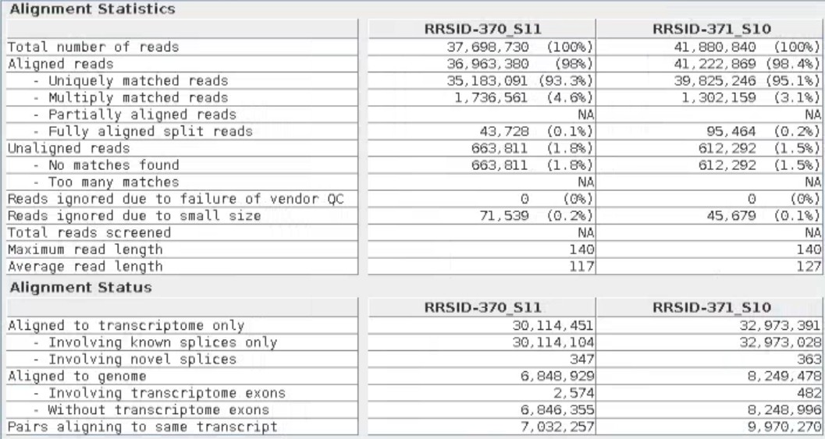

Table S4 GC-MS analysis of hydrolysates obtained after action of CeFe₃O₄-NPs on CCBW during SPH reaction: (A) 0 h and (D) 9h.
(A)
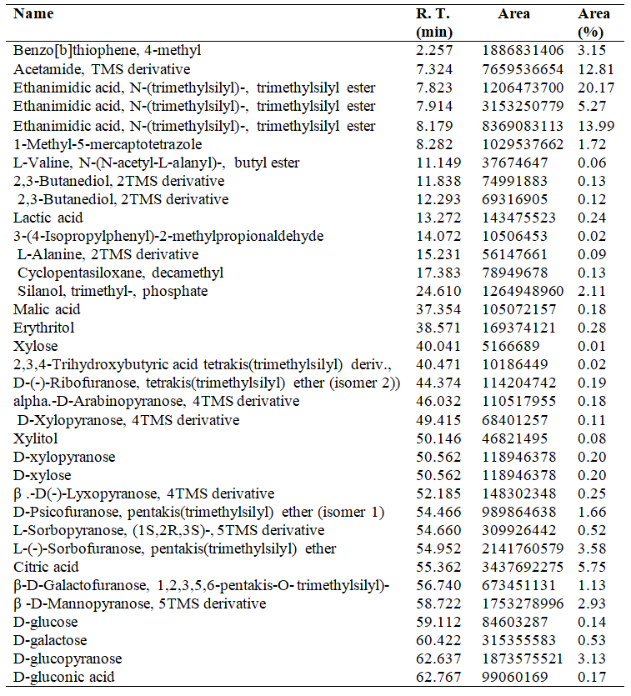

(B)
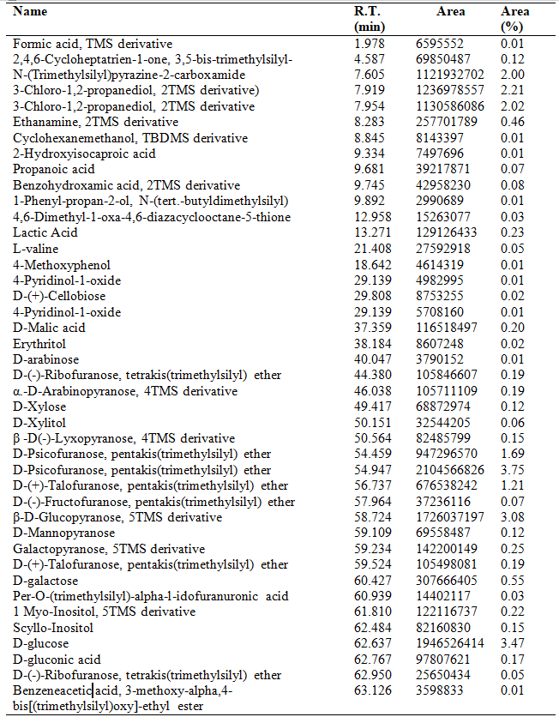

Table S5 Crystallinity index (CrI) and crystallite sizes (nm) of untreated CCBW and treated CCBW samples
Samples | Crystallinity index  (crI) (%) | Relative decrease in crystallinity (%) | Crystallite size  (nm)
Untreated CCBW | 64.11 | - | 563.11
Treated CCBW | 55.14 | 13.99 | 286.20

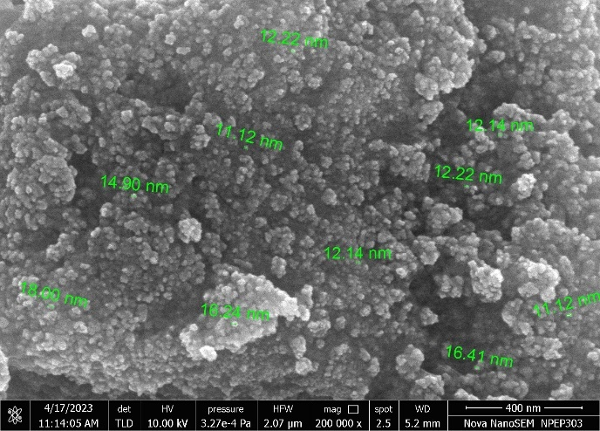

(B)

(A)

(A)

(C)

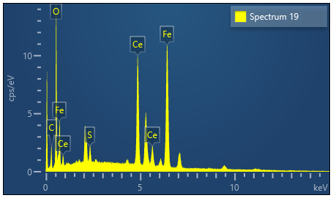
(C)
Element | Wt% | Wt% Sigma | Atomic %
C | 9.01 | 0.35 | 26.35
O | 19.64 | 0.22 | 43.11
S | 1.11 | 0.06 | 1.22
Fe | 30.95 | 0.24 | 19.47
Ce | 39.30 | 0.28 | 9.85
Total | 100.00 |  | 100.00

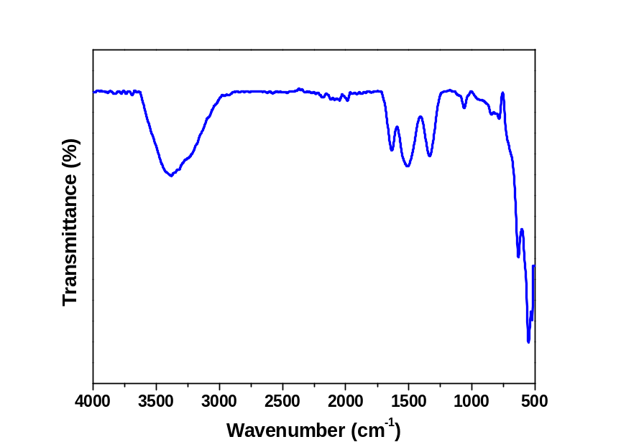
(E)
(D)
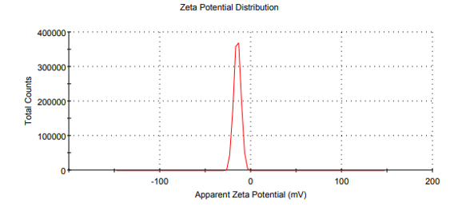

Fig.S1 Characterization of synthesized CeFe₃O₄NPs using: (A)SEM, (B) TEM, (C)EDX, (D)FTIR and (E) Zeta potential analysis methods

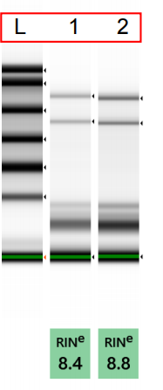

Fig.S2 Checking of total RNA samples on agarose gel. Lanes 1 & 2 correspond to RNA samples extracted from S. cerevisiae cells grown using PCC-Control (RRSID-371) & RCC-Treated (RRSID-370) samples respectively.

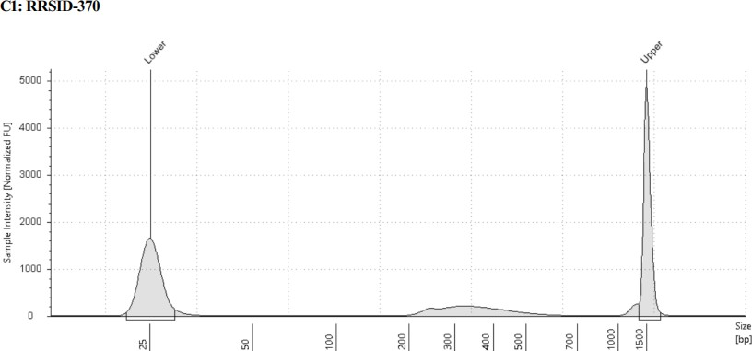
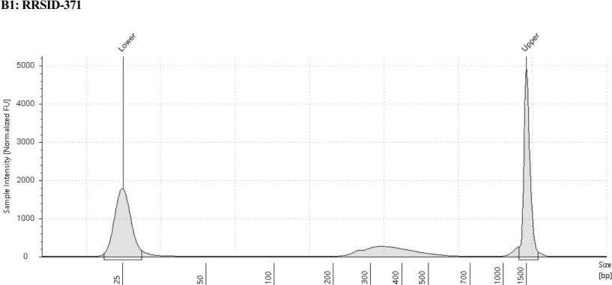
(A)

(B)

Fig.S3 Tape profiles of the obtained libraries of extracted RNA samples from S. cerevisiae cells grown using PCC- Control and RCC-Treated samples

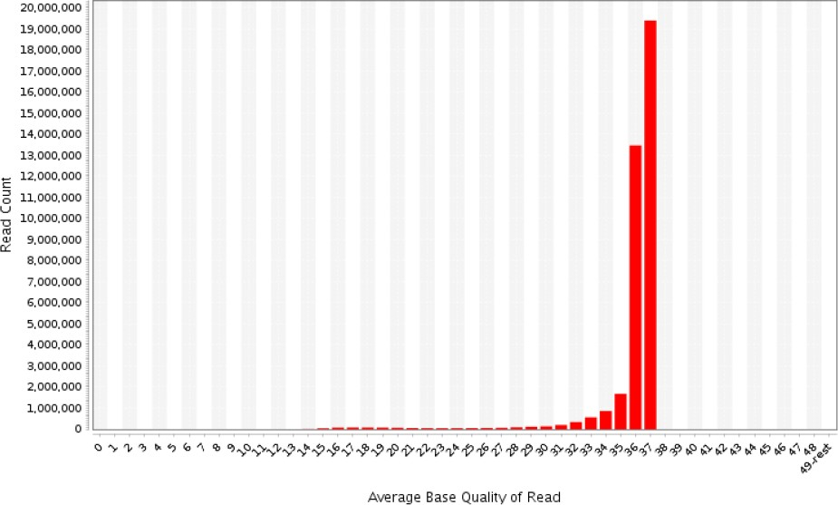
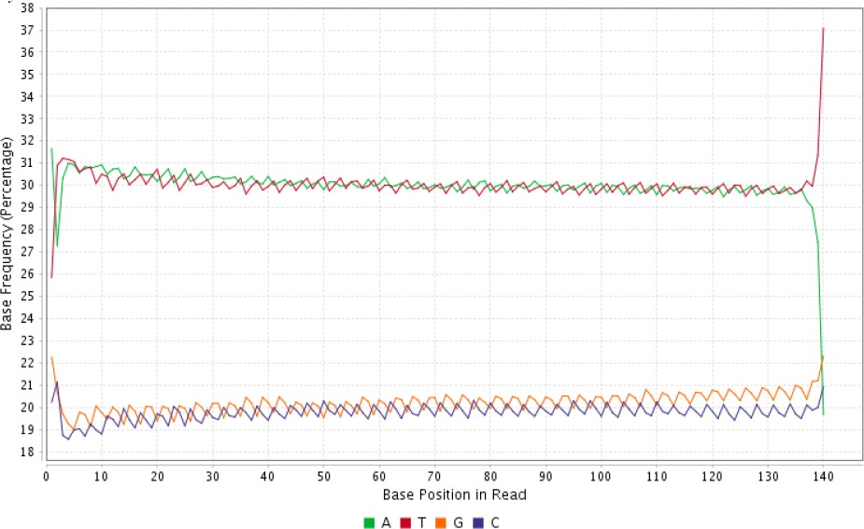
(C)
(D)
(B)
(A)
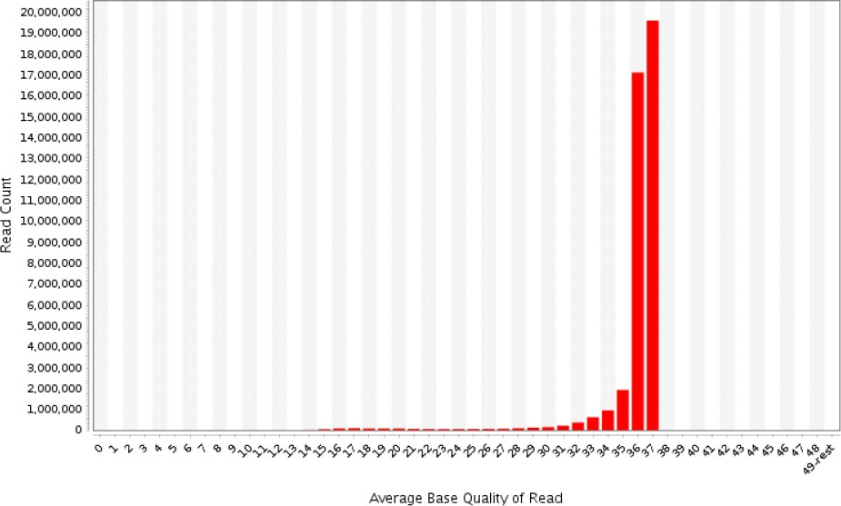
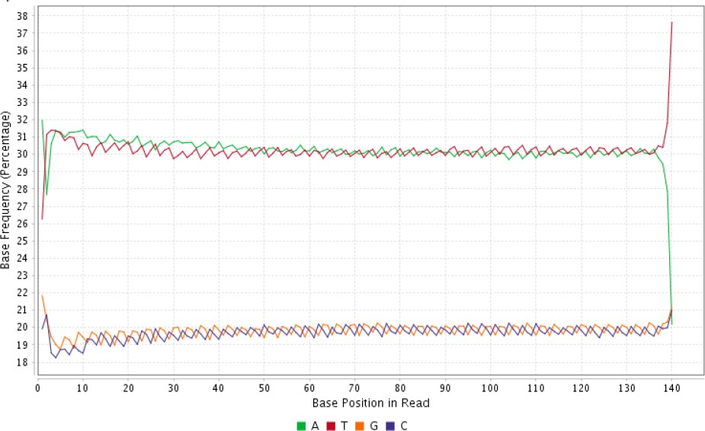

Fig. S4 Pre alignment Quality check: Analysis of raw read pre-processing of PCC-Control (A and B) and RCC-Treated (C and D) samples: (i) Mean quality scores per read (B and D). (ii) Mean quality scores per position (A and C).

RRSID-370_S11 (PCC-Control)
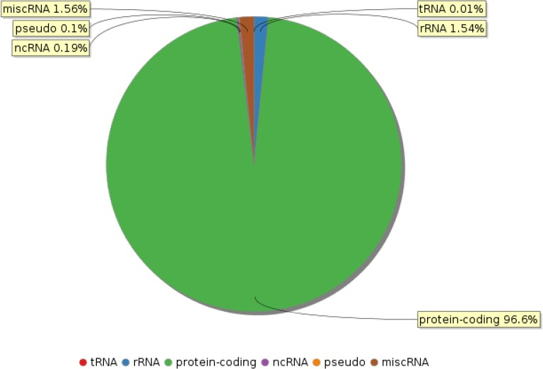
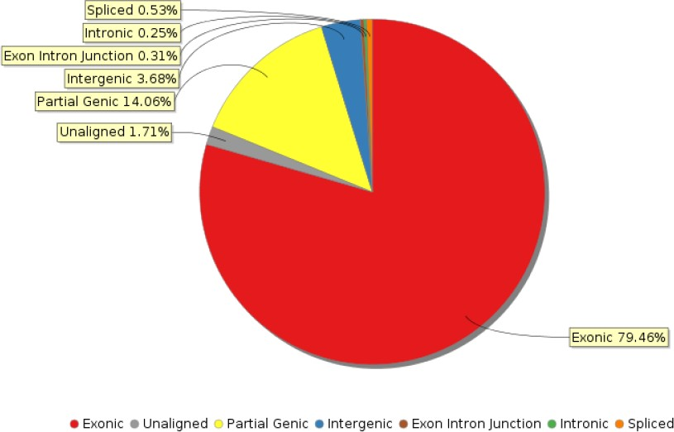
(B)
(A)

RRSID-371_S10 (RCC-Treated)
(C)
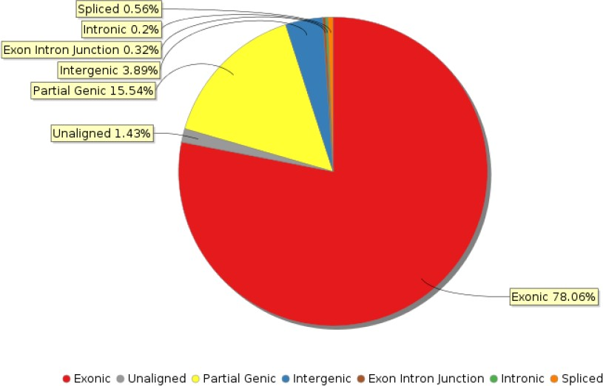
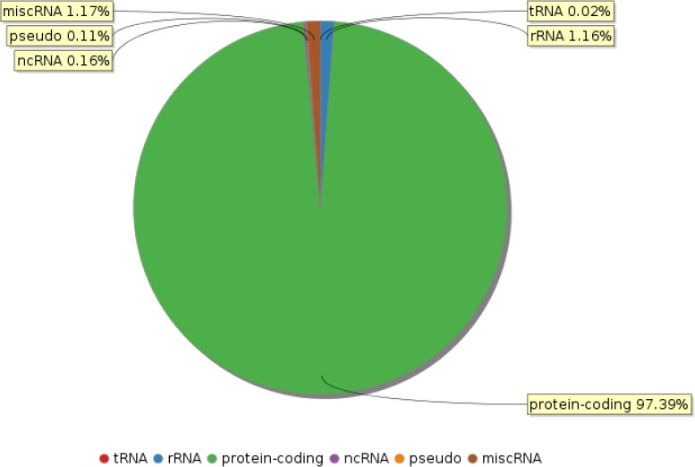
(D)

Fig. S5 Post alignment Quality check analysis of both RRSID-370_S11 (PCC-Control) and RRSID-371_S10 (RCC-Treated) samples in the form of gene type plot (A and C) and genic region plot (B and D).

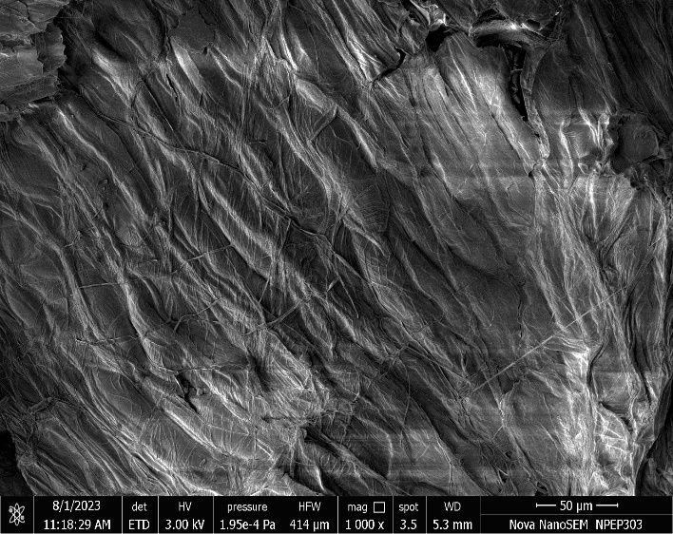
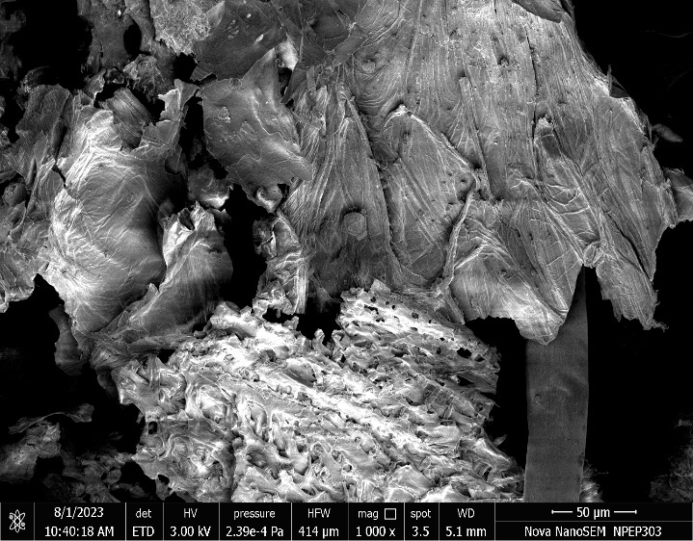
(B)
(A)

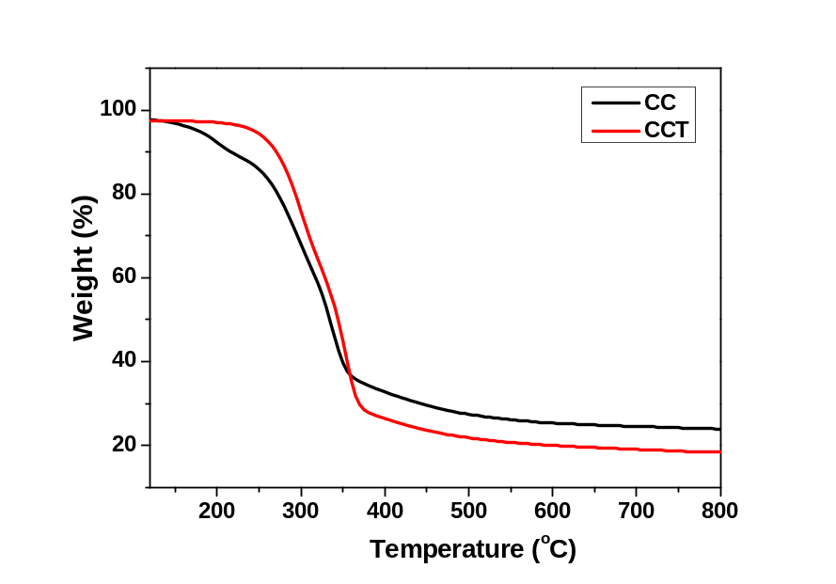
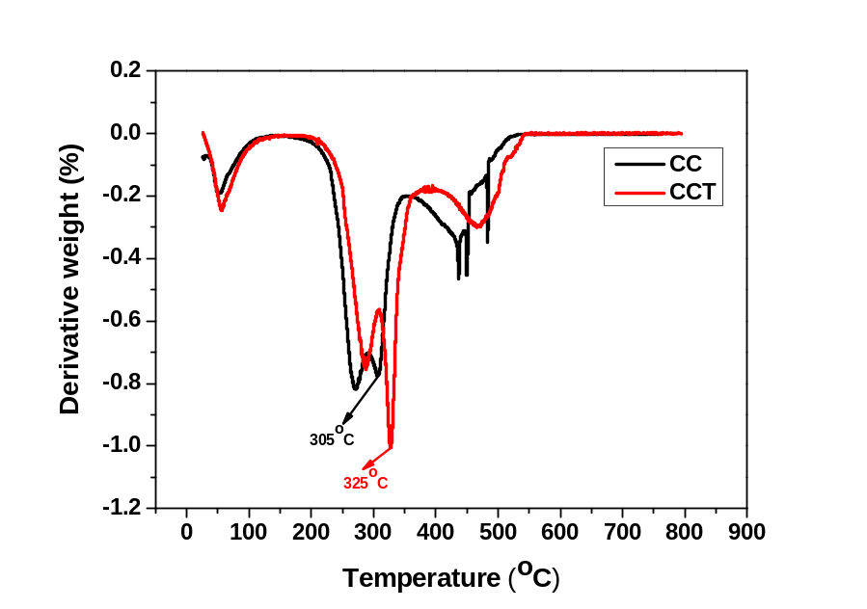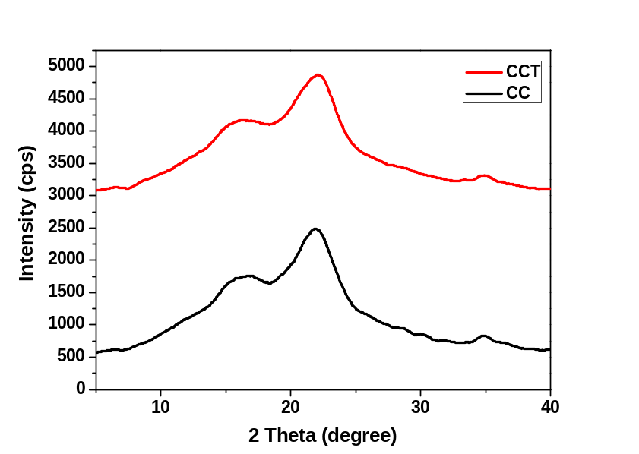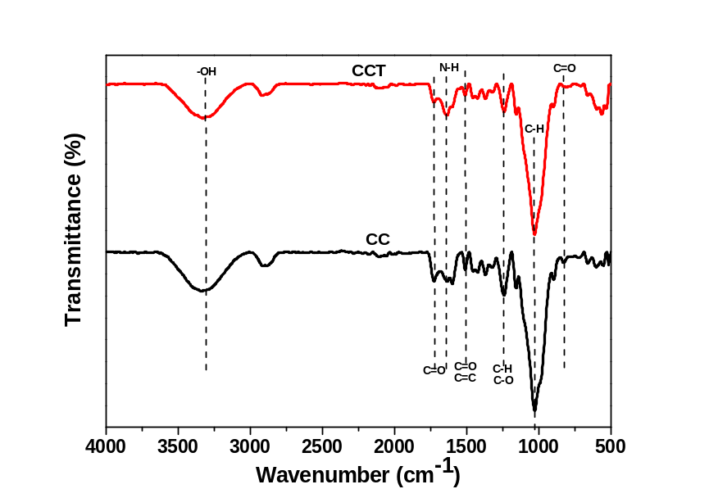
(D)
(C)
(F)
(E)

Fig. S6 Characterization of raw CCBW (i.e. CC) and treated CCBW (i.e. CCT) biomass samples using (A) SEM, (B) TEM, (C) FTIR, (D) XRD, (E) TGA, and (F) DTG analysis.

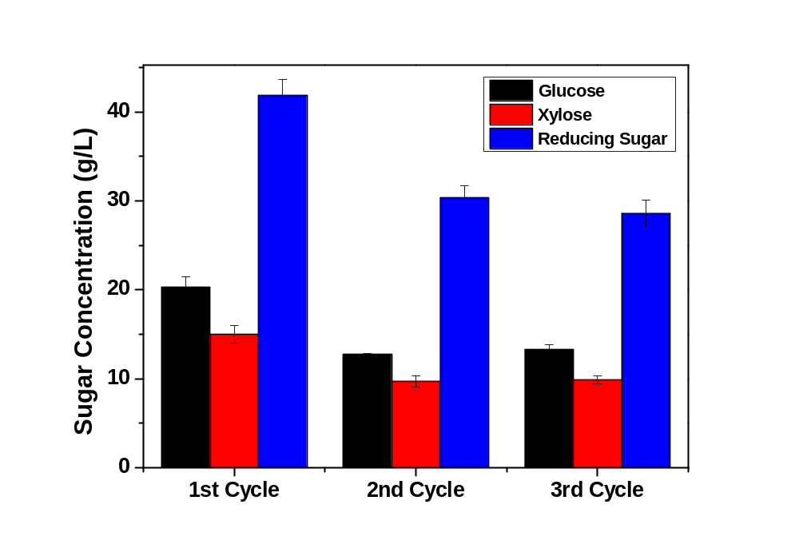

Fig.S7 Reuse of CeFe₃O₄NPs and their Impact on the release of glucose, xylose, and reducing sugar during SPH process.
References
1. A. Avanthi, R. Banerjee, A strategic laccase mediated lignin degradation of lignocellulosic feedstocks for ethanol production. Ind. Crops Prod. 92, 174–185 (2016).
2. Aashima, S. Uppal, A. Arora, S. Gautam, S. Singh, R. J. Choudhary, S. K. Mehta, Magnetically retrievable Ce-doped Fe3O4 nanoparticles as scaffolds for the removal of azo dyes. RSC Adv. 9, 23129–23141 (2019).
3. R. C. Rajak, P. Saha, M. Singhvi, D. Kwak, D. Kim, H. Lee, A. R. Deshmukh, Y. Bu, B. S. Kim, An eco-friendly biomass pretreatment strategy utilizing reusable enzyme mimicking nanoparticles for lignin depolymerization and biofuel production. Green Chem. 23, 5584–5599 (2021).
4. P. Giardina, V. Faraco, C. Pezzella, A. Piscitelli, S. Vanhulle, G. Sannia, Laccases: A never-ending story. Cell. Mol. Life Sci. 67, 369–385 (2010).
5. J. E. Grebel, J. A. Charbonnet, D. L. Sedlak, Oxidation of organic contaminants by manganese oxide geomedia for passive urban stormwater treatment systems. Water Res. 88, 481–491 (2016).
6. T. Jin, Y. Li, W. Jing, Y. Li, L. Fan, X. Li, Cobalt-based metal organic frameworks: A highly active oxidase-mimicking nanozyme for fluorescence “turn-on” assays of biothiol. Chem. Commun. 56, 659–662 (2020).
7. T. Peng, J. Miao, Z. Gao, L. Zhang, Y. Gao, C. Fan, D. Li, Reactivating Catalytic Surface: Insights into the Role of Hot Holes in Plasmonic Catalysis. Small 14, 1–7 (2018).
8. H. Cheng, S. Lin, F. Muhammad, Y. W. Lin, H. Wei, Rationally Modulate the Oxidase-like Activity of Nanoceria for Self-Regulated Bioassays. ACS Sensors 1, 1336–1343 (2016).
9. G. Vinothkumar, P. Arunkumar, A. Mahesh, A. Dhayalan, K. Suresh Babu, Size- and defect-controlled anti-oxidant enzyme mimetic and radical scavenging properties of cerium oxide nanoparticles. New J. Chem. 42, 18810–18823 (2018).
10. R. G. De Paula, A. C. C. Antoniêto, K. M. V. Nogueira, L. F. C. Ribeiro, M. C. Rocha, I. Malavazi, F. Almeida, R. N. Silva, Extracellular vesicles carry cellulases in the industrial fungus Trichoderma reesei. Biotechnol. Biofuels 12, 1–14 (2019).
11. C. Sanhueza, G. Carvajal, J. Soto-Aguilar, M. E. Lienqueo, O. Salazar, The effect of a lytic polysaccharide monooxygenase and a xylanase from Gloeophyllum trabeum on the enzymatic hydrolysis of lignocellulosic residues using a commercial cellulase. Enzyme Microb. Technol. 113, 75–82 (2018).
12. R. Gosselink, Sustainable lignin valorization. (2021).
13. J. Su, J. Fu, Q. Wang, C. Silva, A. Cavaco-Paulo, Laccase: a green catalyst for the biosynthesis of poly-phenols. Crit. Rev. Biotechnol. 38, 294–307 (2018).
14. M. Hernández, M. J. Hernández-Coronado, M. D. Montiel, J. Rodríguez, M. E. Arias, Analysis of alkali-lignin in a paper mill effluent decolourised with two Streptomyces strains by gas chromatography-mass spectrometry after cupric oxide degradation. J. Chromatogr. A 919, 389–394 (2001).
15. N. Feng, L. Guo, H. Ren, Y. Xie, Z. Jiang, M. Ek, H. Zhai, Changes in chemical structures of wheat straw auto-hydrolysis lignin by 3-hydroxyanthranilic acid as a laccase mediator. Int. J. Biol. Macromol. 122, 210–215 (2019).
16. M. P. Pandey, C. S. Kim, Lignin Depolymerization and Conversion: A Review of Thermochemical Methods. Chem. Eng. Technol. 34, 29–41 (2011).
17. M. S. Singhvi, A. R. Deshmukh, B. S. Kim, Cellulase mimicking nanomaterial-assisted cellulose hydrolysis for enhanced bioethanol fermentation: an emerging sustainable approach. Green Chem. 23, 5064–5081 (2021).
18. A. Althuri, L. K. S. Gujjala, R. Banerjee, Partially consolidated bioprocessing of mixed lignocellulosic feedstocks for ethanol production. Bioresour. Technol. 245, 530–539 (2017).
19. G. Charis, G. Danha, E. Muzenda, Characterizations of biomasses for subsequent thermochemical conversion: A comparative study of pine sawdust and acacia tortilis. Processes 8 (2020).
20. B. W. Koo, B. C. Min, K. S. Gwak, S. M. Lee, J. W. Choi, H. Yeo, I. G. Choi, Structural changes in lignin during organosolv pretreatment of Liriodendron tulipifera and the effect on enzymatic hydrolysis. Biomass and Bioenergy 42, 24–32 (2012).
21. E. G. Mission, A. T. Quitain, M. Sasaki, T. Kida, Synergizing graphene oxide with microwave irradiation for efficient cellulose depolymerization into glucose. Green Chem. 19, 3831–3843 (2017).
22. Y. Tao, S. Li, P. Li, Q. Wu, Thermogravimetric analyses (TGA) of lignins isolated from the residue of corn stover bioethanol (CSB) production. Holzforschung 70, 1175–1182 (2016).
23. H. Yang, R. Yan, H. Chen, D. H. Lee, C. Zheng, Characteristics of hemicellulose, cellulose and lignin pyrolysis. Fuel 86, 1781–1788 (2007).

