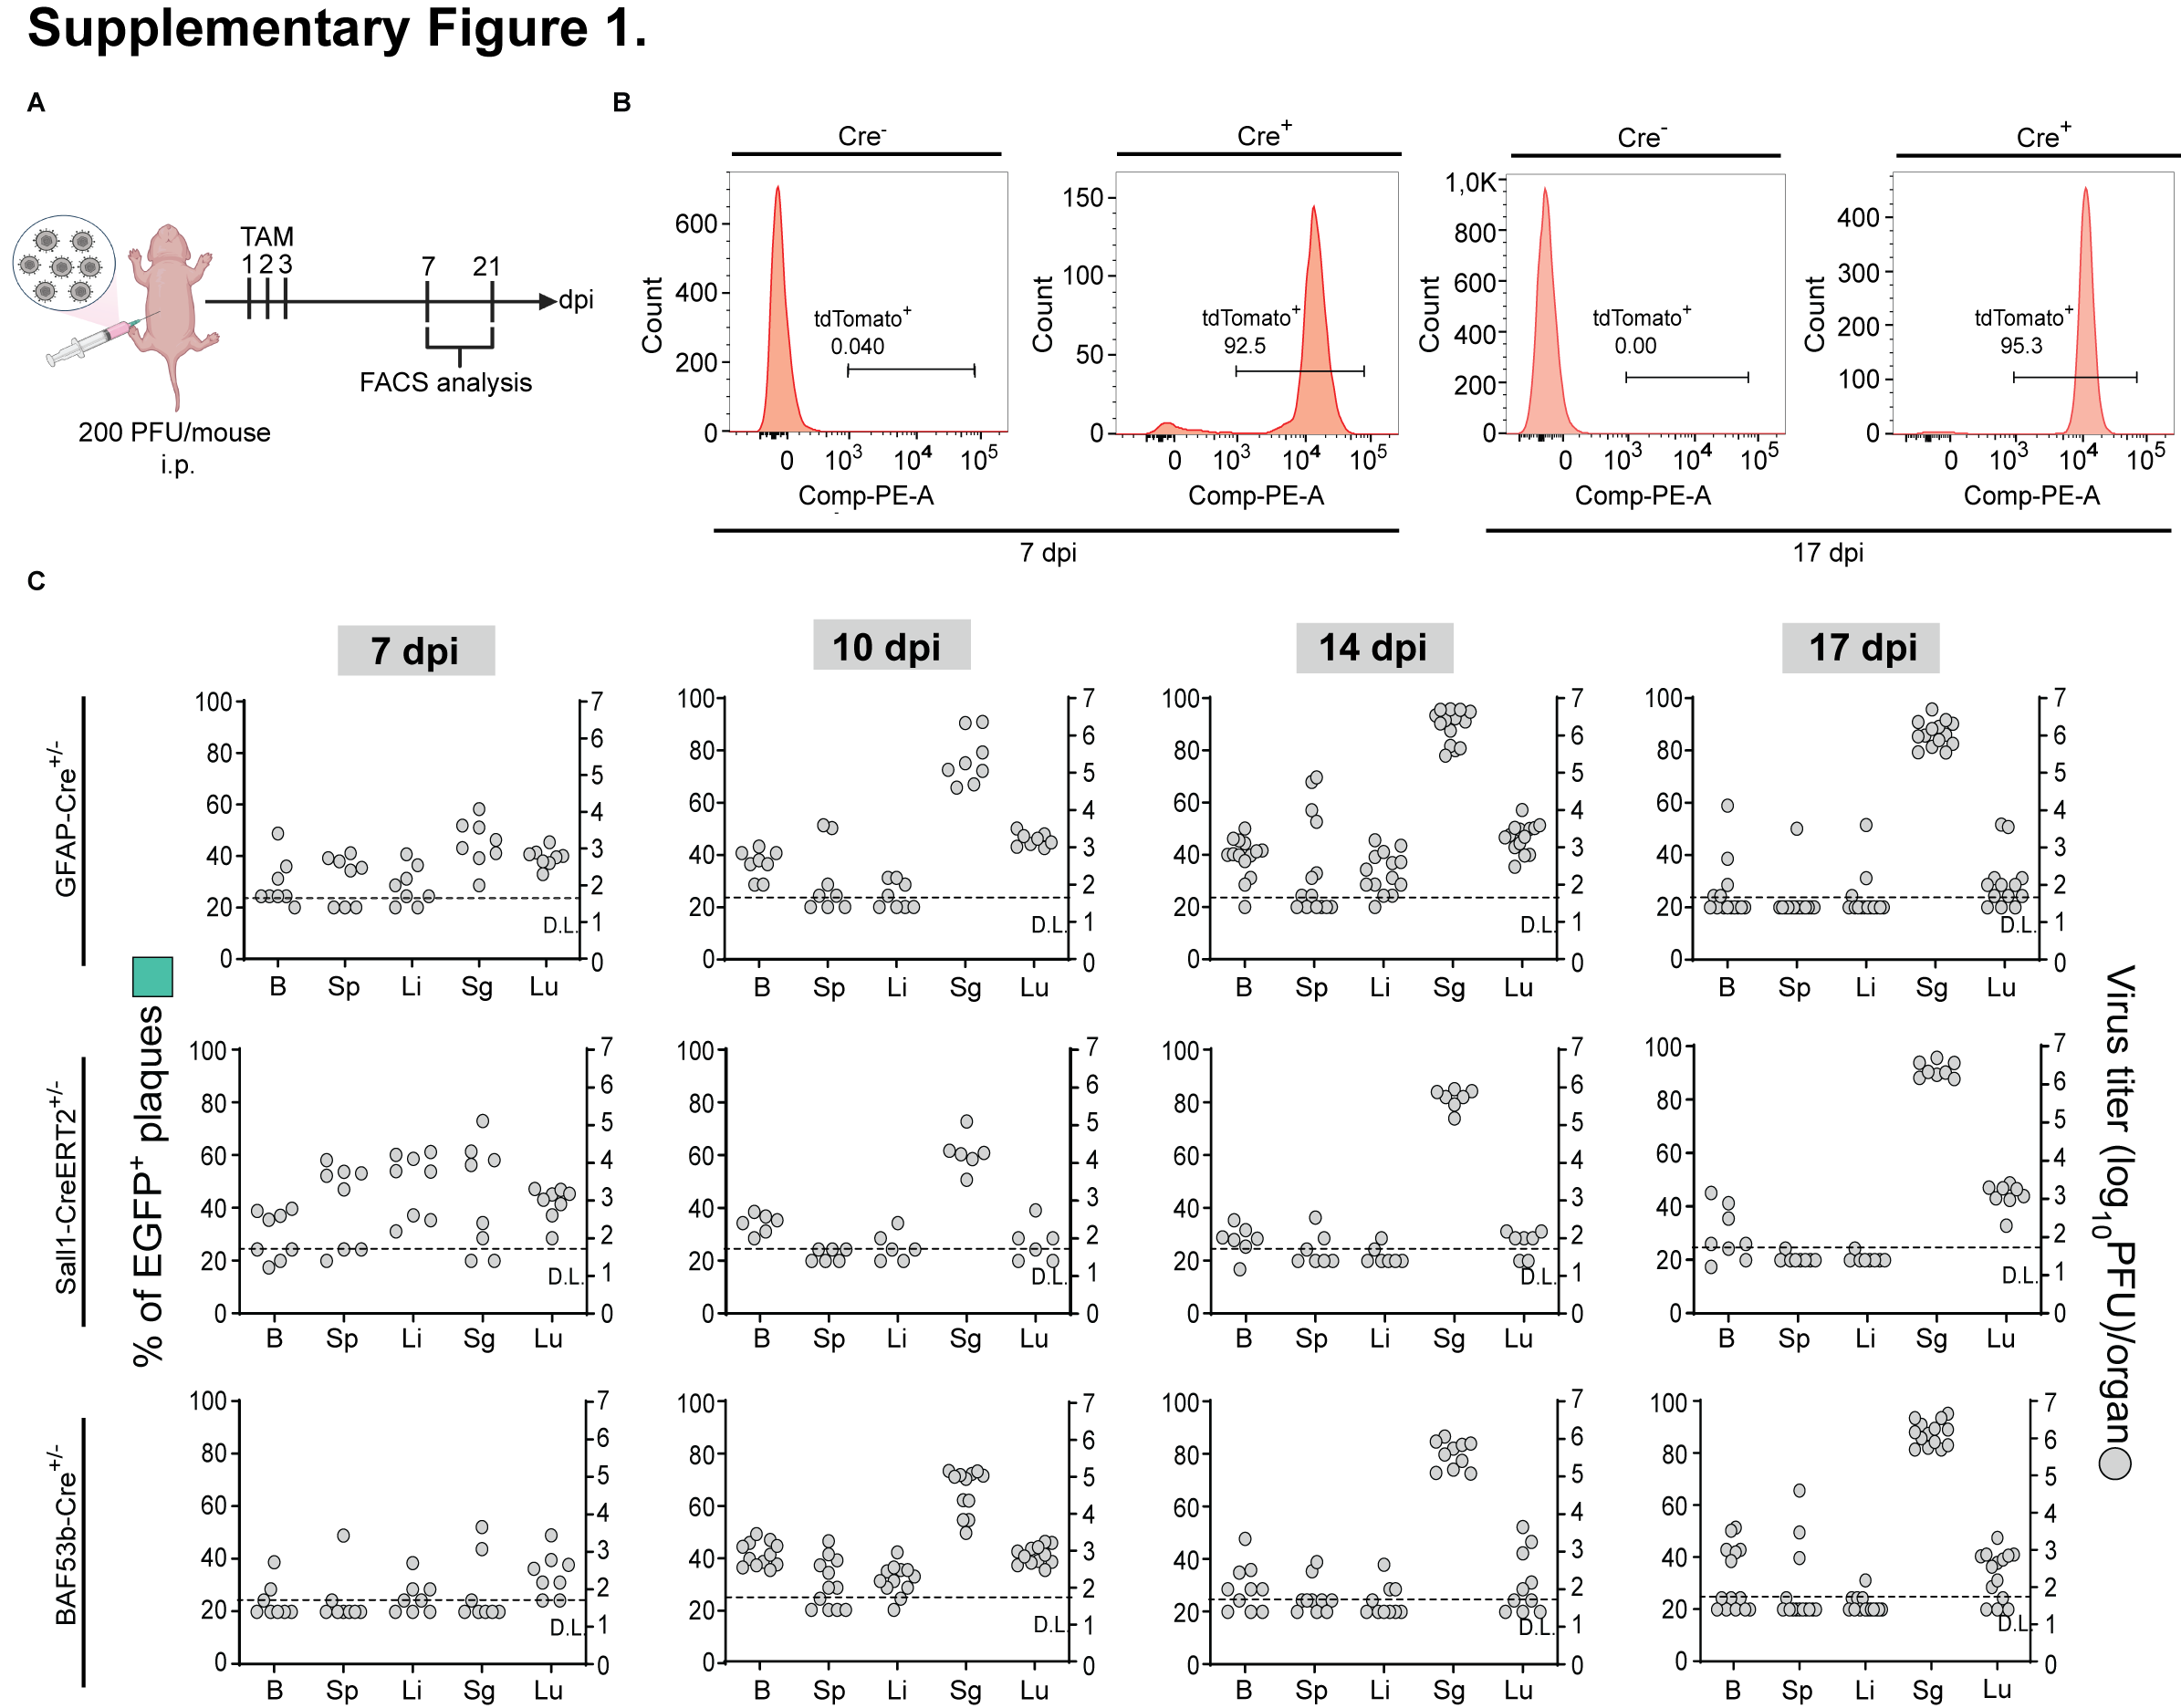Supplementary Figure 1. Tamoxifen treatment of Sall1CreERT2^{+/-} mice and control of spontaneous recombination of MCMV-flox. A) Experimental scheme depicting Tamoxifen (TAM) treatment of newborn mice infected with MCMV intraperitoneally (i.p.). On postnatal days 2, 3 and 4, newborn mice were treated with 50 µg/day of TAM intragastrically (i.g.). The expression of the reporter protein tdTomato was analyzed by flow cytometry (FACS) on postnatal days 7 and 21 dpi. B) Expression of tdTomato by microglia (CD45.2^{int}CD11b⁺) of Sall1-CreERT2^{+/-} x R26^{tdTomato} (Cre⁺) and littermate control (Cre⁻) mice. Representative histograms are shown. C) Newborn Cre-negative mice were infected with 1500 PFU of MCMV-flox i.p. TAM was i.g. administered as described in A. Mice were euthanized at 7, 10, 14, and 17 dpi, and organs were collected. Titers in brain (B), spleen (Sp), liver (Li), salivary glands (Sg) and lungs (Lu) of individual mice are shown (circles); Mean percentage of EGFP⁺ plaques per organ are shown (bars); D.L., detection limit.

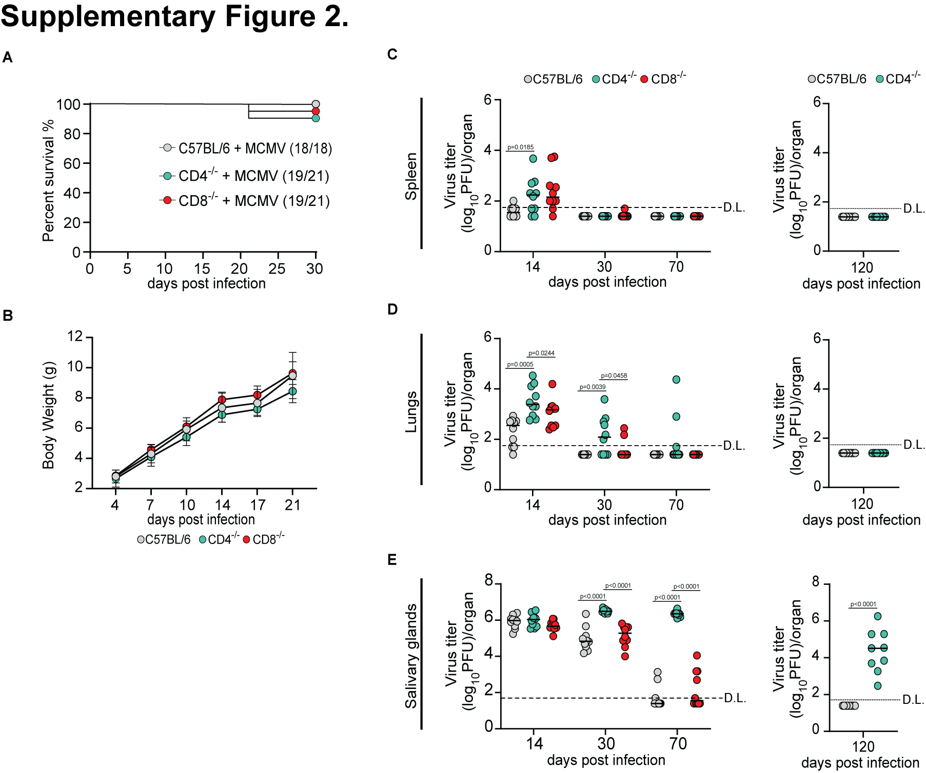
Supplementary Figure 2. Control of MCMV infection in newborn CD4- and CD8-knockout mice. A-C) Newborn C57BL/6, CD4^{-/-} and CD8^{-/-} mice were infected with 200 PFU of MCMV (n=10). A-B) Weight (A) and survival (B) were monitored. Mean values ± SEM are shown (n=18-22). C) Viral titers were determined by plaque assay at 14, 30 and 70 days post-infection. Titers in organs of individual mice are shown (circles); horizontal bars indicate the median values; D.L., detection limit. One-way ANOVA followed by Tukey's multiple comparison test was used; p values indicate significant differences (*p < 0.05; ***p < 0.001, and ****, p < 0.0001).

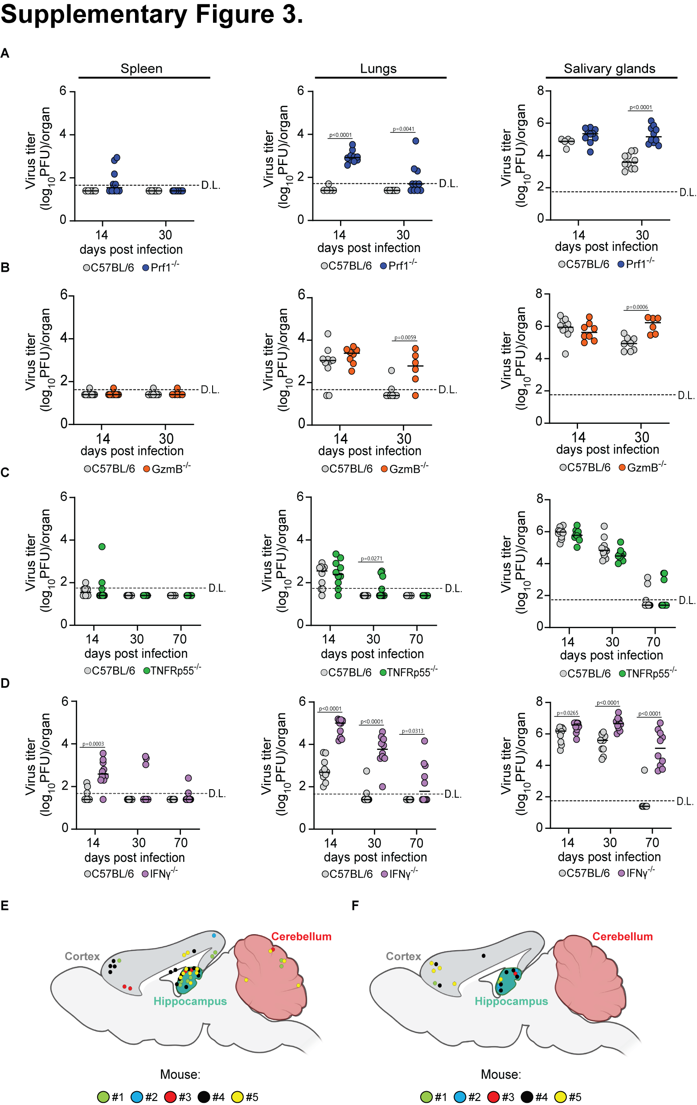
Supplementary figure 3. The role of T-cell effector mechanisms in the control of MCMV infection in newborn mice. Newborn C57BL/6, A) Prf1^{-/-}, B) Gzma^{-/-}Gzmb^{-/-}, C) TNFRp55^{-/-}, and D) IFN-γ^{-/}mice were infected with 200 PFU of MCMV. Viral titers were determined on 14, 30, and 70 dpi. Mean values are shown (n =5-14). Titers in organs of individual mice are shown (circles); horizontal bars indicate the median values; D.L., detection limit. Unpaired two-tailed Student’s test was used; p values indicate significant differences; *p < 0.05; **p < 0.01; ***p < 0.001, ****, p < 0.0001. (E,F) Topography of IE1⁺ cells in the brain of IFN-γ^{-/-} and Il12rb2^{-/-} mice (n=5).

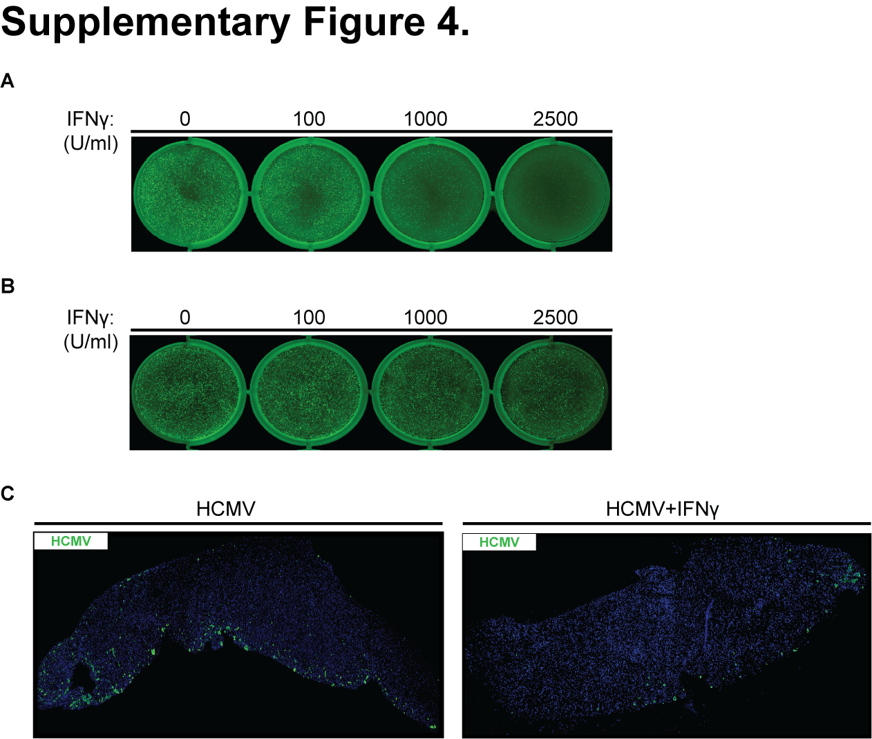
Supplementary figure 4. IFN-γ treatment restricts HCMV infection in neurons. A) Representative scanned plates of IFN-γ treated and KL7-EGP HCMV infected SH-SY5Y cells. Images were recorded using Amersham Typhoon. B) Representative scanned plates of KL7-EGP infected and IFN-γ treated SH-SY5Y cells. Images were recorded using Amersham Typhoon. C) Immunohistochemical staining of HCMV infection of hfOBSCs on day 2 post-infection. hfOBSCs were infected with 10⁷ PFU of KL7-EGP. One group of brain slices was treated with 1000 U/ml of recombinant IFN-γ in a culture medium. Representative images of HCMV-infected hfOBSCs. Tail scan, 20x magnification.

Supplementary figure 5. A) Schematic representation of the recombinant MCMVGFP_Cre virus. B) Newborn C57BL/6 mice were infected with 200 PFU of MCMV. Microglia, astrocytes and red pulp macrophages were sorted 90 dpi by FACS. DNA was isolated from sorted cells and qPCR analysis was performed to determine MCMV genome copy numbers per 10⁵ of sorted cells; Mock – mock-infected mice. RPMC – red pulp mesenchymal cells from spleen (positive control). Each sample represents a pool of 4-5 mice (n=2-6, N=3). Horizontal bars indicate the mean values with SD. C) On PND1, newborn C57BL/6 mice were infected with 200 PFU of MCMV. Viral titers were determined by plaque assay 180 dpi (n=6). Titers in organs of individual mice are shown (circles); horizontal bars indicate the median values; D.L., detection limit. D) Newborn C57BL/6 mice were infected with 200 PFU of MCMV and mice were depleted of CD4⁺ T-cells starting on 90 dpi for 1 month. The efficency of CD4⁺ T-cells depletion in the brain was analyzed using flow cytometry. Representative histograms are shown.

