Supplementary File

Table S1 Best-fit models for the phylogenetic trees construction of eight gene of the novel H3N3 isolate.
Gene | Best-fit model | Parameters | BICª | AICc^{b}
PB2 | GTR^{c}+G^{d}+Ie | 93 | 28272.63 | 27390.10
PB1 | GTR+G+I | 101 | 26987.50 | 26020.47
PA | GTR+G+I | 107 | 26186.52 | 25161.06
HA | GTR+G+I | 157 | 34644.43 | 33116.33
NP | GTR+G+I | 99 | 16715.75 | 15814.28
NA | TN93^{f}+G | 141 | 20591.53 | 19265.54
M | HKY^{g}+G | 106 | 10711.82 | 9775.50
NS | HKY+G | 100 | 11585.58 | 10723.86
ªBayesian Information Criterion; ^{b}Akaike Information Criterion; ^{c}General Time Reversible; ^{d}Gamma distributed; ^{e}Invariant sites; ^{f}Tamura-Nei; ^{g}Hasegawa-Kishino-Yano.

Table S2 Analysis of potential glycosylation sites in the HA protein of A/chicken/China/16/2023(H3N3) isolate.
Strains | Potential glycosylation sites of HA protein
Strains | 24 | 38 | 54 | 61 | 79 | 138 | 174 | 181 | 301 | 499
A/chicken/China/16/2023(H3N3) | - | NGT | NAT | NSS | - | - | - | NVT | NGS | NGT
A/China/ZMD-22-2/2022(H3N8)ª | - | NGT | NAT | NSS | - | - | - | NVT | NGS | NGT
A/China/CSKFQ-22-5/2022(H3N8)ª | - | NGT | NAT | NSS | - | - | - | NVT | NGS | NGT
A/Iran/Clinical Sample/2019(H3N3)ª | NST | NGT | NAT | NSS | NCT | NES | NYT | NVT | NGS | NET
A/bantam/Nanchang/9-366/2000(H3N3) | NNT | NGT | NAT | - | - | - | - | NVT | NGS | NGT
A/duck/Zhejiang/D16/2013(H3N3) | NST | NGT | NAT | - | - | - | - | NVT | NGS | NGT
A/chicken/China/NXFWB5/2022(H3N8) | - | NGT | NAT | NSS | - | - | - | NVT | NGS | NGT
A/chicken/Shantou/481/2022(H3N8) | - | NGT | NAT | NSS | - | - | - | NVT | NGS | NGT
A/duck/Hunan/199/2014(H3N8) | NST | NGT | NAT | - | - | - | - | NVT | NGS | NGT
ªThe strain was originated from human.

Table S3 Analysis of potential glycosylation sites in the NA protein of A/chicken/China/16/2023(H3N3) isolate
Strains | Potential glycosylation sites of NA protein
Strains | 14 | 57 | 66 | 72 | 146 | 308 | 387 | 401
A/chicken/China/16/2023(H3N3) | NTT | NCS | NNT | NIT | NGT | NET | NHT | NWS
A/Pigeon/Nanchang/9-058/2000(H3N3) | NTT | NCS | NNT | NIT | NGT | NET | - | -
A/bantam/Nanchang/9-366/2000(H3N3) | NTT | NCS | NNT | NIT | NGT | NET | - | -
A/aquatic bird/Korea/CN-4/2006(H3N3) | NTT | NCS | NNT | NIT | NGT | NET | - | -
A/duck/Zhejiang/D18/2013(H3N3) | NTT | NCS | NNT | NIT | NGT | NET | - | -
A/duck/Fujian/SD063/2017(H3N3) | - | NCS | NNT | NIT | NGT | NET | - | -
A/Environment/China/04940NA/2021(H10N3) | NTT | NCS | NNT | NIT | NGT | NET | NHT | -
A/China/0428NA/2021(H10N3)ª | NTT | NCS | NNT | NIT | NGT | NET | NHT | -
A/chicken/Zhejiang/516100/2017(H10N3) | NTT | NCS | NNT | NIT | NGT | NET | - | -
A/chicken/China/146-6/2021(H10N3) | NTT | NCS | NNT | NIT | NGT | NET | NHT | -
ªThe strain was originated from human.

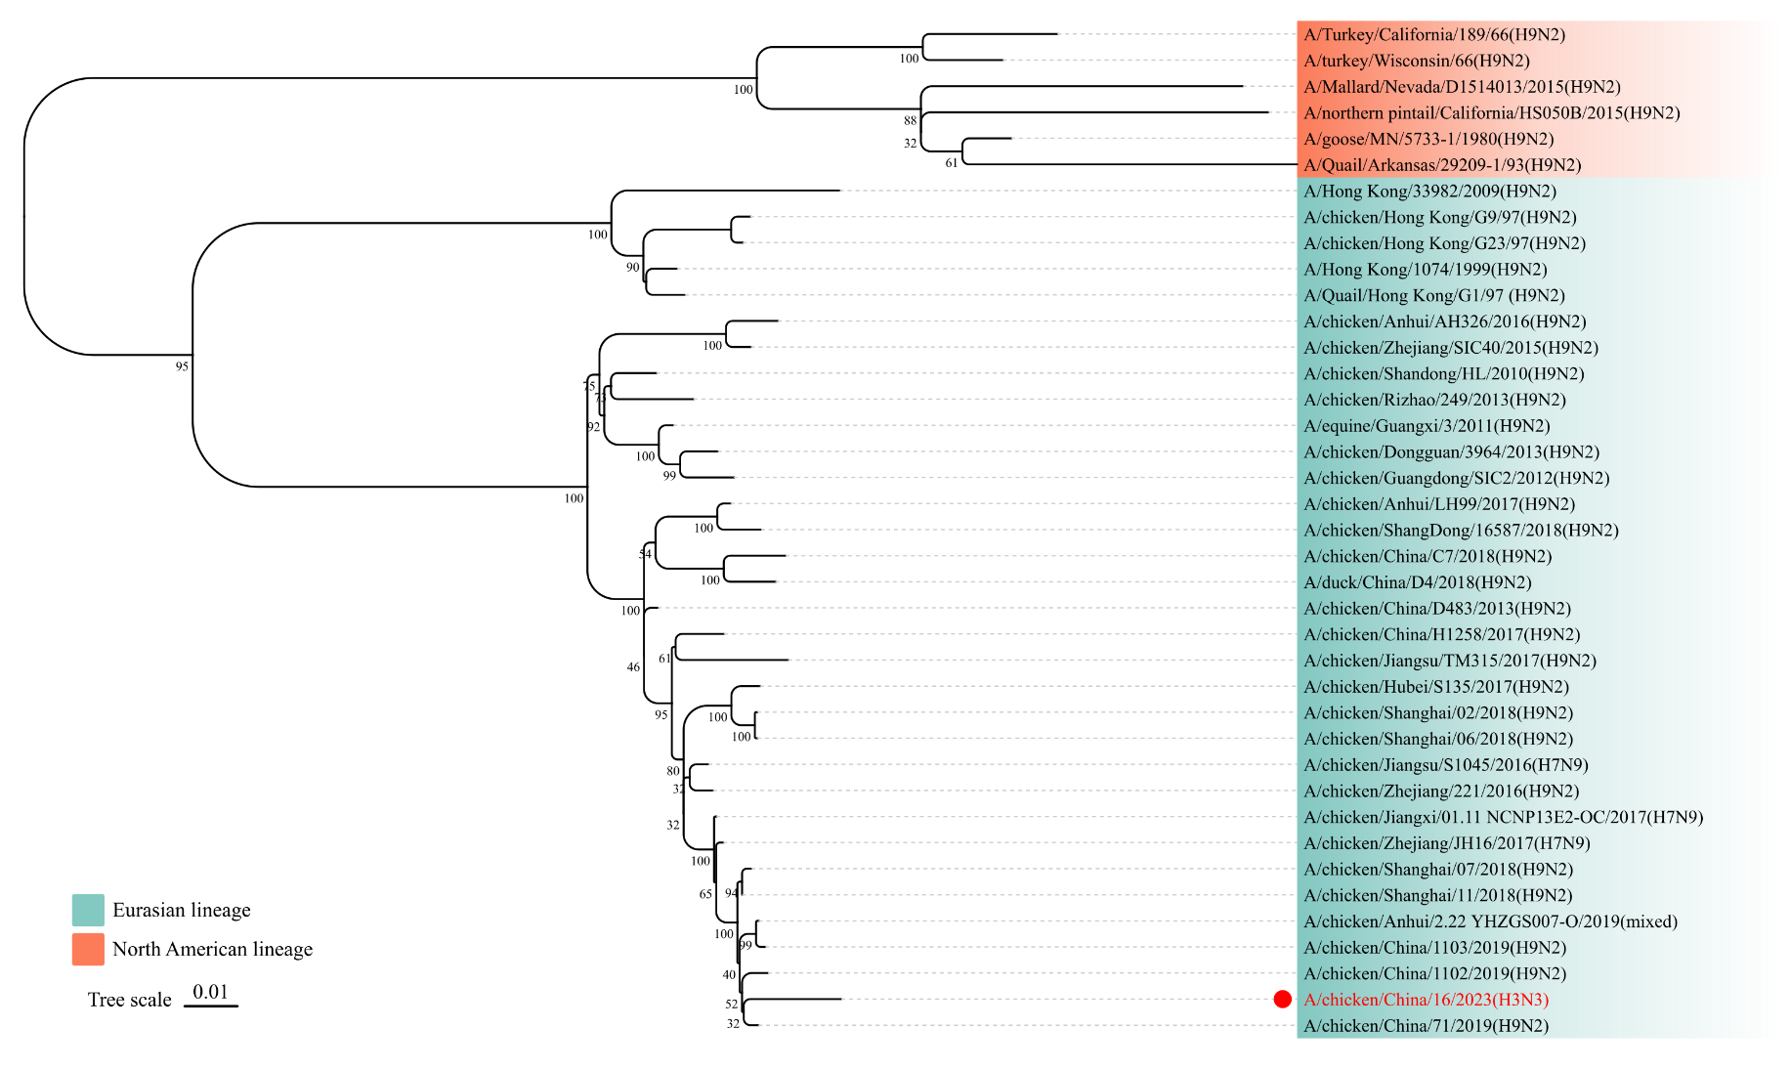
Fig. S1 Phylogenetic analysis of the PB2 gene of A/chicken/China/16/2023(H3N3). The ML tree of PB2 gene was constructed using MEGA software (Version 11.0.11) with 1000 bootstrap replicates. The numbers on the left show bootstrap values as percentages (0-100). The novel H3N3 isolate is highlighted in red.

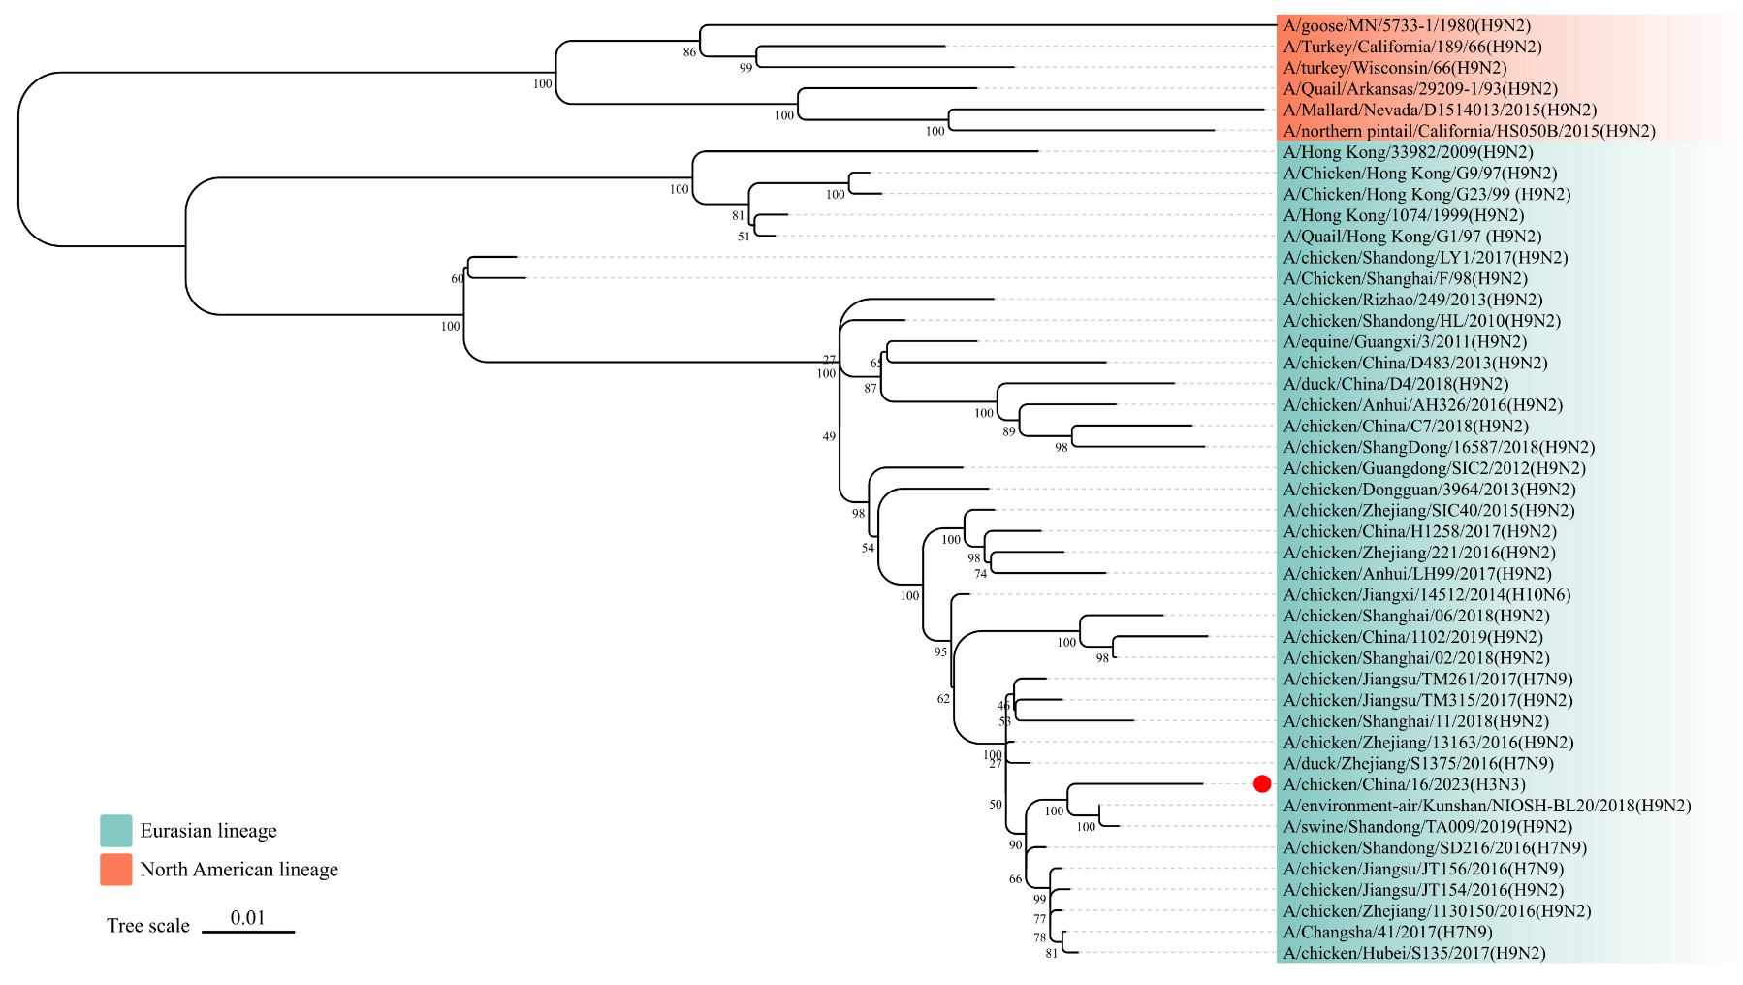
Fig. S2 Phylogenetic analysis of the PB1 gene of A/chicken/China/16/2023(H3N3). The ML tree of PB1 gene was constructed using MEGA software (Version 11.0.11) with 1000 bootstrap replicates. The numbers on the left show bootstrap values as percentages (0-100). The novel H3N3 isolate is highlighted in red.
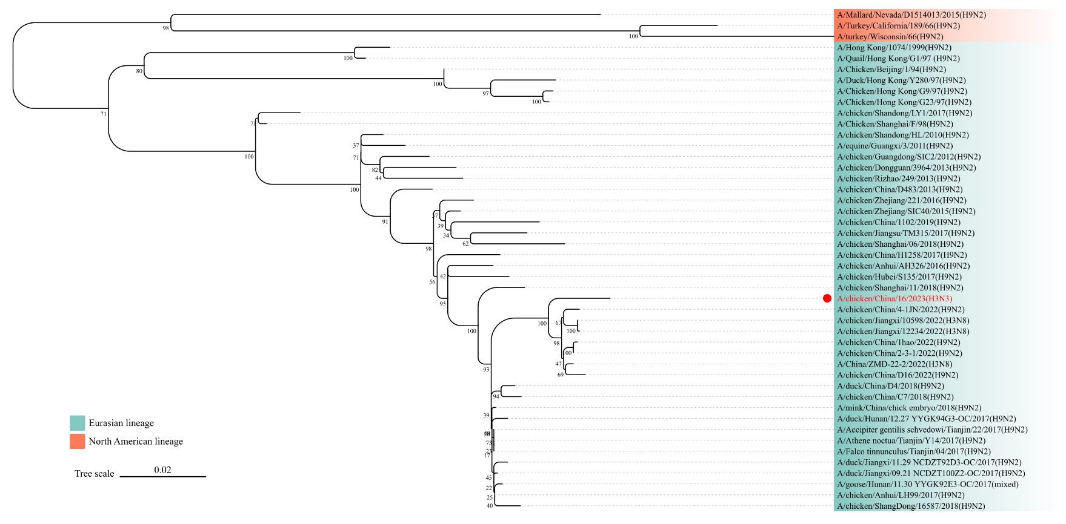
Fig. S3 Phylogenetic analysis of the PA gene of A/chicken/China/16/2023(H3N3). The ML tree of PA gene was constructed using MEGA software (Version 11.0.11) with 1000 bootstrap replicates. The numbers on the left show bootstrap values as percentages (0-100). The novel H3N3 isolate is highlighted in red.
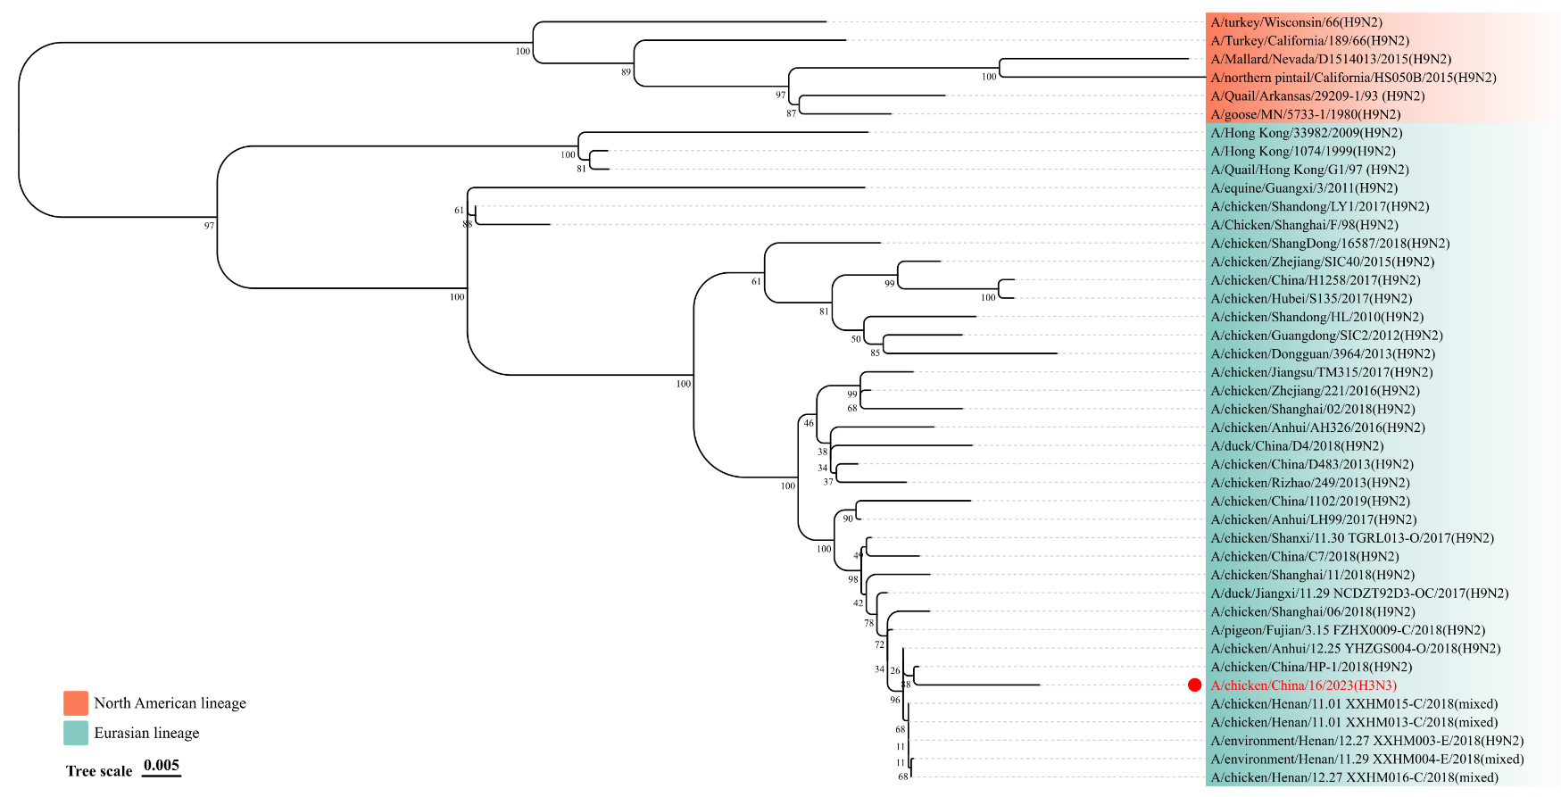

Fig. S4 Phylogenetic analysis of the NP gene of A/chicken/China/16/2023(H3N3). A ML tree was constructed using MEGA software (Version 11.0.11) with 1000 bootstrap replicates. The numbers on the left show bootstrap values as percentages (0-100). The novel H3N3 isolate is highlighted in red.

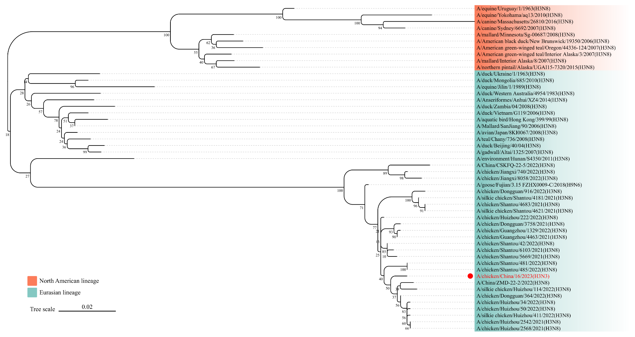
Fig. S5 Phylogenetic analysis of the M gene of A/chicken/China/16/2023(H3N3). The ML tree of M gene was constructed using MEGA software (Version 11.0.11) with 1000 bootstrap replicates. The numbers on the left show bootstrap values as percentages (0-100). The novel H3N3 isolate is highlighted in red.

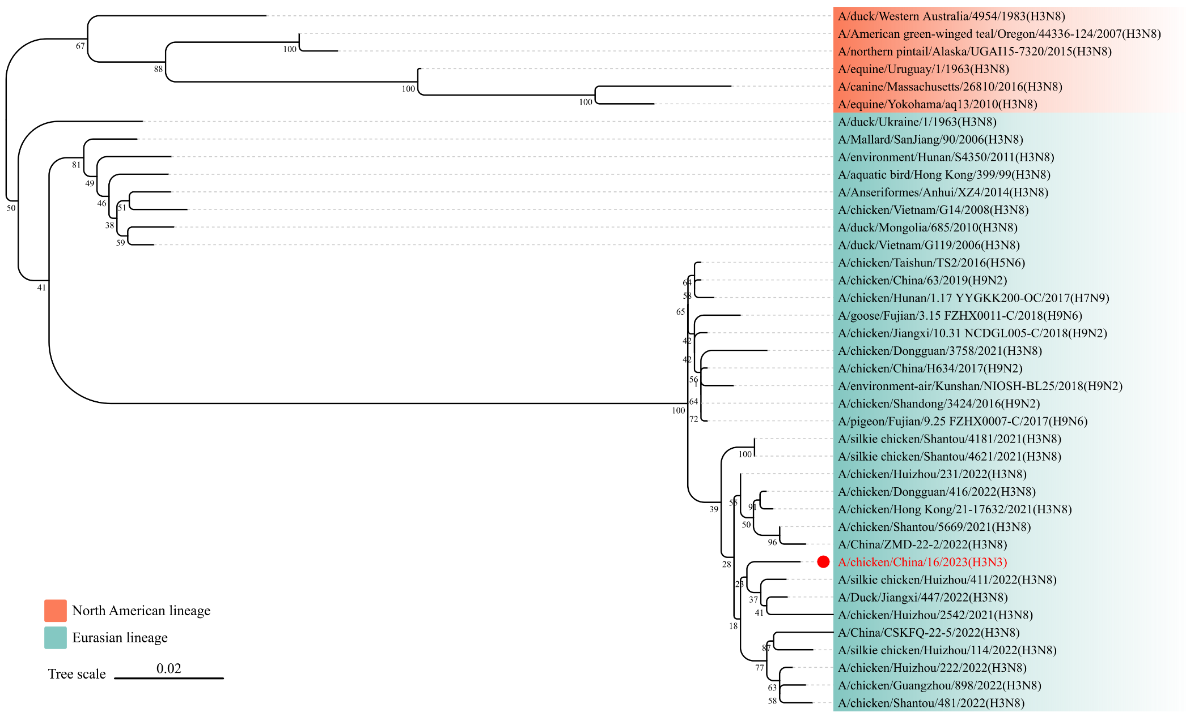

Fig. S6 Phylogenetic analysis of the NS gene of A/chicken/China/16/2023(H3N3). The ML tree of NS gene was constructed using MEGA software (Version 11.0.11) with 1000 bootstrap replicates. The numbers on the left show bootstrap values as percentages (0-100). The novel H3N3 isolate is highlighted in red.

