Supplementary Materials for
Cretaceous fire-resistant angiosperms
Chao Shi, Shuo Wang*, Hao-hong Cai, Hong-rui Zhang, Xiao-xuan Long, Erik Tihelka, Wei-cai Song, Qi Feng, Ri-xin Jiang, Chen-yang Cai, Natasha Lombard, Xiong Li, Ji Yuan, Jian-ping Zhu, Hui-yu Yang, Xiao-fan Liu, Qiao-ping Xiang, Zun-tian Zhao, Chun-lin Long, Xian-chun Zhang, Hua Peng, De-zhu Li, Michael S. Engel, Harald Schneider, Yong-dong Wang, Robert A. Spicer
Corresponding author. E-mail: shuowang0811@163.com
This PDF file includes:
Materials and Methods
Supplementary Text
Captions to Supplementary Videos 1–3
Supplementary Figs. 1–31
References (91–101)
Other Supplementary Materials for this manuscript include the following:
Supplementary Videos 1–3
Supplementary Tables 1 as separate Excel file
1 Supplementary Text
1.1 Location and age of amber mines in Myanmar
Myanmar currently produces three different ambers: the ‘Tanaing’ amber (Hukawng Valley site)¹¹, ‘Hkamti’ amber from northern Myanmar¹⁴, and ‘Tilin’ amber from central Myanmar⁹¹. The Tanaing and Hkamti ambers have produced the most amber in past years, and the Hukawng Valley, especially, has been a source of amber for China since at least the 1st century AD^{92,93}. The amber samples in this study are from Tanaing (19 amber pieces) and Hkamti (2 amber pieces), and the detailed information for these two amber mines is given below:

1.1.1 Location and age of Hukawng Valley amber mines: Noetling performed the first geological survey of the Hukawng Valley amber mine in the Myitkyina District of Kachin state, northern Myanmar (Burma) in 1891–1892 (Supplementary Fig. 2)⁹⁴, and since that time extensive sedimentological, stratigraphic, and especially palaeontological studies have been carried out¹¹. These mines are in the Hukawng Basin (Zee Byue Kone site; 26°16′10.2″ N, 96°33′47.5″ E) ^{11, 95}.
The ambers containing the fossils reported here were collected from a small pit mine and a larger strip mine exposing amber-associated facies about 1 m (75–125 cm) thick¹¹. The ambers are typically reddish brown in colour, with various shades of yellow, orange, and red^{11,12}. These colours range from pale to dark, and can vary from perfectly transparent to opaque. Organic matter (vegetation) is common in the amber (Supplementary Fig. 2).
A mid-Cretaceous age has been assigned to both the amber and surrounding rock¹¹. There are thousands of arthropods in the amber considered to be from the Turonian–Cenomanian⁷⁸, as well as a specimen of the ammonite Mortoniceras (Middle-Upper Albian)¹¹ and distinctive palynomorphs (Upper Albian to Lower Cenomanian)^{11,96} from the amber-bearing horizon, among many other biological inclusions.
A recent study using U-Pb dating of zircons in amber-bearing rock refined the date to 98.79 Ma ± 0.62 Ma⁹⁸. This date was further verified by a newly-discovered Late Albian–Early Cenomanian ammonite, Puzosia (Bhimaites), found among the amber inclusions¹³. A 98.79 ± 0.62 Ma (earliest Cenomanian) origin is now the most widely accepted age for the Hukawng Valley amber mine^{24,99,100}, and accordingly this age is adopted here.

1.1.2 Location and age of Hkamti amber mines: The Hkamti amber mine is located in the Southwest of the Hukawng Valley (Supplementary Fig. 1). The U-Pb dating of the zircons of the Hkamti site yields a weighted-mean age of 109.7 ± 0.4 (ca. 110) Ma¹⁴. Ambers from this mine share some colour range with those of Hukawng Valley but still have some differences. Amber samples of the Tanaing mine usually have a greater range of colour than those from the Hkamti mine, with the latter having more amber with a red tea colour (Supplementary Fig. 3).
In all, our fossils from these two amber mines extend over a time interval of about 110–99 Ma. However, since they are further divided into two different species, and only one species occurs in both amber mines (Supplementary Fig. 6), a minimum age of 99 Ma for both fossil species is adopted in our study.

1.2 Systematic palaeontology
Family Rhamnaceae Jussieu 1789
Subfamily Ziziphoideae Luerss. 1881 (=Ziziphoid Clade)
Tribe Phyliceae Reissek ex Endl. 1840
Genus Eophylica Shi, Wang, & Engel gen. nov.
Etymology: The generic name is a combination of the Greek words, Ēṓs (Ἠώς, meaning “dawn”) and the extant genus Phylica L. (itself derived from Greek: phyllikos, meaning, “leafy”). The gender of the name is feminine.
Type species: Eophylica priscastellata Shi, Wang, & Engel sp. nov.
Generic diagnosis: The genus, as demonstrated by the phylogenetic analyses presented here, is most closely related to Phylica, sharing with the genus most traits documented and utilized herein. It can be distinguished from Phylica by the presence of eight sepals (rather than five in Phylica), the absence of petals (present in most Phylica but secondarily reversed independently in several crown species), and the indumentum composed of stellate Rhamnaceous hairs (simple in Phylica). The genus is presently known only from 110–99-Ma-old Myanmar amber.
Generic description: Every part of plant covered with both stellate and simple linear hairs. Leaves simple, long linear, clustered at twig tip and often form a ‘pseudo-flower head’. Stipules absent. Head of flower small (about 1.0 mm), terminal. Flower not completely open, although well developed. Calyx pedicellate; calyx-tube long, turbinate. Sepals (calyx-lobes) recurved above middle or one-third as long, with a flattened upper surface and a prominent keel running along inner midrib; sepals 8 (2 × 4-merious). Petals absent. Ovary inferior, fused to receptacle. Style columnar, simple. Fruit a typical capsule, obovoid, about 5.0 mm long, crowned with persistent base of calyx with a convex calyx-area (forming capsule); outer surface of fruit smooth, not covered by indumentum.

Eophylica priscastellata Shi, Wang, & Engel sp. nov.
Etymology: The specific epithet is a combination of the Latin terms priscus (meaning, “ancient”) and stellatus (meaning, “starry”).
Type material: Holotype (hic designatus): No. QUST-AM32413 (deposited in the collection of the Qingdao University of Science and Technology, Qingdao, China), and paratypes (17 specimens): No. QUST-AM20501—QUST-AM20512, QUST-AM32413—QUST-AM32417 and QUST-AM33310 (Supplementary Figs. 6–18, 21–25 and 27).
Specimen localities: Except for QUST-AM20511 and QUST-AM32414, all specimens are from the ‘Hkamti’ amber mine, with the remaining fossils from the Hukawng Valley.
Species diagnosis: Plants covered in stellate and linear hairs. Leaves long linear, spirally arranged. Head of flower terminal surrounded by interior spreading, sub-incurved, linear leafy bracts. Bracts about twice as long as flower. Flower single on twig tip. Disc epigynous and covering inside of calyx tube. Sepals 8 (2 × 4-merious). Petals absent.
Species description: The following description is based on 18 fossils included in 17 pieces of amber: Every part of plant covered with both stellate and simple linear hairs. Branchlets slender. Leaves simple, long linear, incurved-erect, about 2.0–26.0 mm long, 0.2–0.5 mm wide, with lower leaves longer than upper; leaves sub-appressed and spirally arranged; leaf base sub-sessile; leaf cross-section sub-terete. Stipules absent. Head of flower terminal, surrounded by a circle of spreading, sub-incurved, linear foliaceous bracts; bracts 2.0–2.5 mm long—about twice as long as the flower—and apiculate with inflexed point; flower not completely open, despite well developed. Calyx pedicellate, 0.8 to 1.0 mm long; calyx-tube turbinate, with an immersed disc partly projecting to form a ledge around middle; segments lanceolate, very villous outside, as long as tube; disc epigynous and covers inside of calyx tube. Sepals (calyx-lobes) recurved above middle or one-third as long, with a flattened upper surface and a prominent keel running along inner midrib; sepals 8 (2 × 4-merious) in number, up to 2.0 mm long; sepals triangular I; inner part of sepals glabrous, outer part densely covered and overtopped with stellate hairs. Petals absent. Ovary inferior and completely fused to receptacle. Style columnar, simple, 0.5 mm high. Stigma slightly lobed. Fruit about 5.0 mm long, shape obovoid, crowned with persistent base of calyx with a convex calyx-area (forming a capsule); outer surface of fruit smooth (not covered with indumentum).

Genus Phylica L. 1753
Phylica piloburmensis Shi, Wang, & Engel sp. nov.
Etymology: The specific epithet is a combination of the Greek term pîlos (πῖλος, meaning, “hair”) and burmensis (itself a combination of Burma and the Latin suffix –ensis, denoting place).
Type material: Holotype (hic designatus): No. QUST-AM32127 (deposited in the collection of the Qingdao University of Science and Technology, Qingdao, China), and Paratypes (three specimens): No. QUST-AM33311, QUST-AM20513—QUST-AM20514 (Supplementary Figs. 6, 19, 20, 26 and 28).
Species diagnosis: Leaves slightly wider (1.5–2.0 mm wide and 4.5–8.0 mm long) and both ad- and abaxial sides covered with simple linear hairs. Flowers not single but forming a corymb. Petals present. Fruit covered with dense indumentum.
Specimen location: All fossils of this species are from the Hukawng Valley amber mine.
Species description: The following description is based on four fossils included in four pieces of amber: Each part of plant covered with simple linear hairs about 0.4 mm long. Leaves simple, short, lanceolate, 1.5–3.0 mm long, 0.2–1.0 mm wide; tip with an acute end; leaves near flower or inflorescence bract-like, relatively short in length (about 1.5 mm long), quickly narrow toward tip; both sides covered with linear hairs; petiole very short, about 0.2 mm long, but masked in bract-like leaves. Stipules absent. Flowers solitary on a short stipe, 1.0 mm long, or in pairs in very short peduncle clusters in axils of upper leafy-bracts; flower usually only semi-open, with roundish heads about 0.8–1.1 mm wide and 1.3–1.7 mm long (including stalk); bracts 0.5–1.5 mm long, acicular, 2–3 in each flower-cluster; inflorescence corymbose and terminal, consisting of 2–3 flowers 0.7–1.0 cm long; each flower with five sepals, petals, and anthers. Calyx-tube turbinate, 0.8–1.0 mm deep in mature flowers. Sepals (calyx-lobes) recurved above middle, with a flattened upper surface and a keel running along inner midrib; sepal shape ovate-deltoid. Petals on upper half of calyx-tube, alternating with sepals, smaller than sepals (about 0.3 mm); petals consist of a galeate or calyptriform lamina, cuneate-oblong, claw half as long. Stamens immediately below petals. Anthers tightly enfolded by petals. Ovary inferior. Fruit larger than flower (10.0 mm long), obovoid, crowned with persistent base of calyx with a convex calyx-area (forming a capsule); outer surface of fruit covered with dense indumentum of simple linear hairs.

1.3 Initial fossil identification
For initial fossil identification, we examined comparative material in the Chinese National Herbarium (Chinese Academy of Sciences; PE), Kunming Institute of Botany (Chinese Academy of Sciences; KUN), and performed exhaustive online searches for high-resolution images of herbarium and living plant specimens. Online herbarium resources included image databases from JSTOR Global Plants (plants.jstor.org/), Chinese Virtual Herbarium (cvh.ac.cn/en), Virtual Herbarium of the New York Botanical Garden (sweetgum.nybg.org/science/vh/), Tropicos (tropicos.org/SpecimenSearch.aspx), Kew Herbarium Catalogue (apps.kew.org/herbcat/navigator.do), and The Australasian Virtual Herbarium (avh.chah.org.au/). Live-plant images were from the Plant Photo Bank of China (ppbc.iplant.cn/), PlantZAfrica (pza.sanbi.org/), Operation Wildflower Association (operationwildflower.org.za/index.php/albums), and others. Over 2,000 new and downloaded images from both herbaria and living plants used in this study can be obtained upon request.
Pollen identification was based on existing literature⁹⁷ and online databases, including the Palynological Database (paldat.org/search/P) and the Australasian Pollen and Spore Atlas (apsa.anu.edu.au/). Specifically, we focused on dried pollen grains, which provided key reference information to identify pollen grains in our amber.
Detailed morphological characters of Rhamnaceae and Phylica described in books²⁶ and other research literature at the tribe, genus, and species levels^{29,98}, were used extensively in our study.

1.4 Correction of previous identification
Our study does not support any prior identification of similar plant fossils as conifers¹⁵ or green algae¹⁶, which were based on incomplete material. Previous studies have identified these kinds of plant fossils as conifers¹⁵ or algae¹⁶, possibly because most fossils (>90%) were conserved as clusters of linear to lance-shaped leaves, with dense linear and stellate hairs and grouped at the tip of twigs; and so quite different from the broad leaves of most angiosperms. However, although rare in angiosperms, to our knowledge, these clustered long linear to lance-shaped leaves clearly match some ericoid plants that live in arid regions, including some plants in Rhamnaceae (Phylica), Ericaceae (Genus Erica), Bruniaceae (Genus Brunia and Berzelia), and some other clades. However, these clades are quite different in leaf arrangement, shape, and size, to the material described here, which has alternatively arranged, heavily haired, very long lineate, but with the margin slightly incurved leaves, as usually seen in Phylica. Most importantly, the organically connected twigs with flowers or fruits, provided exclusive evidence that they represent Phylica, and, of course, confirmed that they were neither conifers nor algae. The morphology of associated pollen grains obtained from the two fossil species also provides additional and definitive evidence that they represent the genus Phylica.

1.5 Failure in isolating and scanning of pollen grains from amber
Pollen grains of two fossil species of similar morphology were found in three different amber pieces, which were observed using light microscopy (LM). However, although the whole pollen surface could be clearly observed, the detailed pattern on the pollen exine could not be resolved, owing to the inherent limitations of LM. For a clear view of the pollen surface, isolation of the pollen grains from the amber and the use of a Scanning Electron Microscope (SEM) is the best approach. We tried to isolate the pollen grains from the amber in order to prepare samples for SEM. However, the pollen grains were so tightly embedded that they could not be isolated, and SEM examination was impossible.

1.6 Morphological characters
We mapped morphological characters of these two fossils to the data matrix (34 characters) commonly used for discriminating genera of Rhamnaceae (41 genera and 13 tribes)^{29,30,89}. These morphological characters included key diagnostic information from habits (1 character), leaves (6 characters), flowers (16 characters), fruits (5 characters), and pollen grains (4 characters). Other characters (indumentum (1 character) and tendril (1 character)) were also included. Most of the character states were from the original data matrix, but some from other species were extracted and supplemented using data from specimens, living plant photos, or literature, as prior studies included different species numbers in their data matrices^{30,89}. Our new data matrix (including two fossil species) is given in (Supplementary Table 1).

List of characters (Character states coded for the fossils are in bold).
- Leaves:
(1) Leaves (0) were ericoid-like or (1) broad.
(2) Leaves (0) are densely crowded at the tip of the twig or (1) not.
(3) Stipules (0) present or (1) absent.
(4) Leaves may be arranged (0) alternately, (1) opposite, or (2) in whorls.
(5) Leaf margins can be (0) revolute or (1) more or less flat.
(6) Leaf venation is either (0) palmate or (1) pinnate.

- Habit:
(7) The habit is either (0) trees/shrubs or (1) climbers/herbs.

- Tendril:
(8) Tendril presence/absence is a simple two-state character. (0) Present and (1) absent.

- Indumentum
(9) Rhamnaceous hairs are either (0) stellate or (1) simple. For two fossil species, E. priscastellata has stellate hairs and P. piloburmensis and all other extant Phylica species have simple hairs.

- Flower:
(10) Flower is (0) terminal/solitary to the twig or (1) axillary to the leaves or (2) both.
(11) Bract (0) present or (1) absent.
(12) Phylica flower size is (0) ≤ 3 mm or (1) > 3 mm.
(13) Aestivation of sepals was (0) imbricate or (1) valvate.
(14) Number of sepals are (0) two, (1) three, (2) four, (3) five, (4) six, (5) eight. P. piloburmensis has five sepals and E. priscastellata has eight (2 × 4-merious) sepals.
(15) Sepals not (0) keeled or (1) keeled.
(16) The sepal may be (0) Recurved with a flattened upper surface, (1) recurved without a flattened upper surface, and (2) not recurved.
(17) The ovary position is (0) superior, (1) semi-inferior, or (2) inferior.
(18) Calyx tube is (0) lengthened (calyx tube longer than the width of the corolla) or (1) not lengthened (calyx tube shorter than the width of the corolla).
(19) Outer surface of the flower (0) are covered with dense hairs or (1) not.
(20) Corolla of the flower was (0) completely opened or (1) not completely opened.
(21) Petals are (0) absent or (1) present. P. piloburmensis has petals, but E. priscastellata does not.
(22) In species with petals, petals are (0) not hooded or (1) hooded.
(23) Stamens and petals may have different arrangement: (0) Stamens and petals alternate with sepals or (1) stamens and petals do not alternate with sepals.
(24) Nectary-disc (0) Present or (1) absent.
(25) The disc may be (0) adnate to the calyx tube and the ovary (i.e. filling the calyx tube), (1) actuate to the calyx tube only (i.e. the ovary is free) or (2) adnate to the ovary only.

- Fruit:
(26) Rhamnaceous fruits are either (0) capsules or (1) drupes.
(27) Carpels of the fruits are (1) one, (0) two, (2) three, or (3) more than three.
(28) Gynoecium (0) apocarpous or (1) syncarpous.
(29) Fruit longitudinal wings (0) absent or (1) present.
(30) Fruit apical wings (0) absent or (1) present.

G. Pollen:
(31) The dried pollen is (0) oblate-spheroidal or (1) prolate in shape.
(32) Colpi of the pollen is (0) as long as the end of the polar or (1) not as long.
(33) Middle of the aperture lalongate, with two ends connected with the thinned part of exine, forming a (0) H-shape or (1) not.
(34) Polar view of the pollen are (0) triangular or (1) circular in shape.

1.7 Phylogenetic analyses
The phylogenetic tree construction was based on combined morphological and molecular data⁹⁰. DNA sequences of the 56 living species above, including seven of the nine sequence clusters previously used in phylogenetic analyses on Rhamnaceae^{22,101}, were downloaded from GenBank. These include one nuclear (ITS) and six plastid regions (rbcL, matK, ndhF, rpl16, 26S, trnL-trnF), and were selected because sequences were available for >70% of the selected taxa. Three species, Adolphia infesta, Smythea lanceolate, and Trevoa trinervis were deleted because there were not enough sequences. We also added another 15 species of Phylica to the sequence alignment because they had nearly all of the above sequences. Thus, a total of 69 species were used in the sequence alignment. Each sequence cluster was individually aligned and examined for topological incongruence using maximum parsimony (MP) and maximum likelihood (ML) methods⁹⁰. Given that no major incongruences were found between sequence clusters and previously publish phylogenetic trees^{22,29,89,101}, we concatenated each aligned sequence supermatrix and the morphological matrix into a single total-evidence dataset. The complete total-evidence matrix contained 71 taxa (including two outgroups and the fossil taxon) and 7,070 characters. The methods for the MP and ML analyses (including model selection and bootstrap replicate numbers in ML) in the combined total-evidence matrix were as previously described⁹⁰. Maximum parsimony (MP) and maximum likelihood (ML) phylogenetic analyses produced similar topologies and were consistent with prior studies of major clades of Rhamnaceae⁹⁸. Both trees clustered the two fossil species with extant species of Phylica with moderate to strong support at the major nodes. Eophylica priscastellata was recovered as sister to Phylica compared to P. piloburmensis that was nested well within the genus Phylica (Supplementary Fig. 30).

1.8 Southern African distribution of extant Phylica (Phyliceae)
With ca. 150 shrubby species, the exact distribution for the extant Phylica (Phyliceae) in southern Africa has been well illustrated in previous studies^{29,30}. Most species (> 140 species) are restricted to the Cape Floristic Region, with four species reaching north into East Africa and Madagascar, and several species occurring on the highly isolated southern Atlantic and southern Indian Ocean islands (including St Helena, Tristan da Cunha, New Amsterdam, Mauritius, and Réunion). We also further verified this distribution pattern in online databases, such as the FloraBase (florabase.dpaw.wa.gov.au/browse/family), African Plant Database (ville-ge.ch/musinfo/bd/cjb/africa/recherche.php?langue=an), and PlantZAfrica (pza.sanbi.org/).

2 Captions to Supplementary Videos 1–3
Supplementary Video 1. Videos of the 3D reconstruction of the fossil specimens QUST-AM20501–14
Supplementary Video 2. Videos of the 3D reconstruction of the fossil specimens QUST-AM32413–16
Supplementary Video 3. Videos of the 3D reconstruction of the fossil specimens QUST-AM32417, QUST-AM33310, QUST-AM32127 and QUST-AM33311

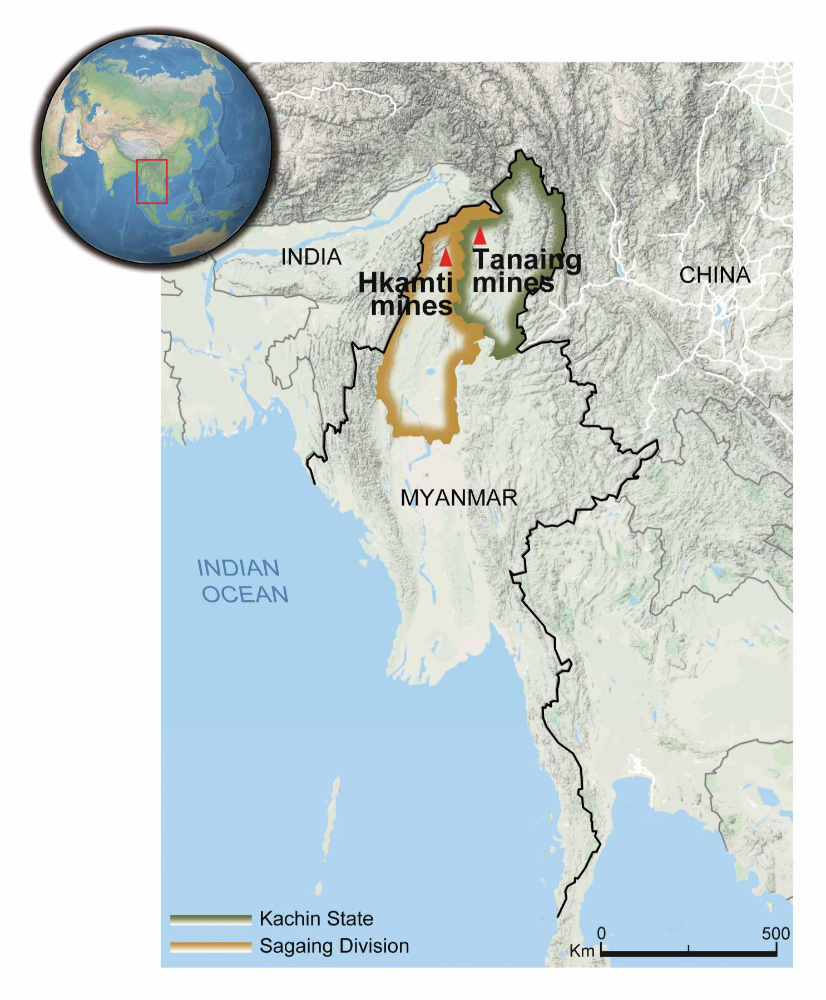
Supplementary Fig. 1 | Location of the two amber mines in Myanmar. The red triangle on the map indicates the ‘Tanaing’ (Hukawng Valley) and ‘Hkamti’ amber mine.

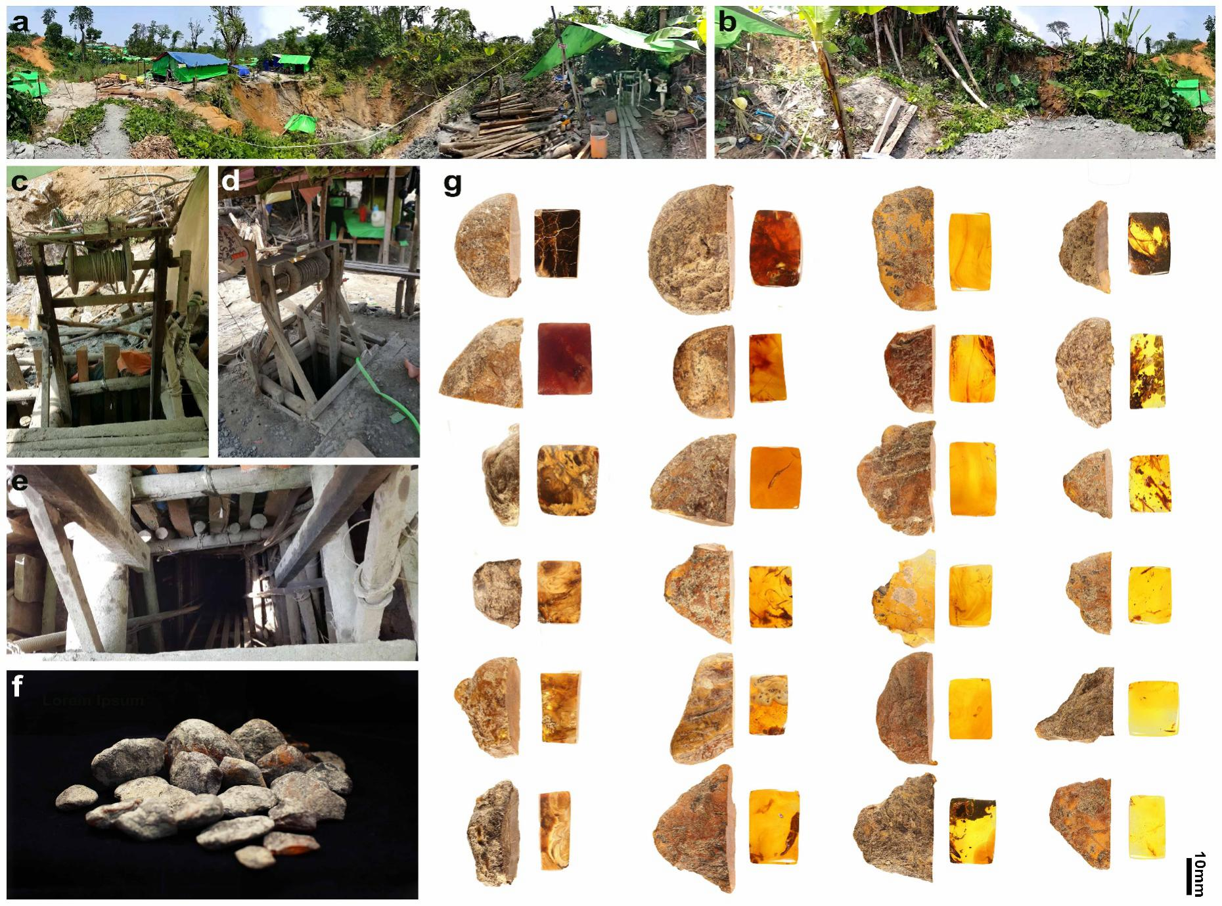
Supplementary Fig. 2 | Environment and ambers of ‘Tanai’ (Hukawng Valley) amber mines. (a, b) Environment of amber mine (photographed at 360° view). c–e, Pit in the mines. f, Raw amber produced from the mines. g, Polished and cut amber obtained from raw amber with varied colour and transparency. Scale bars = 10 mm.
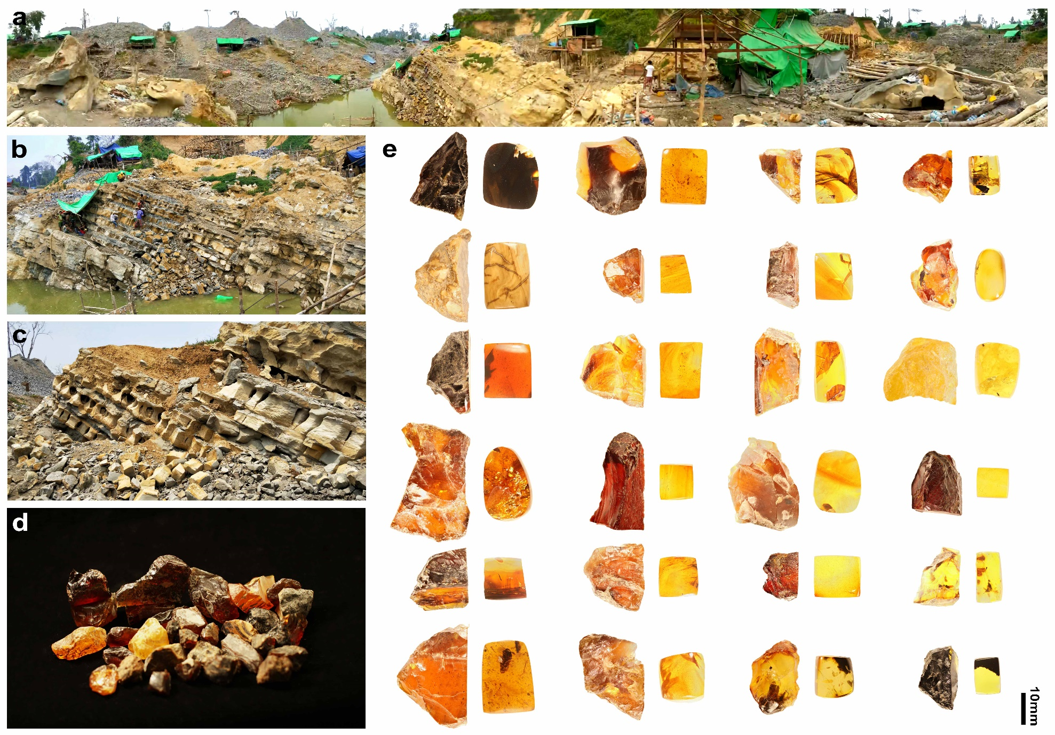
Supplementary Fig. 3 | Environment and ambers of ‘Hkamti’ amber mines. a, Environment of amber mine (photographed at 360° view). (b, c) An overview of the profile which including amber-associated facies. d, Raw amber produced in the mine. e, Polished and cut amber obtained from raw amber, with varied colour and transparency. Scale bars = 10 mm.

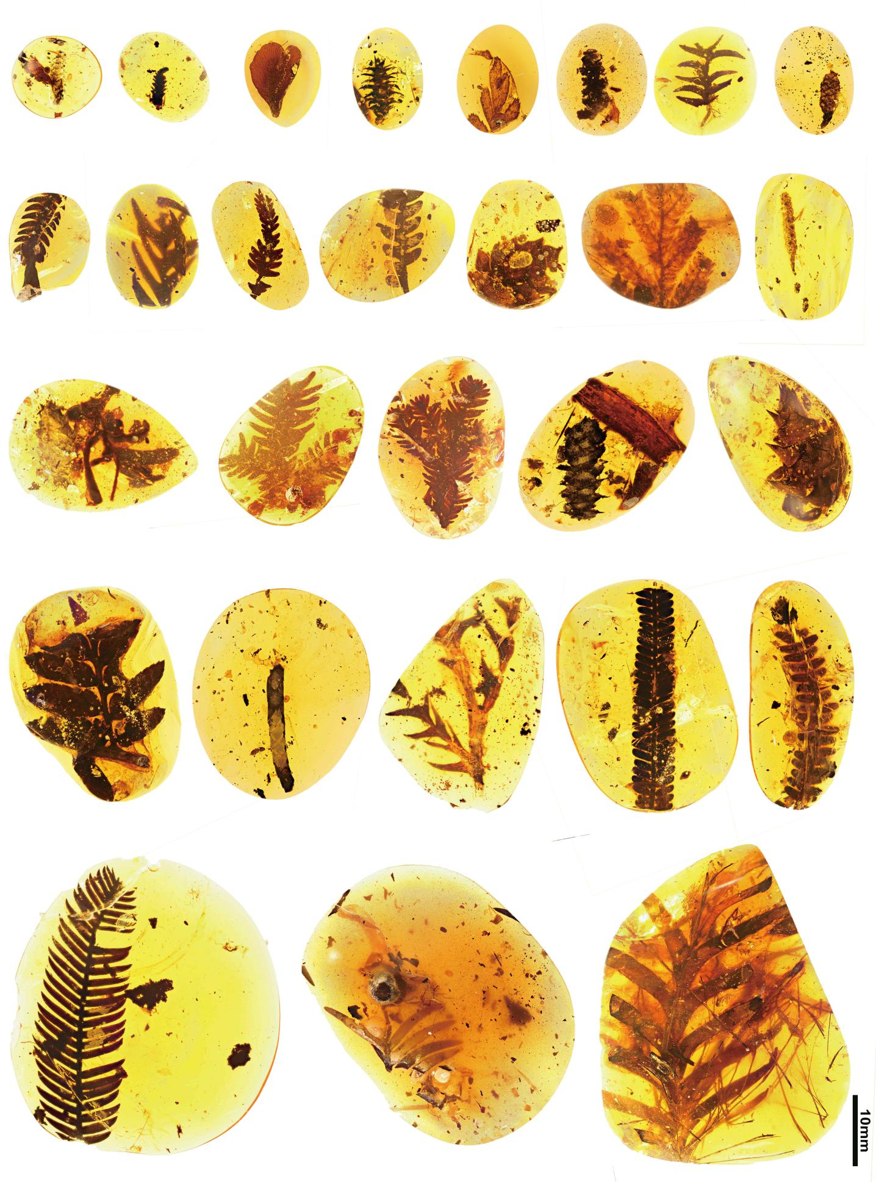
Supplementary Fig. 4 | Gymnosperm from the amber mine. Those gymnosperm fossils included branches, leaves and cones of different sizes and morphologies. Scale bars = 10 mm.

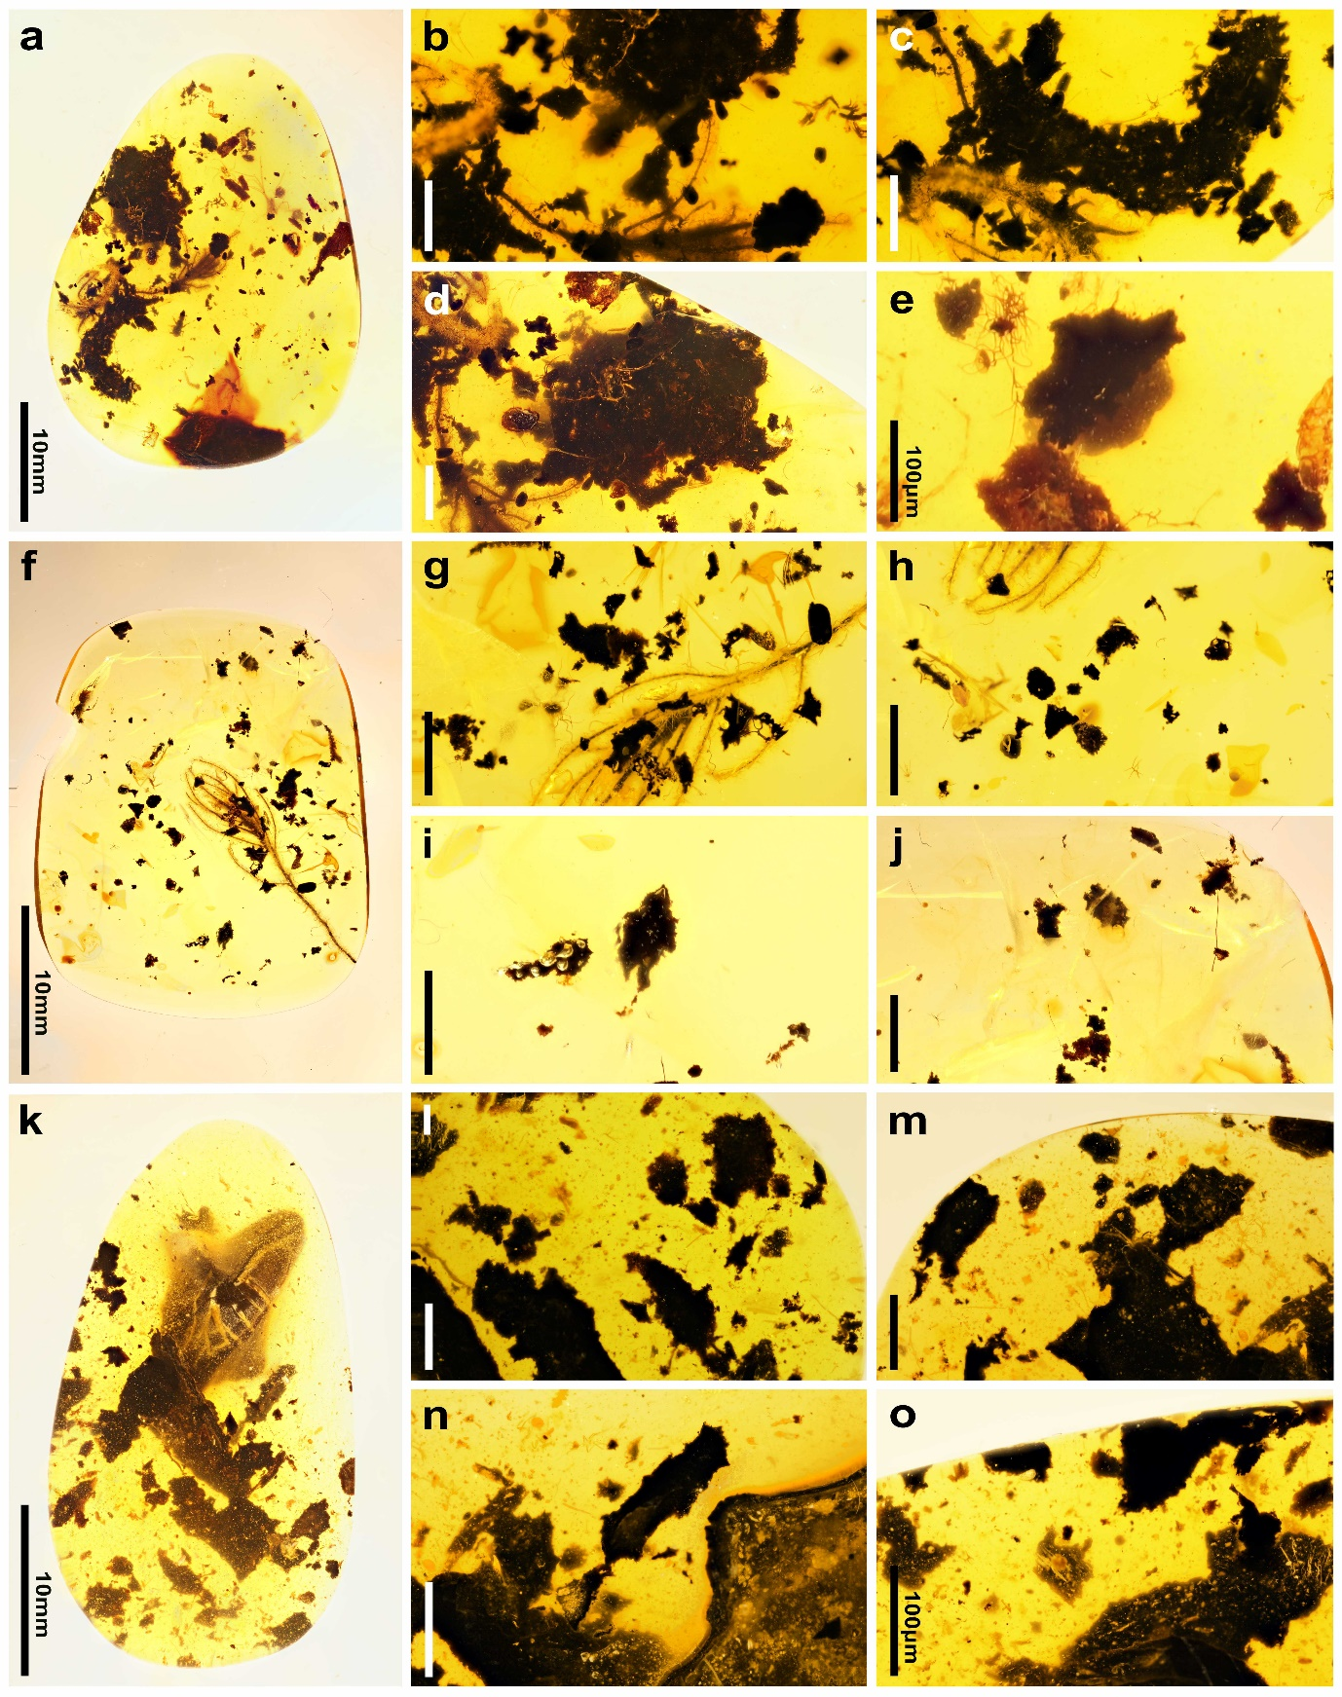
Supplementary Fig. 5 | Abundant remains of burned plants in amber. Among the figures, (a, f and k) are whole amber pieces that include complete plant fossils and abundant remains of burned plants (in dark colour), with details of the latter are further shown in the remaining enlarged figures. It is obvious that 24the burned plant remains are in stark contrast with unburned plant fossils (included in same amber) in colour, size, and completeness, which provide evidence that a light fire affected these plants. Scale bars = 200 μm (if not otherwise indicated).
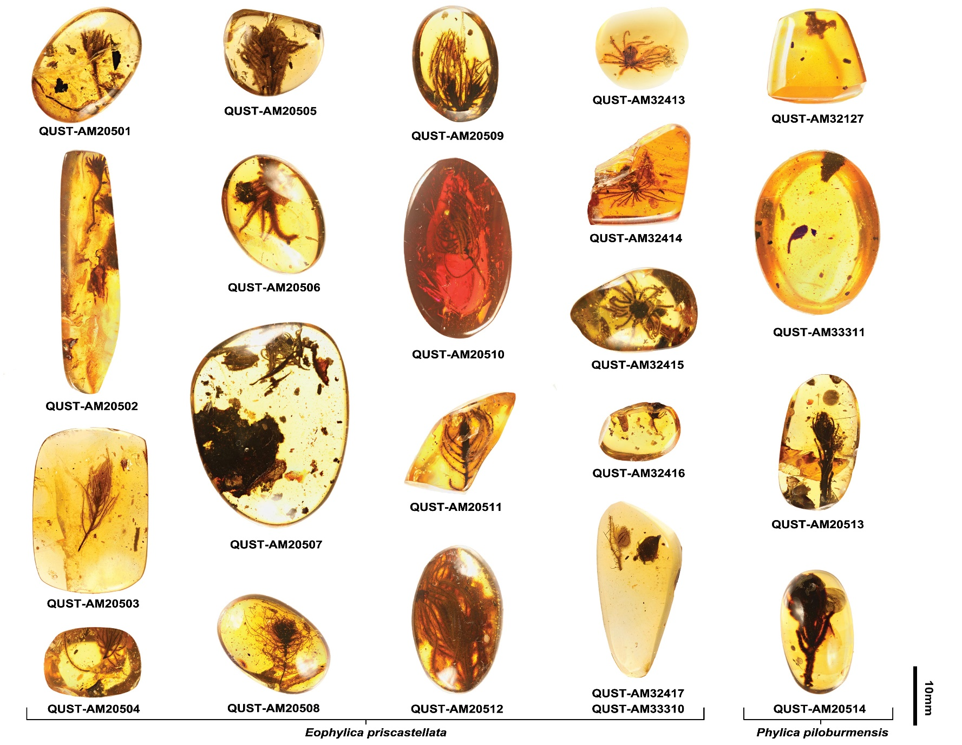
Supplementary Fig. 6 | Amber fossils in our study. There are a total of 21 amber pieces (corresponding to 22 fossil collection numbers) as indicated. Among them, QUST-AM20501—QUST-AM20512, QUST-AM32413—QUST-AM32417 and QUST-AM33310 belong to Eophylica Priscastellata gen. et sp. nov., and QUST-AM32127, QUST-AM33311, QUST-AM20513—QUST-AM20514 belong to Phylica piloburmensis sp. nov. Two amber pieces with accession numbers QUST-AM20511 and QUST-AM32414 are from ‘Hkamti’ amber mines and the other 19 pieces are from Hukawng Valley. Scale bars = 10 mm.
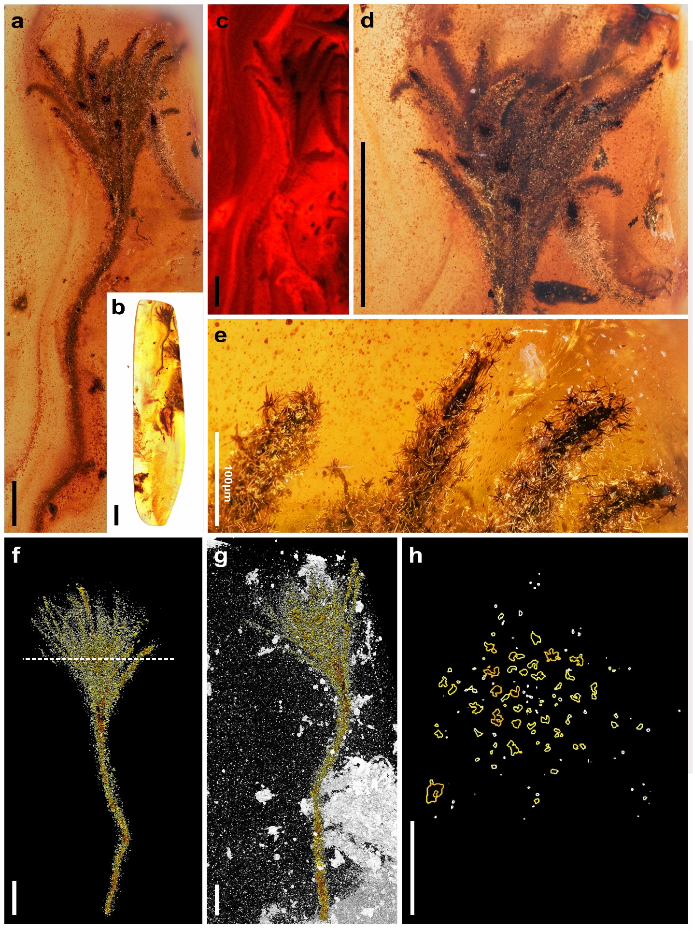
Supplementary Fig. 7 | Tightly clustered leaves before formation of typical pseudo ‘flower head’. This figure gives additional details of specimen QUST-AM20502. (a, c, d) Enlarged cluster of leaves show the arrangement of the leaves at the tip of the stem and the densely stellated hairs on the leaves. Among them, c is the fluorescence image. b, The whole amber piece that included the fossil. (d, e) Enlarged view of the leaves and detailed morphology for stellate hairs (sh) on the leaves. (f, g) MicroXCT scanning image showing arrangement of the leaves at the tip of the stem. h, Transverse section of the clustered leaves (from the MicroXCT scan; dotted line in F is the transverse line) showing arrangement density and shape of the leaves in transverse view. Scale bars = 0.5 mm (if not otherwise indicated).

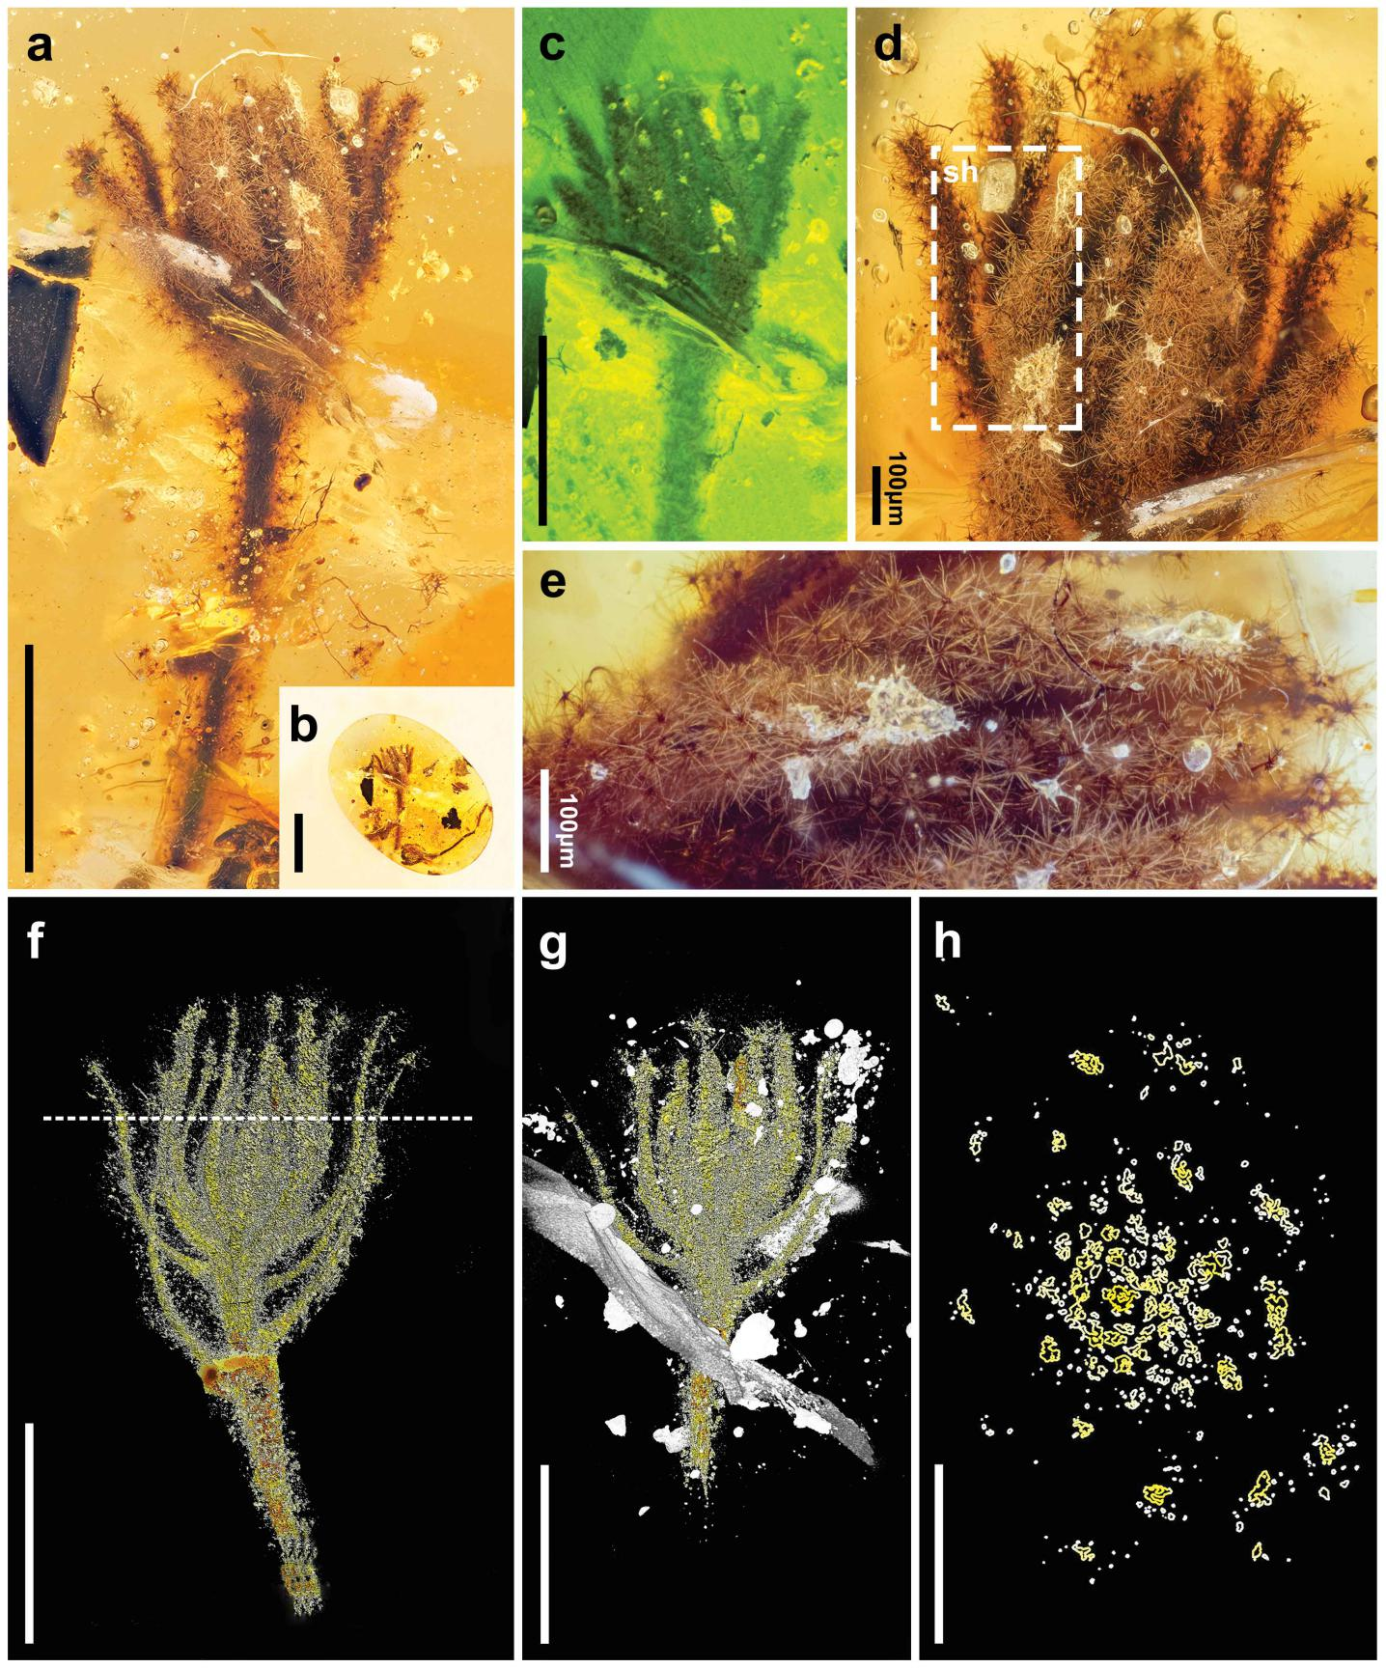
Supplementary Fig. 8 | Tightly clustered leaves before formation of typical pseudo ‘flower head’. This figure gives additional details of specimen QUST-AM20501. (a, c) Enlarged cluster of leaves show the arrangement of the leaves at the tip of the stem and the densely stellated hairs on the leaves. Among them, c is the fluorescence image. b, The whole amber piece that included the fossil. (d, e) 30Enlarged view of the leaves and detailed morphology of stellate hairs (sh) on the leaves. (f, g) MicroXCT scanning image showing the arrangement of the leaves at the tip of the stem. h, Transverse section of the clustered leaves (from the MicroXCT scan; dotted line in f is the transverse line) showing arrangement density and shape of the leaves in transverse view. Scale bars = 0.5 mm (if not otherwise indicated).
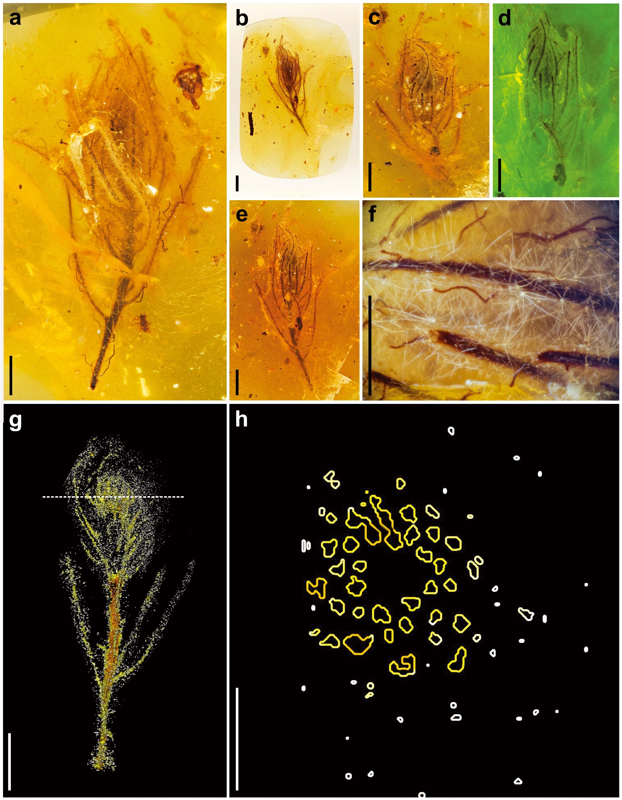
Supplementary Fig. 9 | Tightly clustered leaves before formation of typical pseudo ‘flower head’. This figure gives additional details of specimen QUST-AM20503. (a, c, e) Enlarged cluster of leaves show the arrangement of the leaves at the tip of the stem and the densely stellated hairs on the leaves. Among them, d is the fluorescence image. b, The whole amber piece that included the fossil. f, Enlarged view of the leaves and detailed morphology for stellate hairs on the leaves. g, MicroXCT scanning image showing arrangement of the leaves at the tip of the stem. h, Transverse section of the clustered leaves (from the MicroXCT scan; dotted line in g is the transverse line) showing arrangement density and shape of the leaves in transverse view. Scale bars = 0.5 mm.
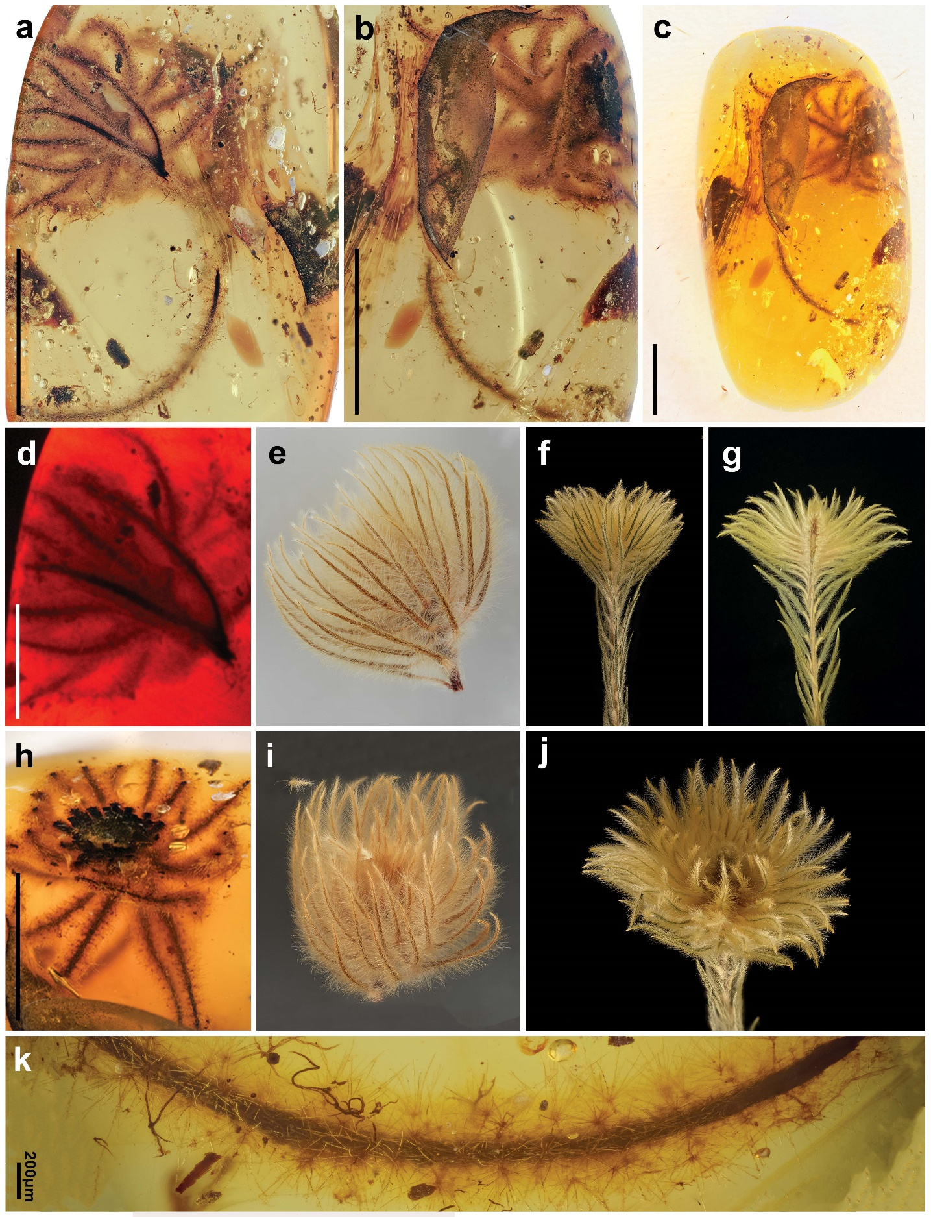
Supplementary Fig. 10 | Tightly clustered leaves before formation of typical pseudo ‘flower head’. This figure gives additional details of specimen QUST-AM20504. (a, b) Enlarged cluster of leaves show the arrangement of the leaves at the tip of the stem and the densely stellated hairs on the leaves. c, The whole amber piece that included the fossil. d, Side view of the clustered leaves (d; fluorescence image) showing arrangement density and shape of the leaves in transverse view and compared with extant Phylica twig of similar morphology (e–g). h–j, Top view of the clustered leaves (h) showing arrangement density and shape of the leaves in transverse view and compared with extant Phylica twig of similar morphology (i, j). k, Enlarged view of the leaves and detailed morphology of stellate hairs on the leaves. Scale bars = 0.5 mm (if not otherwise indicated). 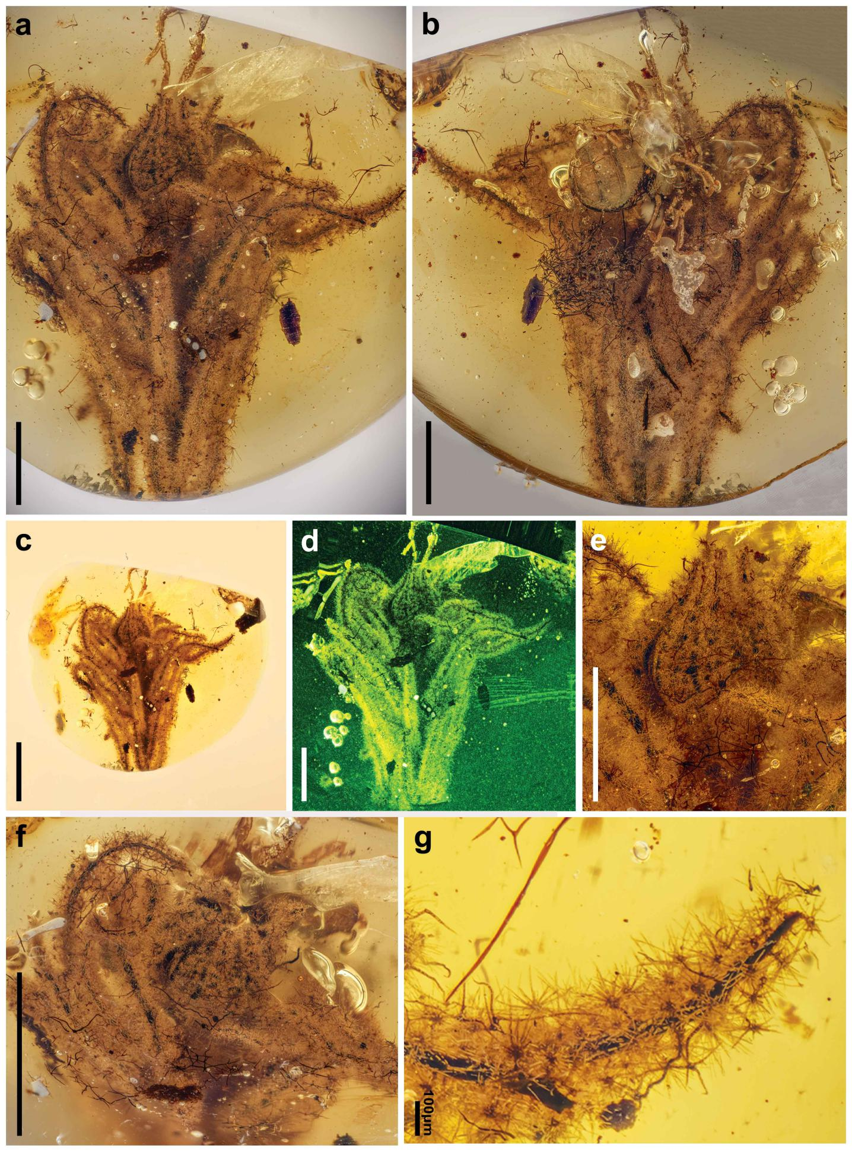
Supplementary Fig. 11 | Typical pseudo ‘flower head’ in amber. This figure gives additional details for specimen QUST-AM20505. (a, b, d) Typical pseudo ‘flower head’ appear from the tightly clustered leaves and the densely stellated hairs on the leaves. Among them, (a, b) are the front and back view, respectively and (d) is the fluorescence image. c, The whole amber piece that included the fossil. e–g, Enlarged view of the leaves and detailed morphology of stellate hairs on the leaves. Scale bars = 0.5 mm (if not otherwise indicated).

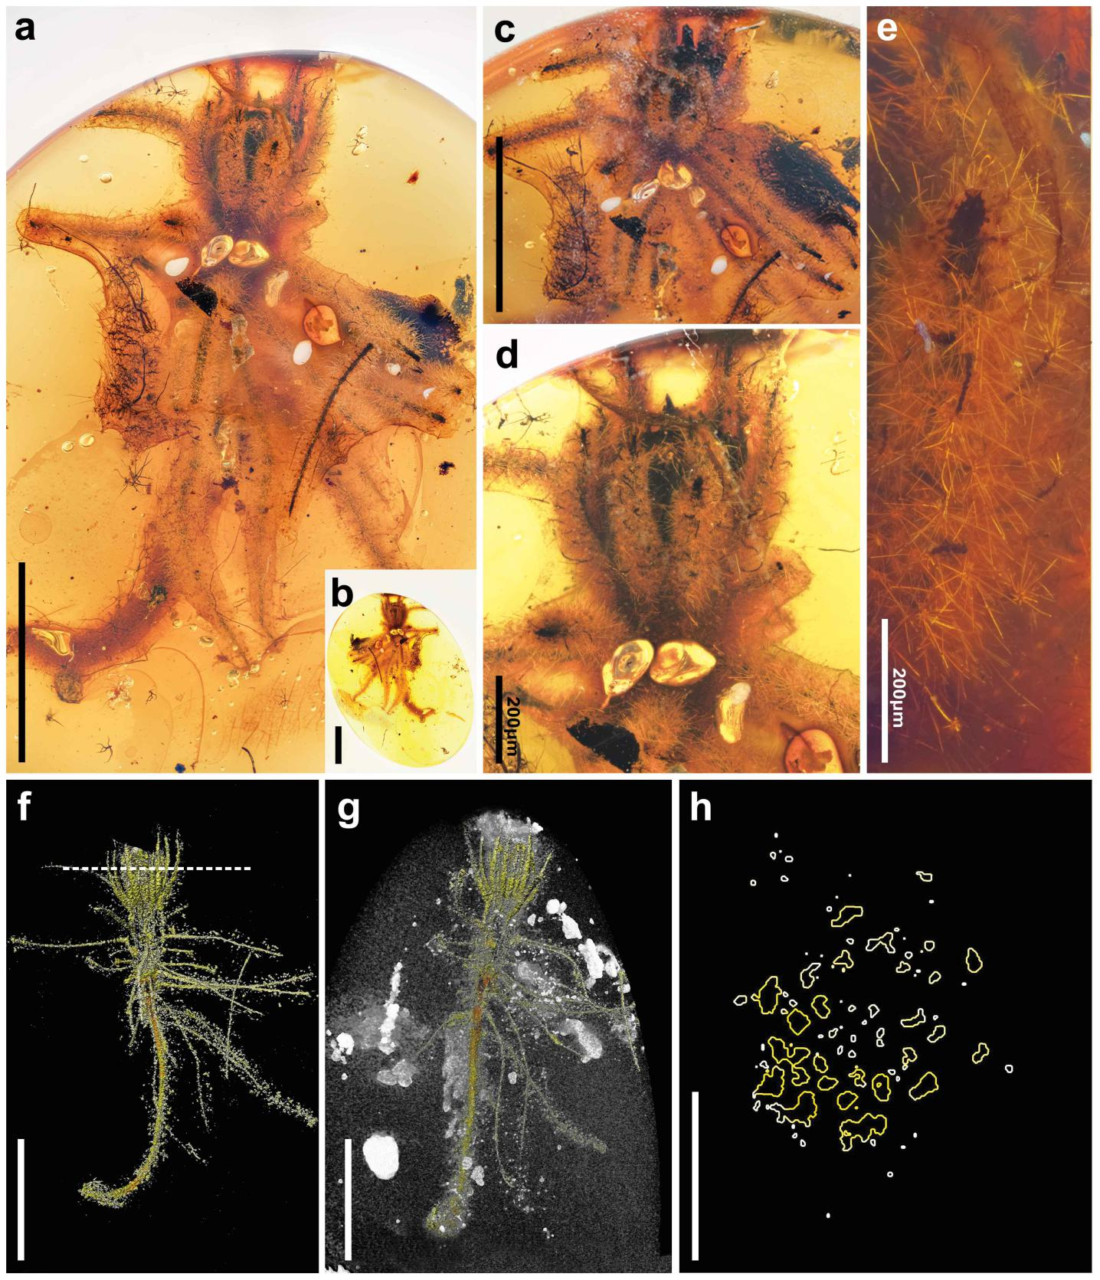
Supplementary Fig. 12 | Typical pseudo ‘flower head’ in amber. This figure gives additional details for specimen QUST-AM20506. (a, c) Typical pseudo ‘flower head’ emerging from the tightly clustered leaves and the densely stellated hairs on the leaves. b, The whole amber piece that included the fossil. (d, e) Enlarged view of the leaves and detailed morphology of stellate hairs on the leaves. (f, g) MicroXCT scanning image showing the arrangement of the leaves (pseudo ‘flower head’) at the tip of the stem. h, Transverse section of the clustered leaves (from the MicroXCT scan; dotted line in f is the transverse line) showing arrangement density and shape of the leaves in transverse view. Scale bars = 0.5 mm (if not otherwise indicated).

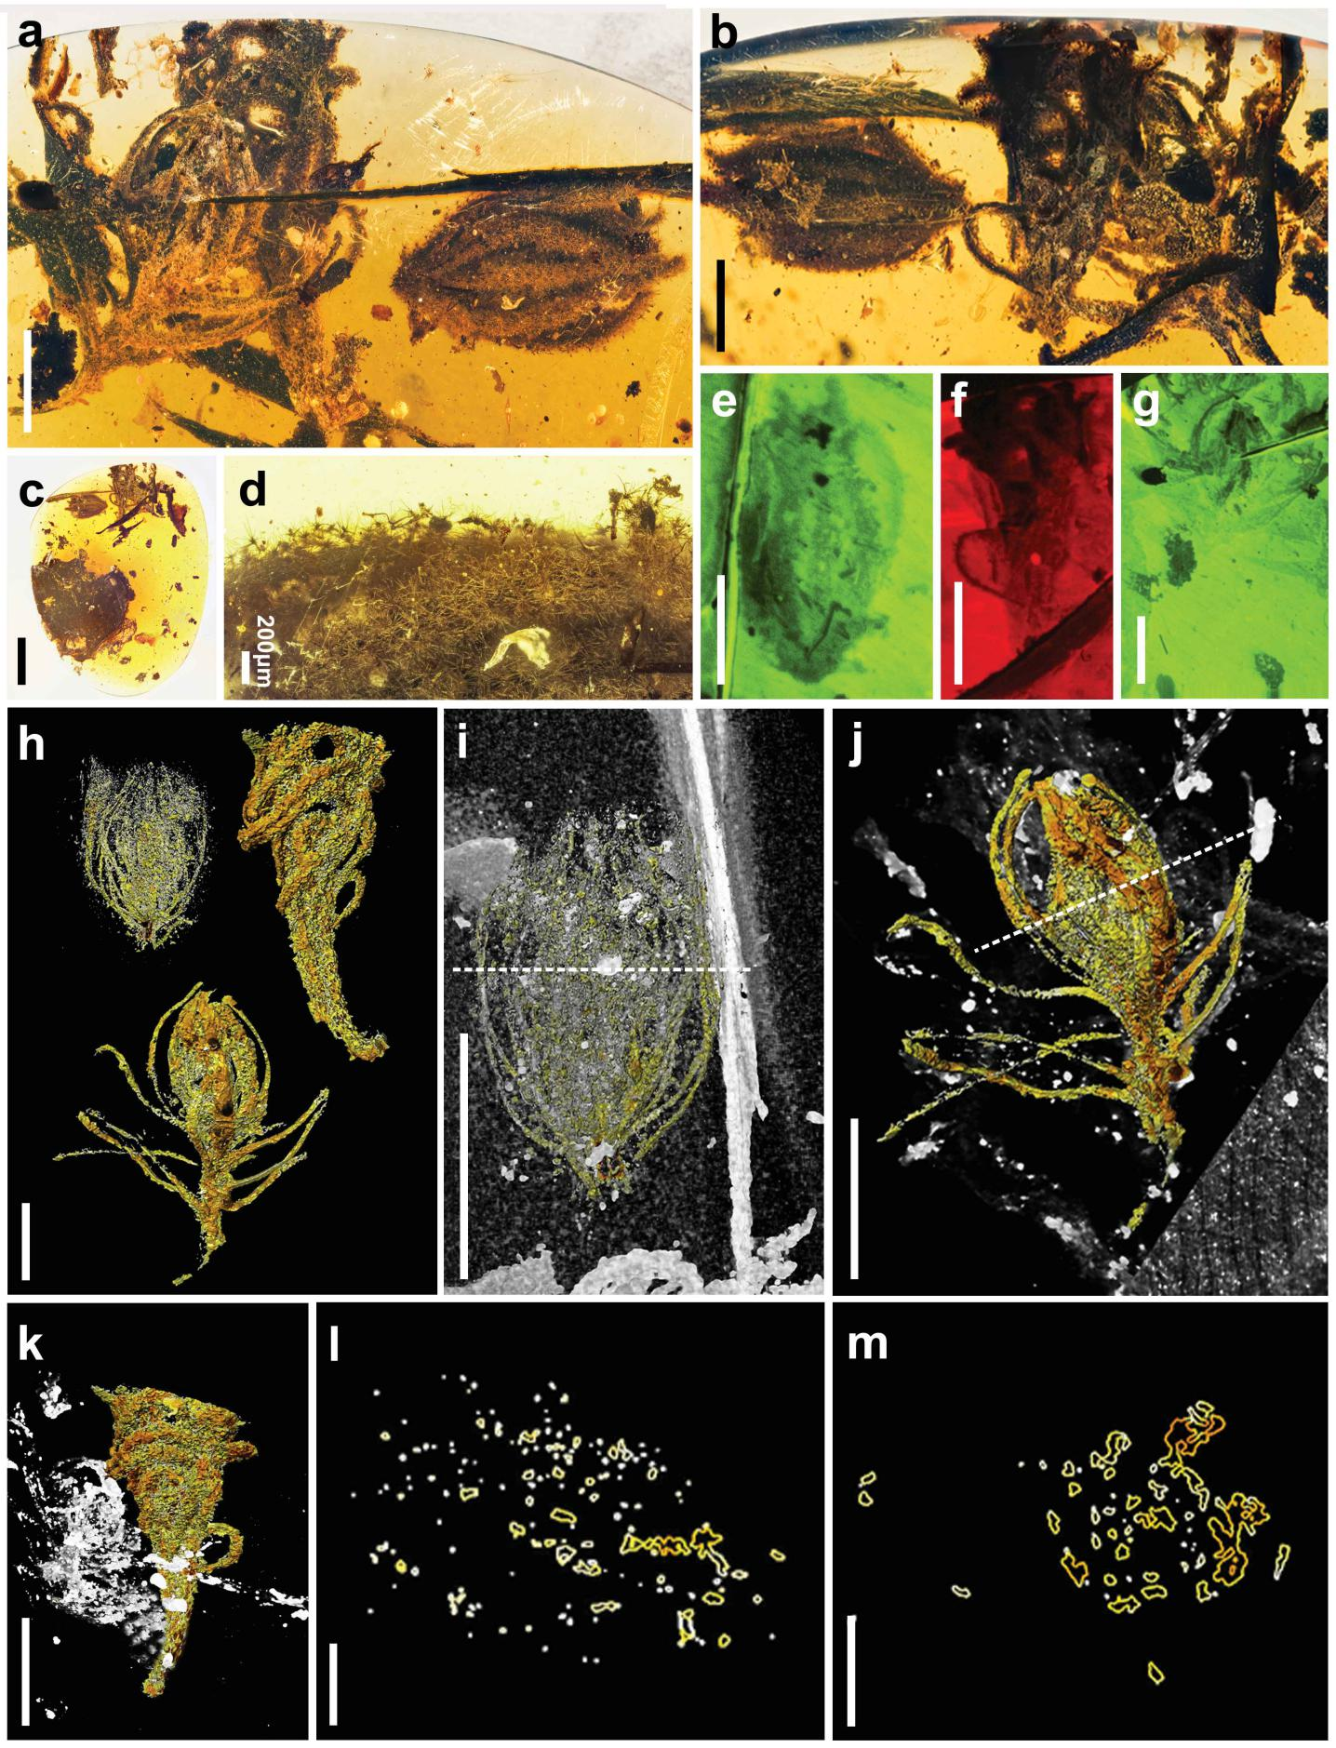
Supplementary Fig. 13 | Typical pseudo ‘flower head’ in amber. This figure gives additional details for specimen QUST-AM20507. This specimen consisted of three stages in the development of the pseudo ‘flower head’ in a single amber piece. (a, b, e–g) Typical pseudo ‘flower head’ emerging from the tightly clustered leaves and the densely stellated hairs on the leaves. Among them, e–g is the fluorescence image (green or red in colour). c, The whole amber piece that included the fossil. d, Enlarged view of the leaves and detailed morphology of stellate hairs on the leaves. h–k, MicroXCT scanning image showing the arrangement of the leaves (pseudo ‘flower head’) of the three fossils, with h is the overall view and i–k are enlarged view of each pseudo ‘flower head’. l–m, Transverse section of the clustered leaves (from the MicroXCT scan; dotted line in i and j is the transverse line) showing arrangement density and shape of the leaves in transverse view. Scale bars = 0.5 mm (if not otherwise indicated).
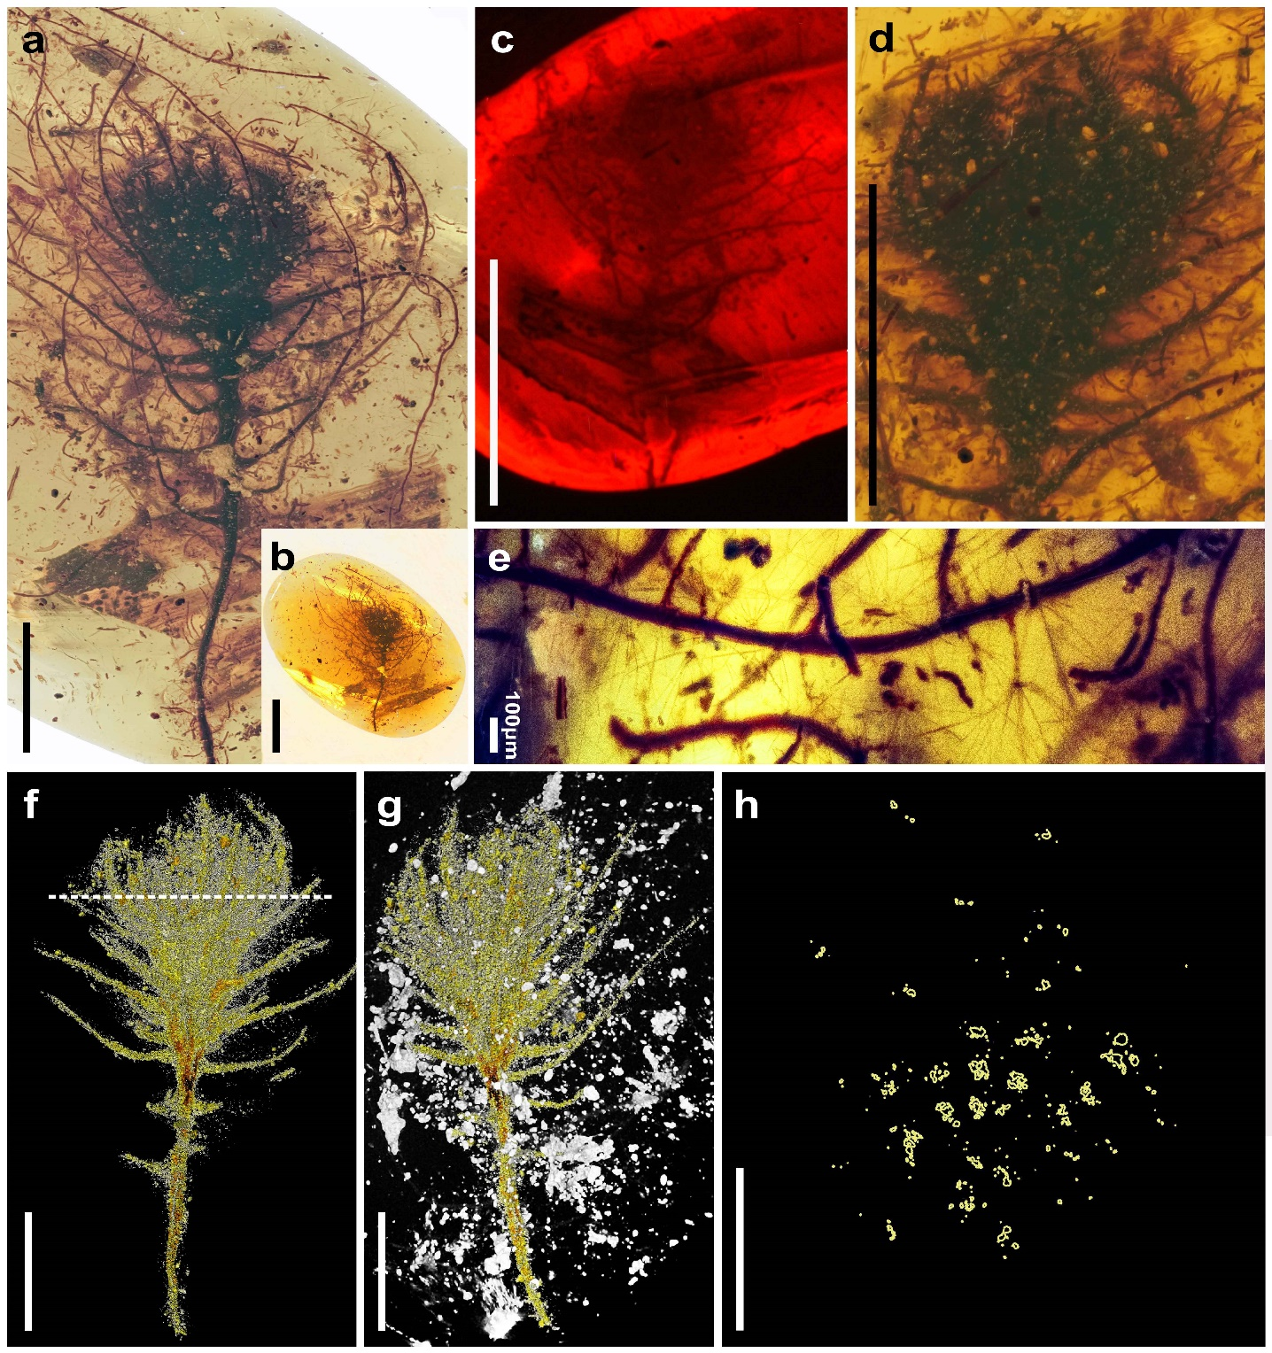
Supplementary Fig. 14 | Typical pseudo ‘flower head’ in amber. This figure gives additional details for specimen QUST-AM20508. This specimen is consisted of one developed pseudo ‘flower head’ in the amber. (a, c, d) Typical pseudo ‘flower head’ emerging from the tightly clustered leaves and the densely stellated hairs on the leaves. Among them, c is the fluorescence image in red colour. b, The whole amber piece that included the fossil. e, Enlarged view of the leaves and detailed morphology of stellate hairs on the leaves. f–g, MicroXCT scanning image showing the arrangement of the leaves (pseudo ‘flower head’) at the tip of the stem. h, Transverse section of the clustered leaves (from the MicroXCT scan; dotted line in f is the transverse line) showing arrangement density and shape of the leaves in transverse view. Scale bars = 0.5 mm (if not otherwise indicated).
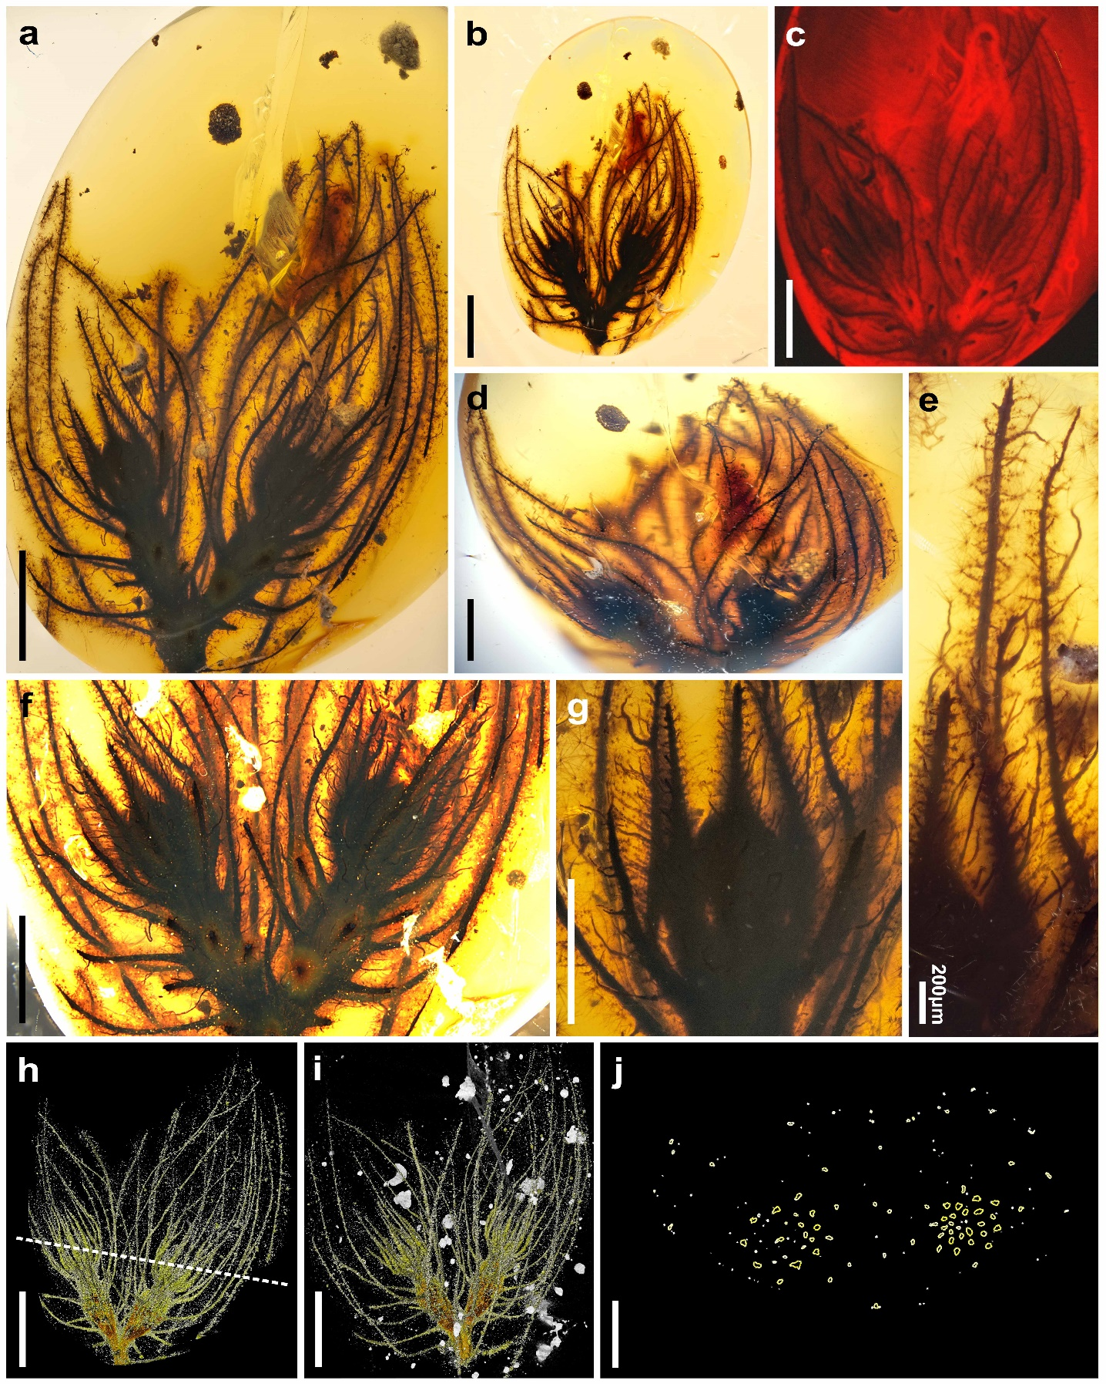
Supplementary Fig. 15 | Further development of the pseudo ‘flower head’ in amber. This figure gives additional details for specimen QUST-AM20509. This specimen consists of two more fully developed pseudo ‘flower heads’ co-occurring on the twig tip. (a, c, d, f–g) The pseudo ‘flower head’ and the densely stellated hairs on the leaves. Among them, c is the fluorescence image (red in colour). b, The whole amber piece that included the fossil. e, Enlarged view of the leaves and detailed morphology of stellate hairs on the leaves. (h, i) MicroXCT scanning image showing the arrangement of the leaves (pseudo ‘flower head’) at the tip of the stem. j, Transverse section of the clustered leaves (from the MicroXCT scan; dotted line in h is the transverse line) showing arrangement density and shape of the leaves in transverse view. Scale bars = 0.5 mm (if not otherwise indicated).

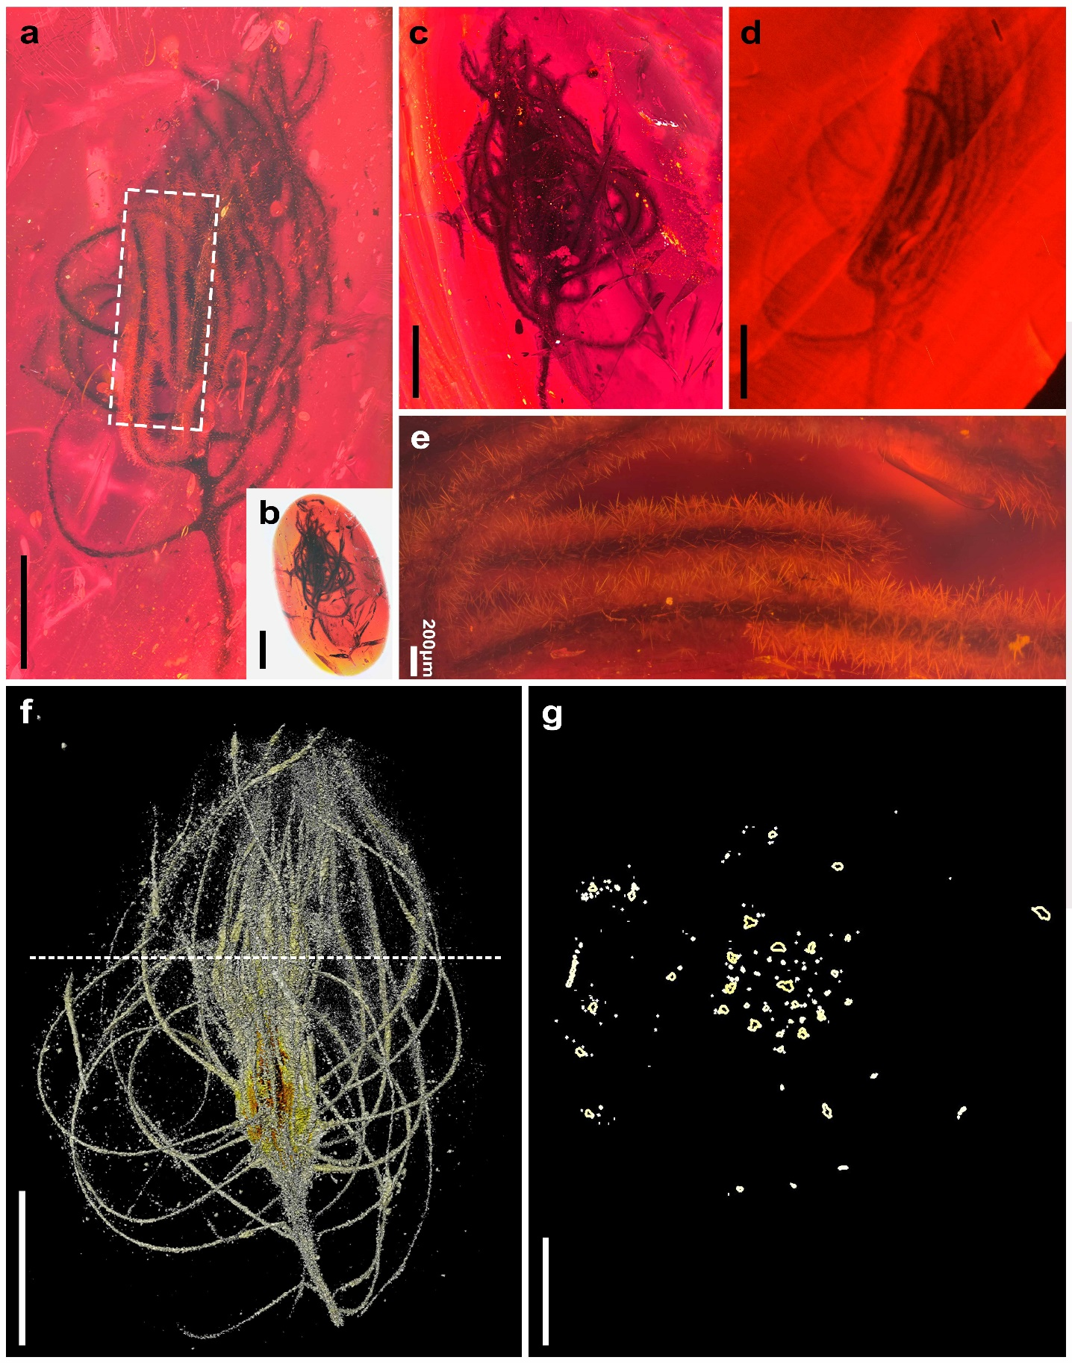
Supplementary Fig. 16 | Further development of the pseudo ‘flower head’ in amber. This figure gives additional details for specimen QUST-AM20510. This specimen consists of one more fully developed pseudo ‘flower head’ in amber with red colour. (a, c, d) Typical pseudo ‘flower Head’ emerging from the tightly clustered leaves and the densely stellated hairs on the leaves. b, The whole amber piece that included the fossil. e, Enlarged view of the leaves and detailed morphology of stellate hairs on the leaves. f, MicroXCT scan showing the arrangement of the leaves (pseudo ‘flower head’) at the tip of the stem. g, Transverse section of the clustered leaves (from the MicroXCT scan; dotted line in f is the transverse line) showing arrangement density and shape of the leaves in transverse view. Scale bars = 0.5 mm (if not otherwise indicated).
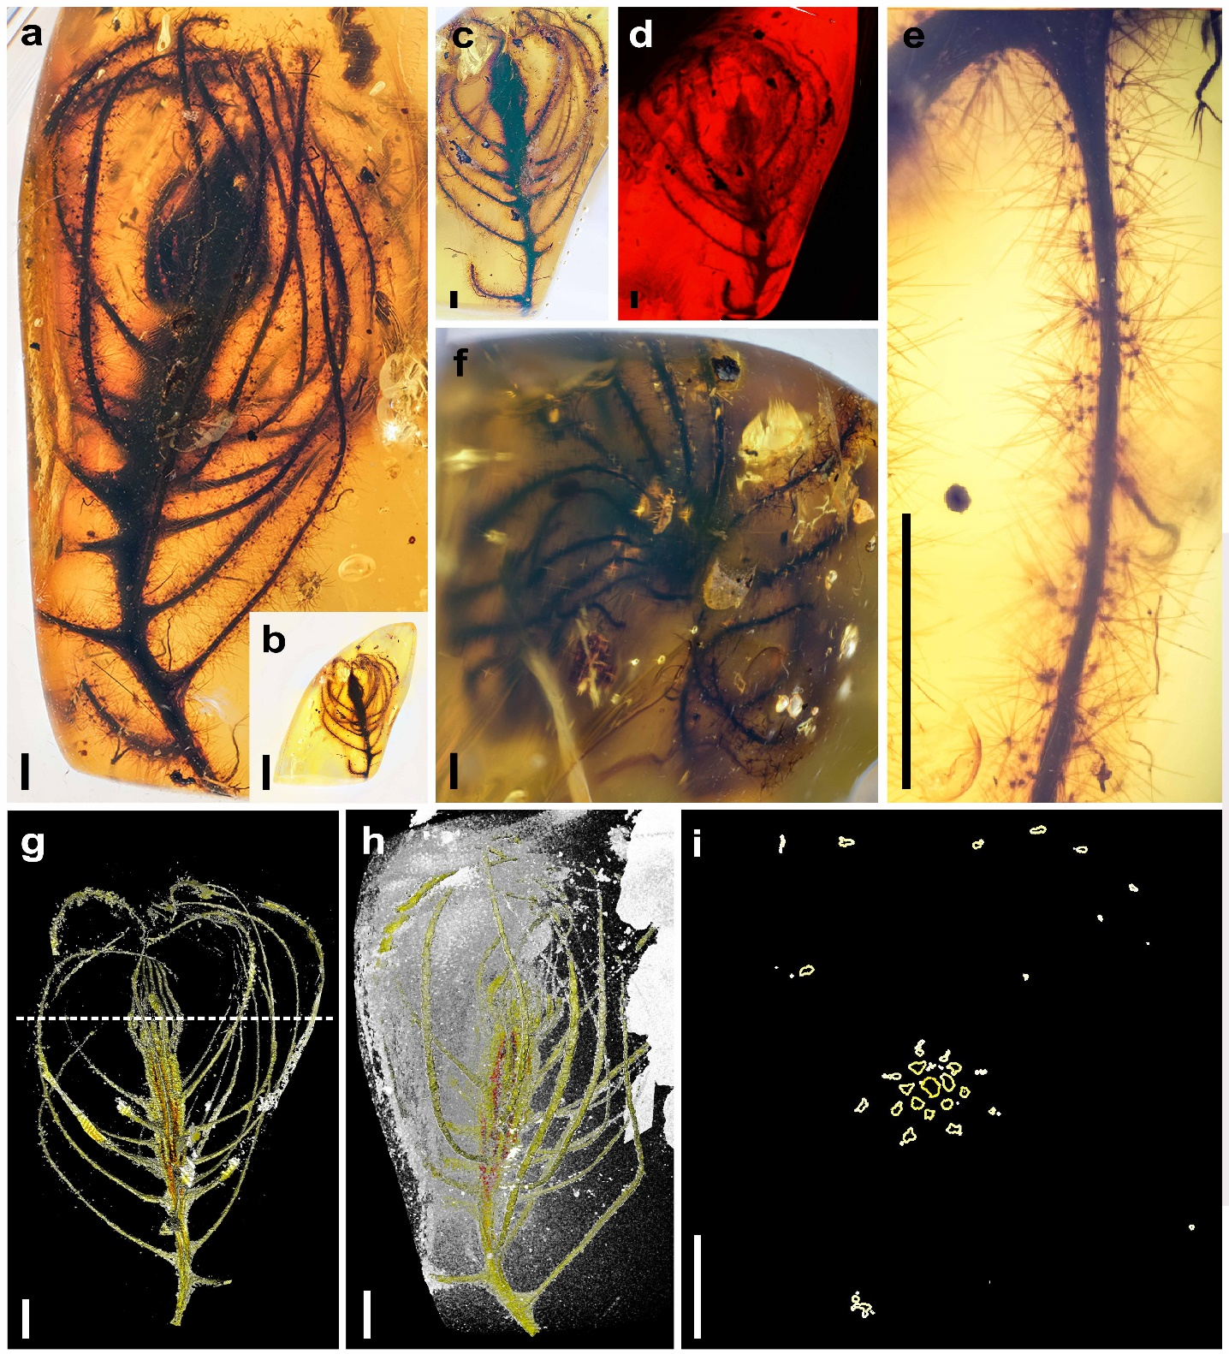
Supplementary Fig. 17 | Further development of the pseudo ‘flower head’ in amber. This figure gives additional details for specimen QUST-AM20511. (a, c, d, f) Typical pseudo ‘flower head’ emerging from the tightly clustered leaves and the densely stellate hairs on the leaves. Among them, (d) is the fluorescence image. b, The whole amber piece that included the fossil. e, Enlarged view of the leaves and detailed morphology of stellate hairs on the leaves. (g, h) MicroXCT scan showing the arrangement of the leaves (pseudo ‘flower head’) at the tip of the stem. i, Transverse section of the clustered leaves (from the MicroXCT scan; dotted line in g is the transverse line) showing arrangement density and shape of the leaves in transverse view. Scale bars = 0.5 mm.

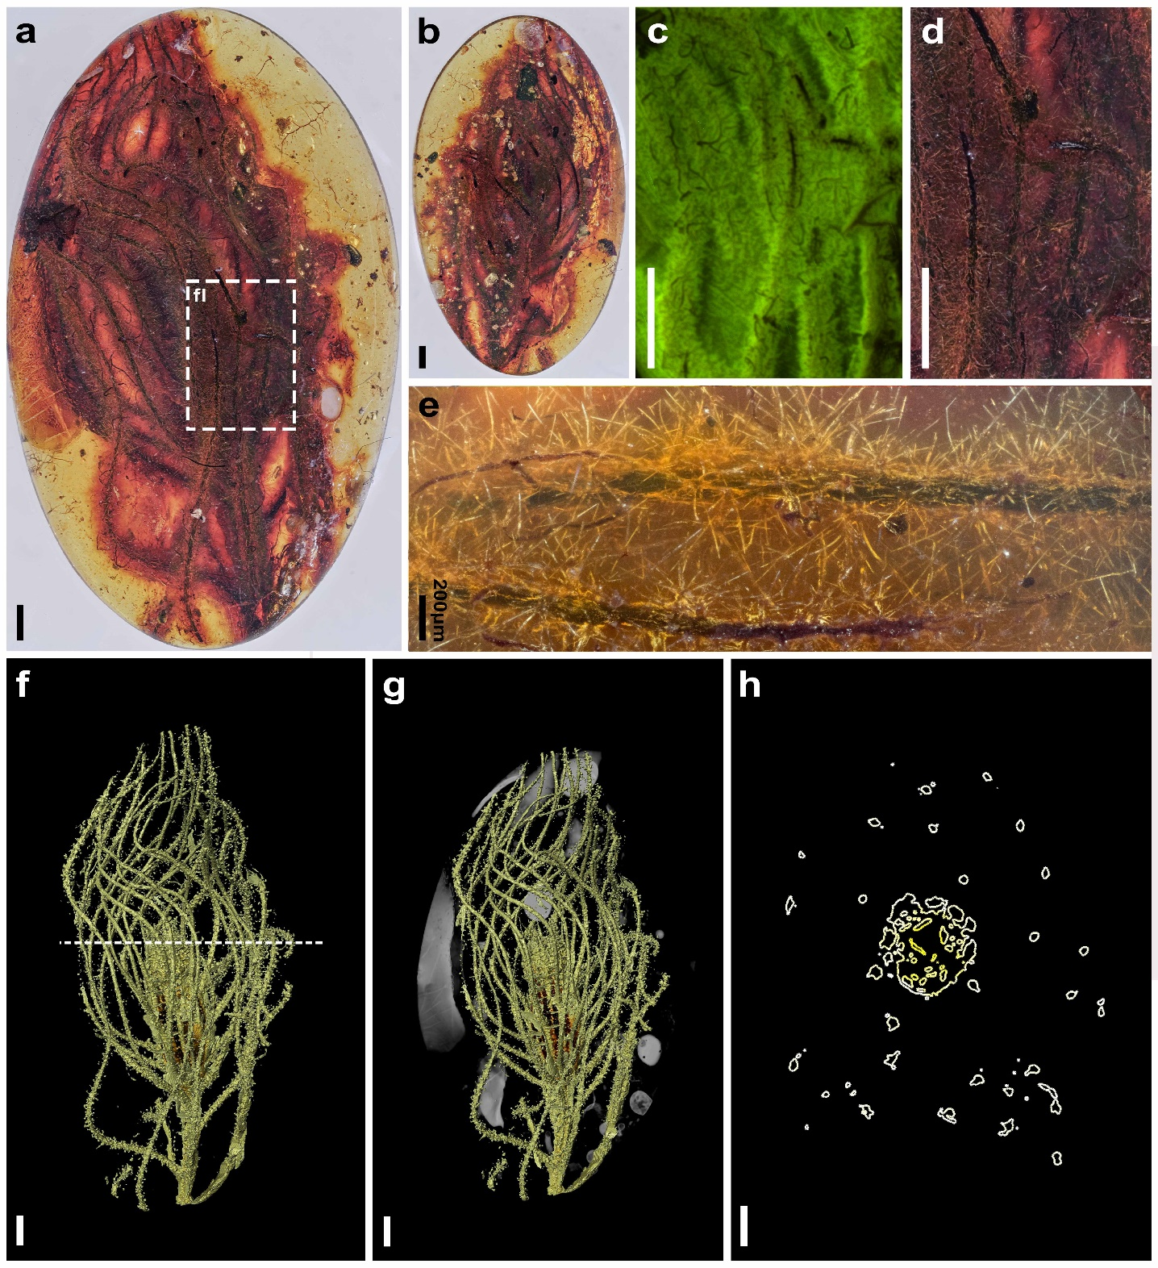
Supplementary Fig. 18 | Further development of the pseudo ‘flower head’ in amber. This figure gives additional details for specimen QUST-AM20512. This specimen consists of one more fully developed pseudo ‘flower head’ in amber. a, Typical pseudo ‘flower head’ appear from the tightly clustered leaves and the densely stellate hairs on the leaves. b, The whole amber piece that included the fossil. c–e, Enlarged view of the leaves and detailed morphology of stellate hairs on the leaves. Among them, d is the fluorescence image in green colour. (f, g) MicroXCT scan showing the arrangement of the leaves (pseudo ‘flower head’) at the tip of the stem. h, Transverse section of the clustered leaves (from the MicroXCT scan; dotted line in f is the transverse line) showing arrangement density and shape of the leaves in transverse view. Scale bars = 0.5 mm (if not otherwise indicated).

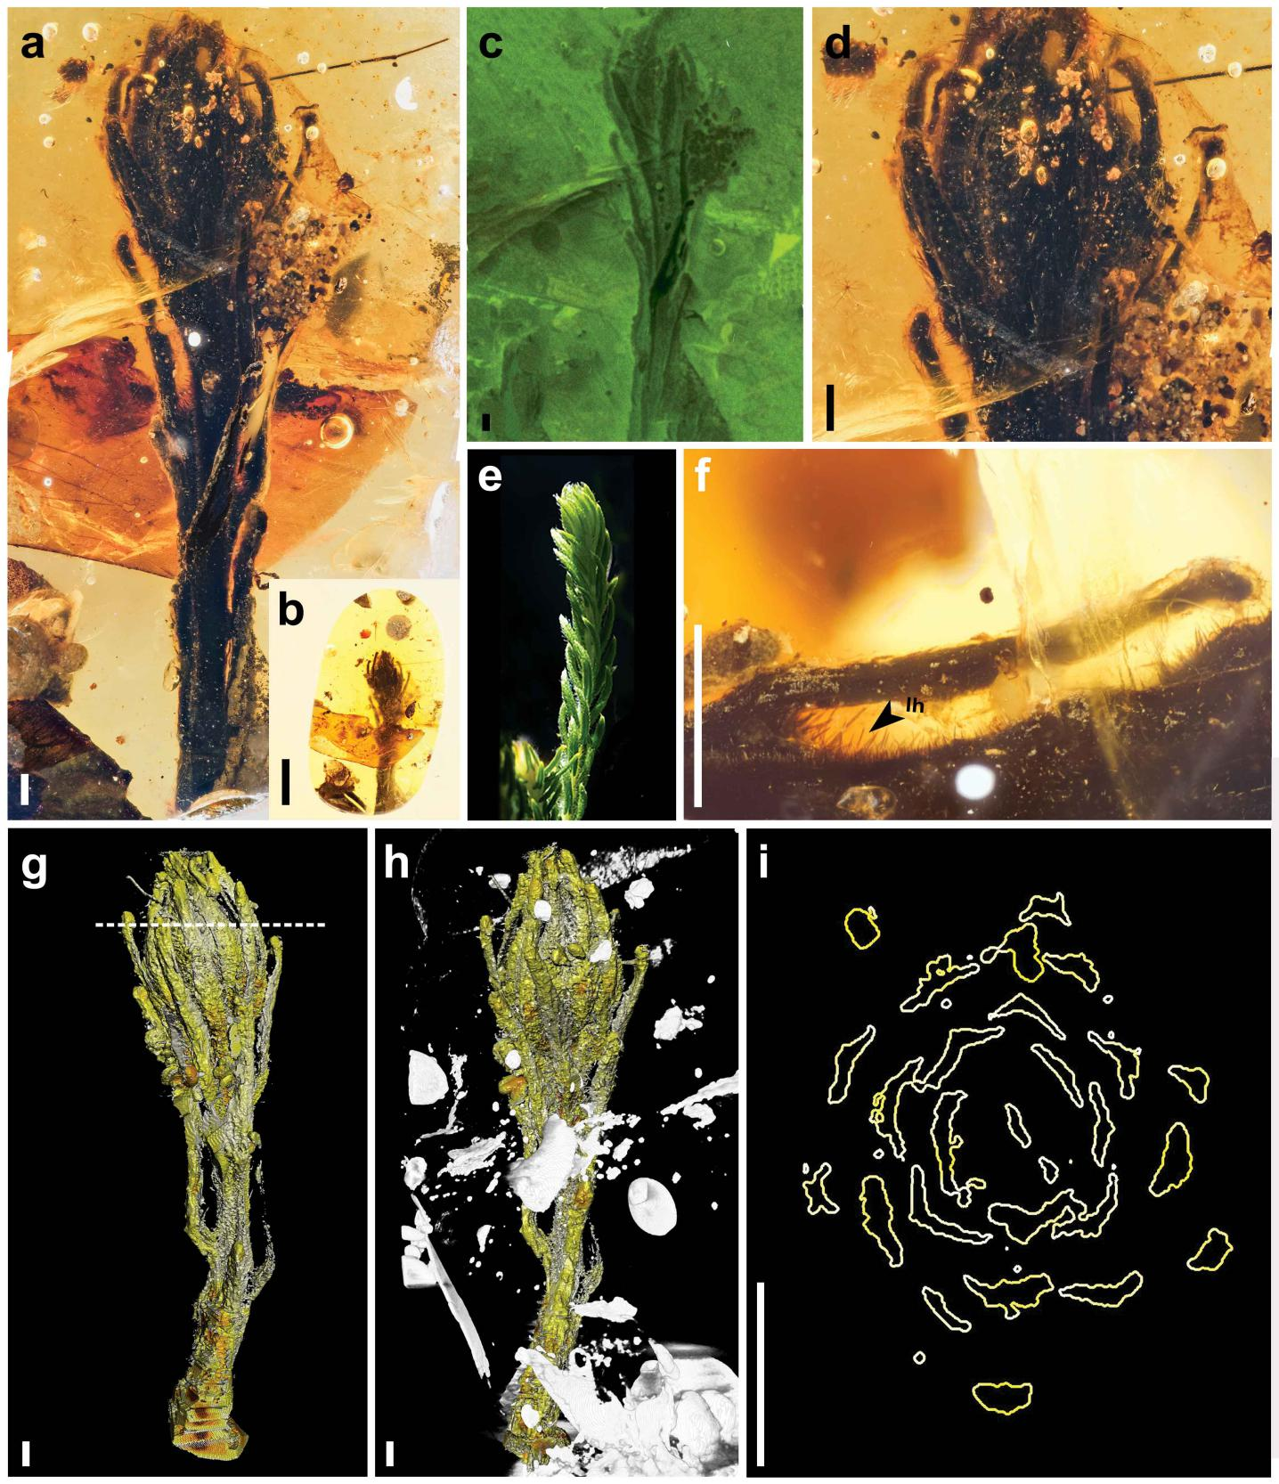
Supplementary Fig. 19 | Tightly clustered leaves before formation of typical pseudo ‘flower head’. This figure gives additional details of specimen QUST-AM20513. (a, c, d) Enlarged cluster of leaves show the arrangement of the leaves at the tip of the stem and the densely stellated hairs on the leaves. Among them, c is the fluorescence image. b, The whole amber piece that included the fossil. e, Clustered leaves from the extant species of Phylica. f, Enlarged view of the leaves and detailed morphology of stellate hairs on the leaves. (g, h) MicroXCT scanning image showing the arrangement of the leaves at the tip of the stem. i, Transverse section of the clustered leaves (from the MicroXCT scan; dotted line in g is the transverse line) showing arrangement density and shape of the leaves in transverse view. lh, linear hair. Scale bars = 0.5 mm (if not otherwise indicated).

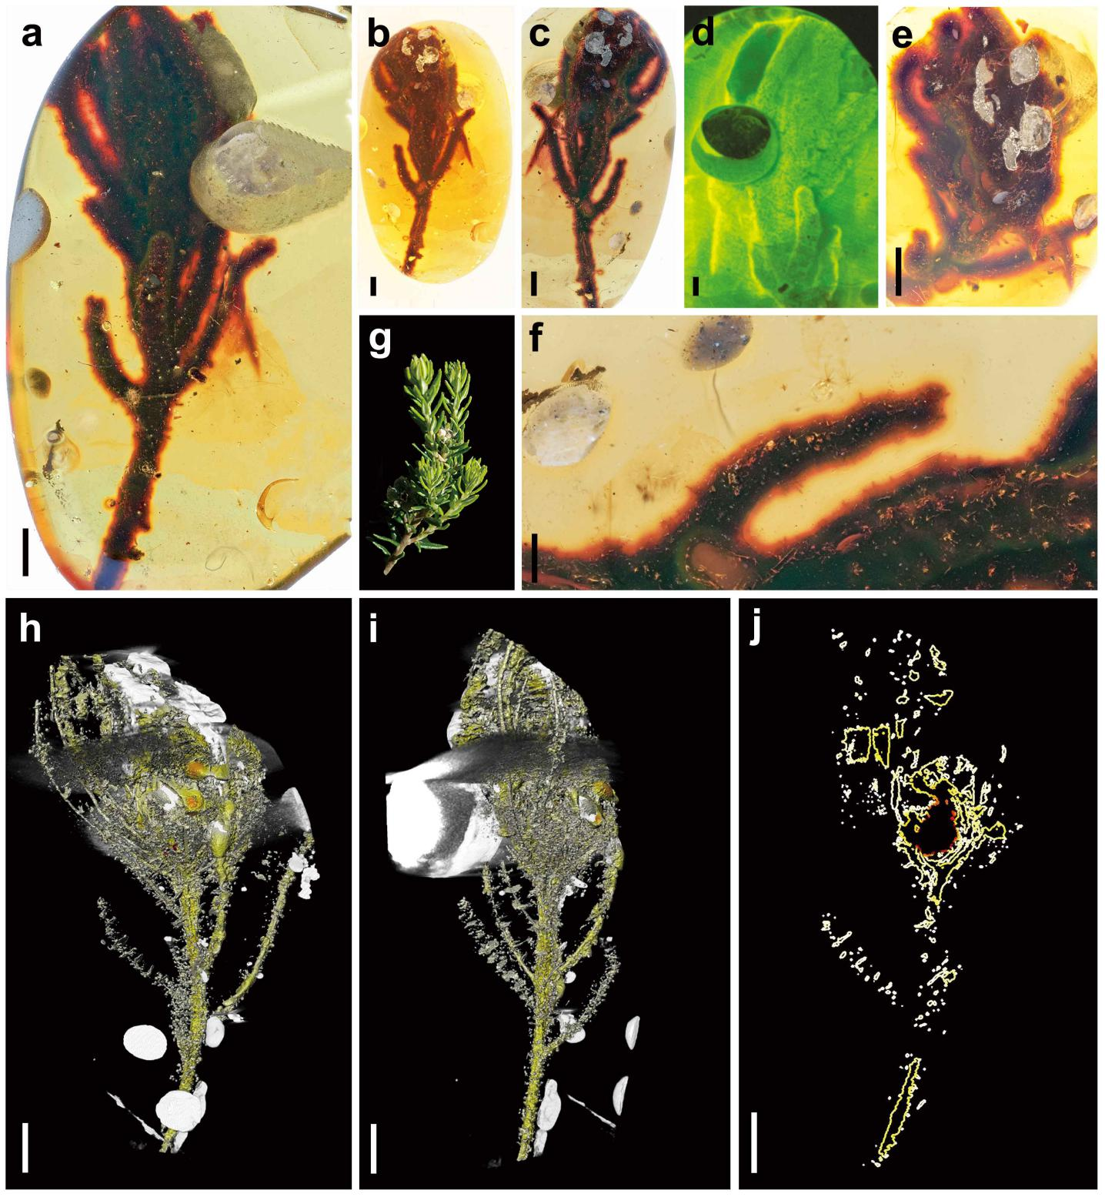Supplementary Fig. 20 | Tightly clustered leaves before formation of typical pseudo ‘flower head’. This figure gives additional details of specimen QUST-AM20514. (a, c–e) Enlarged cluster of leaves show the arrangement of the leaves at the tip of the stem and the densely stellated hairs on the leaves. b, The whole amber piece that included the fossil. d, The fluorescence image. e, Clustered leaves from the extant species of Phylica. f, Enlarged view of the leaves and detailed morphology of stellate hairs on the leaves. g, Clustered leaves from the extant species of Phylica. (h, i) MicroXCT scanning image showing the arrangement of the leaves at the tip of the stem. j, Longitudinal section of the clustered leaves (from the MicroXCT scan). Scale bars = 0.5 mm.

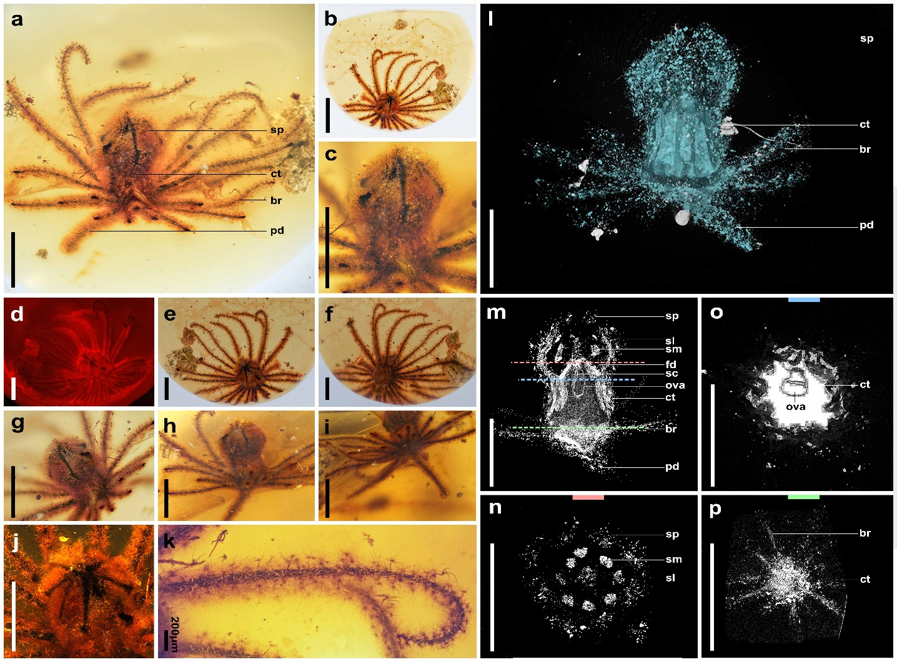
Supplementary Fig. 21 | A flower surrounded by a round of bracts. This figure gives additional details for the holotype specimen QUST-AM32413 of Eophylica priscastellata gen. et sp. nov. (a, c–j) A comprehensive view of the flower from different sides (a–c, g–i, side view; d–e, j, top view; f, bottom view). b, The whole amber piece that included the fossil. k, Enlarge view of the leafy bracts and detailed morphology of stellate hairs on the bracts. i, MicroXCT scanning image showing overall morphology of the flower and bracts. m, Longitudinal section of the flower (from the MicroXCT scan). o, Transverse section of the flower (from the MicroXCT scan; the blue dotted line in m is the transverse line). n–p, Transverse section of the flower (from the MicroXCT scan; the pink, blue and green dotted line in m is the transverse line used for transverse section view in n, o and p, respectively). br, bract; ct, calyx tube; ova, ovary; pd, peduncle; sc, stylar canal; sl, style; sm, stamen; sp, sepal. Scale bars = 0.5 mm (if not otherwise indicated).
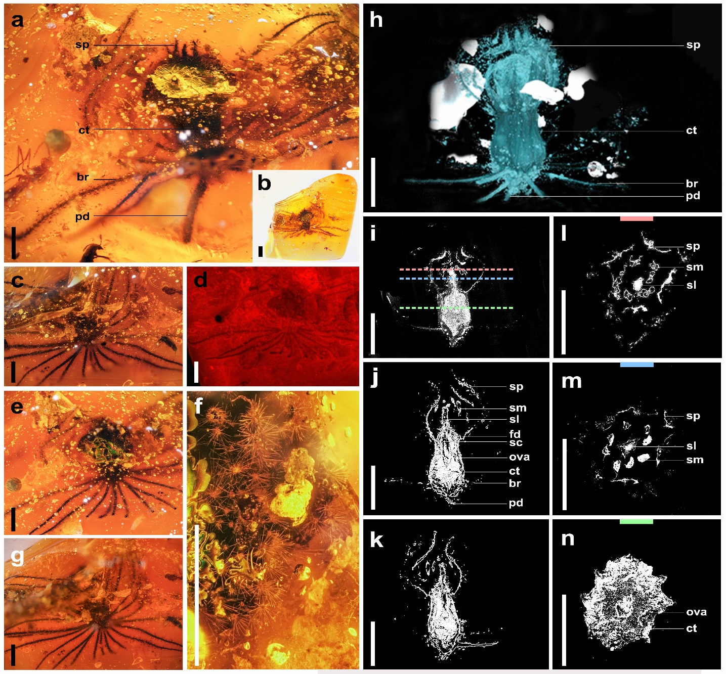
Supplementary Fig. 22 | A flower surrounded by a round of bracts. This figure gives additional details for specimen QUST-AM32414 of Eophylica priscastellata gen. et sp. nov. (a, c–g) Comprehensive view of the flower of different sides. Among them, d is the fluorescence image. b, The whole amber piece that included the fossil. f, Enlarged view of the stellate hairs on the sepals. h, MicroXCT scanning image showing overall morphology of the flower and bracts. i–k, Longitudinal section of the flower (from the MicroXCT scan). Among them, j, k are front and back view of the Longitudinal section of different MicroXCT scanning depth, respectively. l–n, Transverse section of the flower (from the MicroXCT scan; the pink, blue and green dotted line in m is the transverse line that used for transverse section view in l, m and n, respectively). br, bract; ct, calyx tube; ova, ovary; pd, peduncle; sc, stylar canal; sl, style; sm, stamen; sp, sepal. Scale bars = 0.5 mm (if not otherwise indicated).

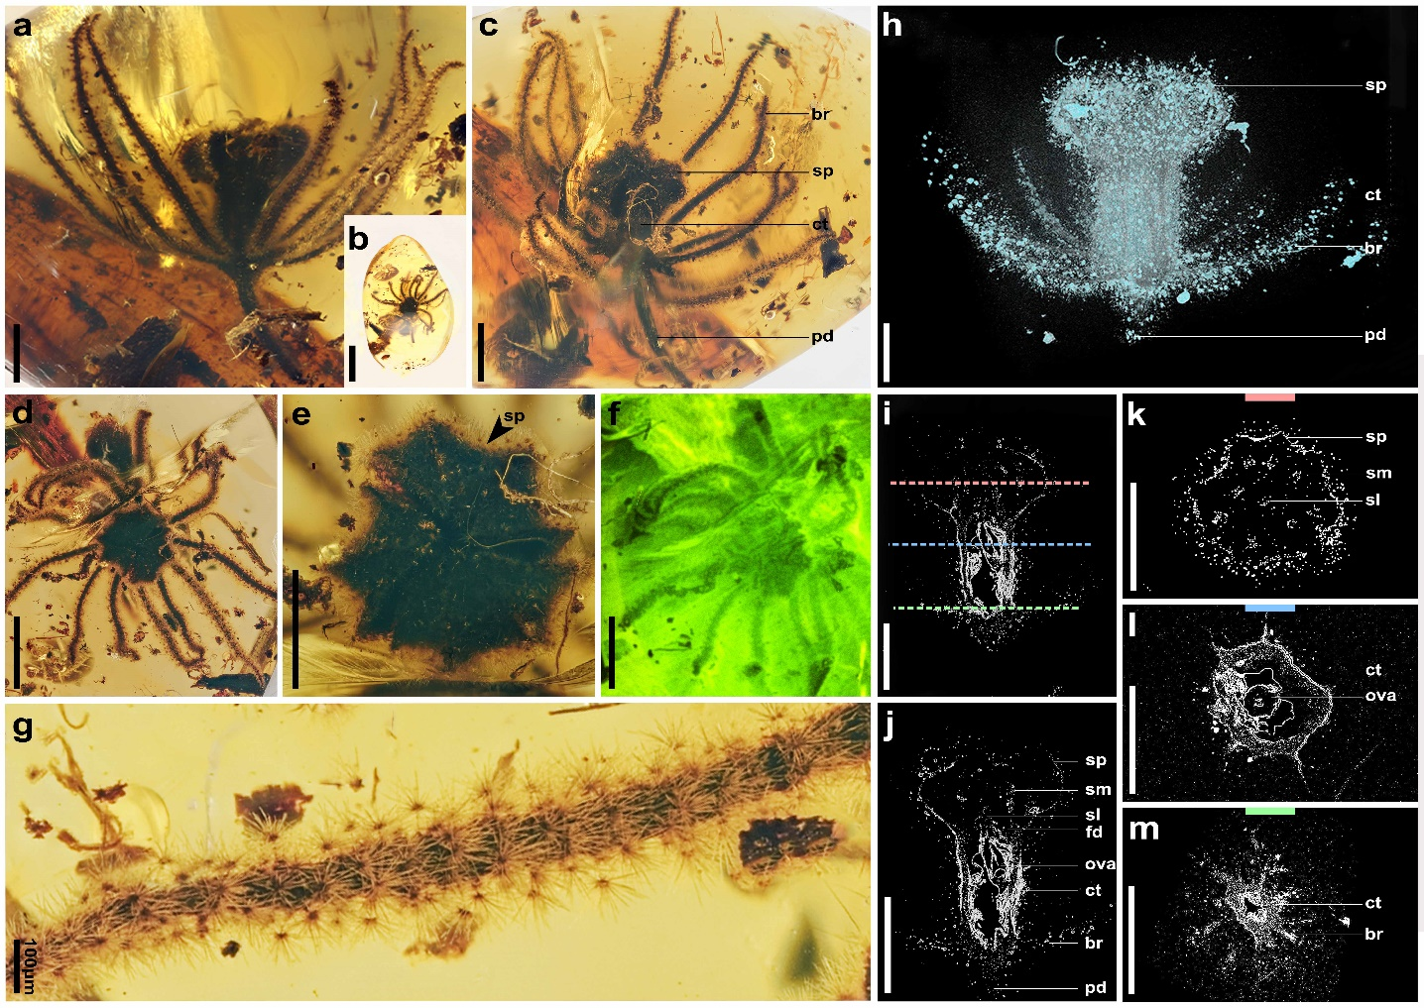
Supplementary Fig. 23 | A flower surrounded by a round of bracts. This figure gives additional details for specimen QUST-AM32415 of Eophylica priscastellata gen. et sp. nov. (a, c–f) A comprehensive view of the flower from different sides (a–c, side view; d–f, top view). b, The whole amber piece that included the fossil. g, Enlarged view of the leafy bracts and detailed morphology of stellate hairs on the bracts. h, MicroXCT scanning image showing overall morphology of the flower and bracts. i–j, Longitudinal section of the flower at different MicroXCT scanning depth. k–m, Transverse section of the flower (from the MicroXCT scan; the pink, blue and green dotted line in m are lines marking transverse sections in k, l and m, respectively). br, bract; ct, calyx tube; ova, ovary; pd, peduncle; sl, style; sm, stamen; sp, sepal. Scale bars = 0.5 mm (if not otherwise indicated).

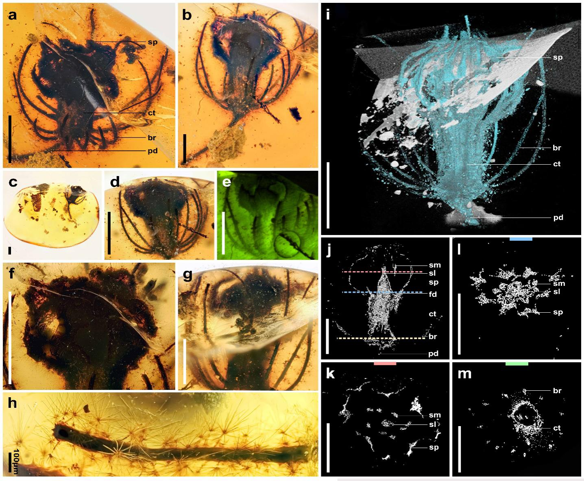
Supplementary Fig. 24 | A flower surrounded by a round of bracts. This figure gives additional details for specimen QUST-AM32416 of Eophylica priscastellata gen. et sp. nov. (a, b, d–g) A comprehensive view of the flower from different sides (a, b, d, e and g, side view; f, top view). Among them, e is the fluorescence image. c, The whole amber piece that included the fossil. h, Enlarged view of the leafy bracts and detailed morphology of stellate hairs on the bracts. i, MicroXCT scanning image showing overall morphology of the flower. j, Longitudinal section of the flower at different MicroXCT scanning depth. k–m, Transverse section of the flower (from the MicroXCT scan; the pink, blue and green dotted lines in j mark the positions of the transverse sections in k, l and m, respectively). br, bract; ct, calyx tube; pd, peduncle; sl, style; sm, stamen; sp, sepal. Scale bars = 0.5 mm.
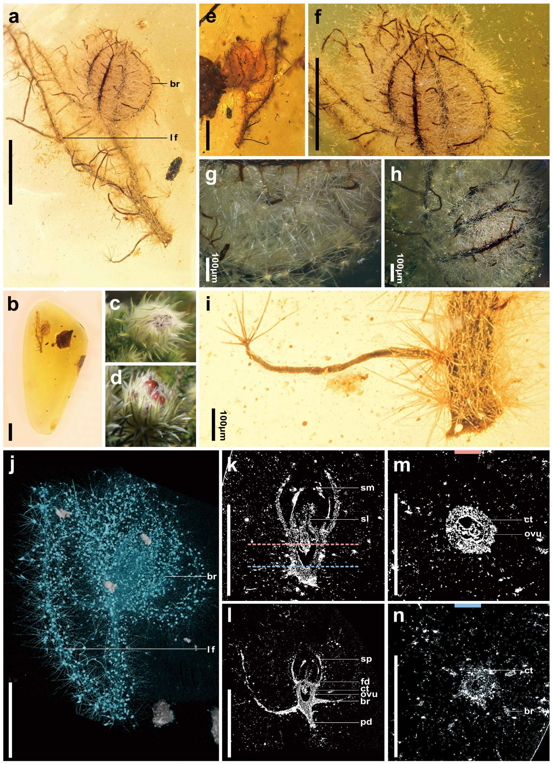
Supplementary Fig. 25 | A flower surrounded by several bracts. This figure gives additional details for specimen QUST-AM32417 of Eophylica priscastellata gen. et sp. nov., showing a flower surrounded by several outer bracts. (a, b) A comprehensive view of the flower from different sides. (g, k–m) Enlarged view of the stellate hairs on the twig. f, The whole amber piece that included the fossil. h, MicroXCT scanning image showing overall morphology of the flower. (i, j) Longitudinal section of the flower at different MicroXCT scanning depth. (k, l) Transverse section of the flower (from the MicroXCT scan; the pink, and blue dotted lines in i mark the positions of the transverse sections in k and i, respectively). br, bract; ct, calyx tube; fd, flower disc; ovu, ovule; pd, peduncle; sl, style; sm, stamen; sp, sepal. Scale bars = 0.5 mm (if not otherwise indicated).

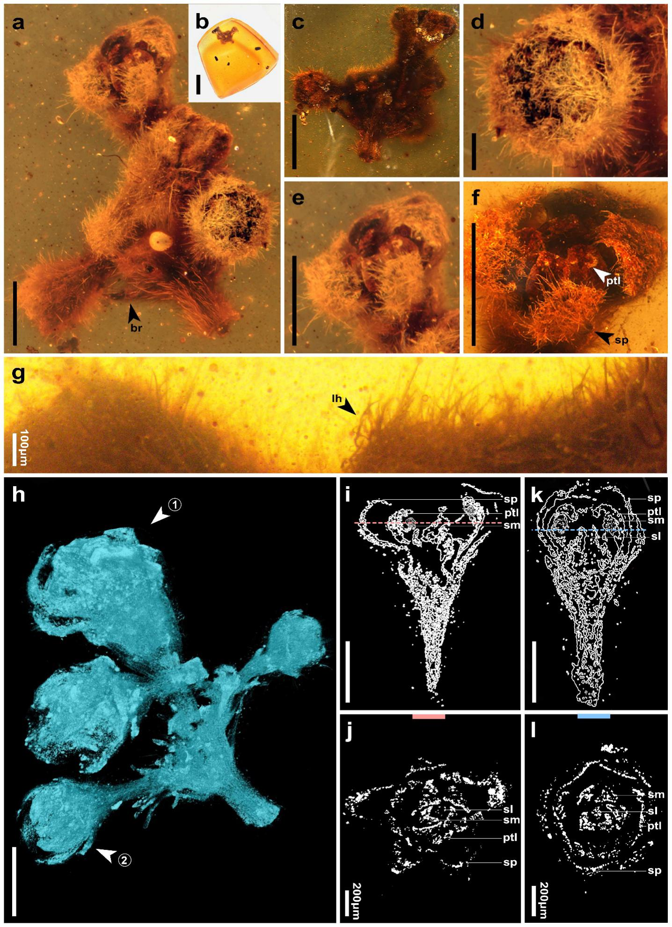
Supplementary Fig. 26 An inflorescence showing four semi-opened and unopened flowers. This figure gives additional details for the holotype specimen QUST-AM32127 of Phylica piloburmensis sp. nov. (a, c) a comprehensive view of the flower from different sides. b, The whole amber piece that included the fossil. d–f, Enlarged view of the flower head. g, Enlarged view of detailed morphology for linear hairs on the flower. h, MicroXCT scanning image showing overall morphology of the inflorescence. (i, j) Longitudinal section of the flower at different MicroXCT scanning depth. (j, l) Transverse section of the flower (from the MicroXCT scan; the pink, blue dotted line in i and j are the transverse lines mark the positions of the transverse sections). br, bract; lh, linear hair; ptl, petal; sl, style; sm, stamen; sp, sepal. Scale bars = 0.5 mm.

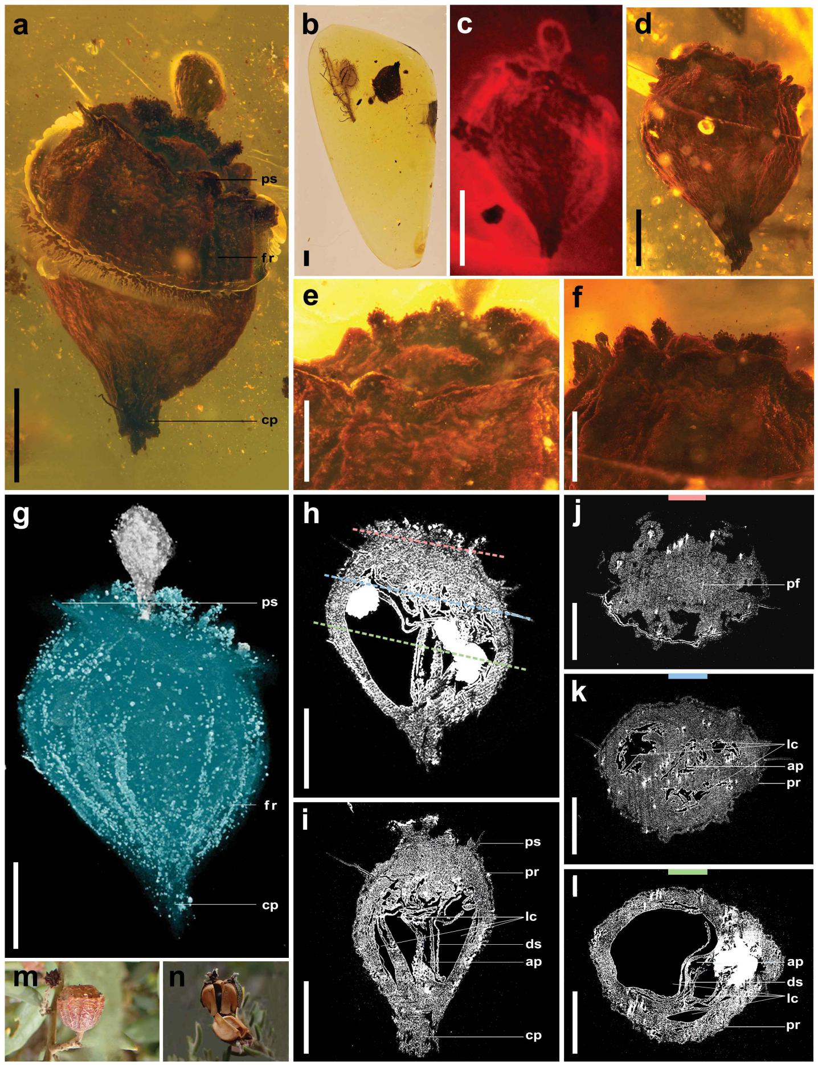
Supplementary Fig. 27 | Fruit. This figure gives additional details for specimen QUST-AM33310 of Eophylica priscastellata gen. et sp. nov. (a, c, d) A comprehensive view of the fruit from different side. b, The whole amber piece that included the fossil. (e, f) Enlarged view of the persistent base of the calyx. g, MicroXCT scanning image showing overall morphology of the fruit. (h, i) Longitudinal section of the fruit at different MicroXCT scanning depth. j–l, Transverse section of the fruit (from the MicroXCT scan; the pink, blue and green dotted lines in H mark the positions of the transverse sections in j–l, respectively). (m, n) Mature fruit of extant Phylica with similar morphology. ap, axile placenta; cp, carpopodium; ds, dissepiment; fr, fruit; lc, locule; pf, persistent flower; pr, pericarp; ps, persistent sepal. Scale bars = 0.5 mm.

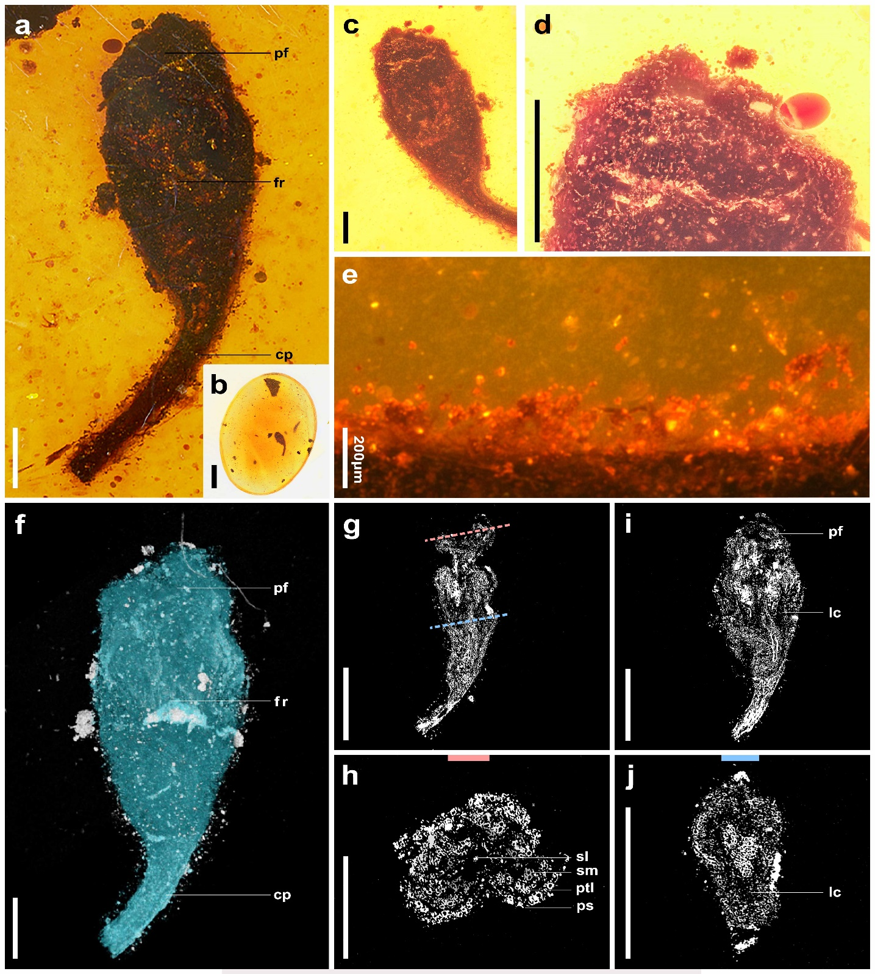
Supplementary Fig. 28 | Fruit. This figure gives additional details of specimen QUST-AM33311 of Eophylica priscastellata gen. et sp. nov. (a, c) A comprehensive view of the fruit from different sides. b, The whole amber piece that included the fossil. (d, e) Enlarged view of the persistent flower. f, MicroXCT scanning image showing overall morphology of the fruit. (g, i) Longitudinal section of the fruit at different MicroXCT scanning depth. (h, j) Transverse section of the fruit (from the MicroXCT scan; the pink, blue dotted lines in g mark the positions of the transverse sections in h and j, respectively). cp, carpopodium; fr,fruit; lc, locule; pf, persistent flower; ps, persistent sepal; ptl, petal; sl, style; sm, stamen; sp, sepal. Scale bars = 0.5 m.

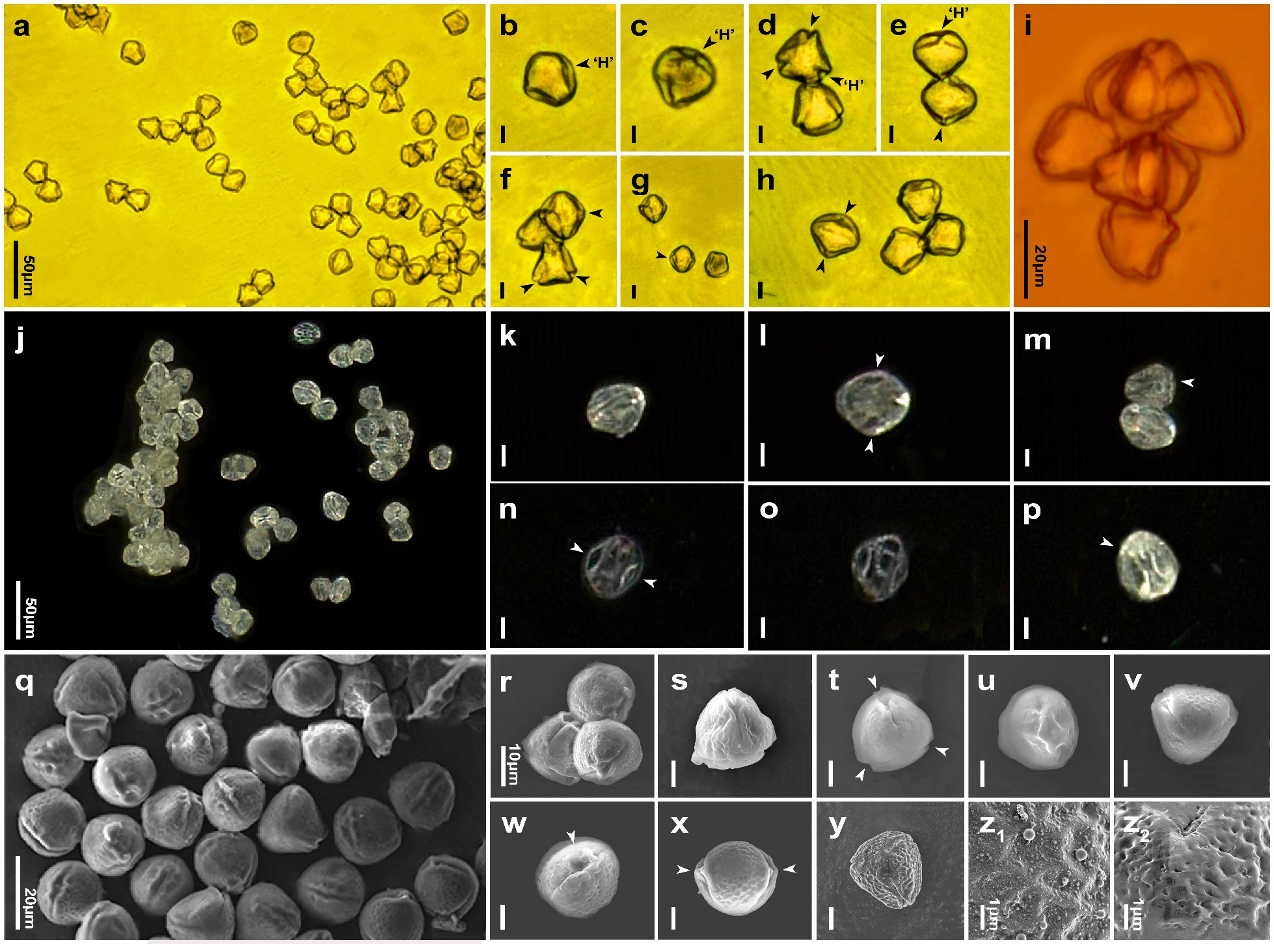
Supplementary Fig. 29 | Pollen grains found in amber and from extant Phylica species. a–h, Pollen grains from type specimen of Eophylica priscastellata gen. et sp. nov. with detailed morphology of each pollen grain further exhibited in (b–h). i, Pollen grains from type specimen of E. priscastellata gen. et sp. nov. (f–i, j–p) Pollen grains from extant Phylica species with detailed morphology of each pollen grain further exhibited in (k–p). (q–z₂) Scanning Electron Microscope (SEM) image of pollen grains from extant Phylica species with detailed morphology of each pollen further exhibited in R–Y and sculpture pattern on pollen exine exhibited in z₁–z₂. Arrows on the pollen indicate the colporate (form ‘H’ shape).

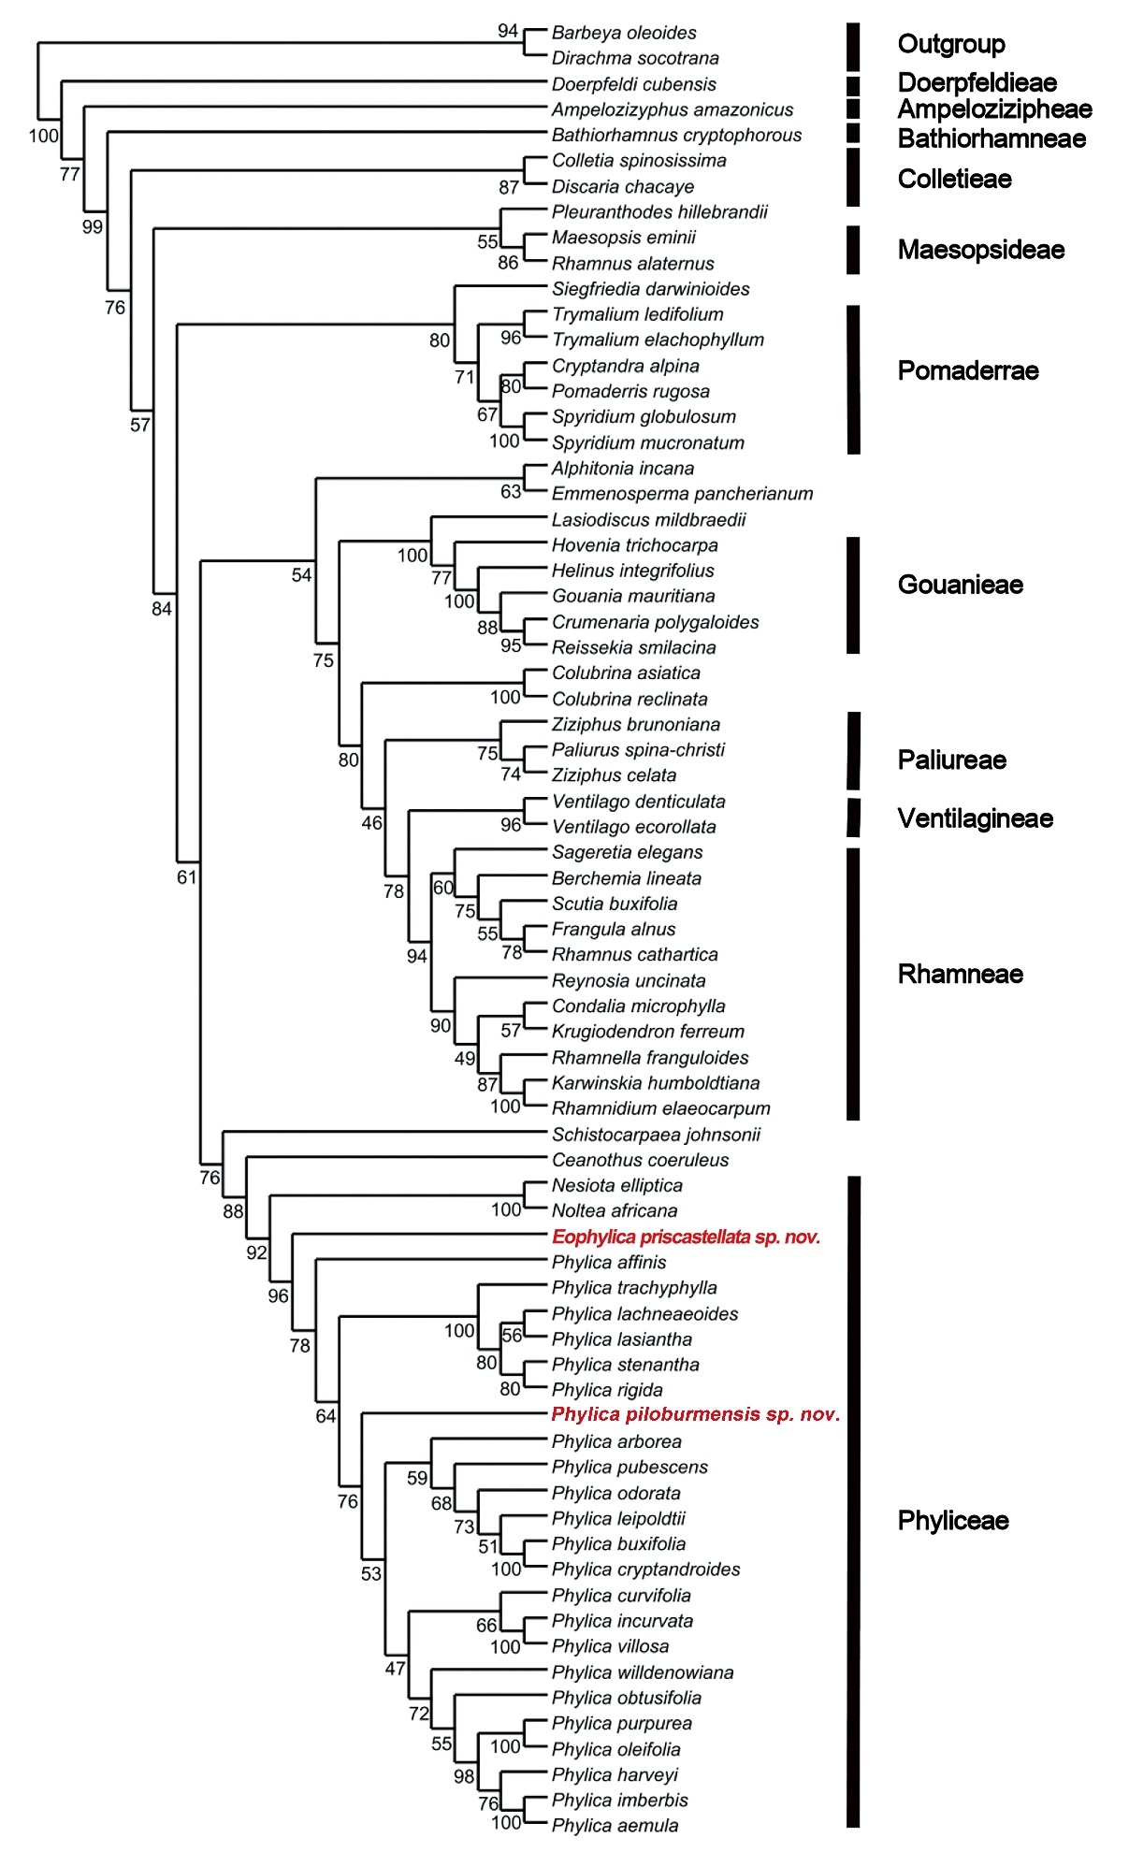
Supplementary Fig. 30 | Position of two fossil species in the Rhamnaceae phylogenetic tree. Maximum likelihood phylogenetic tree showing the position of Eophylica priscastellata gen. et sp. nov and Phylica piloburmensis sp. nov. based on a total evidence analysis using morphology and seven gene partitions. The percentage of replicate trees in which the associated taxa clustered together in the bootstrap test (1000 replicates) is shown next to the branches.

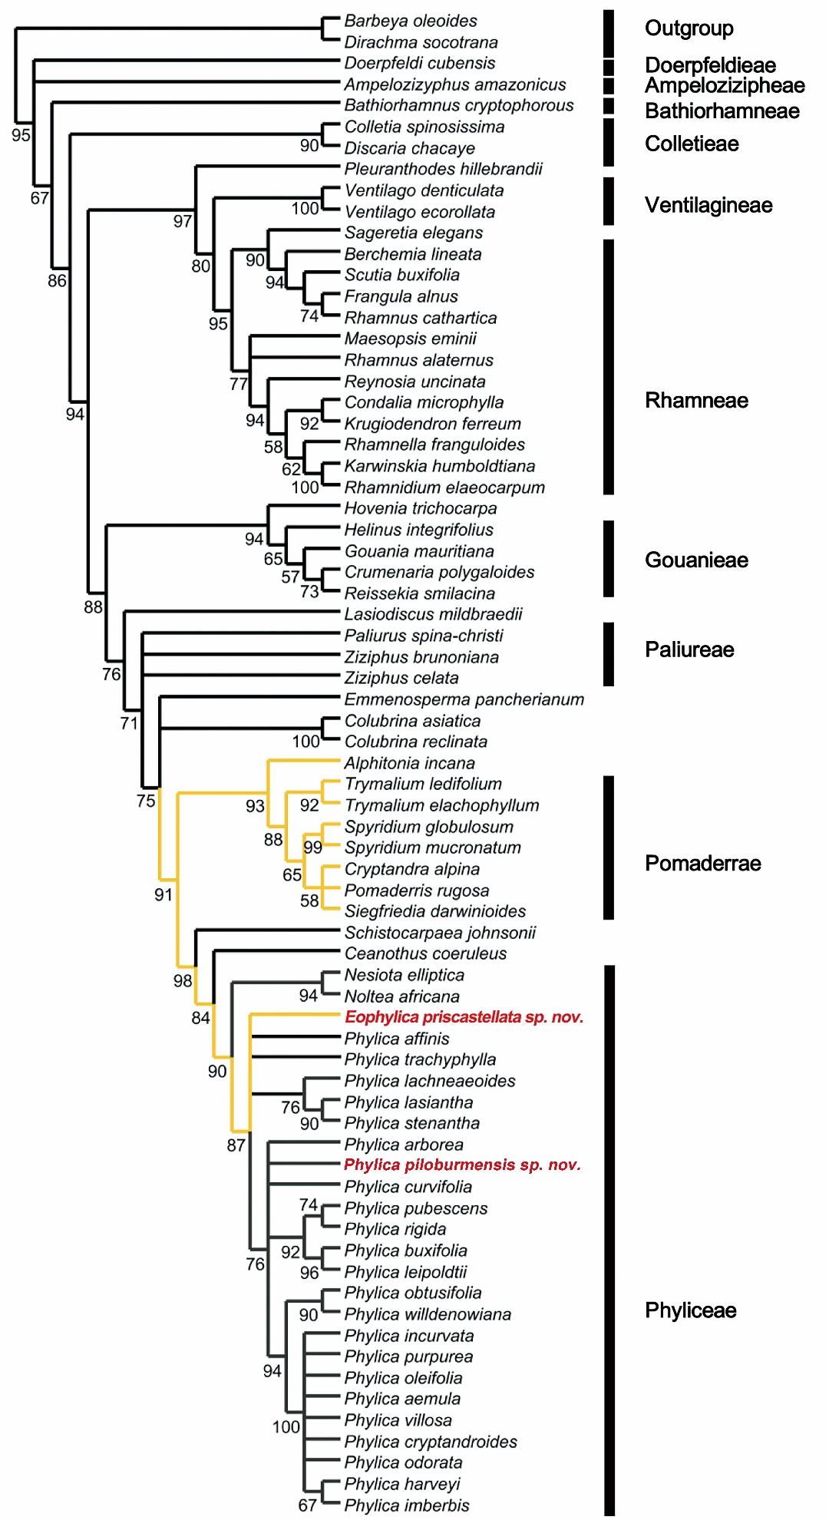
Supplementary Fig. 31 | Evolution of stellate hairs in the Rhamnaceae phylogenetic tree. This tree is the MP strict consensus tree. The yellow branch indicates species with stellate hairs. Numbers at the nodes are support from bootstrapping.

References
91. Zheng, D. R. et al. A Late Cretaceous amber biota from central Myanmar. Nat. Commun. 9, 1–6 (2018).
92. Laufer, B. Historical jottings on amber in Asia. Mem. Am. Anthropol. Assoc. 1, 215–244 (1906).
93. Fraquet, H. Amber. (Butterworth and Co. Ltd, London, 1987).
94. Noetling, F. On the occurrence of Burmite, a new fossil resin from Upper Burma. Rec. Geol. Surv. India. 26, 31–40 (1893).
95. Ali, J. R. & Aitchison, J. C. Greater India. Earth-Science Rev. 72, 169–188 (2005).
96. Davies, E. H. Palynological analysis and age assignments of two Burmese amber sample sets. (Branta Biostrati-graphy Ltd. Leeward Cap. Corp., 2001).
97. Traverse, A. & Nilsson, S. World pollen and spore flora. Bryologist 77, 495 (1974).
98. Richardson, J. E., Fay, M. F., Cronk, Q. C. B. & Chase, M. W. A revision of the tribal classification of Rhamnaceae. Kew Bull. 55, 311–340 (2000).
99. Xing, L. D., Cockx, P. & McKellar, R. C. Disassociated feathers in Burmese amber shed new light on mid-Cretaceous dinosaurs and avifauna. Gondwana Res. 82, 241–253 (2020).
100. Xing, L. D. et al. Mummified precocial bird wings in mid-Cretaceous Burmese amber. Nat.Commun. 7, 1–7 (2016).
101. Onstein, R. E. & Linder, H. P. Beyond climate: convergence in fast evolving sclerophylls in Cape and Australian Rhamnaceae predates the mediterranean climate. J. Ecol. 104, 665–677 (2016).

