Supplementary Material
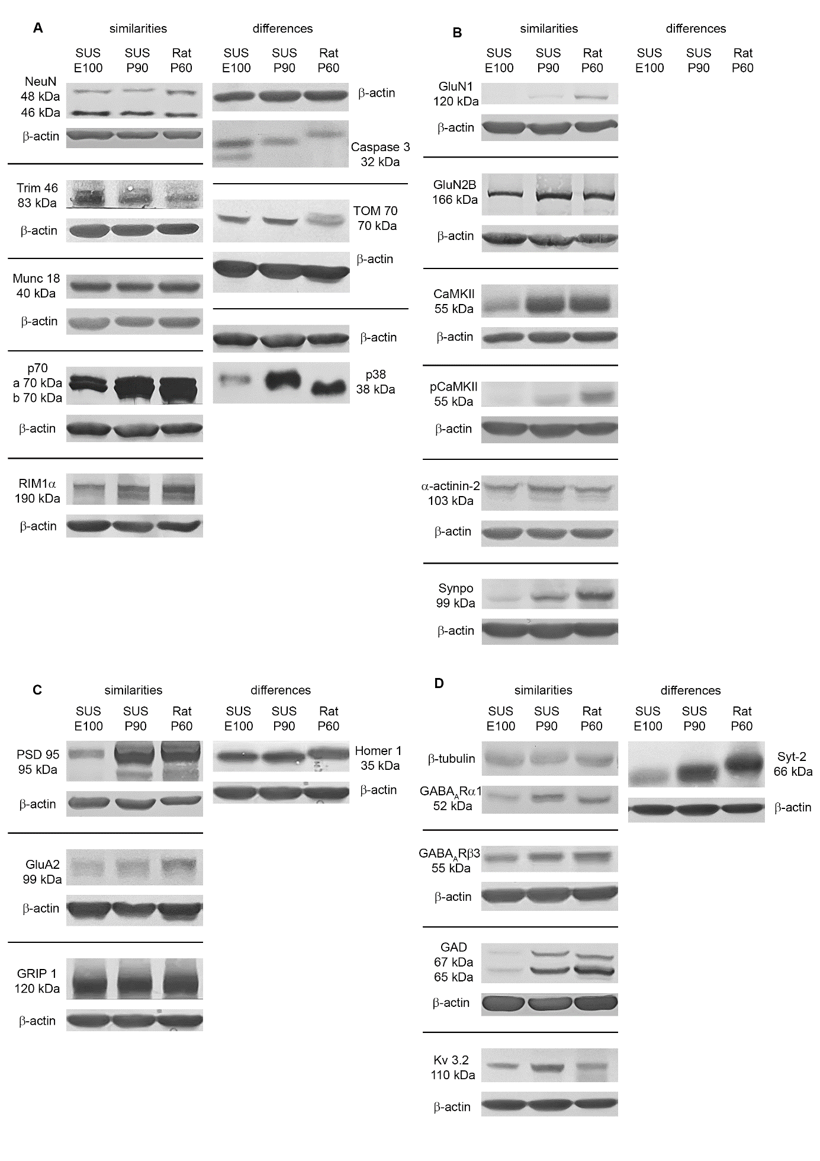 Supplementary Fig. 1. Comparing protein expression levels of pig to rat VC. For this arrangement, we selected blots done with VC lysates which differed from those shown in Figures 1-4. We arranged E100, P90 pig and P60 rat to confirm the reliability of the quantitative analysis. The Figure shows the similarities and in some cases differences in band intensity (strength of protein expression) and band size (subtle difference of molecular weight or gel run behaviour). A. Species comparison of proteins shown in Fig.1. B. Species comparison of proteins shown in Fig. 2. C. Species comparison of proteins shown in Fig. 3. D. Species comparison of proteins shown in Fig. 4.

Supplementary Table 1. Antibodies working in rat cortex lysates but failing to yield reliable and measurable bands in pig cortex lysates
Primary antibodies | Species, label, method | Source, order number, RRID
Ankyrin G | Guinea pig, WB | Synaptic Systems, Göttingen, DE, Cat# 386 004, RRID: AB_2725774
βIV-Spektrin | Mouse, WB | NeuroMab, Davis, CA, USA, Cat. No. 75-377, AB_2315818
Gephyrin | Mouse, WB | Synaptic Systems, Göttingen, DE, Cat# 147111, AB_887719
GluA1 | Rabbit, WB | Alomone Labs Ltd., Jerusalem, IL Cat# AGC-004, RRID: AB_2039878
GluA2 | Rabbit, WB | Alomone Labs Ltd., Jerusalem, IL Cat# AGC-005, RRID: AB_ 2039881
KIF1α | Rabbit, WB | Abcam, Cambridge, UK, Cat# ab240222, RRID: AB_3107103
Kv3.1b | Rabbit, WB | Synaptic Systems, Göttingen, DE, Cat# 242003, RRID: AB_10804287
GluN2A | Rabbit, WB | Merck Millipore, Burlington, MA, USA, Cat# 07-632, RRID: AB_310837?
Tyro-3 | Rabbit, WB | Cell Signaling, Cambridge, UK, Cat# D38C6, RRID: AB_10706782
vGAT | Rabbit, WB | Synaptic Systems, Göttingen, DE, Cat# 131 008, AB_2800534
vGlut | Rabbit, WB | Synaptic Systems, Göttingen, DE, Cat# 135 302, AB_887877

