Supplementary Materials

Pathology-interpretable radiomic model for predicting clinical outcome in patients with osteosarcoma: a retrospective, multicentre study

Supplementary materials index

Supplementary Table S1. MR image acquisition protocol

Supplementary Table S2. The extracted radiomic features

Supplementary Table S3. 150 patient-level nuclear features extracted from H&E WSIs

Appendix E1. Detailed information regarding IHC-staining

Supplementary Figure S1. Two representative cases of hypoxia-immune-related biomarkers

Supplementary Table S5. The selected radiomic features

Supplementary Table S6. Univariate and multivariate Cox analyses of the clinical variables

Supplementary Table S1. MR image acquisition protocol
Center | MR Scanner | TR (ms) | TE (ms) | Slice thickness (mm) | Slice spacing (mm) | Matrix | FOV
Center 1 | Philips 1.5T(Achieva) | 518 | 20 | 5 | 5.5 | 388×310 | 330×330
Center 1 | Philips 3.0T(Ingenia) | 556 | 20 | 4 | 4.6 | 556×502 | 410×410
Center 2 | GE 1.5T  (Signa  EXCITE HD) | 800 | 10 | 5 | 6 | 256×224 | 220×220
Center 2 | GE 3.0 T  (Signa  EXCITE HD) | 240 | 3.3 | 4 | 5 | 288×192 | 200×200
Center 3 | Philips 3.0T  (Achieva) | 500 | 20 | 4 | 5 | 412×322 | 250×160
Center 4 | GE 3.0 T (Discovery MR750) | 170 | 3 | 5 | 5 | 338×310 | 380×380
Center 5 | Philips 3.0T  (iagenia) | 697 | 10 | 3 | 0.3 | 260×260 | 180×180
Center 5 | Philips 3.0T  (Achieva) | 1107 | 15 | 3.5 | 0.8 | 384×311 | 180×180
Center 5 | Siemens 3.0T (prisma) | 550 | 11 | 3 | 0.6 | 288×80 | 180×180
Center 6 | SIEMENS 3.0T (prisma) | 250 | 2.46 | 5 | 1.5 | 220*220 | 400*439
Center 6 | GE 3.0T (signa) | 1900 | 2.26 | 1 | 2.15 | 240*256 | 350*384
Center 7 | Philips 3.0T  (Achieva) | 512 | 11 | 4 | 0.4 | 512×400 | 180×180
Center 8 | GE 3.0T (signa) | 561 | 20 | 3 | 0.3 | 268×184 | 170×160
Center 9 | Philips 3.0T  (Achieva) | 708 | 15 | 4 | 4.4 | 400×239 | 180×160
Center 9 | Siemens 3.0T (prisma) | 630 | 12 | 3 | 0.3 | 320×240 | 180×160
Center 10 | Siemens 3.0T (Magnetom Verio) | 430 | 10 | 3.5 | 1 | 448×246 | 160×160
Center 11 | GE 3.0 T  (Signa  EXCITE HD) | 2200 | 42 | 4 | 1 | 320×224 | 435×197
Center 12 | GE 1.5T(SIGNA HDe) | 590 | 38 | 2.5 | 2.75 | 288×160 | 200×200
Center 13 | Siemens 3.0T T(MAGNETOM Skyra) | 3800 | 38 | 4 | 5.2 | 268×180 | 240×160
Center 14 | Philips 3.0T  (Achieva) | 595 | 20 | 2.5 | 2.75 | 400×292 | 160×160
Abbreviations: TR, Time of repetition; TE, time of echo; FOV, Field of view.

Supplementary Table S2. The extracted radiomic features
- Parameters in radiomic feature extraction
Three types of parameters were used for radiomics feature extraction with an open-source python package (Pyradiomics, Python 3.7.6). The parameters were seen as below:
i) Image type: ‘Original’, ‘LoG’, ‘Wavelet’.
For the derived images, Laplacian of Gaussian (LoG) filter was used for image filtration with ‘sigma’ values of 1, 3, and 5, respectively. Wavelet filter was applied to focus features on the different decomposition and approximation level of the original contoured volumes, and the bin width of which was set as 10.
ii) Image setting: ‘geometryTolerance’, ‘binWidth’, ‘interpolator’, ‘resampledPixelSpacing’.
The geometry tolerance was set as 1.00000e-4. Voxels in each volume were resampled to a unified voxel size of 1×1×1 mm³ using ‘sitkBSpline’ while the bin width was set as 25.
iii) Feature Class: ‘shape’, ’firstorder’, ’glcm’, ‘glrlm’, ‘glszm’, ‘gldm’, ‘ngtdm’.

- Types of radiomic features

Feature group | Number | Feature name | Feature name
Shape | 14 | Flatness | Mesh volume
Shape | 14 | Least axis length | Minor axis length
Shape | 14 | Major axis length | Sphericity
Shape | 14 | Maximum 2D diameter (Column) | Surface area
Shape | 14 | Maximum 2D diameter (Row) | Surface area to volume ratio
Shape | 14 | Maximum 2D diameter (Slice) | Voxel volume
Shape | 14 | Maximum 3D Diameter | Elongation
First-order | 18 | 10th percentile | Median
First-order | 18 | 90th percentile | Minimum
First-order | 18 | Energy | Range
First-order | 18 | Entropy | Robust mean absolute deviation
First-order | 18 | Interquartile range | Root mean squared
First-order | 18 | Kurtosis | Skewness
First-order | 18 | Maximum | Total Energy
First-order | 18 | Mean absolute deviation | Uniformity
First-order | 18 | Mean | Variance
GLCM | 24 | Auto correlation | Inverse difference normalized
GLCM | 24 | Cluster prominence | Informational measure of correlation1
GLCM | 24 | Cluster shade | Informational measure of correlation2
GLCM | 24 | Cluster tendency | Inverse variance
GLCM | 24 | Contrast | Joint average
GLCM | 24 | Correlation | Joint energy
GLCM | 24 | Difference average | Joint entropy
GLCM | 24 | Difference entropy | Maximal correlation coefficient
GLCM | 24 | Difference variance | Maximum probability
GLCM | 24 | Inverse difference | Sum average
GLCM | 24 | Inverse difference moment | Sum entropy
GLCM | 24 | Inverse difference moment Normalized | Sum squares
GLRLM | 16 | Gray level non-uniformity | Run entropy
GLRLM | 16 | Gray level non-uniformity Normalized | Run length non-uniformity
GLRLM | 16 | Gray level variance | Run length non-uniformity Normalized
GLRLM | 16 | High gray level run emphasis | Run percentage
GLRLM | 16 | Long run emphasis | Run variance
GLRLM | 16 | Long run high gray level Emphasis | Short run emphasis
GLRLM | 16 | Long run low gray level Emphasis | Short run high gray level Emphasis
GLRLM | 16 | Low gray level run emphasis | Short run low gray level Emphasis
GLSZM | 16 | Gray level non-uniformity | Size-zone non-uniformity
GLSZM | 16 | Gray level non-uniformity Normalized | Size-zone non-uniformity Normalized
GLSZM | 16 | Gray level variance | Small area emphasis
GLSZM | 16 | High gray level zone emphasis | Small area high gray level Emphasis
GLSZM | 16 | Large area emphasis | Small area low gray level Emphasis
GLSZM | 16 | Large area high gray level Emphasis | Zone entropy
GLSZM | 16 | Large area low gray level Emphasis | Zone percentage
GLSZM | 16 | Low gray level zone emphasis | Zone variance
GLDM | 14 | Dependence entropy | Gray level non-uniformity
GLDM | 14 | Dependence non-uniformity | Gray level variance
GLDM | 14 | Dependence non-uniformity Normalized | High gray level Emphasis
GLDM | 14 | Dependence variance | Large dependence Emphasis
GLDM | 14 | Large dependence high gray level Emphasis | Large dependence low gray level Emphasis
GLDM | 14 | Low gray level Emphasis | Small dependence Emphasis
GLDM | 14 | Small dependence high gray level Emphasis | Small dependence low gray level Emphasis
NGTDM | 5 | Busyness | Contrast
NGTDM | 5 | Coarseness | Strength
NGTDM | 5 | Complexity
Abbreviations: GLCM, gray level co-occurrence matrix; GLRLM, gray level run length matrix; GLSZM, gray level size zone matrix; NGTDM, neighboring gray tone difference matrix.
Supplementary Table S3. 150 patient-level nuclear features extracted from H&E WSIs

Ten types of morphological nuclear features, including nuclear area, lengths of the major and minor axes of cell nucleus, the ratio of major axis length to minor axis length (major, minor, and ratio), mean pixel values of nucleus in RGB three channels, and mean, maximum, and minimum distances (distant, distMax, and distMin) to its neighboring nuclei. | Area | area_bin1
 | Area | area_bin2
 | Area | area_bin3
 | Area | area_bin4
 | Area | area_bin5
 | Area | area_bin6
 | Area | area_bin7
 | Area | area_bin8
 | Area | area_bin9
 | Area | area_bin10
 | Major | major_bin1
 | Major | major_bin2
 | Major | major_bin3
 | Major | major_bin4
 | Major | major_bin5
 | Major | major_bin6
 | Major | major_bin7
 | Major | major_bin8
 | Major | major_bin9
 | Major | major_bin10
 | Minor | minor_bin1
 | Minor | minor_bin2
 | Minor | minor_bin3
 | Minor | minor_bin4
 | Minor | minor_bin5
 | Minor | minor_bin6
 | Minor | minor_bin7
 | Minor | minor_bin8
 | Minor | minor_bin9
 | Minor | minor_bin10
 | Ratio | ratio_bin1
 | Ratio | ratio_bin2
 | Ratio | ratio_bin3
 | Ratio | ratio_bin4
 | Ratio | ratio_bin5
 | Ratio | ratio_bin6
 | Ratio | ratio_bin7
 | Ratio | ratio_bin8
 | Ratio | ratio_bin9
 | Ratio | ratio_bin10
 | R-Mean | rMean_bin1
 | R-Mean | rMean_bin2
 | R-Mean | rMean_bin3
 | R-Mean | rMean_bin4
 | R-Mean | rMean_bin5
 | R-Mean | rMean_bin6
 | R-Mean | rMean_bin7
 | R-Mean | rMean_bin8
 | R-Mean | rMean_bin9
 | R-Mean | rMean_bin10
 | G-Mean | gMean_bin1
 | G-Mean | gMean_bin2
 | G-Mean | gMean_bin3
 | G-Mean | gMean_bin4
 | G-Mean | gMean_bin5
 | G-Mean | gMean_bin6
 | G-Mean | gMean_bin7
 | G-Mean | gMean_bin8
 | G-Mean | gMean_bin9
 | G-Mean | gMean_bin10
 | B-Mean | bMean_bin1
 | B-Mean | bMean_bin2
 | B-Mean | bMean_bin3
 | B-Mean | bMean_bin4
 | B-Mean | bMean_bin5
 | B-Mean | bMean_bin6
 | B-Mean | bMean_bin7
 | B-Mean | bMean_bin8
 | B-Mean | bMean_bin9
 | B-Mean | bMean_bin10
 | DistMean | distMean_bin1
 | DistMean | distMean_bin2
 | DistMean | distMean_bin3
 | DistMean | distMean_bin4
 | DistMean | distMean_bin5
 | DistMean | distMean_bin6
 | DistMean | distMean_bin7
 | DistMean | distMean_bin8
 | DistMean | distMean_bin9
 | DistMean | distMean_bin10
 | DistMax | distMax_bin1
 | DistMax | distMax_bin2
 | DistMax | distMax_bin3
 | DistMax | distMax_bin4
 | DistMax | distMax_bin5
 | DistMax | distMax_bin6
 | DistMax | distMax_bin7
 | DistMax | distMax_bin8
 | DistMax | distMax_bin9
 | DistMax | distMax_bin10
 | DistMin | distMin_bin1
 | DistMin | distMin_bin2
 | DistMin | distMin_bin3
 | DistMin | distMin_bin4
 | DistMin | distMin_bin5
 | DistMin | distMin_bin6
 | DistMin | distMin_bin7
 | DistMin | distMin_bin8
 | DistMin | distMin_bin9
 | DistMin | distMin_bin10
Five statistic measurements (mean, SD, skewness, kurtosis, and entropy). | Mean | area_mean
 | Mean | major_mean
 | Mean | minor_mean
 | Mean | ratio_mean
 | Mean | rMean_mean
 | Mean | gMean_mean
 | Mean | bMean_mean
 | Mean | distMean_mean
 | Mean | distMax_mean
 | Mean | distMin_mean
 | Std | area_std
 | Std | major_std
 | Std | minor_std
 | Std | ratio_std
 | Std | rMean_std
 | Std | gMean_std
 | Std | bMean_std
 | Std | distMean_std
 | Std | distMax_std
 | Std | distMin_std
 | Skewness | area_skewness
 | Skewness | major_skewness
 | Skewness | minor_skewness
 | Skewness | ratio_skewness
 | Skewness | rMean_skewness
 | Skewness | gMean_skewness
 | Skewness | bMean_skewness
 | Skewness | distMean_skewness
 | Skewness | distMax_skewness
 | Skewness | distMin_skewness
 | kurtosis | area_kurtosis
 | kurtosis | major_kurtosis
 | kurtosis | minor_kurtosis
 | kurtosis | ratio_kurtosis
 | kurtosis | rMean_kurtosis
 | kurtosis | gMean_kurtosis
 | kurtosis | bMean_kurtosis
 | kurtosis | distMean_kurtosis
 | kurtosis | distMax_kurtosis
 | kurtosis | distMin_kurtosis
 | entropy | area_entropy
 | entropy | major_entropy
 | entropy | minor_entropy
 | entropy | ratio_entropy
 | entropy | rMean_entropy
 | entropy | gMean_entropy
 | entropy | bMean_entropy
 | entropy | distMean_entropy
 | entropy | distMax_entropy
 | entropy | distMin_entropy

Supplementary Table S4. Description of 10 types of morphological nuclear features

Feature type | Description | Sketch map
Area | Actual size of the cell nucleus | 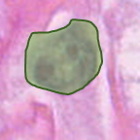
Major axis | The length of the major axis of an ellipse of equal area centered on the cell nucleus | 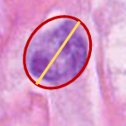
Minor axis | The length of the minor axis of an ellipse of equal area centered on the cell nucleus | 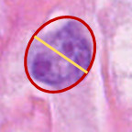
Ratio | The ratio of the length of the major axis to the length of the minor axis of an ellipse of equal area centered on the cell nucleus | 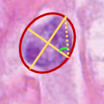
Red channel intensity mean  (R-Mean) | The average intensity of the red (R) channel within the cellular region on the image | 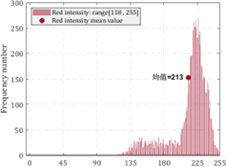
Green channel intensity mean  (G-Mean） | The average intensity of the green (G) channel within the cellular region on the image | 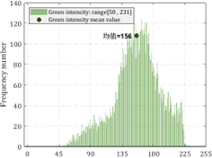
Blue channel intensity mean  (B-Mean) | The average intensity of the blue (B) channel within the cellular region on the image | 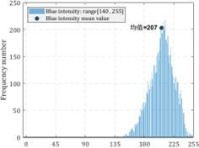
DT graph edge mean  (DistMean) | The average length of all edges connecting cells in a Delaunay triangulation graph constructed with detected cell centers as nodes | 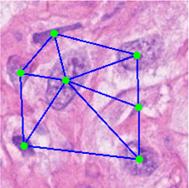
DT graph edge max  (DistMax) | The longest edge length connecting cells in the aforementioned Delaunay triangulation graph | 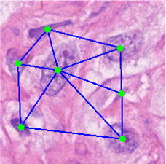
DT graph edge min  (DistMin) | The shortest edge length connecting cells in the aforementioned Delaunay triangulation graph

Appendix E1. Detailed information regarding IHC-staining

1 Experimental equipments and reagents
1.1 Experimental equipments

Name | Manufacturer | Model
dehydrator | DIPATH, Italy | Donatello
Embedding machine | Wuhan Junjie Electronics Co., LTD | JB-P5
Pathological microtome | Shanghai Leica Instrument Co., LTD | RM2016
Frozen table | Wuhan Junjie Electronics Co., LTD | JB-L5
Tissue machine | Zhejiang Jinhua Kedi Instrument Equipment Co., LTD | KD-P
Oven | Shanghai Huitai Instrument Manufacturing Co., LTD | DHG-9140A
slide | Servicebio | G6012
Cover glass | Jiangsu Shitai experimental equipment Co., LTD | 10212432C
Microwave oven | Galanz microwave electric appliance Co., LTD | P70D20TL-P4
Decolorizing table | Servicebio | DS-2S100
Vortex mixer | Servicebio | MV-100
Palm centrifuge | Servicebio | D1008E
Pipette gun | Servicebio
Tissue pencil | Servicebio | G6100
Microscope | Nikon | E100

1.2 Main experimental reagents

Name | Manufacturer | Model
Anhydrous ethanol | SCRC | 100092683
Environmentally friendly dewaxing transparent liquid | Servicebio | G1128
xylene | SCRC | 10023418
n-butanol | SCRC | 100052190
Hydrochloric acid | SCRC | 10011028
20×Citric Acid Antigen Repair Solution (pH 6.0) | Servicebio | G1202
20×Tris-EDTA Antigen Repair Solution (pH 9.0) | Servicebio | G1203
20×Tris-EDTA Antigen Repair Solution (pH 8.0) | Servicebio | G1206
PBS buffer | Servicebio | G0002
Universal Tissue Fixative (Neutral) | Servicebio | G1101
3% hydrogen peroxide disinfectant | Angergech
Bovine serum albumin BSA | Servicebio | GC305010
Normal rabbit serum (concentrated) | Servicebio | G1209
Hematoxylin dye | Servicebio | G1004
Hematoxylin differentiation solution | Servicebio | G1039
Hematoxylin blue return solution | Servicebio | G1040
Super clean fast drying sealant | Servicebio | G1404-100mL
DAB chromogenic reagent for histochemical kit | Servicebio | G1212

1.3 Antibody information and repair conditions
Antigen repair condition | Name of primary antibody | First anti item number | Primary antibody manufacturer | A resistant species | The dilution ratio of one antibody | Name of the corresponding secondary antibody
EDTA  (pH=9.0)  Medium heat 9min，stop 5min，Medium-Low Heat 7min | CD3/  CD8/  FOXP3/  PDL1/  CA-1X/  CD68/ | GB15014/  GB12068/  GB112325/  GB14132/  GB121184/  GB113150 | Servicebio/  Servicebio/  Servicebio/  Servicebio/  Servicebio/  Servicebio/ | Mou/  Mou/  Rab/  Mou/  Mou/  Rab/ | 1:500/  1:500/  1:200/  1:200/  1:500/  1:500/ | HRP-conjugated Goat Anti-Mouse / HRP-conjugated Goat Anti-Mouse /  HRP-conjugated Goat Anti-Rabbit / HRP-conjugated Goat Anti-Mouse / HRP-conjugated Goat Anti-Mouse / HRP-conjugated Goat Anti-Rabbit
Note: The order of adding antibody samples is in accordance with the writing order of antibodies, the number of the second antibody, manufacturer and dilution ratio are shown in the following table.
2 Experimental procedure
2.1 Paraffin sections dewaxing to water: Put the sections into environmentally friendly dewaxing solutionⅠ10 min- Environmentally friendly dewaxing solution Ⅱ10 min- Environmentally friendly dewaxing solution Ⅲ 10 min- anhydrous ethanolⅠ5min- anhydrous ethanol Ⅱ 5 min- anhydrous ethanol Ⅲ 5 min- distilled water in turn.
2.2 Antigen repair: The repair is shown in the table above. During this process, the buffer should be prevented from excessive evaporation and should not be dried. After natural cooling, the slide was placed in PBS (PH7.4) and washed by shaking on the decolorizing shaker for 3 times, 5min each time. (Repair fluid and repair conditions are determined according to the tissue)
2.3 Blocking endogenous peroxidase: The slices were placed in 3% hydrogen peroxide solution, incubated at room temperature away from light for 25 min, and the slides were placed in PBS (PH7.4) and washed three times on a decolorizing shaking table for 5min each time.
2.4 Serum closure: The tissue was uniformly covered with 3%BSA in the tissue chemical circle and closed at room temperature for 30min. (Primary antibody of goat origin is blocked with rabbit serum, other sources are blocked with BSA)
2.5 Add primary antibody: Gently shake off the sealing solution, add PBS to the section in a certain proportion of primary antibody, and the section is placed flat in a wet box at 4°C for overnight incubation.
2.6 Adding secondary antibody: The slide was placed in PBS (PH7.4) and washed by shaking on the decolorizing shaker for 3 times, 5min each time. After the slices were slightly dried, the tissue was covered with the secondary antibody (HRP label) of the corresponding species of the primary antibody, and incubated at room temperature for 50min.
2.7 DAB color development: The slide was placed in PBS (PH7.4) and washed by shaking on the decolorizing table for 3 times, 5min each time. After the sections were slightly dried, the freshly prepared DAB color developing solution was added into the circle. The color developing time was controlled under the microscope. The positive color was brown and yellow, and the sections were rinsed with tap water to terminate the color development.
2.8 Restaining nuclei: hematoxylin restaining for about 3min, washing with tap water, hematoxylin differentiation solution for a few seconds, rinse with tap water, hematoxylin return to blue solution, and rinse with running water.
2.9 Dewatering and sealing: Put the slices into 75% alcohol for 5 min--85% alcohol for 5 min-- anhydrous ethanol for 5 min-- anhydrous ethanol for 5 min--n-butanol for 5 min-- xylene for 5 min to dehydrate and transparent, take the slices out of xylene to dry slightly, and seal the slices with glue.
3 Second antibody
The nucleus of hematoxylin stain is blue, and the positive signal of DAB is brown-yellow.
Second antibody and TSA name | Model | Manufacturer | Dilution ratio
CY3 Labeled Goat Anti-Rabbit IgG | GB21303 | Servicebio | 1:300
CY3 tagged Goat anti-mouse IgG | GB21301 | Servicebio | 1:300
CY3 Labeled Goat anti-rat IgG | GB21302 | Servicebio | 1:300
CY3 Labeled Donkey Anti-Goat IgG | GB21404 | Servicebio | 1:300
Cy3-labeled Donkey anti-mouse IgG | GB21401 | Servicebio | 1:300
CY3 Labeled Donkey Anti-Rabbit IgG | GB21403 | Servicebio | 1:300
Alexa Fluor 488 Labeled Goat Anti-Rabbit IgG | GB25303 | Servicebio | 1:400
Alexa Fluor 488 labeled Goat anti-mouse IgG | GB25301 | Servicebio | 1:400
CY5 Labeled Goat anti-mouse IgG | GB27301 | Servicebio | 1:400
CY5 Labeled Goat anti-Rabbit IgG | GB27303 | Servicebio | 1:400
HRP * Polyclonal Rabbit Anti-Goat IgG | GB23204 | Servicebio | 1:200
Goat anti-mouse IgG labeled by HRP | GB23301 | Servicebio | 1:200
HRP * Polyclonal Goat anti-Rat IgG | GB23302 | Servicebio | 1:200
HRP was used to label goat anti-rabbit secondary antibody | GB23303 | Servicebio | 1:200
HRP was used to detect donkey antibody against goat antibody | GB23404 | Servicebio | 1:200
FITC * Donkey Anti-Goat IgG | GB22404 | Servicebio | 1:200
Fitc-labeled Goat anti-rat IgG | GB22302 | Servicebio | 1:200
Fitc-labeled Donkey Anti-Rabbit IgG | GB22403 | Servicebio | 1:200
Fitc-labeled Donkey Anti-Mouse IgG | GB22401 | Servicebio | 1:200
Alexa Fluor 594 Labeled Goat Anti-Rabbit IgG | 111-585-003 | Jackson | 1:400
Alexa Fluor 594 labeled Goat anti-mouse IgG | 115-585-003 | Jackson | 1:400
CY3-Tyramide | G1223 | Servicebio | 1:500
iF488-Tyramide | G1231 | Servicebio | 1:500
iF647-Tyramide | G1232 | Servicebio | 1:400
FITC-Tyramide | G1222 | Servicebio | 1:500

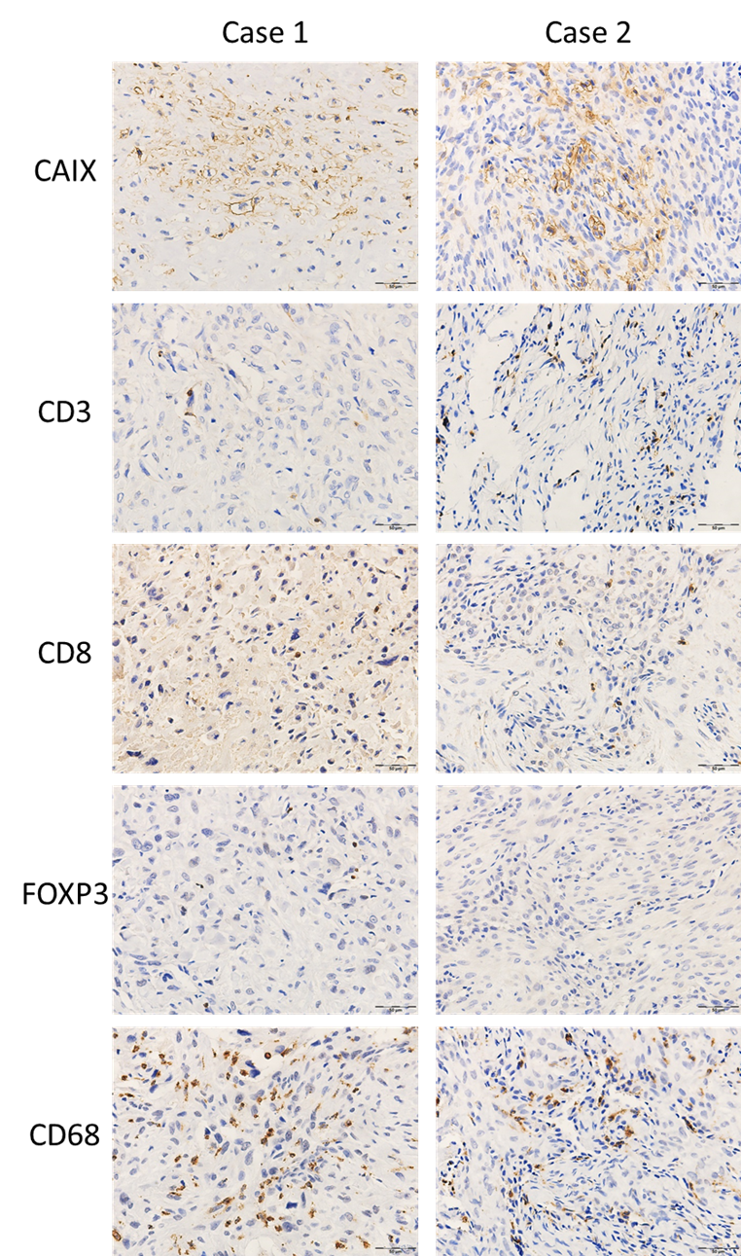
Supplementary Figure S1. Two representative cases of hypoxia-immune-related biomarkers

Supplementary Table S5. The selected radiomic features

Image type | Feature class | Feature name
Original | GLCM | Contrast
Original | First-order | Interquartile Range
Original | GLRLM | Short Run Low Gray Level Emphasis
Original | GLSZM | Zone Percentage
Original | First-order | Entropy
Wavelet-HLL | GLCM | Cluster Prominence
Wavelet-LHL | GLCM | Difference Variance
Wavelet-HHL | GLCM | Cluster Shade
Wavelet-LLL | GLSZM | Large Area High Gray Level Emphasis
Wavelet-LLL | GLSZM | Large Area Emphasis
Wavelet-LHL | First-order | Variance
Wavelet-HLH | First-order | Variance

Supplementary Table S6. Univariate and multivariate Cox analyses of the clinical variables

 | Univariate analysis |  | Multivariate analysis
 | HR (95%CI) | P-value | HR (95%CI) | P-value
Pathological subtypes | 0.885 (0.526-1.491) | 0.647 | - | -
Tumor location | 1.125 (0.704-1.797) | 0.622 | - | -
Pathological fracture | 1.207 (0.602-2.417) | 0.596 | - | -
Age | 1.005 (0.990-1.021) | 0.502 | - | -
Gender | 1.022 (0.660-1.584) | 0.921 | - | -
Tumor volume | 1.000 (1.000-1.000) | 0.028 | - | -
Maximum tumor diameter | 1.104 (1.052-1.160) | <0.001 | - | -
T stage | 2.077 (1.346-3.204) | <0.001 | 2.077 (1.346-3.204) | <0.001
N stage | 3.361 (0.463-24.41) | 0.231 | - | -
M stage | 2.147 (1.072-4.300) | 0.031 | - | -

