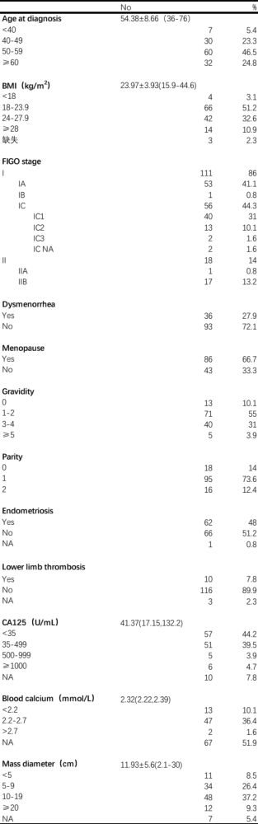
Table 1. Clinical data of OCCC patients

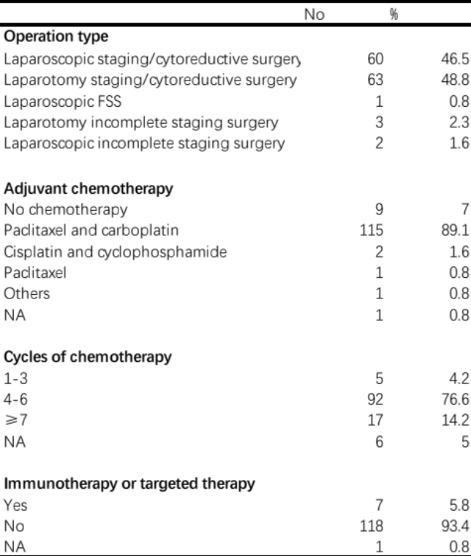
Table 2. Surgery and Postoperative Treatment of the OCCC patients

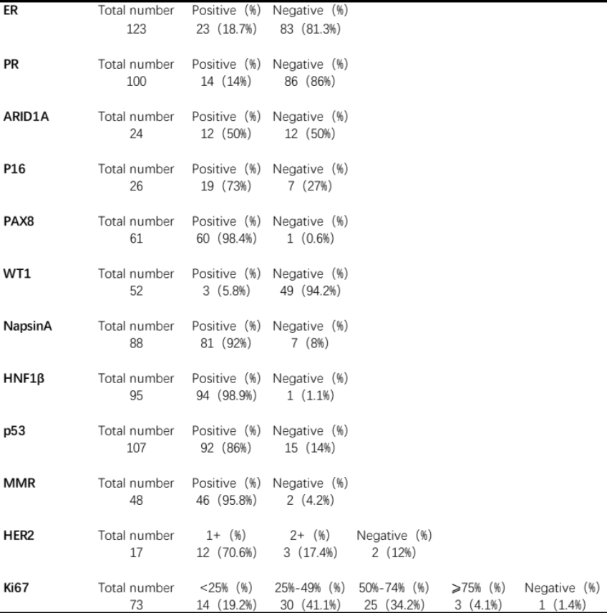
Table 3. Immunohistochemical characteristics of OCCC patients
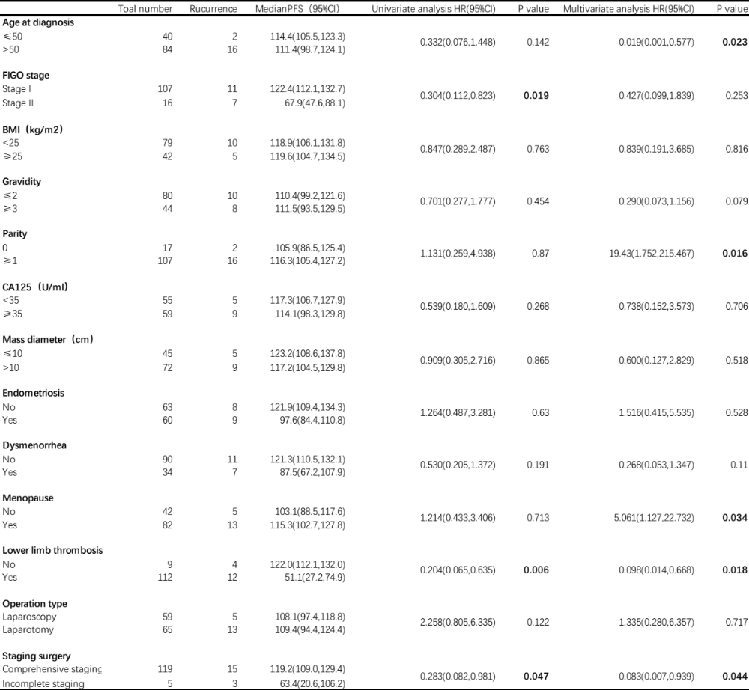
Table 4. Significant predictors of survival in univariate and multivariate survival analysis

