Antimicrobial peptide production with Corynebacterium glutamicum on lignocellulosic side streams

Daniel Waldschitz, Mark-Richard Neudert, Jakob Kitzmüller, Yannick Bus, Eva Maria Karner, Jae Hwi Bong, Peter Sinner, Oliver Spadiut

Lignosulfonate based peptide precipitation validation for pediocin PA-1
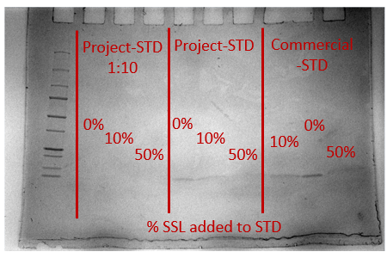
Figure 1: Agarose-Gel for pediocin PA-1 standard mixed 1:1 (v/v) with UF-SSL / ultra pure water mixtures (final UF-SSL concentration of 0/10/50% UF-SSL in sample before preparation with Lämmli-buffer). Both internal produced pediocin PA-1 as well as commercial purchased pediocin PA-1 was tested as indicated. Higher UF-SSL concentration in samples lead to fainter bands, indicating a UF-SSL concentration precipitation of peptide before loading.

