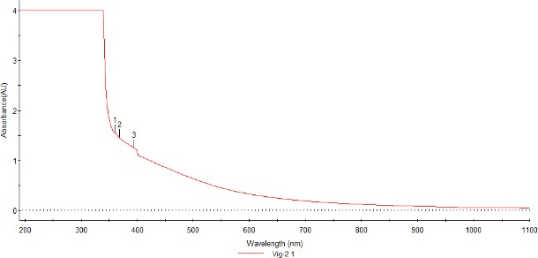
Graph 3.1 UV-Visible Spectroscopy Image for TtSN-particles

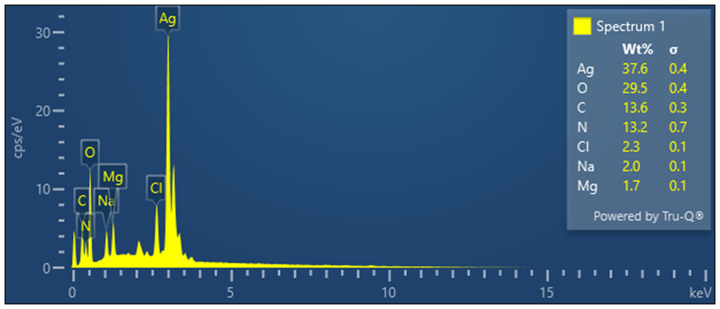
Graph 3.2 Energy Dispersive X-Ray

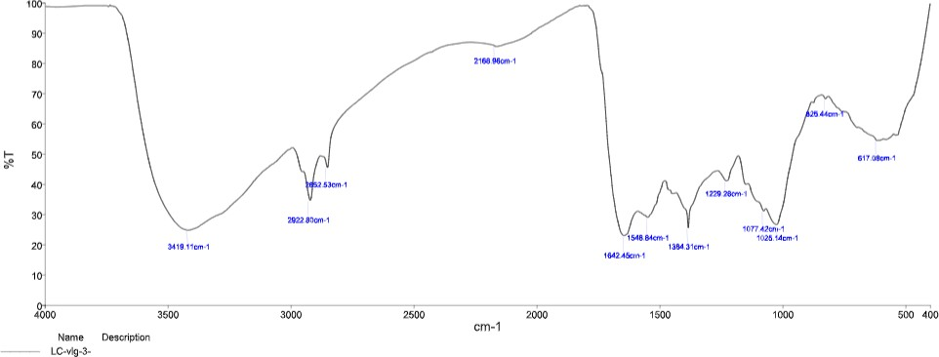
Graph 3.3 FTIR Analysis

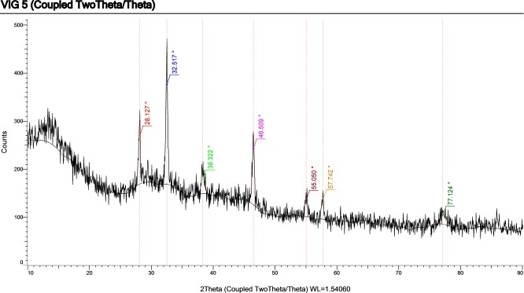

Graph 3.5 Dynamic Light Scattering analysis

