Fabrication of flexible AgNWs/cellulose hybrid film with heat preservation and antibacterial properties for agriculture application
Yu Chen ª, ShuangHong Yang ª, Zhiwei Qiu ª, Yuqi Li ^{b},
Fengxian Qiu ª*, Tao Zhang ^{a,c} *
ª School of Chemistry and Chemical Engineering, Jiangsu University, Zhenjiang 212013, China
^{b} Key Laboratory of New Processing Technology for Nonferrous Metal & Materials, Ministry of Education/ Guangxi Key Laboratory of Optical and Electronic Materials and Devices, Guilin University of Technology, Guilin 541004, China
^{c} Institute of Green Chemistry and Chemical Technology, Jiangsu University, Zhenjiang 212013, China

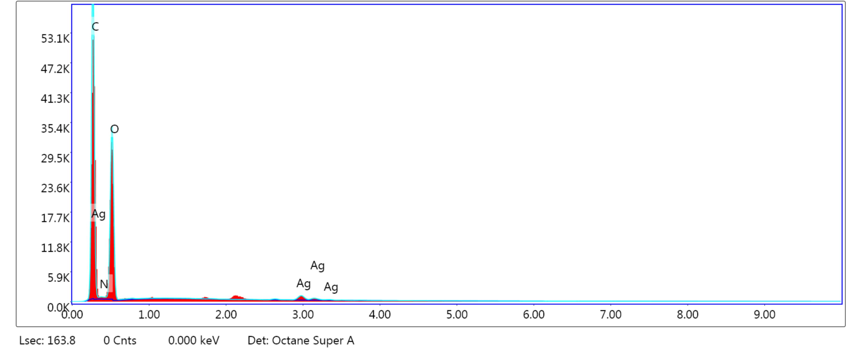
Fig. S1 EDS Spectrum of the AgNWs/cellulose hybrid film

Fig. S2 XPS survey spectrums of cellulose film and AgNWs/cellulose hybrid film

Fig. S3 Digital photos of resistance of cellulose film (A), plastic film (B), AgNWs/cellulose hybrid film (C).

*Corresponding authors: Tel./fax: +86 511 88791800. E-mail: fxqiu@ujs.edu.cn (F. Qiu) zhangtaochem@163.com (T. Zhang)

