Table 1S. Real-Time PCR Primer Sequences.
Gene | Sequence of primer pairs (5'→3')
β-actin | F: TGGCACCCAGCACAATGAA
β-actin | R: CTAAGTCATAGTCCGCCTAGAAGCA
Nrf2 | F: CAACTCAGCACCTTGTATC
Nrf2 | R: TTCTTAGTATCTGGCTTCTT
Keap1 | F: GTGGAGACAGAGACCTGGACTTTC
Keap1 | R: TGTCAAGCGGGTCACTTCACTC
HO-1 | F: CAAGCGCTATGTTCAGCGAC
HO-1 | R: GCTTGAACTTGGTGGCACTG
GCLC | F: CAGTCAAGGACCGGCACAAG
GCLC | R: CAAGAACATCGCCTCCATTCAG

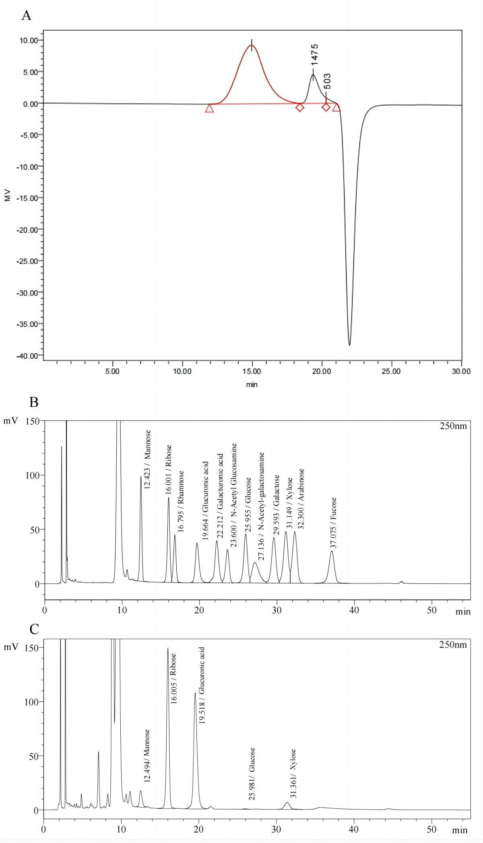

Figure 1S. Molecular weight distribution curve of FHA (A) and monosaccharide composition chromatograms of mixed solution (B) and FHA (C).

