Exploring the Effects of Delphinidin Treatment on Browning Processes in 3T3-L1 Preadipocyte Cells: A Foodomics Approach
Elif Didem Örs,^{a, b} Kübra Ucar Baş,^{b} Aslıhan Agacdiken,^{b} Dilem Tugal Aslan,^{b} Tuba Recber,^{c} Tugba Gulsun,^{d} Mustafa Çelebier,^{c} and Zeynep Göktaş ^{b*}
ª Department of Nutrition and Dietetics, Nezahat Keleşoğlu Faculty of Health Sciences, Necmettin Erbakan University, Konya, Turkiye
^{b} Department of Nutritional Sciences, Faculty of Health Sciences, Hacettepe University, Ankara 06100, Turkiye
^{c} Department of Analytical Chemistry, Faculty of Pharmacy, Hacettepe University, Ankara 06100, Turkiye
^{d} Department of Pharmaceutical Technology, Faculty of Pharmacy, Hacettepe University, Ankara 06100, Turkiye
*Correspondence: should be addressed to Zeynep Göktaş; zeynep.goktas@hacettepe.edu.tr (Phone number: +90 312 309 1310)

Table S1. The metabolites and relative concentrations identified by GC-MS analysis in the differentiation process and in the maturation process
 | Differentiation
 | Delphinidin 0 | Delphinidin 5 |  | Delphinidin 10 |  | Delphinidin 20
Metabolite name | x̄ ± SD | x̄ ± SD | p | x̄ ± SD | p | x̄ ± SD | p
1,4-cyclohexanedione | 0.7 ± 0.85 | 0.2 ± 0.07 | 0.357 | 0.3 ± 0.20 | 0.462 | 0.7 ± 0.89 | 0.937
2-ketocaproic acid | 0.3 ± 0.06 | 0.2 ± 0.03 | 0.117 | 0.4 ± 0.08 | 0.102 | 0.4 ± 0.14 | 0.401
3-hydroxypropanoic acid | 0.6 ± 0.16 | 1.1 ± 0.08 | 0.008 | 1.3 ± 0.24 | 0.017 | 1.4 ± 0.60 | 0.098
Alanine | 0.2 ± 0.04 | 0.2 ± 0.01 | 0.341 | 0.3 ± 0.08 | 0.113 | 0.3 ± 0.06 | 0.119
Benzoic acid | 0.7 ± 0.49 | 0.7 ± 0.28 | 0.974 | 0.9 ± 0.37 | 0.568 | 0.8 ± 0.23 | 0.858
Caprylic acid | 0.5 ± 0.26 | 0.5 ± 0.25 | 0.960 | 1.0 ± 0.50 | 0.211 | 1.2 ± 0.56 | 0.130
Catechol | 0.4 ± 0.13 | 0.6 ± 0.07 | 0.048 | 0.8 ± 0.14 | 0.014 | 1.0 ± 0.48 | 0.102
Dithiothreitol | 0.5 ± 0.14 | 1.2 ± 0.07 | 0.002 | 1.2 ± 0.02 | 0.001 | 1.1 ± 0.45 | 0.096
Fructose | 0.7 ± 0.18 | 2.4 ± 0.18 | 0.000 | 1.9 ± 0.38 | 0.010 | 2.4 ± 1.40 | 0.108
Fucose | 0.9 ± 0.24 | 0.0 ± 0.00 | 0.004 | 1.7 ± 0.37 | 0.028 | 1.9 ± 0.79 | 0.097
Glyceraldehyde | 0.1 ± 0.05 | 0.1 ± 0.10 | 0.607 | 0.3 ± 0.04 | 0.015 | 0.2±0.08 | 0.319
Glycerol | 0.7 ± 0.61 | 0.2 ± 0.04 | 0.213 | 0.1 ± 0.03 | 0.169 | 0.5±0.64 | 0.705
Glycine | 0.9 ±0.23 | 1.6 ± 0.18 | 0.014 | 2.6 ± 1.43 | 0.107 | 2.7±1.31 | 0.083
Glycolic acid | 0.3 ± 0.12 | 0.3 ± 0.17 | 0.991 | 0.3 ± 0.23 | 0.631 | 0.5±0.08 | 0.036
Lactamide | 0.0 ± 0.01 | 0.0 ± 0.00 | 0.309 | 0.0 ± 0.05 | 0.484 | 0.9±1.58 | 0.376
Lactic acid | 0.3 ± 0.08 | 0.5 ± 0.10 | 0.099 | 0.8 ± 0.56 | 0.194 | 0.7±0.14 | 0.020
Linoleic acid | 0.0 ± 0.00 | 0.0 ± 0.00 | 0.255 | 0.0 ± 0.01 | 0.048 | 0.0±0.01 | 0.359
Maleic acid | 2.2 ± 0.52 | 2.1 ± 0.01 | 0.858 | 2.0 ± 0.22 | 0.725 | 1.7±0.30 | 0.291
Malonic acid | 0.7 ± 0.24 | 1.2 ± 0.26 | 0.097 | 1.4 ± 0.58 | 0.141 | 0.9±0.48 | 0.677
Mannose | 0.8 ± 0.28 | 3.2 ± 0.13 | 0.000 | 2.1 ± 0.41 | 0.011 | 1.6±0.59 | 0.109
Methyl oleate | 0.3 ± 0.19 | 0.4 ± 0.14 | 0.740 | 0.6 ± 0.31 | 0.262 | 2.8±4.06 | 0.350
Myo-inositol | 1.1 ± 0.32 | 1.8 ± 0.24 | 0.042 | 2.0 ± 0.44 | 0.049 | 2.1±0.81 | 0.113
Oleic acid | 0.2 ± 0.16 | 0.0 ± 0.00 | 0.072 | 0.3 ± 0.30 | 0.745 | 0.4±0.33 | 0.573
Oxalic acid | 0.9 ± 0.23 | 1.4 ± 0.05 | 0.032 | 1.9 ± 0.37 | 0.021 | 2.3±1.35 | 0.146
Palmitic acid | 0.0 ± 0.00 | 0.0 ± 0.00 | 0.338 | 0.0 ± 0.00 | 0.179 | 0.0±0.00 | 0.135
Panthenol | 0.2 ± 0.05 | 0.2 ± 0.03 | 0.646 | 1.6 ± 2.20 | 0.328 | 0.3±0.12 | 0.248
p-cresol | 0.0 ± 0.05 | 0.0 ± 0.03 | 0.847 | 0.0 ± 0.03 | 0.865 | 0.1±0.04 | 0.573
Porphine | 0.4 ± 0.12 | 0.3 ± 0.03 | 0.288 | 0.7 ± 0.12 | 0.050 | 0.7±0.21 | 0.094
Ribitol | 0.8 ± 0.27 | 1.8 ± 0.13 | 0.004 | 1.8 ± 0.40 | 0.023 | 1.8±0.81 | 0.116
Serine | 1.6 ± 0.27 | 2.1 ± 0.24 | 0.100 | 2.2 ± 0.64 | 0.198 | 1.9±0.56 | 0.428
Sorbitol | 0.5 ± 0.24 | 0.8 ± 0.20 | 0.195 | 0.9 ± 0.39 | 0.218 | 0.9±0.35 | 0.276
Stearic acid | 0.0 ± 0.01 | 0.1 ± 0.04 | 0.063 | 0.1 ± 0.03 | 0.051 | 0.1±0.05 | 0.029
Sucrose | 0.9 ± 0.13 | 0.5 ± 0.19 | 0.037 | 1.6 ± 0.29 | 0.014 | 2.2±1.58 | 0.220
Tagatose | 0.8 ± 0.28 | 2.1 ± 0.16 | 0.002 | 1.9 ± 0.44 | 0.024 | 1.6 ± 0.69 | 0.120
Talose | 0.9 ± 0.31 | 2.8 ± 0.25 | 0.001 | 2.2 ± 0.50 | 0.021 | 1.8 ± 0.70 | 0.109
Threitol | 0.7 ± 0.24 | 1.3 ± 0.10 | 0.015 | 1.5 ± 0.37 | 0.031 | 1.6 ± 0.68 | 0.090
Thymidine | 1.6 ± 0.70 | 0.9 ± 0.37 | 0.217 | 2.4 ± 1.11 | 0.359 | 3.0 ± 2.62 | 0.420

 | Maturation
 | Delphinidin 0 | Delphinidin 5 |  | Delphinidin 10 |  | Delphinidin 20
Metabolite name | x̄ ± SD | x̄ ± SD | p | x̄ ± SD | p | x̄ ± SD | p
1,4-cyclohexanedione | 1.2 ± 1.07 | 2.0 ± 0.11 | 0.294 | 1.8 ± 0.10 | 0.430 | 1.1 ± 0.99 | 0.915
2-ketocaproic acid | 1.6 ± 0.25 | 1.2 ± 0.44 | 0.229 | 1.7 ± 0.34 | 0.775 | 2.1 ± 0.41 | 0.208
3-hydroxypropanoic acid | 0.9 ± 0.09 | 1.1 ± 0.18 | 0.281 | 0.9 ± 0.06 | 0.776 | 0.8 ± 0.09 | 0.136
Alanine | 2.0 ± 0.32 | 1.7 ± 0.19 | 0.296 | 1.9 ± 0.24 | 0.663 | 1.4 ± 1.24 | 0.485
Benzoic acid | 1.3 ± 0.53 | 0.7 ± 0.13 | 0.158 | 1.3 ± 0.53 | 0.940 | 1.5 ± 0.69 | 0.614
Caprylic acid | 1.2 ± 0.37 | 1.0 ± 0.30 | 0.535 | 1.2 ± 0.32 | 0.996 | 1.5 ± 0.33 | 0.349
Catechol | 1.5 ± 0.23 | 1.5 ± 0.36 | 0.908 | 1.2 ± 0.60 | 0.557 | 1.0 ± 0.31 | 0.086
Dithiothreitol | 1.0 ± 0.26 | 1.3 ± 0.36 | 0.296 | 1.0 ± 0.31 | 0.935 | 0.8 ± 0.30 | 0.406
Fructose | 0.1 ± 0.09 | 0.2 ± 0.08 | 0.808 | 0.2 ± 0.08 | 0.432 | 0.2 ± 0.09 | 0.812
Fucose | 0.9 ± 0.17 | 0.8 ± 0.07 | 0.617 | 0.9 ± 0.10 | 0.903 | 0.9 ± 0.11 | 0.690
Glyceraldehyde | 1.8 ± 0.34 | 2.2 ± 0.61 | 0.349 | 1.7 ± 0.10 | 0.654 | 1.6 ± 0.26 | 0.562
Glycerol | 1.6 ± 0.06 | 1.8 ± 0.13 | 0.144 | 1.6 ± 0.10 | 0.352 | 1.4 ± 0.14 | 0.075
Glycine | 0.0 ± 0.00 | 0.0 ± 0.01 | 0.060 | 0.0 ± 0.00 | 0.324 | 0.1 ± 0.02 | 0.352
Glycolic acid | 1.7 ± 0.22 | 1.5 ± 0.17 | 0.229 | 1.7 ± 0.26 | 0.920 | 1.7 ± 0.24 | 0.941
Lactamide | 1.8 ± 0.17 | 1.9 ± 0.21 | 0.374 | 1.9 ± 0.20 | 0.546 | 1.5 ± 0.34 | 0.270
Lactic acid | 1.8 ± 0.76 | 0.6 ± 0.75 | 0.120 | 1.5 ± 0.47 | 0.510 | 1.8 ± 0.89 | 0.989
Linoleic acid | 1.9 ± 0.60 | 1.5 ± 0.38 | 0.434 | 1.9 ± 0.47 | 0.920 | 2.6 ± 0.51 | 0.224
Maleic acid | 0.0 ± 0.00 | 0.0 ± 0.00 | 0.817 | 0.0 ± 0.00 | 0.155 | 0.0 ± 0.00 | 0.920
Malonic acid | 0.9 ± 0.13 | 1.1 ± 0.31 | 0.362 | 0.9 ± 0.07 | 0.622 | 0.9 ± 0.19 | 0.606
Mannose | 0.1 ± 0.01 | 0.1 ± 0.01 | 0.477 | 0.1 ± 0.01 | 0.211 | 0.0 ± 0.01 | 0.044
Methyl oleate | 1.0 ± 0.29 | 0.8 ± 0.25 | 0.556 | 1.0 ± 0.31 | 0.944 | 1.2 ± 0.37 | 0.498
Myo-inositol | 0.3 ± 0.25 | 0.3 ± 0.31 | 0.974 | 0.1 ± 0.04 | 0.415 | 0.3 ± 0.28 | 0.842
Oleic acid | 1.8 ± 1.00 | 1.4 ± 0.69 | 0.616 | 1.7 ± 1.01 | 0.873 | 2.1 ± 1.37 | 0.762
Oxalic acid | 0.4 ± 0.06 | 0.4 ± 0.08 | 0.993 | 0.4 ± 0.06 | 0.681 | 0.4 ± 0.13 | 0.778
Palmitic acid | 2.0 ± 0.57 | 1.7 ± 0.39 | 0.476 | 2.0 ± 0.25 | 0.908 | 2.3 ± 0.43 | 0.533
Panthenol | 0.7 ± 0.35 | 1.7 ± 1.61 | 0.389 | 1.2 ± 0.38 | 0.179 | 2.2 ± 2.54 | 0.376
p-cresol | 3.7 ± 0.59 | 0.6 ± 0.07 | 0.001 | 0.7 ± 0.10 | 0.001 | 2.8 ± 1.85 | 0.457
Porphine | 1.5 ± 0.06 | 1.6 ± 0.10 | 0.758 | 1.5 ± 0.11 | 0.694 | 1.3 ± 0.12 | 0.056
Ribitol | 0.4 ± 0.27 | 0.4 ± 0.32 | 0.939 | 0.4 ± 0.26 | 0.856 | 0.5 ± 0.10 | 0.535
Serine | 0.0 ± 0.00 | 0.0 ± 0.00 | 0.288 | 0.0 ± 0.00 | 0.861 | 0.0 ± 0.00 | 0.712
Sorbitol | 0.8 ± 0.62 | 1.0 ± 1.09 | 0.802 | 0.9 ± 0.58 | 0.803 | 2.1 ± 1.33 | 0.204
Stearic acid | 1.9 ± 0.56 | 1.6 ± 0.34 | 0.436 | 1.9 ± 0.38 | 0.959 | 2.4 ± 0.43 | 0.339
Sucrose | 1.2 ± 1.44 | 0.3 ± 0.23 | 0.320 | 0.5 ± 0.49 | 0.474 | 0.8 ± 0.32 | 0.647
Tagatose | 0.5 ± 0.25 | 0.5 ± 0.27 | 0.953 | 0.3 ± 0.10 | 0.367 | 0.3 ± 0.10 | 0.356
Talose | 0.1 ± 0.05 | 0.1 ± 0.01 | 0.529 | 0.1 ± 0.02 | 0.505 | 0.1 ± 0.01 | 0.440
Threitol | 0.7 ± 0.04 | 0.8 ± 0.11 | 0.204 | 0.6 ± 0.29 | 0.381 | 0.7 ± 0.09 | 0.240
Thymidine | 0.0 ± 0.01 | 0.0 ± 0.01 | 0.996 | 0.0 ± 0.01 | 0.533 | 0.0 ± 0.03 | 0.285

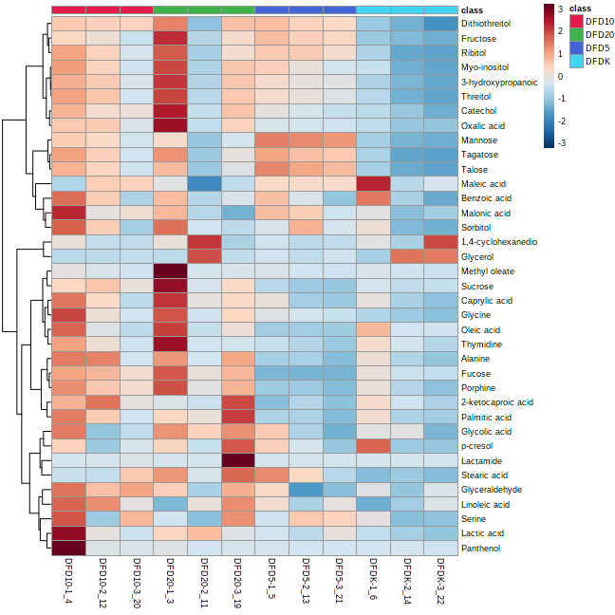

Figure S1. Heat color graphics of selected metabolites that are effective in the differentiation of metabolic profiles in the differentiation process
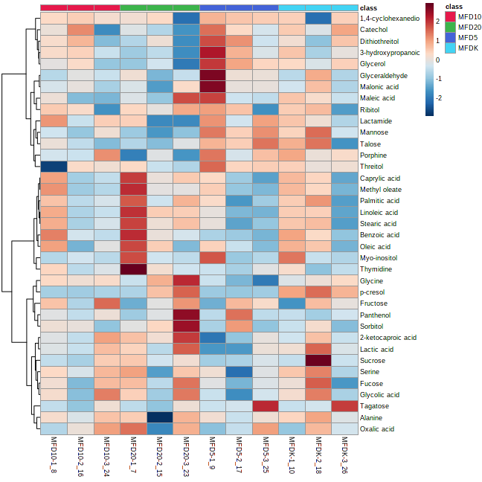
Figure S2. Heat color graphics of selected metabolites that are effective in the differentiation of metabolic profiles in the maturation process

