Supplementary Figure 1: Genus Specific shifts in AMF abundance. Cumulative abundance is shown for each AM fungal genus at low, middle, and high elevations.
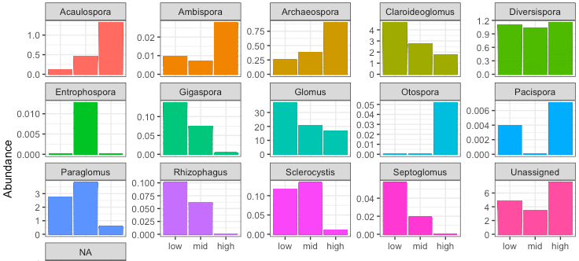

Supplementary Figure 2: Microbial Biomass Carbon: Linear relationship of MBC with elevation. Plot includes results from MELM for pH and elevation.

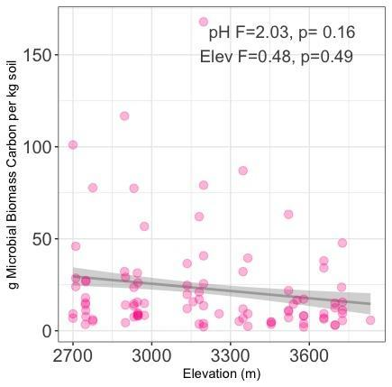

Supplementary Figure 3: Soil NH₄⁺: Linear relationship of NH₄⁺ with elevation. Plot includes results from MELM for pH and elevation.

