Supplementary Information
Understanding the Morphogenesis of Hierarchically Porous Graphitic Aerogels Produced from Protein Precursors
M. Shaharyar Wani^{1,2}, Bridget Denzer^{2,3}, Nick J. Caggiano³, Robert K Prud’homme³, Craig B. Arnold^{1,2*}
¹Department of Mechanical and Aerospace Engineering, Princeton University, Princeton, NJ, 08544, USA
²Princeton Materials Institute, Princeton University, Princeton, NJ 08544, USA
³Department of Chemical and Biological Engineering, Princeton University, Princeton, NJ, 08544, USA
*Correspondence to: C.B.A cbarnold@princeton.edu

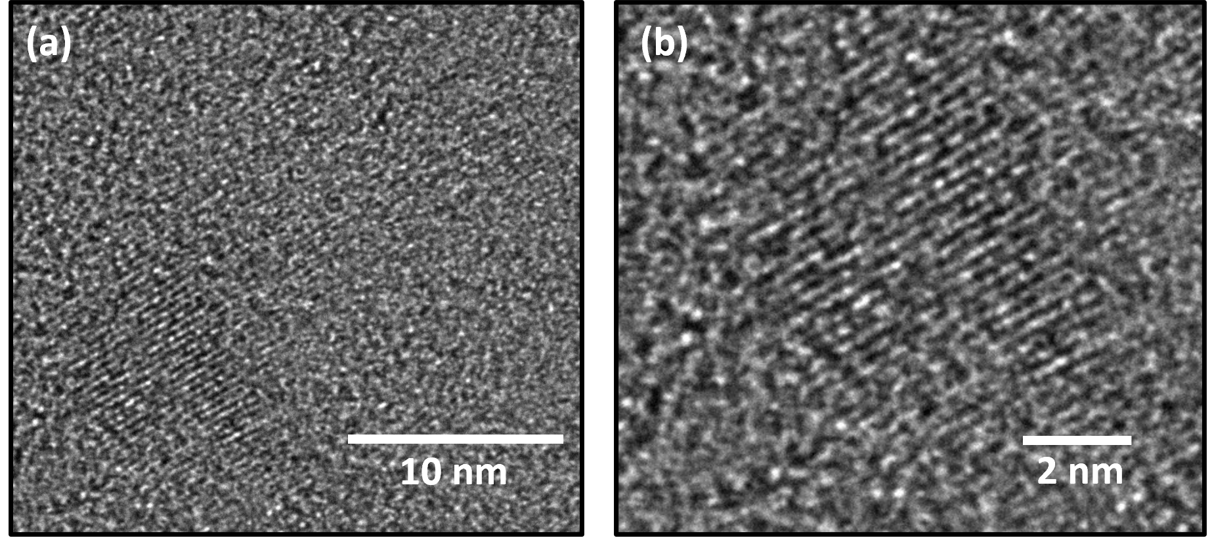
Supplementary Fig. S1. (a, b) High-resolution transmission electron microscopy image
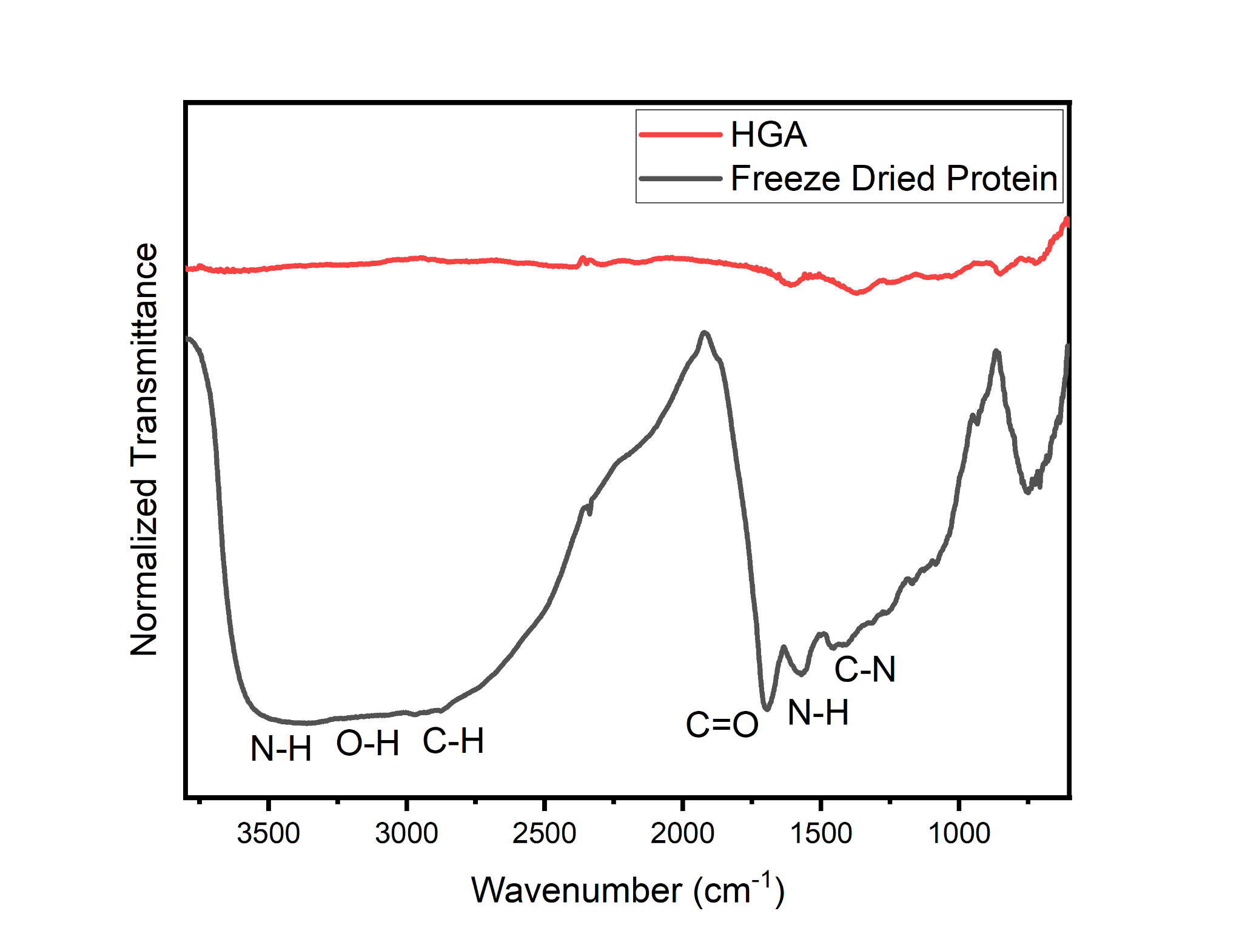
Supplementary Fig. S2. FTIR of freeze-dried protein and HGA
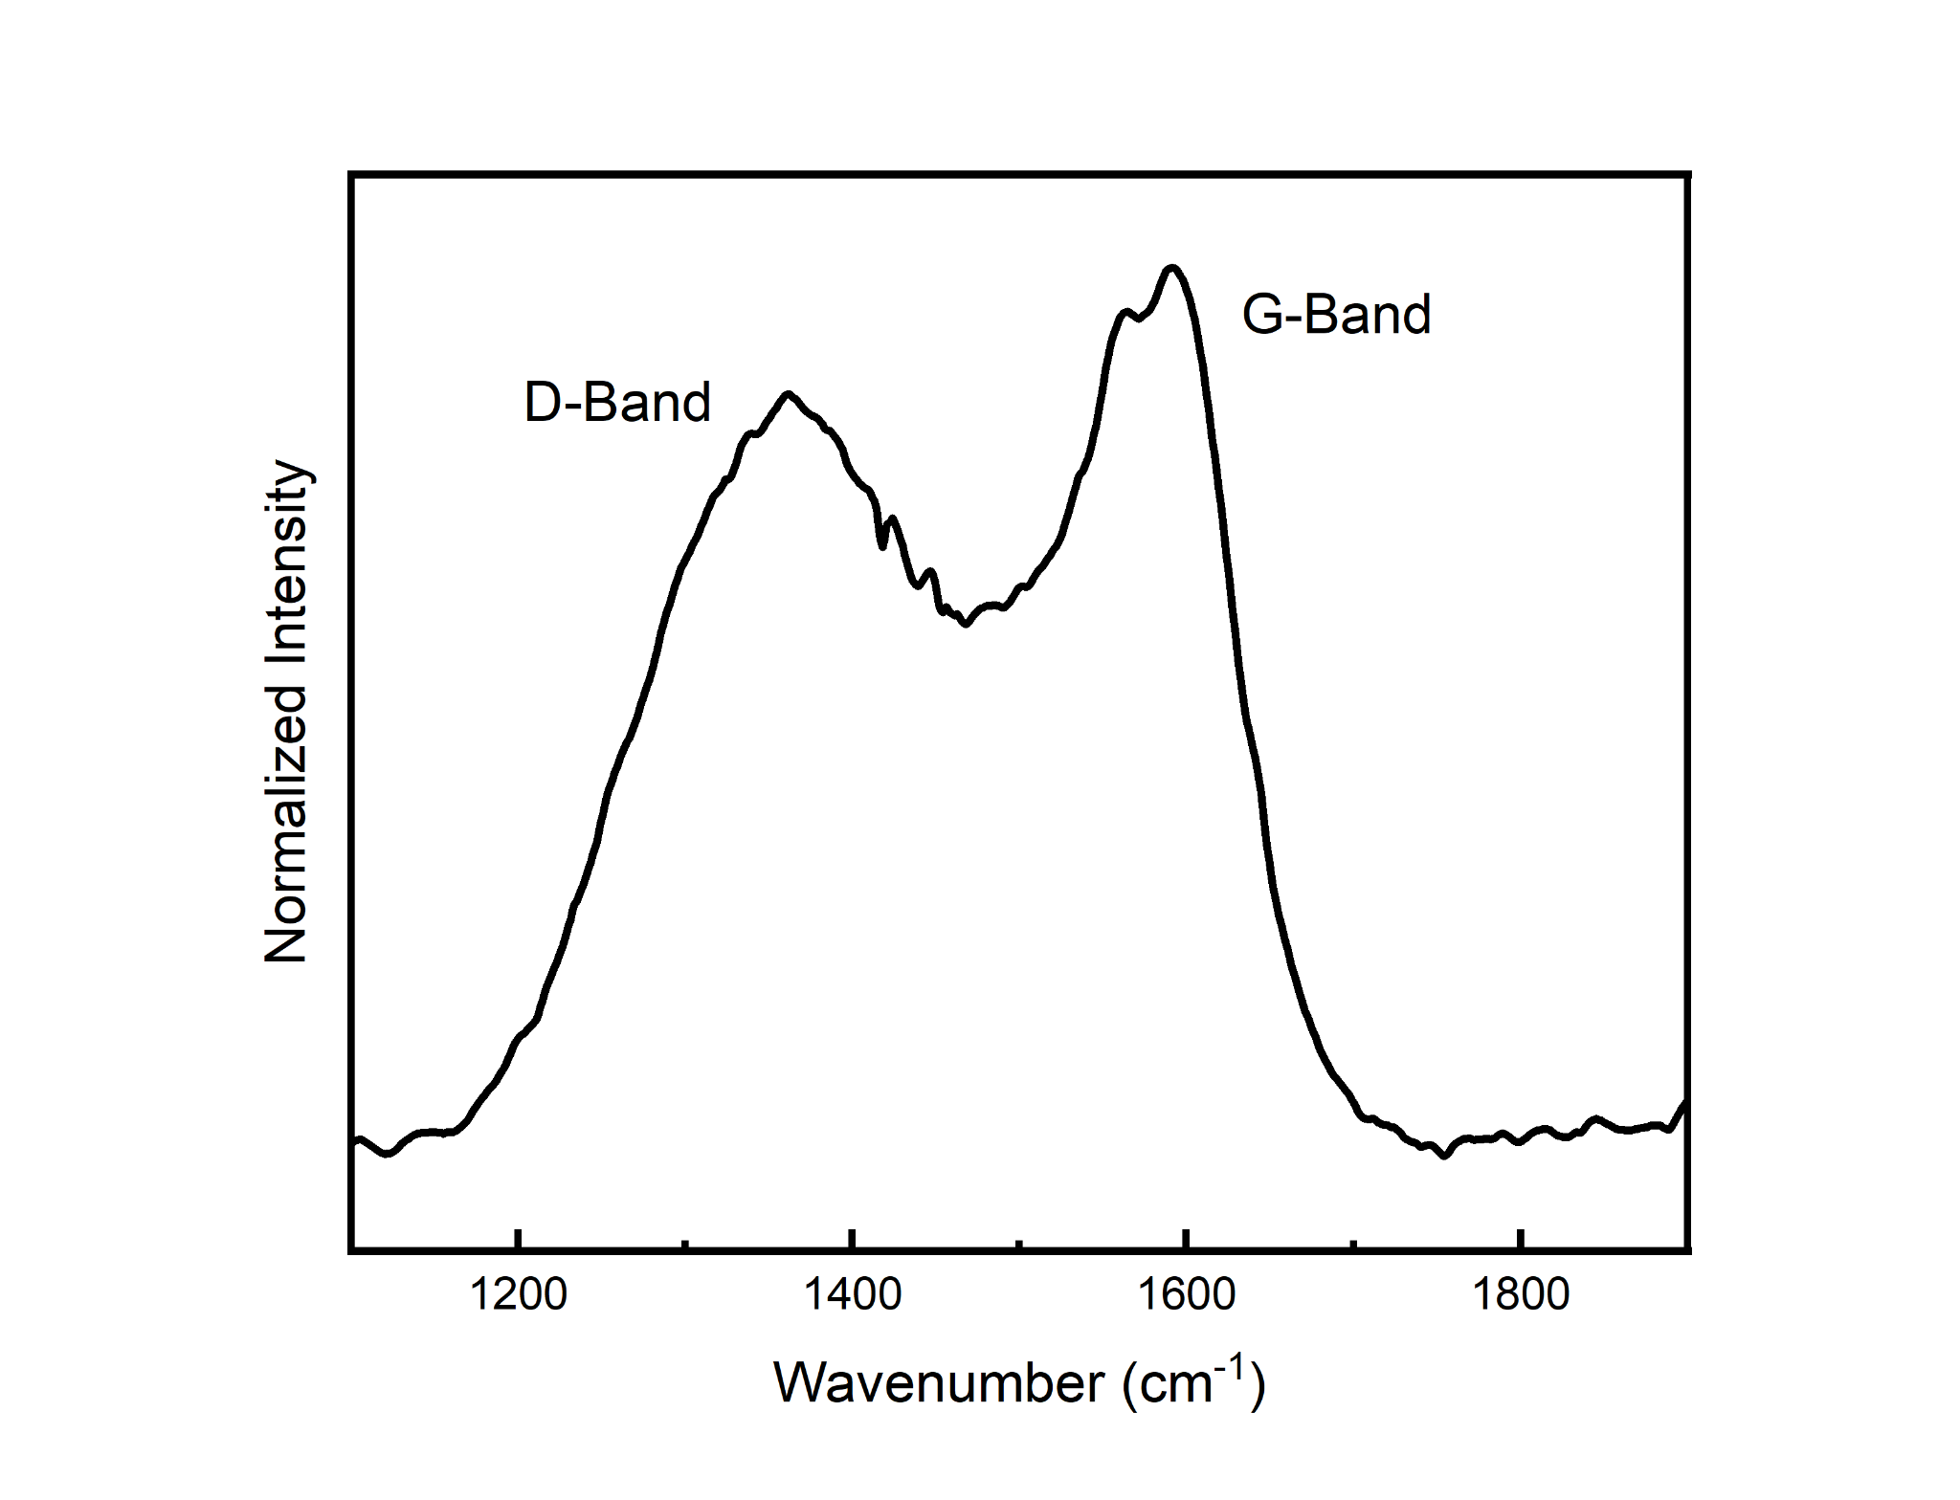
Supplementary Fig. S3. Raman spectra of HGA

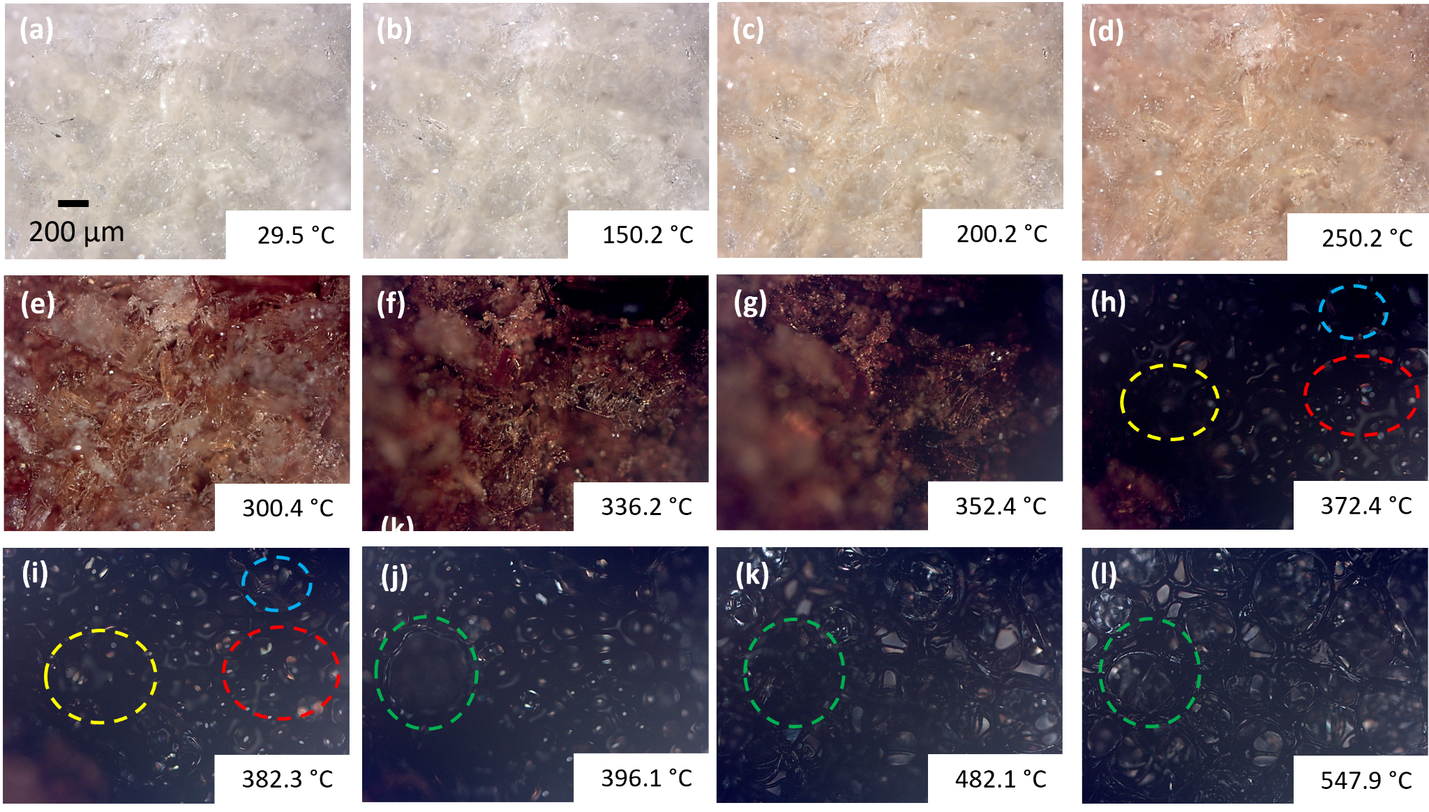
Supplementary Fig. S4. In-situ optical microscopy images showing the evolution of the freeze-dried egg white protein into HGA.

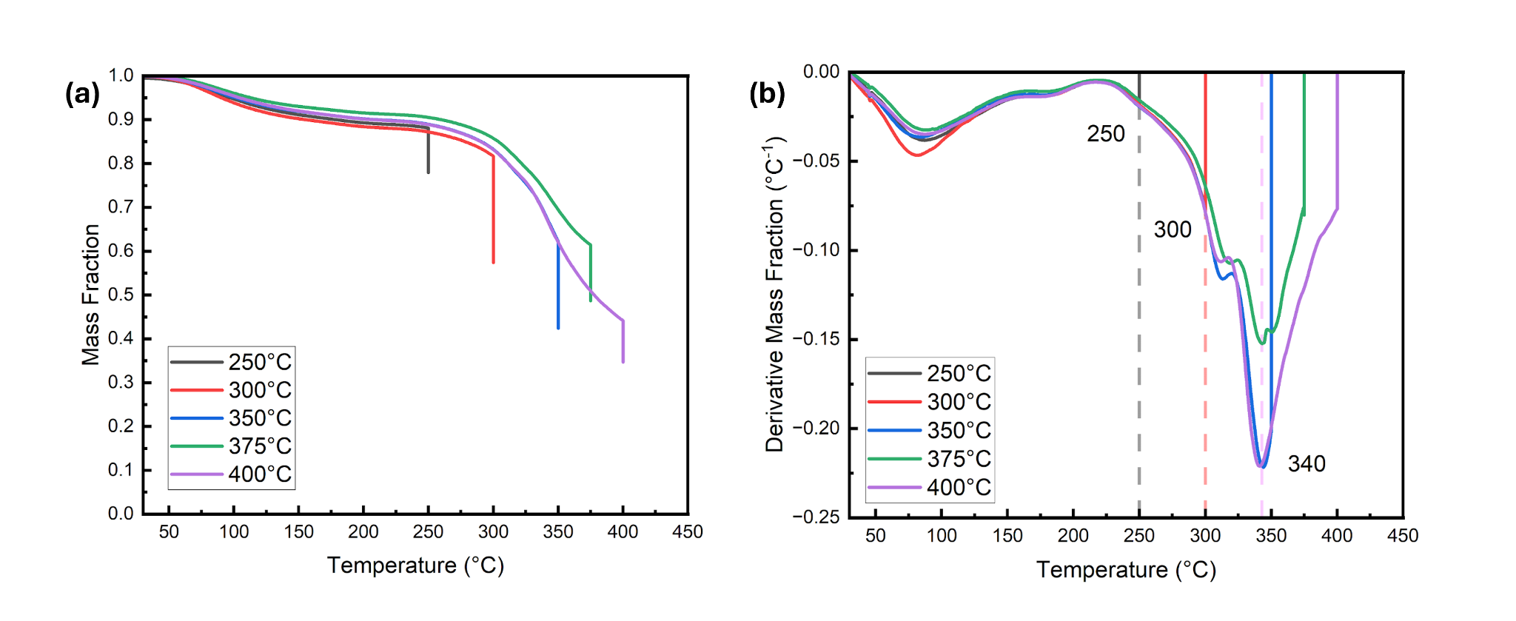
Supplementary Fig. S5. TGA of samples at different peak temperatures (250, 300, 350, 375, and 400 °C)

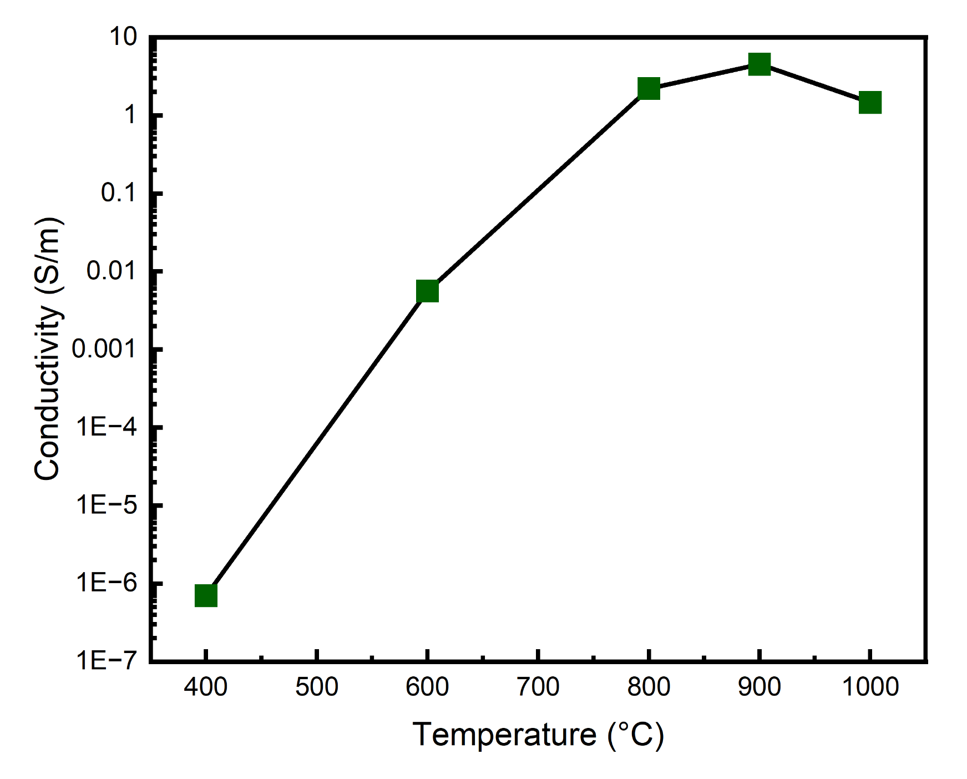
Supplementary Fig. S6. Conductivity of aerogels prepared at different peak temperatures.

