Appendix
Presented in Fig. A(a) through (n) are the close-up photographs of the strain gauges mounted on the concrete surface of the CRCSW panel at the final stage of loading.
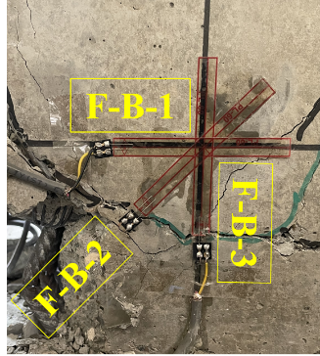 | 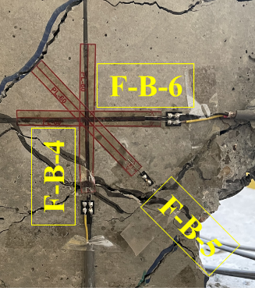 |  | 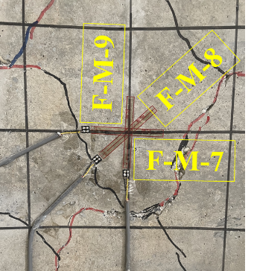 | 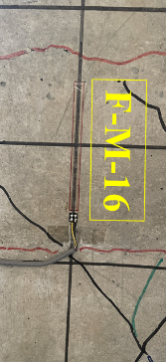 | 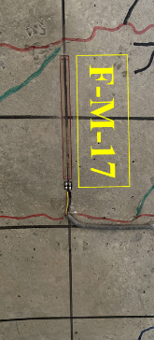
(a) F-B-1, F-B-2, F-B-3 | (b) F-B-4, F-B-5, F-B-6 |  | (c) F-M-7, F-M-8, F-M-9 | (d) F-M-16 | (e) F-M-17
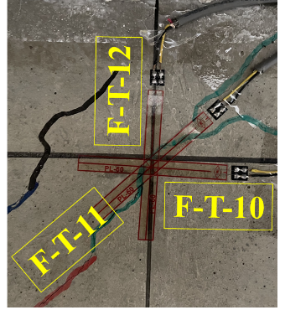 | 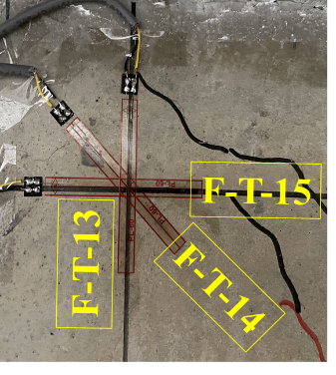 |  | 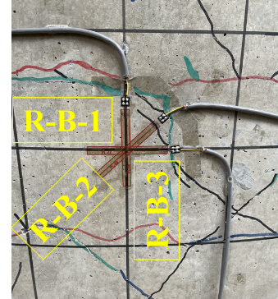 | 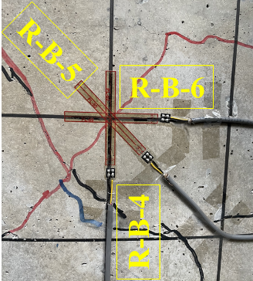
(f) F-T-10, F-T-11, F-T-12 | (g) F-T-13, F-T-14, F-T-15 |  | (h) R-B-1, R-B-2, R-B-3 | (i) R-B-4, R-B-5, R-B-6
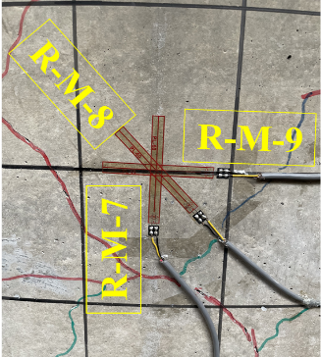 | 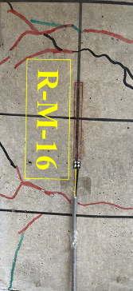 | 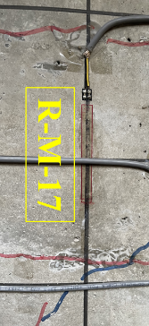 | 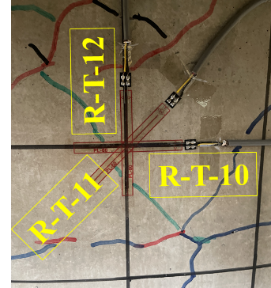 | 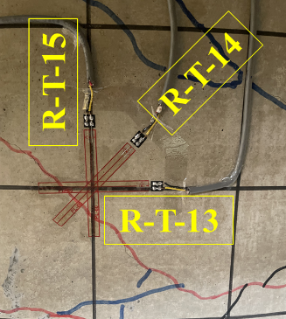
(j) R-M-7, R-M-8, R-M-9 | (k) R-M-16 | (l) R-M-17 | (m) R-T-10, R-T-11, R-T-12 | (n) R-T-13, R-T-14, R-T-15
Fig. A Close-up photos of the concrete surface strain gauges mounted on the wall panel at the final stage of loading.

