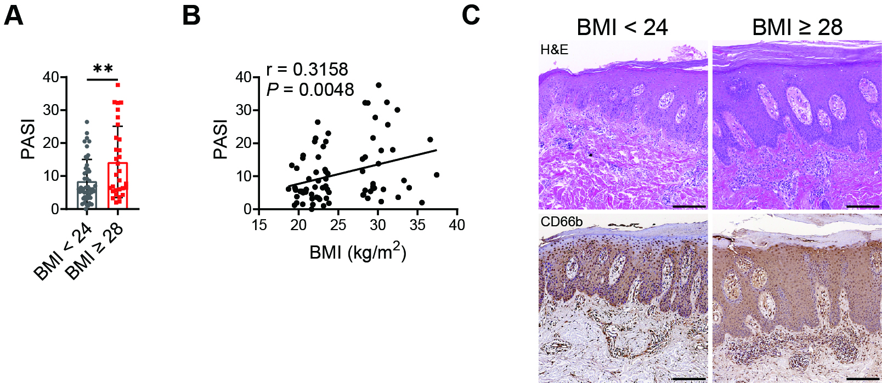
Supplemental Figure 1. Disease severity increases in obese psoriasis patients. (A) Summarized bar graphs of clinical severity. (B) Correlation of clinical severity against BMI (n = 78). (C) Representative images of H&E staining and immunohistochemistry staining for CD66b in skin lesions of psoriasis patients (scale bar = 200 μm). Error bars show means ± SEM. ns, not significant. *P < .05, **P < .01, ***P < .001.

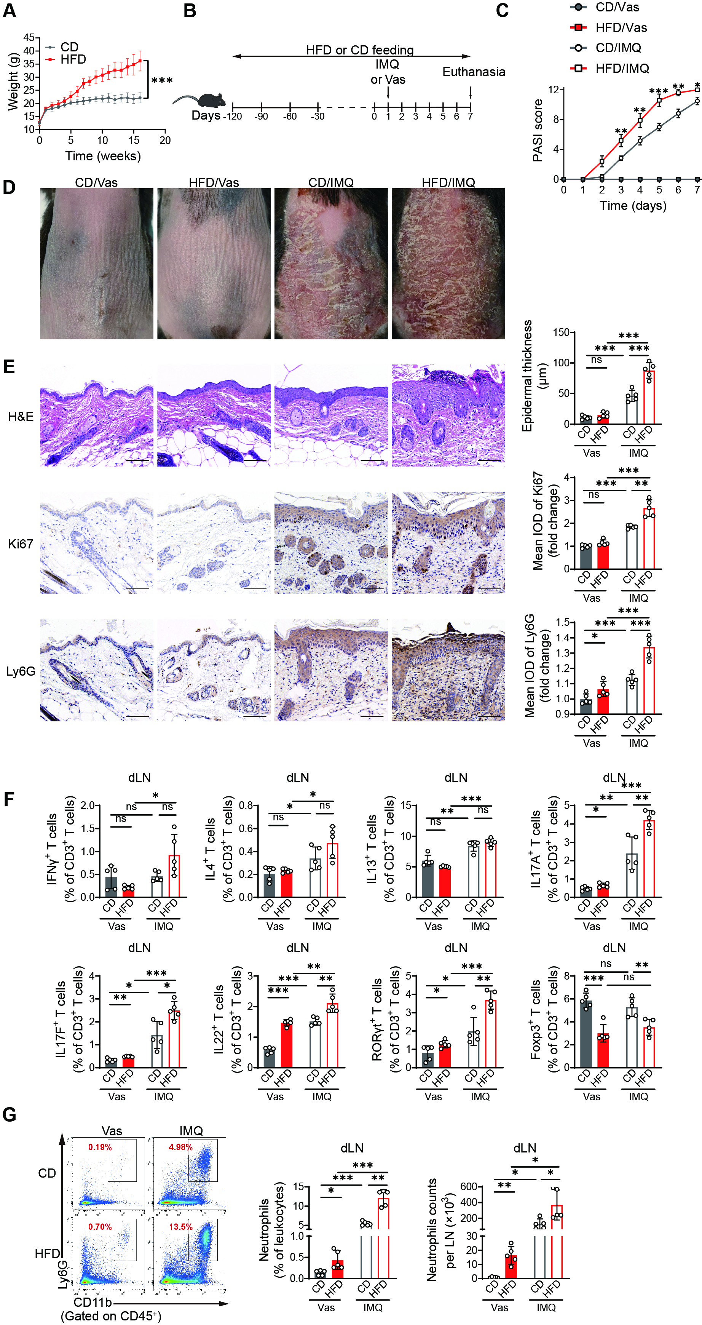
Supplemental Figure 2. HFD-induced obesity exacerbates imiquimod-mediated psoriasiform dermatitis in mice. (A) Changes of mouse weight. (B) Schematic overview of the experimental protocol. (C) Changes of clinical severity. (D) Representative clinical photographs. (E) Representative images of H&E staining and immunohistochemistry staining and summarized bar graphs of epidermal thickness and mean IOD of Ki67 and Ly6G in mouse skin (scale bar = 100 μm). (F) Flow cytometric analysis of frequencies of IFNγ⁺, IL-4⁺, IL-13⁺, IL-17A⁺, IL-17F⁺, IL-22⁺, RORγt⁺, Foxp3⁺ T cells gated on CD45⁺CD3⁺ T cells from mouse dLN. (G) Representative flow cytometric plots and summarized bar graph of the frequencies and numbers of CD11b⁺Ly6G⁺ neutrophils gated on CD45⁺ population from mouse dLN. Results are from 3 independent experiments with 3 to 5 mice per group. Error bars show means ± SEM. ns, not significant. *P < .05, **P < .01, ***P < .001.

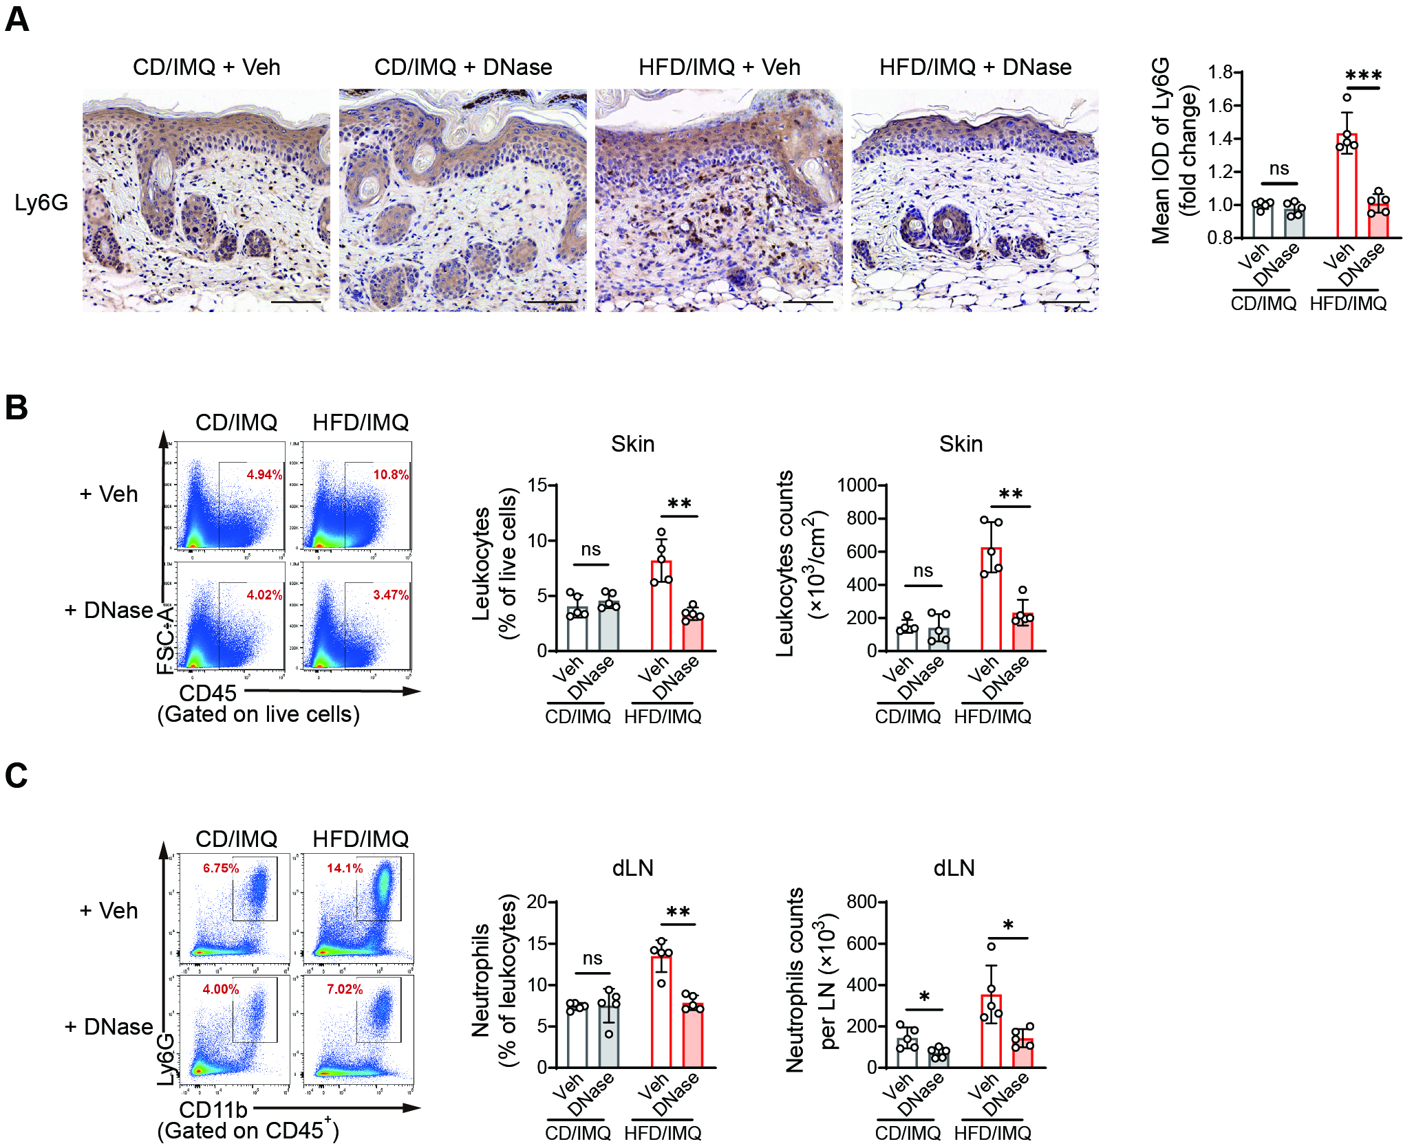
Supplemental Figure 3. Changes of neutrophil recruitment in skin and dLN of obese psoriasis-like mice with NETs inhibition. (A) Representative images of immunohistochemistry staining and summarized bar graphs of mean IOD of Ly6G in mouse skin (scale bar = 100 μm). (B) Representative flow cytometric plots and summarized bar graph of the frequencies and numbers of CD45⁺ leukocytes gated on live cells from mouse skin. (C) Representative flow cytometric plots and summarized bar graph of the frequencies and numbers of CD11b⁺Ly6G⁺ neutrophils gated on CD45⁺ population from mouse dLN. Results are from 3 independent experiments with 3 to 5 mice per group. Error bars show means ± SEM. ns, not significant. *P < .05, **P < .01, ***P < .001.

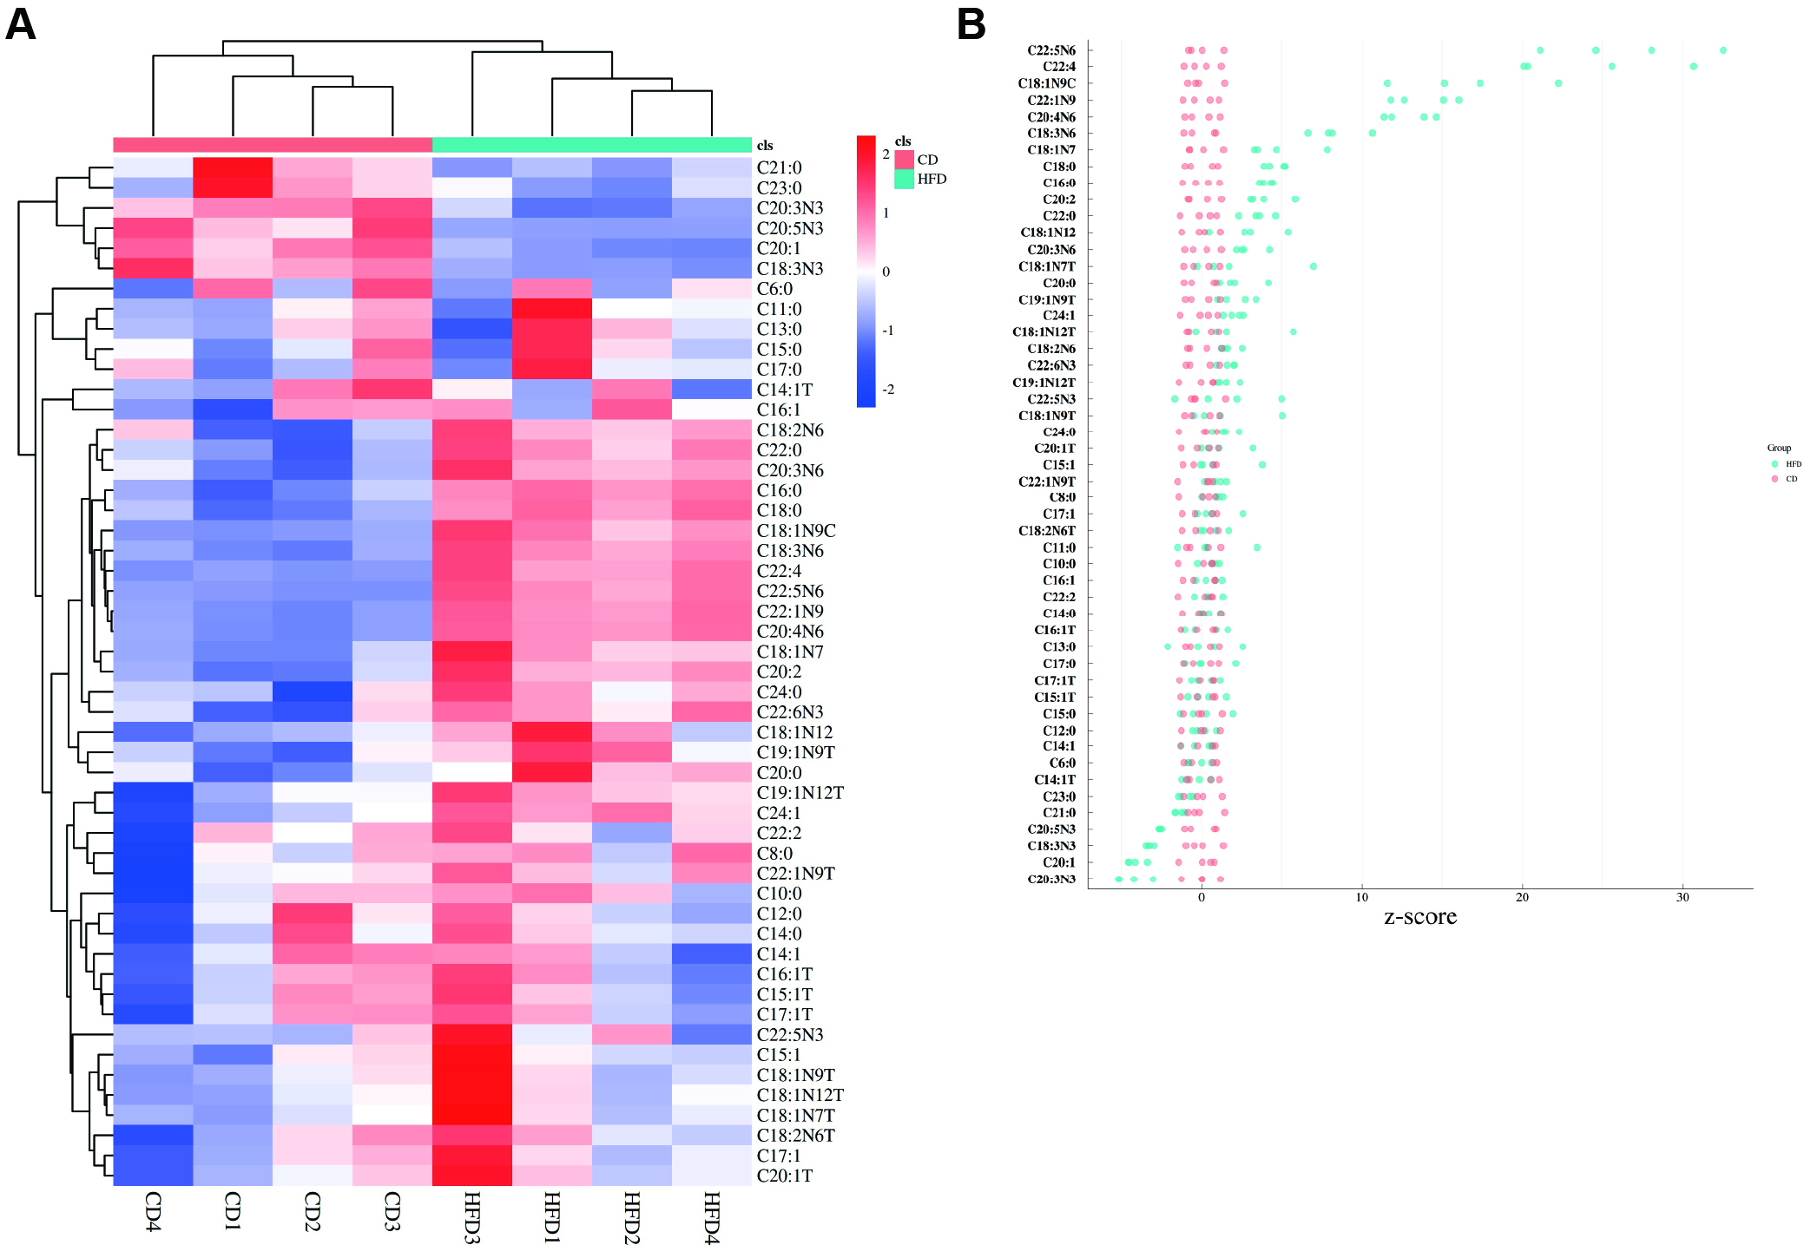
Supplemental Figure 4. HFD-induced obesity leads to fatty acid metabolism abnormality in mice. (A) Heat map of free fatty acids in mouse serum (n = 4). (B) Z-score of free fatty acids in mouse serum (n = 4).

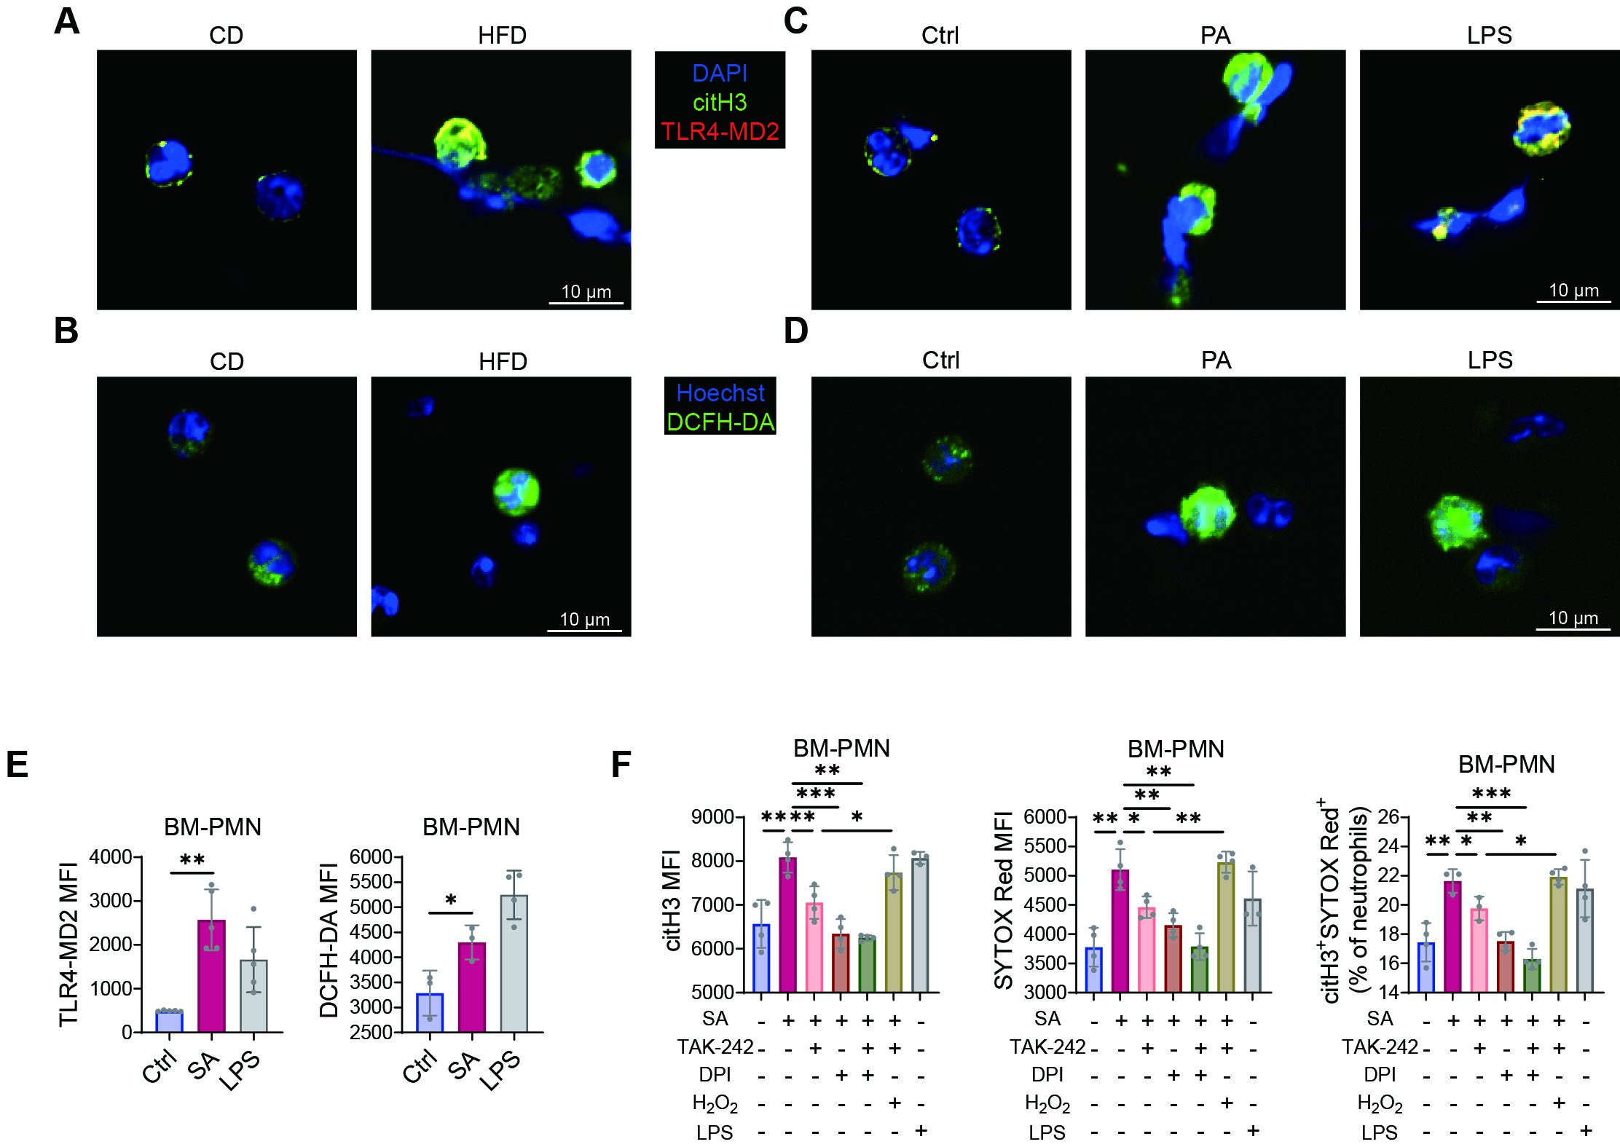
Supplemental Figure 5. PA and SA promote NETs production ex vivo through TLR4-MD2/ROS signaling pathway. (A) Representative immunofluorescence staining of citH3, TLR4-MD2, and DAPI in BM-derived neutrophils ex vivo (scale bar = 10 μm). (B) DCFH-DA staining was performed to determine total ROS levels in BM-derived neutrophils ex vivo (scale bar = 10 μm). (C) Representative immunofluorescence staining of citH3, TLR4-MD2, and DAPI in BM-derived neutrophils ex vivo (scale bar = 10 μm). (D) DCFH-DA staining was performed to determine total ROS levels in BM-derived neutrophils ex vivo (scale bar = 10 μm). (E) Flow cytometric analysis of TLR4-MD2 complex and DCFH-DA in BM-derived neutrophils ex vivo. (F) Flow cytometric analysis of ex vivo NETs formation from BM-derived neutrophils. Results are from 3 independent experiments. ns, not significant. Error bars show means ± SEM. *P < .05, **P < .01, ***P < .001.

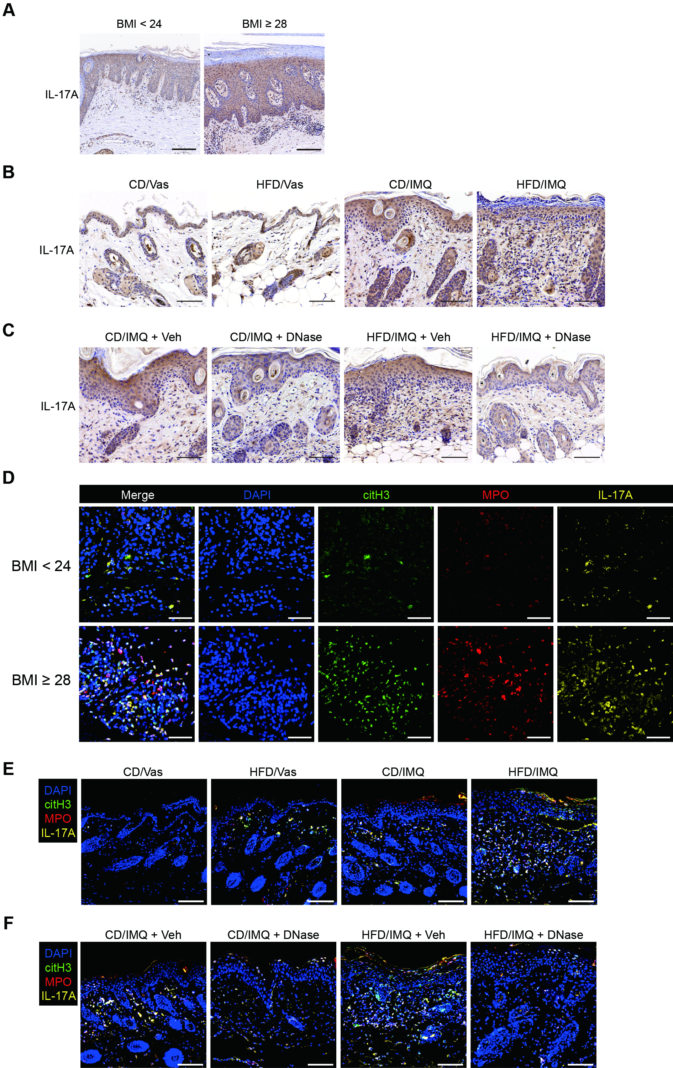
Supplemental Figure 6. Abundance of IL-17A⁺ cell infiltration and NETs within obesity-exacerbated inflamed skin of psoriasis patients and psoriasis-like mice. (A) Representative images of immunohistochemistry staining for IL-17A in skin lesions of psoriasis patients (scale bar = 200 μm). (B and C) Representative images of immunohistochemistry staining of IL-17A in mouse skin (scale bar = 100 μm). (D) Representative immunofluorescence staining of citH3, MPO, IL-17A and DAPI in skin lesions of psoriasis patients (scale bar = 50 μm). (E and F) Representative immunofluorescence staining of citH3, MPO, IL-17A and DAPI in mouse skin (scale bar = 100 μm). Results are from 3 independent experiments.

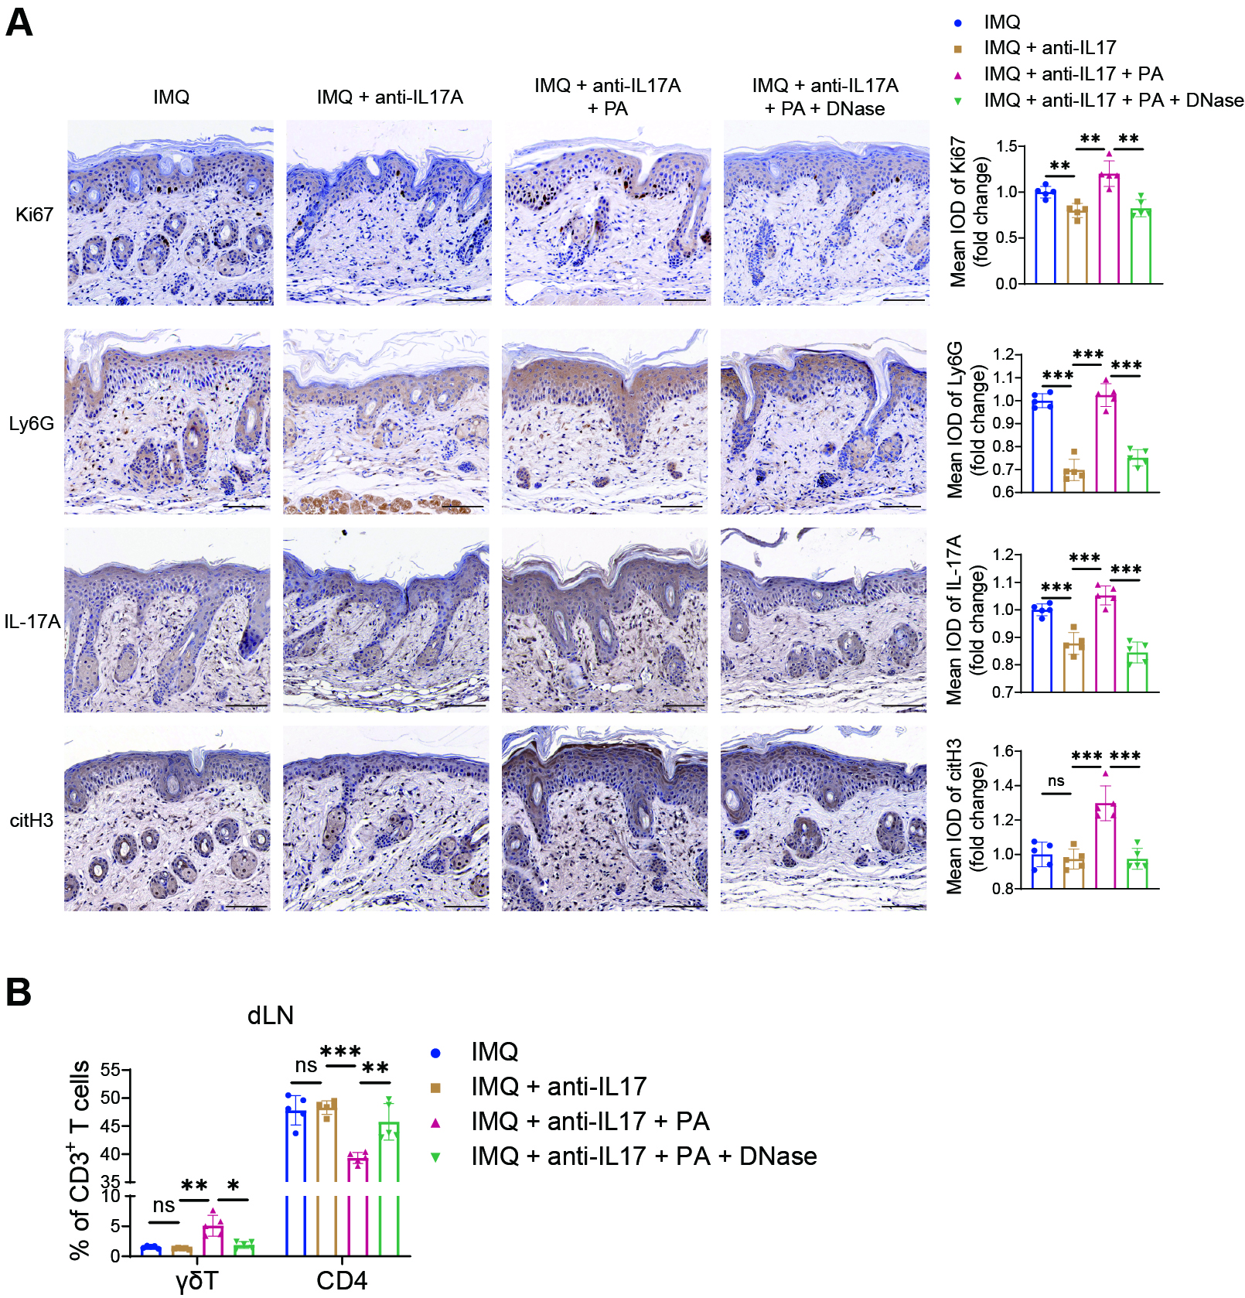
Supplemental Figure 7. Histologic analysis of dorsal skin from anti-IL17A-treated psoriatic mice with PA intervention with or without DNase Ⅰ treatment. (A) Representative images of immunohistochemistry staining and summarized bar graphs of mean IOD of Ki67, Ly6G, IL-17A and citH3 in mouse skin (scale bar = 100 μm). (B) Flow cytometric analysis of the frequencies of γδT and CD4⁺ T cells gated on CD3⁺ T cells cells from dLN. Results are from 3 independent experiments with 3 to 5 mice per group. ns, not significant. Error bars show means ± SEM. *P < .05, **P < .01, ***P < .001.

