Extended data figures
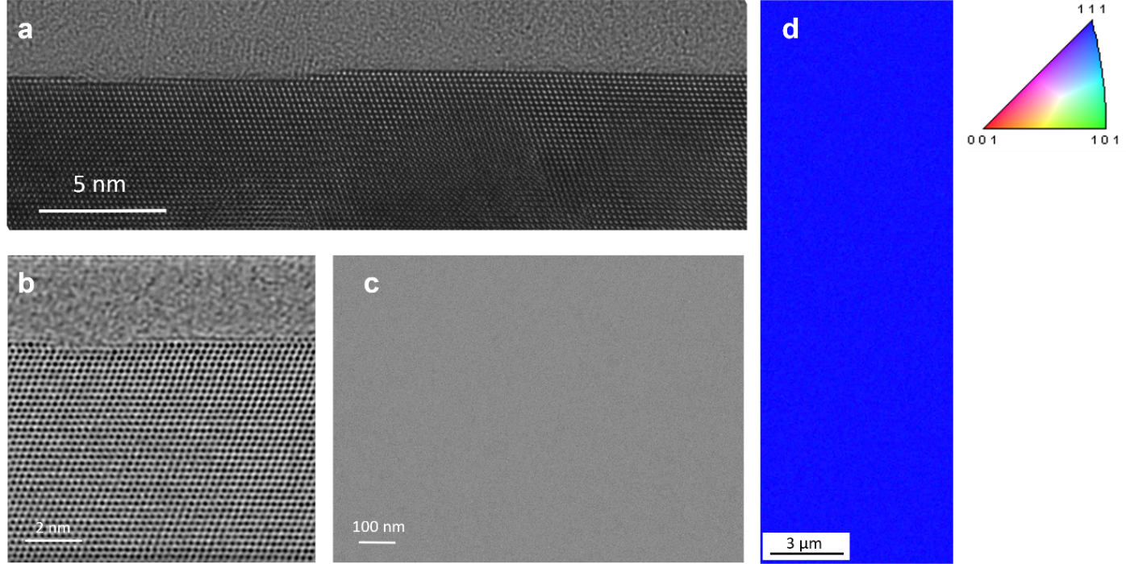
Extended Data Fig. 1 │ Surface of a single-crystal copper thin film grown via atomic sputtering epitaxy (ASE). a, Cross-sectional HRTEM image of the surface region of the copper thin film observed along the [110] orientation. All the HRTEM images of SCCF show that the atomic layers on the surface are terminated by monoatomic step edges. b, ABF-STEM image of the surface region of the SCCF. c, Scanning electron microscopy images of the surface of the SCCF showing no traces of grain boundaries. d, EBSD map showing perfect alignment along the (111) plane.

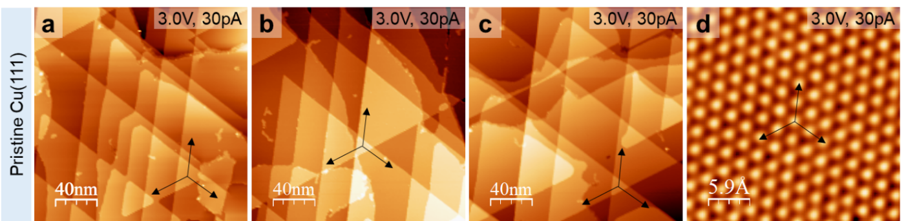
Extended Data Fig. 2 │ Ultraflat surface of SCCF(111). a-c, Large-scale STM images taken from different areas of ultraflat Cu(111) films. d, Atomic-resolution image of the SCCF(111) surface. The black arrows represent the crystal axes of Cu(111).

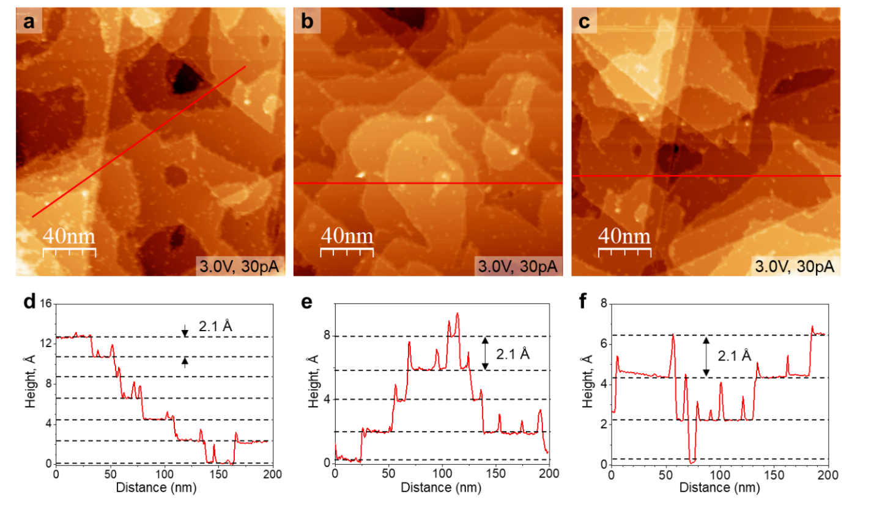
Extended Data Fig. 3 │ SCCF(111) surface after exposure to 100 L of oxygen at room temperature. a-c, Large-scale STM images taken from different areas of the SCCF(111) surface after exposure to oxygen. d-f, Line profiles taken along the red lines in (a-c) showing monoatomic steps.

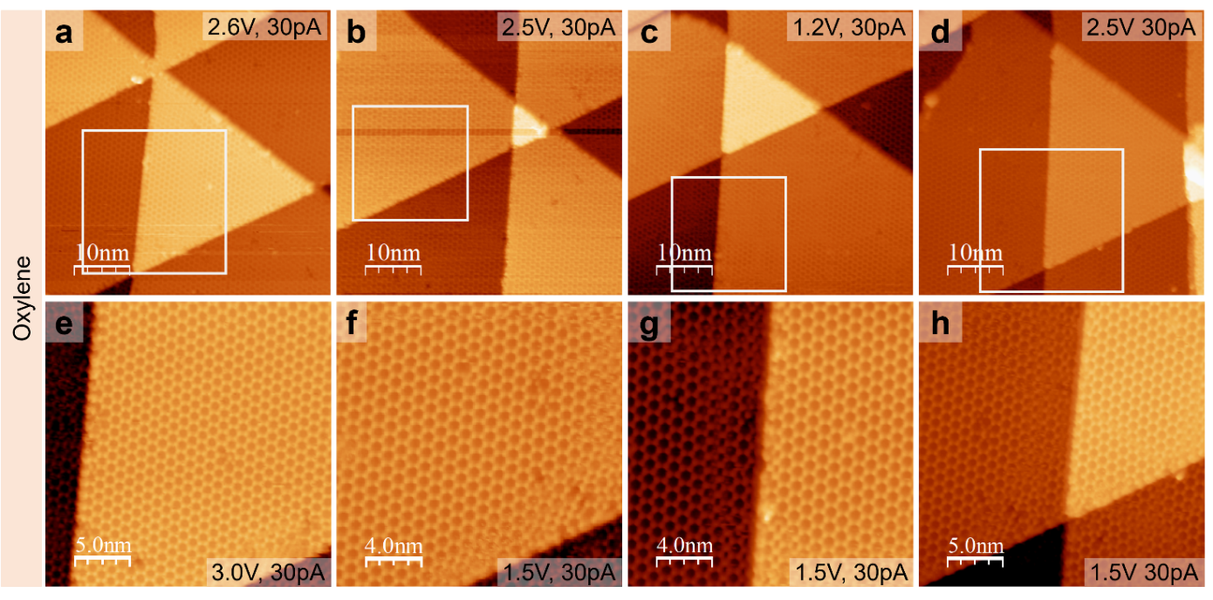
Extended data Fig. 4 │ Highly ordered honeycomb structure of oxylene on SCCF(111). a-d, Series of STM images of oxylene obtained from different locations on the SCCF(111) surface. e-h, Enlarged images of the white boxes in (a-d).

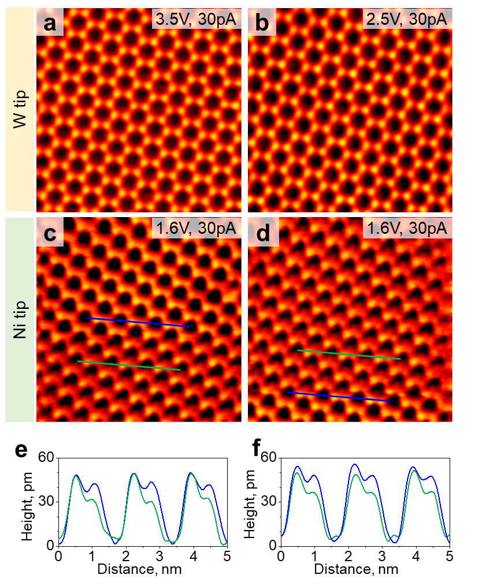
Extended data Fig. 5 │ Magnetic structure of oxylene. a, b, STM images obtained with a nonmagnetic W tip. c, d, STM images obtained with a ferromagnetic Ni tip. e, f, Line profiles taken along the blue and green lines in (c) and (d), respectively. The size of all the STM images is 10 × 10 nm².

Note to Extended data Fig. 5: During the process of obtaining STM images with a Ni tip, the magnetic moment alignment of the Ni tip changes, leading to variations in the contrast of the hcp sites in oxylene.

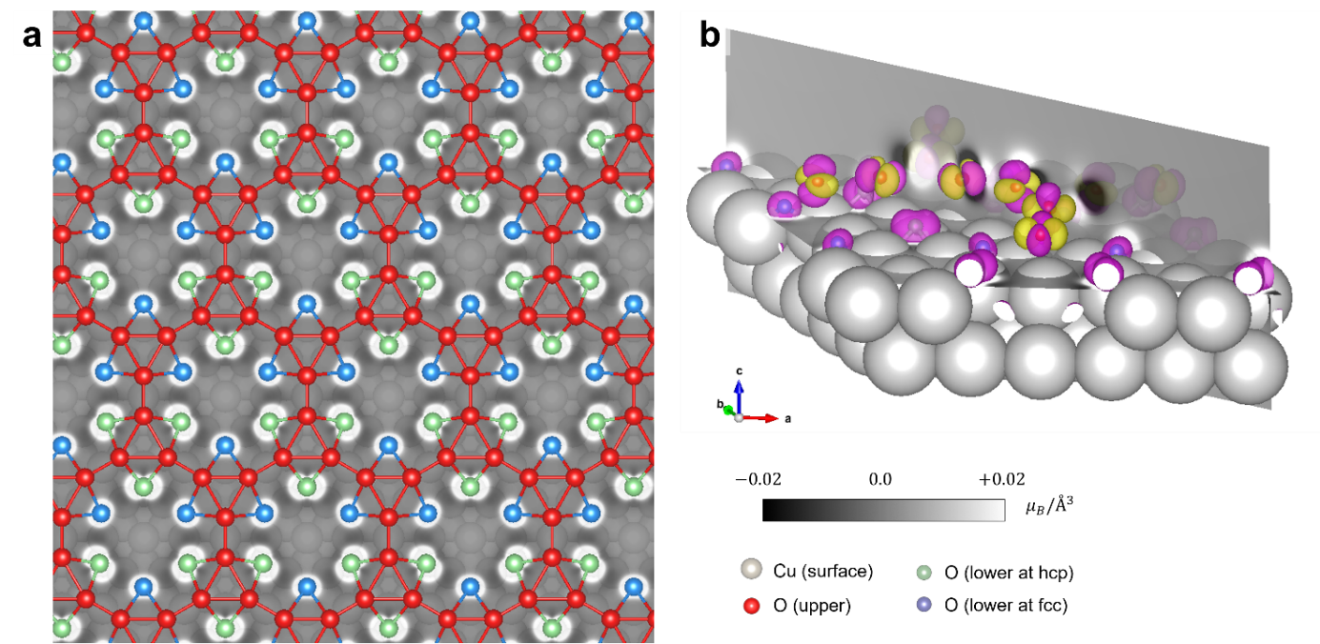
Extended data Fig. 6 │ Magnetic moments of oxylene. a, Contour plot of the perpendicular component of the magnetization density of oxylene. The contour plot is evaluated on the horizontal slice plane at the lower O atoms at the hcp sites. The isosurface is drawn at a magnetization density of $±0.115 μ_{B}/Å^{3}$. Magenta (yellow) lobes are positive (negative) values. b, 3D view of the contour plot and isosurfaces of the perpendicular component of the magnetization density of oxylene. The view is tilted from the vertical direction to exhibit the atomic magnetic octupole moments.

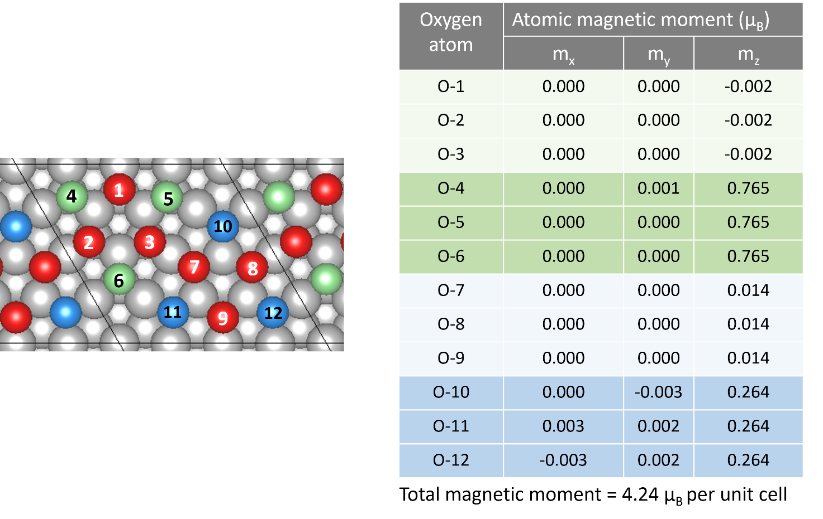
Extended data Fig. 7 │ Atomic magnetic moments of oxylene. Local magnetic moments for each O atom of oxylene. The atoms are indexed in the accompanying figure.

Note to Extended data Fig. 7: The atomic magnetic moments of the upper O-atoms (O-1,2,3, and O-7,8,9) are magnetic octupoles of $S_{Z}\left(x^{2}-y^{2}\right)$ and $S_{Z}\left(x^{2}-z^{2}\right)$, and therefore their net magnetic moments are nearly zero. On the other hand, the atomic magnetic moment of the lower O-atoms (O-4,5,6, and O-10,11,12) are magnetic octupoles of $S_{Z}\left(x^{2}\right)$, and they have substantial net magnetic moments.

